Relative abundances through the years by plot type:

* PPs used to primarily hang out in krat exclosures
* When PBs came in, they stayed mostly in krat exclosures
* This pushed PPs into controls at roughly equal rates as krat exclosures
* With decline of PBs, PPs have gone back to krat exclosures but also still hang out in controls

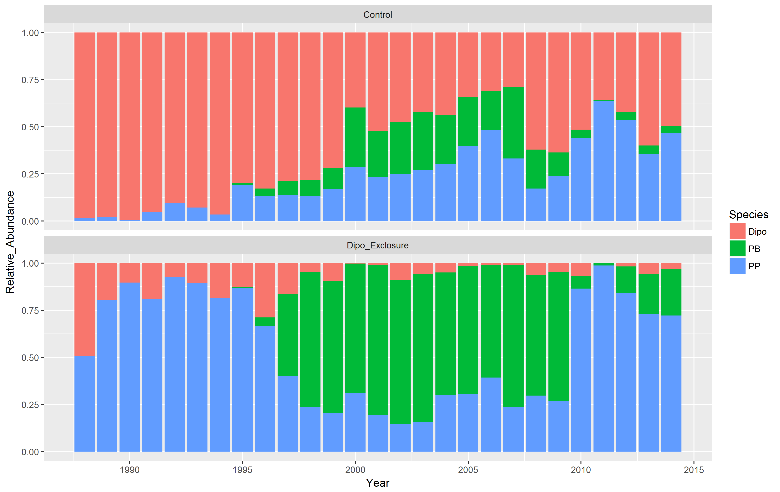

Average number of individuals per plot per year:

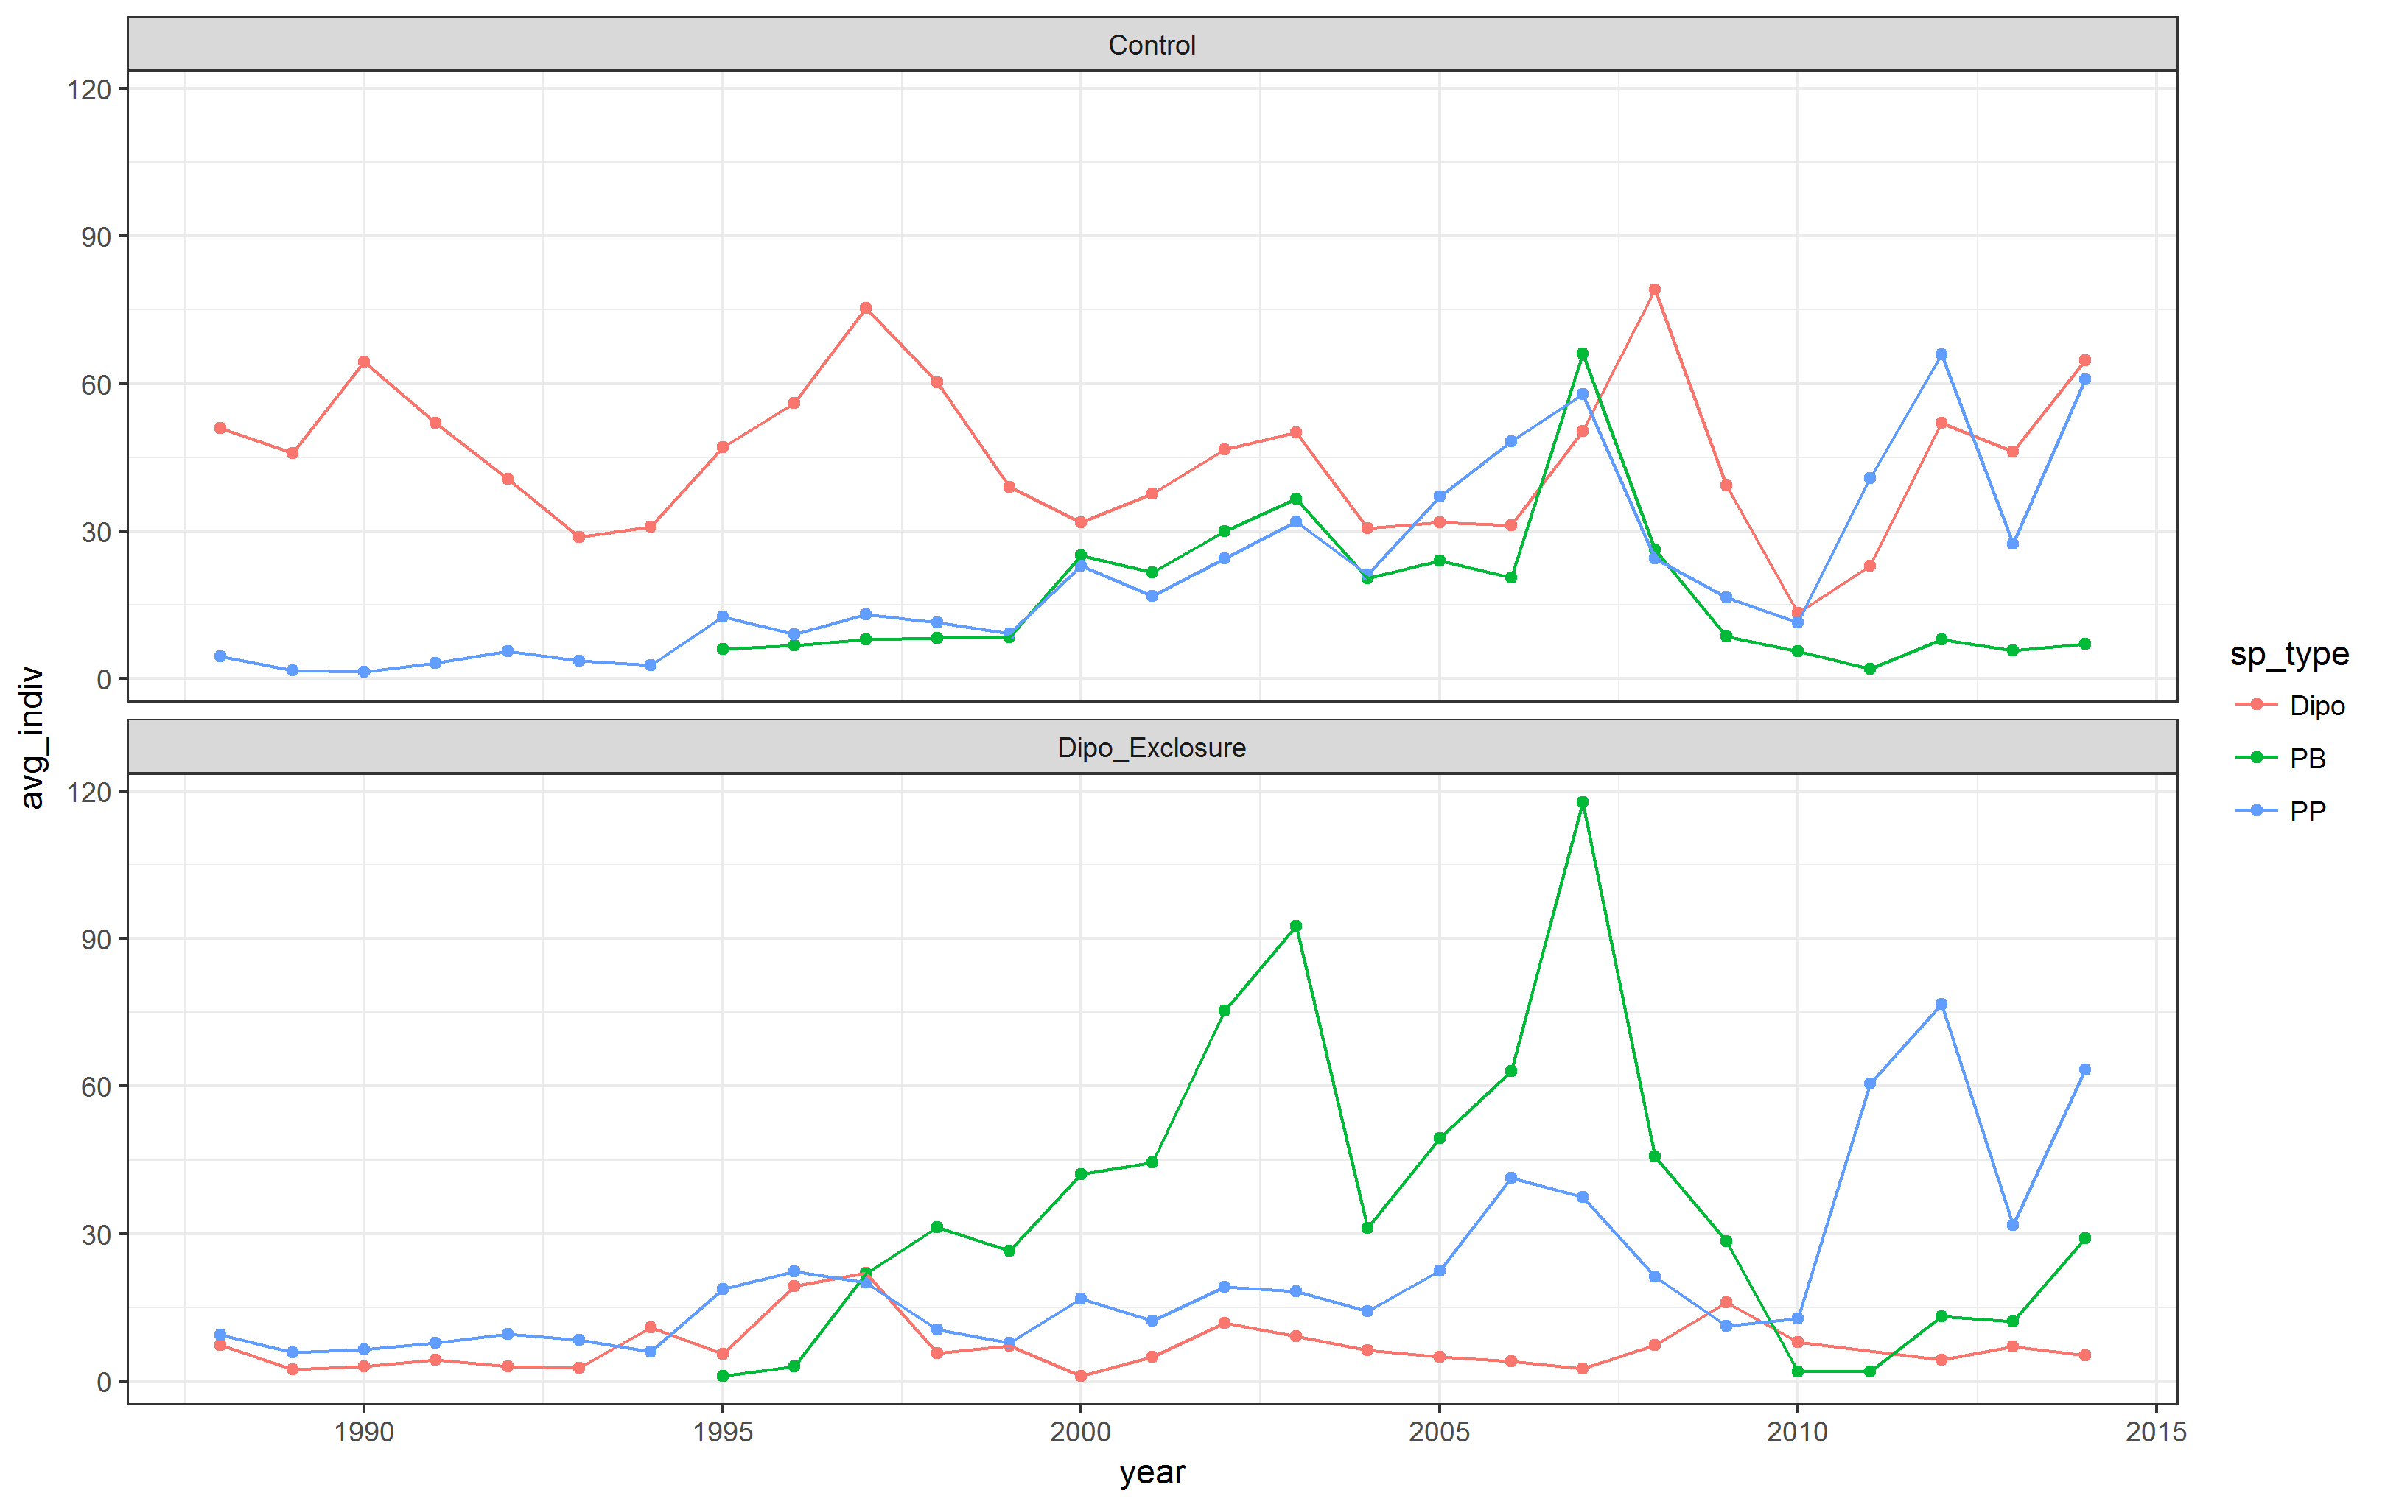

PPs by plot type:

* Regression line is close to 1:1 (add regression results to figure)
* Positive residuals mean more PPs in krat exclosures than controls
* Negative residuals mean more PPs on controls than krat-exclosures

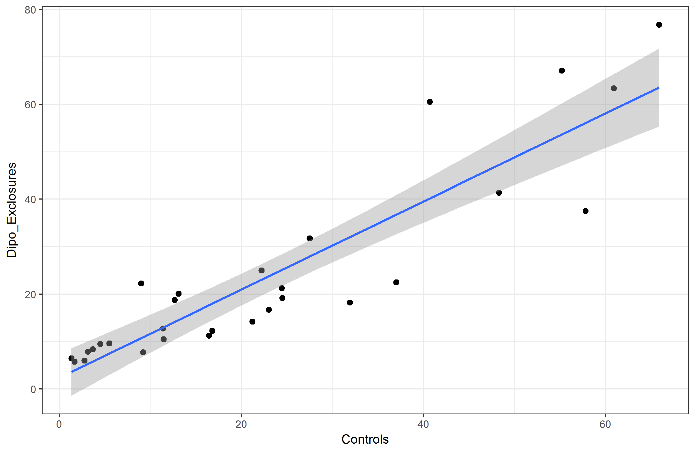

SIDEBAR: PPs by plot type, regressions run by season:

* Summer is close to 1:1 line
* Winter is a little bit under 1:1 line, but not by much (add regression results to figure)

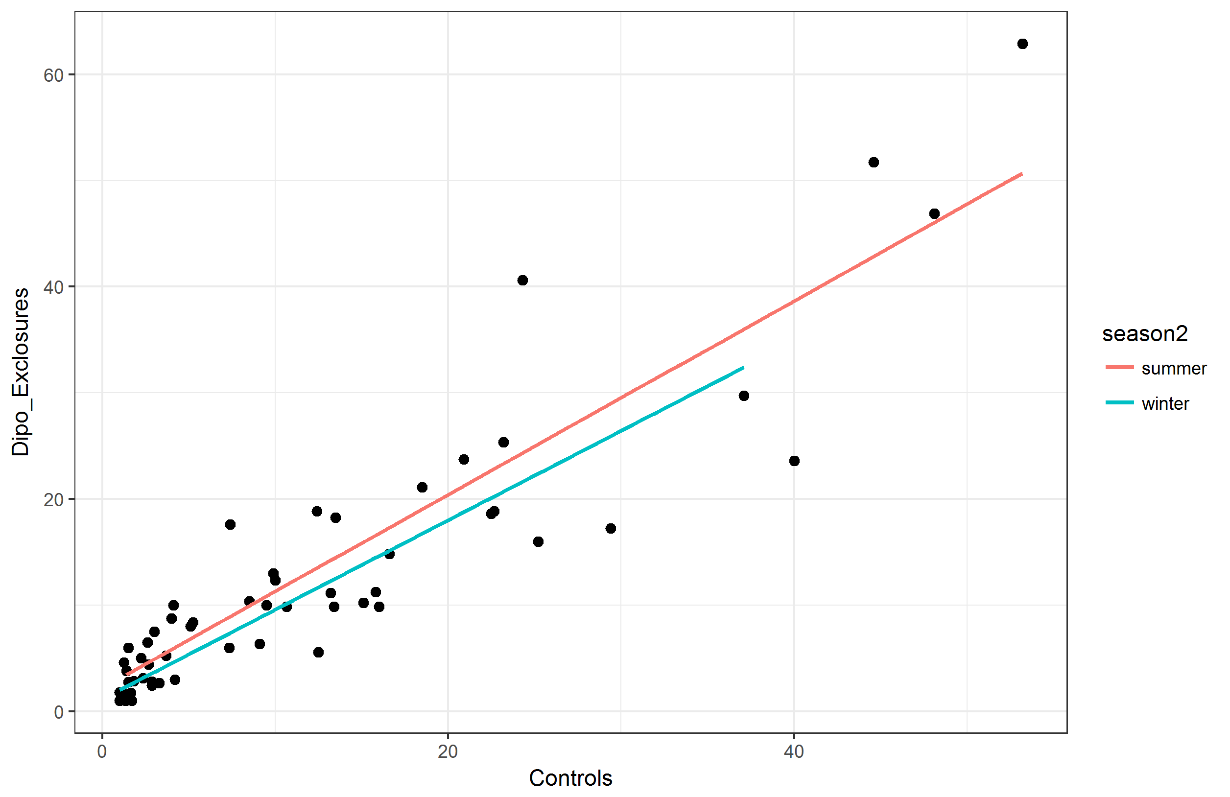

PP residuals by PB abundance:

* As the average number of PBs per plot increases, PP residuals go from positive to negative
* This indicates PPs are shifting from krat exclosures to controls when PB numbers are high

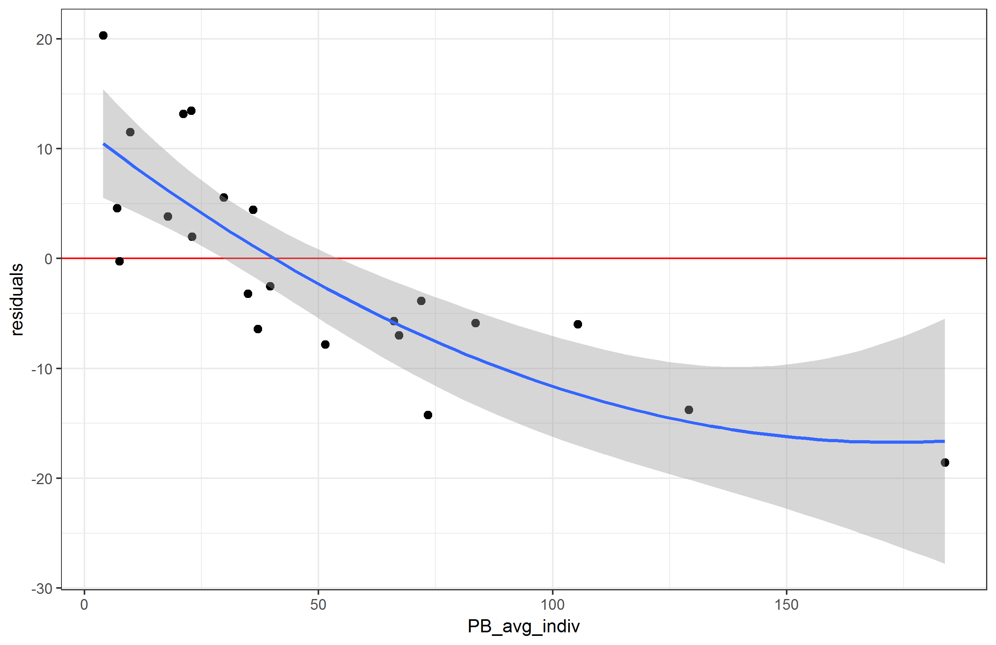

PP residuals through time and against PB abundance through time:

* Reiterating what is show above but also through time
* At points in time with high PB abund, residuals become negative

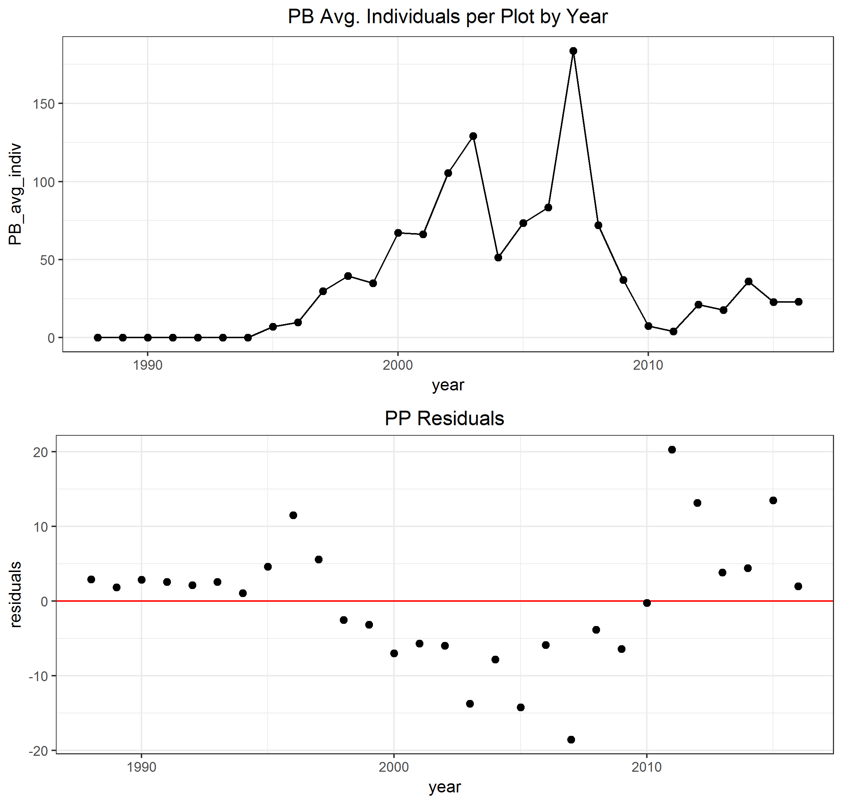

PP and PB movement frequency:

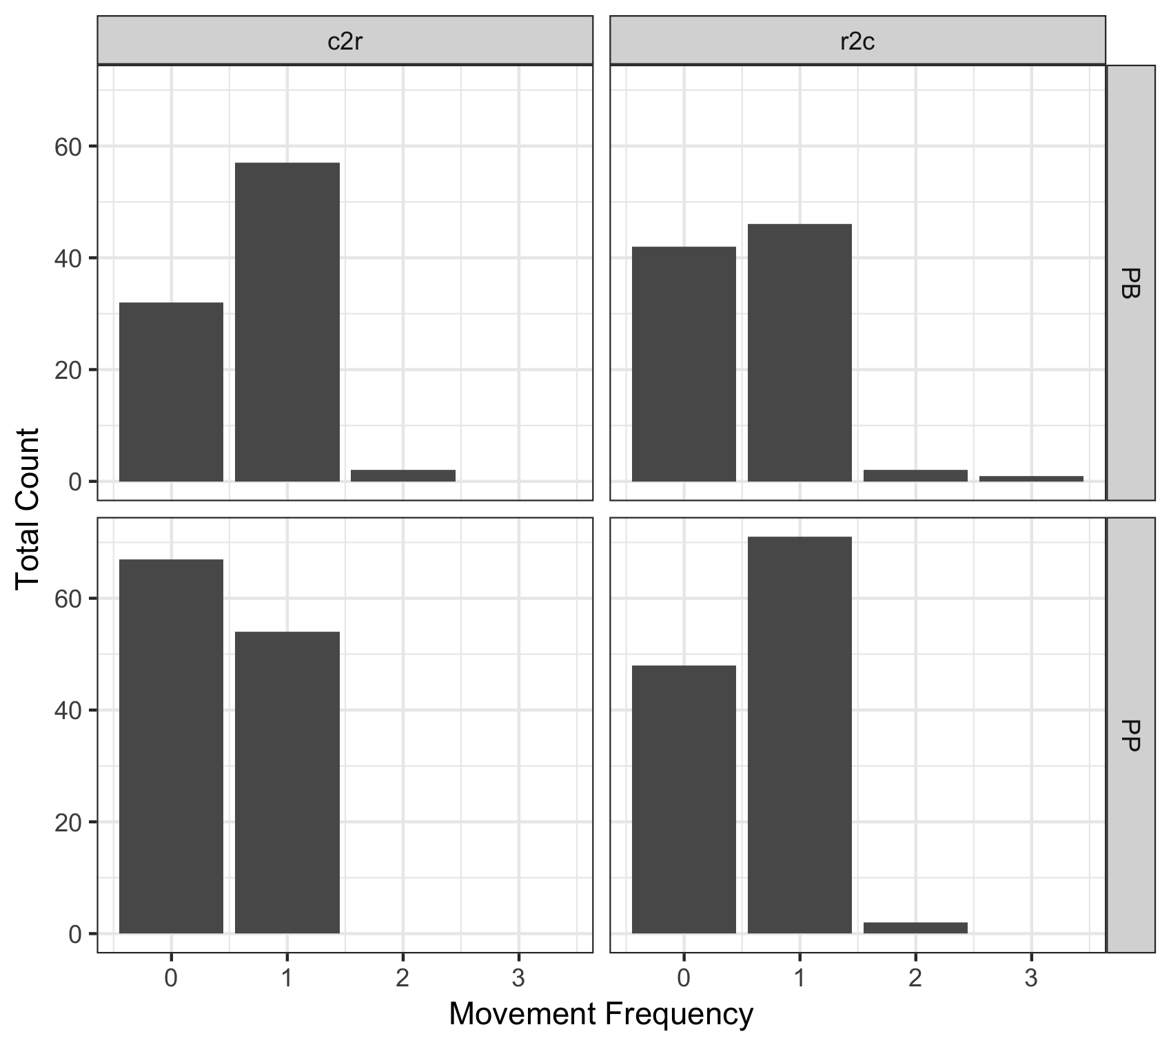

PP and PB movers, mean time spent in each treatment:

* Seems pretty average, aka maybe it wasn’t established animals moving, but new animals?
* Of 2652 PP individuals caught, only 121 of them move treatments at all

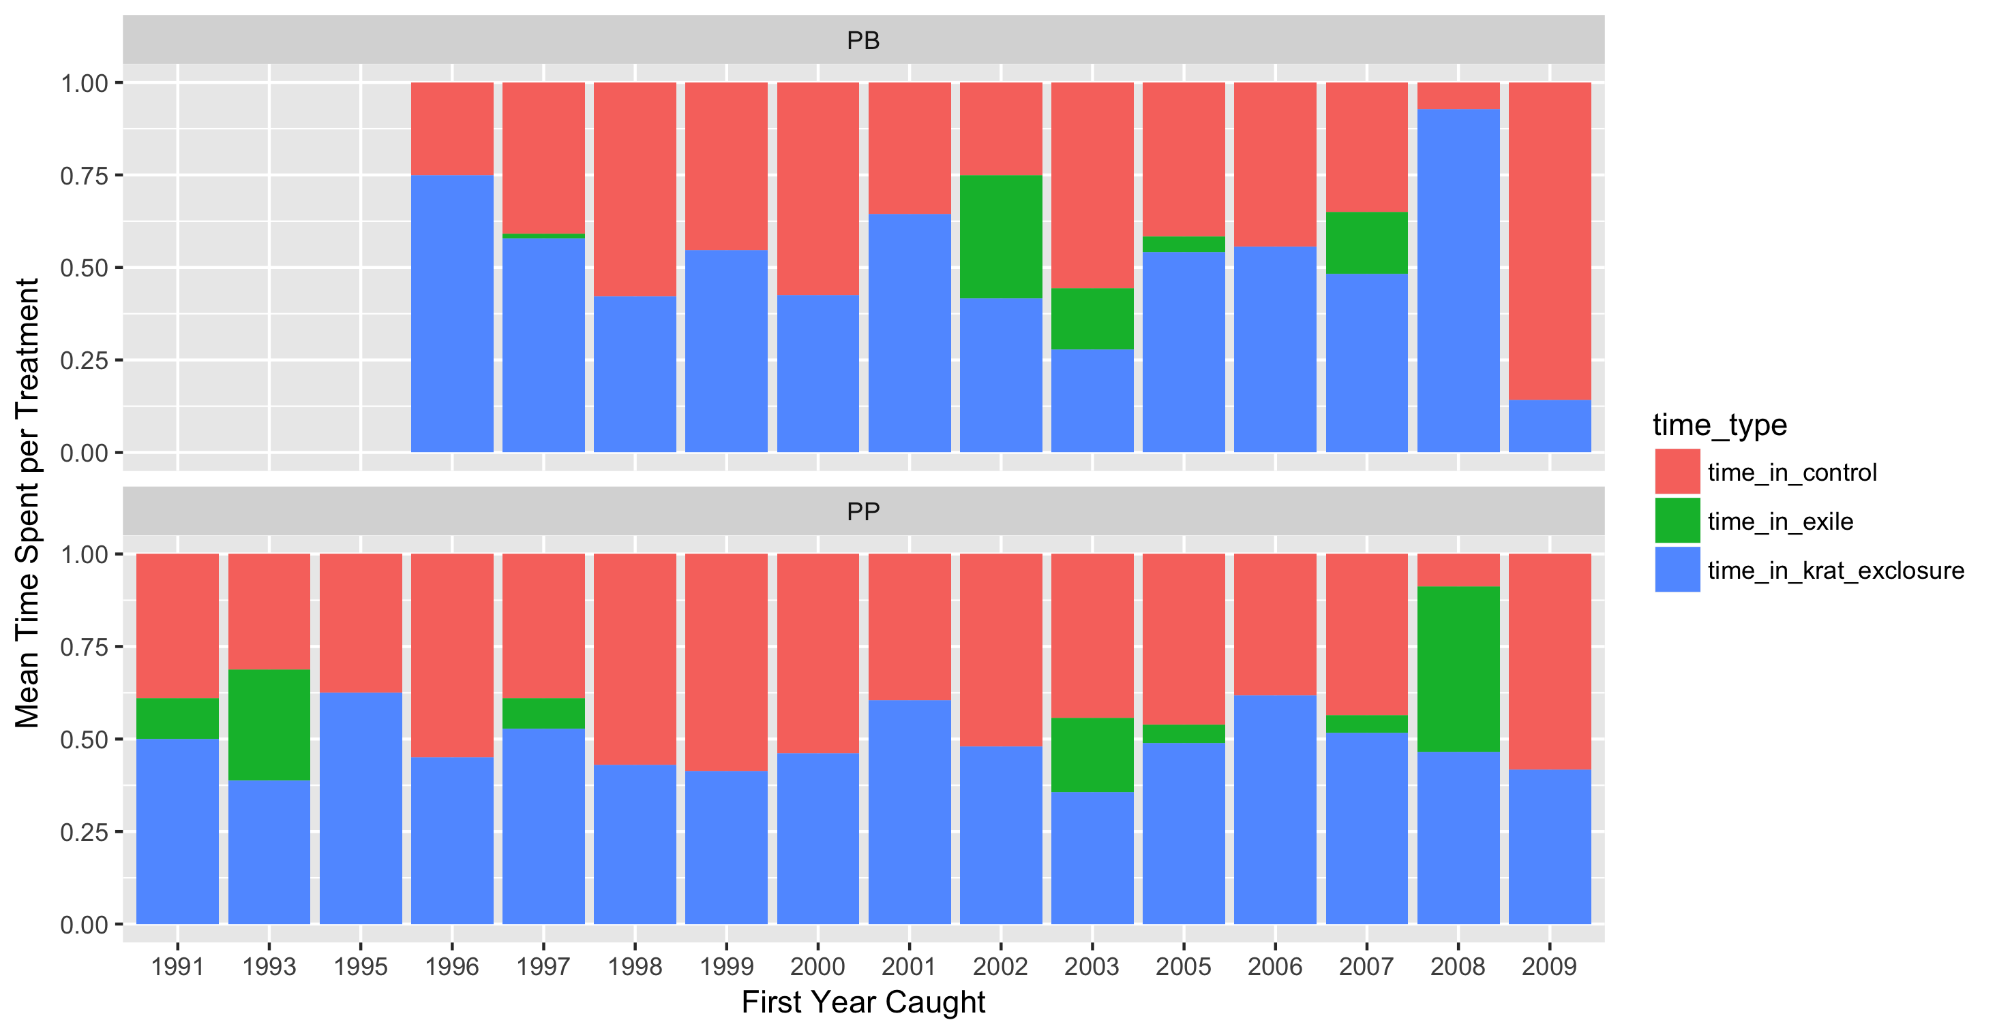

Biomass through time by plot type:

