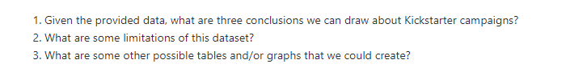

1. There were 3 major categories that were successful more than 50% with the Kickstarter campaigns – theater, film & video, and music. It is difficult to attract institutional investors in these areas, so they chose the platform to appeal to everyday, individual investor who can help them.
2. The number of Plays’ Kickstarter campaigns dwarfed that of all other subcategories. It was popular in two countries, U.S. and U.K. For further research, we will need to look into qualitative data that had caused this outlier.
3. The campaigns had the best of chance of success in April or May. Their worst month is December, which is the only month that the failed % out of grand total is higher than successful %.
4. The dataset