ASSIGNMENT 1 FRONT SHEET

Qualification | TEC Level 5 HND Diploma in Computing
Unit number and title | Unit 43: Internet of Things
Submission date |  | Date Received 1st submission
Re-submission Date |  | Date Received 2nd submission
Student Name |  | Student ID
Class |  | Assessor name
Student declaration
I certify that the assignment submission is entirely my own work and I fully understand the consequences of plagiarism. I understand that making a false declaration is a form of malpractice.
 |  | Student’s signature
Grading grid
P1 | P2 | P3 | P4 | M1 | M2 | M3 | M4 | D1 | D2

❒ Summative Feedback: ❒ Resubmission Feedback:

Grade: | Assessor Signature: | Date:
Internal Verifier’s Comments:
Signature & Date:

P1 Explore various forms of IoT functionality.

IoT overview.

IoT Definition.
The Internet of Things (IoT) refers to the billions of physical devices around the world that are currently connected to the Internet, collecting and sharing data. Thanks to the advent of ultra-cheap computer chips and the ubiquity of wireless networks, everything from the smallest of pills to the largest of airplanes can be turned into part of the IoT. Connecting all these different objects and adding sensors can give devices that otherwise would not function a level of digital intelligence, enabling them to communicate real-time data without human intervention. The Internet of Things will make the fabric of the world around us smarter and more responsive, connecting the digital and physical worlds.
Almost any physical object can be turned into an IoT device if it can be connected to the internet and controlled or sent information.
A light bulb that can be turned on via a smartphone app is an IoT device, just like a motion sensor or smart thermostat in your office, or a connected streetlight. IoT devices can be fluffy like a child's toy or full-blown like a driverless truck. Some large objects may themselves contain many small IoT components. Airplane engines, for example, have thousands of sensors that collect and send back data to operate efficiently. On a larger scale, smart city projects are filling entire regions with sensors that help us understand and control our environment.
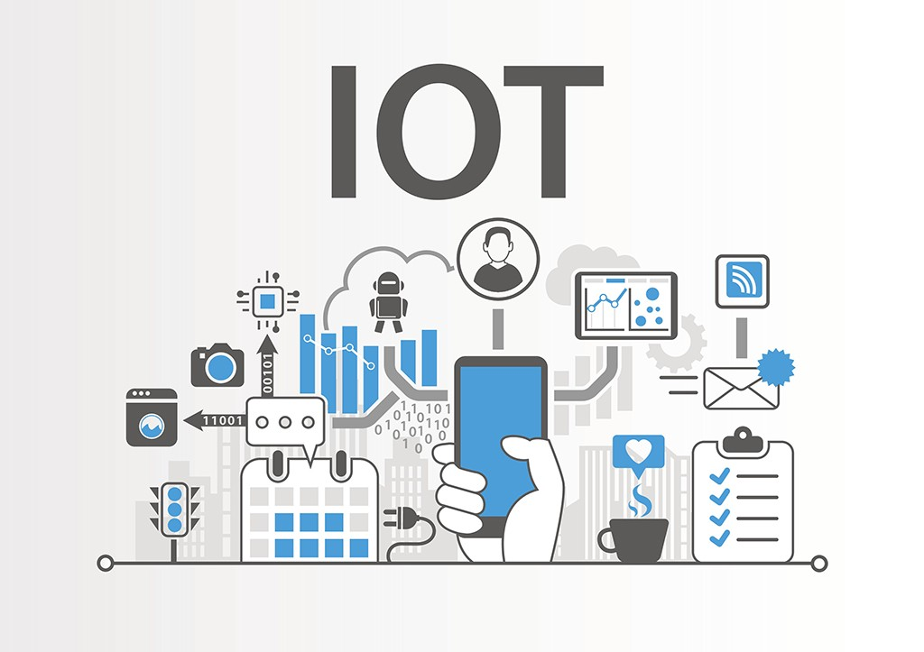
Figure 1: IoT
The term "IoT" is primarily used for devices that are not normally intended for Internet connectivity and can communicate with networks without human intervention. For this reason, a PC is generally not considered his IoT device, nor is a smartphone, even if it is full of sensors. However, smartwatches, fitness bands, and other wearable devices can count as IoT devices.
Ecosystem of IoT:
Defining an IoT ecosystem is not easy. It's also difficult to get the company right because of its size, new opportunities, and speed of expansion across the industry. However, an IoT ecosystem is a connection of different kinds of devices that collect and analyze data and communicate with each other over a network.

In the IoT ecosystem, users use smart devices such as smartphones, tablets and sensors to send commands and information requests to devices over the network. The device responds by executing commands and returning information about the network to the user after analysis.
A typical IoT ecosystem is shown in the diagram below, with smart devices sending and receiving data from themselves in an integrated environment via networks and cloud computing.
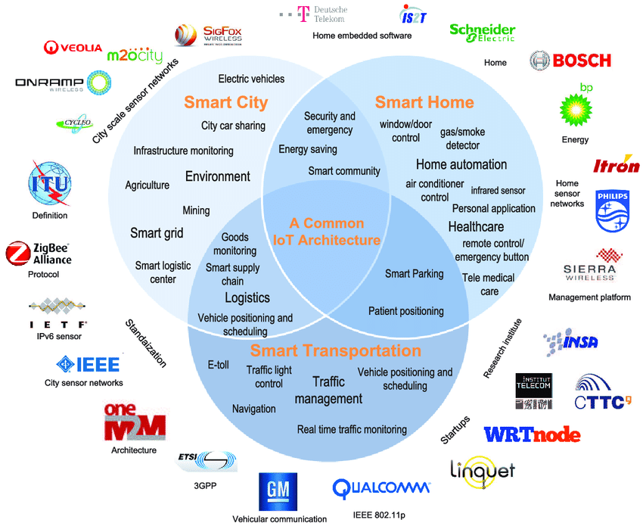
Figure 2: Ecosystem of IoT
IoT itself is an ecosystem of networked devices that transmit data. It also works with big data and cloud computing.
- Sensing, embedded processing, connectivity: The IoT ecosystem senses the environment such as temperature, gyroscope, and pressure. Perform embedded processing using the device. These devices are connected over the network through all kinds of devices such as GPS, WiFi, RFID.
- Smart Devices and Environment, Cloud Computing, Big Data: Sending and receiving data between smart devices and environments is communicated through cloud computing and other servers and stored as big data.
- Technologies, software and applications: The IoT ecosystem uses a variety of technologies, software, and applications to communicate and connect with smart devices and environments.
- User or community group: The products or services produced by the IoT ecosystem will be consumed by groups of users or communities to help intelligent lives.

How IoT works.
IoT architecture consists of intelligent "things", or devices that use embedded systems (processors, sensors, hardware). These devices collect, transmit and manage data and systems based on data collected from the environment. IoT devices connect, and share collected sensor data with IoT gateways, IoT platforms, or other devices for analytics.
IoT platforms are designed to recognize patterns, make recommendations, and identify potential problems before they occur. Artificial intelligence (AI) and machine learning are also helping IoT developers make data collection and processing simpler and more dynamic.
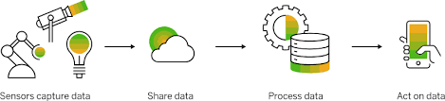
Figure 3: IoT working process
IoT devices incorporate sensors. These sensors can detect their environment. Devices that store information in some form of data. These include devices such as cell phones, coffee makers, microwave ovens, geysers, fire alarms, air conditioners, cars, and more.
Sensors built into these devices continuously emit data about the environment and about the operating information of these devices. IoT serves as the platform to dump all the data collected by these devices.
The IoT platform consists of cloud servers and large databases. IoT platforms work on data. It integrates and processes information. Furthermore, the platform analyzes the data in depth to gather important details. The platform will then return instructions based on the provided data.
Finally, aggregate data to be shared with other devices for better performance in the future. It is also done to improve the user experience.

IoT Feature.
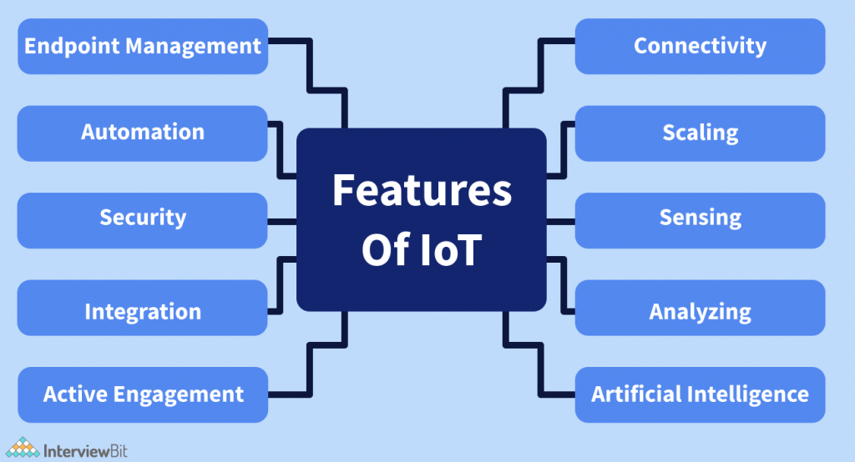
Figure 4: Feature of IoT
Connectivity
The heart of IoT is its connectivity. A connection is the establishment of a connection between different devices (or nodes) so that they can communicate independently. IoT requires various devices, sensors, computers, and data buses to interact and communicate with each other. Fast and secure connectivity is a must for businesses to take advantage of IoT. IoT also connects devices to cross-domain technologies such as cloud computing, artificial intelligence, and blockchain technology. You can connect via radio waves, WiFi, Bluetooth, or cable.
Scaling
IoT systems are designed so that the number of devices, sensors, and computers can grow or shrink as needed. IoT systems must be flexible enough to handle peak workloads and return to normal when demand is low.
Detection
IoT devices collect information about the environment (temperature, light, sound, acceleration, pressure, etc.) and make decisions after analyzing the data. Sensors, therefore, help automate by gathering information and performing actions that humans would otherwise perform. The raw and analyzed data collected serve as the foundation for how IoT works. For example, automatic doors collect data through sensors such as radar and optical sensors. The door will automatically open when it recognizes someone coming. Sensors used in IoT include humidity sensors, temperature sensors, accelerometers, gyroscopes, motion sensors, image sensors, liquid level sensors, and proximity sensors.
Analyse
We know that IoT collects raw information through sensors, but why does IoT need data? What is the IoT doing with all this raw data? The data itself has no intrinsic value. It is meaningless and useless until it is deliberately processed to derive meaningful insights from it. IoT collects raw data and extracts meaning from it. Raw data can be very useful when properly processed and should be analyzed in terms of structure, correlation and usability. For example, in the example of the automatic door above, it should be possible to distinguish between humans and animals by analyzing data with sensors.
Artificial intelligence
IoT becomes even more useful when combined with artificial intelligence. For example, if you run out of groceries, your smart refrigerator will remind you to bring groceries on your way home. This is possible with the help of artificial intelligence. IoT devices collect raw data from the environment and transform it into useful and insightful information. IoT devices and systems are also trained with various machine learning models to better understand environmental changes and perform better.
Small device
Currently, devices and equipment (semiconductor chips, sensors, etc.) are getting smaller. In IoT, these small devices efficiently provide precision and performance. It's interesting that such a small device can do so many things and improve our quality of life (for example, a small sensor can tell us the air quality in our area and help us avoid pollution). ).
Aynamic nature
To drive business value, IoT systems must be dynamic and change as the environment changes. Let's try to understand this with an example. A smart air conditioner should be able to adjust the room temperature according to prevailing weather conditions based on data collected by temperature sensors. It should also be possible to set the optimum indoor humidity level as the environmental humidity level changes.
Active involvement
IoT connects devices and products with cross-domain technologies such as cloud computing, artificial intelligence, and blockchain technology. Active collaboration between these products and technologies is essential to collecting and manipulating data so that it can be used for business purposes. Raw data holds great potential and can greatly improve business decisions. Therefore, it is common to see lively discussions between various IoT products and these technologies.
Integration
IoT integrates various cross-domain technologies such as cloud computing, artificial intelligence, big data, and deep learning to bring amazing experiences to users. The Internet of Things is no longer the Internet of Things, it really has become the Internet of Everything. The whole ecosystem of integrated devices works very efficiently and improves our quality of life.
Automation
All technologies come with some degree of automation. IoT is all about automation. IoT is designed to make people's lives and businesses easier through automation. H. IoT farming system automates irrigation and prevents water waste.
Safety
Security is one of the main concerns of IoT users. IoT systems transfer and store a lot of sensitive information, so the security of data flowing between devices should be a top priority. When designing IoT systems, appropriate security measures are implemented to prevent possible security breaches. Ensuring secure and highly conductive IoT systems requires significant resources and investments, but we also need to ensure their security. Failure to do so can create a sense of distrust between users and businesses and reduce demand.
Endpoint management
A well-trained and carefully implemented IoT is an asset to the business world. However, it is important to adopt endpoint management for IoT systems. Otherwise, the whole system may collapse. For example, a smart refrigerator orders groceries from a retail store while you are away. However, leaving home for a few days can lead to food loss, which is a failure of IoT. Endpoint management is therefore a necessary feature of the Internet of Things.

IoT History.
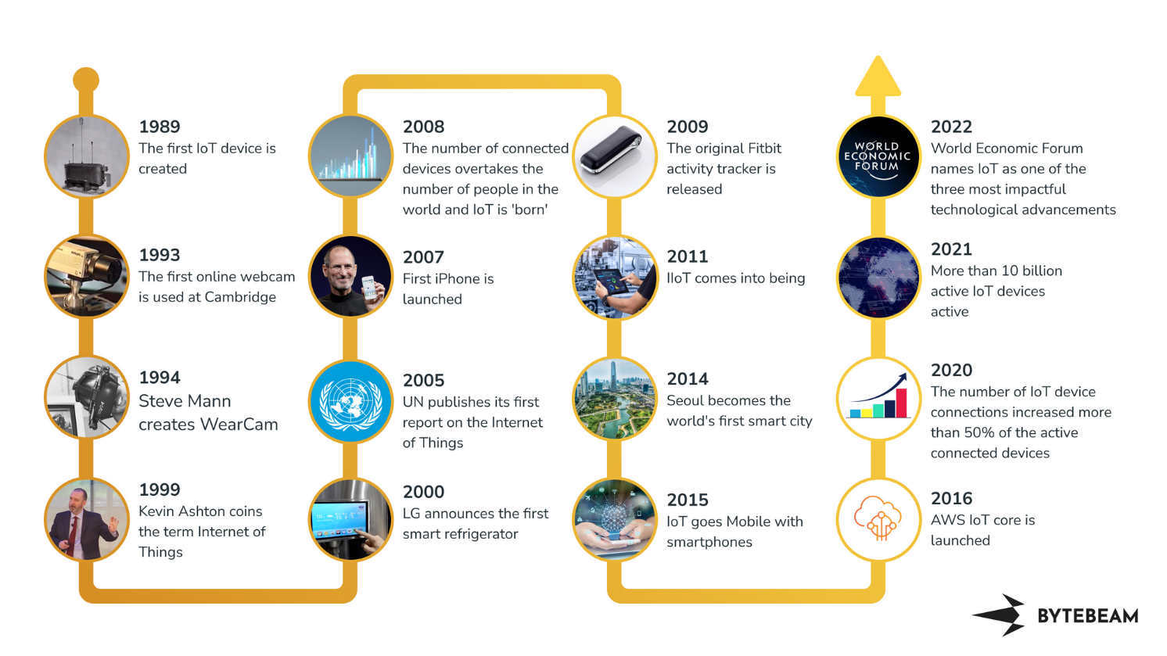
Figure 5: History of IoT
The idea of ​​adding sensors and intelligence to basic physical objects was discussed in the 1980s and 1990s (with perhaps some older ancestors), but early examples including internet-connected vending machines Progress has been slow and sluggish, except for a few projects., simply because the technology wasn't ready yet. The chips were too big and bulky, and there was no way for objects to communicate effectively.
Before it was finally cost-effective to connect billions of devices, processors were needed that were cheap enough and low power to be virtually disposable. The advent of RFID tags (low-power chips capable of wireless communication) has solved some of these problems along with the increased availability of broadband his internet, mobile phones and wireless networks. The advent of IPv6, among other things, should provide enough IP addresses for all the devices the world (or this galaxy) is likely to need in the future, but it is also a necessary step to scale the IoT. bottom.
Kevin Ashton coined the term "Internet of Things" in 1999, but it took at least another decade for technology to catch up to that vision.
"The IoT integrates the interconnectedness of human culture -- our 'things' -- with the interconnectedness of our digital information system -- 'the internet.' That's the IoT," Ashton told ZDNet.
Adding RFID tags to expensive pieces of equipment to help track their location was one of the first IoT applications. But since then, the cost of adding sensors and an internet connection to objects has continued to fall, and experts predict that this basic functionality could one day cost as little as 10 cents, making it possible to connect nearly everything to the internet.
The IoT was initially most interesting to business and manufacturing, where its application is sometimes known as machine-to-machine (M2M), but the emphasis is now on filling our homes and offices with smart devices, transforming it into something that's relevant to almost everyone. Early suggestions for internet-connected devices included 'blogjects' (objects that blog and record data about themselves to the internet), ubiquitous computing (or 'ubicomp'), invisible computing, and pervasive computing. But it was the Internet of Things and the Internet of Things that got stuck.

IoT Application.
IoT finds application in various private and public aspects of life.
Agriculture:
The growing world population drives the demand for agricultural products. However, the migration of young people to big cities destabilizes the human resources needed for agricultural development. IoT and related technologies could be the key to automating agricultural processes and meeting food demand.
Consumer Application:
The Internet of Things makes people's lives easier by tracking and managing their lifestyle. There is a huge market for smart electronics, watches, TV systems, fitness trackers and virtual reality. Additionally, IoT is leading the market with applications such as home security and personal asset tracking.

Health care:
Wearable IoT devices offer many benefits to patients and healthcare providers. By extension, IoT enables healthcare professionals to monitor patients remotely. The devices can automatically collect important patient data such as blood pressure, heart rate, temperature, and more.
ensure:
IoT is changing traditional business models like insurance. It simplifies and speeds up the claims and underwriting process. In addition to reducing costs, digital networking over IoT generates additional revenue. Cross-selling and increasing customer engagement is becoming a strategic component of insurance companies.

Make:
The Internet of Things creates a more technical environment for manufacturing industries. It can automatically track development cycles, facilitate production processes, and manage inventory.

Retail:
IoT devices can collect important data about a product's purchase lifecycle. When this data is processed and analyzed, retail managers can make valuable decisions to improve retail operations and customer experience.

Carriage:
IoT applications integrate personal and commercial vehicles by improving the ability to communicate and distribute information. In addition to connecting consumers and goods, it also provides benefits such as route optimization, vehicle tracking, weather tracking, distance, and more.
Utility/Energy:
A network can be IoT capable with smart meters, receivers, sensors, and power boxes communicating with each other. IoT applications in utilities generate revenue, improve efficiency, and conserve resources. Utility providers can meet growing demand by optimizing energy and distribution using IoT.

Traffic monitoring:
Intelligent traffic monitoring improves decision making and realizes urban development. The IoT-based system collects, processes, and analyzes traffic data in real time to provide up-to-date information on traffic incidents and congestion. In addition, early warning messages save travel time during rush hour.

Hospitality:
Many hotels allow guests to control air conditioning, heating or ventilation from a central location. TV remotes and home appliances are also common. In addition, Internet of Things devices alert employees to the operating status of various devices. As a result, technicians can repair critical equipment even before a major loss of functionality occurs.
Water supply:
Water scarcity is a reality. IoT applications have a potential solution for monitoring, controlling, and regulating water quality and usage. In addition, maintenance of attached equipment such as pumps, pipes, etc. Smart water technology connects the water system with the people.

Fleet management:
IoT enables predictive fleet maintenance by improving visibility, efficiency, and manageability. It helps to better monitor the cargo and improve the driver's performance. Additionally, IoT devices can predict maintenance and help replace parts before problems become too costly.

Intelligent pollution control:
Connected IoT devices and sensors are located at key locations in the city. They monitor pollution levels and periodically upload data to the IoT cloud. The system then processes the information to trigger general actions such as redirects or road closures.
Smart cities:
A smart city has better utilities, infrastructure, services, etc. Smart meters allow utility companies to efficiently regulate the flow of energy, while connected vehicles make mass transit extremely efficient. In addition, smart grids are emerging to save resources and reduce stress during peak hours.

Real life example of IoT.
1. Smart home security
Let's start with how IoT helps protect your home. Window and door contacts, broken glass and motion detectors as well as heat, smoke and water detectors combined with security alarm blocks, cameras and smart doorbells help protect the home your home from break-ins, fires and floods.
The readings and alarms from these sensors are transmitted to the home controller, and then to the cloud over the Internet or via a battery-powered mobile communicator.
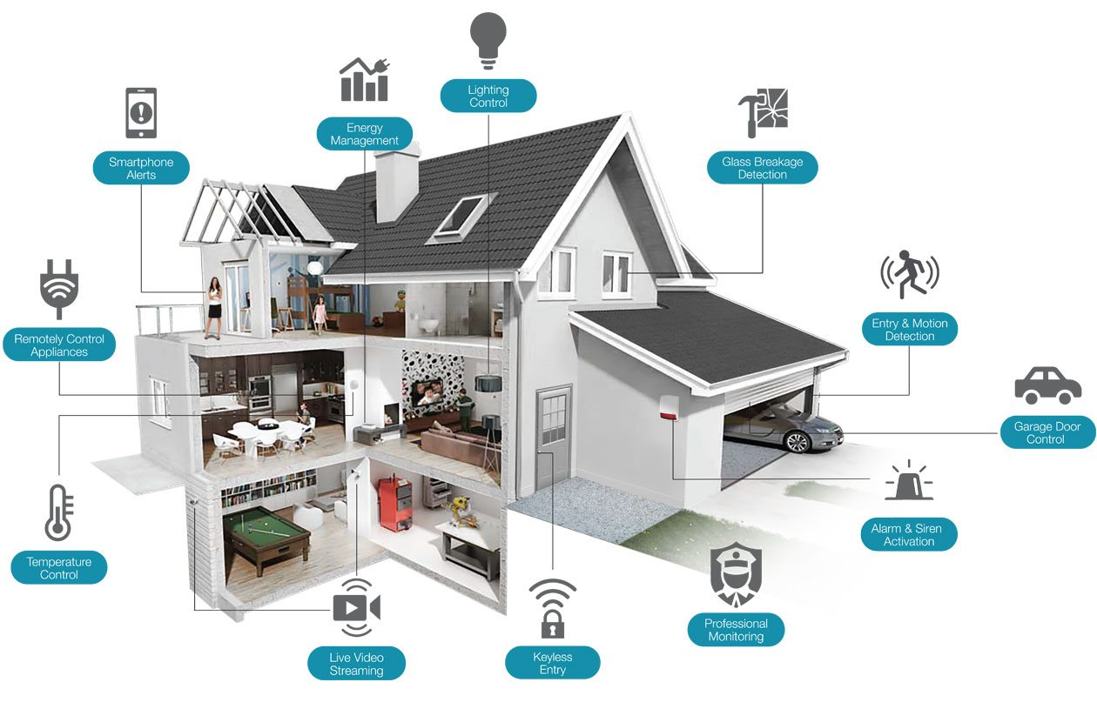
Figure 6: Smart home
From the cloud, you'll be alerted via mobile phone or computer app to any unwanted activity in your home. Using the app, you can check sensor and camera logs to determine what's happening and were. You can enable or disable the security system remotely to deny or allow access to your home. For added security, you can set up a custom passcode for specific authorized users and be notified when they enter and leave your home.
Forgot to equip your security system? With geo-fencing enabled reminders, you'll be notified if you exceed a specified distance from your home. You can then use your app to activate the system.
You could already open the front door with a keypad code, but now iris scanning, voice recognition and facial recognition could soon eliminate the need for keys or codes.
2. Smart home: heating and cooling
Programmable thermostats have long been able to sense and adjust temperature and humidity to suit individual preferences:
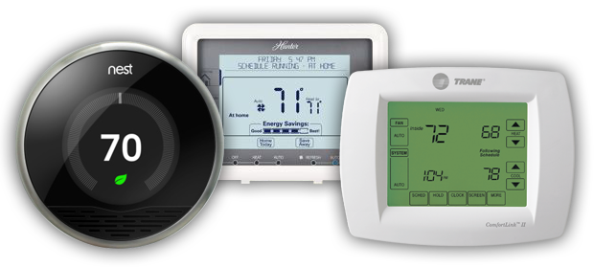
Figure 7: Thermostats Programmable.
day, night, holiday, weekend, etc. Now, with smart thermostats and sensors, a whole new set of features is available. First, the system can be Wi-Fi connected to the cloud and accessed and controlled remotely via a mobile app. From a vacation spot, in the car or even from the couch in front of their TV, users can monitor and adjust the temperature for maximum comfort. And with smart sensors in your bathroom or gym, the system can automatically and individually adjust temperature and humidity when you or another family member takes a shower or workout. exercise.
If you live in an old house without central heating or air conditioning, you can always buy a smart air conditioner. Coming home on a hot evening? Just turn on the device first through the app on your mobile phone. Or ask Google Assistant or Amazon Alexa to turn it on when you walk through the door.
Your heating and cooling system can be configured to send you an alarm if it detects something out of an acceptable range. On a winter day, you definitely want to know if your heating is off before the water pipes freeze and burst! This gives you the ability to turn off the water with the Smart Home app or just disable your security system, so a friend can come over to do it the old fashioned way!
Heating systems can also include gas, smoke or CO2 sensors and test the air in your home to determine if conditions are outside of set parameters, alerting you (and providing your alarm) about the possibility of a gas leak, fire or water leak.
3. Smart home: Kitchen
One of the first commercial IoT devices was the digital Internet DIOS smart refrigerator announced by LG Electronics in 2000. Although this web-based model was not considered a success, it was followed. by smart IoT products from most kitchen appliance manufacturers.
In your kitchen today you will find a refrigerator, faucet, gas and electric stove, microwave, coffee maker, pizza oven, wine cooler, dishwasher and grill. The bread machine has Wi-Fi support. You'll also find a Wi-Fi-controlled washer and dryer in your laundry room and even a smart toilet in your bathroom!
Smart refrigerators have many features that you can control through a mobile phone app. Some of the features include a camera inside the fridge so you can keep an eye on what's inside, and a touchscreen so you can view recipes or create shopping lists.
Smart devices are often compatible with voice assistants in the industry, so you can ask Siri, Alexa or Google Assistant to deliver ice, turn on the oven, or add something to your shopping list!
4. Smart driving
There are only a few decades left before self-driving cars and delivery trucks become the norm. But even without driverless vehicles, there are plenty of examples of IoT technology being implemented in your everyday driving life. Consider safety services like General Motors' OnStar. Sensors in the car can detect mechanical problems and collisions and (via a mobile link) upload details to the cloud and provide 24-hour service advice. You have seen the TV commercials. The advisor speaks directly to the driver and takes the necessary measures by dispatching emergency or incident services, as the case may be. And, thanks to GPS, the advisor locates your vehicle. If the problem is mechanical, the advisor can perform remote diagnostics on the car, so a response mechanic is ready when they arrive.
Another widely used type of IoT application are navigation applications such as Waze, Google Maps, and Apple Maps. You use them on mobile phones or in-car dashboard variants. Using a combination of mobile network and GPS, these apps get you from A to Z! Waze is a great example of IoT. The app continuously collects vehicle location data and sends it to the cloud, where the app has location data for all of the user's other vehicles. By calculating the relative motion of each vehicle, Waze is able to determine its speed, and also identify decelerations and traffic jams. It can estimate traffic times, redirect the driver to an alternative route that bypasses obstacles, and recalculate the driver's expected arrival time. Waze accepts driver-submitted data about road hazards, police presence, traffic jams, and more. that it forwards to all users on that route!
5. Wearables
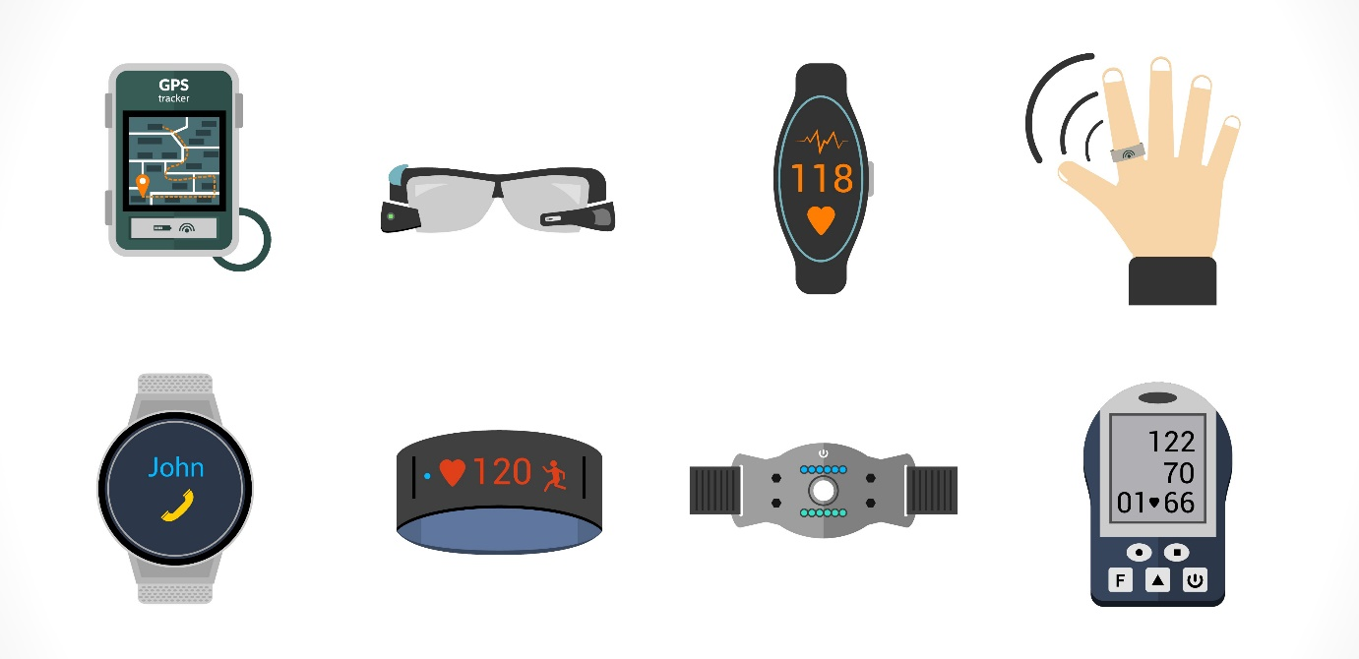
Figure 8: wearable
"Dick Tracy"'s dream of communication devices and mobile computers is now a reality, with applications in personal fitness, entertainment, wellness and wellness. Biometric sensors in watches, rings, and bracelets can detect respiratory rate, temperature, and heart rate. and rates of change, as well as blood sugar and oxygen. These wearable devices collect and store raw data before uploading it to the cloud infrastructure via a cellular link or the Internet.
Wearable devices often contain an accelerometer, which measures steps taken and detects movements such as golfing or even falling. By using links to global positioning satellites (GPS), the devices can determine your exact location and calculate the distance traveled. The golf watch contains a GPS map of each golf course and can show your location on each hole, distance to the lawn and hazards like water and bunkers, and distance per hit! But you still have to let him know which golf club you used… that's still not smart!
6. Health
Many wearables have health and wellness applications, but there are also many direct medical applications of IoT technology. For example, smartwatches have been reported to be able to detect the initial symptoms of COVID-19 a week earlier than a nose swab test.
In fact, everyone is now talking about the Internet of Medical Things (IOMT). The most popular IoT healthcare applications are patient monitors and monitors. This can be for diagnostic purposes or for remote patient monitoring. The monitor can measure vital signs such as heart rate, temperature, blood pressure and blood sugar.
An innovative IoMT application is the smart pill dispenser. When a patient takes a medication, the medication sequencer transmits the patient's data and the medications taken to a cloud server, where they are processed and stored along with the patient's records, including prescriptions. their. The server will send the patient an SMS if they miss a dose or when the prescription renewal is due.
The list of IoT applications for healthcare is growing day by day. We even have Wi-Fi enabled hearing aids. Although many IoMT devices are wearable, some are surgically implanted. For example, there are internet-connected pacemakers, which are used to help keep patients alive with slow or irregular heartbeats.

Various forms of IoT.

Consumer Internet of Things (CIoT).
Consumer IoT (CIoT) is the use of IoT for consumer applications and devices. His CIoT products in general include smartphones, wearables, smart assistants, consumer electronics and more.
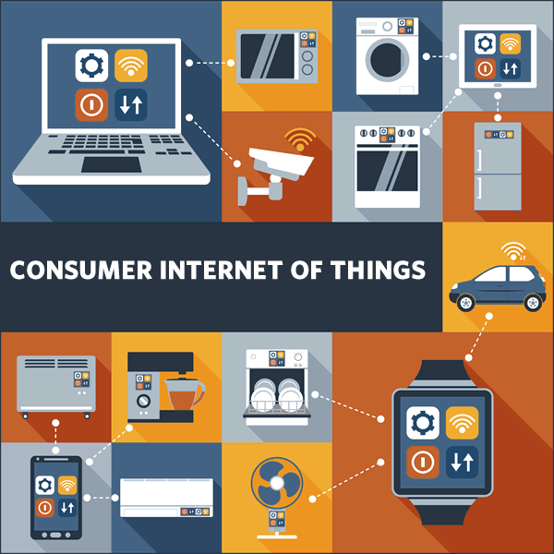
Figure 9: CIoT
CIoT solutions typically use Wi-Fi, Bluetooth, and ZigBee to facilitate connectivity. These technologies enable short-range communication and are suitable for use in small locations such as homes and offices.

Commercial Internet of Things.
While CIoT tends to focus on improving the environment of individuals and homes, commercial IoT goes a step further and brings the benefits of IoT to large venues. think:
Commercial office buildings, supermarkets, shops, hotels, medical facilities, entertainment facilities.
There are many commercial IoT use cases, such as monitoring environmental conditions, controlling access to corporate facilities, and reducing utility and power consumption in hotels and other large venues. Many commercial IoT solutions are aimed at improving customer experience and business conditions.

Industrial Internet of Things (IIoT).
Industrial IoT (IIoT) is perhaps the most dynamic area of ​​the IoT industry. We focus on extending existing industrial systems to increase productivity and efficiency. IIoT deployments are typically found in large factories and manufacturing plants and are commonly associated with industries such as healthcare, agriculture, automotive, and logistics.
The Industrial Internet is perhaps the best-known example of the IIoT.

Infrastructure Internet of Thing.
Infrastructure IoT is concerned with developing intelligent infrastructure that integrates IoT technologies to improve efficiency, cost savings, maintenance, and more. This includes the ability to monitor and control the operation of urban and rural infrastructure such as bridges, railroad tracks, onshore and offshore wind farms.
Technically, Infrastructure IoT is a subset of IIoT. However, because of its importance, it is often treated as something else.

Internet of Military Things (IoMT).
The final type of IoT is the Military Internet of Things (IoMT), often referred to as Battlefield IoT, Battlefield Internet of Things, or simply IoBT. IoMT is exactly what it sounds like, his use of IoT in military environments and on the battlefield. This is primarily aimed at increasing situational awareness, improving risk assessment and reducing response time.
Common IoMT applications include connecting ships, aircraft, tanks, soldiers, drones, and even forward operating bases through network systems. Additionally, IoMT produces data that can be used to improve military practices, systems, equipment, and strategy.

Pros and cons of IoT.

Advantage.
The Internet of Things brings many benefits to our daily life. Some of its benefits are listed below.
- Minimize human effort: IoT devices interact and communicate with each other so that tasks can be automated. This improves the quality of service for companies and reduces the need for human intervention.
- To save time: Reducing human effort saves a lot of time. Saving time is one of the main benefits of using an IoT platform.
- Advanced data collection: Information is easily accessible even when away from your physical location and is updated regularly in real time. Therefore, these devices can access their information anytime, anywhere and from any device.
- Improved security: Connected systems can support smarter control of homes and cities via mobile phones. Increase security and protect individuals.
- Efficient use of resources: Knowing the features and capabilities of each device allows you to increase resource utilization and monitor natural resources.
- Reduce use of other electronic devices: The ability to directly connect electrical devices and communicate with a controlling computer, such as a mobile phone, makes efficient use of power. This eliminates the wasteful use of electrical equipment.
- Use in transportation systems: Asset tracking, delivery, surveillance, traffic and shipment tracking, inventory management, individual order tracking, and customer management can all be done more cost-effectively with the right tracking system using IoT technology.
- Useful for security reasons: It contributes to security by detecting possible dangers and alerting the user. For example, GM OnStar is an integrated device that detects car and road accidents. If an accident or incident is detected, an emergency call will be made immediately. Useful in the medical industry:
- Patient care can be performed more efficiently in real time without the need for a doctor's visit. It gives them the opportunity to make decisions and provide evidence-based care.

Disadvantage.
The Internet of Things has its advantages, but it also has significant disadvantages. Some of the shortcomings of IoT are listed below.
- Security issues: IoT systems are interconnected and communicate over networks. Therefore, despite all security measures in place, the system is largely uncontrollable and various types of network attacks can occur.
- Privacy Issues: IoT systems fully provide vital personal data without active user participation.
- Increased unemployment: Unskilled or even skilled workers are at high risk of losing their jobs, leading to high unemployment rates. Smart surveillance cameras, robots, smart ironing systems, smart washing machines, and other devices are replacing people doing these jobs.
- System complexity: Designing, developing, maintaining, and activating the rich technology of IoT systems is extremely complex.
- Likely to damage the entire system: In the event of system failure, attached devices may be damaged.
- Lack of international standardization: The lack of international compatibility standards in IoT makes it problematic for devices from different manufacturers to communicate with each other.
- Highly reliant on the Internet: They rely heavily on the internet and cannot function effectively without it.
- Reduced mental and physical activity: The overuse of the internet and technology makes people ignorant, lethargic and inactive as they rely on smart devices for no manual labor.

P2 Review standard architecture, frameworks, tools, hardware and APIs available for use in IoT development.

IoT standard architecture.
On the Internet, communication is based on a stack of TCP/IP protocols. Similarly, the IoT model is a layered technology that supports meaningful communication of billions of smart objects equipped with processors, sensors/actuators, and communicators. Considering the basic elements of IoT, IoT basically connects many types of hardware devices with many application domains. The heterogeneity of application and hardware domains poses diverse and important challenges that must be overcome for the successful implementation of simple and complex IoT systems. In addition to heterogeneity, with ubiquitous connectivity all the time, IoT has to deal with many issues including scalability, interoperability, security/privacy and quality of service for the requirements. high traffic/storage issues that ultimately affect the architecture of IoT systems. Some IoT architecture will be proposed in the document. These architectures are not only diverse in terms of each other's functionality but also in technical terminology. Interoperability between different IoT systems is limited because the proposed architectures have not yet converged to a single reference architecture. Therefore, there should be a layered architecture that is at the heart of all IoT projects. from the group of proposed IoT architectures, the function of each layer in the following IoT architectures has been explained:
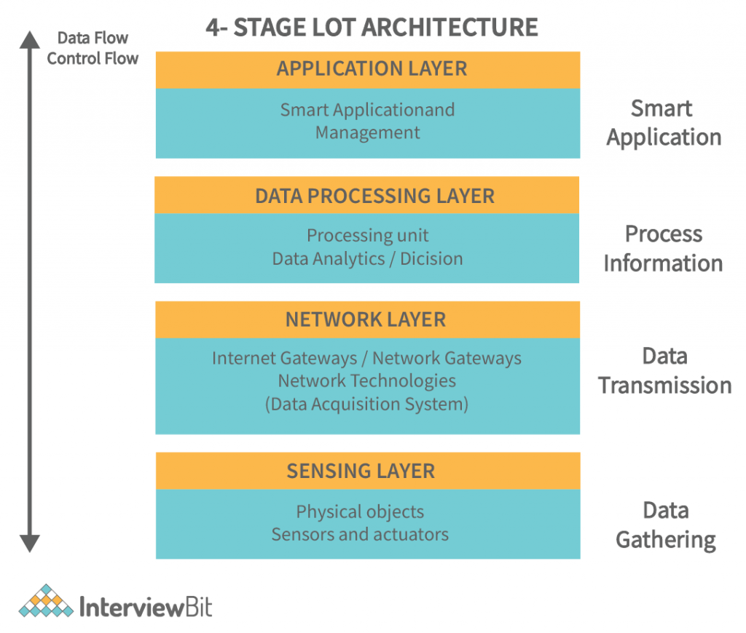
Figure 10: IoT Architecture.
- Perception Layer
The perception layer at the bottom of the IoT architecture is responsible for collecting different types of information through physical sensors or smart object components (i.e. RFID, sensors, tag objects, etc.) or RFID sensors, etc.). Furthermore, the perception layer transmits the processed information to the upper network layer through service interfaces. The main perception challenge relates to the recognition and perception of environmental factors through the use of low energy and nanoscale technologies in smart things.
- network layer
The middle layer of a three-layer IoT architecture is the network layer (aka the transmission line). The network layer accepts processed information from the perception layer and forwards the received data to one or more remote application interfaces using integrated networking, the Internet, and other communication technologies. Several communication technologies (i.e. Wireless Local Area Network (WLAN), Wi-Fi, LTE, Bluetooth Low Energy [BLE], Bluetooth, 3G/4G/5G, etc.) are built into the processing IoT gateways heterogeneous data types to or from different things to applications and vice versa. In addition to network operations, the network layer is being improved in some cases to perform information operations in the cloud.
- Application Layer
The application layer on top of the three-layer IoT architecture is responsible for providing services according to user requirements, e.g. temperature, humidity, barometric pressure, light intensity measurement, etc. In addition to the services requested by the user, the application layer provides data services (i.e. data warehousing, big data storage, data mining, etc.) to perform semantic analysis of the Data. . Smart health, smart transportation system, smart building, smart industry and smart city are some of the applications with smart user interface at the application layer.
- Data processing layer
A fundamental component of an IoT system architecture is its processing layer, also known as the middleware layer, which typically leverages multiple simultaneously connected computers, in the form of cloud computing. , to deliver outstanding performance in compute, storage, networking, and security.
In particular, the processing layer in the IoT system architecture is responsible for analyzing the input data to generate new insights, useful predictions, and timely alerts.

An IoT system typically manages huge volumes of data, generated by many edge devices, across multiple sites at the edge of the network. The processing layer middleware uses a three-step approach to prepare this data for the application layer:
- Data accumulation: middleware that correctly identifies and assigns different data types to the appropriate storage. Unstructured data, such as audio and video streams as well as images, typically require more storage space and are stored in a data warehouse. While structured data, including instrument readings, log values ​​and measurements (telemetry data) is more space-saving and stored in a data warehouse.
- Data abstraction: involves aggregating data from multiple sources, as well as ensuring that the data is converted into a format that can be "read" by application layer software.
- Data analysis: use a machine learning (ML) or deep learning algorithm that specializes in detecting patterns in large and seemingly random data sets.

IoT framework.

Definition.
Usually, when big data is created and transmitted across multiple devices, there must be a specific point where everything is collected and combined.
This particular point is essential in the network, as it gathers all the data, allowing us to understand the generated data.
However, smooth data transmission and generation does not happen by accident. In contrast, this is often done thanks to the Internet of Things Framework (IoT infrastructure). So, what is the IoT framework? The Internet of Things (IoT) framework can be described as an ecosystem consisting of many connected devices that communicate with each other through the Internet. These connected devices typically work to transmit and sense data over the internet, while requiring very little human intervention.
The IoT framework allows connected devices to have seamless communication over the internet. No wonder it is called the "Internet of Things" framework, or in other words, the framework that facilitates the interaction of "things" (devices) on the Internet.
The IoT framework is a very important piece of technology in the modern world, applied in almost every industry. For example, one of the main applications of IoT is smart home design.
The concept of IoT frameworks is also applied in the design of various physical objects, such as thermostats, electrical equipment, security and alarm systems, as well as vending machines, among many others.

Common IoT frameworks.
1. IoT KAA
Kaa IoT is one of the most efficient and rich open-source Internet of Things cloud platforms where anyone can freely deploy their smart product concepts. You can manage N number of connected devices with interoperability on this platform. You can monitor your machine in real time by provisioning and configuring remote devices. Kaa enables information exchange between linked devices, IoT clouds, information systems and visualizations, and other elements of the IoT ecosystem.
2. Cisco IoT Cloud Connectivity
Cisco IoT Cloud Connect provides powerful, automated, and highly secure connectivity for businesses. Cisco's Kinetic IoT Platform manages IoT data for data extraction, movement, and computation. As Cisco is well known for its security services, it protects IoT deployments against threats with a secure IoT architecture.
3. ZETTA IoT
Zetta is a server-oriented platform that is developed based on REST, NodeJS and hypermedia-API-strip Siren based responsive programming philosophy. Once abstracted as REST APIs, they are connected to cloud services. These Internet services include tools for viewing machine analytics and support, such as Splunk. It builds a distributed network through connectivity from systems like Heroku to terminals like Arduino and Linux hackers.
4. IoT Salesforce
The sales force is powered by thunder. Thunder empowers businesses to unlock never-before-seen ideas and empowers anyone to do proactive, personalized business from any device to bring their customers closer ever. Salesforce has more than 150,000 customers worldwide. Salesforce has a 19.7% market share in the CRM world. SAP (12.1%), Microsoft (6.2%) and Oracle (9.1%) are far behind their closest competitors. Many companies are now developing apps or migrating to Salesforce on the Salesforce Platform. This has increased demand for Salesforce developers and administrators.

5. IoT devices
DeviceHive is another rich open source IoT platform distributed under the Apache 2.0 license and can be used and modified free of charge. It provides deployment options for Docker and Kubernetes and can be downloaded and used by public and private clouds. You can run batch analytics and machine learning in addition to your device information. DeviceHive supports many libraries including Android and iOS.
6. Oracle IoT
We certainly include Oracle, a global software company known for providing the best enterprise software and database management solutions, when we compare Internet platforms of Things best. Oracle provides a flexible environment with exceptional enterprise capabilities for building enterprise applications. Oracle supports processing and building large-scale IoT networks with very large data. The use of advanced security systems to protect IoT systems against external threats is also worth mentioning. Since these systems often have different devices, some of which lack security tools, it is not enough to justify deploying centralized security measures.
7. SAP IoT
The SAP Internet of Things cloud platform has everything you need to build and manage IoT applications. The SAP platform provides a convenient environment to remotely manage and monitor all the connected devices in your IoT system. We can connect remote devices directly or through a cloud service on the SAP platform. SAP can use IoT information to build machine learning and artificial intelligence applications while maintaining the latest technology trends.

IoT tools.

Definition.
IoT Tools stands for Internet of Things Tools. It is a network or connection of devices, vehicles and devices that apply electronics in vehicles, home appliances, buildings, etc. It helps to collect and exchange different types of data. It also allows users to control devices remotely over the network.
Today, in the world driven by the internet, IoT has engulfed the IT industry and is the latest buzzword. It has opened up many new horizons for companies and developers working on IoT. Many outstanding products have been developed through the development of IoT applications. Internet of Things companies create hardware and software designs to help IoT developers create remarkable new IoT devices and applications.

several IoT tools.
The Internet of Things (IoT) has changed the way we interact with technology by enabling seamless connectivity and communication between devices. As IoT continues to evolve, developers and organizations gain access to a wide variety of tools that enable the efficient development and deployment of IoT solutions.

A variety of tools, including hardware and software platforms, network analyzers, and IoT-specific platforms, enable developers to build, connect, analyze, and monitor IoT solutions seamlessly. effectively. These tools accelerate development, ensure data security, and optimize the performance of IoT applications.
1.Arduino
Arduino manufactures electronics and software for the IoT market, providing top-of-the-line hardware for many projects. They are a leader in IoT tools that make it easy to build functional and innovative home automation and robotics projects.
Overview and features:
- Arduino board: Arduino provides different microcontroller boards for IoT projects with different specifications.
- Arduino IDE: The integrated development environment (IDE) provides a user-friendly interface that facilitates the process of writing and uploading code to the Arduino board.
- Libraries and templates: Arduino provides a large collection of pre-made codes and templates that streamline the creation of IoT applications.
- Contribution to the community: The Arduino community consists of a vibrant group of developers that actively interact with each other, exchange knowledge, and provide support to other users.
2. Apache NetBeans
Apache NetBeans is a general-purpose, open-source integrated development environment (IDE) that supports many different programming languages. It provides a solid foundation for developing IoT applications.
Overview and features:
- Language support: NetBeans supports multiple programming languages ​​like Java, JavaScript, C++, etc., allowing developers to choose the ideal language for their IoT projects.
- Project management: NetBeans streamlines IoT application development with templates, code completion, and debugging.
- Plugins and extensions: NetBeans have a thriving plugin ecosystem for IoT-specific requirements.
- Collaboration tools: NetBeans supports team collaboration on IoT projects with version control, code sharing, and collaboration features.
3. Kinoma
Kinoma is an IoT toolkit that supports the development of embedded applications and devices. It includes a JavaScript framework and hardware suite for rapid prototyping.
Overview and features:
- Kinoma Create: Kinoma Create is a hardware development kit with a programmable device and color touchscreen for building IoT prototypes quickly.
- JavaScript framework: Kinoma's JavaScript framework allows developers to build IoT applications and user interfaces in a familiar and accessible programming environment.
- Built-in tools: Kinoma Studio simplifies the creation and management of IoT applications with an intuitive interface for creating and connecting workflows.
- Internet connection: Kinoma allows IoT devices to connect and communicate with other devices, cloud services, and web APIs using different communication protocols.
4. MQTT (Remote Message Queuing Transport)
MQTT is a lightweight messaging protocol for efficient IoT communication that enables real-time data exchange with low bandwidth consumption.
Overview and features:
- lightweight: MQTT is optimized for resource constrained IoT devices with low processing power and limited bandwidth.
- Publish-subscribe model: MQTT uses a publish-subscribe model, where devices publish messages to topics and others subscribe to receive them.
- Quality of service levels: MQTT has three levels of QoS for reliable messaging based on application requirements.
- Messages on hold: MQTT retains the last value, ensuring that subscribers receive the most recent message even if they were offline when the message was posted.

IoT Hardware.

Definition.
IoT hardware is made up of many different types of devices that are completely connected to each other. IoT stands for Internet of Things. IoT hardware is the technology that is slowly starting to dominate our world, from new ways of driving to fully integrated home systems, IoT hardware is everywhere.
IoT hardware includes many types of devices such as routers, bridges, sensors, etc. These IoT devices handle key tasks and functions such as system activation, security, action specifications, communication and detection of specific targets and support actions.
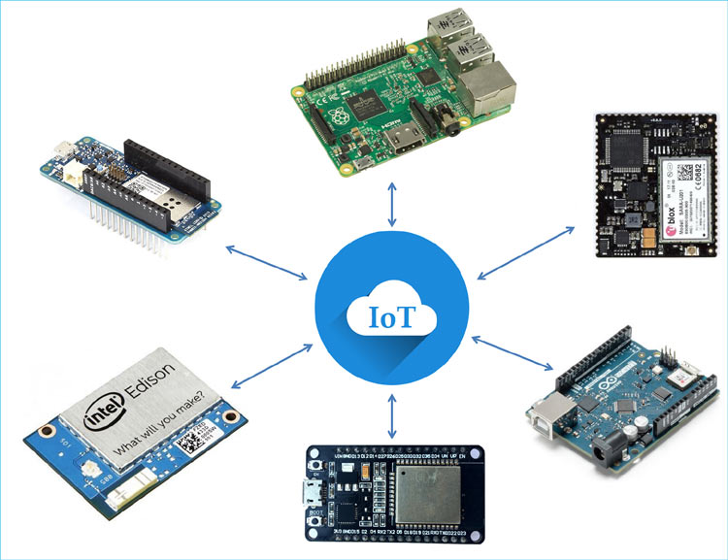
Figure 11: Hardware.
IoT hardware components can vary from low power boards; single board processors like the Arduino Uno, which are essentially smaller boards plugged into the motherboard to enhance and enhance its functionality by introducing specific functions or features (such as such as GPS, light and heat sensors or interactive displays).
A programmer specifies the inputs and outputs of a board, then creates a circuit design to illustrate how these inputs and outputs interact.

Common IoT hardware.
raspberry cake
A Linux-based single-board computer, Raspberry Pi is one of the most popular and accessible IoT development platforms.
Arduino
Renowned in IoT development, Arduino produces a wide variety of microcontrollers, open-source development tools, toolkits, and software.
Pycom
Pycom is known for its WiPy and LoPy boards, which pack a lot of functionality into a small package. The company offers modules with flexible connectivity options including Bluetooth Low Energy, Wi-Fi and mobile LPWAN.
Particle
With a variety of development kits and connectivity modules, Particle hardware is designed to work with the company's software platform, Particle IoT Device Management, which includes tools to help you create and connect devices its IoT. SODAQ
SODAQ's durable solar-powered IoT detection and tracking hardware is designed for B2B and large-scale deployments. They also offer technical services if you need help with your IoT design and prototype.
Locust results
As an open source hardware company, Adafruit offers a variety of IoT development boards and kits with different features and capabilities.
SparkFun
SparkFun's microcontroller development and deployment boards let you build and test prototype IoT devices, and they sell additional hardware like cables, LTE antennas, and more.
Espressif
Espressif's microcontrollers are very popular among IoT developers. The company specializes in creating highly integrated chips that help you design IoT devices that are easy to manufacture and deploy.

IoT APIs.

Definition.
Application Program Interfaces (APIs) connect the connected "things" of the "Internet of Things". In addition, the IoT API is the point of interaction between the IoT device and the Internet and/or other network elements. To better understand what an IoT API is, let's look at its application or implementation. Take, for example, a smartwatch or fitness tracker. These are sensors that collect information. Usually, these devices are first connected to your phone via Bluetooth. Phones take care of connecting them to the Internet. Usually, there is an application that provides most of the information to the user. In addition, connecting these applications to the provider is usually done through an API. APIs act as data conduits to send data to the cloud and retrieve meaningful insights.
There are four common types of APIs: Public, Partners, Internal and Composite APIs.
Public API
Public APIs, also known as open APIs, are available to the public without restrictions. This allows developers outside of an organization to access data to improve their own applications. Single sign-on, using your email or social media account, is possible through the public API, by embedding your email provider or social platform token in your app.
Partner API
Partner APIs can be operated by the client or the application's partners. These APIs require the user to sign in and authenticate with an API key to access the API. The Hologram API is an example of a partner API that allows customers to communicate directly with their connected devices and report data for their applications.

Internal API
The APIs used by a company to create and manage its applications are internal or private APIs. This ensures that only people working on the product have access to make changes to the product or sensitive data on the platform.
Composite APIs
Composite APIs combine multiple API requests into a single API call. This reduces the number of trips to a server. By grouping a sequence of API calls into a single API, a client can make an API request that consists of a sequence of calls and ends with a response.

Type of API architecture and delivery format.

Although we have discussed different types of APIs, there are also different approaches to how data is transmitted over the network by API calls. REST and SOAP are the most advanced architectures but offer different benefits to users. JSON and XML are formats in which data is delivered.
SOAP-API
SOAP (Simple Object Access Protocol) is a protocol specification for exchanging data between two terminals. SOAP is mainly used for applications that require a high level of security, such as payments.
REST API
REST, also known as RESTful API (Representative State Transfer), is an architectural style for building client-server applications. REST supports high-performance and reliable communication at scale, regardless of the technology used. It is a lighter architecture than SOAP.
JSON and XML
JSON and XML are two of the formats in which data is delivered. SOAP relies only on XML while REST allows XML, JSON, HTML and plain text. JSON is a lightweight, human readable format that can be used with any programming language. Most public web services use REST API with JSON.

P3 Investigate architecture, frameworks, tools, hardware and API techniques available to develop IoT applications.

IoT architecture and development.

IoT Architecture with three layers(tiers).
While there is no single widely accepted IoT architecture, the most basic and widely accepted format is a three-layer architecture. It was first introduced during early research on the Internet of Things.
This architecture reduces to only have three main key elements: Perception, Network, and Application.
- The cognitive layer is the physical layer, which has sensors to detect and collect information about the environment. It detects certain physical parameters or identifies other smart objects in the environment.
- The network layer is responsible for connecting to other smart objects, network devices, and servers. Its functions are also used to transmit and process sensor data.
- The application layer is responsible for providing application-specific services to users. It identifies various applications in which the Internet of Things can be deployed, for example smart homes, smart cities, and smart health.
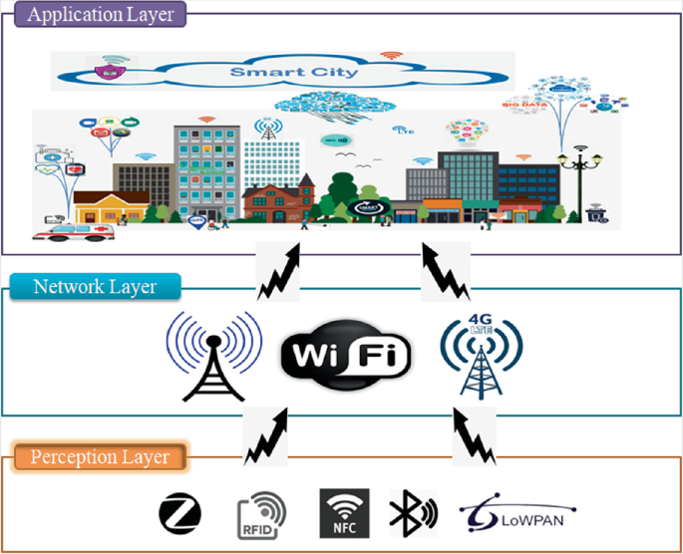
Figure 12: Three layered IoT architecture.

Perception
It is the physical layer of the architecture. This is where sensors and connected devices come into play as they collect varying amounts of data depending on the needs of the project. These can be peripherals, sensors, and actuators that interact with their environment.
Network
The data collected by all these devices must be transmitted and processed. This is the job of the network layer. It connects these devices to other intelligent network objects, servers and devices. It also manages the transmission of all data.
Application
The application layer is what the user interacts with. This is what is responsible for providing application-specific services to users. This could be a smart home implementation, for example, where the user presses a button in the app to turn on the coffee machine.

Framework.

Google Cloud Platform – Internet of Things framework.
Google Cloud Platform (GCP) is a collection of cloud computing services that Google launched on April 7, 2008. GCP runs on the same infrastructure as Google products, such as search engines. search Google, YouTube, etc. GCP provides various tools and services that help in infrastructure management, server provisioning, and network configuration. GCP also offers modular cloud services, including computing, application development, machine learning, data analytics, and data warehousing. Developers, cloud administrators, and other IT professionals can access Google Cloud Platform (GCP) through a public or dedicated network.
GCP is considered the third largest cloud service provider (CSP) after Amazon's AWS and Microsoft Azure.
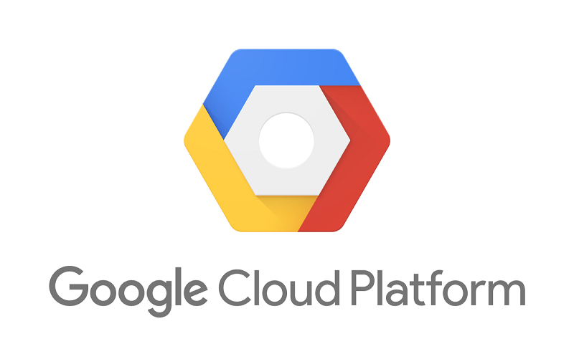
Figure 13: Google cloud platform.
The main reasons to choose GDP over other CSPs are:
1. Scalability:
One of the main disadvantages of cloud computing is downsizing. But GCP provides extremely easy scaling and minification.
2. Price:
Google offers GCP services at the best prices in the cloud market compared to competitors. Google lays out four key elements in its pricing philosophy.

- Hourly payment:
Payment to be made only for a specific time is requested. For example, unlike other CSPs, GCP does not round to the next hour if service is requested in half an hour. Instead, payments are made in only half an hour.
- Long-term discount:
Google grants an increasing discount of 25% if we use it for long-term use of computing resources instead of using it for temporary purposes.
- Customized machine type:
GCP allows you to dial in your application's CPU and memory resources and be charged accordingly. Up to 15% cost savings can be achieved with this method.
- Priority cases:
If the system is designed with fault tolerance, it can enable other systems, helping to reduce costs.
3. Integrated service:
You can use multiple APIs, AI and ML, IoT, compute engines, databases, big data analytics, development tools, security, and storage simultaneously.
4. Quick cooperation:
GCP enables fast collaboration for all users. Multiple users can access and edit the project at the same time.
5. Serverless computing:
It is a cloud computing execution model in which the CSP runs the server and manages resource allocation dynamically. Therefore, pricing will be based on the actual number of resources consumed by the application rather than the number of resources purchased in advance.

Tools.

Arduino.
Arduino is an open-source platform that helps circuit developers create electronic projects. It includes both hardware and software. The Arduino hardware is a programmable circuit board called a microcontroller. Arduino software is an IDE (integrated development environment) through which developers write and upload code to the microcontroller.
We can provide a program with a set of instructions on the Arduino board that can perform simple to complex tasks. Traditional programmable boards require separate hardware to upload code to the board. But the Arduino eliminates the need for hardware; instead, it uses a simple USB cable to upload the code to the Arduino board.
Arduino boards allow developers to deliver programs in a simplified version of the C++ language, making it easier for them to learn and code.
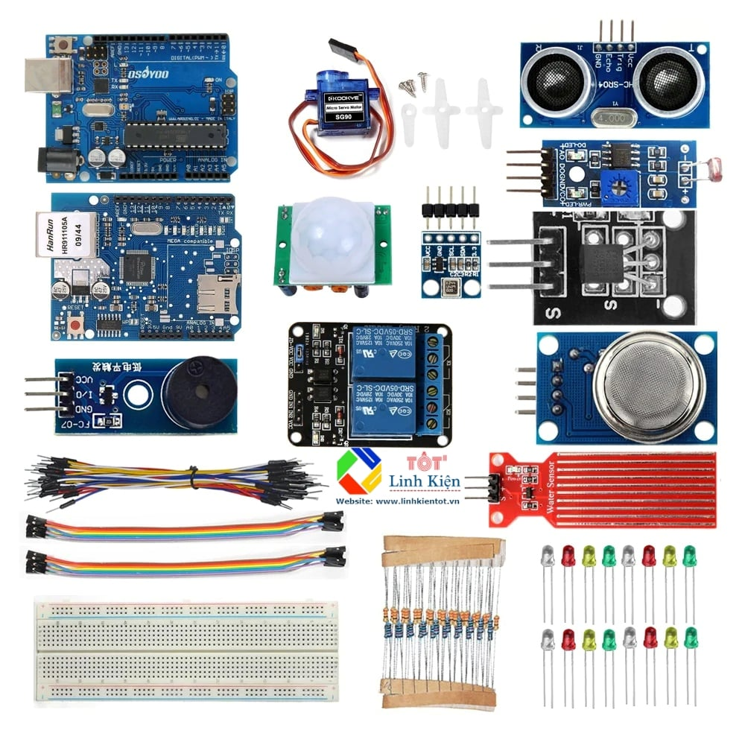
Figure 14: Arduino products.
Arduino hardware
The Arduino hardware is a programmable circuit board. You may have come across many different Arduino boards in your work, but the most commonly used Arduino board is the Arduino UNO. All Arduino boards have a microcontroller called a small computer, which is the heart of the Arduino.
So, when learning Arduino, it is essential to know more about microcontrollers and how to use them. The Arduino microcontroller is responsible for reading the various inputs and controlling the outputs.
Arduino software
The Arduino software is called the Arduino IDE. You can download software to your computer and program the Arduino boards to perform various tasks respectively.
The IDE is similar to a text editor where you write instructions for the Arduino board.

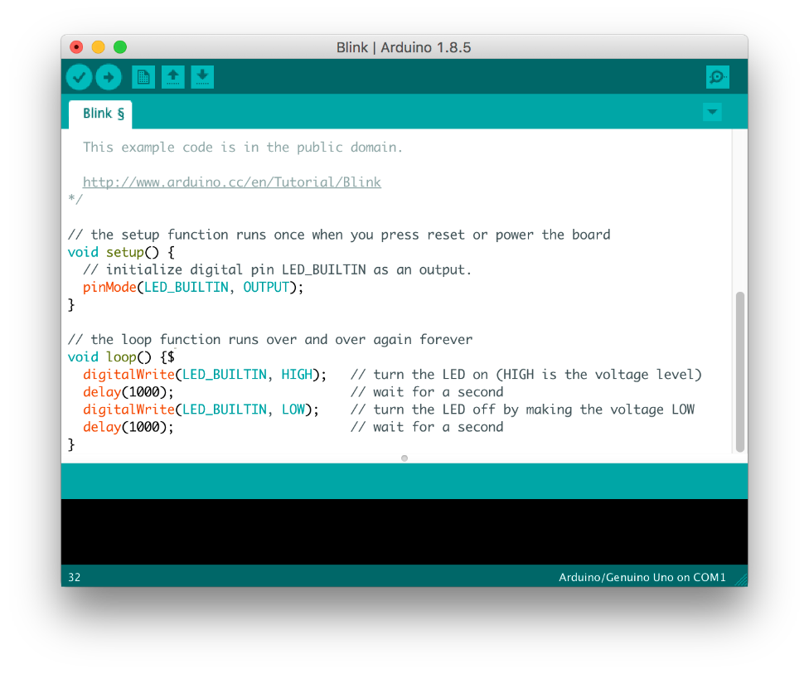
Figure 15: software.

Arduino code
Besides the hardware and software, the third most important aspect of the Arduino is its code, also known as the sketch. You can write the code in the Arduino IDE and upload it to the board. You may be wondering what language Arduino uses to code. Arduino has a native language similar to C++, called the Arduino Programming Language. Any program developed using the Arduino programming language is called a sketch and is saved in a file with the .ino extension.
To write instructions for the Arduino board, you must have a basic understanding of the C and C++ programming languages.
Together, the hardware, software, and code make up the Arduino.

Hardware.

Temperature sensor.
A temperature sensor is a device used to measure temperature. It can be air temperature, liquid temperature or solid material temperature.
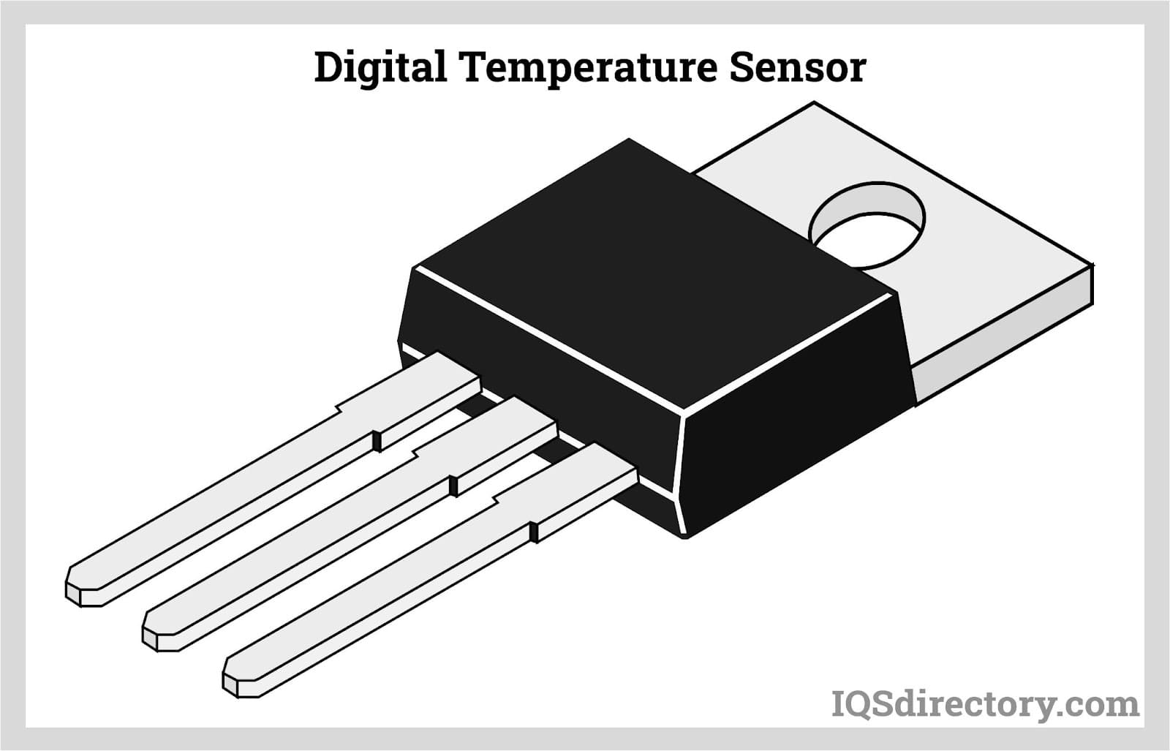
Figure 16: Temperature sensor.
There are different types of temperature sensors, and each uses different technologies and principles to measure temperature.
- Different types of temperature sensor
- Thermistors can be very small in size. They consist of a sensing element that can be glass or epoxy coated and have 2 wires so that they can be connected to the circuit. They measure temperature by measuring the change in resistance of an electric current. Thermistors are available in NTC or PTC form and are generally inexpensive.
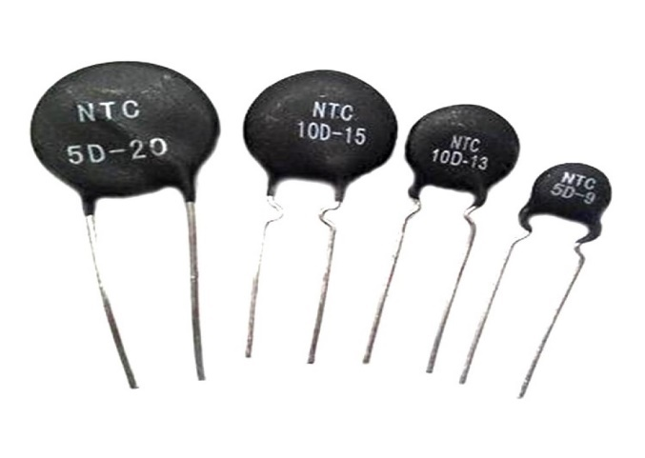
Figure 17: Thermistors.
- RTD or resistance temperature detector works similar to thermistor and measures ohmic resistance to measure temperature. They are connected to the same circuit as thermistor insulation, but they have a much wider temperature range and can measure extreme temperatures.

Figure 18: RTD.
- Thermocouples use two conductors made of dissimilar metals joined at the ends to form a junction. When this junction is subjected to heat, a voltage is generated that is proportional to the temperature input. They are very versatile because different metal combinations allow for different measuring ranges; however, they lack the accuracy of NTC and RTD, making them the least accurate of the three.
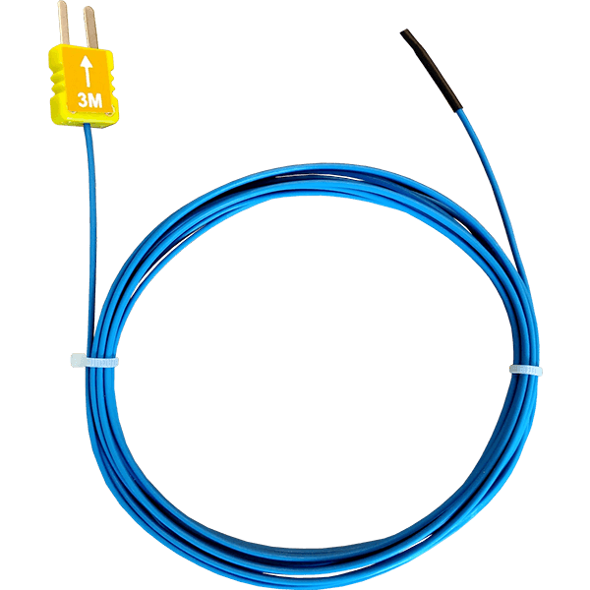
Figure 19: Thermocouples.
- The temperature probe is a very common and diverse type of temperature sensor. They consist of a thermistor, thermocouple or RTD sensing element and may be terminated with a terminal header. All three types of sensors can be manufactured in a variety of housings - in stock and custom. This allows for enhanced utility, which can span the multitude of different environments and vehicles they encounter.
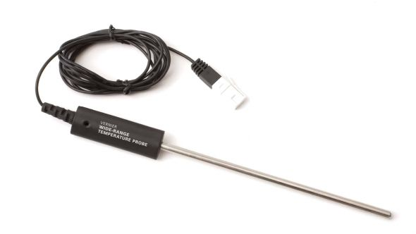
Figure 20: Temperature probe.

Gas sensor.
A gas sensor is a device that detects the presence or concentration of a gas in the atmosphere. Based on the gas concentration, the sensor generates a corresponding potential difference by varying the resistance of the material inside the sensor, which can be measured by the output voltage. Based on this voltage value, the type and concentration of the gas can be estimated.
The type of gas the sensor can detect depends on the sensing material inside the sensor. Usually, these sensors are available as modules with comparator as shown above. These comparators can be set for a specific gas concentration threshold value. When the gas concentration exceeds this threshold, the digital pin will stay high. Analog pins can be used to measure gas concentrations.
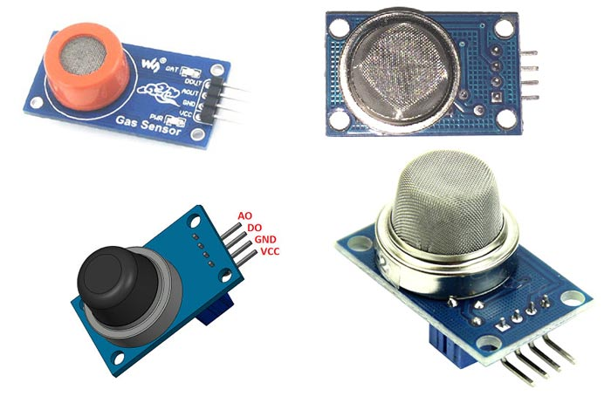
Figure 21: Gas sensor
- Types of gas sensors
Gas sensors are often classified into different types based on the type of sensing element they are made of. Below is a classification of the different types of gas sensors based on the sensing element commonly used in different applications:
- Gas sensor based on metal oxide.
- Optical gas sensor.
- Electrochemical gas sensor.
- Capacitive gas sensor. Gas temperature sensor.
- Sound-based gas sensor.

Water pump.
A water pump is a machine used to transfer water from one place to another. This can be used to divert water from a site for use as drinking or irrigation, or it can be used to drain water from an area to prevent spoilage. There are many types of water pumps available and you can choose the best option for your needs.

How does the water pump work?
A water pump is a type of pulse turbine that works by using a rotating wheel to convert potential energy from pressure into kinetic energy. Water is pumped from a lower altitude to a storage area, where it is collected until needed. The water is then released from the storage area at a higher altitude, allowing the water to move to the desired location.
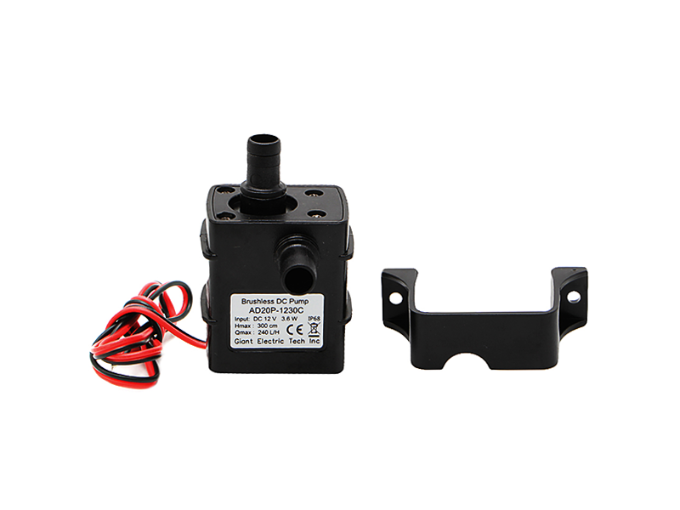
Figure 22: water pump.
- different types of water pumps.
- There are different types of water pumps so you can choose the right one for your needs. Some water pumps are better for certain tasks than others, so it's important to know what each water pump is used for before making a purchase.
- Submersible pumps are the most common type of water pump. These pumps are installed below the surface of a body of water, usually an irrigation pond or well.
- On the other hand, the above ground pump is installed on the water surface. These pumps are designed to lift water below the surface of a body of water, such as a lake or stream. They are usually not as powerful as submersible pumps, but can be useful for smaller jobs.
- Centrifugal pumps use a rotating impeller to draw water from below the surface of a body of water. They are commonly used in municipal water systems to pump water to homes. They are also commonly used to pump water below the well surface.

Distance detector.
As their name suggests, distance sensors are used for determining the distance of an object from another object or obstacle without any physical contact involved.
What is ultrasonic distance sensor?
Ultrasonic sensors are arguably the most common distance sensors, also known as sonar sensors. It detects the distance to objects by emitting high frequency sound waves.
Ultrasonic wave sensor:
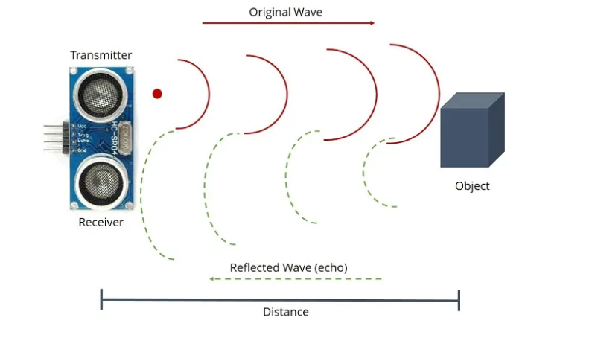
operating principle
- The ultrasonic sensor emits high frequency sound waves towards the target object and the timer is started.
- The target object sends sound waves back to the sensor.
- The receiver picks up the reflected wave and stops the timer.
- The time it takes for the wave to return is measured at the speed of sound to determine the distance traveled.

LCD.
LCD (Liquid Crystal Display) is a type of flat panel display that uses liquid crystal as its primary active form. LEDs have many use cases for consumers and businesses, as they are commonly found in smartphones, TVs, computer monitors, and consoles.
Types of LCD screens include:
- Twisted Nematic (TN) - inexpensive while having a high response time. However, the TN screen has poor contrast, viewing angles and color contrast.
- In panel switch display (IPS panel) - provides much better contrast ratio, viewing angle and color contrast than TN LCD.
- Vertically Aligned Panels (VA Panels) - considered the mid-range between TN and IPS displays.
- Advanced Fringe Field Switching (AFFS) - outperforms IPS displays in color reproduction range.
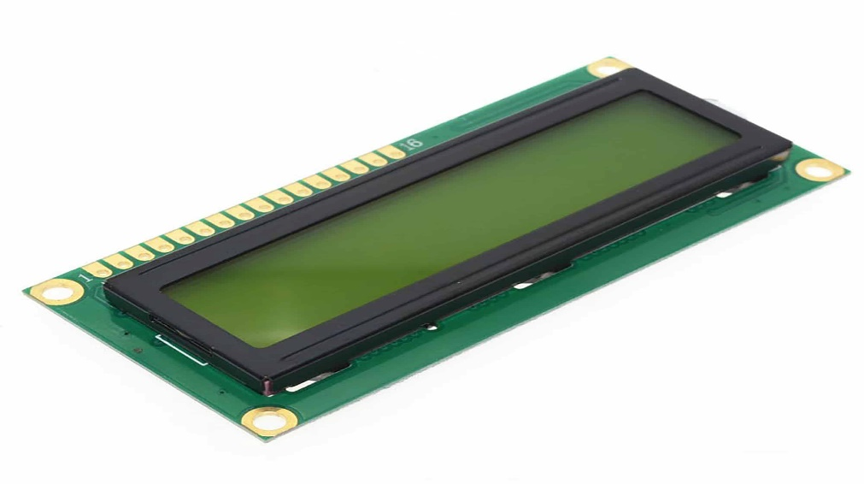
Figure 23: LCD.

Arduino Uno R3.
The Arduino Uno R3 is a microcontroller board based on the detachable ATmega328 AVR dual inline package (DIP) microcontroller. It has 20 digital input/output pins (6 of which can be used as PWM outputs and 6 of which can be used as analog inputs). Programs can be downloaded here from the easy-to-use Arduino computer program. Arduino has a large support community, making it a very easy way to get started with the onboard electronics. R3 is the third and final version of the Arduino Uno.
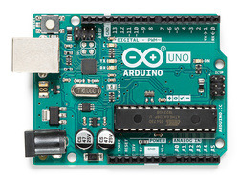
Figure 24: Arduino uno R3.
Arduino Uno is a microcontroller board based on ATmega328. It has 20 digital input/output pins (6 of which can be used as PWM outputs and 6 of which can be used as analog inputs), a 16 MHz resonator, USB connection, power jack, in-circuit system programming (ICSP) header and a reset button. It contains everything needed to support the microcontroller; Simply connect it to a computer with a USB cable or power it with an AC-DC adapter or battery to get started.

The Uno differs from all previous cards in that it does not use a USB-Serial FTDI driver chip. Instead, it has an ATmega16U2 programmed as a USB-to-serial adapter. This auxiliary microcontroller has its own USB bootloader, allowing advanced users to reprogram it.
Arduino has a large support community and a full set of support libraries and additional "shields" (for example, you can easily create a wireless network for your Arduino using our Wixel shield. ), making it a great showcase for integrated electronics. Note that we also provide the SparkFun Inventor Kit, which includes the Arduino Uno along with a wide range of components (e.g. breadboard, sensors, jumpers and LEDs) so you can create some projects. Interesting introduction.
This is the 3rd version of Uno (R3), with some changes:
The USB controller chip has changed from ATmega8U2 (8K flash) to ATmega16U2 (16K flash). It does not increase the flash or RAM available for the sketch. Three new pins have been added, all of which are copies of the previous pins. I2C pins (A4, A5) have also been marked on the side of the board near the AREF. There is an IOREF pin next to the reset pin, which is a duplicate of the 5V pin.
The reset button is now on the side of the USB connector, making it easier to reach when using the shield.

Node MCU ESP8266.
NodeMCU (Node MicroController Unit) is an open-source hardware and software development environment built around an inexpensive system on chip (SoC) called ESP8266. The ESP8266, designed and manufactured by Espressif Systems, contains the following key computer components:
CPU, RAM, network connectivity (WiFi) and even modern operating systems and SDKs. This makes it a great choice for all kinds of Internet of Things (IoT) projects.
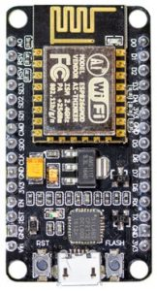
Figure 25: Node MCU.
However, as a chip, the ESP8266 is also difficult to access and use. You have to solder wires of the appropriate analog voltage to its pins to perform the simplest tasks like powering or sending keystrokes to the "computer" on the chip. You also need to program it according to low-level machine instructions so that the on-chip hardware can understand it. This level of integration is not an issue when using the ESP8266 as an integrated control chip in mass-produced electronics. It is a big burden for hobbyists, hackers or students who want to experience it in their own IoT projects.
But what about the Arduino? The Arduino project created an open-source software SDK and hardware design for their general-purpose IoT controller. Similar to the NodeMCU, Arduino’s hardware is a microcontroller board with standard USB headers, LEDs, and data pins. It also defines standard interfaces for interacting with sensors or other tags. But unlike NodeMCU, Arduino boards can have different types of CPU chips (usually ARM or Intel x86 chips) with memory chips and various programming environments. There is also an Arduino reference design for the ESP8266 chip. However, the versatility of Arduino also means that there are significant differences between different vendors. For example, most Arduino boards don't have WiFi capabilities, and some even have a serial data port instead of a USB port.
NodeMCU Specifications
NodeMCU is available in different package styles. The basic ESP8266 core is common to all designs. The architecture-based designs retain the standard 30-pin layout. Some designs use the most common narrow (0.9″) footprint, while others use a wide (1.1″) footprint – an important consideration to take into account. The most popular NodeMCU models are Amica (based on standard narrow pin spacing) and LoLin which have wider pin spacing and larger boards. The open-source design of the ESP8266 base allows the market to continuously design new variants of the NodeMCU.

APIs.

Advantage.
Increased interactivity:
API solutions allow different software systems to communicate with each other, regardless of their programming language or platform. This improves interoperability between systems, allowing the exchange of data and functionality.
Improve efficiency:
API-based frameworks allow developers to reuse code and functionality from existing software systems, saving time and reducing the amount of code that needs to be written from scratch.
Better user experience:
APIs can allow third-party developers to build applications that integrate with existing software systems, providing a better user experience and enhanced functionality.
Increased flexibility:
APIs give developers greater flexibility, allowing them to choose the best programming languages ​​and frameworks for their needs.
New revenue stream:
APIs can allow businesses to create new revenue streams by giving third-party developers access to their software systems.

Disadvantage.
Security vanity:
API infrastructure can be vulnerable to security vulnerabilities, such as SQL injection and cross-site scripting (XSS) attacks, it is important to implement security measures against these threats.
Complexity:
APIs can be complex, requiring significant development effort to deploy and maintain.
Compatibility issues:
APIs may experience compatibility issues between different versions of the same software system or between different systems, which can lead to bugs and system failures.
Reliance on third party developers:
The API relies on third-party developers to build applications that integrate with the software system. This can create dependencies beyond the control of the company that owns the software system.
Administration and Management:
APIs require proper administration and management to ensure that they are used correctly and consistently across different applications and systems.

P4 Determine a specific problem to solve using IoT.

Scenario.
Problem:
Whenever the rainy season comes the place that near water area get flooded. We don’t know whenever the flood occurs and how to know when it come.

Solution.

Solution:
Tank Water Monitoring System using node mcu.
This device uses the power of the Internet of Things to create a water monitoring system to reduce water waste. It alerts you when the water reaches the maximum or minimum level. The main components used in this project are the Arduino UNO, the ultrasonic sensor, the buzzer, and the Wi-Fi Bolt module. This IoT project can be very useful for building a smart home device.
Equipment:
- ESP8266 NodeMCU.
- Ultrasonic Sensor.
- Power supply.
- LEDs (Red & Green).
- Breadboard.
- Jumpers.

Illustration of Problem using Arduino.
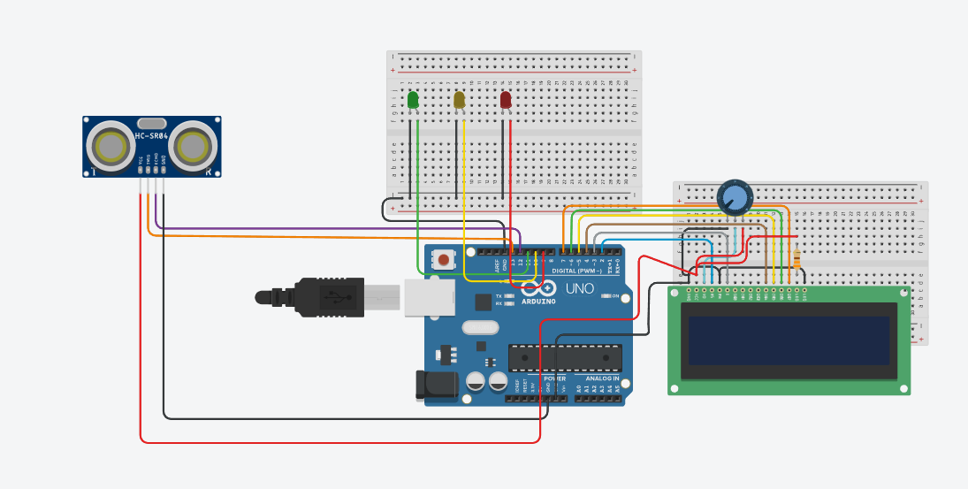
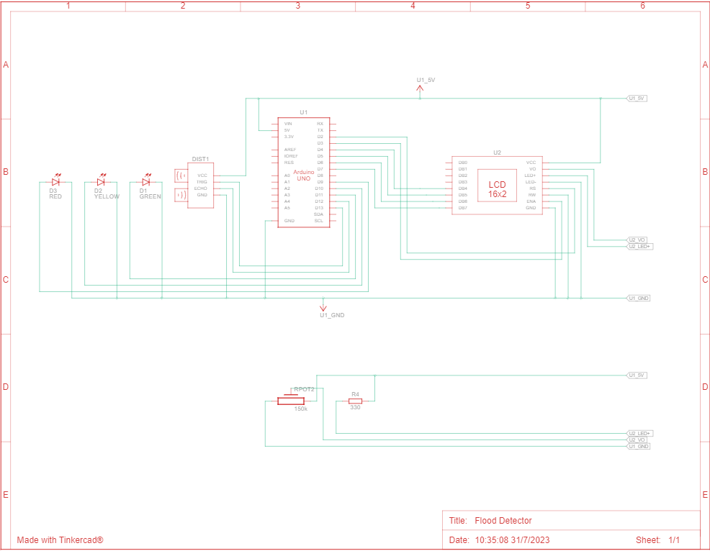

REFERENCES:

Admin (2023) What are the applications of IOT?, STL Tech, [online] Available at: https://stl.tech/blog/what-are-the-applications-of-iot/#:~:text=IoT%20enables%20seamless%20communication%20between,embedded%20unique%20identifiers%20(UIDs). (Accessed 27 July 2023).

Anon (2023a) IOT framework: Check out list of different IOT framework, EDUCBA, [online] Available at: https://www.educba.com/iot-framework/ (Accessed 29 July 2023).

Anon (2023b) IOT tools: Concept and a few popular IOT development tools, EDUCBA, [online] Available at: https://www.educba.com/iot-tools/ (Accessed 29 July 2023).

Anon (2023c) Top 10 IOT tools to consider in 2023, GeeksforGeeks, GeeksforGeeks, [online] Available at: https://www.geeksforgeeks.org/top-iot-tools/ (Accessed 30 July 2023).
Anon (2023d) Top features of IOT, InterviewBit, [online] Available at: https://www.interviewbit.com/blog/features-of-iot/ (Accessed 27 July 2023).
Anon (n.d.) What is the iot? everything you need to know about the internet of things right now, ZDNET, [online] Available at: https://www.zdnet.com/article/what-is-the-internet-of-things-everything-you-need-to-know-about-the-iot-right-now/ (Accessed 27 July 2023).
Contributor, T. (2019) What is LCD (liquid crystal display)?, WhatIs.com, TechTarget, [online] Available at: https://www.techtarget.com/whatis/definition/LCD-liquid-crystal-display (Accessed 30 July 2023).

