*
Qualification | BTEC Level 5 HND Diploma in Computing
Unit number and title | Prog102: Procedural Programming
Submission date |  | Date Received 1st submission
Re-submission Date |  | Date Received 2nd submission
Student Name |  | Student ID
Class |  | Assessor name
Student declaration
I certify that the assignment submission is entirely my own work and I fully understand the consequences of plagiarism. I understand that making a false declaration is a form of malpractice.
 |  | Student’s signature
Grading grid
P1 | P2 | P3 | M1 | M2 | D1

Summative Feedback: Resubmission Feedback:

Grade: | Assessor Signature: | Date:
Lecturer Signature:

Contents
I. INTRODUCTION 5
1. SCENARIO 5
2. PROGRAMMING LANGUAGES 5
2.1 C LANGUAGE 6
3. PROCEDURAL PROGRAMMING (P1) 7
3.1 PROCEDURAL PROGRAMMING LANGUAGE (P1) 7
4. USER REQUIREMENT (P1) 9
I. SENARIO ANALYSIS (P2, P3) 9
1. VARIABLE AND DATATYPES IN THIS PROGRAM (P2) 9
2. CONDITIONAL STATEMENTS (P2) 11
2.1 If: 11
2.2 Switch-case: 11
3. LOOP STATEMENT (P2): 13
3.1 for: 13
3.2 Do-while: 14
3.3 While: 15
II. FUNCTION OF PROGRAM (P2) 16
1. SPLIT FUNCTION: 16
2. HIERARCHY DIAGRAM 17
III. DIAGRAM (P3) 18
1. USE-CASE DIAGRAM 18
2. FLOW CHART 19
2.1 Menu option 19
2.2 Print ID and grade 21
2.3 Find highest grade 22
2.4 Find lowest grade 25
References 27

INTRODUCTION
Procedural programming has become more and more popular since the need is increasing in many different aspects of life (White & Sivitanides , 2005).
In this report, I will write an introduction about procedural programming and theories of computer programming language. The management program is used for solving any problem which users want. The aspects of this program will describe with theories and structures for writing the program so that users grasp and evaluate the product. (no citation)
>> overview of your research
Other Programing types: hardware programing, object oriented programing , …
>> research problem
Necessity: why you choose?
Issues need to be addressed
Structure of the remainder parts

SCENARIO
A math teacher wants to manage the grades of a class. He asks you to help him to write a small application to do that. He needs to enter student IDs, and student grades and store this information into 2 separate arrays (integer array for IDs and float array for grades). Then he needs to print all student IDs together with their grades. Finally, he needs to know which student has the highest grade and lowest grade. Your program should be menu based on the options above. When an option is done, the program should go back to the main menu so he can choose another option. There should be an option to quit the program (White & Sivitanides , 2005).

PROGRAMMING LANGUAGES
- A programming language is a type of written language that tells computers what to do. Examples are Python, Ruby, Java, JavaScript, C, C++, and C#. Programming languages are used to write all computer programs and computer software. A programming language is like a set of instructions that the computer follows to do something. (Corp, 2022)
- Programming languages have various types. Most programming languages do not follow one type alone, so it is difficult to assign a type for each language.

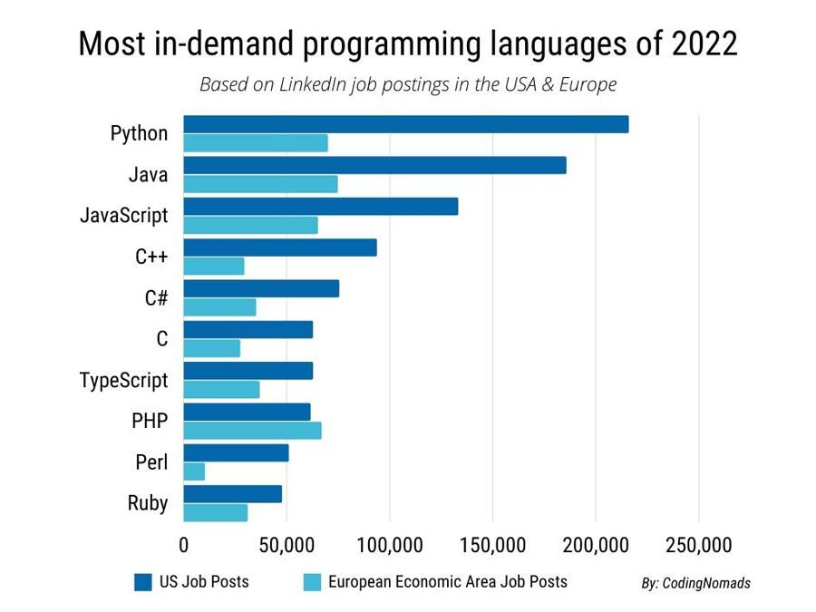 Figure 1: Most in-demand programming languages of 2022

2.1 C LANGUAGE
- C is a general-purpose high-level language that was originally developed by Dennis Ritchie for the Unix operating system. C is a successor of the B language which was introduced around 1970. The language was formalized in 1988 by the American National Standard Institute (ANSI) (Tutorials, 2022).
- It was first implemented on the Digital Equipment Corporation PDP-11 computer in 1972. The Unix operating system and virtually all Unix applications are written in the C language. C has now become a widely used professional language for several reasons (Tutorials, 2022).
- The code written in C language is simple and execution efficient. As a result, the development of various languages has been influenced by the C language. These languages are C++ (also known as C with classes), C#, Python, Java, JavaScript, Perl, PHP, Verilog, D, Limbo, and C shell of Unix, etc. Every language uses C language in variable capacity. For example, Python uses C for creating standard libraries, whereas the syntaxes and control structures of languages like C++, PHP, and Perl are based on C (Tutorials, 2022).
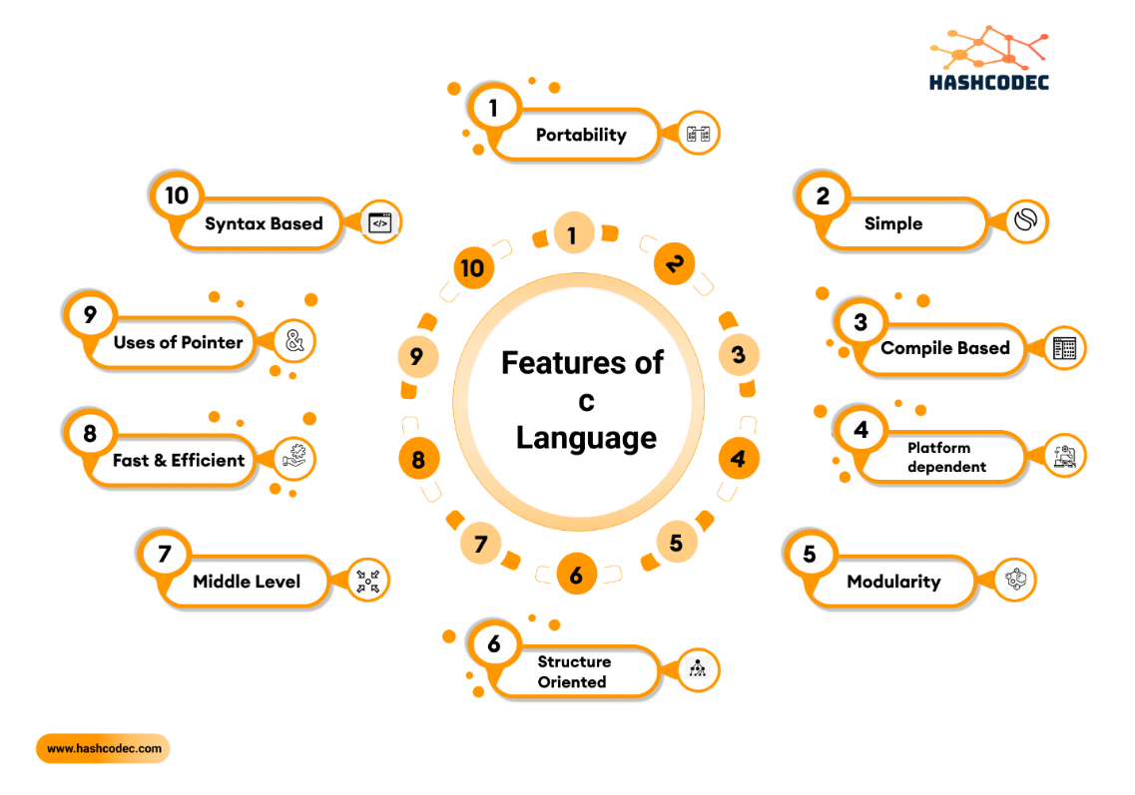
Figure 2: C Language features

PROCEDURAL PROGRAMMING (P1)

PROCEDURAL PROGRAMMING LANGUAGE (P1)
- Procedural programming is a method of programming which has the support of splitting the functionalities into several procedures. In procedural programming, a large program is broken down into smaller manageable parts called procedures or functions. Here, priority is given on functions rather than data. In a procedural programming language, a program consists of a sequence of instructions each of which tells the computer to do something such as reading inputs from the user, doing the necessary calculation, displaying output (Corp, 2022, p. 7).
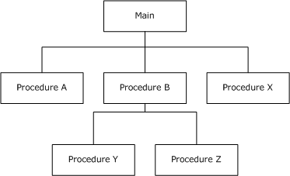
Figure 3: Structure of procedural programming
Key features of Procedural programing
- Predefined functions: A predefined function is typically an instruction identified by a name. Usually, the predefined functions are built into higher-level programming languages, but they are derived from the library or the registry, rather than the program. One example of a pre-defined function is ‘charAt()’, which searches for a character position in a string.
- Local Variable: A local variable is a variable that is declared in the main structure of a method and is limited to the local scope it is given. The local variable can only be used in the method it is defined in, and if it were to be used outside the defined method, the code will cease to work.
- Global Variable: A global variable is a variable which is declared outside every other function defined in the code. Due to this, global variables can be used in all functions, unlike a local variable.
- Global Variable: A global variable is a variable which is declared outside every other function defined in the code. Due to this, global variables can be used in all functions, unlike a local variable.

USER REQUIREMENT (P1)
- As a user I want to have two distinct arrays (integer array or IDs and float array for grades), so that I can easily store data in.
- As a user I want to have an option to print Grades along with their IDs, so that I can have a list of all my students IDs and their grades.
- As a user I want to have an option to find and print Students with the highest grade and students with the lowest grade, so that I can know who have the highest grade and who have the lowest.
- As a user I want to have a option to exit the program so that whenever I want to end the program I can choose the option and exit.
- As the user I want to have a Menu based with the option above so that I can choose to do what I want.

- The main solution is to write an application based on the use of C programming languages and procedural programming. The program created will solve the needs of the customer stated above and can be developed to other problem that may be encountered.

SENARIO ANALYSIS (P2, P3)

VARIABLE AND DATATYPES IN THIS PROGRAM (P2)
The program contains 6 main variables related to the user purpose. Each of them has their own data type that suitable for solving the problem.

Table 1: Variables and data type
 | Variable name | Data type | Reason
Student IDs | sID | integer array | Student ID is a 4-digit number
Student’s grade | sGrade | Float array | Student's grade is a real number 0 to 10
User’s option for menu | n | integer | The options are numbered from 1 to 5
Student has highest grade | maxGrade | float | Student's grade is a real number from 0 to 10
Student has lowest grade | minGrade | float | Student's grade is a real number from 0 to 10

Note : n in the flowchart for menu operation is different from ones in others flowchart.

CONDITIONAL STATEMENTS (P2)

2.1 If:
This is the most important tool in the selection process. Used to execute a single or group statement when the condition is true. If the condition is false, the statement is skipped, and the program executes the first statement after the if selection structure to continue.

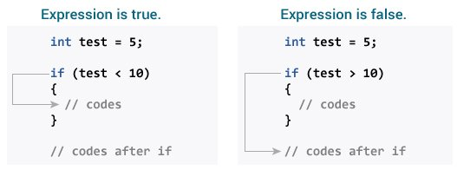
Figure 4: If statement

I use the if statement structure to find the student with the highest grade function and the student with the lowest grade function. First, use a for loop to accept the sGrade input from the array. The program begins comparing the inputs of the array one by one. If the value is high, maxGrade will be assigned and the program will continue to run (sGrade +1) times. The final value of maxGrade is the highest grade. For the lowest, first use a for loop to accept sGrade input from the array. The program begins comparing the inputs of the array one by one. If the value is small, minGrade will be assigned and the program will continue to run (sGrade +1) times. The final value of the minGrade is the lowest grade.

2.2 Switch-case:
In C, the switch statement compares the value of a variable to some scenarios. When a case match is found, a block of statements related to that particular case is executed.
Each case in the switch block has a unique name or number called an identifier. The user's value is compared to all cases in the switch block until a match is found.
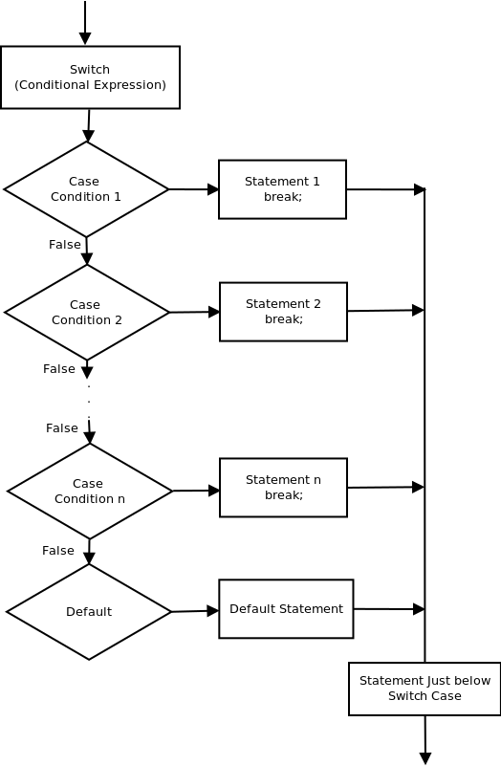
Figure 5: Switch case flow chart
xyx2+y2dx=5 ( 1)
The value of the variable or expression in parentheses is compared to the value provided by the switch statement on each instance. If a match is found, the statement following the case is executed. If no match is found, the default statement is used. You must place a keyword break at the end of each case to exit the switch immediately after the statement is executed at equation ( 1).
In this scenario, the programmer defines an integer variable named n. There, the n is considered only once and compared to the value of the case. If a block of statements follows a case that has a matching value, the statements within that block will be executed.
I use switch case to make the menu in the program each case equal to an option that user can choose.
- case 1 Input ID and grade of student.
- case 2 Print all student ID together with their grades.
- case 3 Print student has highest grade.
- case 4 Print student has lowest grade.
- case 5 Go back to the main menu.
- case 6 Quit program.

3. LOOP STATEMENT (P2):

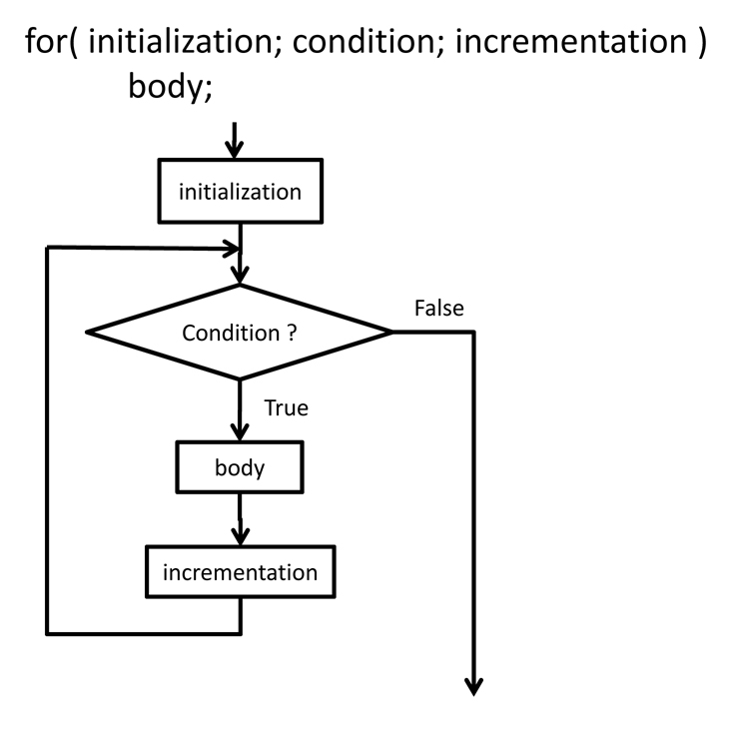
3.1 for:
A for loop is a control flow statement used to repeatedly execute a series of statements as long as the conditions are met. Repeated statements are another name for this type of statement. As a result, the for loop is an iterative statement.
Figure 6: for loop
For loop operation sequence:
• Step 1: Initialize the iterator value, only do it once
• Step 2: Check the loop condition, if the condition is false => Go to step 5
• Step 3: Execute the loop content inside the loop body
• Step 4: Update the iterator value => Go back to Step 2
• Step 5: End the loop.
The situation is currently being reassessed. If it’s true, the loop will run and the procedure will repeat (body of the loop, then increment step, and then again condition). The ‘for’ loop ends when the condition becomes false.
I use a for loop in the scenario to accept sGrade inputs from the array. In the body of the loop, it will include the if statement. the for loop will continue to run (sGrade +1) times to find the highest and lowest grade. Then we will use a for loop to find out who the students with the highest or lowest grade are. By putting the if statement inside this loop. If grade = maxGrade or grade = minGrade then print the student's ID. So we have found the people with the highest grade and those with the lowest grade.

3.2 Do-while:
Unlike for and while loops, which verify the loop condition at the top, the do-while loop in C programming checks it at the bottom.
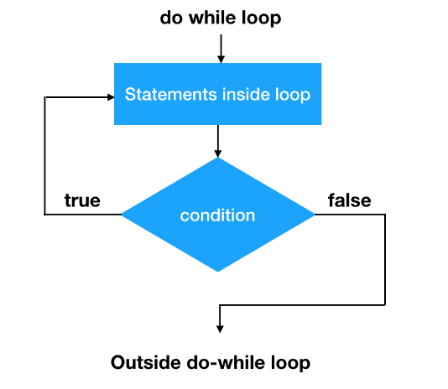
A do-while loop is similar to a while loop, except it guarantees that it will be executed at least once.
Figure 7: Do-while

I use two statement actions in the program: one for input variables and the other for scanning variable values. When the do-while command is executed, it begins processing the sGrade values at the end. The loop condition is then used; if true, the loop will return to the start and the loop's body will be run once more. This procedure repeats itself until the condition no longer exists. The do-while loop is responsible for verifying the state of variables as they are typed in.

3.3 While:
In while loop, a condition is evaluated before processing a body of the loop. If a condition is true then and only then the body of a loop is executed.
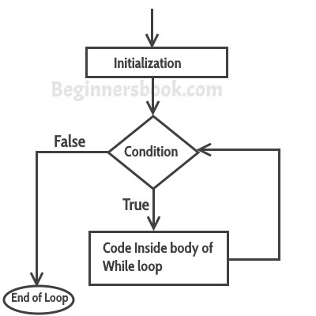
Here, the statement can be a single statement or a block of statements. Condition is any expression and true is a non-zero value. The loop will keep repeating as long as the condition is true. If the condition is false, program control is passed to the line immediately following the loop.
Figure 8: while loop
I use the while loop to make a condition for the first function that if the user enter the same ID the while loop will be execute and make the user to enter the new ID for that student.

FUNCTION OF PROGRAM (P2)

SPLIT FUNCTION:
Table 2: Split function
FUNCTION | INPUT | OUTPUT
1. Enter the student’s IDs and grades. | ID and grade of student | ID and grade of student
2. Display the student’s IDs and grades | This function doesn’t need the input. | The student’s grade.
3. Find and display the students have highest grade | This function doesn’t need the input. | List of students who have highest grade
4. Find and display the students have lowest grade | This function doesn’t need the input. | List of students who have lowest grade
5. Select keys menu. | Your choice. | Your option.

HIERARCHY DIAGRAM
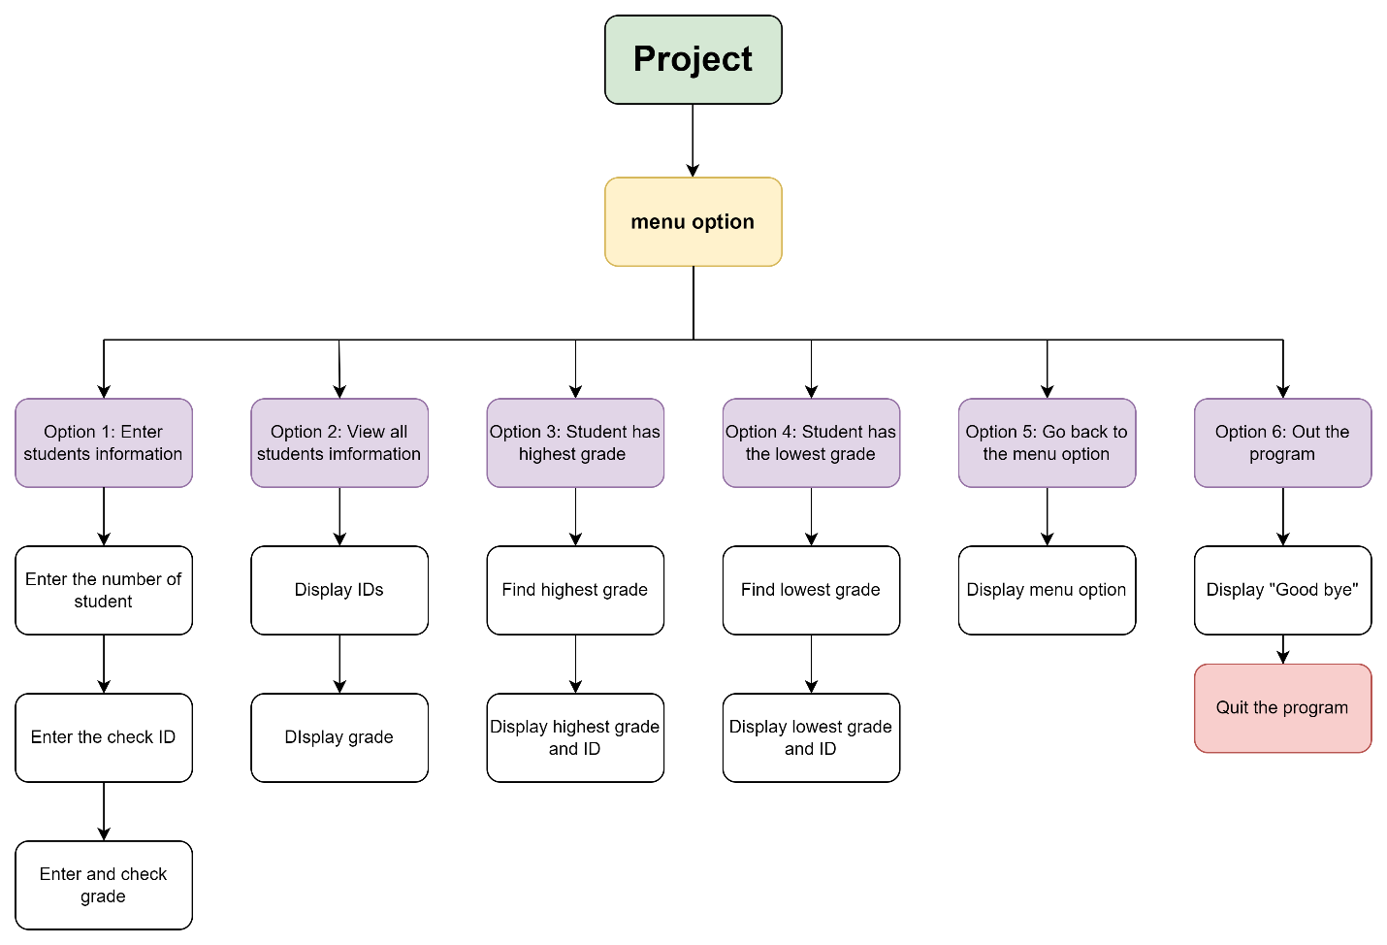
Figure 9: Hierarchy diagram

DIAGRAM (P3)

USE-CASE DIAGRAM
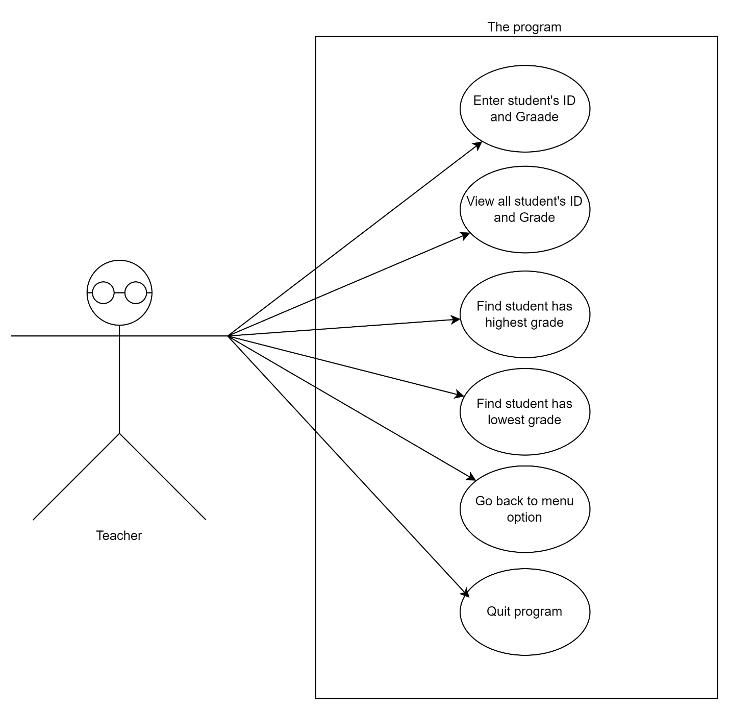
Figure 10: Use-case diagram for the scenario
The use-case diagram also identify the interactions between the program and its actors (teacher). First, teacher must input grades and IDs of students for saving in memory of 20 program. Then teacher can choose any work like: view all student’s grades and IDs, Find highest or lowest point. After done one of choices the program will go back main menu for other options or quit program.

FLOW CHART

Menu option
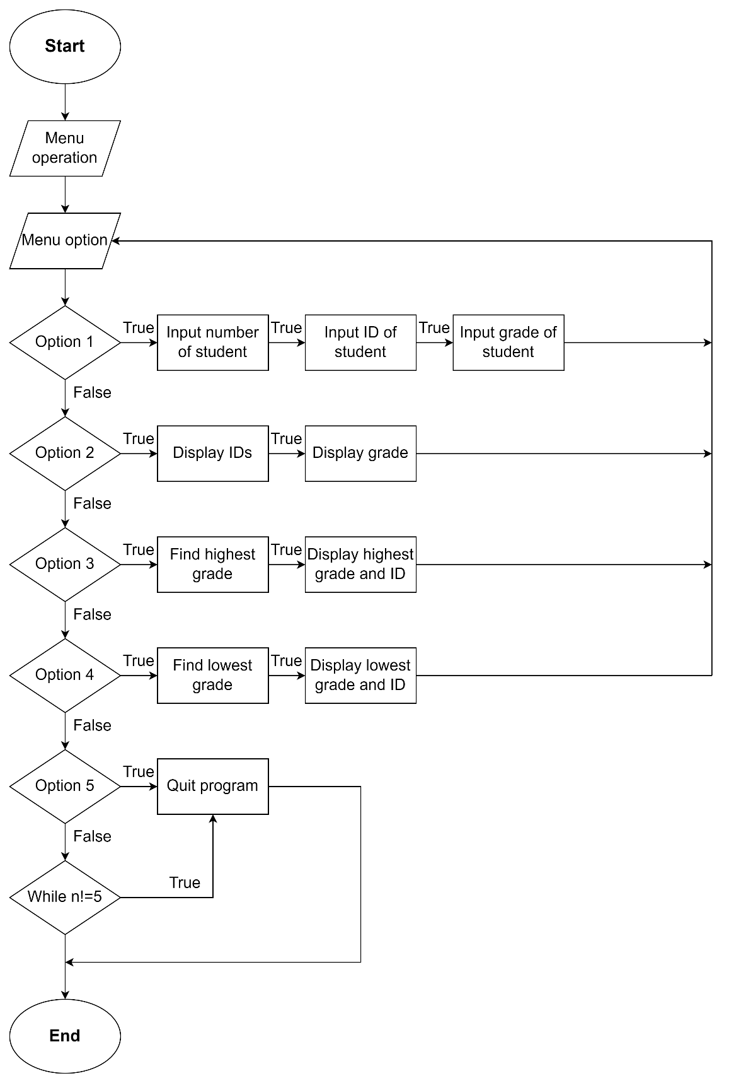
Figure 11: Menu flow chart
Explain flowchart:
Step 1. Start
Step 2. Set menu option
Step 3. Set choice
Step 4. Read option 1
Step 5. Print the value option 1 + If number of student, grade or ID is the word restart menu + Student’s information will be saved and go back step 2
Step 6. Read option 2
Step 7. Print the value option 2 + If true print all information of student and go back step 2
Step 8. Read option 3 + If true print highest grade and ID and go back step 2
Step 9. Read option 4 + If true print lowest grade and ID and go back step 2
Step 10. Read option 5 + If true: Quit program +If false: run while n!=5 and Quit program
Step 11. End

Print ID and grade
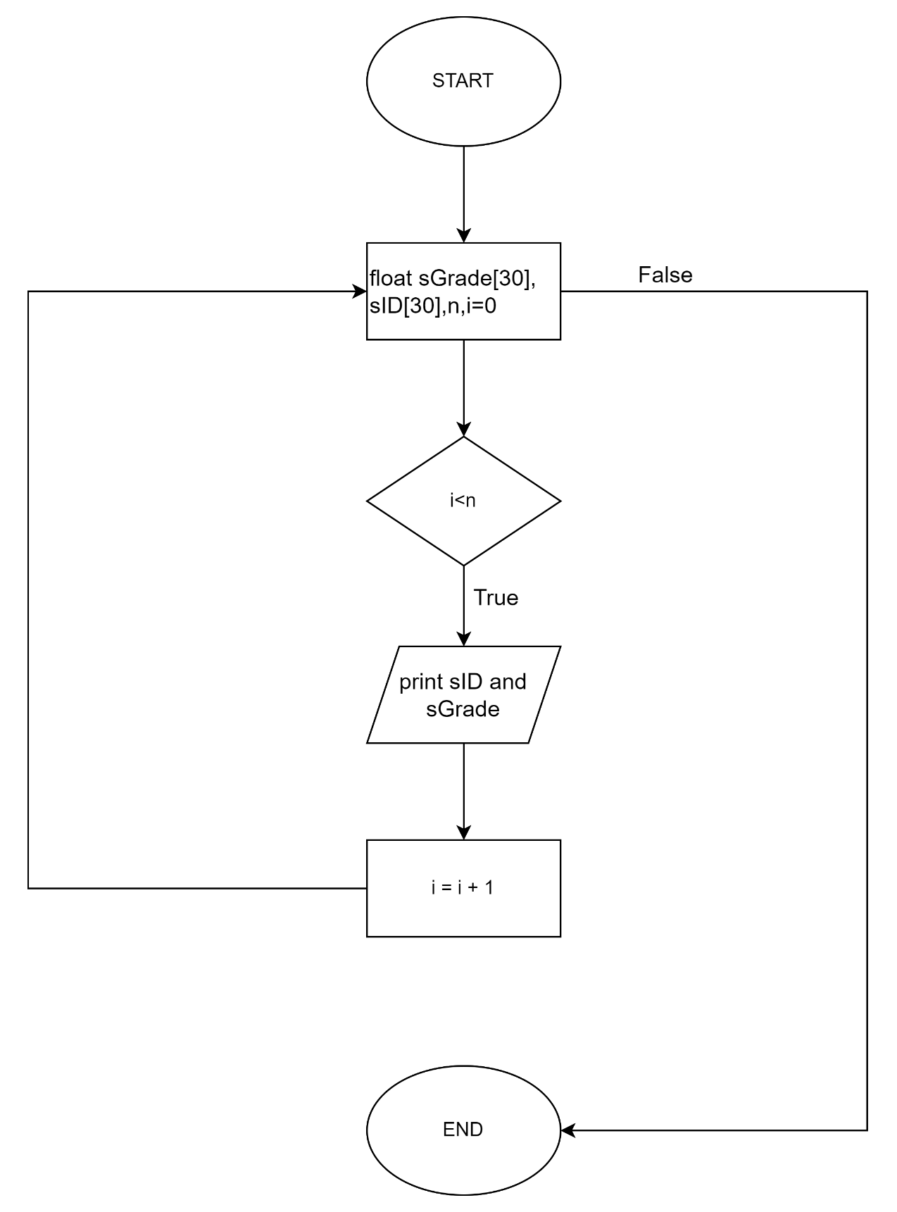
Figure 12: Print ID and grade flow chart

Explain flowchart:
Step 1. Start
Step 2. Declare float sGrade[30], sID[30], n,i=0
Step 3. Check condition + If true go to step 4 + If false go to step 8
Step 4. Print IDs and sGrade
Step 5. Increase i by 1
Step 6. Go back step 3
Step 7. Go to step 4 if done step 6 and get true step 3
Step 8. Stop

Find highest grade

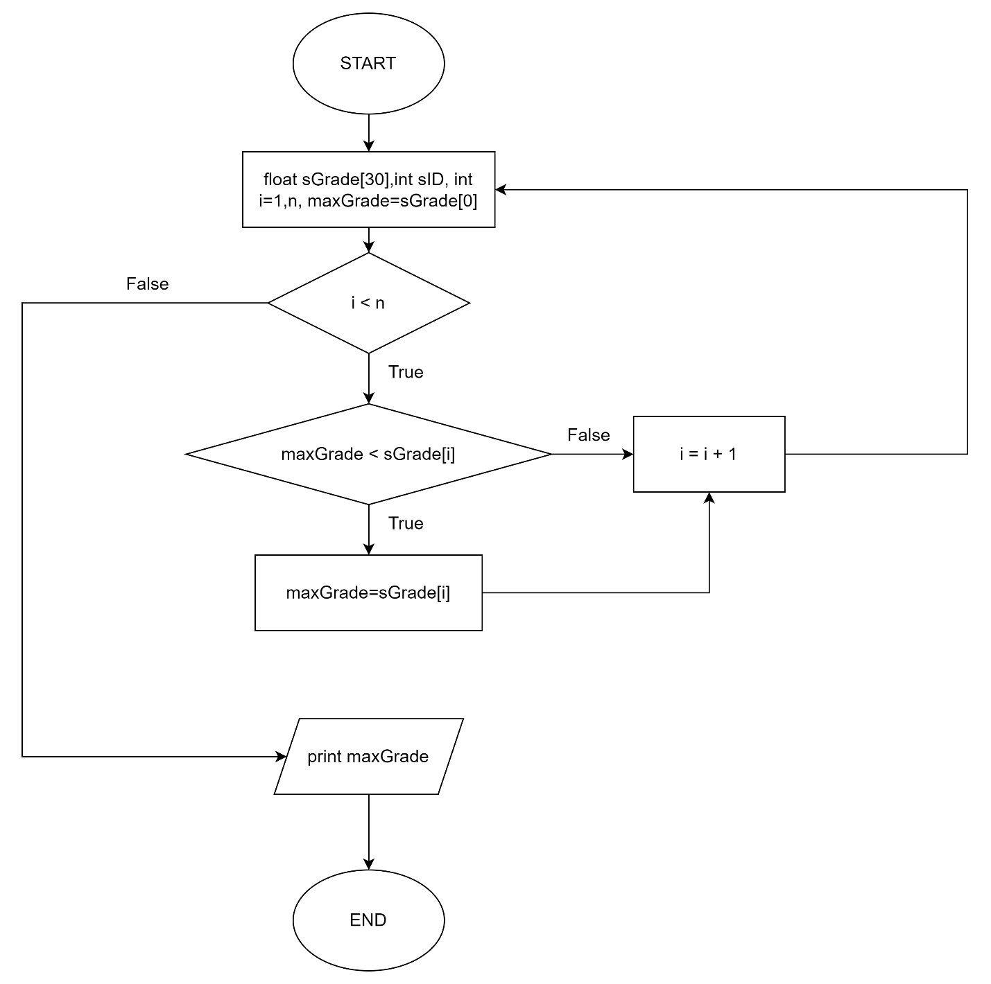
Figure 13: Find highest grade flow chart

Explain flowchart:
Step 1. Start.
Step 2. Declare float sGrade[30], int sID[30], i=1, maxGrade=sGrade[0].
Step 3. Check the condition “i < n”:
- If false, print maxGrade to the screen.
- If true, go to step 4.
Step 4. Check the condition “maxgrade < sGrade[i]”:
- If true, set maxgrade = sGrade[i] and go to step 5.
- If false, go straight to step 5.
Step 5. Increase i by +1 then repeat step 3.
Step 6. End.

Find lowest grade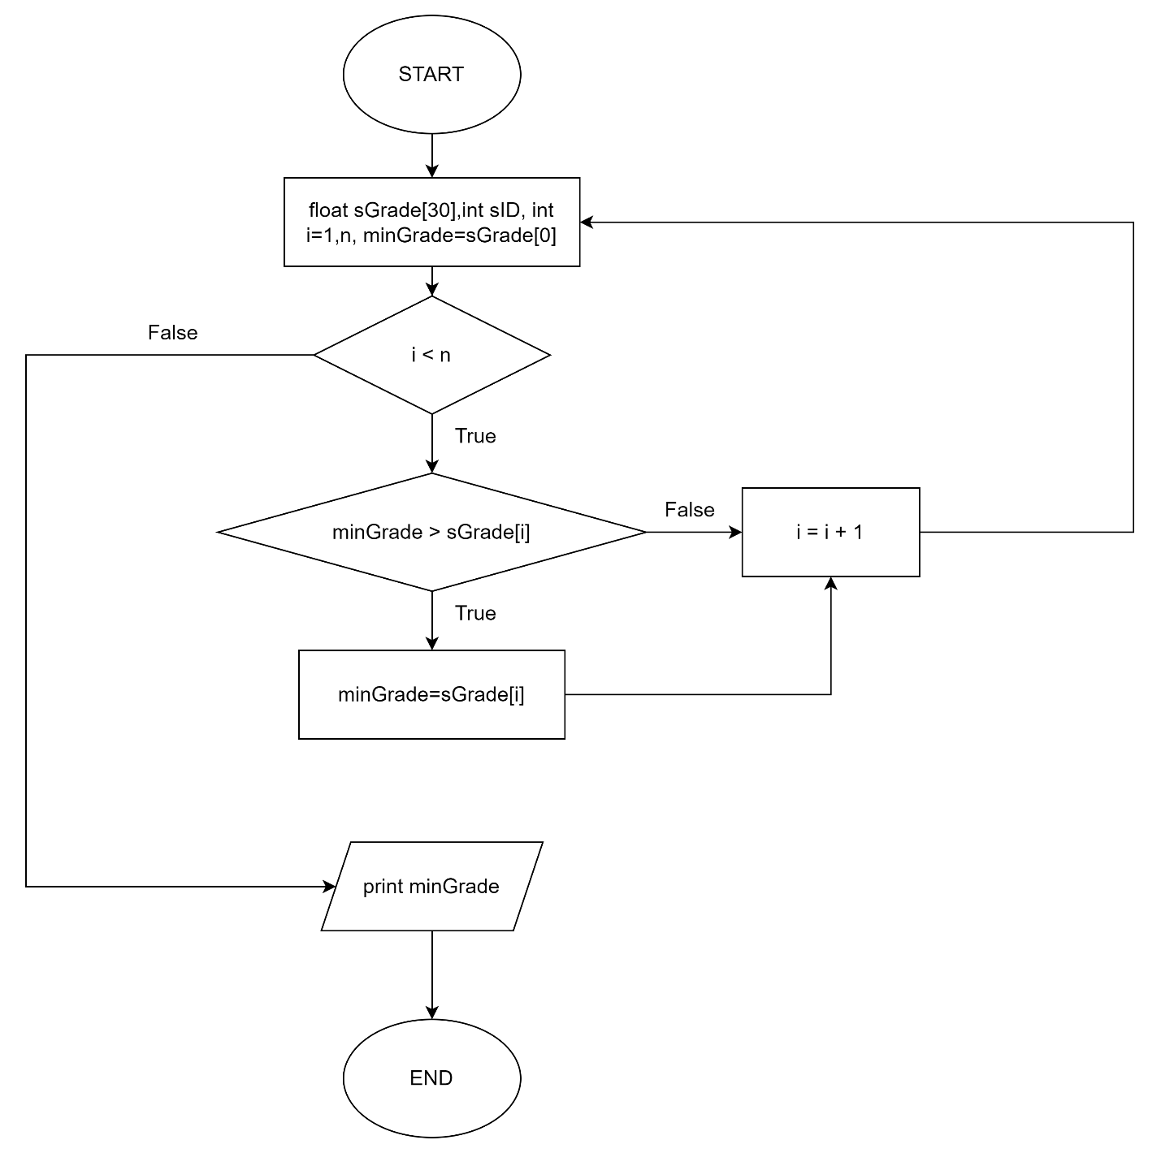
Figure 14: Lowest grade flow chart
Explain flowchart:
Step 1. Start.
Step 2. Declare float sGrade[30], int sID[30], i=1, minGrade=sGrade[0].
Step 3. Check the condition “i < n”:
- If false, print minGrade to the screen.
- If true, go to step 4.
Step 4. Check the condition “minGrade > sGrade[i]”:
- If true, set minGrade = sGrade[i] and go to step 5.
- If false, go straight to step 5.
Step 5. Increase i by +1 then repeat step 3.
Step 6. End.

References
Anon., 2022. javatpoint. [Online]
Available at: https://www.javatpoint.com/what-is-procedural-language
[Accessed 13 june 2022].
Anon., 2022. Procedural programming definition and more. [Online]
Available at: https://the-definition.com/term/procedural-programming
[Accessed 13 june 2022].
Anon., n.d. learnonline. [Online]
Available at: http://learn.onlinegdb.com/switch_case_statement_c.
[Accessed 13 june 2022].
Corp, D., 2022. Deepsource. [Online]
Available at: https://deepsource.io/glossary/procedural-programming/
[Accessed 13 6 2022].
point, T., 2019. do while loop in c. [Online]
Available at: https://www.tutorialspoint.com/cprogramming/c_do_while_loop.htm.
[Accessed 13 june 2022].
Tutorials, 2022. Tutorials. [Online]
Available at: https://www.tutorialspoint.com/ansi_c/c_introduction.htm
[Accessed 13 6 2022].
White, G. & Sivitanides , M., 2005. Cognitive Differences Between Procedural Programming and Object Oriented Programming. Information Technology and Management, Volume 6, pp. 330 - 250.
Whitney, L., 2021. The best programming languages to learn in 2022. [Online]
Available at: https://www.techrepublic.com/article/the-best-programming-languages-to-learn-in-2022/
[Accessed 13 june 2022].

Please refer to the study of Jang et al in (Anon., 2022). In pages 2,3 of this work, they already proved this results.

