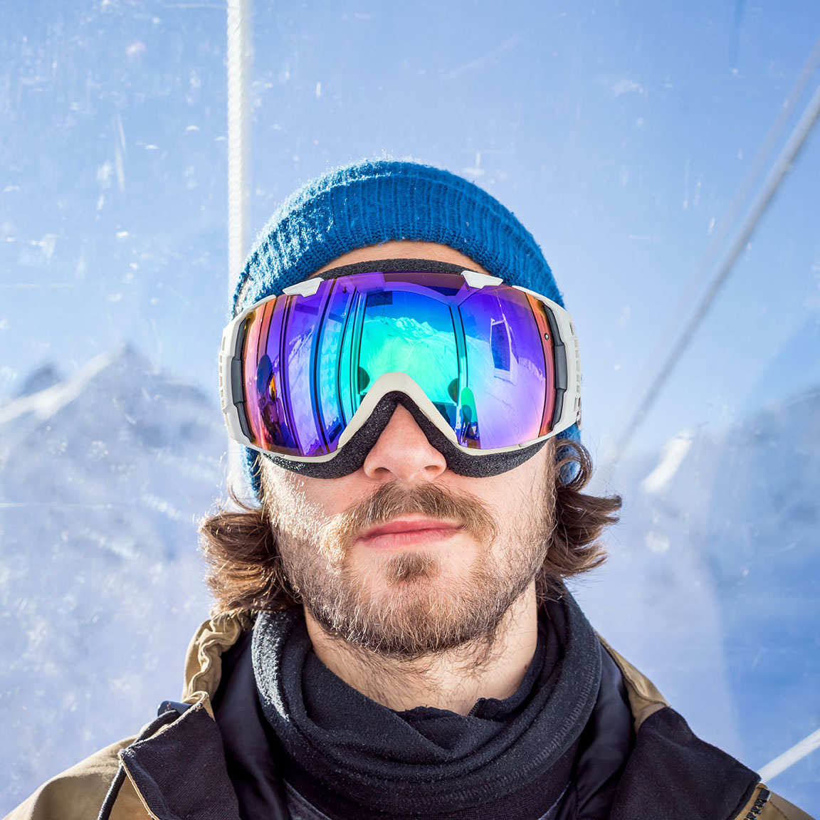

## Ian Provo

PHOTOGRAPHER

| Metadata | |
| --- | --- |
| theme | author |