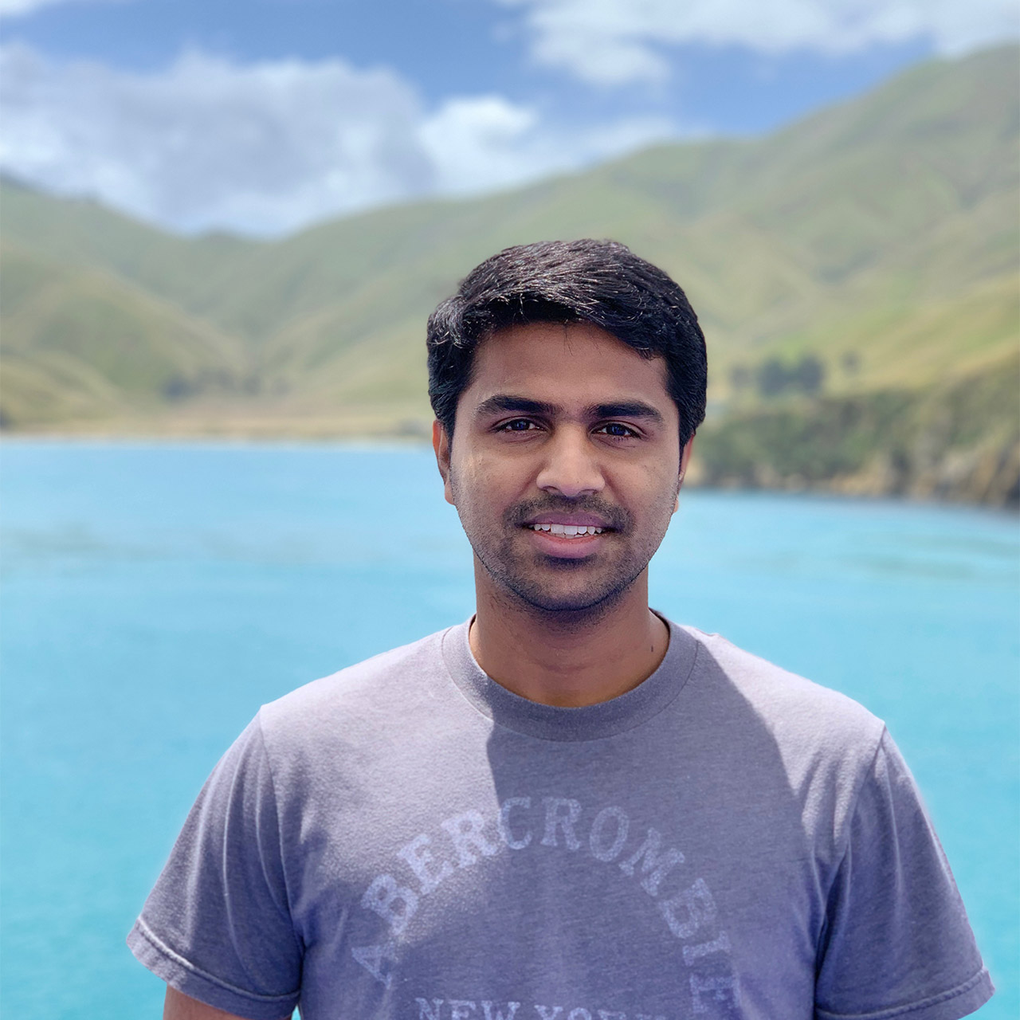

## Kumar Selveraj

PHOTOGRAPHER, SURFER

| Metadata | |
| --- | --- |
| theme | author |