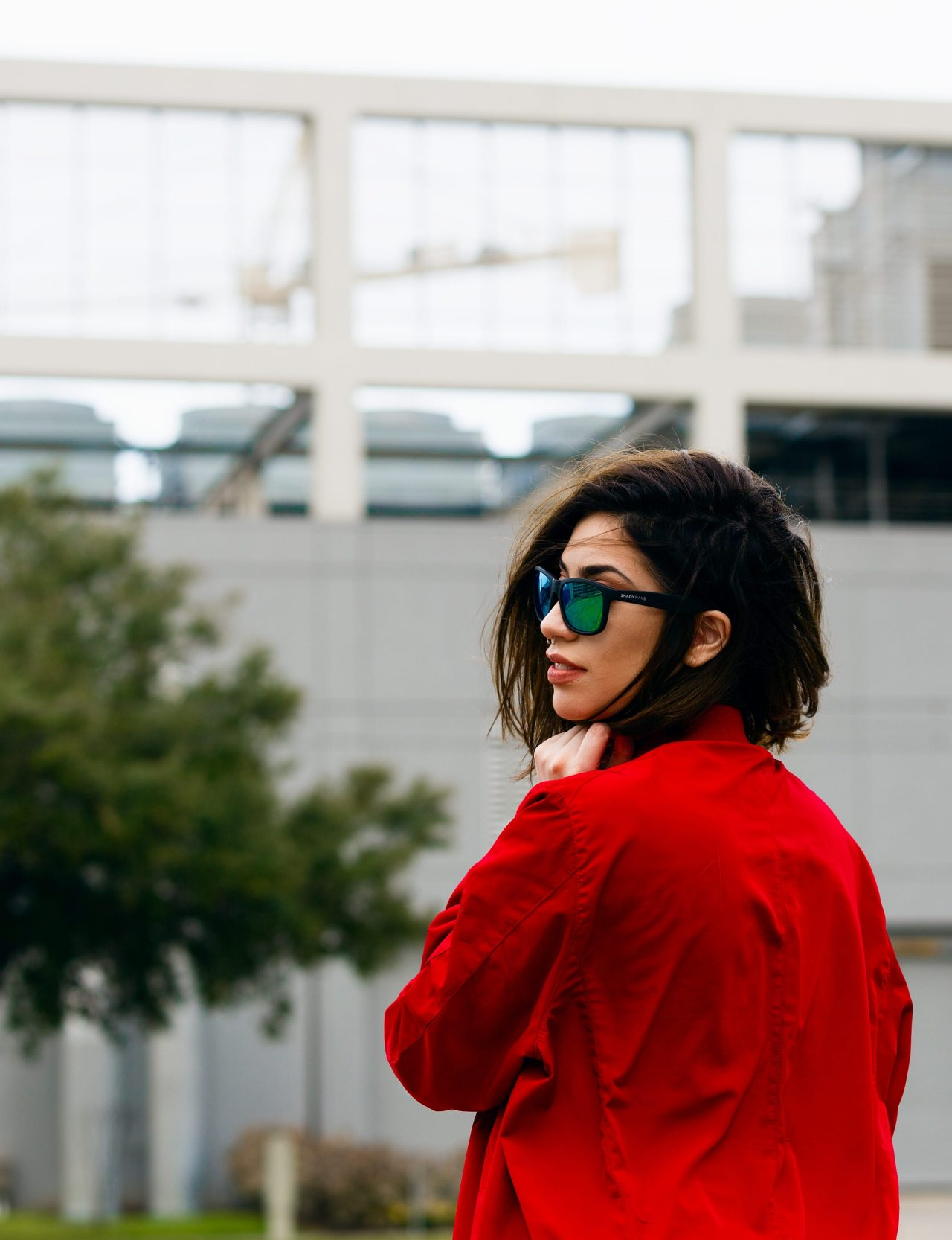

## Sofia Sjöberg

PHOTOGRAPHER, SKIIER, YOUTUBER

| Metadata | |
| --- | --- |
| theme | author |