**(SYSTEM FLOWCHART)**

**ENTER USERNAME**

**ENTER PASSWORD**

1. **MY CLASS**
2. **NOTIFICATION**
3. **DOWNLOADABLE**
4. **ASSIGNMENT**
5. **QUIZ**
6. **LOGOUT**

**IS USERNAME AND PASSWORD CORRECT**

**NO**

**YES**

**IF OPTION 1**

**GOTO**

**MY CLASS**

**YES**

**IF OPTION 2**

**GOTO**

**NOTIFICATION**

**YES**

**NO**

**IF OPTION 3**

**GOTO**

**DOWNLOADABLE**

**YES**

**NO**

**IF OPTION 4**

**GOTO**

**ASSIGNMENT**

**REGISTRATION**

**YES**

**NO**

**NO**

**IF OPTION 5**

**GOTO**

**QUIZ**

**REGISTRATION**

**YES**

**NO**

**IF OPTION 6**

**GOTO**

**LOGOUT**

**REGISTRATION**

**YES**

**NO**

**(SAMPLE OUTPUT)**

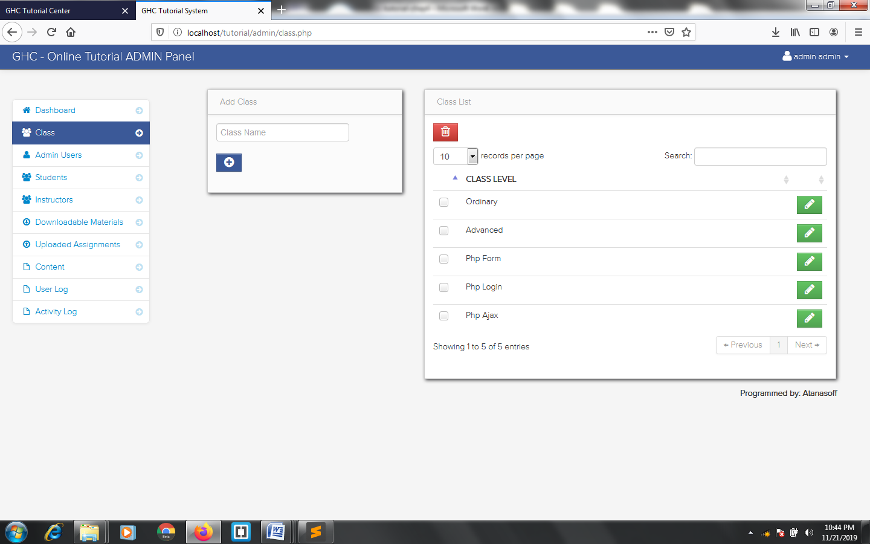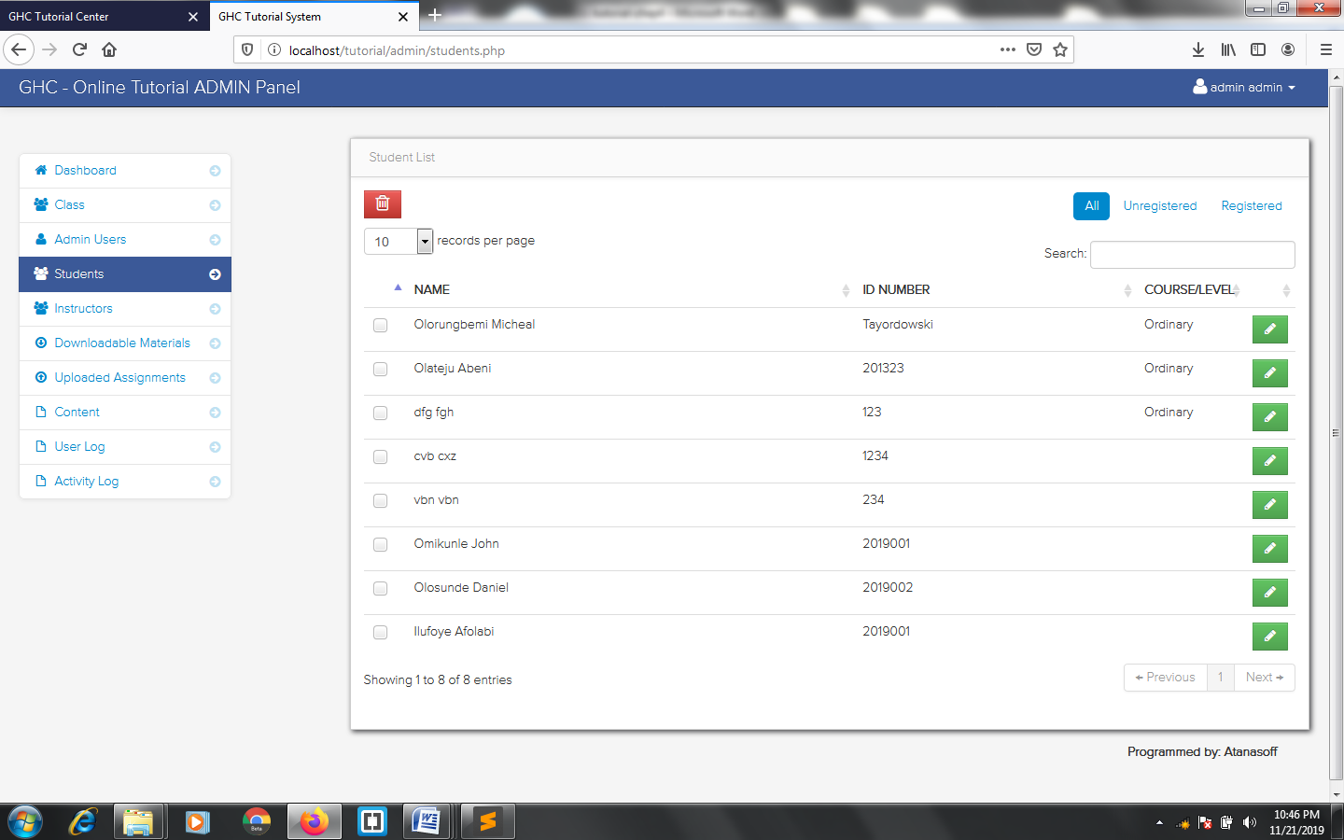

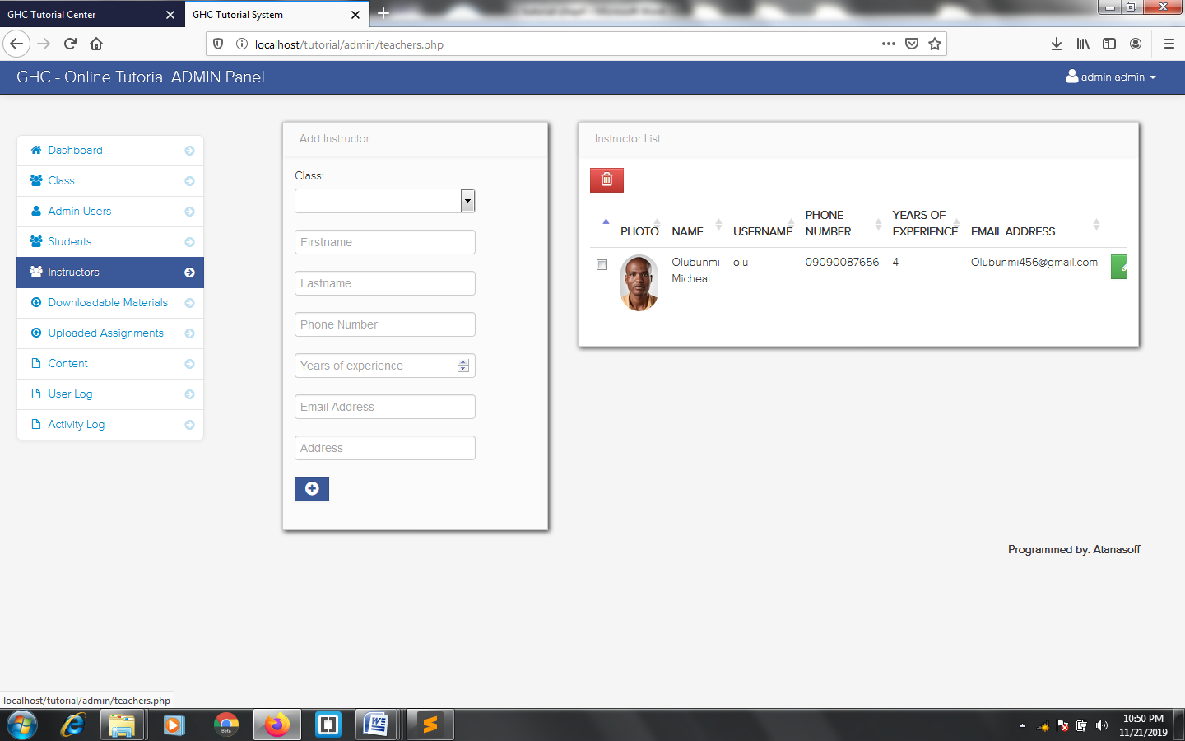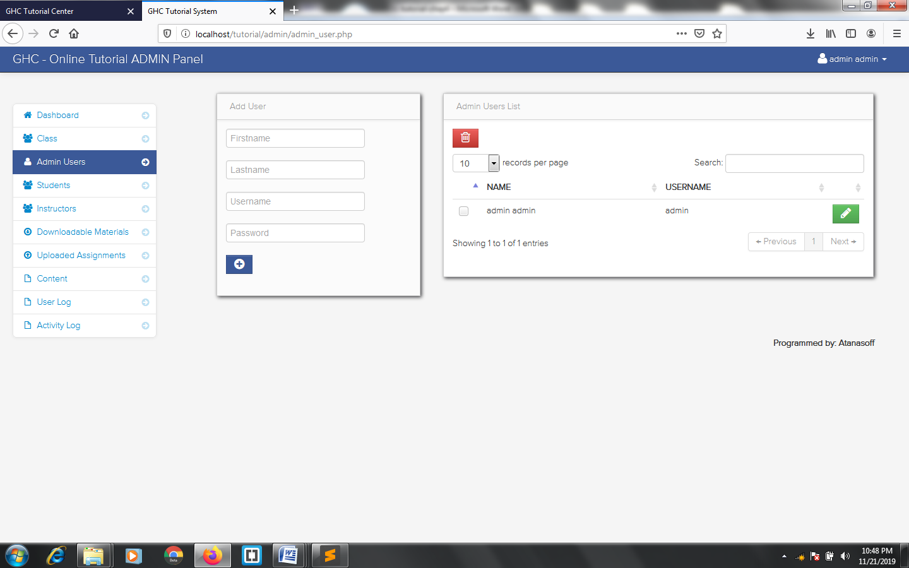

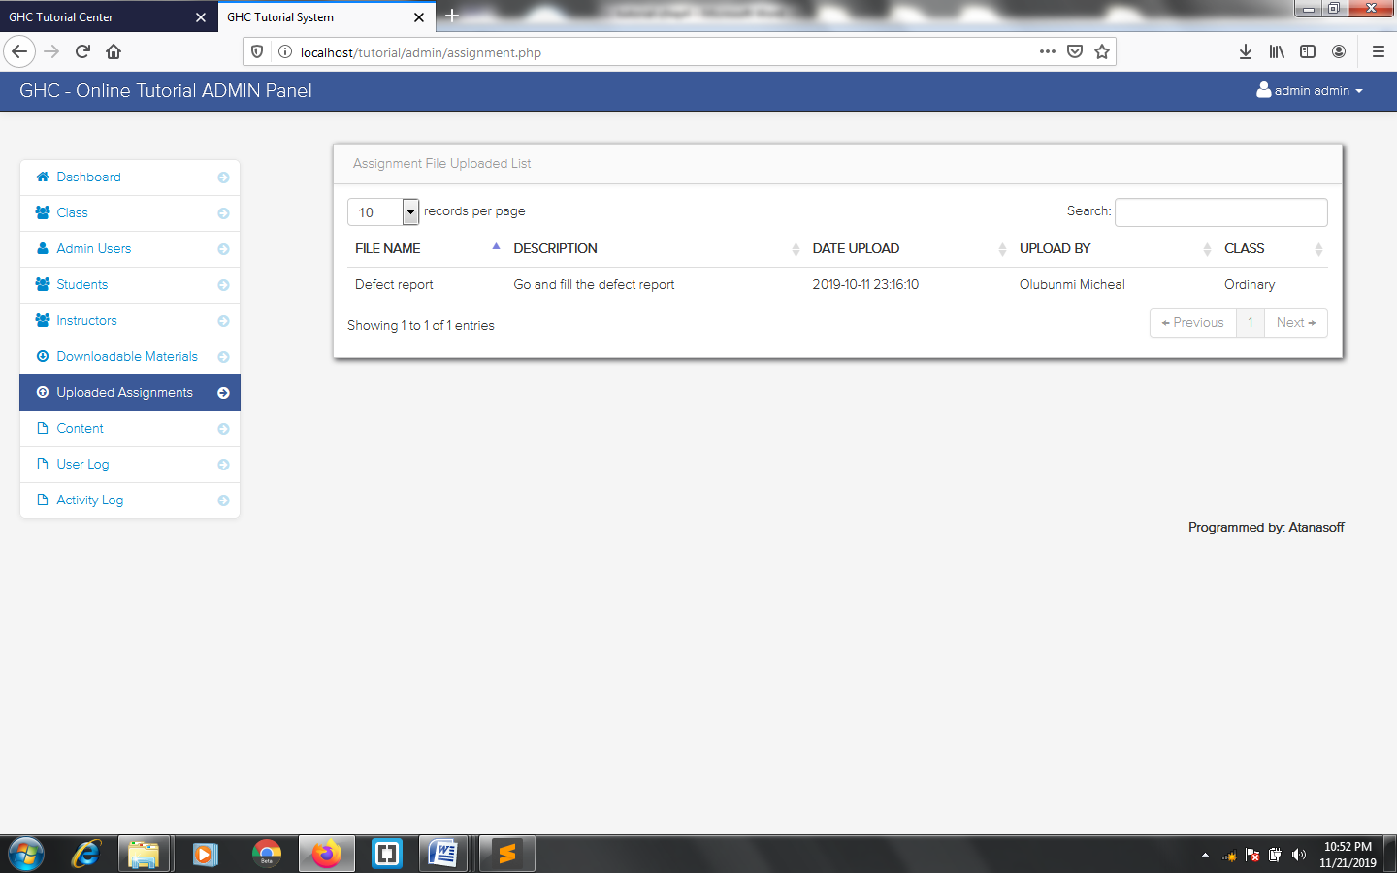

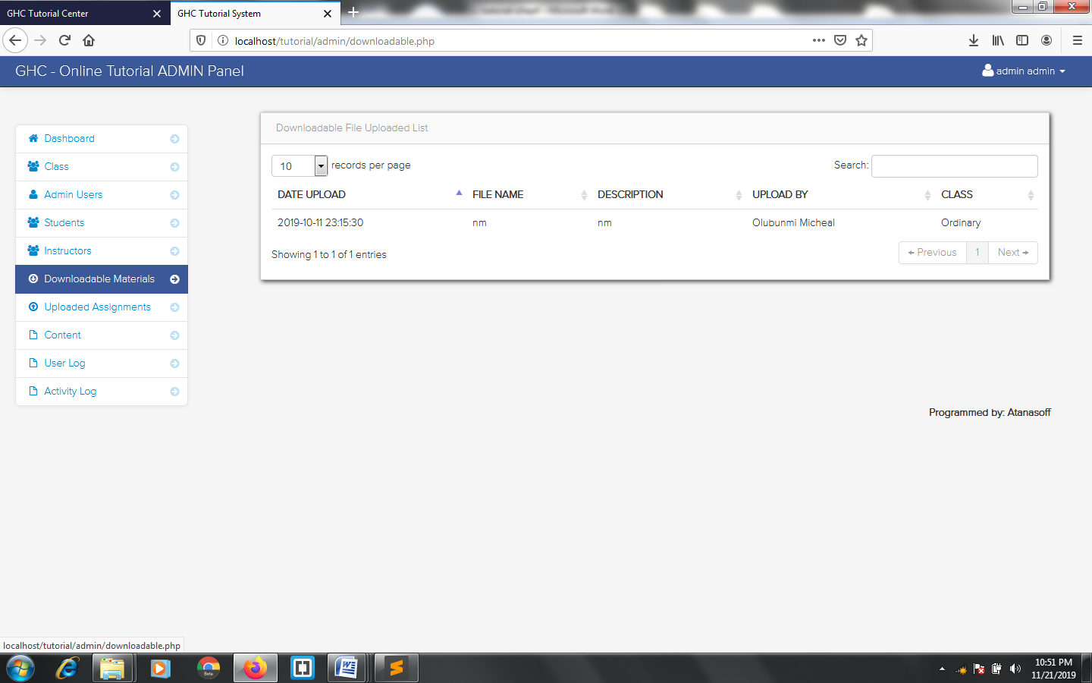

**(PROGRAM LISTING)**

**1. Index Page:**

<?php

$pagename = "Home";

include('core/connection.php');

include('inc/header.php');

?>

<!-- ##### Hero Area Start ##### -->

<div class="hero-area">

<div class="welcome-slides owl-carousel">

<!-- Single Welcome Slides -->

<div class="single-welcome-slides bg-img bg-overlay jarallax" style="background-image: url(img/bg-img/bg1.jpg);">

<div class="container h-100">

<div class="row h-100 align-items-center">

<div class="col-12 col-lg-10">

<div class="welcome-content">

</div>

</div>

</div>

</div>

</div>

<!-- Single Welcome Slides -->

<div class="single-welcome-slides bg-img bg-overlay jarallax" style="background-image: url(img/bg-img/bg2.png);">

<div class="container h-100">

<div class="row h-100 align-items-center">

<div class="col-12 col-lg-10">

<div class="welcome-content">

</div>

</div>

</div>

</div>

</div>

<!-- Single Welcome Slides -->

<div class="single-welcome-slides bg-img bg-overlay jarallax" style="background-image: url(img/bg-img/bg3.jpg);">

<div class="container h-100">

<div class="row h-100 align-items-center">

<div class="col-12 col-lg-10">

<div class="welcome-content">

</div>

</div>

</div>

</div>

</div>

<!-- Single Welcome Slides -->

<div class="single-welcome-slides bg-img bg-overlay jarallax" style="background-image: url(img/bg-img/bg4.jpg);">

<div class="container h-100">

<div class="row h-100 align-items-center">

<div class="col-12 col-lg-10">

<div class="welcome-content">

</div>

</div>

</div>

</div>

</div></div>

</div>

<!-- ##### Hero Area End ##### -->

<!-- ##### Our Products Area Start ##### -->

<?php include('inc/ourproduct.php'); ?>

<!-- ##### Our Products Area End ##### -->

<?php

include('inc/footer.php');

?>

**2. Shop**

<?php

$pagename = "Shop";

include('core/connection.php');

include('inc/header.php');

?>

<!-- ##### Breadcrumb Area Start ##### -->

<div class="breadcrumb-area bg-img bg-overlay jarallax" style="background-image: url('img/bg-img/back1.jpg');">

<div class="container h-100">

<div class="row h-100 align-items-center">

<div class="col-12">

<div class="breadcrumb-text">

<h2>Shop</h2>

</div>

</div>

</div>

</div>

</div>

<div class="famie-breadcrumb">

<div class="container">

<nav aria-label="breadcrumb">

<ol class="breadcrumb">

<li class="breadcrumb-item"><a href="index.php"><i class="fa fa-home"></i> Home</a></li>

<li class="breadcrumb-item active" aria-current="page">Shop</li>

</ol>

</nav>

</div>

</div>

<!-- ##### Breadcrumb Area End ##### -->

<!-- ##### Shop Area Start ##### -->

<section class="shop-area section-padding-0-100">

<div class="container">

<div class="row">

<!-- Shop Filters -->

<div class="col-12">

<div class="shop-filters mb-30 d-flex align-items-center justify-content-between">

<!-- Product View Mode -->

<div class="produtc-view-mode">

<a href="#"><i class="fa fa-th"></i></a>

</div>

</div>

</div>

</div>

<div class="row">

<!-- Shop Products Area -->

<div class="col-12 col-md-12 col-lg-12">

<div class="row">

<?php

$select = $conn->query("SELECT * FROM product LIMIT 10");

$fetch = $select->fetchAll(PDO::FETCH_OBJ);

$count = $select->rowCount();

if ($count > 0) {

foreach ($fetch as $key) {

$id = $key->id;

$name = $key->name;

$autor = $key->autor;

$files = $key->files;

$desc = $key->desc;

$price = $key->price;

$pic = $key->pic;

$image = "http://localhost/bookstore/products/$pic";

$fille = "http://localhost/bookstore/files/$files";

?>

<!-- Single Product Area -->

<div class="col-12 col-sm-6 col-lg-3">

<div class="single-product-area mb-50 wow fadeInUp" data-wow-delay="100ms">

<!-- Product Thumbnail -->

<div class="product-thumbnail">

<img src="<?php echo $image ?>" alt="">

<!-- Product Meta Data -->

<div class="product-meta-data">

<a href="#" data-toggle="tooltip" data-placement="top" title="Add To Cart" onclick="pro('<?php echo $fille ?>', '<?php echo $image ?>', '<?php echo $name ?>', '<?php echo $price ?>', '<?php echo $id ?>')"><i class="icon_cart_alt"></i></a>

<a href="#" data-toggle="modal" data-target="#accept<?php echo $id ?>" data-placement="top" title="View"><i class="fa fa-eye"></i></a>

</div>

</div>

<!-- Product Description -->

<div class="product-desc text-center pt-4">

<a href="#" class="product-title"><?php echo $name ?></a>

<h6 class="price">(NGN) <?php echo $price ?></h6>

</div>

</div>

</div>

<?php

}

}

?>

</div>

</div>

</div>

</div>

</section>

<!-- ##### Shop Area End ##### -->

<!-- ##### Footer Area Start ##### -->

<?php

include('inc/footer.php');

?>

<div class="modal fade" id="accept<?php echo $id; ?>" tabindex="-1" role="dialog" aria-labelledby="myModalLabel" aria-hidden="true">

<div class="modal-dialog">

<div class="modal-content">

<div class="modal-header" style="background: white;">

<p class="modal-title" id="myModalLabel" style="color: black; text-align: center; text-transform: capitalize; font-weight: bolder;">Details</p>

<button type="button" class="close" data-dismiss="modal" aria-hidden="true" style="color: black;">&times;</button>

</div>

<div class="modal-body">

<img src="products/<?php echo $pic ?>" width="100%">

<hr>

<p style="font-size: 50px; text-transform: capitalize;"><b><?php echo $name; ?></b></p>

<p><b>Origin:</b> <?php echo $origin; ?></p>

<p><b>Type of Animal:</b> <?php echo $toa; ?></p>

<p><b>Description:</b> <?php echo $desc; ?></p>

<p><b>Price:</b> <?php echo $price; ?></p>

</div>

</div><!-- /.modal-content -->

</div><!-- /.modal -->

</div>

**3. Admin Page**

<?php

require '../core/connection.php';

if(isset($_POST['startapp'])){

$username = sanitize($_POST['username']);

$password = $_POST['password'];

$hash = sha1(md5($password));

if(empty($username) || empty($password)){

$error = "All fields must be filled to login";

}else{

$verify = get_alias('admin','username',$username,'password',$hash);

if($verify->rowCount() > 0){

$fetch = $verify->fetchAll(PDO::FETCH_OBJ);

foreach($fetch as $log){

$id = $log->id;

$user = $log->username;

$encode_id = md5($id);

session_start();

$_SESSION['is_admin'] = $encode_id;

$_SESSION['username'] = $username;

$_SESSION['admin_id'] = $id;

redirect('main.php');

}

}else{

$error = "Invalid login credentials. Try again";

}

}

}

?>

<!DOCTYPE html>

<html lang="en">

<head>

<meta http-equiv="Content-Type" content="text/html; charset=UTF-8">

<!-- Meta, title, CSS, favicons, etc. -->

<meta charset="utf-8">

<meta http-equiv="X-UA-Compatible" content="IE=edge">

<meta name="viewport" content="width=device-width, initial-scale=1">

<title>LiverBooks | Admin Login </title>

<link rel="icon" href="../image/favicon.png">

<!-- Bootstrap -->

<link href="vendors/bootstrap/dist/css/bootstrap.min.css" rel="stylesheet">

<!-- Font Awesome -->

<link href="vendors/font-awesome/css/font-awesome.min.css" rel="stylesheet">

<!-- NProgress -->

<link href="vendors/nprogress/nprogress.css" rel="stylesheet">

<!-- Animate.css -->

<link href="vendors/animate.css/animate.min.css" rel="stylesheet">

<link rel="icon" type="icon" href="https://blessedafricancuisines.com/images/blessedicon.png">

<!-- Custom Theme Style -->

<link href="build/css/custom.min.css" rel="stylesheet">

</head>

<body class="login">

<div>

<a class="hiddenanchor" id="signup"></a>

<a class="hiddenanchor" id="signin"></a>

<div class="login_wrapper">

<div class="animate form login_form">

<section class="login_content">

<form method="post">

<h1>Login</h1>

<?php

if(isset($error)){ ?>

<div class="alert alert-danger">

<strong>ERROR: </strong> <?php echo $error; ?>

</div>

<?php

}

?>

<div>

<input type="text" class="form-control" name="username" autocomplete="off" placeholder="Username" required="" />

</div>

<div>

<input type="password" class="form-control" required name="password" placeholder="********" />

</div>

<div>

<button class="btn btn-default submit" type="submit" name="startapp">Log in</button>

</div>

<div class="clearfix"></div>

<div class="separator">

<div class="clearfix"></div>

<br />

<div>

<h1><i class="fa fa-paw"></i> LiverBooks System</h1>

<p>&copy; <?php echo date('Y'); ?> All Rights Reserved</p>

</div>

</div>

</form>

</section>

</div>

</div>

</div>

</body>