|  |
| --- |
| IT Division |
| Metaforums – Functional Requirement |
| Final Project for PHP |

|  |
| --- |
| Version 2  11-12-2021 |

This page is Intentionally Left Blank

# Table of Contents

Table of Contents 0

1 Introduction 1

1.1 Objectives 1

1.2 Background 1

1.3 Project Rules 1

2 Requirement 2

2.1 Business and Requirement Function 2

2.2 User Roles 3

2.2.1 Guest 3

2.2.2 User 3

2.2.3 Moderator 3

2.2.4 Administrator 3

2.3 Modules 3

2.3.1 Sign Up 3

2.3.2 Log In 5

2.3.3 Home 6

2.3.4 Forum Thread 8

2.3.5 Account 9

2.3.6 Category Administration 10

2.3.7 User Management 11

2.3.8 Moderator Management 12

2.3.9 Forum Management 13

# Introduction

## Objectives

Metaforums is an online, web-based application intended to be used as a dynamic forum where the following is achieved:

* The application can function as a forum website
* The application can provide effective user, thread, and category management

## Background

The project was created in order to gauge and evaluate the capabilities of AMDP participants in web programming as well as problem solving and prioritization. We hope that participants can do the project as best as they could.

## Project Rules

The statements below describe the conditions and rules for the project to be eligible:

1. The backend of the application must be written in **PHP** without the use of frameworks or third-party libraries. Use of frameworks or third-party PHP libraries will result in heavy score penalty (Framework: -75%, Libraries: -10% each).
2. DBMS that are allowed are **MySQL, PostgreSQL, SQL Server, or MongoDB**
3. **Apache, Nginx, and IIS** can be used as web servers
4. **Plagiarization** and/or **cheating** is strictly prohibited. Violation in this rule will result in a project score of zero (0).
5. **Front-end design is not graded**, application usability and requirements are the graded aspects. Layout and design are at the creativity of the participant.

The statements below describe several things that are allowed when creating the project:

1. The usage of frontend libraries (jQuery is one), plug-ins (CKEditor is helpful), and CSS frameworks are allowed (Bootstrap, Foundation, etc)
2. Additional features are **very welcome**, and may be leveraged to increase project score

When turning in the project file, the project structure **must** be one zip file with content as follows:

1. The folder of the web application
2. A form of documentation (README.md, PDF documentation, Markdown, etc) that describes:
   1. Project structure
   2. Software Stack (PHP Version, database version, web server)
   3. Reference to external libraries and plug-ins*
   4. Reference to CSS Frameworks or other CSS styles used*
   5. Additional development/creativity outside of requirements
3. An export of the Database schema

As a guidance for the e-mail verification feature, participants can use *any* SMTP server they want. E-mail verification feature must be written **without** the use of third-party libraries. Please ensure that there are as little errors as possible when turning in the project. If a feature is unable to run due to programming errors, it may not be graded depending on the grader.

* - a link to the github page or the official site must be provided when listing the items

# Requirement

## Business and Requirement Function

Describe the summary of functional requirements.

|  |  |  |  |  |
| --- | --- | --- | --- | --- |
| Module Number | *Functional Requirement Name* | *Description* | *Subfeature Number* | *Subfeature* |
| 2.3.1 | Sign Up | Guests can register new accounts. Newly registered accounts must be verified first by email before they can post more than one thread per day. | - |  |
| 2.3.2 | Log In | A page for the user to log in to their account and request a forgot password request. | 2.3.2.1 | Log In |
|  | 2.3.2.2 | Forgot Password |
| 2.3.3 | Home | Serves as the website landing page, which contains all groups, with each respective category, and their forum threads. | - |  |
| 2.3.4 | Forum Thread | Shows all posts contained within the thread. Moderators can also manage the thread. | 2.3.4.1 | Thread View |
|  | 2.3.4.2 | Report Abuse |
|  | 2.3.4.3 | Thread Management |
| 2.3.5 | Account | Allows users to manage their account and profile, such as change e-mail address, display name, password, and profile picture. Users can also view each other’s profiles. | 2.3.5.1 | Profile |
|  | 2.3.5.2 | Account Management |
| 2.3.6 | User Management | Moderators can moderate accounts through this module. | - |  |

## User Roles

Describe the roles available within the application.

### Guest

Guests are the default role that are granted to visitors of the application that doesn’t have an account yet. They have limited module access.

### User

Regular accounts that can add, edit, or delete threads, as well as participate in forum posting.

### Moderator

Moderators are assigned by the Site Admin (by database) and have their own category or categories to manage. They can moderate user accounts such as pardoning, silencing, or banning them. Moderators can also lock threads to prevent additional posts.

### Site Admin

Site admin is responsible for administrating moderators and managing things such as existing groups, categories, and maintenance. Site admin is usually the site creator.

## Modules

Describe the modules available within the application.

### Sign Up

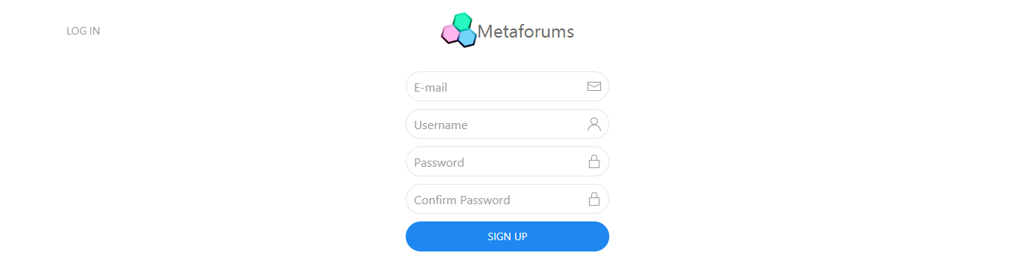

Picture 2.3.1.1 - Sign Up Form

Role Access : GUEST

Guests can register a new account to Metaforums through this page. They must provide:

1. A valid e-mail address (simply check for the format)
2. Username (doesn’t exist yet, a combination of strictly alphanumeric characters between 6-20 characters)
3. Password (must be at least 8 characters long)
4. Password confirmation (must be the exact same as the one within the password field)

If any of the above requirements fail, display the associated error messages:

1. Invalid e-mail format
2. Username is already taken/Username must only contain alphanumeric characters/Username must be between 6 and 20 characters long
3. Password must be at least 8 characters long
4. Please correctly confirm the password

After successfully filling in the required fields, the user will be redirected to the log-in page and an email containing a confirmation link is sent to the associated e-mail.

The confirmation mechanism is simply a flag within the user Database (boolean) that is set to true when the user clicks on the confirmation link. Please make the confirmation mechanism secure.

When the user account has been registered, please exercise caution in storing the password. The password should be securely encrypted and salted using appropriate algorithms. ***Refrain from using insecure ways of storing password*.**

### Log In

Role Access : GUEST

The log-in page for guests. Guests input their username or e-mail and their password. They can also choose the “Forgot Password” option, in which they will receive a password reset link from their e-mail. After they have filled out the credentials, guests can log-in into their account.

#### Log In

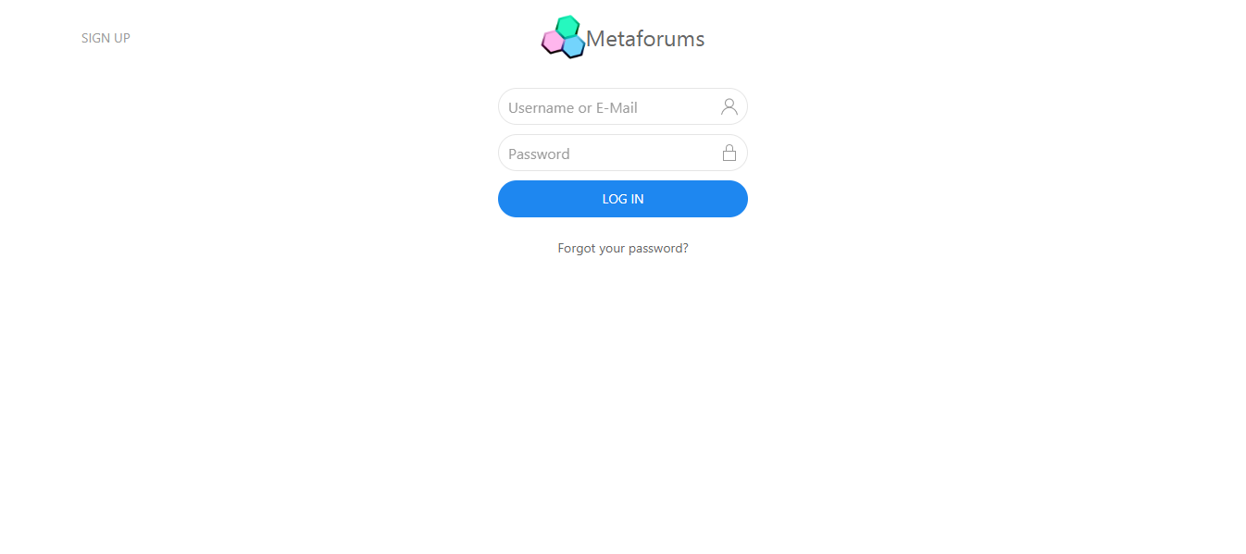

Picture 2.3.2.1 - Log In Form

Role Access : GUEST

Guests input their username/e-mail and password into the two fields provided. If the credentials is incorrect, the user is alerted with an error message of the following:

1. *If the username does not exist*: “Username does not exist.”
2. *If the e-mail is not registered*: “E-mail is not associated with an account.”
3. *If the password is incorrect*: “Invalid password”

Clicking the Sign-Up button will redirect the guest to the Sign-Up page. Clicking the Log In button will log the guest into their account and redirect them back to the home page. Clicking the forgot password text will bring up the forgot password form.

#### Forgot Password



Picture 2.3.2.2 - Forgot Password Form

Role Access : GUEST

Guests input their e-mail that is associated with their account. Whether there is an account or not associated with the e-mail, display the following message: “We have sent a reset password link to the provided e-mail. If there is an account associated with the e-mail, the e-mail will be received in the inbox.”

***Do not attempt to send the password to the user by e-mail. Sending a password (or a stored representation of it) to the user is poor practice and should be avoided without exception.***

### Home

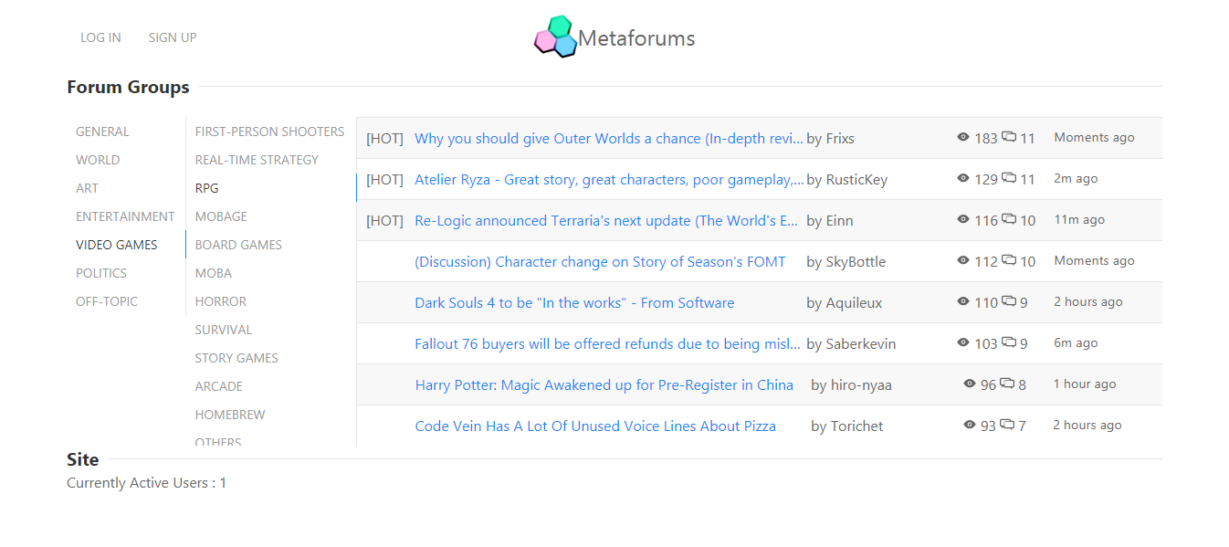

Picture 2.3.3.1 - Home View

Role Access : All

The home page consists of a title bar with two buttons that redirect users to their respective pages: Log-in and Sign Up. Below the title bar, forum groups can be found, which further goes into forum categories, and then forum threads. Also shows the number of users currently online. The title bar changes depending on the role.



Picture 2.3.3.2 - Title Bar for Users



Picture 2.3.3.3 - Title Bar for Moderators

Clicking on the logo on the title bar will always redirect the user to the home page.

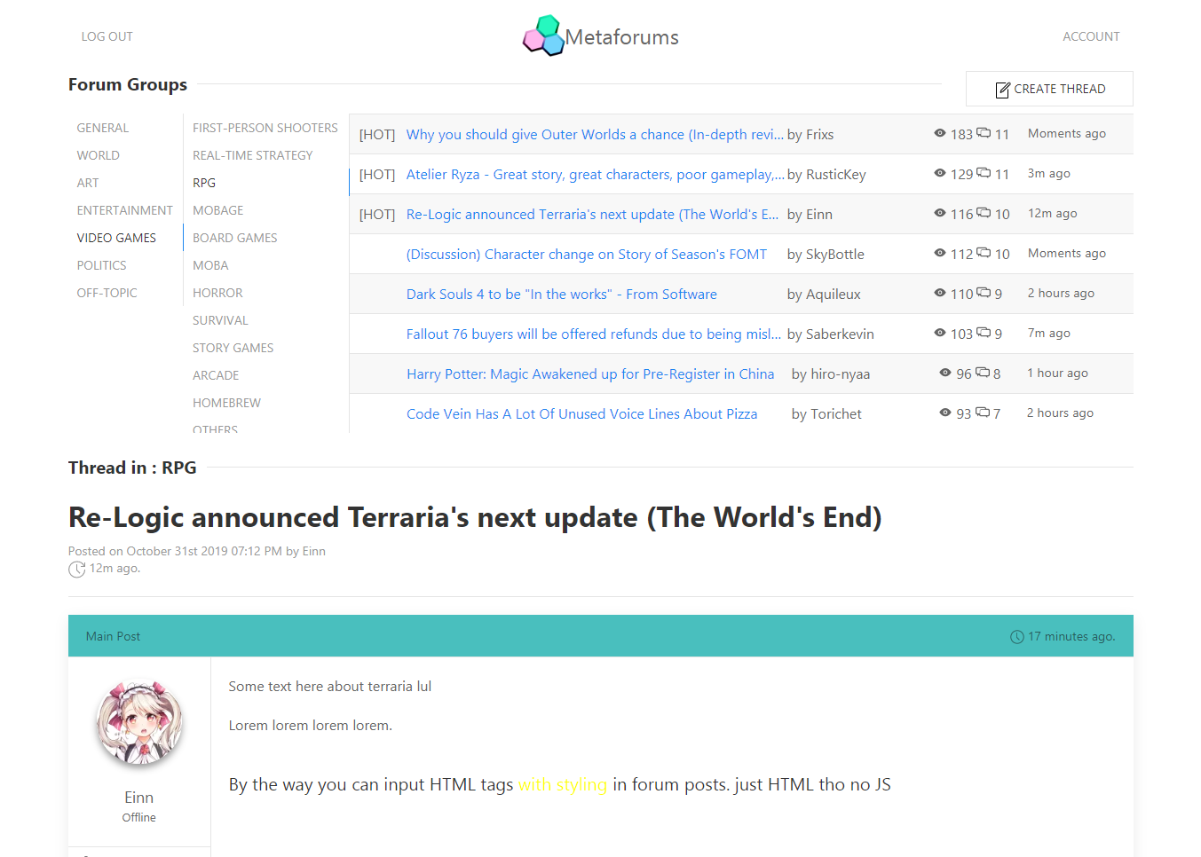

Picture 2.3.3.4 - Create Thread Button

If the user is logged in, **has a verified email**, and is not silenced, then the user can create a new thread in the selected category. Otherwise the button is hidden or disabled. If the user is banned from a particular category, then that category is no longer visible to them.

Each thread display in the thread view has five elements:

1. Badge
2. Title
3. Author
4. View Count
5. Replies
6. Last Reply

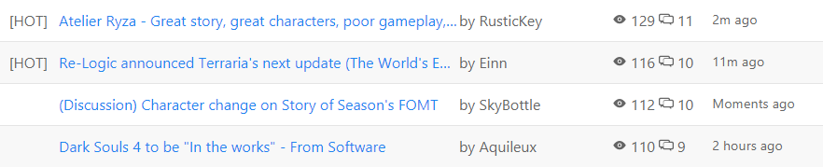

Picture 2.3.3.5 - Thread List

A thread will be given a **[HOT]** badge and will be placed on top if it’s highly active. A thread is considered highly active if it **garners on average more than 10 posts every 5 minutes**. Aside from that, threads are ordered by this formula:

(View + (Post * 10)) / Thread Age (in seconds)

However, highly active threads are always placed first.

Clicking on one of the threads will **dynamically load the thread page below the thread list** if the user is logged in. If the user is a guest, display a prompt that will redirect them to the Log In page.

### Forum Thread



Picture 2.3.4.1 - Forum Thread View

Role Access : User, moderator

The thread view is loaded when the user clicks on one of the thread items within the thread list. Each thread contains a **main post**, as well as subsequent posts by other users. Users can participate in **thread discussion** and **report abuse**. Threads can also be **moderated** by **moderators**.

#### Thread View

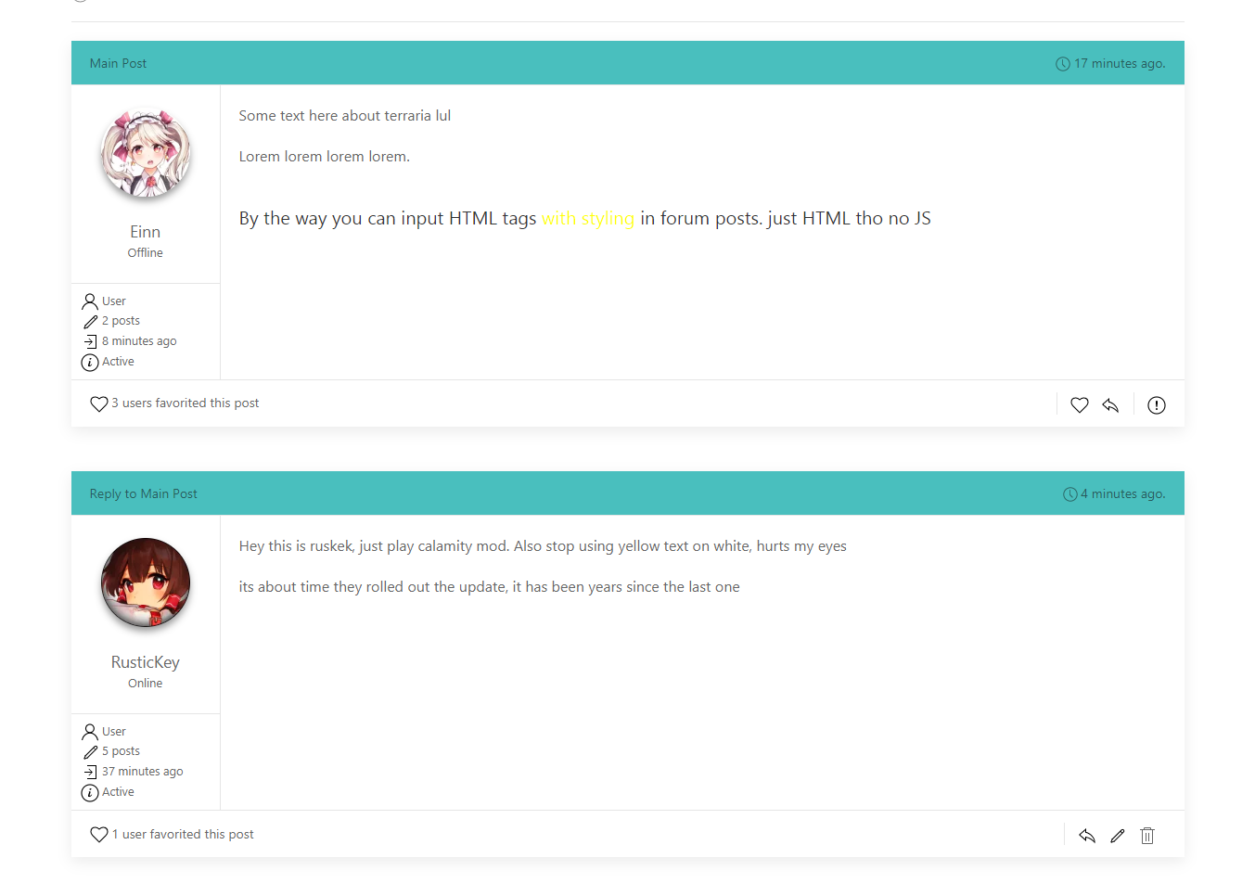

Picture 2.3.4.2 - Forum Posts View

Role Access : User, moderator

The thread view displays the current category the thread is in, as well as the thread title, post date, post author, and last posted time. Users can view the posts contained within the thread. Each post has the following items:

1. Reply To
2. Posted At
3. User Panel
   1. Avatar (clicking on this redirect to their profile)
   2. Display name (clicking on this redirect to their profile)
   3. Online status
   4. Role
   5. Post count
   6. Last log-in
   7. Moderation Status (Active, Silenced, Banned)
4. Post content (contains HTML and CSS)
5. Favorites
6. User Controls
   1. Other users
      1. Favorite post
      2. Reply to post
      3. Report abuse
   2. Self
      1. Reply to post
      2. Edit
      3. Delete
   3. Moderators
      1. Moderate user
      2. Lock Thread

**Users** can edit or delete their post if it’s under 5 minutes old. After 5 minutes, the user can no longer edit or delete their post. Other users can reply to and favorite other people’s posts if the thread is not locked, and they’re not silenced. If a post has been favorited by a user, it cannot be favorited by the same user again.

When clicking reply, edit, or when the user chooses “Create Thread” from the thread list, the following view will be shown, in which an empty editor is loaded on the last position of the thread. If the user chose to edit, the editor will be loaded with the post’s contents at the post’s current location instead.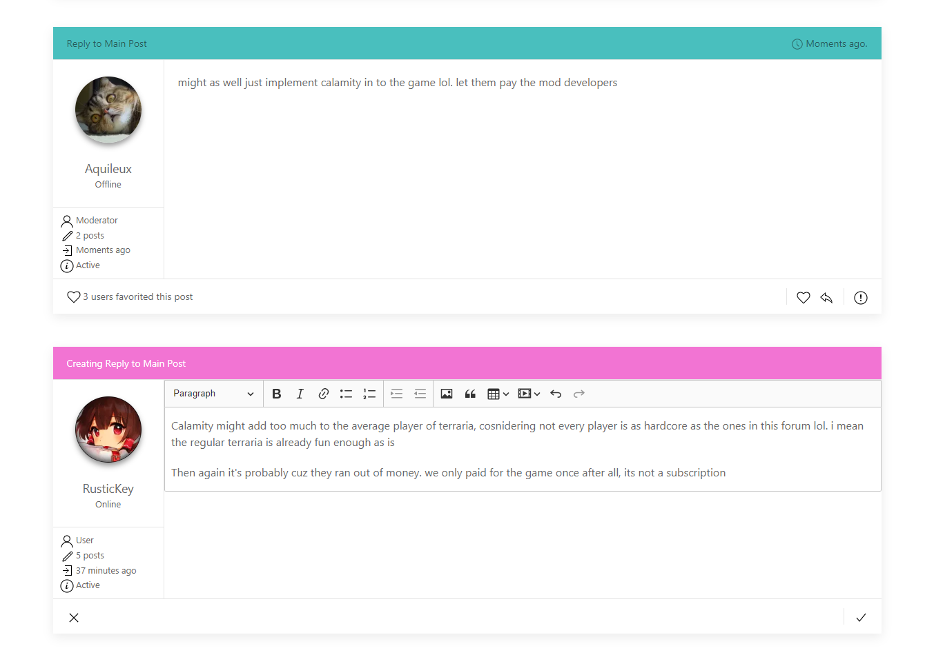

Picture 2.3.4.3 - Post Creation/Edit/Reply Form

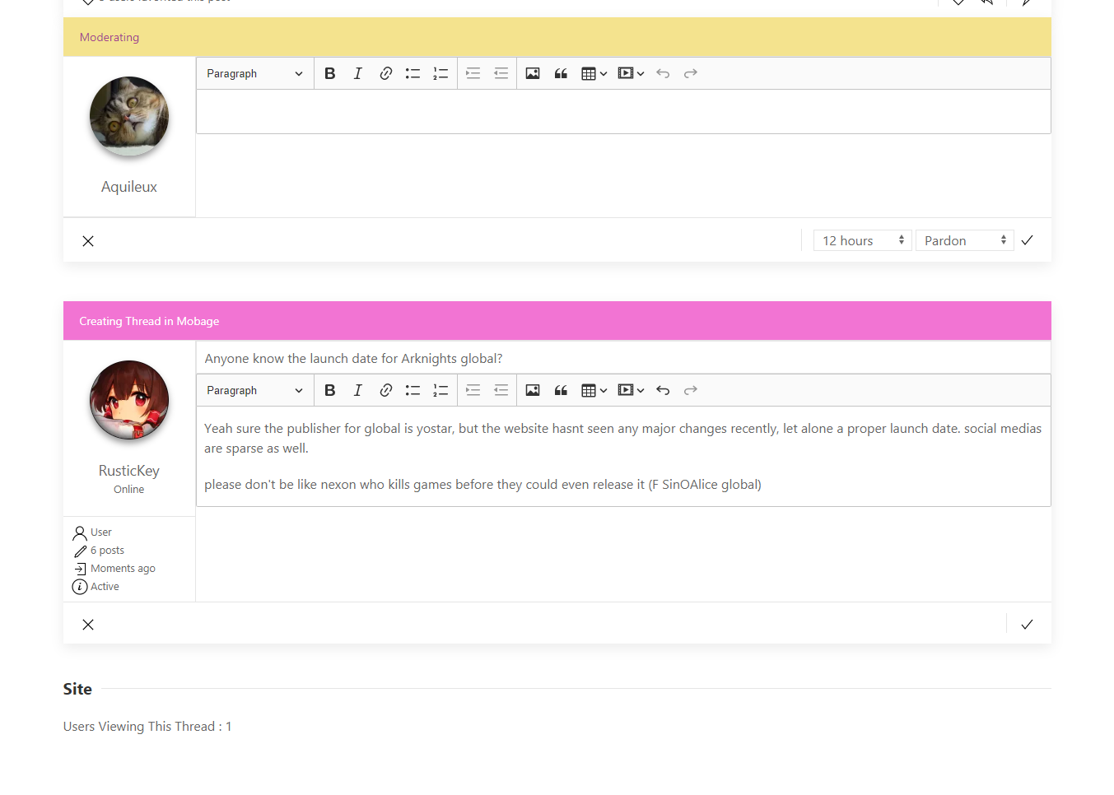

Picture 2.3.4.4 - Thread Creation Form

The header **adjusts** based on whichever **action** the user chose. The header may have values of the following:

1. If creating the thread, the header writes “Creating Thread in *<<Category Name>>*”
2. If replying to the main thread, the header writes “Creating Reply to Main Post”
3. If replying to a user’s post, the header writes “Creating Reply to *<<Target Display Name>>*”
4. If editing a post, the header writes “Editing Post”

Clicking the cancel button **prompts the user** to confirm. When confirmed, the post creation is cancelled. Clicking on the **check** button will either **append the post** to the thread or **update the existing post**.

**Users without verified e-mails** can only post **once per day**, whether if it is a reply or a new post, and as stated in the previous module, unverified users cannot create threads.

#### Report Abuse

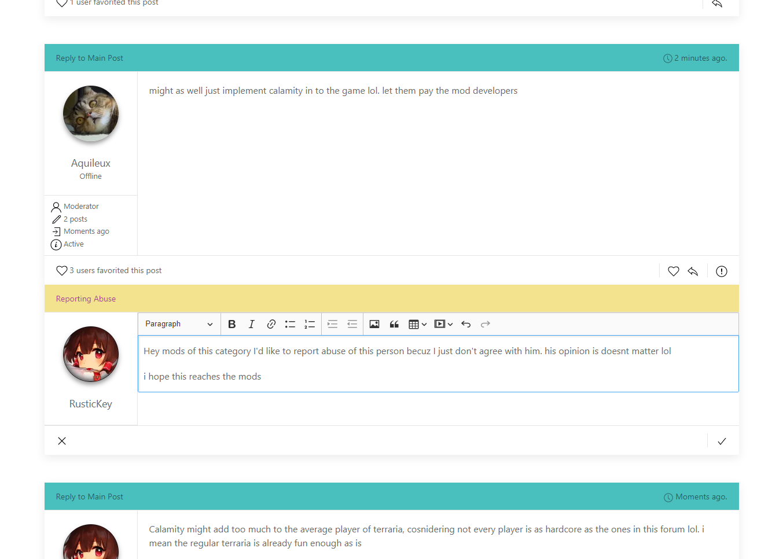

Picture 2.3.4.5 - Report Abuse Form

Role Access : User

Report abuse is a mechanism to allow normal users to help moderate the forum, or moderators that are outside of their assigned category.



Picture 2.3.4.6 - Report Abuse Form



Picture 2.3.4.7 Report Abuse Button (in this project)

**Users** can press a “**Report Abuse**” button on a **forum post** to show a “**Report Abuse Form**”.

When the form is filled, an e-mail is sent to **all moderators assigned to the forum thread’s category** containing the report filed by the user. Report abuse can only be used once per day per user. This action is not available to moderators that are within their assigned category. If a category moderator is reported, instead of notifying assigned moderators, the Site Admin is notified instead. **Unverified users cannot report abuse.**

#### Thread Management

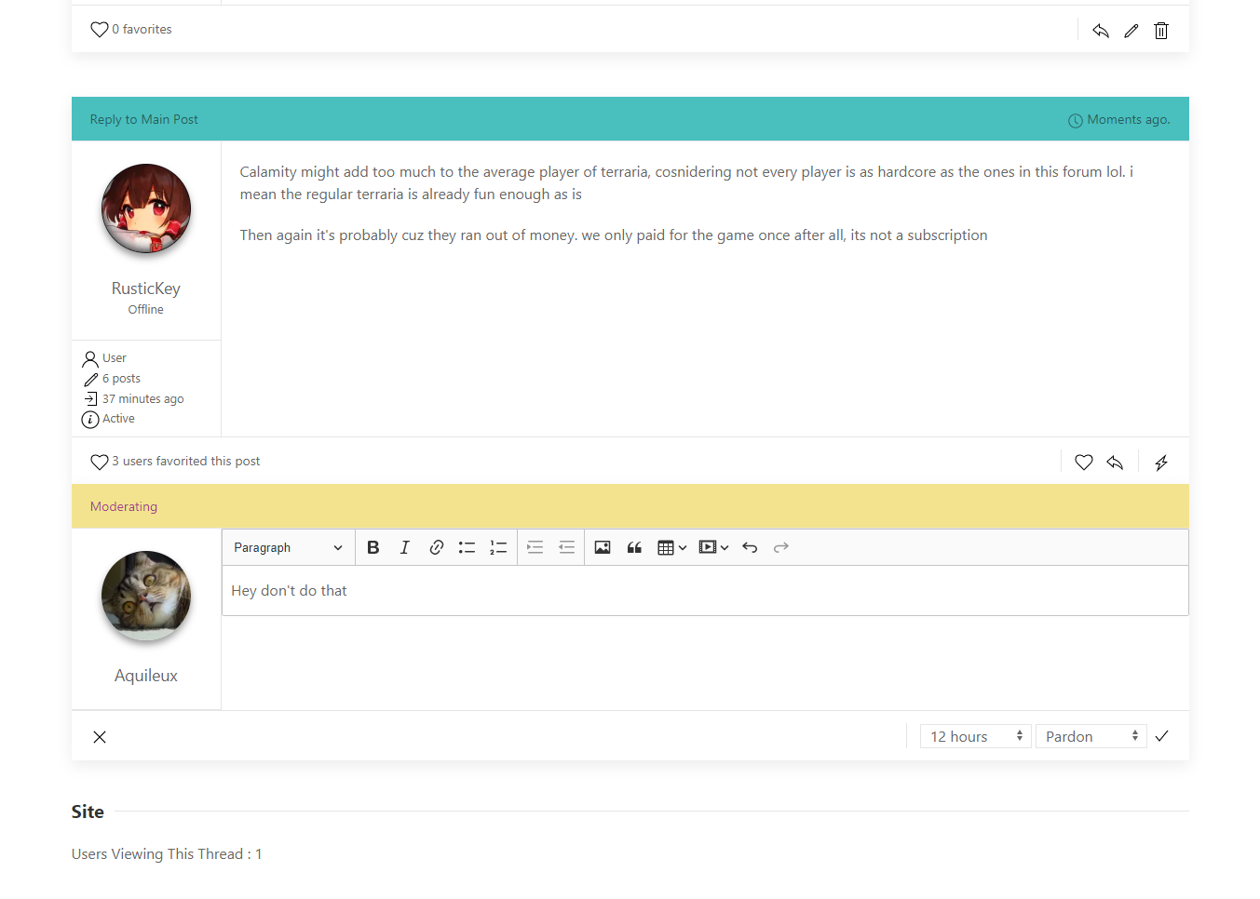

Picture 2.3.4.8 - Moderating a Thread

Role Access : moderator

Thread management is a form similar to report abuse but for category moderators. This allows them to moderate a user with a provided reason.



Picture 2.3.4.9 - Moderating Form



Picture 2.3.4.10 - Moderate Button (in this project)

**Moderators** can click on a “**Moderate**” button to show a “**Moderating Form**” and act on a forum post user if they deem a user is breaking forum guidelines. Moderators can choose from the three actions:

1. Pardoning
2. Silencing
3. Banning
4. Thread Lock

**Pardoning** sends an e-mail to the user in question, with the e-mail body containing the message written within the form, and they are unable to post in that thread for a set time by the moderator.

**Silencing** also does the same as pardoning, however it instead prevents the user from posting any further within that category for a set time by the moderator.

**Banning** the user does the same, except that it disallows their account from having access to a category for a set time or indefinitely. They cannot open or create new threads within that category.

Moderators can also choose to **lock the thread**, appending a new post at the end of the thread **containing the moderation message** and **prevents any other user or moderators not assigned to the thread category** from being able to post **for a set time or indefinitely**. When a user opens a locked thread, they can only read what’s in it, and is unable to reply or add any more post until a **category moderator** unlocks it. Moderators assigned to the category can choose to **manually unlock a thread** (with a button) whenever they want.

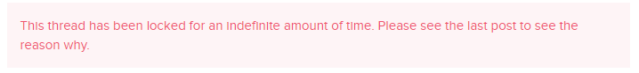

Picture 2.3.4.11 - Alert when a user visits a locked thread (on top of the thread)

Moderators can moderate other moderators that are not assigned to their category. Users and moderators can still, however, report an assigned moderator to notify the Site Admin by e-mail.

### Account

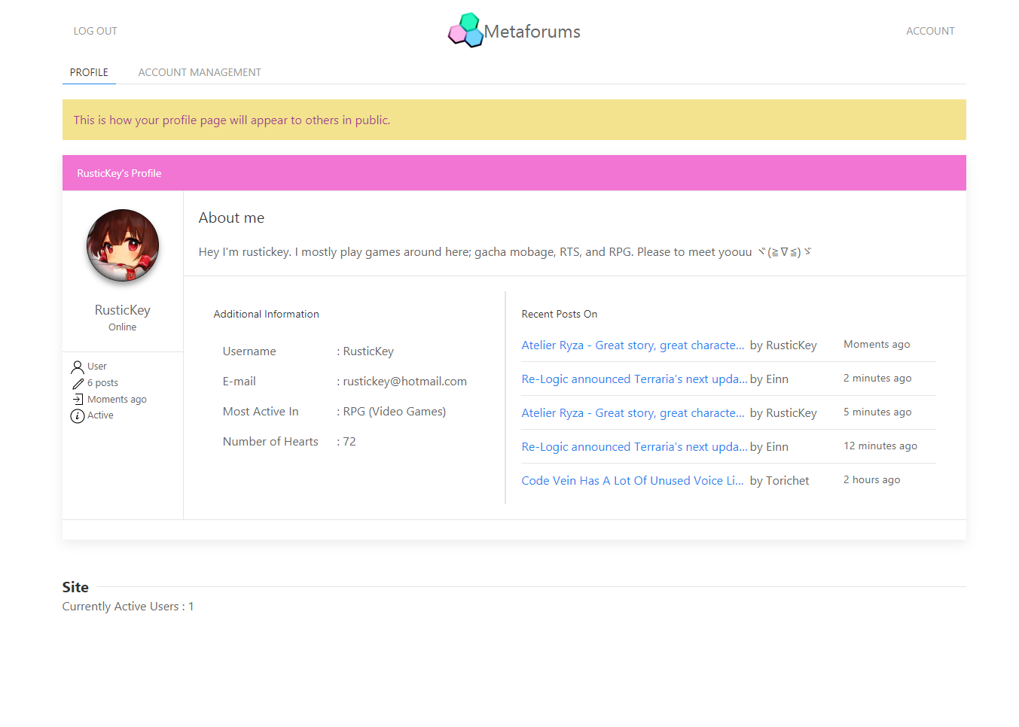

Picture 2.3.5.1 - Account View

Role Access : User, moderator

Account is a module for registered users to change their profile attributes and see other people’s profiles.

#### Profile

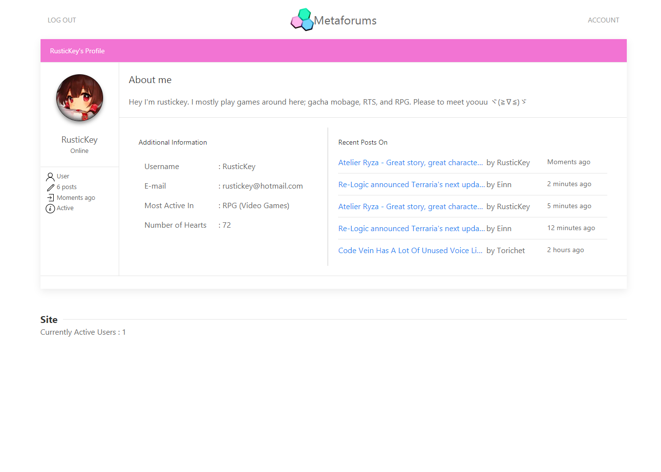

Picture 2.3.5.2 - Profile View

Role Access : User, moderator

Profile is the page that shows a user’s info and their **5 most recent posts**. Clicking on one of the items in the recent posts will **redirect the user to that thread’s page and jumps to the post**. Also shows their **status**, **number of “hearts”** (how many favorites on their posts from other users) and their **most active category participation** (determined by the number of posts and threads that the user have made).

#### Account Management

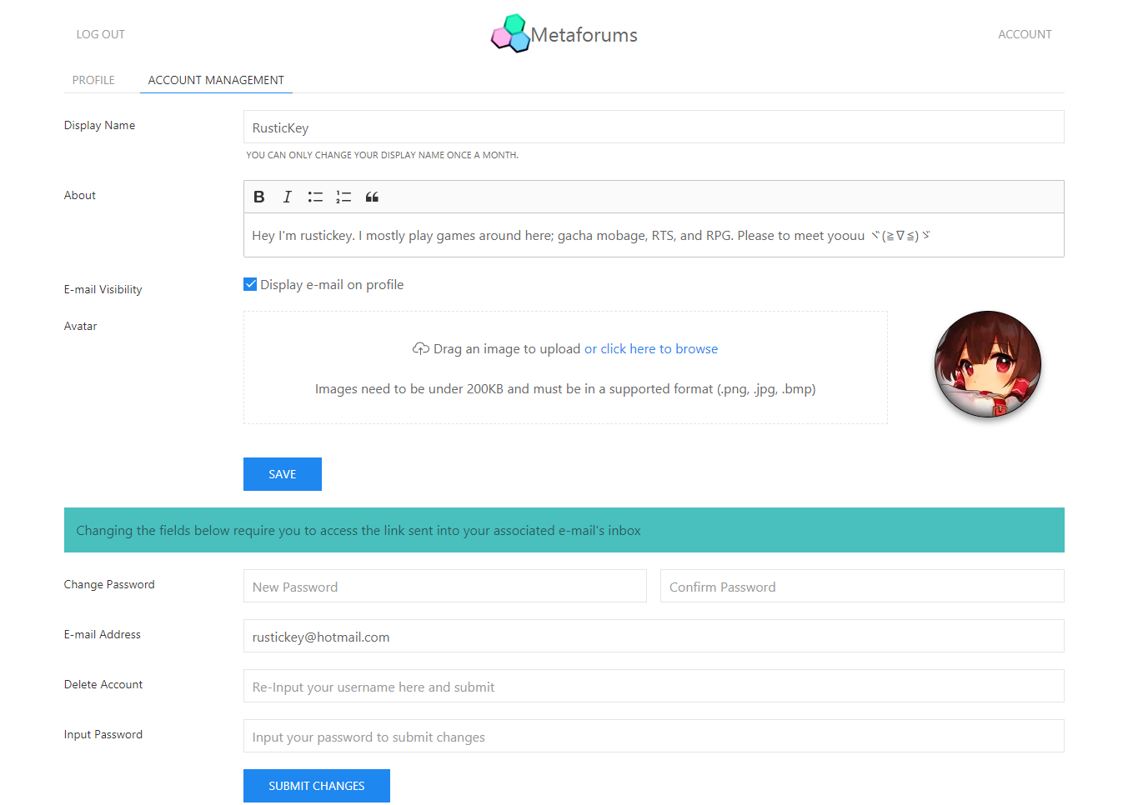

Picture 2.3.5.3 - Account Management Form

Role Access : User, moderator

Account Management allows users to **change their profile attributes**, **password**, **e-mail**, and commence **account deletion**. Display name can only be changed **once every 30 days**. If the user had already changed theirs within the last 30 days, **the field is disabled**. Users can also choose to hide or show their e-mail address and change their profile pictures.

Anything else require the user to **input their current account password** and they need to have access to their e-mail address. Submitting will send an e-mail to the currently linked address. When they receive the e-mail and they click on the link within, the changes will be saved. In the case of account deletion, the account will no longer be accessible after clicking the link. **In the case of e-mail change, the new e-mail will need to be verified again. This means that when the e-mail has been changed successfully, a new verification e-mail is sent to the new e-mail.**

**They can’t change fields that require e-mail access if their e-mail hasn’t been verified yet.**

### User Management

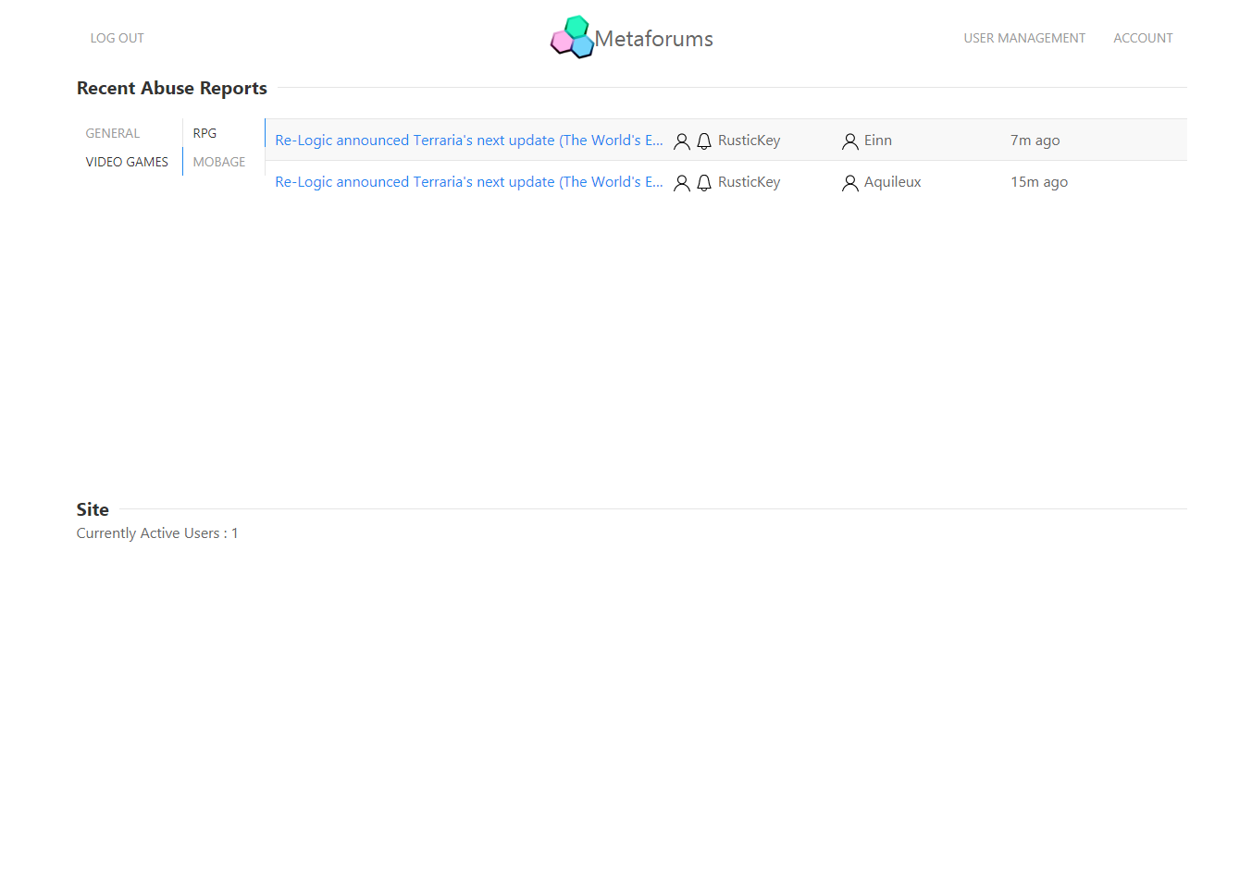

Role Access : moderator

User Management is a tool to help moderators manage recent abuse reports within their assigned category and allow them to review and act accordingly. Moderators will be able to see abuse reports **sorted by time**, and when clicked, the moderator will be redirected to the forum thread and immediately **jump to the associated post**.

**Moderators** can choose which category they want to overview, which will retrieve the correct results. Each result contains the thread title, the user who reported, the user being reported, and time of report.

If a moderator has been reported for abuse, they can see those reports in their own Recent Abuse Reports, however they **cannot moderate themselves**. Other moderators can “moderate“ other moderators by sending the aforementioned e-mail notification to the **Site Admin**.

# Grading

## Scoring Factors

|  |  |  |  |
| --- | --- | --- | --- |
| Module | Aspect | | Score |
| Sign Up | User can sign up | | 3 |
| User receives verification e-mail | | 3 |
| All validations work | | 1 |
| User’s password is properly encrypted | | 3 |
| **Total** | | **10** |
| Log In | User can log in | | 3 |
| User’s session is set | | 2 |
| All validations work | | 1 |
| **Total** | | **6** |
| Forgot Password | User can request forgot password and receive e-mail | | 4 |
| User’s password is reset | | 1 |
| **Total** | | **5** |
| Home | User can click on the logo to go to home | | 1 |
| User can see all available groups, categories, and threads | | 5 |
| Title bar adapts according to user role | | 2 |
| Thread ranking works as expected | | 2 |
| [HOT] badge work as expected | | 2 |
| **Total** | | **12** |
| Forum Thread | Forum Thread can be loaded dynamically instead of redirecting | | 5 |
| User can create new thread | | 3 |
| All validations in checking user’s eligibility in posting work | | 10 |
| Not Verified | 3 |
| Pardoned | 2 |
| Silenced | 2 |
| Banned | 2 |
| Thread Lock | 1 |
| User can view thread with privileges according to role | | 4 |
| User can participate in forum posting (add, edit, delete) | | 4 |
| User can report abuse, and report abuse mechanism works correctly | | 2 |
| **Total** | | **27** |
| Account | User can view their profile | | 2 |
| User can manage their profile | | 3 |
| User can manage their account | | 9 |
| Change E-mail | 4 |
| Change password | 2 |
| Delete Account | 3 |
| User can log out | | 1 |
| **Total** | | **15** |
| Moderation | Moderators can manage thread well | | 7 |
| Pardoning | 2 |
| Silencing | 2 |
| Banning | 2 |
| Thread Locking | 1 |
| Moderators can report other category moderators to Site Admin | | 2 |
| Moderators can view recent abuse reports | | 1 |
| **Total** | | **10** |

Describe the aspects being scored and their attainable scores

## Grading Notes

Describe the grading notes applicable to this project

1. The maximum attainable score is **85**
2. The rest **15** are graded from code quality subjective to the grader and is only attainable when score is at least **60.** The following aspects (but not limited to these) may be considered:
   1. Project structure
   2. Code convention
   3. Best practices
   4. Documentation quality
   5. Self-describing code
   6. etc
3. A score is either **zero** or the **specified amount**; there are no partial scores unless the score is segmented (e.g *All validations in checking user’s eligibility in posting work*). An example is *User’s password is properly encrypted.* If the password is encrypted but by using an unrecommended method, then the score is **zero** (0), otherwise if it’s properly implemented it will receive a full mark of **three** (3)
4. For the following features, the score can only be attainable if the e-mail functionality works:
   1. User receives verification e-mail
   2. User can request forgot password and receive e-mail
   3. All validations in checking user’s eligibility in posting work (*Not Verified*)
   4. User can manage their account (*Change E-mail, Change password, Delete Account*)
   5. Moderators can manage thread well (*Pardoning, Silencing, Banning, Thread Locking*)
   6. Moderators can report other category moderators to Site Admin
5. The maximum attainable score without completing any of the features having to do with e-mail is **57**
6. E-mail content does not matter as much, as long as they have the appropriate messages and contain all of the features specified within the requirement
7. If a feature is specified without a provided design or layout, the participant can feel free to think of their own

**PERATURAN PENGUMPULAN TUGAS :**

1. Tugas ini dikerjakan secara individu dan paling telat dikumpulkan hari Jumat, 26 November 2021 jam 23.59
2. Jawaban kalian nanti diupload dengan login ke aplikasi IT Division : https://amjs-recruitment.apps.binus.edu/Login , langkah-langkahnya -> Home -> Assignment -> pada Menu Upload Assignment nanti kalian klik SUBMIT untuk mengupload jawabannya.
3. Buatlah file notepad yang berisi link onedrive file jawabannya.
4. Semua jawaban yang kalian buat tolong dimasukan ke dalam zip sebelum diupload ke aplikasi IT Division.

~ Good Luck ~