2.0 Kërkesa e projektit
Projekti E-Shëndeti është një platformë për menaxhimin e shërbimeve shëndetësore online. Sistemi mundëson regjistrimin e përdoruesve, menaxhimin e mjekëve, rezervimin e termineve, ruajtjen e të dhënave mjekësore dhe administrimin e njoftimeve.
Kërkesat funksionale
- Regjistrimi dhe kyçja e përdoruesve
- Menaxhimi i roleve (Admin, Doctor, Patient)
- Menaxhimi i departamenteve
- Menaxhimi i orareve të mjekëve
- Rezervimi i termineve online
- Menaxhimi i kartelave mjekësore
- Menaxhimi i recetave
- Dërgimi i njoftimeve
- Auditimi i aktiviteteve të sistemit
Kërkesat jofunksionale
- Siguria e të dhënave
- Performanca e databazës
- Integriteti referencial
- Disponueshmëria e sistemit
- Dizajn responsive

3.0 Diagrami ER
Entitetet kryesore të sistemit:
- Users
- Doctors
- Departments
- Appointments
- Medical_Records
- Prescriptions
- Notifications
- Feedback
- Audit_Log
Relacionet:
- Një përdorues mund të ketë shumë termine
- Një mjek i përket një departamenti
- Një termin lidhet me një pacient dhe një mjek
- Një kartelë mjekësore lidhet me pacientin dhe mjekun
- Një kartelë mund të ketë shumë receta

4.0 Modeli Relacionar
USERS
- id (PK)
- email
- password_hash
- role
- name
- surname
DOCTORS
- id (PK)
- user_id (FK)
- department_id (FK)
DEPARTMENTS
- id (PK)
- name
APPOINTMENTS
- id (PK)
- patient_id (FK)
- doctor_id (FK)
- department_id (FK)
MEDICAL_RECORDS
- id (PK)
- patient_id (FK)
- doctor_id (FK)
PRESCRIPTIONS
- id (PK)
- medical_record_id (FK)

5.0 UML – Tabelat për SQL
Users
Fusha | Tipi
id | INT
email | VARCHAR
password_hash | VARCHAR
role | ENUM
name | VARCHAR
surname | VARCHAR
Doctors
Fusha | Tipi
id | INT
user_id | INT
department_id | INT
Appointments
Fusha | Tipi
id | INT
patient_id | INT
doctor_id | INT
appointment_date | DATE
appointment_time | TIME

6.0 Krijimi i tabelave
CREATE TABLE users (
id INT PRIMARY KEY AUTO_INCREMENT,
email VARCHAR(255) NOT NULL UNIQUE,
password_hash VARCHAR(255) NOT NULL,
role ENUM('patient', 'doctor', 'admin') DEFAULT 'patient',
name VARCHAR(100) NOT NULL,
surname VARCHAR(100) NOT NULL,
personal_id VARCHAR(20) UNIQUE,
date_of_birth DATE,
gender ENUM('male', 'female', 'other'),
phone VARCHAR(20),
address TEXT,
profile_image VARCHAR(255),
email_verified BOOLEAN DEFAULT FALSE,
email_verified_at DATETIME,
is_active BOOLEAN DEFAULT TRUE,
last_login DATETIME,
created_at DATETIME DEFAULT CURRENT_TIMESTAMP,
updated_at DATETIME DEFAULT CURRENT_TIMESTAMP ON UPDATE CURRENT_TIMESTAMP,

INDEX idx_email (email),
INDEX idx_role (role),
INDEX idx_personal_id (personal_id)
) ENGINE=InnoDB;

-- =====================================================
-- DEPARTMENTS TABLE
-- Medical departments/specializations
-- =====================================================
CREATE TABLE departments (
id INT PRIMARY KEY AUTO_INCREMENT,
name VARCHAR(100) NOT NULL,
name_sq VARCHAR(100) NOT NULL, -- Albanian name
description TEXT,
description_sq TEXT,
icon VARCHAR(50),
is_active BOOLEAN DEFAULT TRUE,
sort_order INT DEFAULT 0,
created_at DATETIME DEFAULT CURRENT_TIMESTAMP,
updated_at DATETIME DEFAULT CURRENT_TIMESTAMP ON UPDATE CURRENT_TIMESTAMP,

INDEX idx_active (is_active)
) ENGINE=InnoDB;

-- =====================================================
-- DOCTORS TABLE
-- Extended information for users with doctor role
-- =====================================================
CREATE TABLE doctors (
id INT PRIMARY KEY AUTO_INCREMENT,
user_id INT NOT NULL UNIQUE,
department_id INT NOT NULL,
specialty VARCHAR(150),
specialty_sq VARCHAR(150),
license_number VARCHAR(50),
experience_years INT,
biography TEXT,
biography_sq TEXT,
rating DECIMAL(2,1) DEFAULT 0.0,
consultation_fee DECIMAL(10,2),
is_available BOOLEAN DEFAULT TRUE,
created_at DATETIME DEFAULT CURRENT_TIMESTAMP,
updated_at DATETIME DEFAULT CURRENT_TIMESTAMP ON UPDATE CURRENT_TIMESTAMP,

FOREIGN KEY (user_id) REFERENCES users(id) ON DELETE CASCADE,
FOREIGN KEY (department_id) REFERENCES departments(id) ON DELETE RESTRICT,
INDEX idx_department (department_id),
INDEX idx_available (is_available)
) ENGINE=InnoDB;

-- =====================================================
-- DOCTOR_SCHEDULE TABLE
-- Working hours for doctors
-- =====================================================
CREATE TABLE doctor_schedules (
id INT PRIMARY KEY AUTO_INCREMENT,
doctor_id INT NOT NULL,
day_of_week TINYINT NOT NULL, -- 0=Sunday, 1=Monday, etc.
start_time TIME NOT NULL,
end_time TIME NOT NULL,
slot_duration INT DEFAULT 30, -- minutes
is_active BOOLEAN DEFAULT TRUE,
created_at DATETIME DEFAULT CURRENT_TIMESTAMP,
updated_at DATETIME DEFAULT CURRENT_TIMESTAMP ON UPDATE CURRENT_TIMESTAMP,

FOREIGN KEY (doctor_id) REFERENCES doctors(id) ON DELETE CASCADE,
INDEX idx_doctor_day (doctor_id, day_of_week)
) ENGINE=InnoDB;

-- =====================================================
-- APPOINTMENTS TABLE
-- Patient appointment bookings
-- =====================================================
CREATE TABLE appointments (
id INT PRIMARY KEY AUTO_INCREMENT,
patient_id INT NOT NULL,
doctor_id INT NOT NULL,
department_id INT NOT NULL,
appointment_date DATE NOT NULL,
appointment_time TIME NOT NULL,
end_time TIME,
status ENUM('pending', 'confirmed', 'completed', 'cancelled', 'no_show') DEFAULT 'pending',
type ENUM('consultation', 'follow_up', 'emergency') DEFAULT 'consultation',
reason TEXT,
notes TEXT,
cancelled_by INT,
cancelled_reason TEXT,
cancelled_at DATETIME,
confirmed_at DATETIME,
completed_at DATETIME,
created_at DATETIME DEFAULT CURRENT_TIMESTAMP,
updated_at DATETIME DEFAULT CURRENT_TIMESTAMP ON UPDATE CURRENT_TIMESTAMP,

FOREIGN KEY (patient_id) REFERENCES users(id) ON DELETE RESTRICT,
FOREIGN KEY (doctor_id) REFERENCES doctors(id) ON DELETE RESTRICT,
FOREIGN KEY (department_id) REFERENCES departments(id) ON DELETE RESTRICT,
FOREIGN KEY (cancelled_by) REFERENCES users(id) ON DELETE SET NULL,
INDEX idx_patient (patient_id),
INDEX idx_doctor (doctor_id),
INDEX idx_date (appointment_date),
INDEX idx_status (status),
UNIQUE KEY unique_appointment (doctor_id, appointment_date, appointment_time)
) ENGINE=InnoDB;

-- =====================================================
-- MEDICAL_RECORDS TABLE
-- Patient medical history and reports
-- =====================================================
CREATE TABLE medical_records (
id INT PRIMARY KEY AUTO_INCREMENT,
patient_id INT NOT NULL,
doctor_id INT NOT NULL,
appointment_id INT,
record_type ENUM('examination', 'lab', 'imaging', 'prescription', 'other') DEFAULT 'examination',
title VARCHAR(255) NOT NULL,
title_sq VARCHAR(255),
diagnosis TEXT,
diagnosis_sq TEXT,
symptoms TEXT,
treatment TEXT,
treatment_sq TEXT,
notes TEXT,
notes_sq TEXT,
attachments JSON, -- Array of file paths
is_confidential BOOLEAN DEFAULT FALSE,
record_date DATE NOT NULL,
created_at DATETIME DEFAULT CURRENT_TIMESTAMP,
updated_at DATETIME DEFAULT CURRENT_TIMESTAMP ON UPDATE CURRENT_TIMESTAMP,

FOREIGN KEY (patient_id) REFERENCES users(id) ON DELETE CASCADE,
FOREIGN KEY (doctor_id) REFERENCES doctors(id) ON DELETE RESTRICT,
FOREIGN KEY (appointment_id) REFERENCES appointments(id) ON DELETE SET NULL,
INDEX idx_patient (patient_id),
INDEX idx_doctor (doctor_id),
INDEX idx_type (record_type),
INDEX idx_date (record_date)
) ENGINE=InnoDB;

-- =====================================================
-- PRESCRIPTIONS TABLE
-- Medical prescriptions
-- =====================================================
CREATE TABLE prescriptions (
id INT PRIMARY KEY AUTO_INCREMENT,
medical_record_id INT NOT NULL,
patient_id INT NOT NULL,
doctor_id INT NOT NULL,
medication_name VARCHAR(255) NOT NULL,
dosage VARCHAR(100),
frequency VARCHAR(100),
duration VARCHAR(100),
instructions TEXT,
instructions_sq TEXT,
quantity INT,
refills_allowed INT DEFAULT 0,
refills_used INT DEFAULT 0,
is_active BOOLEAN DEFAULT TRUE,
start_date DATE,
end_date DATE,
created_at DATETIME DEFAULT CURRENT_TIMESTAMP,
updated_at DATETIME DEFAULT CURRENT_TIMESTAMP ON UPDATE CURRENT_TIMESTAMP,

FOREIGN KEY (medical_record_id) REFERENCES medical_records(id) ON DELETE CASCADE,
FOREIGN KEY (patient_id) REFERENCES users(id) ON DELETE CASCADE,
FOREIGN KEY (doctor_id) REFERENCES doctors(id) ON DELETE RESTRICT,
INDEX idx_patient (patient_id),
INDEX idx_active (is_active)
) ENGINE=InnoDB;

-- =====================================================
-- NOTIFICATIONS TABLE
-- System notifications for users
-- =====================================================
CREATE TABLE notifications (
id INT PRIMARY KEY AUTO_INCREMENT,
user_id INT NOT NULL,
type ENUM('info', 'success', 'warning', 'error', 'appointment', 'report', 'system') DEFAULT 'info',
title VARCHAR(255) NULL,
title_sq VARCHAR(255),
message TEXT NULL,
message_sq TEXT,
link VARCHAR(255),
is_read BOOLEAN DEFAULT FALSE,
read_at DATETIME,
created_at DATETIME DEFAULT CURRENT_TIMESTAMP,

FOREIGN KEY (user_id) REFERENCES users(id) ON DELETE CASCADE,
INDEX idx_user (user_id),
INDEX idx_read (is_read),
INDEX idx_created (created_at)
) ENGINE=InnoDB;

-- =====================================================
-- FEEDBACK TABLE
-- User feedback and support requests
-- =====================================================
CREATE TABLE feedback (
id INT PRIMARY KEY AUTO_INCREMENT,
user_id INT,
type ENUM('suggestion', 'complaint', 'appreciation', 'bug_report', 'support') DEFAULT 'suggestion',
subject VARCHAR(255) NOT NULL,
message TEXT NOT NULL,
rating TINYINT, -- 1-5 stars
status ENUM('pending', 'in_progress', 'resolved', 'closed') DEFAULT 'pending',
admin_response TEXT,
responded_by INT,
responded_at DATETIME,
created_at DATETIME DEFAULT CURRENT_TIMESTAMP,
updated_at DATETIME DEFAULT CURRENT_TIMESTAMP ON UPDATE CURRENT_TIMESTAMP,

FOREIGN KEY (user_id) REFERENCES users(id) ON DELETE SET NULL,
FOREIGN KEY (responded_by) REFERENCES users(id) ON DELETE SET NULL,
INDEX idx_user (user_id),
INDEX idx_type (type),
INDEX idx_status (status)
) ENGINE=InnoDB;

-- =====================================================
-- AUDIT_LOG TABLE
-- Track important system actions for security
-- =====================================================
CREATE TABLE audit_log (
id INT PRIMARY KEY AUTO_INCREMENT,
user_id INT,
action VARCHAR(100) NOT NULL,
entity_type VARCHAR(50),
entity_id INT,
old_values JSON,
new_values JSON,
ip_address VARCHAR(45),
user_agent TEXT,
created_at DATETIME DEFAULT CURRENT_TIMESTAMP,

FOREIGN KEY (user_id) REFERENCES users(id) ON DELETE SET NULL,
INDEX idx_user (user_id),
INDEX idx_action (action),
INDEX idx_entity (entity_type, entity_id),
INDEX idx_created (created_at)
) ENGINE=InnoDB;

-- =====================================================
-- PASSWORD_RESETS TABLE
-- Password reset tokens
-- =====================================================
CREATE TABLE password_resets (
id INT PRIMARY KEY AUTO_INCREMENT,
email VARCHAR(255) NOT NULL,
token VARCHAR(255) NOT NULL,
expires_at DATETIME NOT NULL,
used_at DATETIME,
created_at DATETIME DEFAULT CURRENT_TIMESTAMP,

INDEX idx_email (email),
INDEX idx_token (token)
) ENGINE=InnoDB;

-- =====================================================
-- USER_SESSIONS TABLE
-- Track user sessions for security
-- =====================================================
CREATE TABLE user_sessions (
id INT PRIMARY KEY AUTO_INCREMENT,
user_id INT NOT NULL,
token VARCHAR(255) NOT NULL UNIQUE,
ip_address VARCHAR(45),
user_agent TEXT,
last_activity DATETIME DEFAULT CURRENT_TIMESTAMP,
expires_at DATETIME NOT NULL,
is_active BOOLEAN DEFAULT TRUE,
created_at DATETIME DEFAULT CURRENT_TIMESTAMP,

FOREIGN KEY (user_id) REFERENCES users(id) ON DELETE CASCADE,
INDEX idx_user (user_id),
INDEX idx_token (token),
INDEX idx_active (is_active)
) ENGINE=InnoDB;

7.0 Popullimi i tabelave
INSERT INTO departments (name, name_sq, description, description_sq, icon, sort_order) VALUES
('Cardiology', 'Kardiologji', 'Heart and cardiovascular system', 'Sëmundjet e zemrës', 'heart', 1),
('Dermatology', 'Dermatologji', 'Skin conditions and diseases', 'Sëmundjet e lëkurës', 'skin', 2),
('Neurology', 'Neurologji', 'Nervous system disorders', 'Sistemi nervor', 'brain', 3),
('Orthopedics', 'Ortopedi', 'Bones and joints', 'Kockat dhe kyçet', 'bone', 4),
('Pediatrics', 'Pediatri', 'Children health', 'Shëndeti i fëmijëve', 'baby', 5),
('Ophthalmology', 'Oftalmologji', 'Eye health', 'Shëndeti i syve', 'eye', 6),
('Dentistry', 'Stomatologji', 'Dental health', 'Shëndeti i dhëmbëve', 'tooth', 7),
('General Medicine', 'Mjekësi e Përgjithshme', 'General health checkups', 'Kontrolla të përgjithshme', 'stethoscope', 8),
('Gynecology', 'Gjinekologji', 'Women health', 'Shëndeti i gruas', 'female', 9);

-- Insert default admin user (password: Admin123!)
-- Note: In production, use proper password hashing (bcrypt)
INSERT INTO users (email, password_hash, role, name, surname, is_active, email_verified) VALUES
('admin@eshendeti.com', '$2y$10$HGaj/ln4OuNkV27osVaICedwxUfLUSF5YTDm0NFm8pSEWvH0ymyaW', 'admin', 'Admin', 'System', TRUE, TRUE);

8.0 Query për databazën
Shfaq te gjithe mjeket
SELECT * FROM doctors;
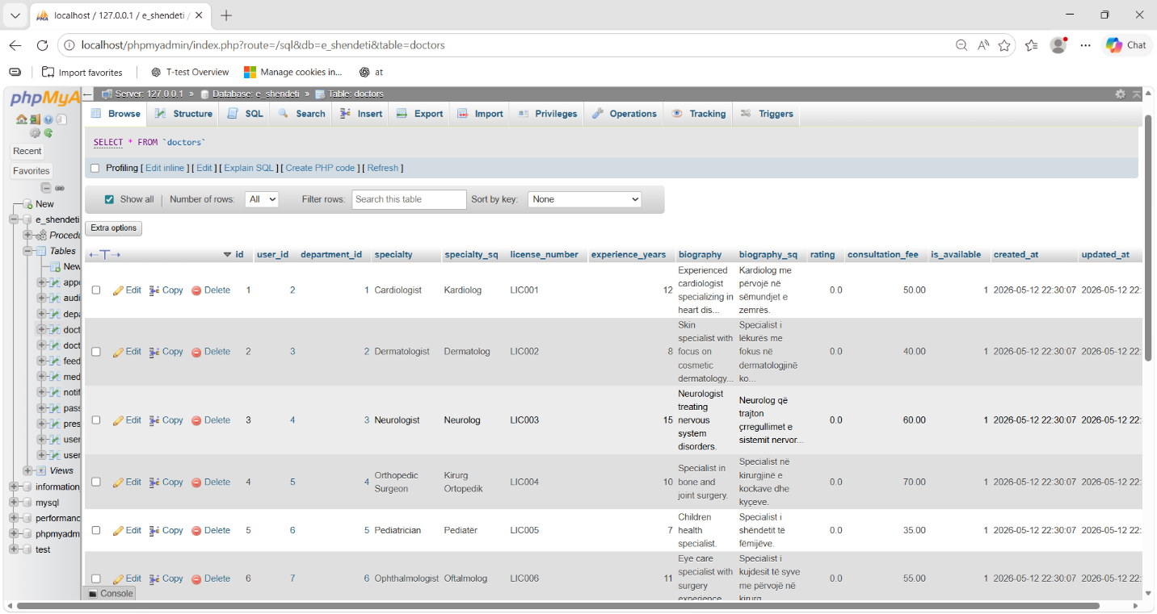
s

Shfaq ter minet
SELECT * FROM appointments;
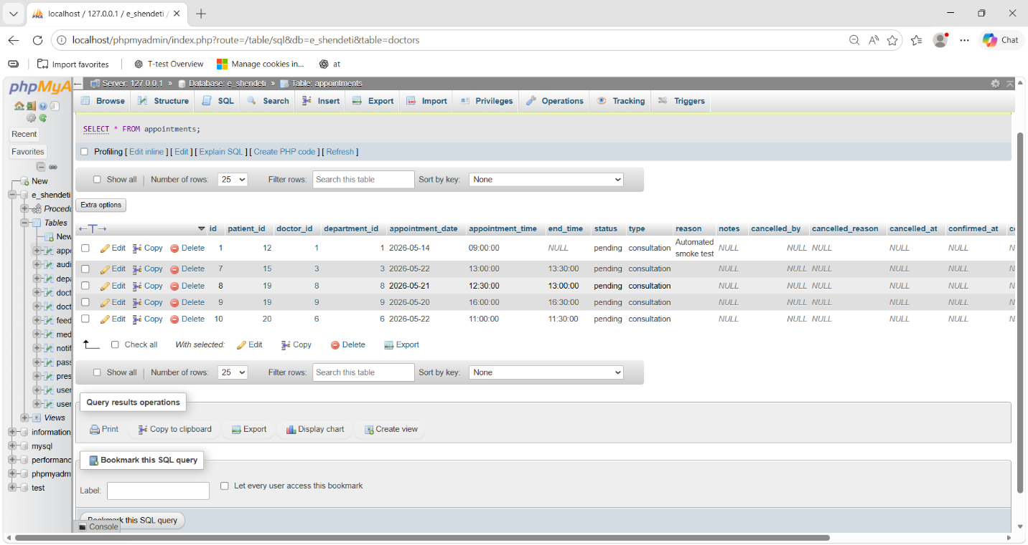

Shfaaq pacientet
SELECT * FROM users WHERE role=’patient’;
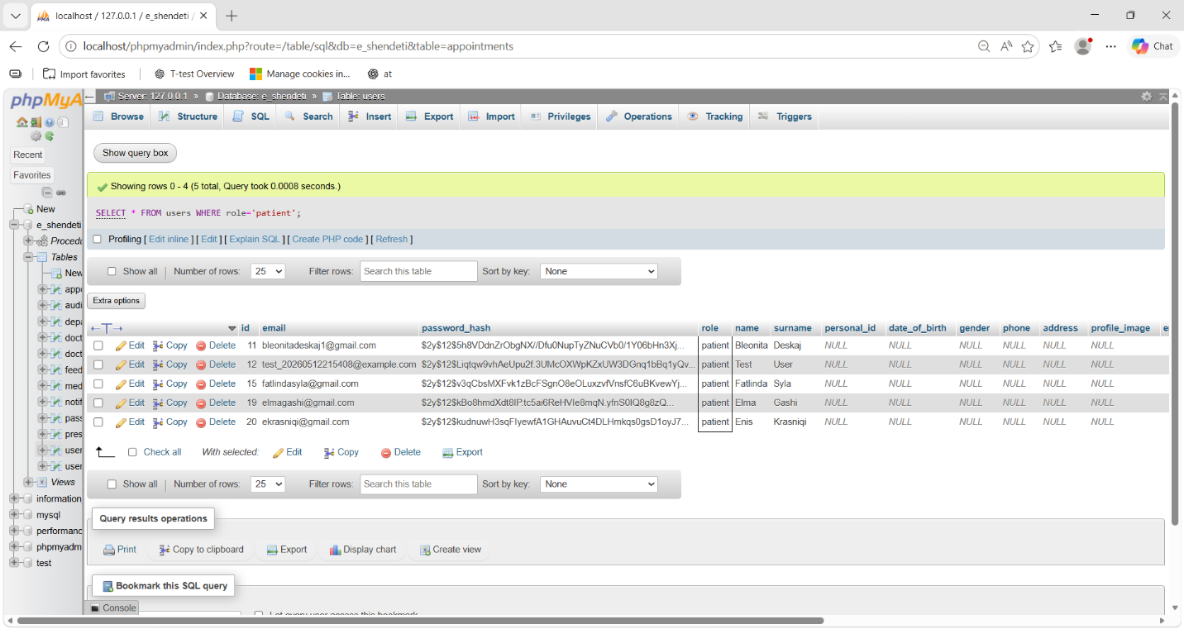

Shfaq terminet me emrat e mjekeve
SELECT
a.id,
u.name,
u.surname,
a.appointment_date
FROM appointments a
JOIN doctors d ON a.doctor_id=d.id
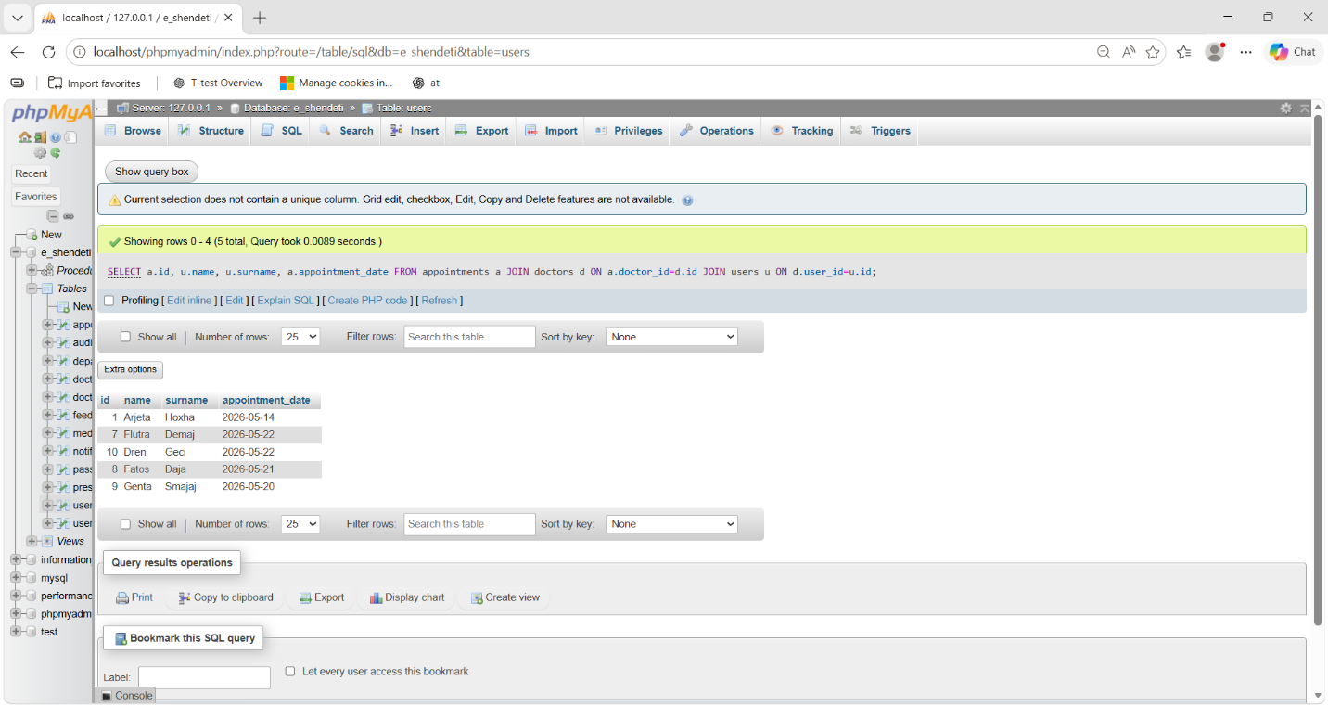
JOIN users u ON d.user_id=u.id;

Shfaq te gjitha takimet me emrin e pacientit dhe doktorrit
SELECT
a.id,
CONCAT(p.name, ' ', p.surname) AS pacienti,
CONCAT(du.name, ' ', du.surname) AS doktori,
dep.name_sq AS departamenti,
a.appointment_date,
a.appointment_time,
a.status
FROM appointments a
INNER JOIN users p ON a.patient_id = p.id
INNER JOIN doctors d ON a.doctor_id = d.id
INNER JOIN users du ON d.user_id = du.id
INNER JOIN departments dep ON a.department_id = dep.id;
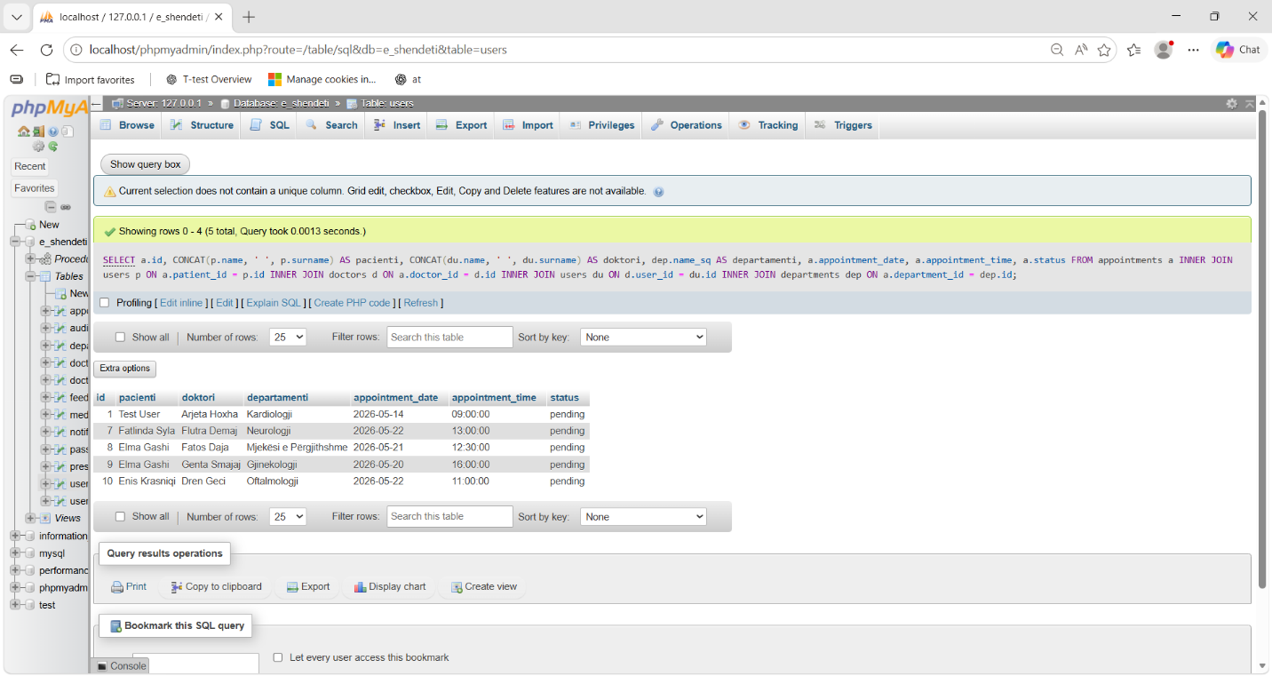

Shfaq vetem takimet e konfirmuara
SELECT *
FROM appointments
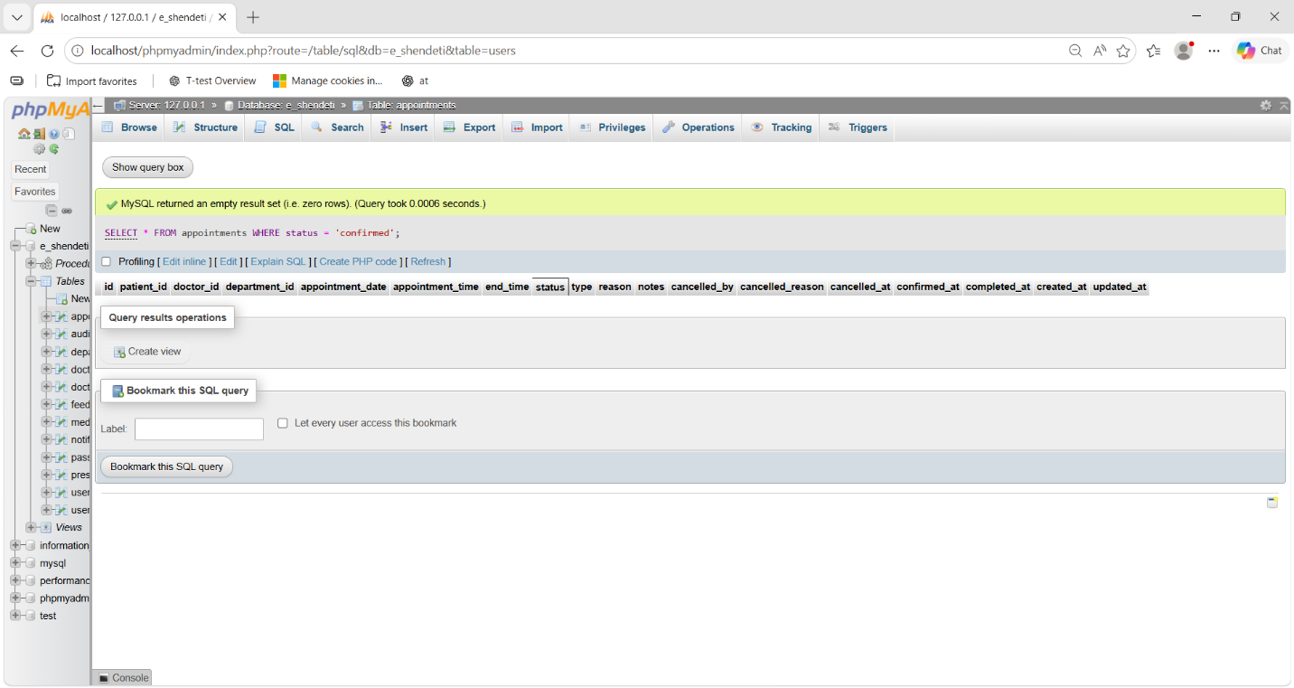
WHERE status = 'confirmed';

Shfaq doktorret dhe departamentet e tyre
SELECT
CONCAT(u.name, ' ', u.surname) AS doktori,
dep.name_sq AS departamenti,
d.specialty_sq
FROM doctors d
INNER JOIN users u ON d.user_id = u.id
INNER JOIN departments dep ON d.department_id = dep.id;
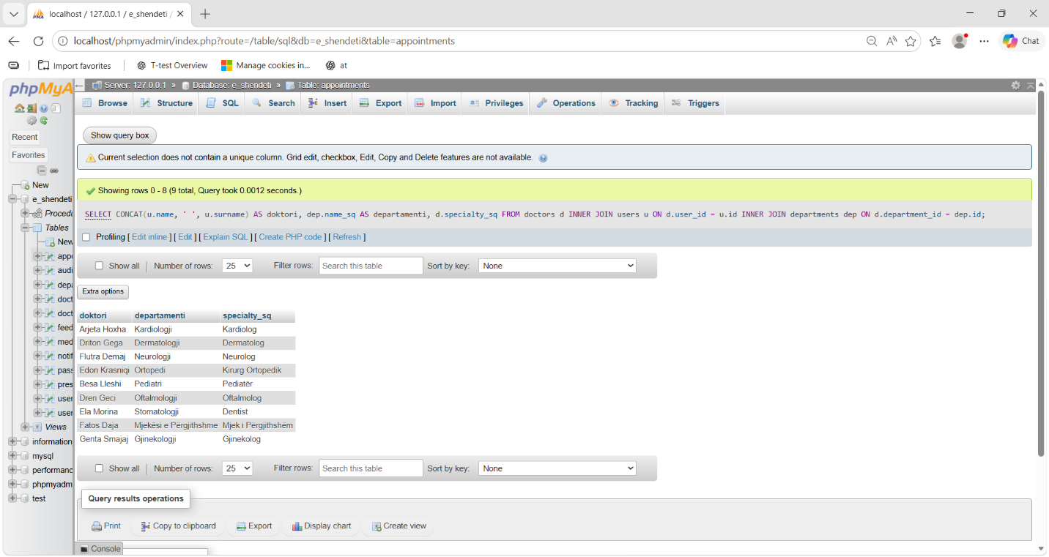

Numri I takimeve per secilin doctor
SELECT
CONCAT(u.name, ' ', u.surname) AS doktori,
COUNT(a.id) AS nr_takimeve
FROM doctors d
LEFT JOIN appointments a ON d.id = a.doctor_id
INNER JOIN users u ON d.user_id = u.id
GROUP BY d.id;
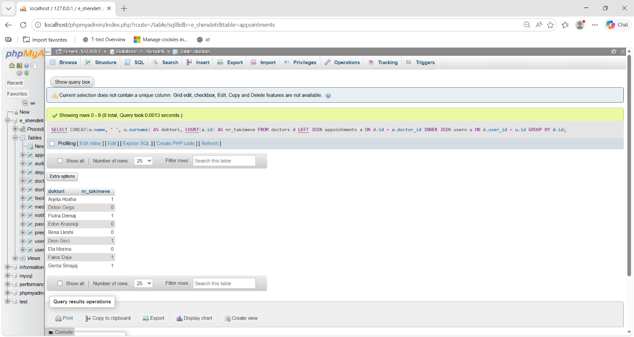

Shfaq pacientet qe kane rezervime
SELECT DISTINCT
CONCAT(u.name, ' ', u.surname) AS pacienti,
u.email
FROM users u
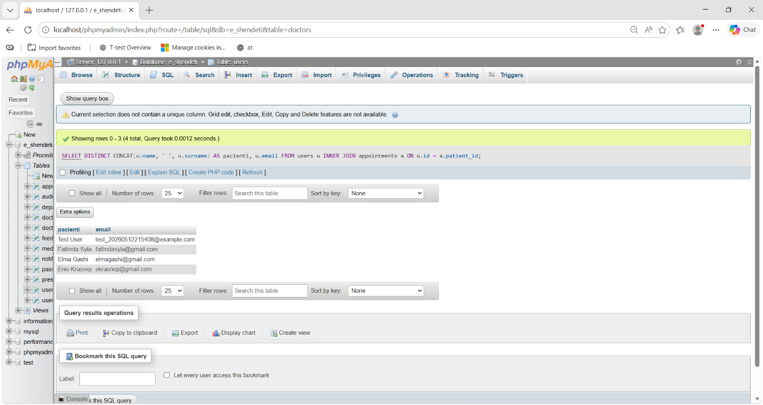
INNER JOIN appointments a ON u.id = a.patient_id;

Shfaq takimet sipas dates
SELECT *
FROM appointments
WHERE appointment_date = CURDATE();
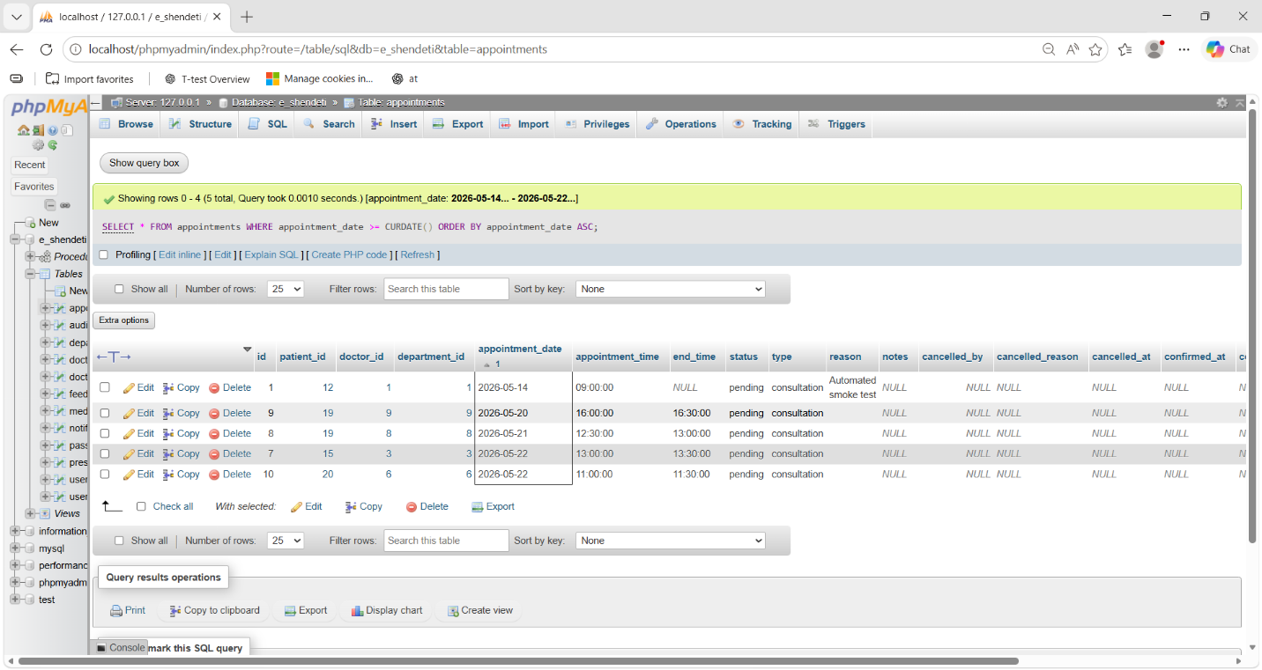

Shfaq doktoret pa asnje takim
SELECT
CONCAT(u.name, ' ', u.surname) AS doktori
FROM doctors d
LEFT JOIN appointments a ON d.id = a.doctor_id
INNER JOIN users u ON d.user_id = u.id
WHERE a.id IS NULL;

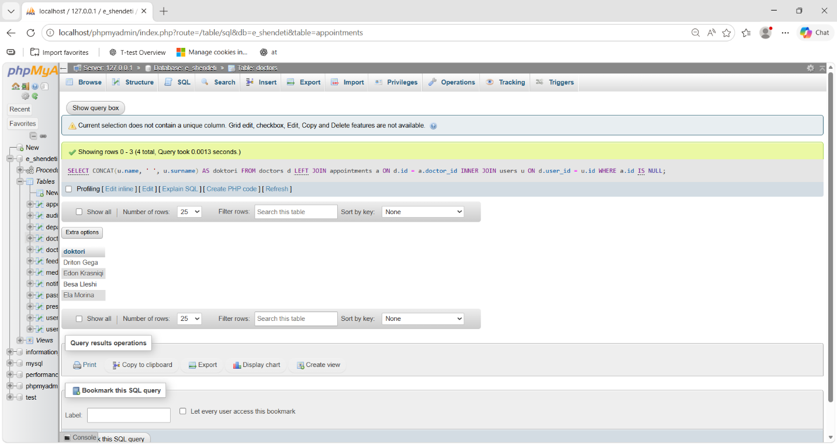

Shfaq pacientet dhe numrin e takimeve te tyre
SELECT
CONCAT(u.name, ' ', u.surname) AS pacienti,
COUNT(a.id) AS total_takime
FROM users u
LEFT JOIN appointments a ON u.id = a.patient_id
WHERE u.role = 'patient'
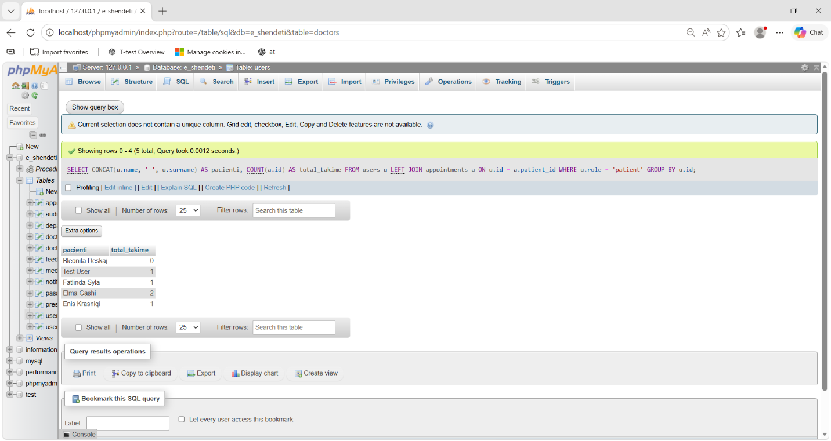
GROUP BY u.id;

Shfaq rezervimet me status pending
SELECT
a.id,
CONCAT(p.name, ' ', p.surname) AS pacienti,
a.appointment_date,
a.appointment_time
FROM appointments a
INNER JOIN users p ON a.patient_id = p.id
WHERE a.status = 'pending';
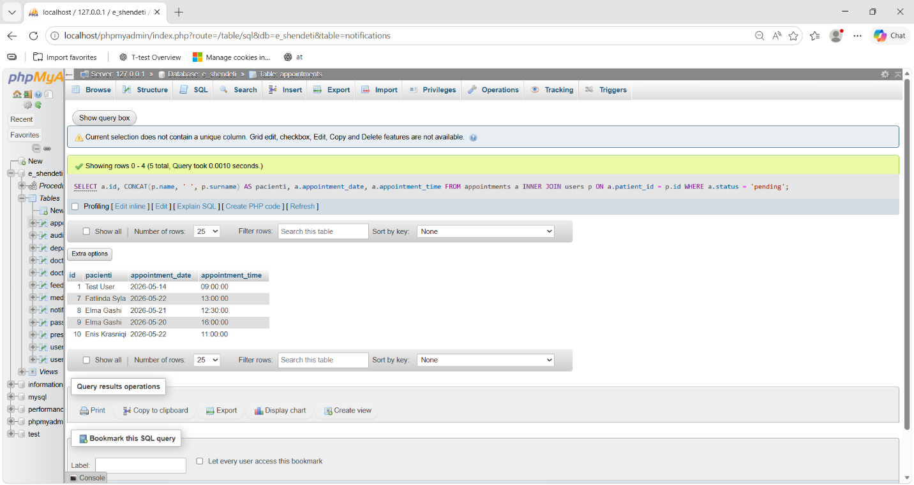

Shfaq doktorin me me se shumti takime
SELECT
CONCAT(u.name, ' ', u.surname) AS doktori,
COUNT(a.id) AS total_takime
FROM doctors d
INNER JOIN users u ON d.user_id = u.id
LEFT JOIN appointments a ON d.id = a.doctor_id
GROUP BY d.id
ORDER BY total_takime DESC
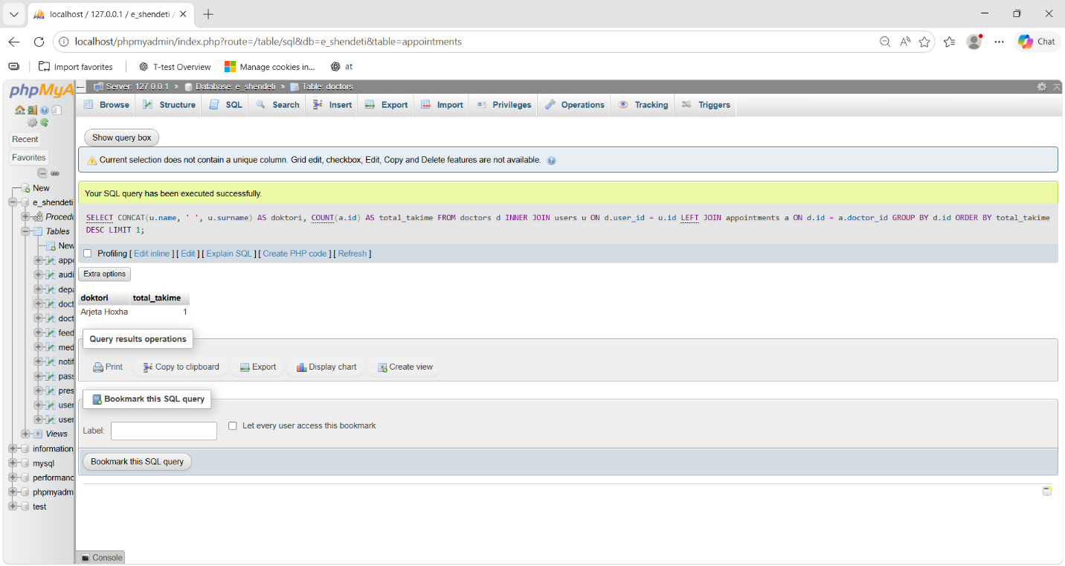
LIMIT 1;

Shfaq te gjitha appointment me join te plote
SELECT
a.id,
CONCAT(p.name, ' ', p.surname) AS pacienti,
CONCAT(doc.name, ' ', doc.surname) AS doktori,
dep.name_sq AS departamenti,
a.appointment_date,
a.appointment_time,
a.status,
a.reason
FROM appointments a
INNER JOIN users p ON a.patient_id = p.id
INNER JOIN doctors d ON a.doctor_id = d.id
INNER JOIN users doc ON d.user_id = doc.id
INNER JOIN departments dep ON a.department_id = dep.id
ORDER BY a.created_at DESC;
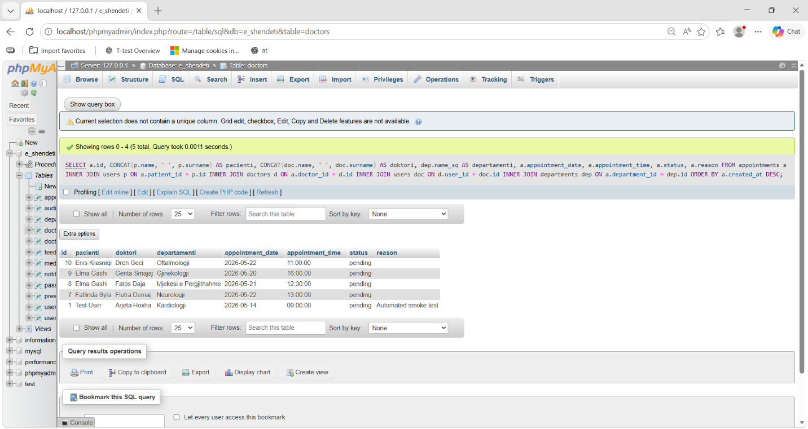

Query per kerkim sipas emrit te doktorrit
SELECT
CONCAT(u.name, ' ', u.surname) AS doktori,
dep.name_sq
FROM doctors d
INNER JOIN users u ON d.user_id = u.id
INNER JOIN departments dep ON d.department_id = dep.id
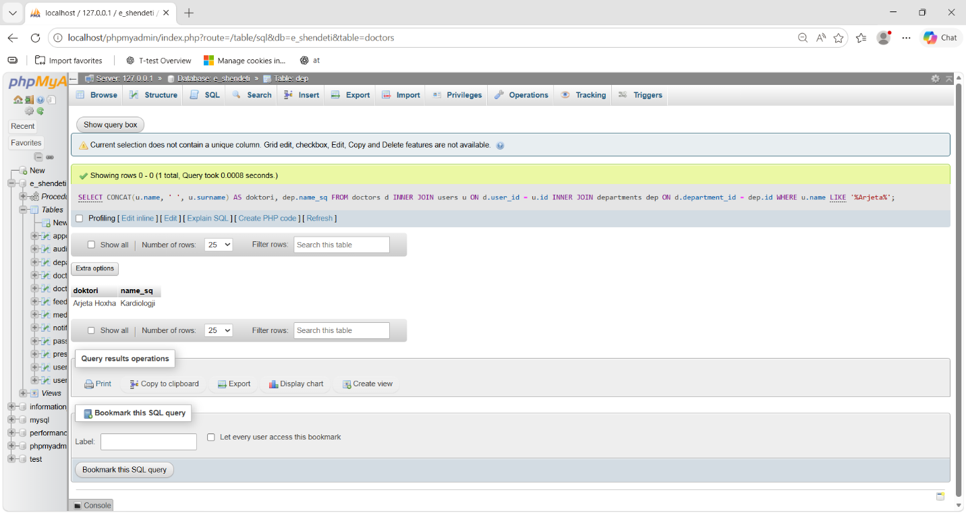
WHERE u.name LIKE '%Arjeta%';

Shfaq user-at aktiv
SELECT
id,
name,
surname,
email,
role
FROM users
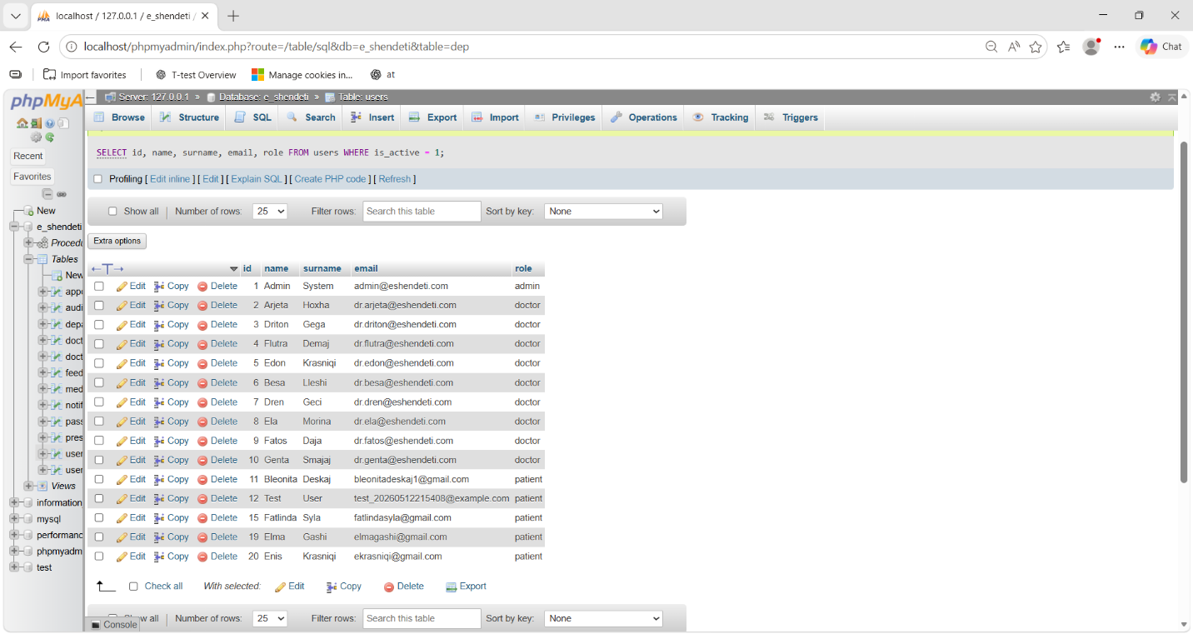
WHERE is_active = 1;

9.0 Nëntema tjetër
Siguria e databazës
Sistemi përdor:
- Foreign Keys
- Password Hashing
- PDO Prepared Statements
- Session Authentication
- Audit Logs
Menaxhimi i termineve
Pacientët mund:
- të rezervojnë termin

- të anulojnë termin
- të shohin historikun
Mjekët mund:
- të konfirmojnë termine
- të përfundojnë termine
Admini mund:
- të menaxhojë përdoruesit
- të menaxhojë departamentet
- të monitorojë aktivitetet
- 10.0 Konkluzioni
- Projekti E-Shëndeti paraqet një sistem modern për menaxhimin e shërbimeve shëndetësore online. Sistemi mundëson administrimin e përdoruesve, termineve dhe të dhënave mjekësore në mënyrë efikase dhe të sigurt. Përdorimi i databazës relacionale siguron integritetin e të dhënave dhe performancë të lartë të sistemit.
11.0 Referencat
- MySQL Documentation
- PHP Documentation
- XAMPP Documentation
- W3Schools SQL Tutorial
- Stack Overflow
- phpMyAdmin Documentation

