COREP OUTREACH - DATA ANALYSIS REPORT
Report Generated: August 27, 2026 at 07:08 AM
Source File: corep_data_20260827_065242.xlsx
======================================================================

EXECUTIVE SUMMARY
Metric | Count
Total Patients | 100
Total Consultations | 56
Total Lab Tests | 24
Total Optical Assessments | 24
Total Pharmacy Orders | 87
Total Drugs | 62
Total Notifications | 335
Total Dispensing Records | 20
Total Users | 38

1. PATIENT DEMOGRAPHICS
Total Patients: 100

Gender Distribution:
- • FEMALE: 55
- • MALE: 45

Age Statistics:
• Average Age: 42.0 years
• Median Age: 38.0 years
• Age Range: 11 - 73 years

Workflow Stages:
- • COMPLETED: 51
- • REGISTERED: 40
- • NURSING: 6
- • PHARMACY: 3

2. CONSULTATION ANALYSIS
Total Consultations: 56
Completed Consultations: 56

Referrals:
- • Pharmacy: 39
- • Laboratory: 16
- • Optician: 23
- • Specialist: 22

Top 5 Diagnoses:
- • a: 7
- • Hypertension: 7
- • Allergic Reaction: 6
- • Arthritis: 5
- • Malaria: 4

3. LABORATORY TEST ANALYSIS
Total Lab Tests: 24
Completed Tests: 14

Malaria Parasite Results:
- • PENDING: 10
- • POSITIVE: 8
- • NEGATIVE: 6

HBsAg Results:
- • NEGATIVE: 11
- • PENDING: 7
- • POSITIVE: 6

Random Blood Sugar:
• Average: 7.7 mmol/L
• Range: 2.0 - 12.0 mmol/L

4. OPTICAL ASSESSMENT ANALYSIS
Total Assessments: 24
Walk-in Patients: 8
Total Glasses Allocated: 29
Average Glasses per Patient: 1.2

Visual Acuity (Left Eye):
- • 6/6: 8
- • 6/12: 6
- • 6/9: 5

5. PHARMACY ANALYSIS
Total Orders: 87
Total Quantity Dispensed: 239
Average Order Size: 2.7
Orders Dispensed: 28

Top 5 Prescribed Drugs:
- • Prescription from Treatment Plan: 42
- • Lisinopril 10mg: 7
- • Ibuprofen 200mg: 6
- • Amoxicillin 500mg ii tid 7/7: 5
- • Vitamin C 100mg: 5

6. DRUG INVENTORY
Total Drugs: 62
Total Stock Units: 18156
Low Stock Items (<50): 23

Drug Categories:
- • ANTIBIOTICS: 13
- • OTHER: 10
- • ANALGESICS: 10
- • VITAMINS: 9
- • ANTIHYPERTENSIVE: 5
- • OPHTHALMIC: 4
- • ANTIMALARIAL: 3
- • RESPIRATORY: 3
- • GASTROINTESTINAL: 3
- • INJECTABLES: 1
- • ANTIFUNGAL: 1

7. USER PROFILES
Total Users: 38
Active Users: 38
Inactive Users: 0

User Roles:
- • USER: 19
- • HIM: 4
- • NURSE: 3
- • PHYSICIAN: 3
- • PHARMACY: 3
- • MLS: 3
- • OPTOMETRIST: 3

8. CHARTS

Gender
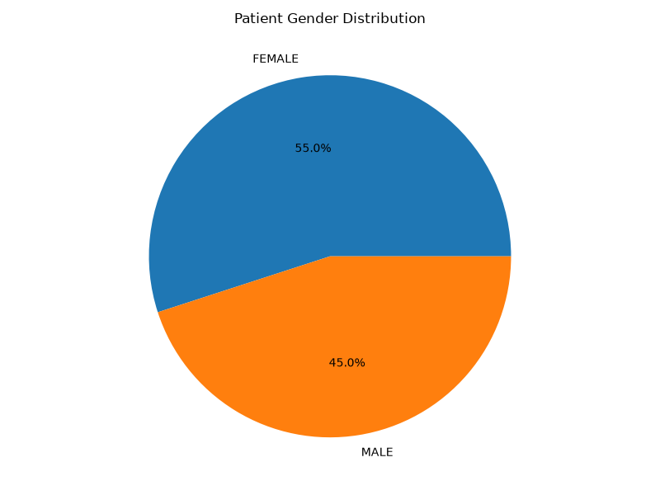

Age
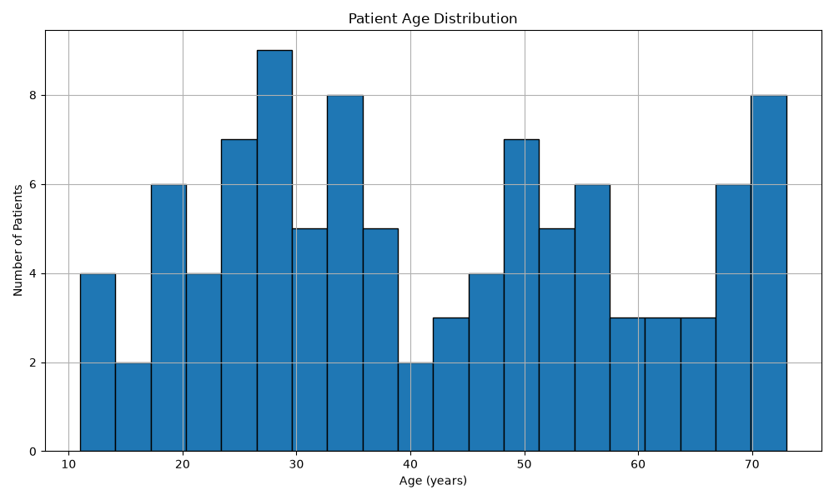

Referrals
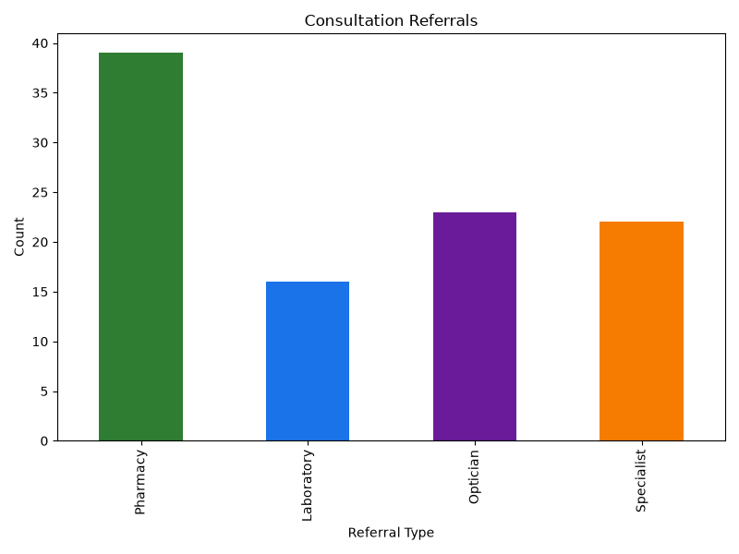

Malaria
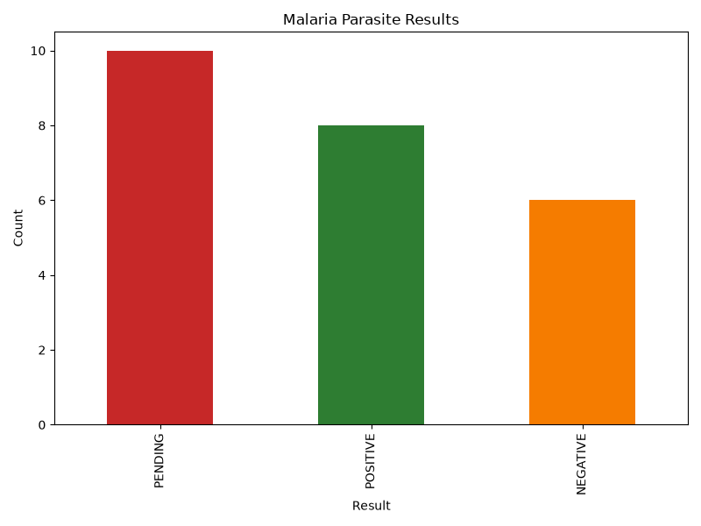

Drug Categories
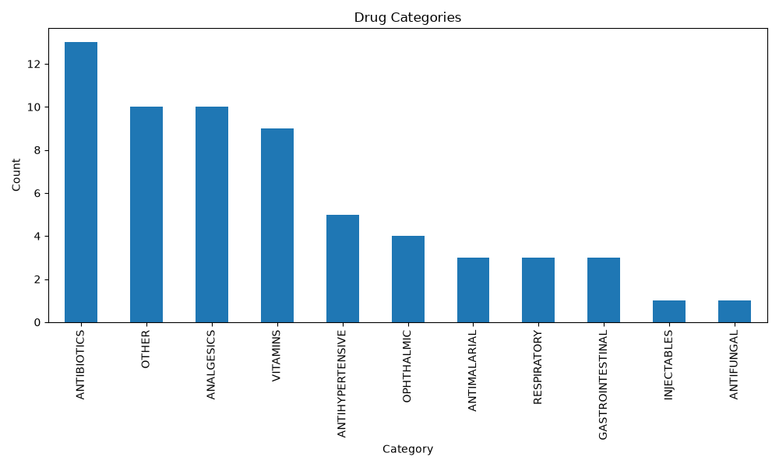

======================================================================
Report generated by COREP Outreach System
Generated on: 2026-08-27 07:08:07

