COREP Clinical Data Analysis Report ™
Generated on 2026-09-17 11:27 | Landscape · 0.5" margins
Blessedera Glowtechies Innovative Enterprises / CAC NO. 9156249™
Developed by omobuwa BLESSED ADEOYE · Data Scientist & Analytics Engineer, Health Information Management Specialist
© 2026 Blessedera Glowtechies Innovative Enterprises / CAC NO. 9156249™. All rights reserved.

1. Executive Summary
Total Patients | 189
Gender Split | FEMALE: 150, MALE: 39
Average Age | 40.4 years
Top 5 Diagnoses | Malaria (17) | Arthritis (11) | Allergies (6) | Hypertension (5) | Stable (4)
Malaria Positive Tests | 0
Top 5 Dispensed Drugs | Multivite (13) | Vit c (11) | Albendazole 400mg stat (10) | Vit bco (9) | Vitamin c (9)
Drugs Needing Reorder | 19

2. Charts & Findings

2.1 Patient Demographics
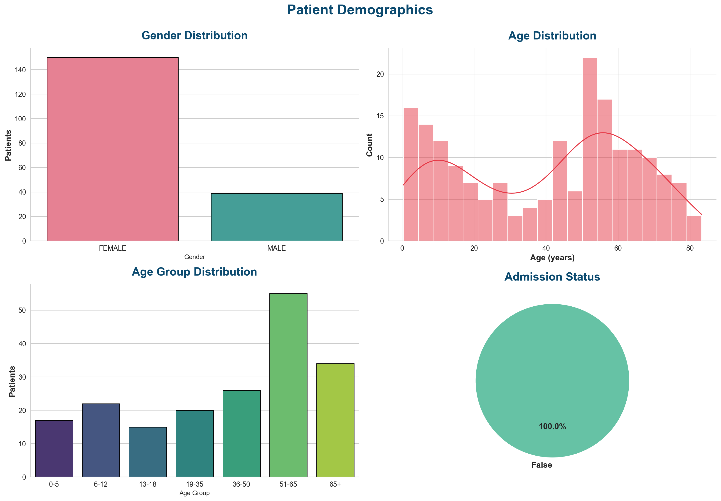

2.2 Top 15 Diagnoses
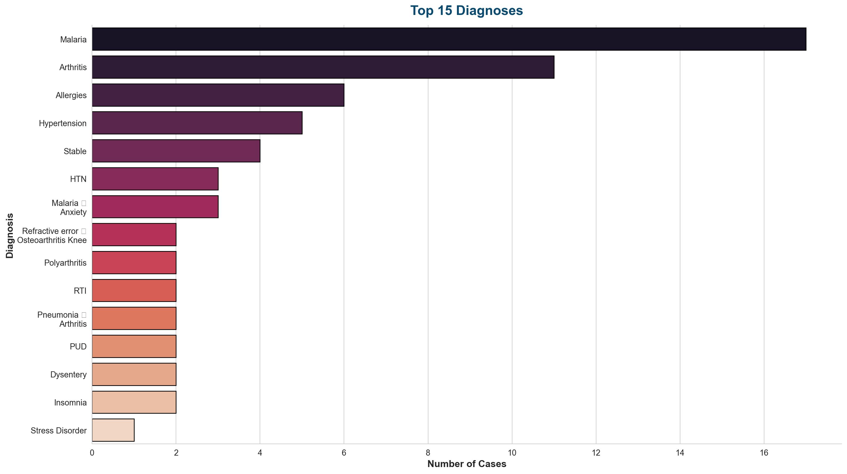

2.3 Top 15 Dispensed Drugs
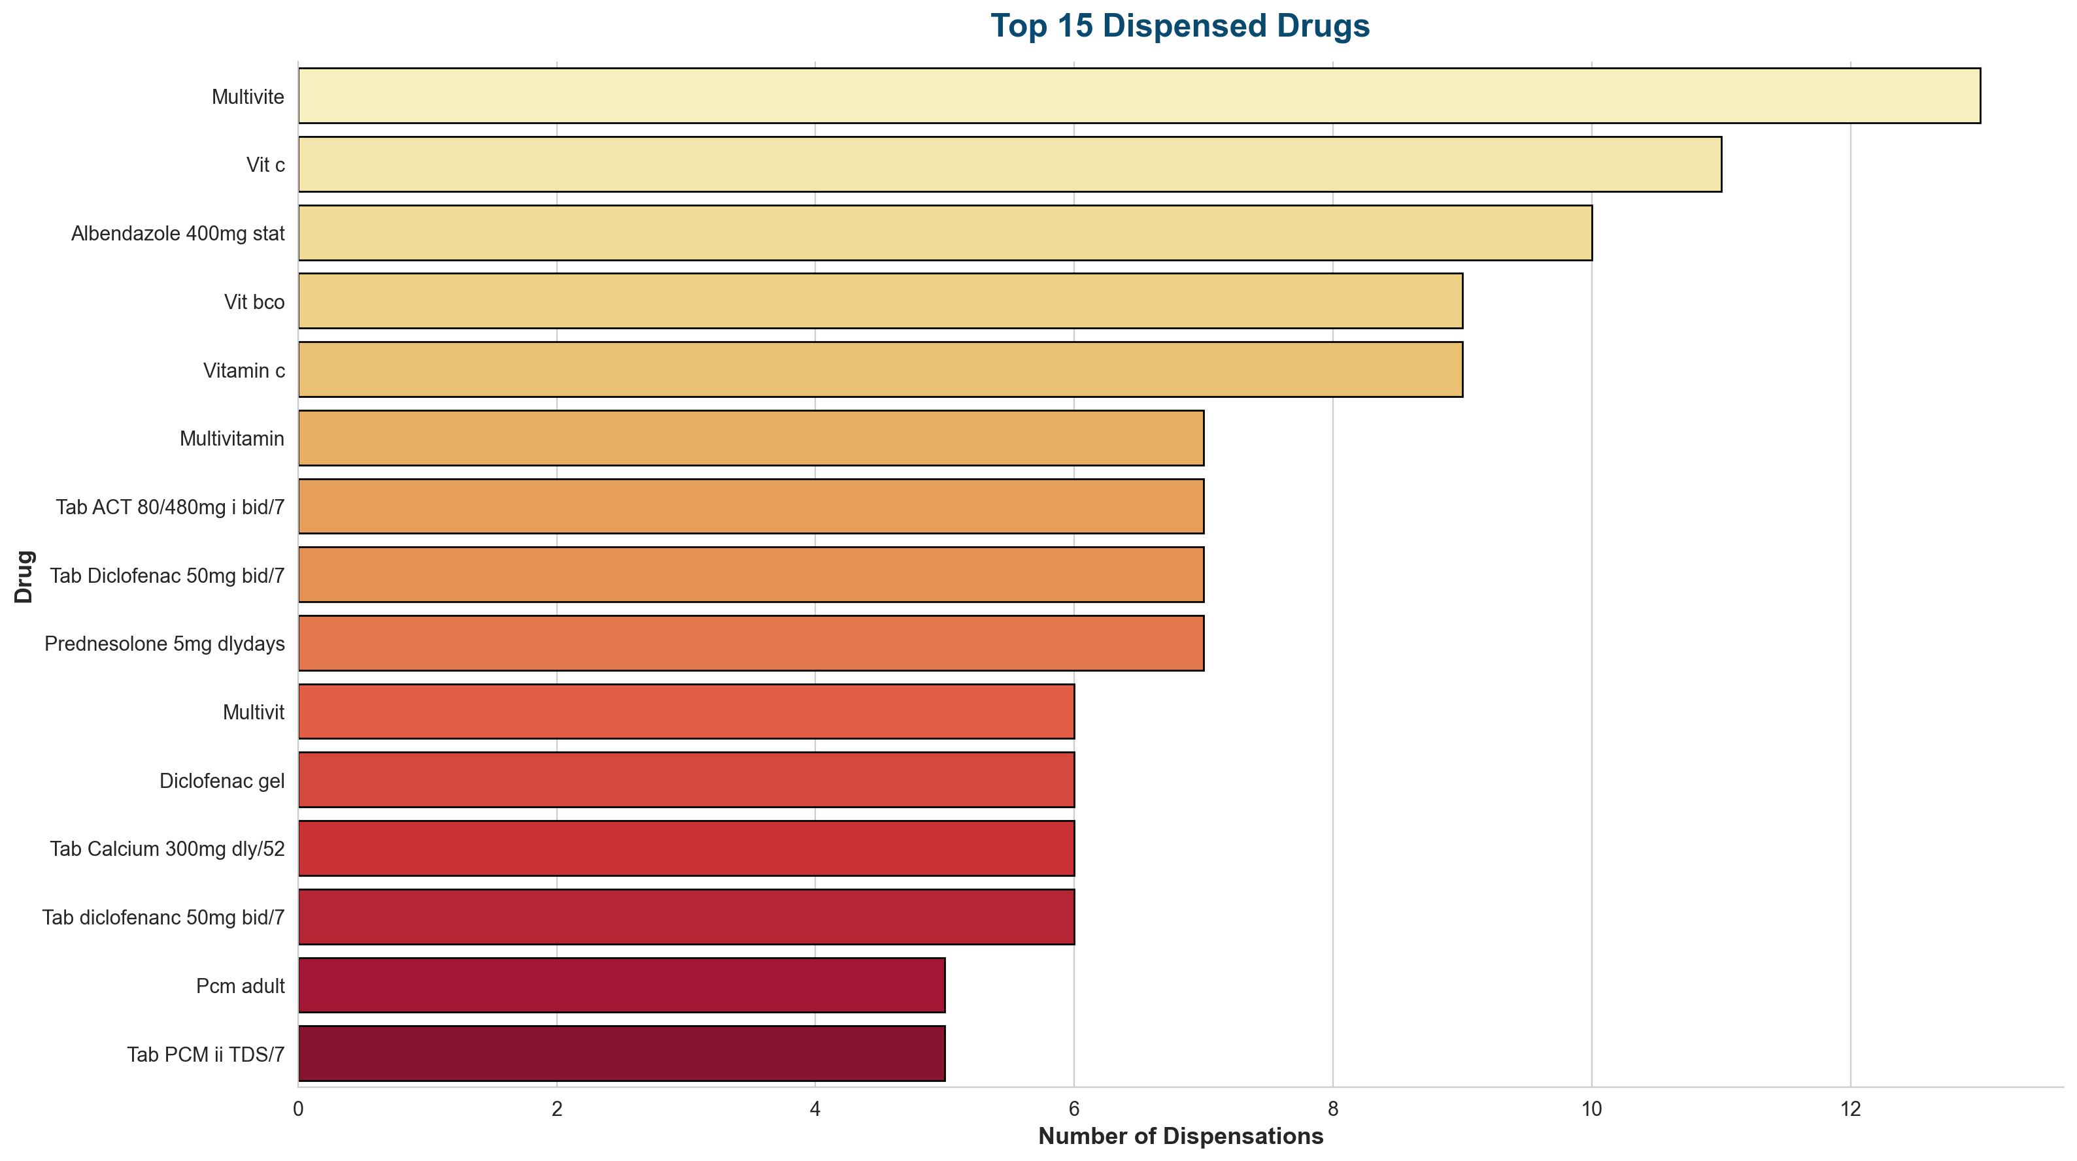

2.4 Vital Signs
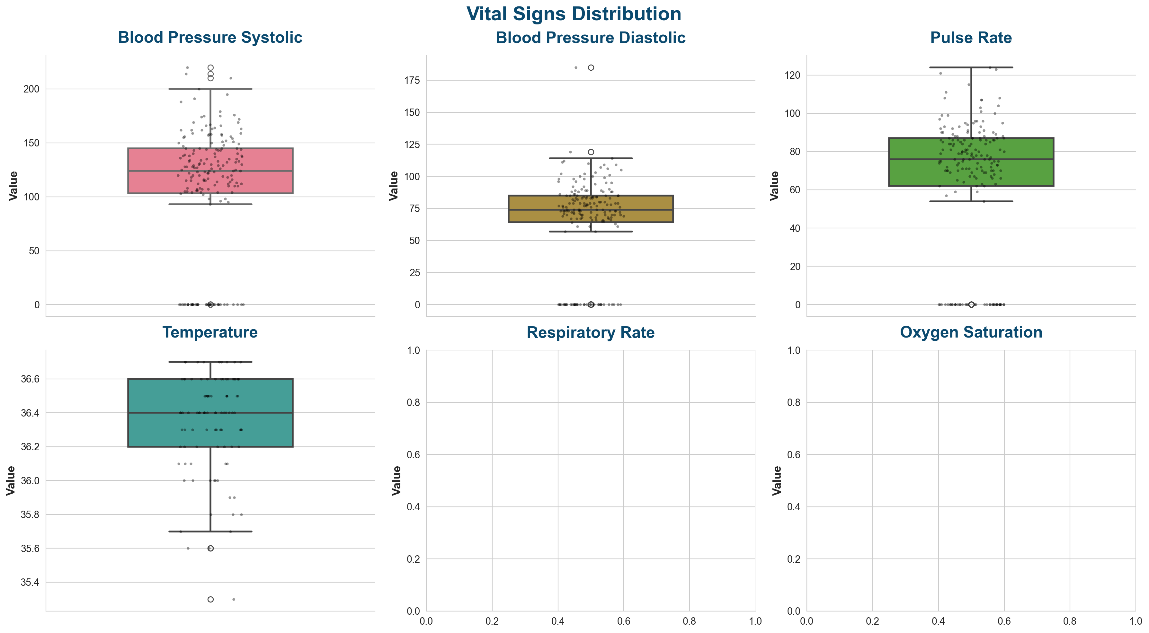

3. Treatment Plans (Clinical Only)
Prescription-related text has been removed. Only clinical/non-pharmacy instructions are shown.
Consultation ID | Treatment Plan (Clinical)
1 | Diclofenac Tizanidine Gelusil 2
2 | Nifedipine Hydrex
3 | Prednesolone
4 | Refered to Eye Antallergebeye drop 1 bid x 2weeks Vitamin b co Multivitamin
5 | Diclofenac Cough
6 | Cefixime Vitc c Vitamin b Co Multivit
7 | Diclofenac Vit bco Piriton
8 | Diclofenac Vit bco Muktivit Prition Diclofenac gel
9 | Diclofenac Vit bco Muktivit Prition Diclofenac gel
11 | Nifedipine Vasoprin Diclofenac
12 | Vit c Multivite Piriton
13 | Antallerge eye drop Vit c Vitbco Multivite
14 | Vitc c Mutivit Diclofenac
15 | Flagyl Tab
16 | Amoxil 5mls Vit c
17 | Diclofenac Prednesolone Vit c Multivit Vitbco Mectizan
18 | Vit c Multivit Vit bco
20 | Mectizan Yeast 2 x 2 weeks
21 | Yeast 3 x 1 month Loratdadine Vitamin b Co Multivitamin
22 | Nifidipine Vasoprin , then Diclofenac Albedazole

4. Key Insights
- Patient registrations show a consistent trend — monitor monthly volume.
- Top diagnoses drive most of the clinical workload.
- Referral pathway shows the strongest downstream load.
- Low-stock alerts must be actioned promptly.
- Use forecasting to plan drug & staff demand.
- Patient clusters reveal distinct risk groups.

