COREP Clinical Data Analysis Report
Generated on 2026-09-17 09:58

1. Executive Summary
Total Patients | 189
Gender Split | FEMALE: 150, MALE: 39
Average Age | 40.4 years
Admitted Patients | 0
Top 5 Diagnoses | Malaria (17) | Arthritis (11) | Allergies (6) | Hypertension (5) | Stable (4)
Malaria Positive Tests | 0
Top 5 Drugs | Prescription from Treatment Plan (121) | Multivite (13) | Vit c (11) | Albendazole 400mg stat (10) | Vitamin c (9)
Drugs Needing Reorder | 19

2. Charts & Findings
Patient Demographics
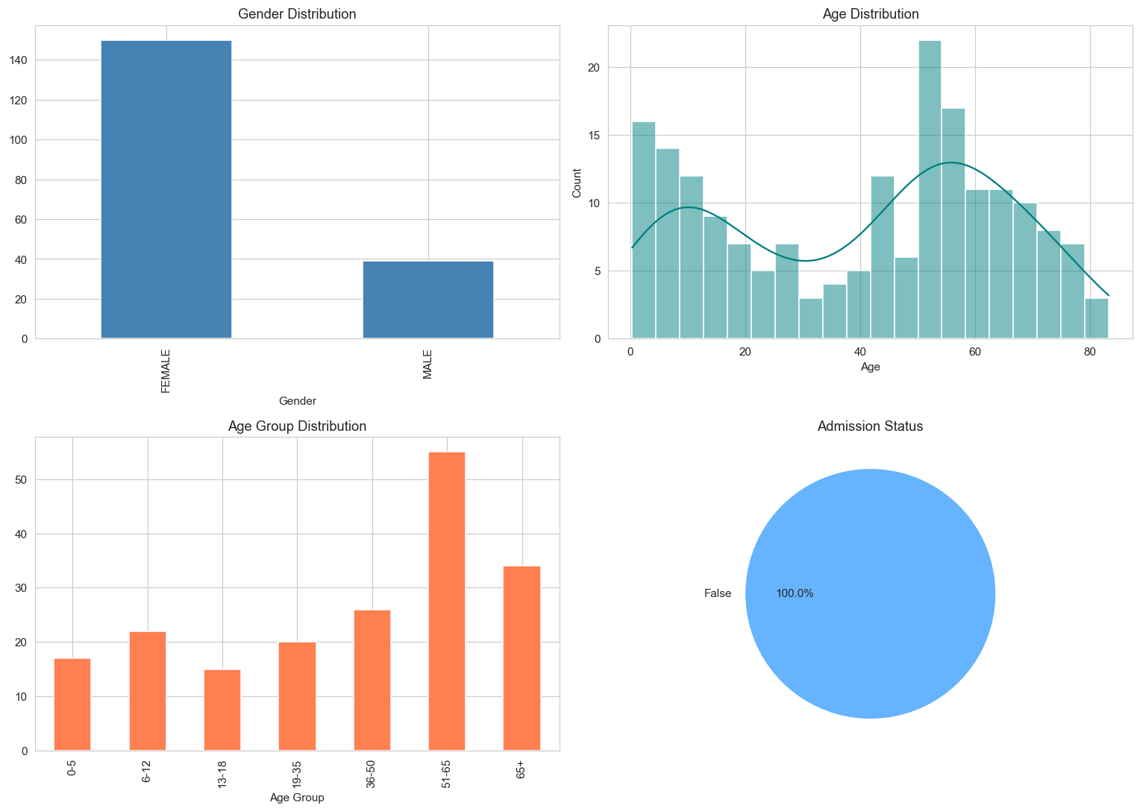

Vitals Boxplots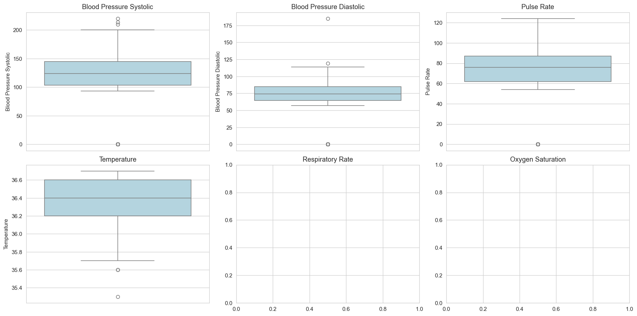

Registrations By Dayofweek
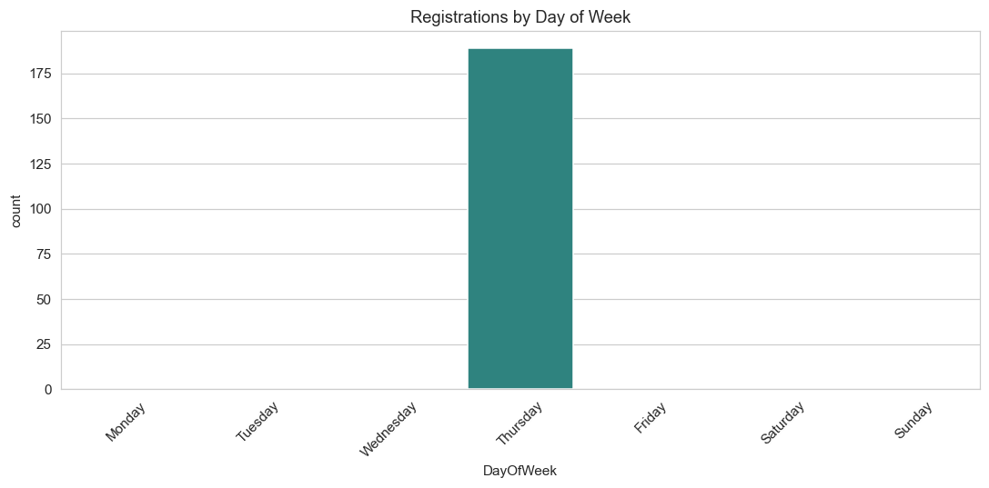

Vitals Distributions
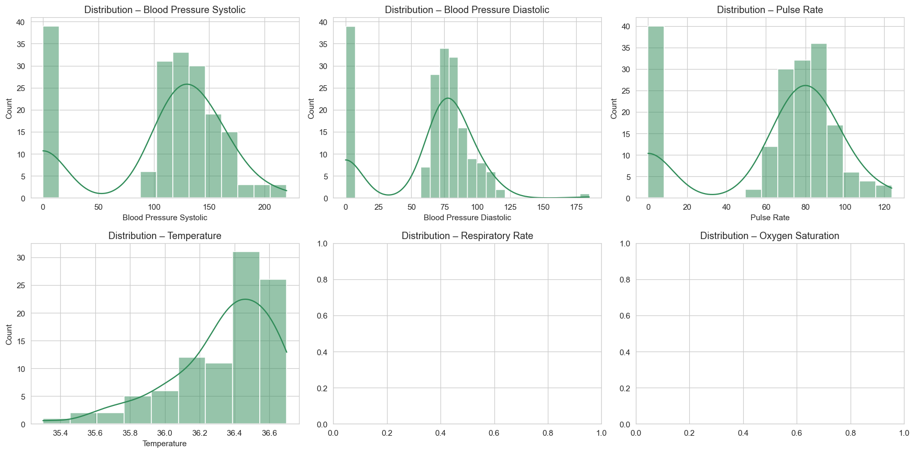
Vitals Correlation
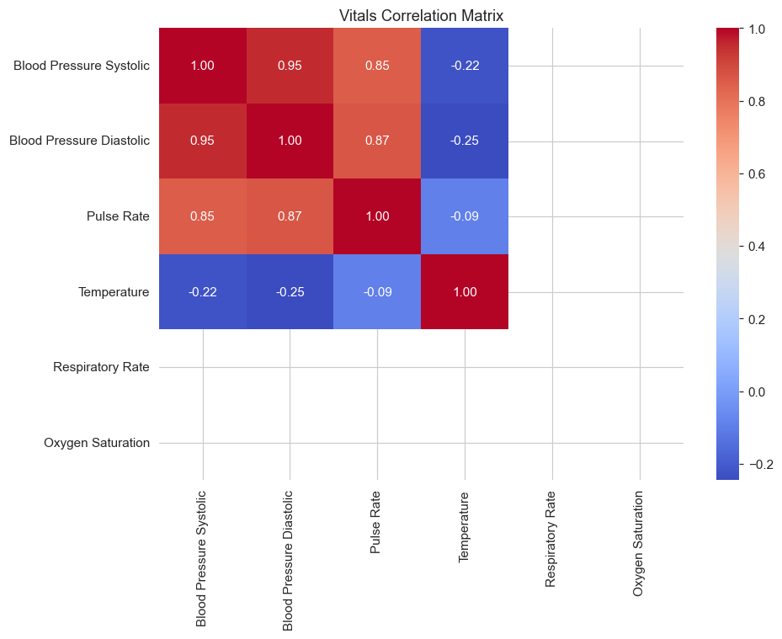

Biohazard Isolation
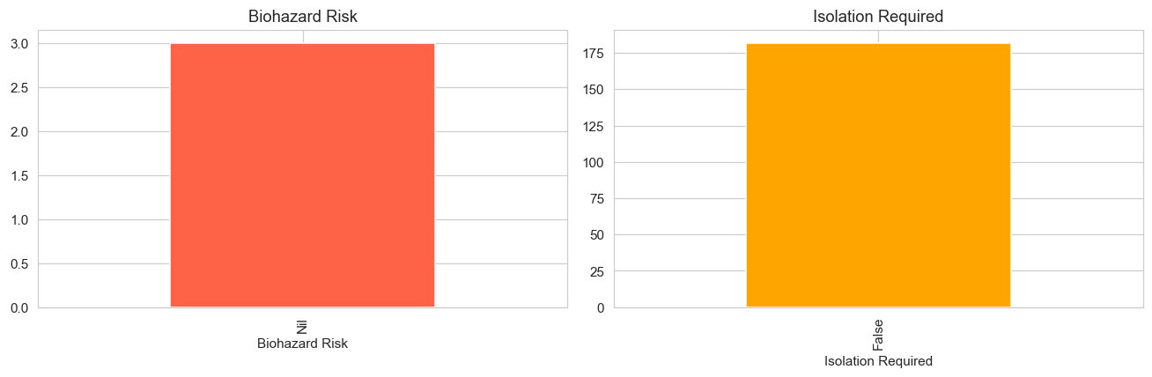
Top15 Diagnoses
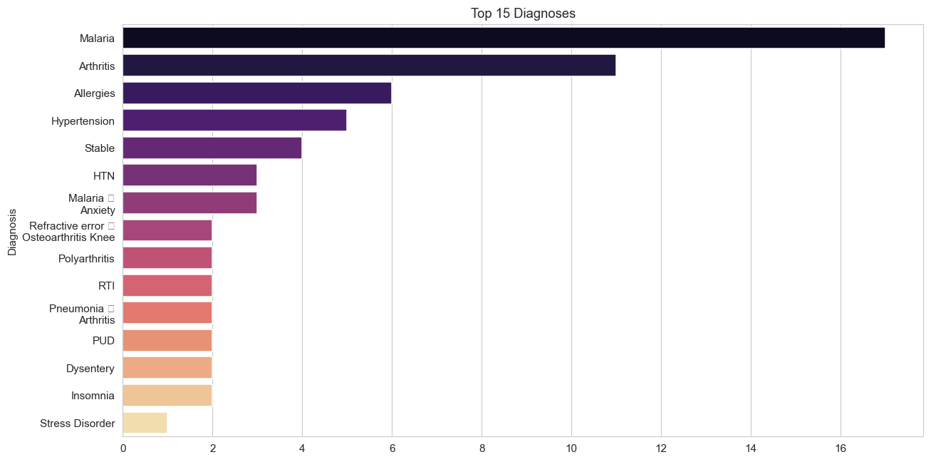
Diagnoses By Gender
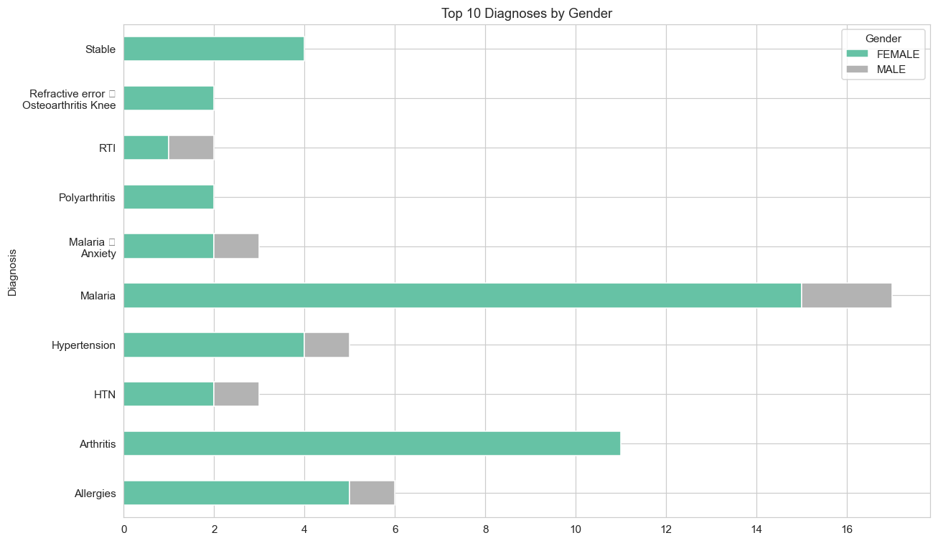

Referrals
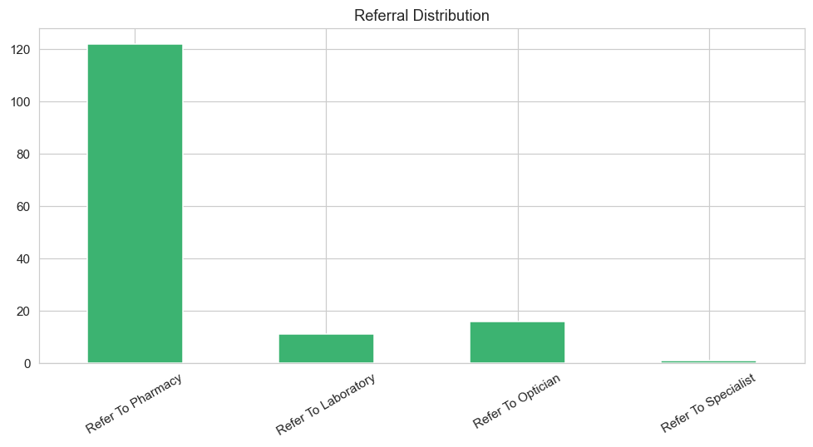

Consultations By Hour
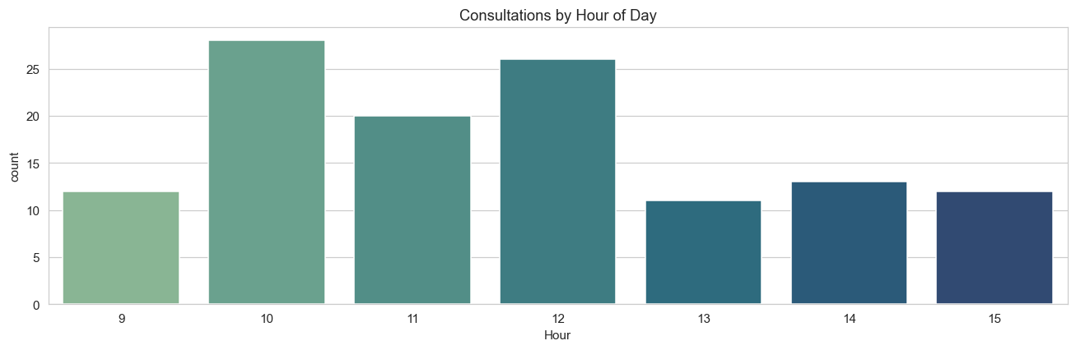

Lab Test Results
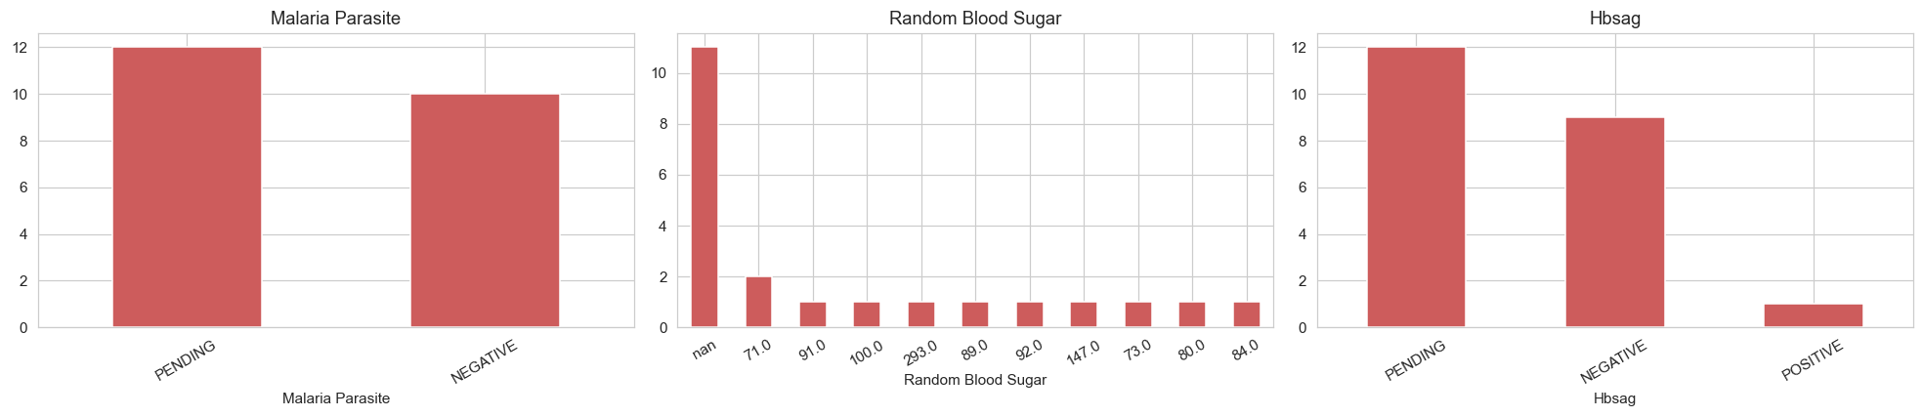
Lab Turnaround Time
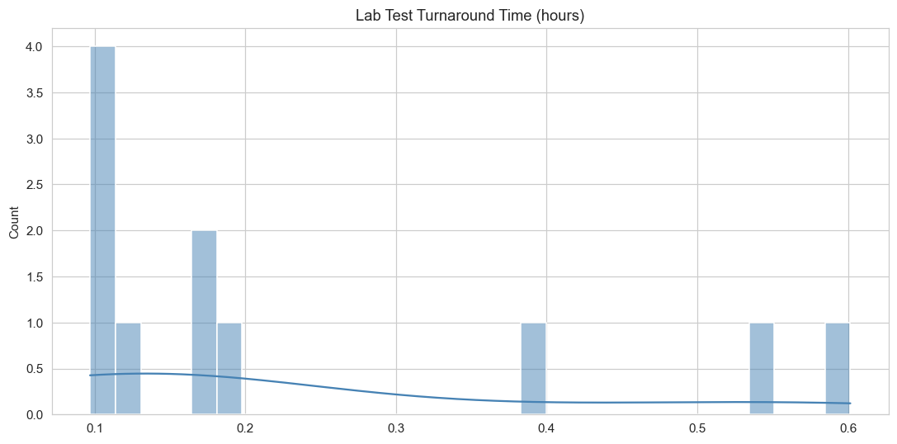

Top15 Drugs
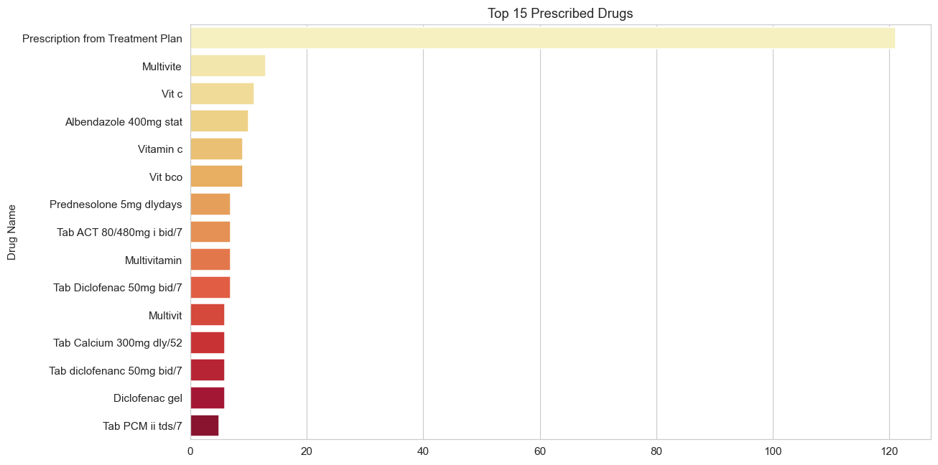

Dispense Rate

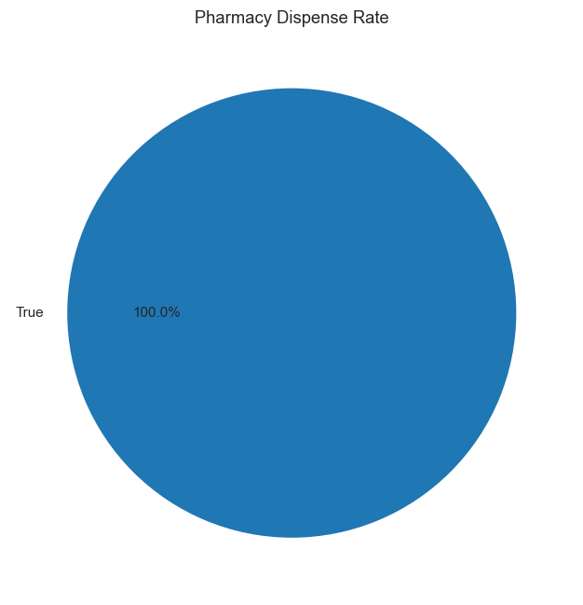

Stock By Category
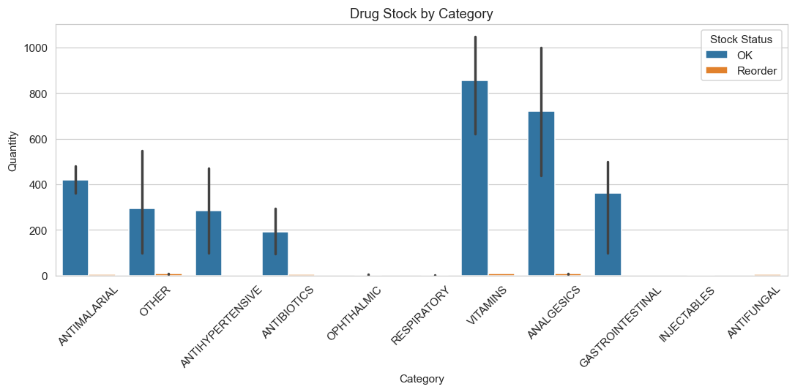

Patient Journey Funnel
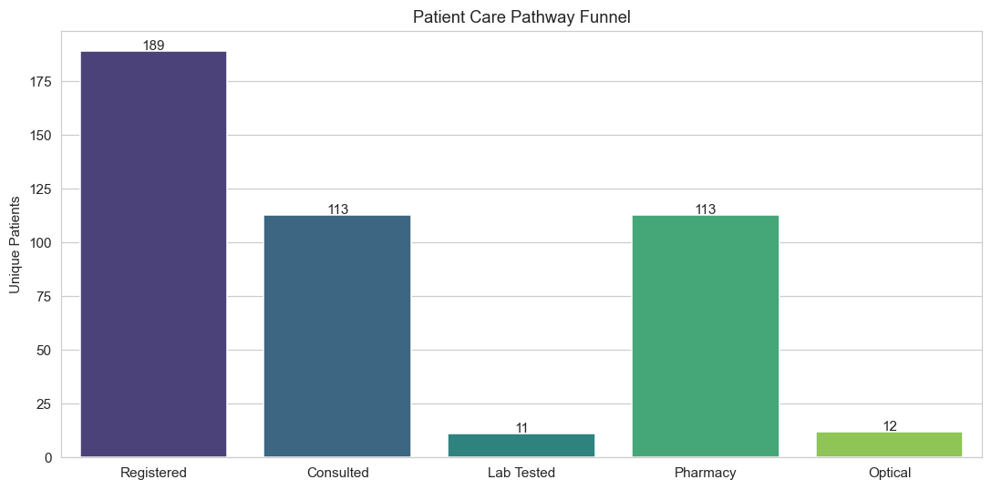

Children Diagnoses
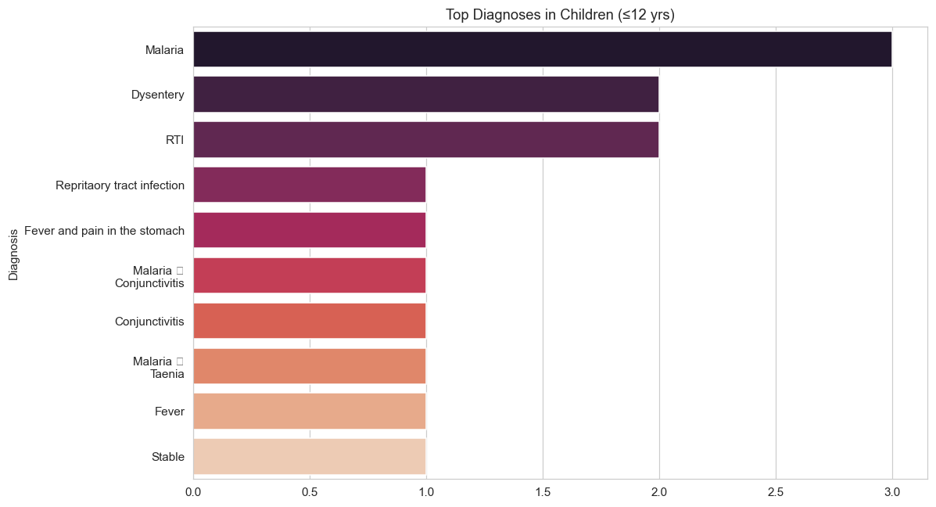

Malaria Drugs
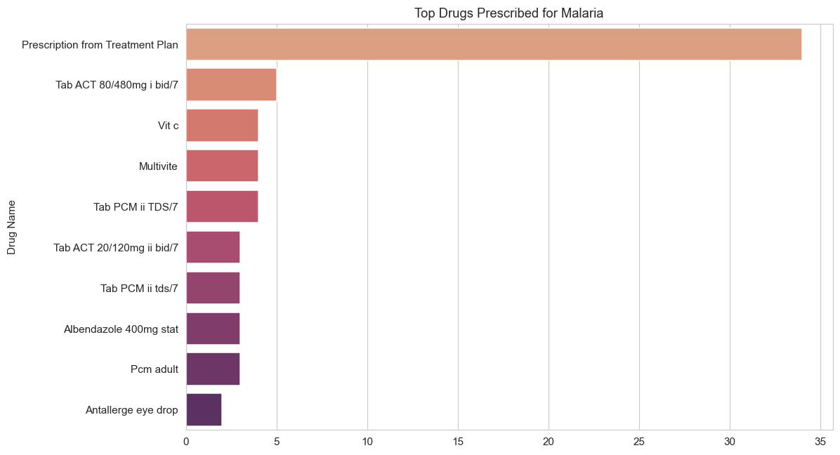

Malaria By Age
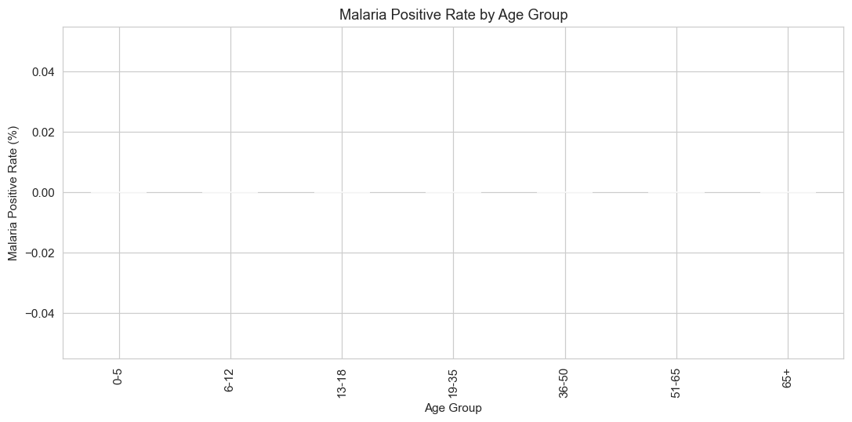

Consult To Lab Time
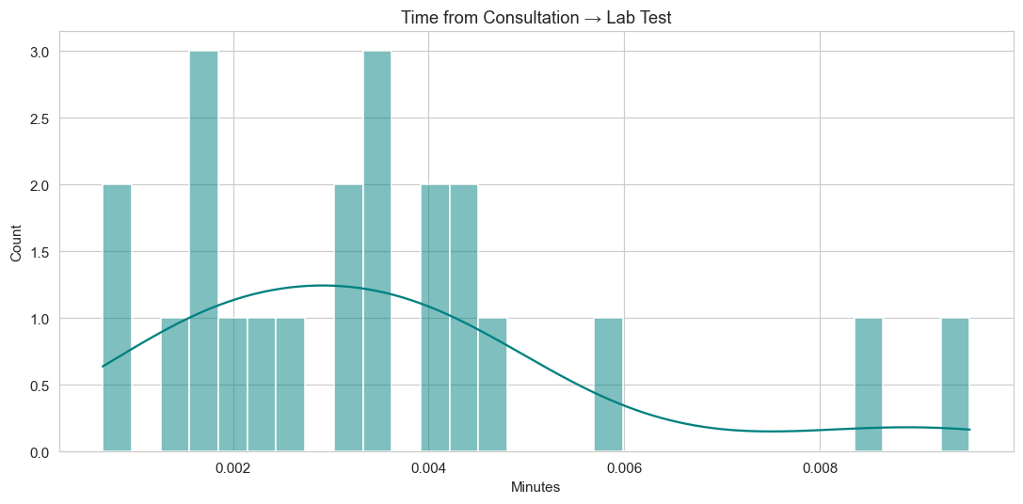

Staff Workload
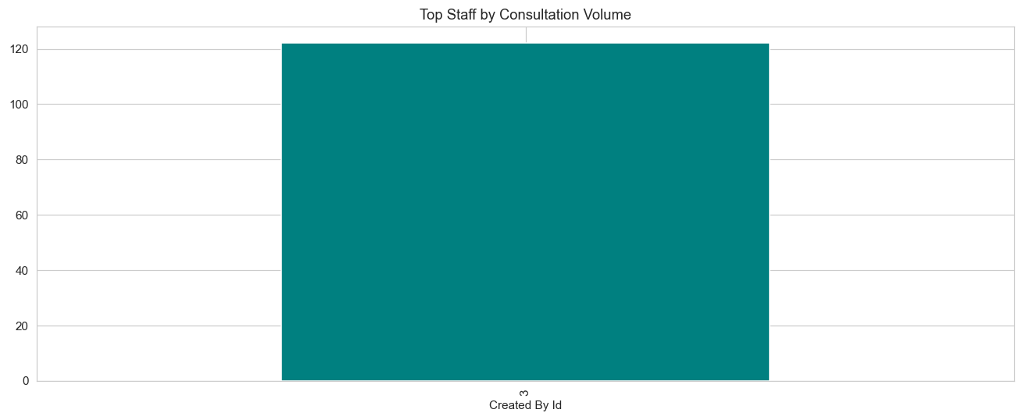

3. Key Insights
- Patient registrations show a consistent trend — monitor monthly volume for resource planning.
- Top diagnoses drive most of the clinical workload — target training and drug stocking accordingly.
- Referral pathway indicates the strongest downstream load (Lab vs Pharmacy vs Optical).
- Low-stock alerts must be actioned promptly to avoid stockouts.
- Use the forecasting module to plan drug & staff demand for the coming month.
- Patient clusters reveal distinct risk groups for targeted interventions.

