COREP Clinical Data Analysis Report
Generated on 2026-09-17 10:24

1. Executive Summary
Total Patients | 189
Gender Split | FEMALE: 150, MALE: 39
Average Age | 40.4 years
Admitted Patients | 0
Top 5 Diagnoses | Malaria (17) | Arthritis (11) | Allergies (6) | Hypertension (5) | Stable (4)
Malaria Positive Tests | 0
Top 5 Dispensed Drugs | Multivite (13) | Vit c (11) | Albendazole 400mg stat (10) | Vit bco (9) | Vitamin c (9)
Drugs Needing Reorder | 19
2. Charts & Findings
Patient Demographics
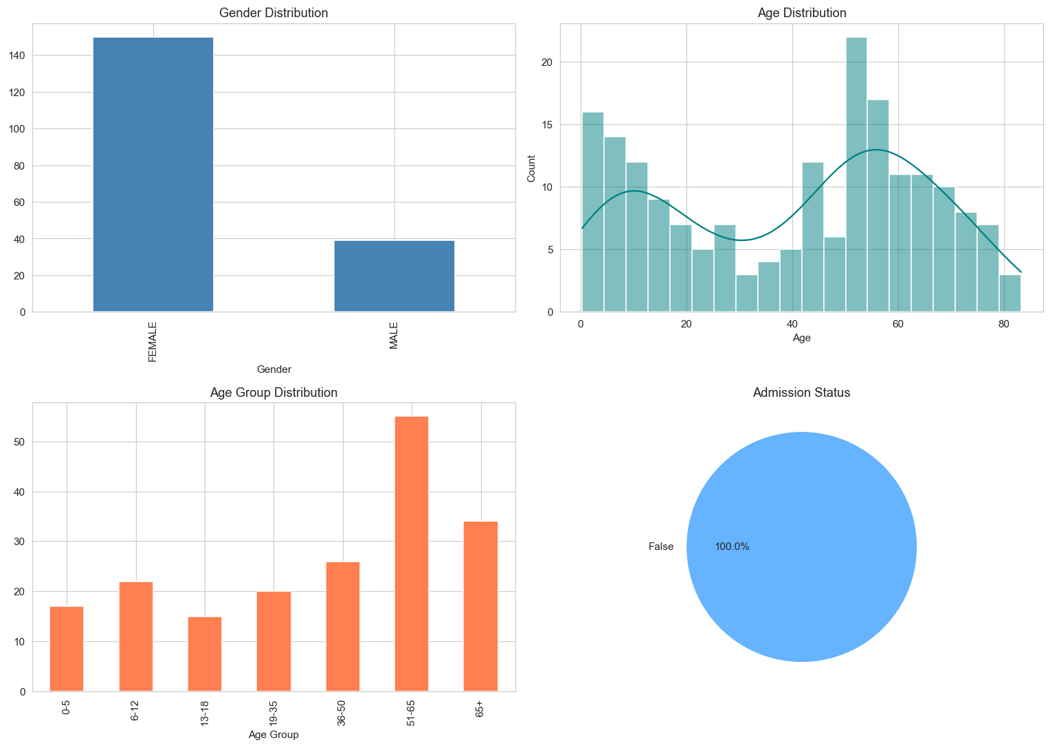

Vitals Boxplots
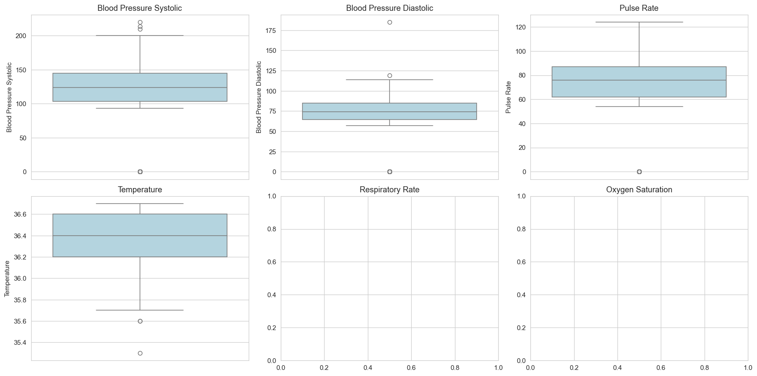

Registrations By Dayofweek
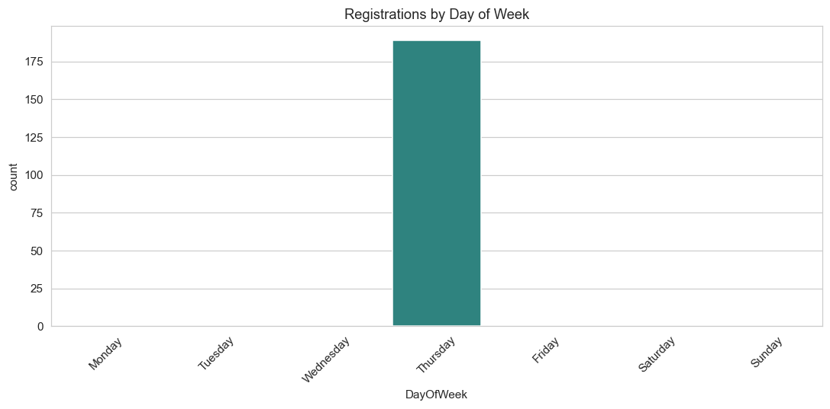

Vitals Distributions
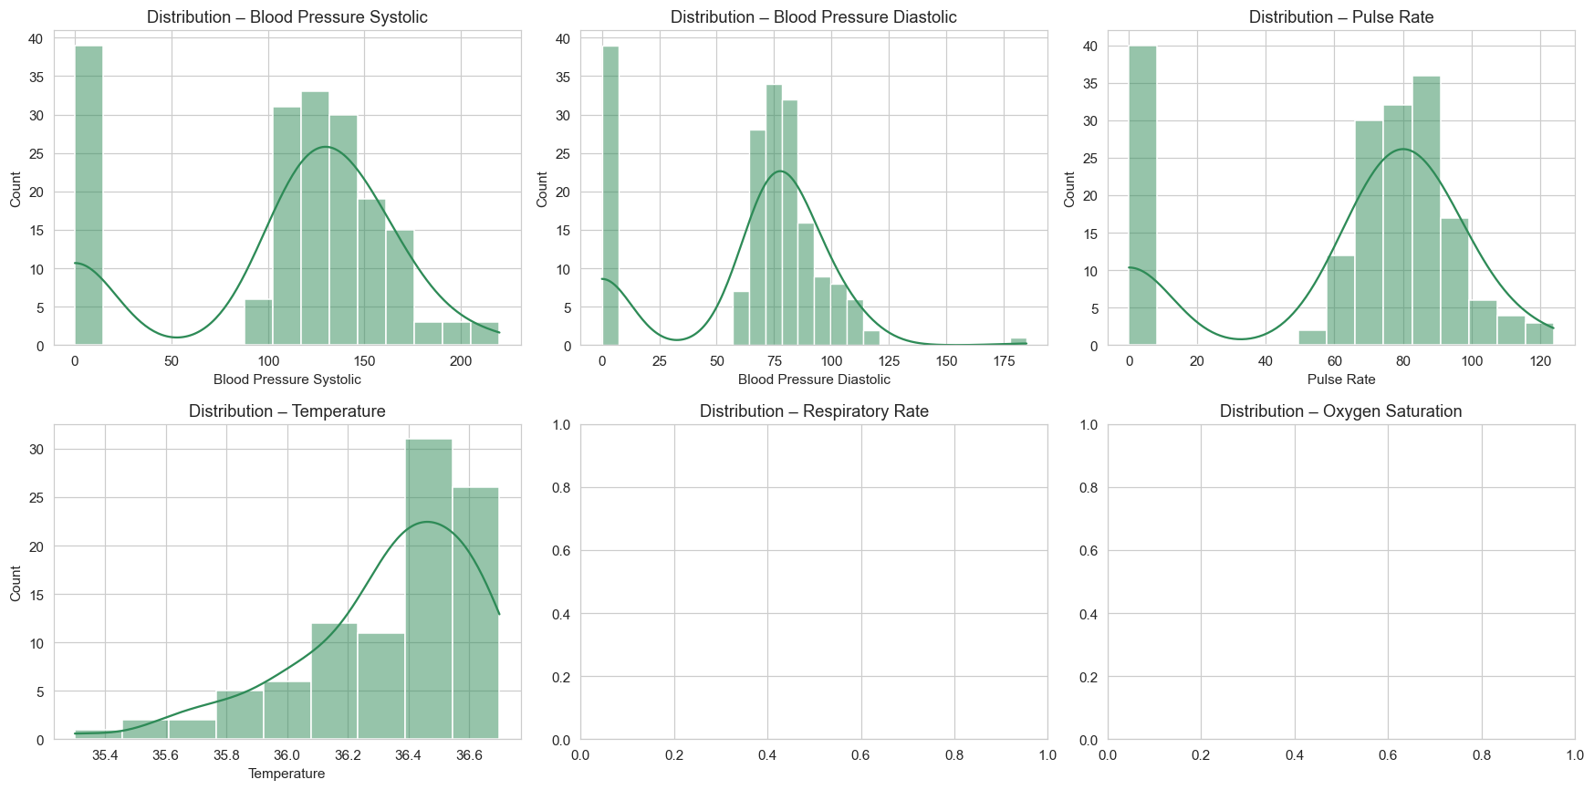

Vitals Boxplots

Vitals Correlation
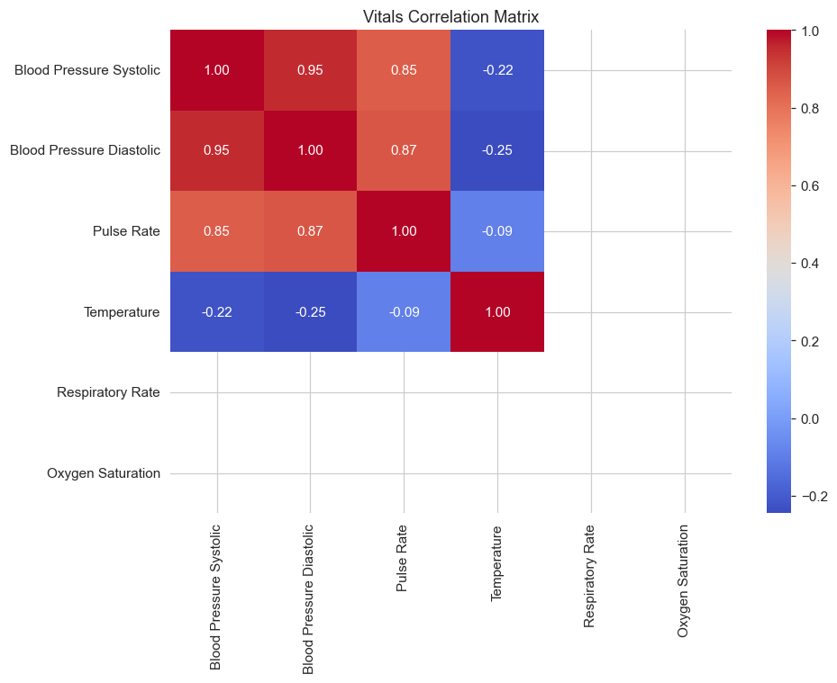

Biohazard Isolation
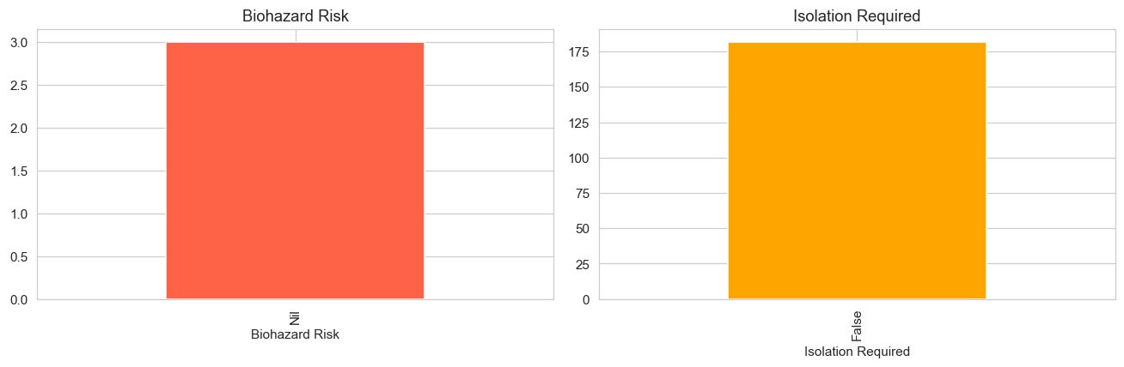

Vitals Distributions

Top15 Diagnoses
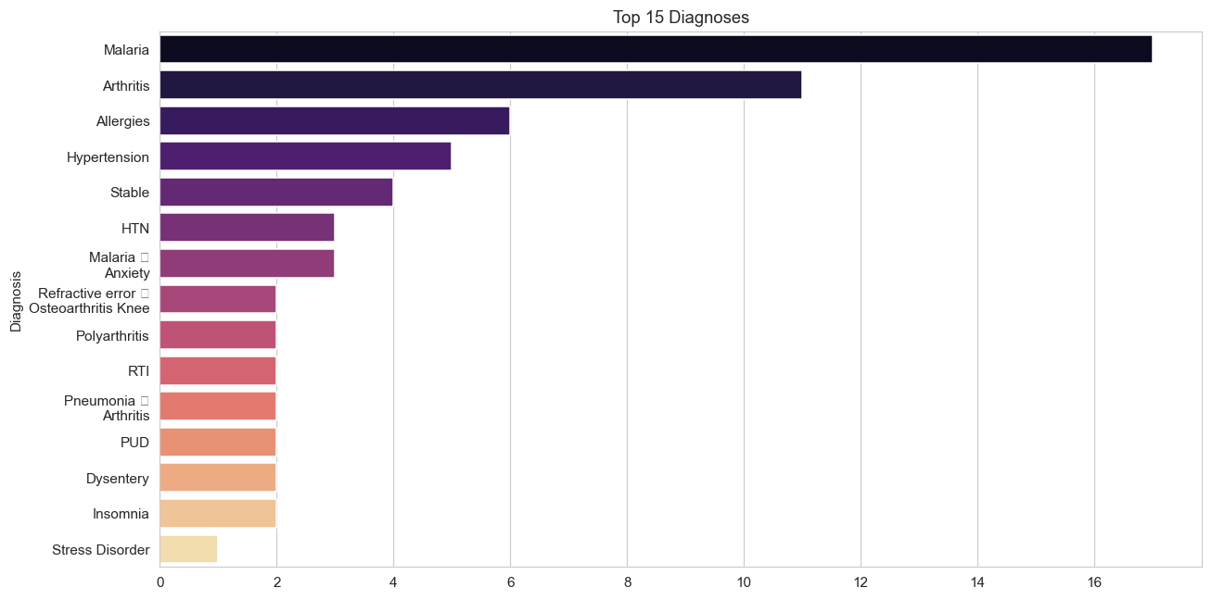

Vitals Correlation

Biohazard Isolation

Top15 Diagnoses

Diagnoses By Gender
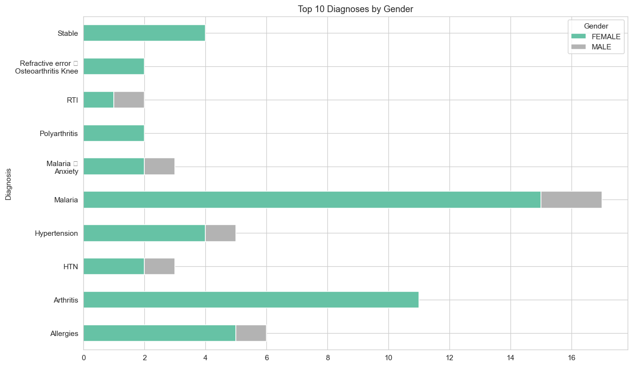

Referrals
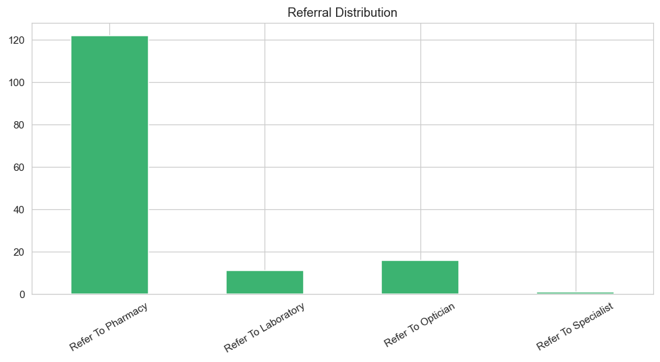

Monthly Consultations
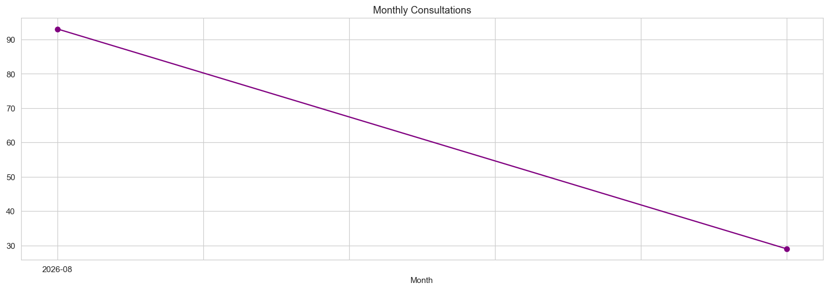

Consultations By Hour
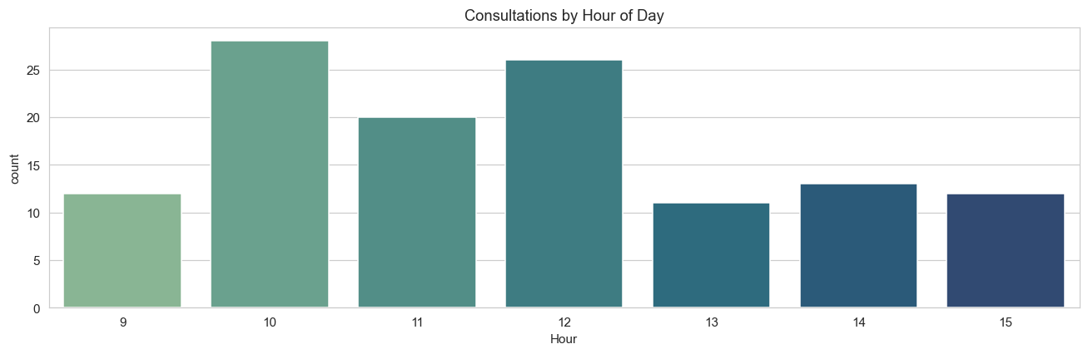

Lab Test Results
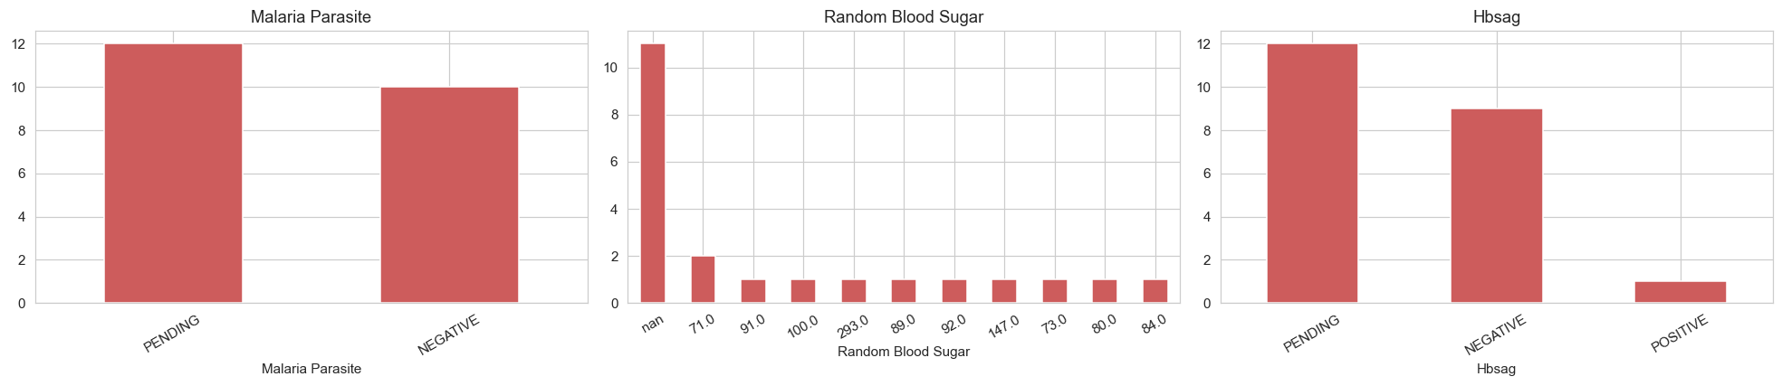

Lab Turnaround Time
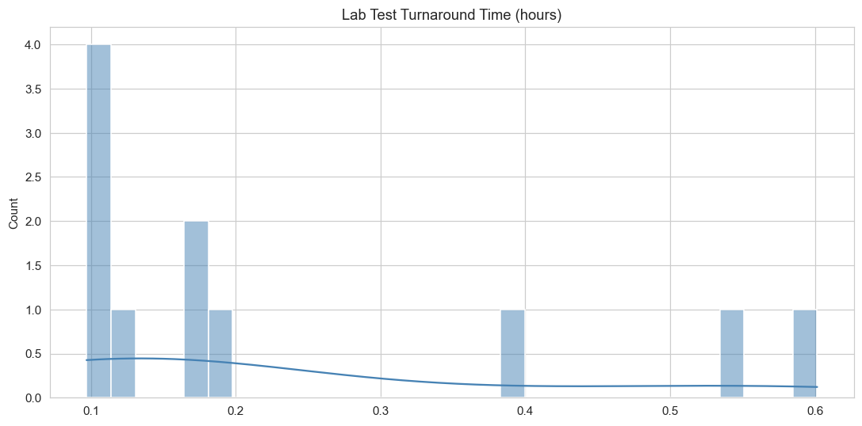

Optical Walkin Vs Referred
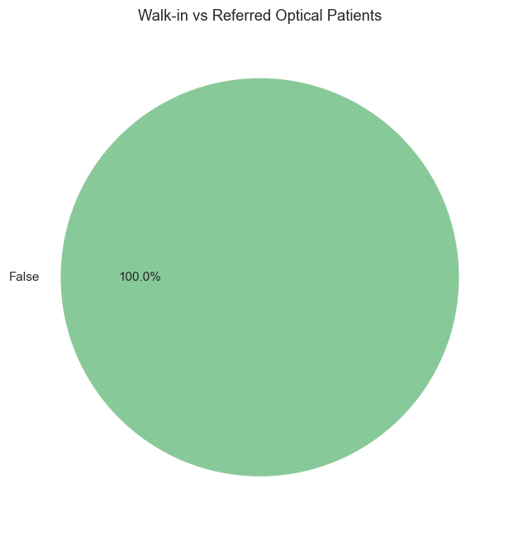

Glasses Allocated
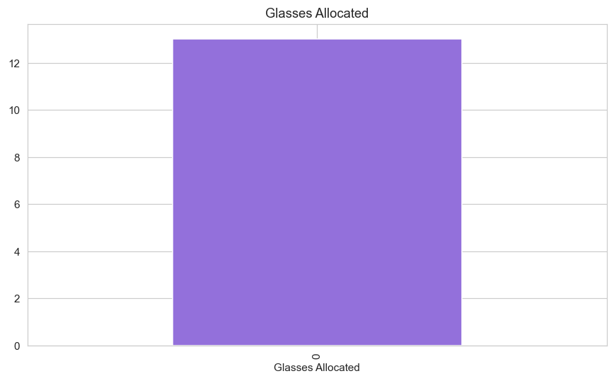

Visual Acuity
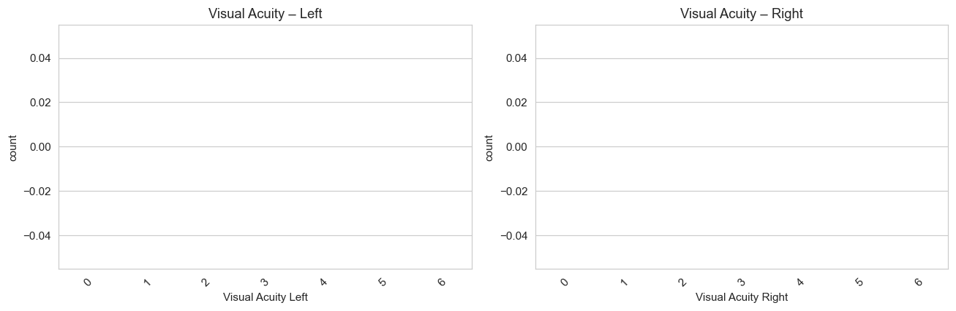

Top15 Drugs
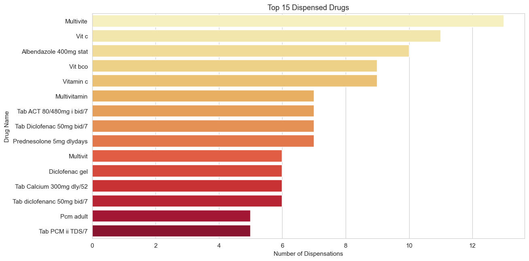

Dispense Rate
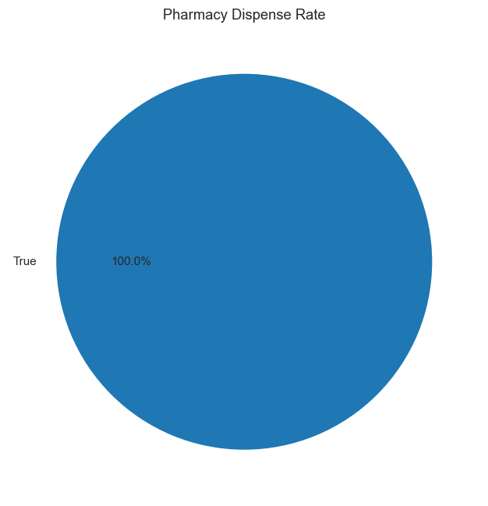

Stock By Category
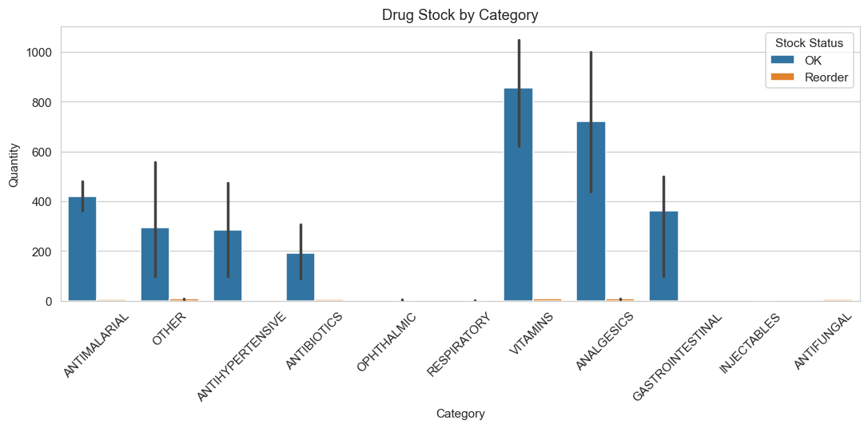

Patient Journey Funnel
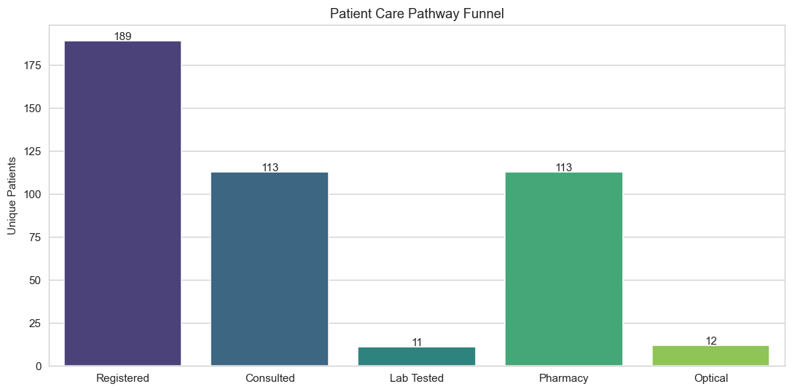

Children Diagnoses
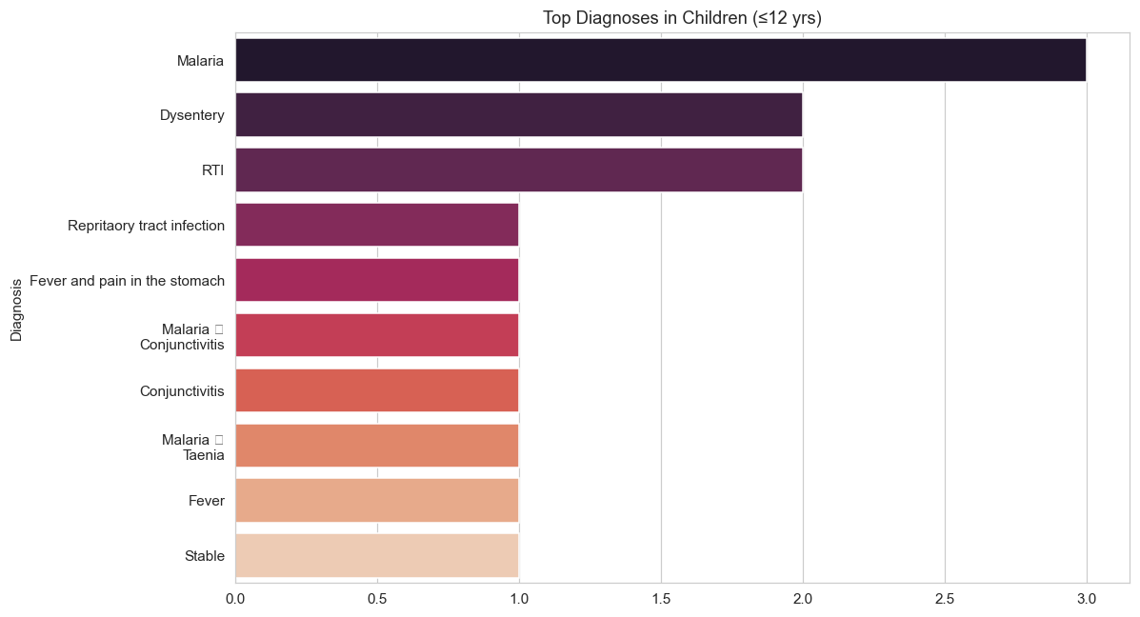

Admission By Gender
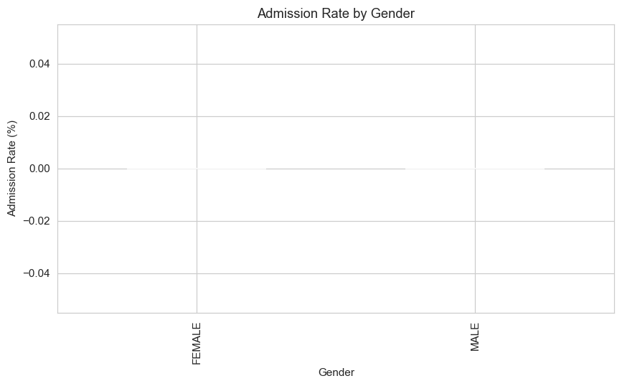

Malaria Drugs
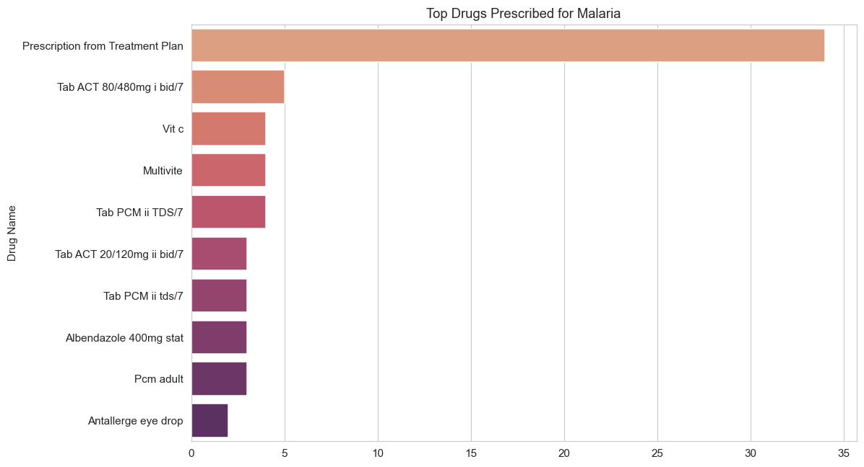

Malaria By Age
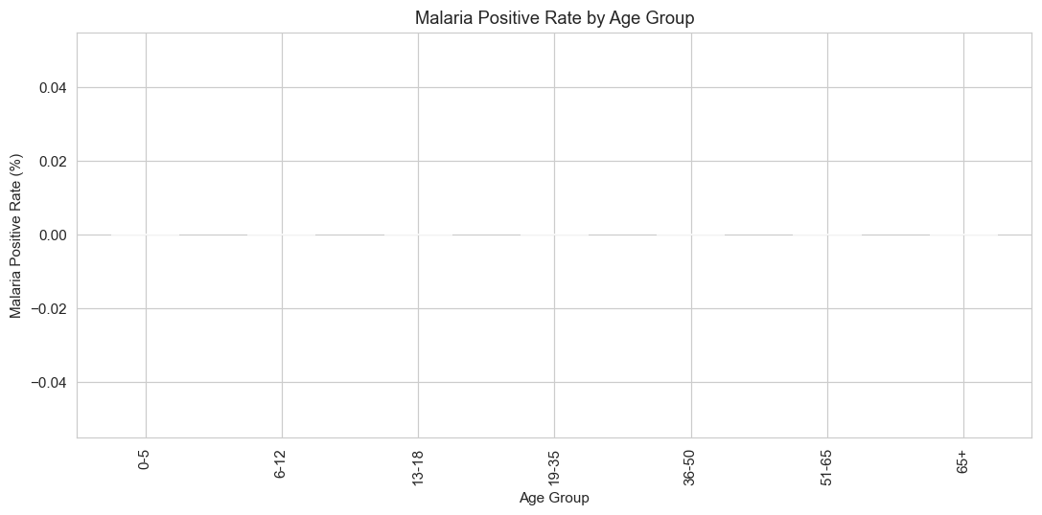

Consult To Lab Time
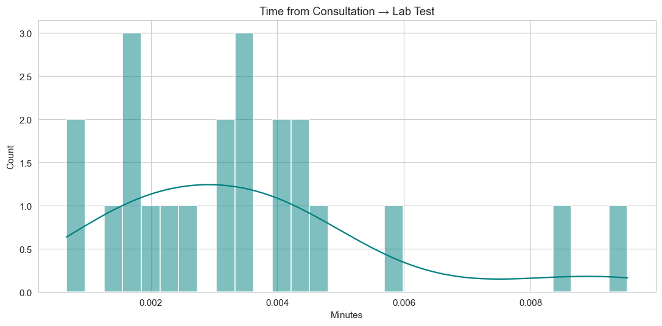

Staff Workload
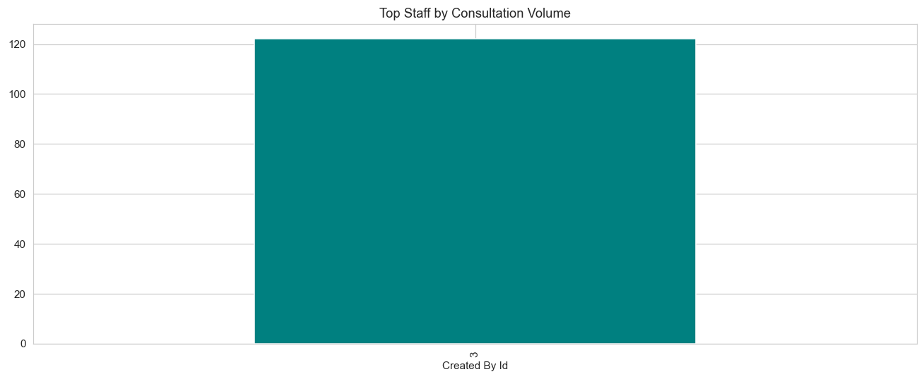

3. Treatment Plans (Clinical Only)
Prescription-related text has been removed. Only clinical/non-pharmacy instructions are shown.
Consultation ID | Treatment Plan (Clinical)
1 | Diclofenac Tizanidine Gelusil 2
2 | Nifedipine Hydrex
3 | Prednesolone
4 | Refered to Eye Antallergebeye drop 1 bid x 2weeks Vitamin b co Multivitamin
5 | Diclofenac Cough
6 | Cefixime Vitc c Vitamin b Co Multivit
7 | Diclofenac Vit bco Piriton
8 | Diclofenac Vit bco Muktivit Prition Diclofenac gel
9 | Diclofenac Vit bco Muktivit Prition Diclofenac gel
11 | Nifedipine Vasoprin Diclofenac
12 | Vit c Multivite Piriton
13 | Antallerge eye drop Vit c Vitbco Multivite
14 | Vitc c Mutivit Diclofenac
15 | Flagyl Tab
16 | Amoxil 5mls Vit c
17 | Diclofenac Prednesolone Vit c Multivit Vitbco Mectizan
18 | Vit c Multivit Vit bco
20 | Mectizan Yeast 2 x 2 weeks
21 | Yeast 3 x 1 month Loratdadine Vitamin b Co Multivitamin
22 | Nifidipine Vasoprin , then Diclofenac Albedazole

4. Key Insights
- Patient registrations show a consistent trend — monitor monthly volume for resource planning.
- Top diagnoses drive most of the clinical workload — target training and drug stocking accordingly.
- Referral pathway indicates the strongest downstream load (Lab vs Pharmacy vs Optical).
- Low-stock alerts must be actioned promptly to avoid stockouts.
- Use the forecasting module to plan drug & staff demand for the coming month.
- Patient clusters reveal distinct risk groups for targeted interventions.

