Comprehensive Molecular Docking and Binding-Mode Analysis of Selected Polyphenols as Potential Alpha-Amylase Inhibitors
Target Protein: Alpha-Amylase (PDB ID: 2QV4)

1. Project Background and Description
Diabetes mellitus is a chronic metabolic disorder characterized by elevated blood glucose levels resulting from impaired insulin secretion, insulin resistance, or both. One important therapeutic strategy for controlling postprandial hyperglycemia involves inhibition of carbohydrate-digesting enzymes such as alpha-amylase. Alpha-amylase catalyzes the hydrolysis of starch into smaller sugars, thereby contributing to glucose release into the bloodstream.
This project was designed to computationally validate the hypothesis that naturally occurring dietary polyphenols can function as potential antidiabetic agents through inhibition of alpha-amylase activity. Molecular docking studies were performed using AutoDock-based docking simulations against alpha-amylase (PDB ID: 2QV4).
Five selected polyphenolic compounds - Luteolin, Quercetin, Catechin, Pelargonidin, and Epigallocatechin Gallate (EGCG) - were docked against the enzyme and compared with Acarbose, a clinically approved alpha-amylase inhibitor, and Maltotriose, the natural substrate molecule. The interaction patterns, docking scores, residue contacts, and binding modes were analyzed in order to determine inhibitory potential.
Docking scores were interpreted as indicators of binding affinity, where more negative values indicate stronger and more stable ligand-enzyme interactions. Residue interaction analysis was additionally used to evaluate the molecular mechanisms responsible for stabilization inside the catalytic pocket.

2. Docking Parameters
Target Enzyme: Alpha-Amylase
PDB ID: 2QV4
Docking Coordinates:
X = 14.29
Y = 46.06
Z = 24.0
Grid Dimensions = 24.0 × 26.0
Grid Radius = 9.7

3. Docking Score Summary
Compound | Category | Docking Score (kcal/mol)
Acarbose | Standard Drug | -9.242
Maltotriose | Substrate | -6.948
Luteolin | Polyphenol | -9.099
Quercetin | Polyphenol | -9.134
Catechin | Polyphenol | -8.773
Pelargonidin | Polyphenol | -8.631
Epigallocatechin Gallate (EGCG) | Polyphenol | -8.498
Alpha-Amylase (2QV4) | Target Enzyme | Reference Protein

4. Binding-Mode Analysis
Binding-mode analysis evaluates how ligands orient themselves within the active site of the target protein and identifies the molecular interactions responsible for stabilization of the ligand-enzyme complex. In alpha-amylase inhibition, interactions with catalytic and neighboring residues such as ASP197, ASP300, GLU233, TYR62, TRP59, HIS299, and HIS305 are particularly important because these residues contribute directly to substrate recognition, catalytic activity, and ligand stabilization.
The docking results demonstrated that stronger inhibitors generally formed:
• Extensive conventional hydrogen bonds
• Aromatic pi-pi stacking interactions
• Electrostatic interactions such as pi-anion or salt bridge interactions
• Multiple van der Waals contacts that enhanced steric complementarity
Polyphenols with aromatic ring systems were especially capable of forming strong hydrophobic and aromatic interactions with residues such as TRP59 and TYR62. These interactions improved active-site retention and contributed significantly to binding affinity.
The strongest-performing compounds, Quercetin and Luteolin, demonstrated binding modes highly comparable to Acarbose, suggesting their potential as natural alpha-amylase inhibitors.

Luteolin Binding-Mode Analysis
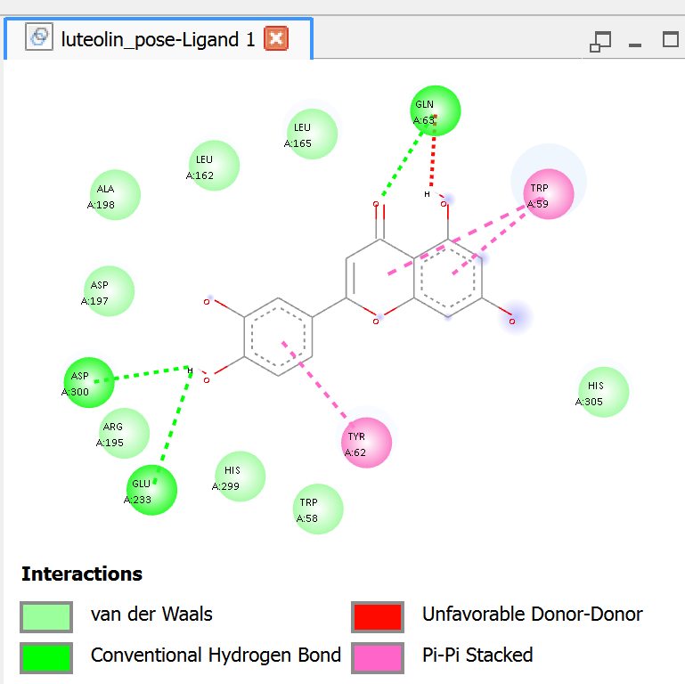
Luteolin exhibited a docking score of -9.099 kcal/mol, indicating very strong binding affinity towards alpha-amylase. The ligand occupied the catalytic pocket in a stable orientation that enabled multiple stabilizing interactions.
The molecule formed conventional hydrogen bonds with GLN63, ASP300, and GLU233. Hydrogen bonding is essential for proper ligand orientation and contributes significantly to stabilization within the active site. ASP300 and GLU233 are catalytically important acidic residues involved in substrate processing.
Luteolin additionally demonstrated pi-pi stacked interactions with TRP59 and TYR62. These aromatic interactions arise from overlap between the aromatic ring systems of the ligand and the aromatic side chains of amino acid residues. Pi-pi stacking significantly increases hydrophobic stabilization and active-site retention.
Several van der Waals interactions involving LEU162, LEU165, ASP197, HIS299, HIS305, ARG195, and TRP58 provided steric complementarity and helped stabilize the ligand-enzyme complex.
An unfavorable donor-donor interaction near GLN63 was observed; however, the extensive favorable interactions greatly outweighed this destabilizing effect. Overall, the interaction network explains the highly favorable docking score.

Quercetin Binding-Mode Analysis
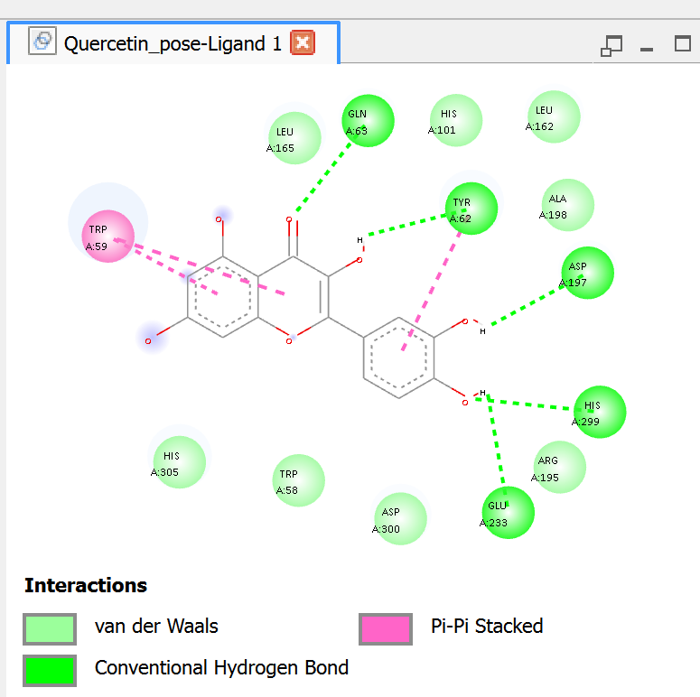
Quercetin recorded one of the strongest docking scores (-9.134 kcal/mol), making it the best-performing polyphenol in the study. Its binding orientation allowed extensive interactions within the catalytic pocket.
The ligand formed multiple conventional hydrogen bonds with GLN63, TYR62, ASP197, HIS299, and GLU233. These interactions enhanced ligand stability and ensured close proximity to catalytically important residues.
Strong pi-pi stacked interactions were additionally formed with TRP59 and TYR62. These aromatic interactions contribute substantially to binding affinity by increasing hydrophobic stabilization inside the active site.
Additional van der Waals contacts involving LEU165, LEU162, HIS101, ASP300, ARG195, HIS305, and TRP58 enhanced steric complementarity and active-site occupancy.
The simultaneous presence of extensive hydrogen bonding and aromatic stabilization explains why Quercetin achieved a docking score comparable to that of Acarbose.

7. Catechin Binding-Mode Analysis
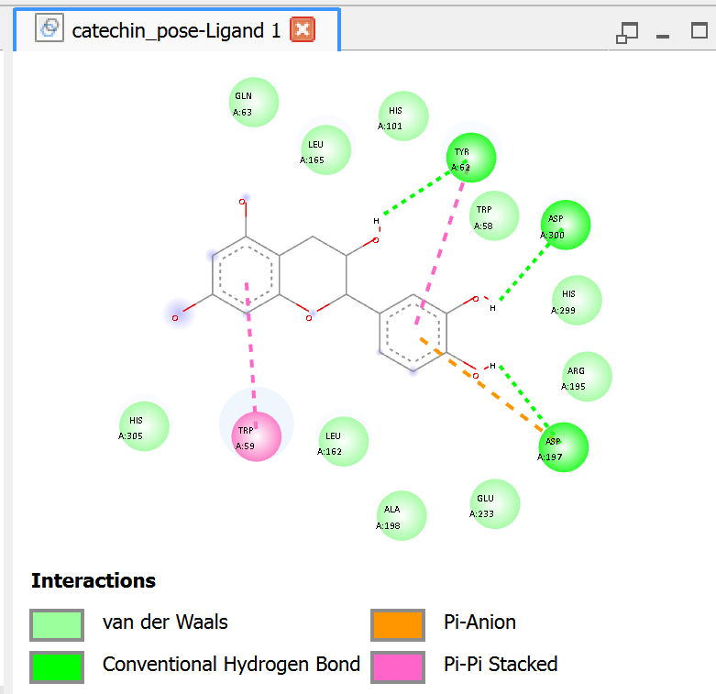
Catechin exhibited a docking score of -8.773 kcal/mol, demonstrating favorable interaction with alpha-amylase.
The compound formed conventional hydrogen bonds with TYR62, ASP300, and ASP197. These residues contribute significantly to active-site stabilization and catalytic interactions.
Catechin also demonstrated pi-pi stacked interaction with TRP59 and a pi-anion interaction with ASP197. Pi-anion interactions involve electrostatic attraction between negatively charged residues and aromatic systems, thereby improving complex stability.
Van der Waals contacts involving GLN63, LEU165, HIS101, HIS305, ARG195, HIS299, ALA198, and GLU233 further stabilized the ligand inside the catalytic pocket.
Compared with Quercetin and Luteolin, Catechin formed fewer extensive aromatic interactions, which may explain its comparatively lower docking score.

Pelargonidin Binding-Mode Analysis
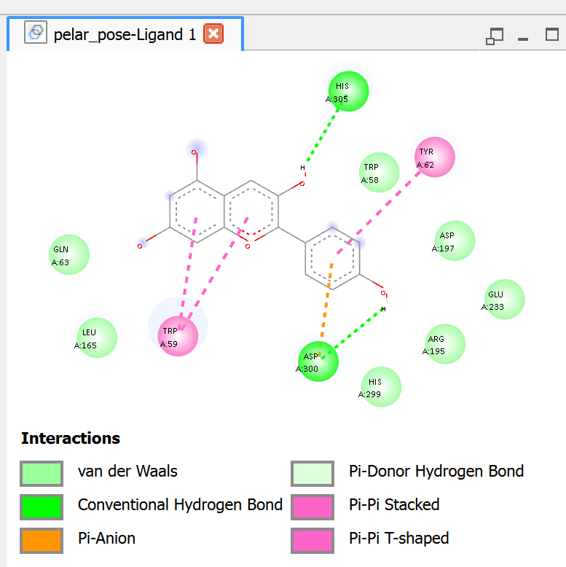

Pelargonidin produced a docking score of -8.631 kcal/mol, reflecting moderate-to-strong binding affinity.
The ligand formed conventional hydrogen bonds with HIS305 and ASP300. These interactions contributed to stabilization near the catalytic region of the enzyme.
The compound additionally formed multiple aromatic interactions including pi-pi stacked and pi-pi T-shaped interactions with TRP59 and TYR62. These interactions increased hydrophobic stabilization and improved active-site retention.
A pi-anion interaction with ASP300 further contributed electrostatic stabilization. Several residues including GLN63, LEU165, TRP58, ASP197, GLU233, ARG195, and HIS299 participated through van der Waals interactions.
The comparatively lower number of hydrogen bonds relative to Quercetin and Luteolin likely contributed to the slightly reduced docking affinity.

9. Epigallocatechin Gallate (EGCG) Binding-Mode Analysis
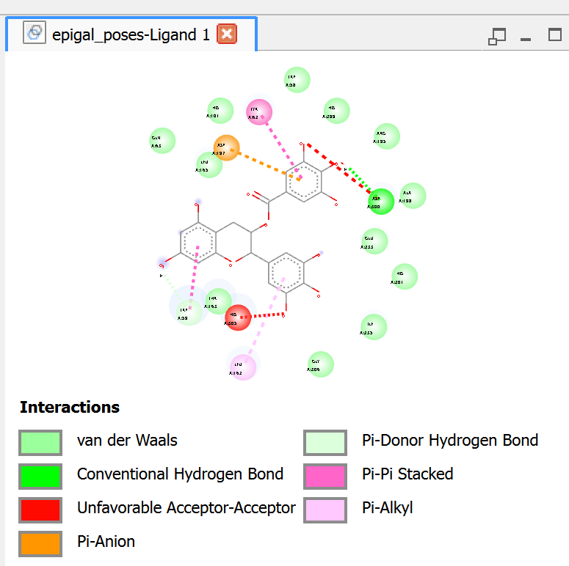
EGCG exhibited a docking score of -8.498 kcal/mol, indicating favorable but comparatively weaker binding.
The ligand formed conventional hydrogen bonding interactions with ASP300 and additional pi-donor hydrogen bonding interactions within the active site. Hydrogen bonding contributed to stabilization and orientation of the ligand.
EGCG also demonstrated pi-pi stacked interactions with TYR62 and a pi-anion interaction with ASP197, which enhanced hydrophobic and electrostatic stabilization.
However, unfavorable acceptor-acceptor interactions near ASP197 and HIS305 introduced destabilizing electrostatic effects. Such interactions may reduce overall binding efficiency despite the presence of several favorable interactions.
Van der Waals interactions involving GLU233, ARG195, HIS101, LEU162, ALA198, GLU255, and GLY306 further stabilized the ligand-enzyme complex.

10. Acarbose Binding-Mode Analysis
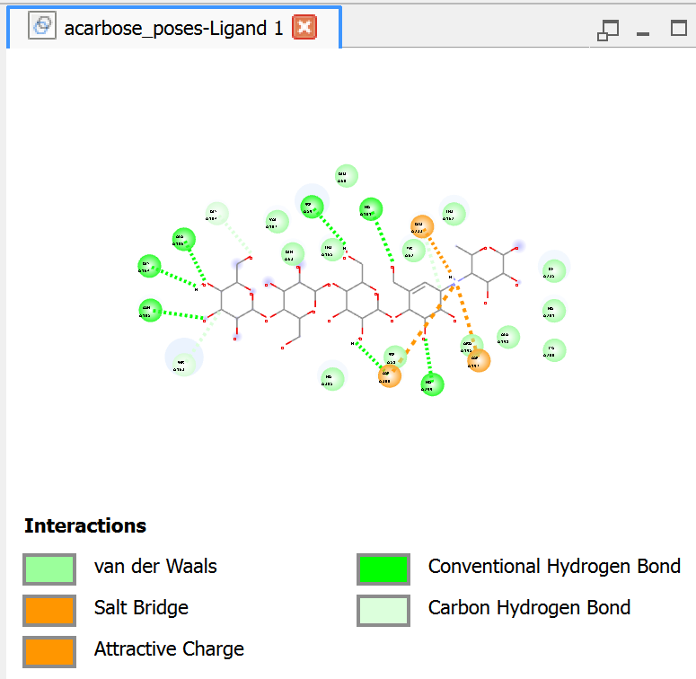
Acarbose produced the strongest docking score (-9.242 kcal/mol), validating its established role as a potent alpha-amylase inhibitor.
The ligand formed extensive conventional hydrogen bonds involving ASP197, GLN63, HIS101, ASP300, and neighboring residues. Its multiple hydroxyl groups enabled formation of a highly stable hydrogen-bonding network.
Salt bridge interactions and attractive charge interactions additionally contributed strong electrostatic stabilization. Salt bridges are among the strongest non-covalent interactions in ligand-enzyme complexes and play major roles in active-site binding.
Extensive van der Waals interactions surrounding the ligand enhanced steric complementarity and active-site occupancy.
The combination of strong hydrogen bonding, electrostatic interactions, and hydrophobic stabilization explains the superior docking affinity of Acarbose.

11. Maltotriose Binding-Mode Analysis
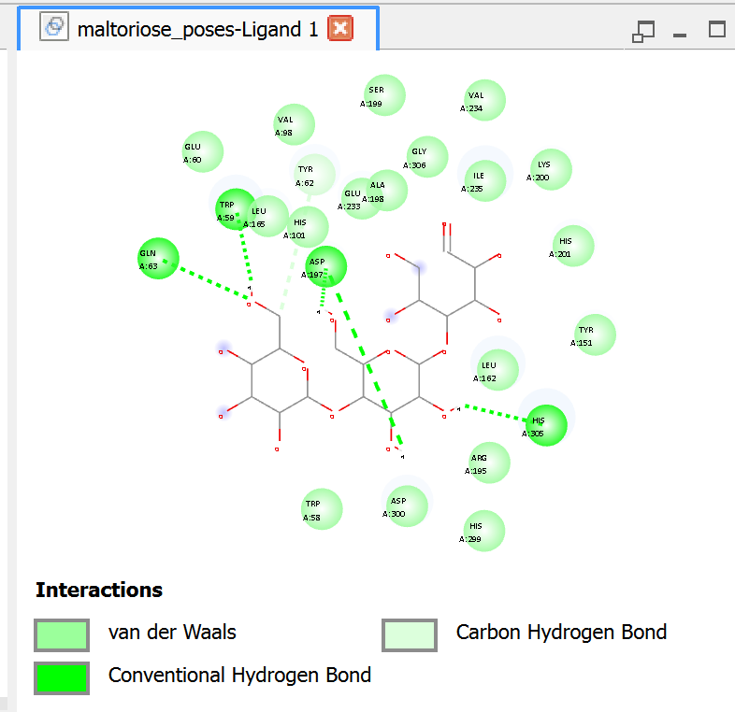
Maltotriose recorded the weakest docking score (-6.948 kcal/mol), which is consistent with its role as a natural substrate rather than a strong inhibitor.
The ligand formed conventional hydrogen bonds with GLN63, TRP59, ASP197, and HIS305. These interactions facilitated substrate recognition and catalytic positioning.
Additional carbon hydrogen bonds and van der Waals interactions involving TYR62, LEU165, ALA198, VAL98, GLY306, and ARG195 contributed to temporary stabilization inside the catalytic pocket.
Compared with inhibitor ligands, Maltotriose lacked extensive aromatic interactions and strong electrostatic stabilization, which explains its weaker binding affinity and reduced active-site retention.

12. Comparative Interaction Trend
A clear relationship was observed between docking affinity and interaction complexity. Compounds with stronger docking scores generally formed more extensive hydrogen bonding networks, multiple aromatic interactions, and stronger electrostatic stabilization.
Acarbose exhibited the strongest overall interaction profile due to its extensive hydrogen bonding and salt bridge interactions. Among the polyphenols, Quercetin and Luteolin emerged as the strongest-performing compounds because they combined strong hydrogen bonding with multiple pi-pi stacked interactions.
Catechin and Pelargonidin demonstrated moderate docking affinities supported mainly by aromatic stabilization and fewer hydrogen bonds. EGCG formed several favorable interactions but also displayed unfavorable acceptor-acceptor interactions, which likely reduced overall stability.
Maltotriose mainly formed substrate-recognition interactions without extensive inhibitory stabilization, resulting in the weakest docking score.

13. Conclusion
The molecular docking study demonstrated that selected polyphenols possess significant inhibitory potential against alpha-amylase. Quercetin and Luteolin displayed binding affinities highly comparable to the standard inhibitor Acarbose, supporting their potential use as natural antidiabetic lead compounds.
Hydrogen bonding, aromatic pi-pi interactions, pi-anion interactions, electrostatic stabilization, and hydrophobic interactions were identified as major contributors to ligand stabilization within the catalytic pocket.
The results provide computational evidence supporting further experimental validation of dietary polyphenols as potential alpha-amylase inhibitors for antidiabetic therapy.

