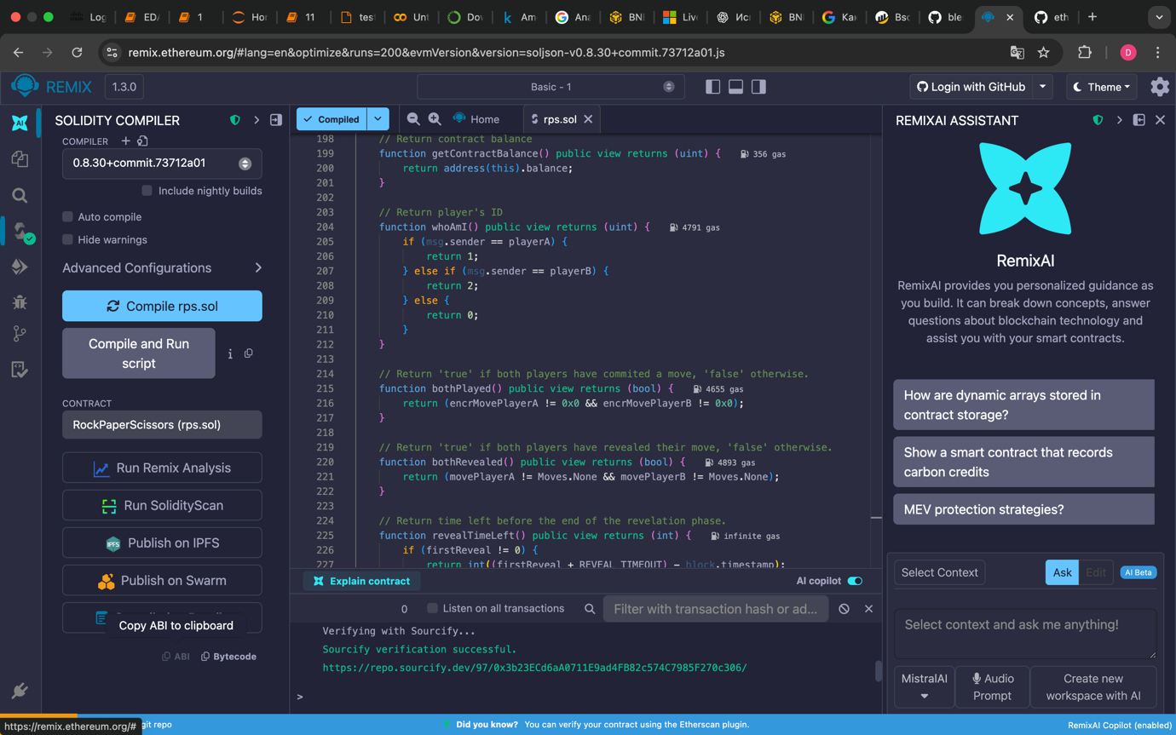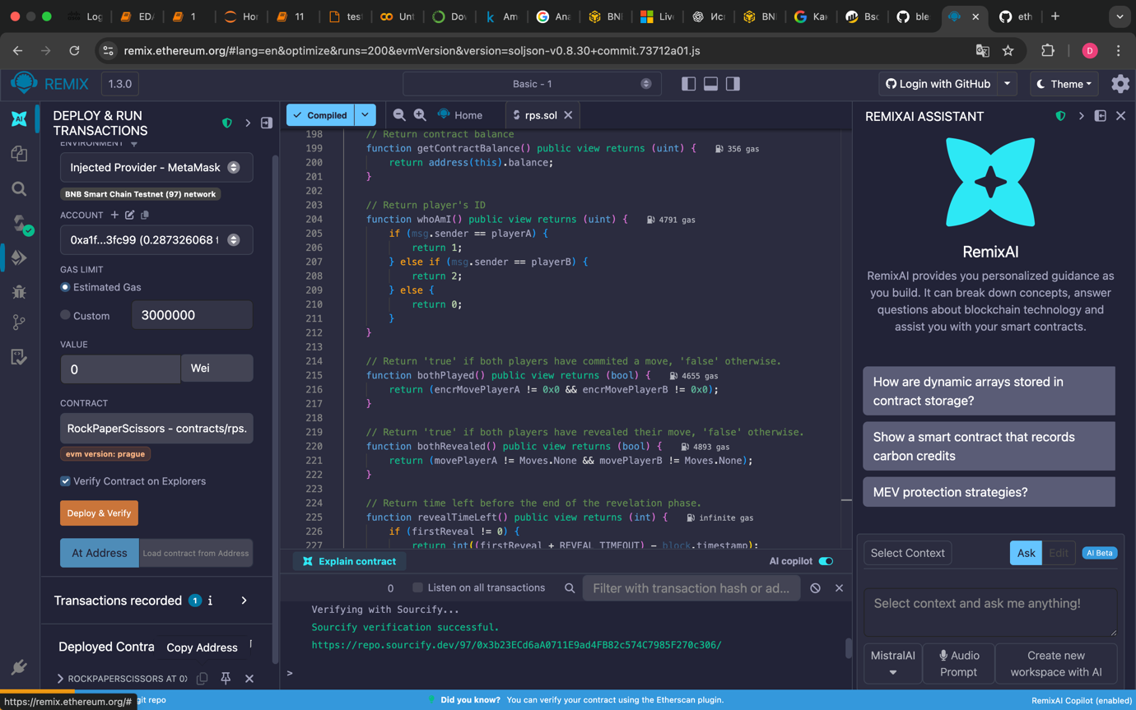 Contract Address: 0xE8Db106a45D817Bf7a9d67A98909AF457371d4A1
ABI: [
{
"inputs": [],
"stateMutability": "nonpayable",
"type": "constructor"
},
{
"anonymous": false,
"inputs": [
{
"indexed": true,
"internalType": "address",
"name": "player",
"type": "address"
},
{
"indexed": false,
"internalType": "enum RPS.Move",
"name": "playerMove",
"type": "uint8"
},
{
"indexed": false,
"internalType": "enum RPS.Move",
"name": "computerMove",
"type": "uint8"
},
{
"indexed": false,
"internalType": "string",
"name": "result",
"type": "string"
},
{
"indexed": false,
"internalType": "uint256",
"name": "amountWon",
"type": "uint256"
}
],
"name": "GameResult",
"type": "event"
},
{
"inputs": [
{
"internalType": "enum RPS.Move",
"name": "_playerMove",
"type": "uint8"
}
],
"name": "play",
"outputs": [],
"stateMutability": "payable",
"type": "function"
},
{
"inputs": [
{
"internalType": "uint256",
"name": "amount",
"type": "uint256"
}
],
"name": "withdraw",
"outputs": [],
"stateMutability": "nonpayable",
"type": "function"
},
{
"inputs": [],
"name": "getBalance",
"outputs": [
{
"internalType": "uint256",
"name": "",
"type": "uint256"
}
],
"stateMutability": "view",
"type": "function"
},
{
"inputs": [],
"name": "minBet",
"outputs": [
{
"internalType": "uint256",
"name": "",
"type": "uint256"
}
],
"stateMutability": "view",
"type": "function"
},
{
"inputs": [],
"name": "owner",
"outputs": [
{
"internalType": "address",
"name": "",
"type": "address"
}
],
"stateMutability": "view",
"type": "function"
}
]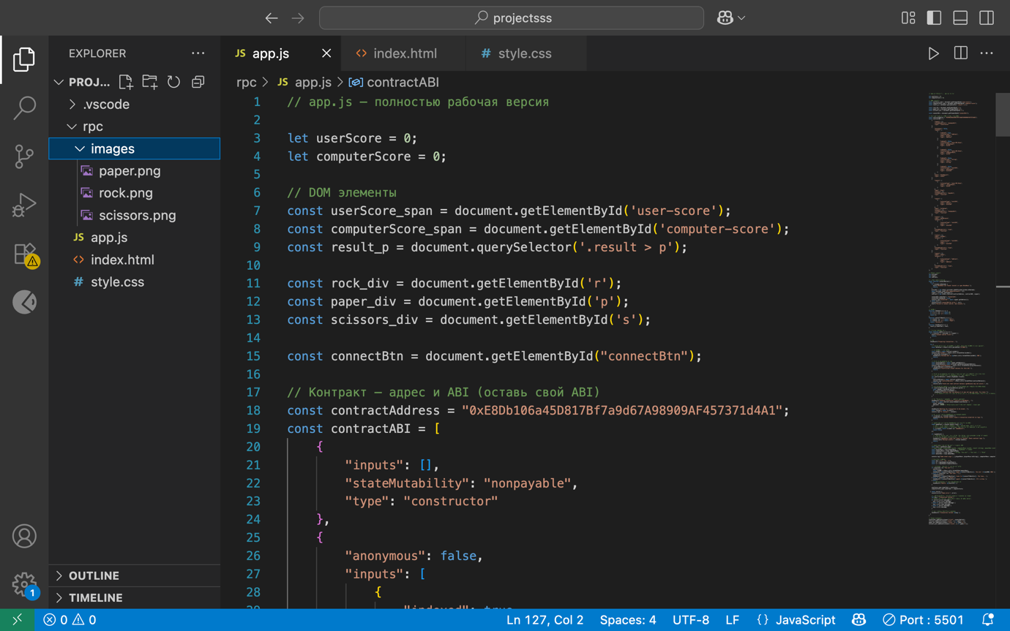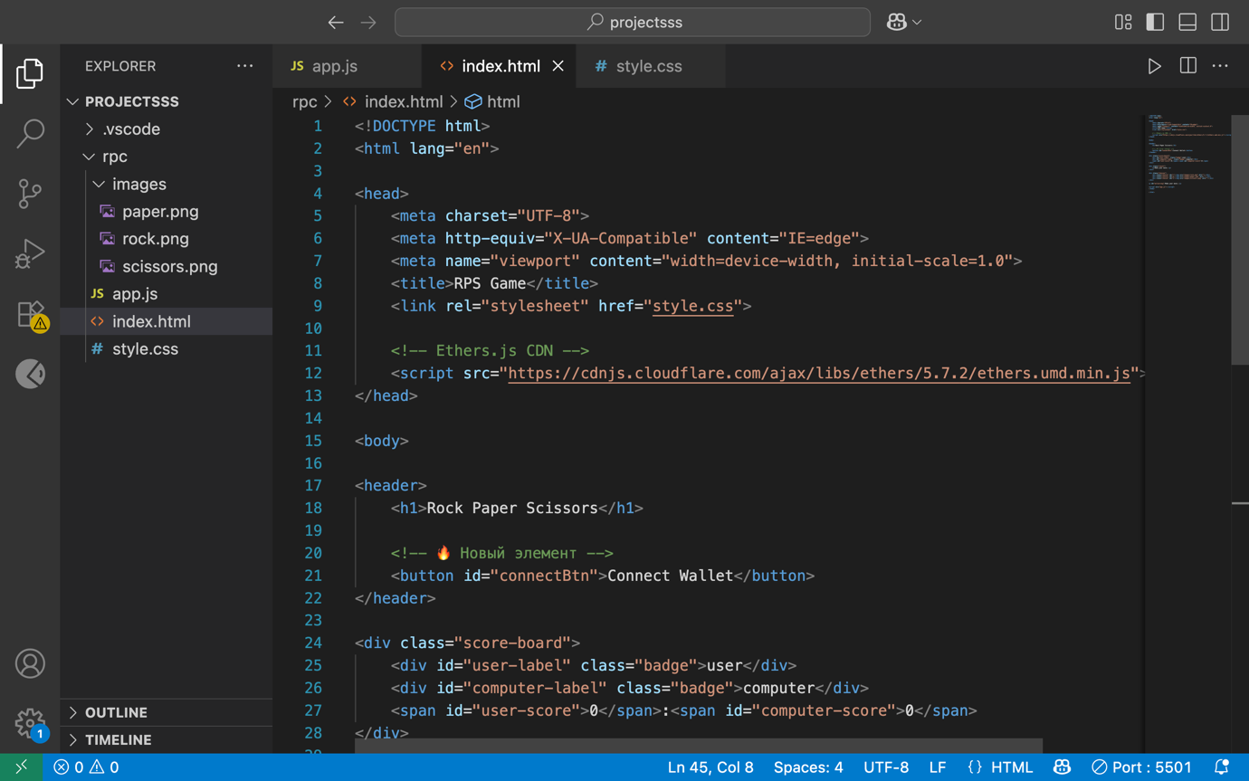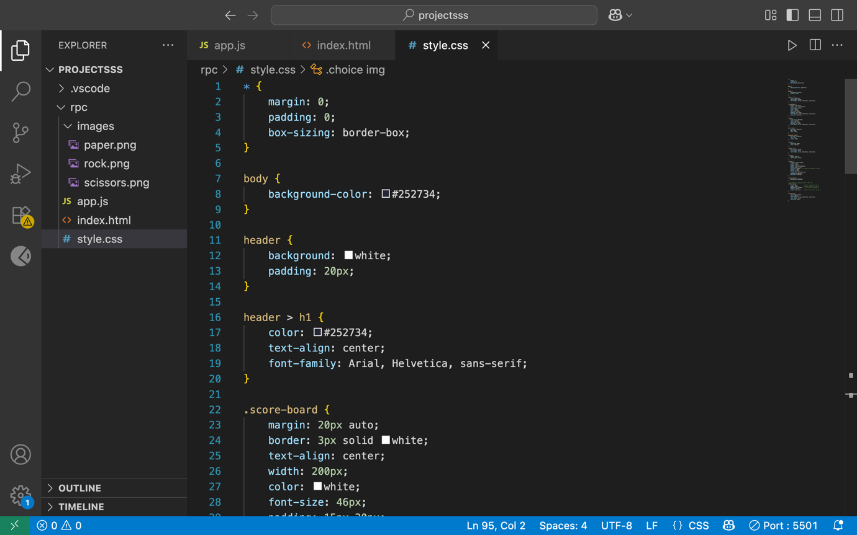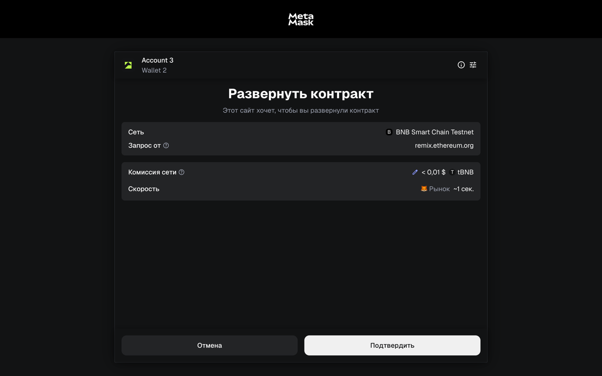x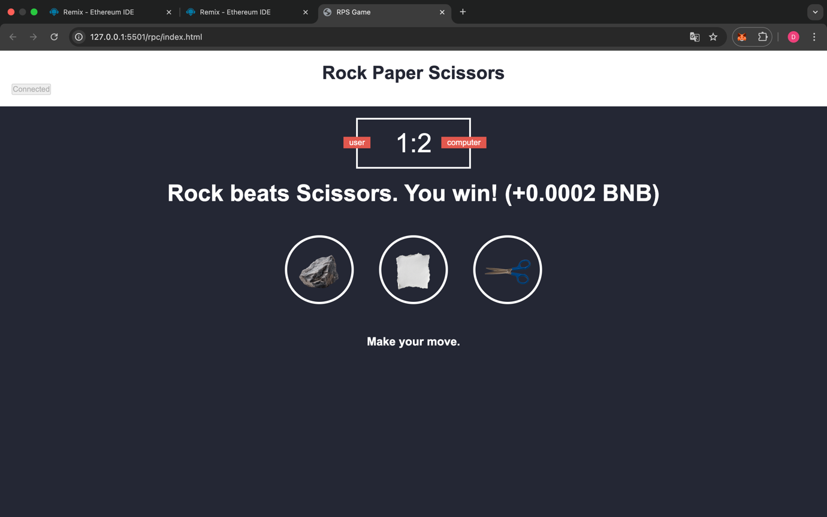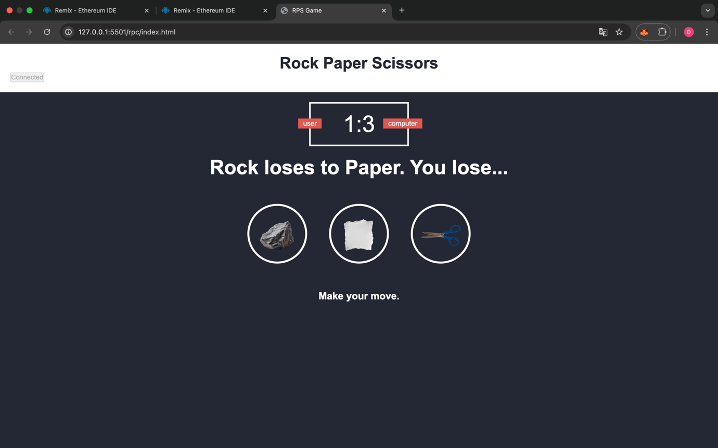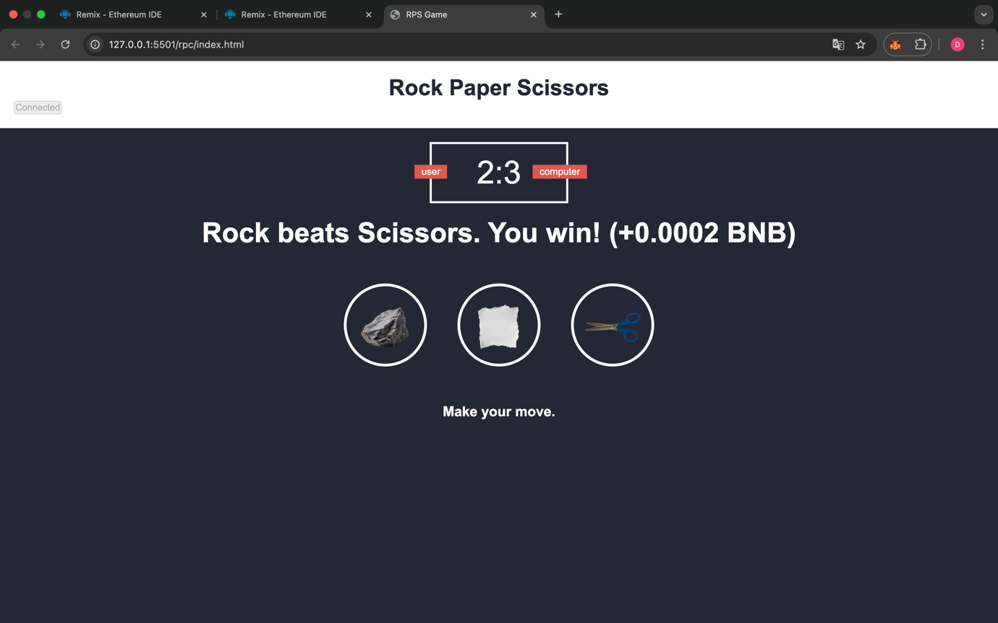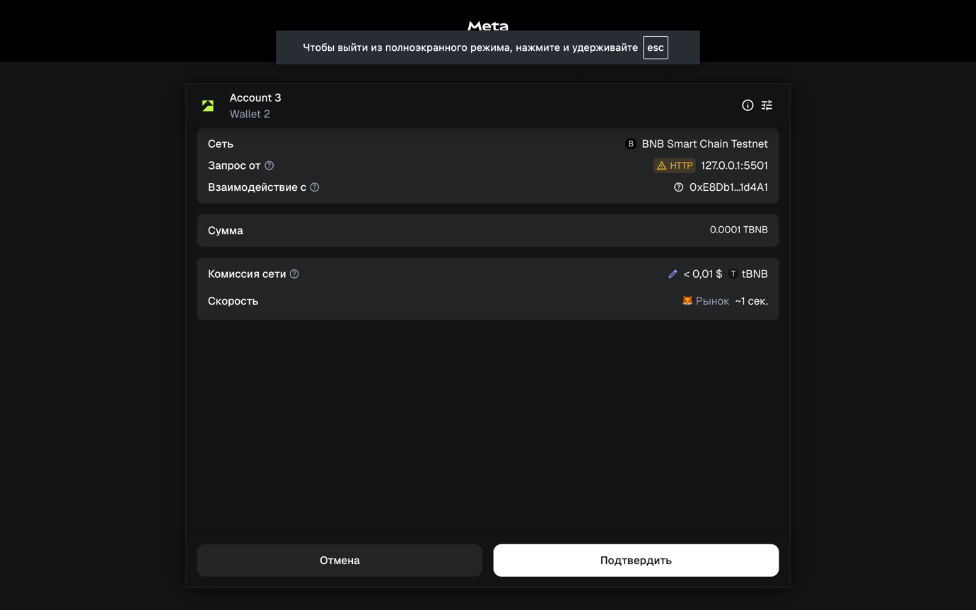
https://testnet.bscscan.com/address/0xE8Db106a45D817Bf7a9d67A98909AF457371d4A1

