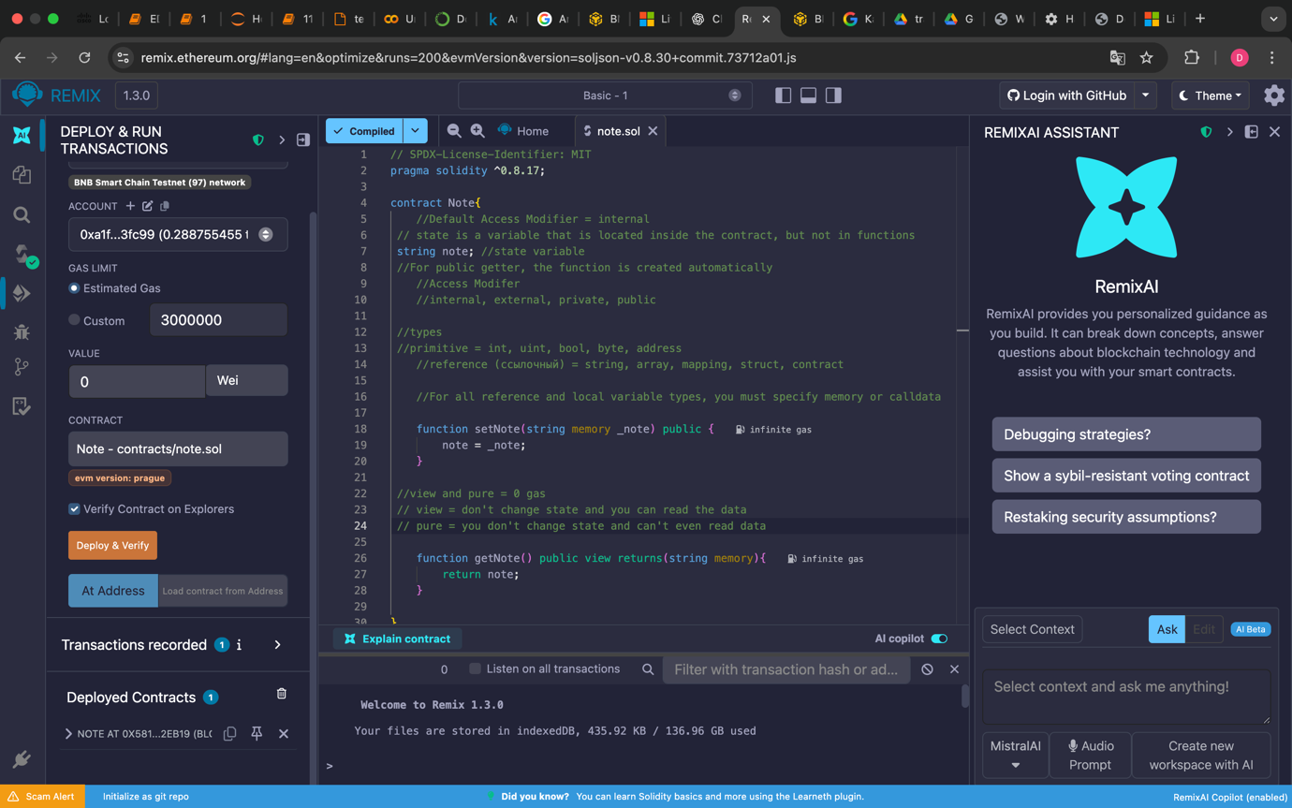
Contract address: 0x58134575Ae302d51650230E01EFF61Fe9372eB19
Contract ABI (in the compile tab, at the bottom): [
{
"inputs": [
{
"internalType": "string",
"name": "_note",
"type": "string"
}
],
"name": "setNote",
"outputs": [],
"stateMutability": "nonpayable",
"type": "function"
},
{
"inputs": [],
"name": "getNote",
"outputs": [
{
"internalType": "string",
"name": "",
"type": "string"
}
],
"stateMutability": "view",
"type": "function"
}
]

Part 2. Creating a basic web page
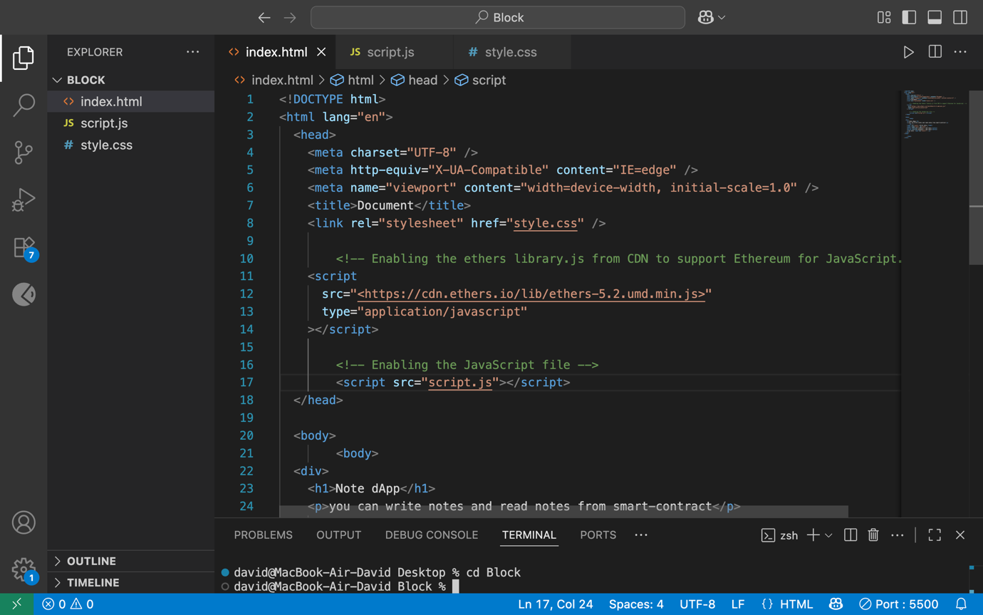
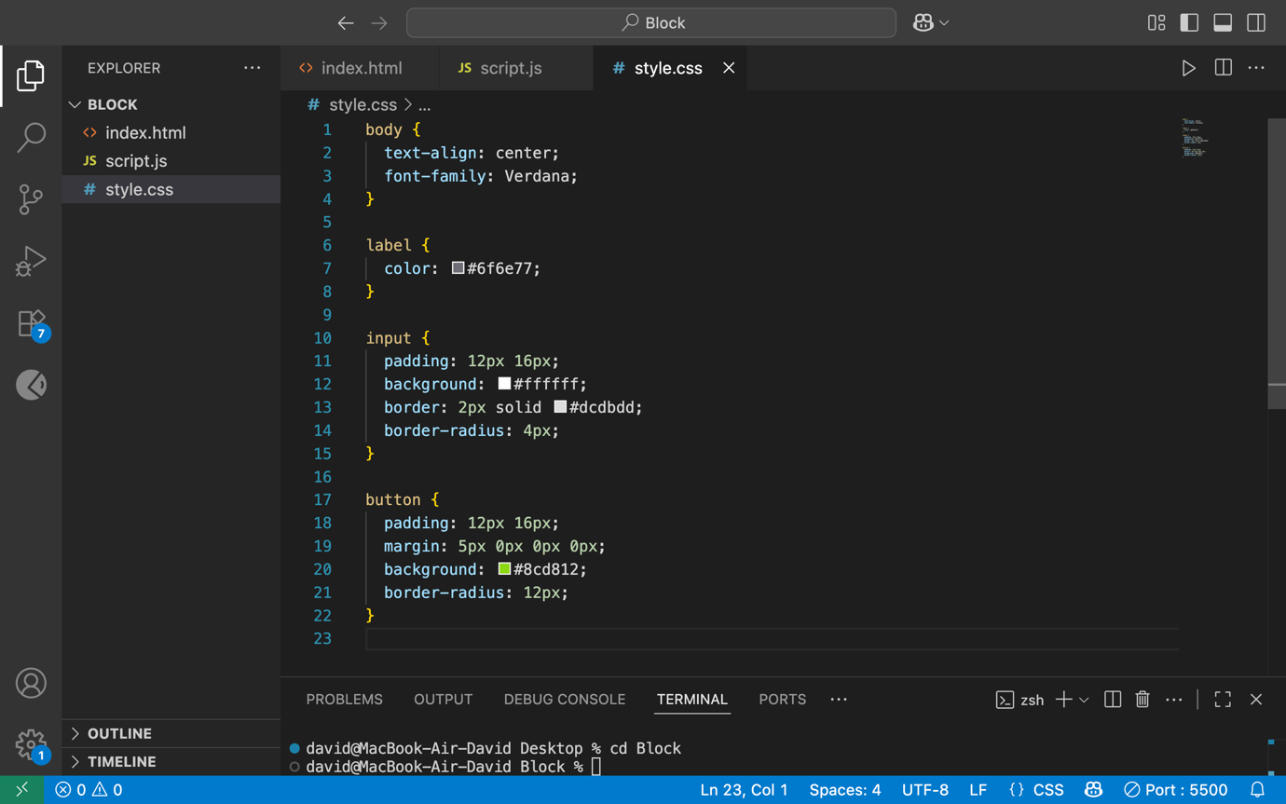
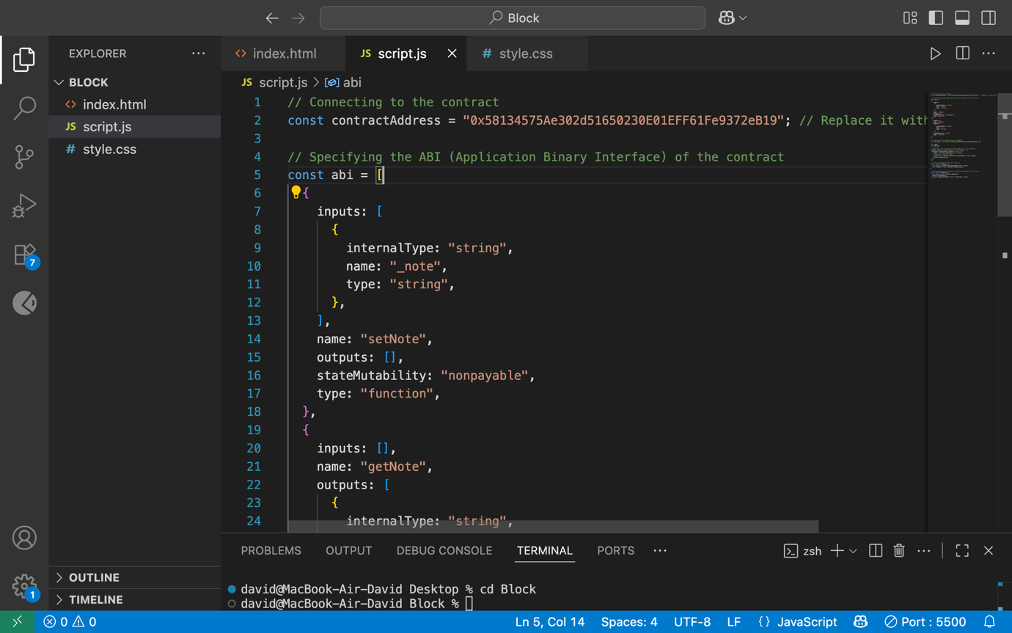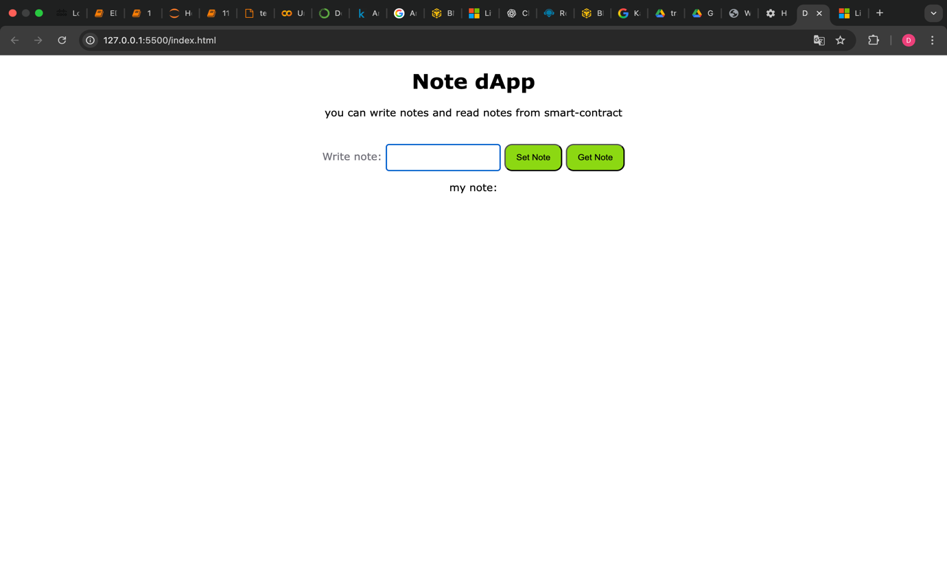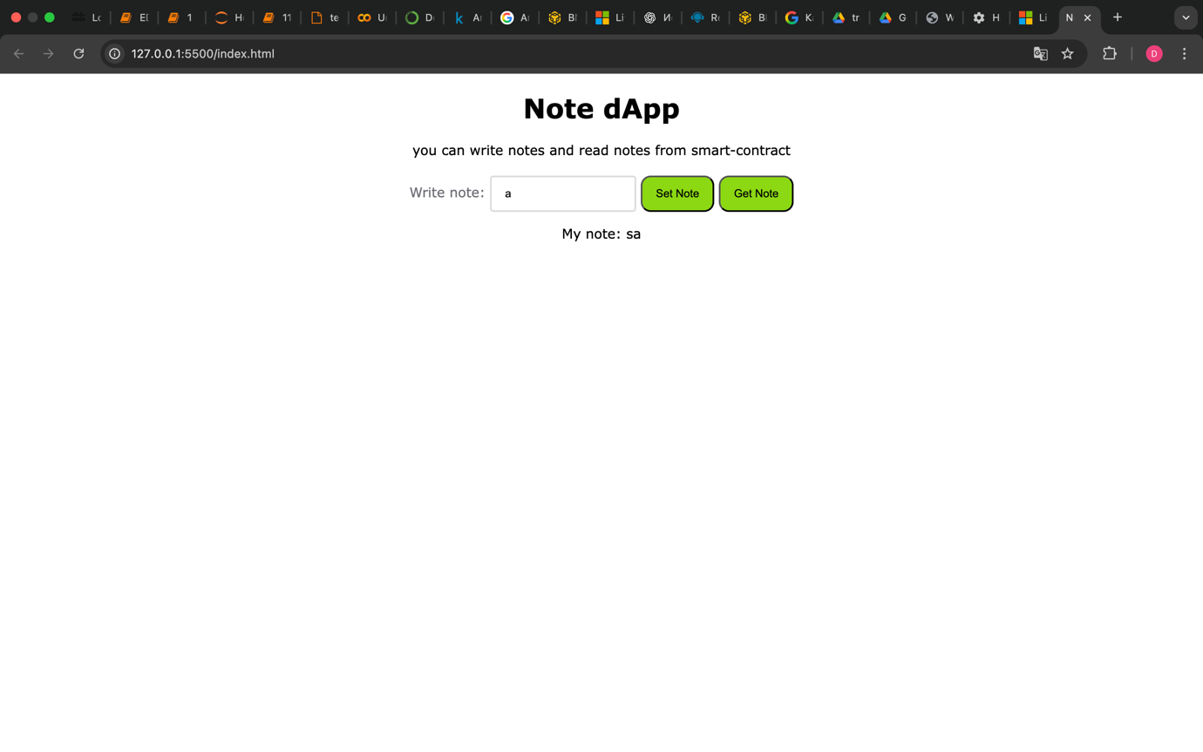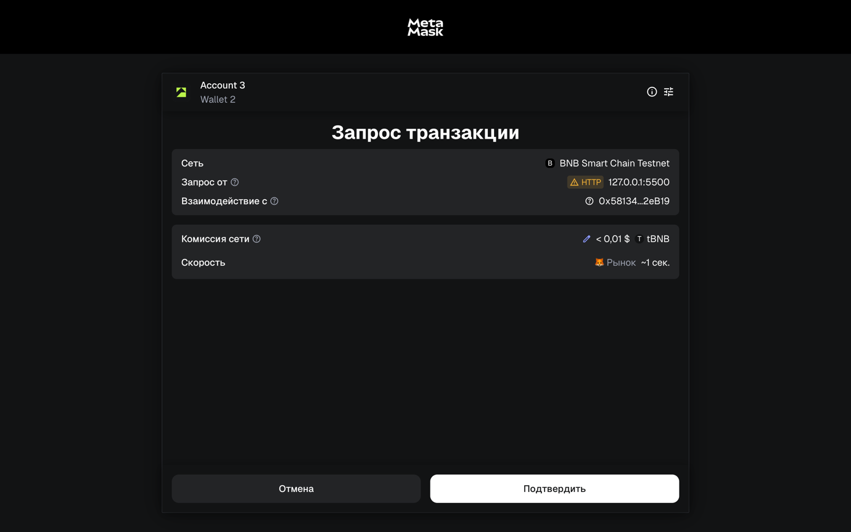 https://testnet.bscscan.com/tx/0xfa2da6aaa0d14843e6139186772cbdf3b6559a186684b19fed40f1c379f2d581