НАЦІОНАЛЬНИЙ ТЕХНІЧНИЙ УНІВЕРСИТЕТ УКРАЇНИ

«Київський політехнічний інститут імені Ігоря Сікорського»

ФАКУЛЬТЕТ ПРИКЛАДНОЇ МАТЕМАТИКИ

Кафедра програмного забезпечення комп’ютерних систем

**КУРСОВА РОБОТА**

***з дисципліни "Компоненти програмної інженерії"***

Виконав: Ярмоленко Андрій Геннадійович

Група: КП-01

Перевірив: Погорєлов Володимир

Володимирович

__________________

1 семестр 2022/2023

НАЦІОНАЛЬНИЙ ТЕХНІЧНИЙ УНІВЕРСИТЕТ УКРАЇНИ

«Київський політехнічний інститут імені Ігоря Сікорського»

ФАКУЛЬТЕТ ПРИКЛАДНОЇ МАТЕМАТИКИ

Кафедра програмного забезпечення комп’ютерних систем

|  |  |
| --- | --- |
| Узгоджено  Керівник роботи    __________/Погорєлов.В.В./ | ЗАХИЩЕНА "__"_________2023р.  з оцінкою_________________  __________/ Погорєлов.В.В./ |

**Програмний додаток серверу що міститься у Docker-контейнері, та тести написані з використанням Robot framework**

Виконавець роботи

Ярмоленко Андрій Геннадійович

______________2023р.

# Код

|  |
| --- |
| app.py (server) |

from flask import Flask, request, jsonify

from models.directory import directory

from models.binary_file import binary_file

from models.log_text_file import log_text_file

from models.buffer_file import buffer_file

app = Flask(__name__)

root = directory('root', 100)

deleted_list = []

#directory

@app.route('/directory', methods=['POST', 'GET', 'PATCH', 'DELETE'])

def directory():

   if request.method == 'POST':

      if any(x.name == request.args.get('name') for x in root.list) or request.args.get('name') == 'root':

         return jsonify({

         "message": "Directory already exists.",

      }), 400

      dir = directory(request.args.get('name'), request.args.get('max_elems'), root)

      return jsonify({

         "message": "Directory created successfully.",

         "directory": {

            "parent": str(dir.parent),

            "name": str(dir.name),

            "DIR_MAX_ELEMS": int(dir.DIR_MAX_ELEMS),

            "count_elems": int(dir.count_elems),

            "list": str(dir.list)

         }

      }), 201

   elif request.method == 'GET':

      if any(dir.name == request.args.get('name') for dir in root.list) or request.args.get('name') == 'root':

         if request.args.get('name') == 'root':

            dir = root

         else:

            dir = next(x for x in root.list if x.name == request.args.get('name'))

         return jsonify({

         "message": "Directory was read successfully.",

         "directory": {

            "parent": str(dir.parent),

            "name": str(dir.name),

            "DIR_MAX_ELEMS": int(dir.DIR_MAX_ELEMS),

            "count_elems": int(dir.count_elems),

            "list": str(dir.list)

         }

      }), 200

      return jsonify({

         "message": "Directory doesn't exist.",

         }), 400

   elif request.method == 'PATCH':

      if any(dir.name == request.args.get('name') for dir in root.list):

         dir = next(x for x in root.list if x.name == request.args.get('name'))

         dir.move(root)

         return jsonify({

         "message": "Directory moved successfully.",

         "directory": {

            "parent": str(dir.parent.name),

            "name": str(dir.name),

            "DIR_MAX_ELEMS": int(dir.DIR_MAX_ELEMS),

            "count_elems": int(dir.count_elems),

            "list": str(dir.list)

         }

      }), 200

      return jsonify({

         "message": "Directory doesn't exist.",

         }), 400

   else:

      if request.args.get('name') not in deleted_list and any(dir.name == request.args.get('name') for dir in root.list):

         dir = next(x for x in root.list if x.name == request.args.get('name'))

         del dir

         deleted_list.append(request.args.get('name'))

         return jsonify({

         "message": "Directory deleted successfully.",

         }), 200

      return jsonify({

         "message": "Directory was not deleted.",

         }), 400

@app.route('/binaryfile', methods=['POST', 'GET', 'PATCH', 'DELETE'])

def binaryfile():

   if request.method == 'POST':

      if any(x.name == request.args.get('name') for x in root.list):

         return jsonify({

         "message": "File already exists.",

      }), 400

      file = binary_file(root, request.args.get('name'), request.args.get('info'))

      return jsonify({

         "message": "File created successfully.",

         "file": {

            "parent": str(file.parent.name),

            "name": str(file.name),

            "info": str(file.info)

         }

      }), 201

   elif request.method == 'GET':

      if any(file.name == request.args.get('name') for file in root.list):

         file = next(x for x in root.list if x.name == request.args.get('name'))

         return jsonify({

         "message": "File was read successfully.",

         "file": {

            "parent": str(file.parent.name),

            "name": str(file.name),

            "info": str(file.info)

         }

      }), 200

      return jsonify({

         "message": "File doesn't exist.",

         }), 400

   elif request.method == 'PATCH':

      if any(file.name == request.args.get('name') for file in root.list):

         file = next(x for x in root.list if x.name == request.args.get('name'))

         file.move(root)

         return jsonify({

         "message": "File moved successfully.",

         "file": {

            "parent": str(file.parent.name),

            "name": str(file.name),

            "info": str(file.info)

         }

      }), 200

      return jsonify({

         "message": "File doesn't exist.",

         }), 400

   else:

      if request.args.get('name') not in deleted_list and any(file.name == request.args.get('name') for file in root.list):

         file = next(x for x in root.list if x.name == request.args.get('name'))

         del file

         deleted_list.append(request.args.get('name'))

         return jsonify({

         "message": "File deleted successfully.",

         }), 200

      return jsonify({

         "message": "File was not deleted.",

         }), 400

@app.route('/logtextfile', methods=['POST', 'GET', 'PATCH', 'DELETE'])

def logtextfile():

   if request.method == 'POST':

      if any(x.name == request.args.get('name') for x in root.list):

         return jsonify({

         "message": "File already exists.",

      }), 400

      file = log_text_file(root, request.args.get('name'), request.args.get('info'))

      return jsonify({

         "message": "File created successfully.",

         "file": {

            "parent": str(file.parent.name),

            "name": str(file.name),

            "info": str(file.info)

         }

      }), 201

   elif request.method == 'GET':

      if any(file.name == request.args.get('name') for file in root.list):

         file = next(x for x in root.list if x.name == request.args.get('name'))

         return jsonify({

         "message": "File was read successfully.",

         "file": {

            "parent": str(file.parent.name),

            "name": str(file.name),

            "info": str(file.info)

         }

      }), 200

      return jsonify({

         "message": "File doesn't exist.",

         }), 400

   elif request.method == 'PATCH':

      if any(file.name == request.args.get('name') for file in root.list):

         file = next(x for x in root.list if x.name == request.args.get('name'))

         if request.args.get('parent'):

            file.move(root)

            return jsonify({

            "message": "File moved successfully.",

            "file": {

               "parent": str(file.parent.name),

               "name": str(file.name),

               "info": str(file.info)

            }

         }), 200

         if request.args.get('append'):

            file.append_line(request.args.get('append'))

            return jsonify({

            "message": "Line added successfully.",

            "file": {

               "parent": str(file.parent.name),

               "name": str(file.name),

               "info": str(file.info)

            }

         }), 201

         return jsonify({

         "message": "Bad request.",

         }), 400

      return jsonify({

         "message": "File doesn't exist.",

         }), 400

   else:

      if request.args.get('name') not in deleted_list and any(file.name == request.args.get('name') for file in root.list):

         file = next(x for x in root.list if x.name == request.args.get('name'))

         del file

         deleted_list.append(request.args.get('name'))

         return jsonify({

         "message": "File deleted successfully.",

         }), 200

      return jsonify({

         "message": "File was not deleted.",

         }), 400

@app.route('/bufferfile', methods=['POST', 'GET', 'PATCH', 'DELETE'])

def bufferfile():

   if request.method == 'POST':

      if any(x.name == request.args.get('name') for x in root.list):

         return jsonify({

         "message": "File already exists.",

      }), 400

      file = buffer_file(root, request.args.get('max_size'), request.args.get('name'))

      return jsonify({

         "message": "File created successfully.",

         "file": {

            "parent": str(file.parent),

            "name": str(file.name),

            "MAX_BUF_FILE_SIZE": int(file.MAX_BUF_FILE_SIZE),

            "info": list(file.info )

         }

      }), 201

   elif request.method == 'GET':

      if any(file.name == request.args.get('name') for file in root.list):

         file = next(x for x in root.list if x.name == request.args.get('name'))

         return jsonify({

         "message": "File was read successfully.",

         "file": {

            "parent": str(file.parent),

            "name": str(file.name),

            "MAX_BUF_FILE_SIZE": int(file.MAX_BUF_FILE_SIZE),

            "info": list(file.info )

         }

      }), 200

      return jsonify({

         "message": "File doesn't exist.",

         }), 400

   elif request.method == 'PATCH':

      if any(file.name == request.args.get('name') for file in root.list):

         file = next(x for x in root.list if x.name == request.args.get('name'))

         if request.args.get('parent'):

            file.move(root)

            return jsonify({

            "message": "File moved successfully.",

            "file": {

               "parent": str(file.parent.name),

               "name": str(file.name),

               "MAX_BUF_FILE_SIZE": int(file.MAX_BUF_FILE_SIZE),

               "info": list(file.info)

            }

         }), 200

         if request.args.get('append'):

            file.push(request.args.get('append'))

            return jsonify({

            "message": "Line added successfully.",

            "file": {

               "parent": str(file.parent.name),

               "name": str(file.name),

               "MAX_BUF_FILE_SIZE": int(file.MAX_BUF_FILE_SIZE),

               "info": list(file.info)

            }

         }), 201

         if request.args.get('consume'):

            if len(file.info) > 0:

               file.consume()

            return jsonify({

            "message": "Line consumed successfully.",

            "file": {

               "parent": str(file.parent.name),

               "name": str(file.name),

               "MAX_BUF_FILE_SIZE": int(file.MAX_BUF_FILE_SIZE),

               "info": list(file.info)

            }

         }), 200

         return jsonify({

         "message": "Bad request.",

         }), 400

      return jsonify({

         "message": "File doesn't exist.",

         }), 400

   else:

      if request.args.get('name') not in deleted_list and any(file.name == request.args.get('name') for file in root.list):

         file = next(x for x in root.list if x.name == request.args.get('name'))

         del file

         deleted_list.append(request.args.get('name'))

         return jsonify({

         "message": "File deleted successfully.",

         }), 200

      return jsonify({

         "message": "File was not deleted.",

         }), 400

if __name__ == '__main__':

    app.run(host='0.0.0.0')

|  |
| --- |
| Binary_file.py |

class binary_file:

    def __init__(self, parent, name, info):

        if (parent.count_elems >= parent.DIR_MAX_ELEMS ):

            print('Parent directory is full.')

            return

        self.parent = parent

        self.parent.count_elems += 1

        self.name = name

        self.info = info

        self.parent.list.append(self)

    def __delete__(self, instance):

        print('Directory was deleted.')

        return

    def move(self, location):

        if (location.count_elems >= location.DIR_MAX_ELEMS):

            print('Directory is full. Can\'t move.')

            return

        self.parent.count_elems -=1

        index = self.parent.list.index(self)

        self.parent.list.pop(index)

        self.parent = location

        self.parent.list.append(self)

        self.parent.count_elems +=1

    def read(self):

        return self.info

|  |
| --- |
| Buffer_file.py |
| from itertools import count  class buffer_file:      def __init__(self, parent, max_size, name):          if (parent.count_elems >= parent.DIR_MAX_ELEMS ):              print('Parent directory is full')              return          self.parent = parent          self.parent.count_elems += 1          self.parent.list.append(self)          self.MAX_BUF_FILE_SIZE = max_size          self.name = name          self.info = []      def __delete__(self, instance):          print('Directory was deleted.')          return      def move(self, location):          if (location.count_elems >= location.DIR_MAX_ELEMS):              return          self.parent.count_elems -=1          index = self.parent.list.index(self)          self.parent.list.pop(index)          self.parent = location          self.parent.list.append(self)          self.parent.count_elems +=1        def push(self, elem):          if len(self.info) >= int(self.MAX_BUF_FILE_SIZE):              print('File is full. Can\'t push new line.')              return          self.info.append(elem)      def consume(self):          self.info.pop() |

|  |
| --- |
| Directory.py |

class directory:

    def __init__(self, name, max_elems, parent = None):

        if parent != None:

            if (parent.count_elems >= parent.DIR_MAX_ELEMS ):

                print('Parent directory is full.')

                return

            parent.count_elems += 1

            parent.list.append(self)

        self.parent = parent

        self.name = name

        self.DIR_MAX_ELEMS = max_elems

        self.count_elems = 0

        self.list = []

    def __delete__(self, instance):

        print('Directory was deleted.')

        return

    def list_elems(self):

        res = self.name + ': ( '

        for item in self.list:

            if type(item) is directory:

                res += item.list_elems()

            else:

                res += item.name

                res += ', '

        res += '), '

        return res

    def move(self, location):

        if (location.count_elems >= location.DIR_MAX_ELEMS + self.count_elems + 1):

            print('Directory is full. Can\'t move.')

            return

        if self.parent != None:

            self.parent.count_elems -= self.count_elems + 1

            index = self.parent.list.index(self)

            self.parent.list.pop(index)

        self.parent = location

        self.parent.list.append(self)

        self.parent.count_elems += self.count_elems + 1

|  |
| --- |
| Log_text_file.py |

class log_text_file:

    def __init__(self, parent, name, info):

        if (parent.count_elems >= parent.DIR_MAX_ELEMS ):

            print('Parent directory is full.')

            return

        self.parent = parent

        self.name = name

        self.info = info

        self.parent.count_elems += 1

        self.parent.list.append(self)

    def __delete__(self, instance):

        print('Directory was deleted.')

        return

    def move(self, location):

        if (location.count_elems >= location.DIR_MAX_ELEMS):

            print('Directory is full. Can\'t move.')

            return

        self.parent.count_elems -=1

        index = self.parent.list.index(self)

        self.parent.list.pop(index)

        self.parent = location

        self.parent.list.append(self)

        self.parent.count_elems +=1

    def read(self):

        return self.info

    def append_line(self, line):

        self.info += '\n'

        self.info += line

|  |
| --- |
| CLI.py |

import sys

import pip._vendor.requests as requests

n = len(sys.argv)

Request = "http://localhost:8888/" + sys.argv[2]

response = ""

if sys.argv[1] == "get":

    response = requests.get(Request)

if sys.argv[1] == "post":

    response = requests.post(Request)

if sys.argv[1] == "patch":

    response = requests.patch(Request)

if sys.argv[1] == "delete":

    response = requests.delete(Request)

print("Response: ", response.status_code + response.json())

|  |
| --- |
| Robot.robot |

|  |
| --- |
| *** Settings ***  Library Process  Library OperatingSystem  *** Variables ***  ${cli} /home/andrii/Documents/GitHub/qa-kp01-Yarmolenko/coursework/CLI.py  *** Test Cases ***  Dir root create  ${result} = Run Process python3 ${cli} get directory?name\=root  Should Contain ${result.stdout} Status code: 200  Dir inner create  ${result} = Run Process python3 ${cli} post directory?parent\=root&name\=child&max_elems\=8  Should Contain ${result.stdout} Status code: 201  Dir move  ${result} = Run Process python3 ${cli} patch directory?name\=child&parent\=root  Should Contain ${result.stdout} Status code: 200  Dir delete  ${result} = Run Process python3 ${cli} delete directory?name\=child  Should Contain ${result.stdout} Status code: 200  Buffer create  ${result} = Run Process python3 ${cli} post bufferfile?parent\=root&max_size\=100&name\=bufferfile  Should Contain ${result.stdout} Status code: 201  Buffer read  ${result} = Run Process python3 ${cli} get bufferfile?name\=bufferfile  Should Contain ${result.stdout} Status code: 200  Buffer move  ${result} = Run Process python3 ${cli} patch bufferfile?parent\=root&name\=bufferfile  Should Contain ${result.stdout} Status code: 200  Buffer delete  ${result} = Run Process python3 ${cli} delete bufferfile?name\=bufferfile  Should Contain ${result.stdout} Status code: 200  Bin create  ${result} = Run Process python3 ${cli} post binaryfile?name\=binaryfile&parent\=root&info\=test  Should Contain ${result.stdout} Status code: 201  Bin read  ${result} = Run Process python3 ${cli} get binaryfile?name\=binaryfile  Should Contain ${result.stdout} Status code: 200  Bin move  ${result} = Run Process python3 ${cli} patch binaryfile?name\=binaryfile&parent\=root  Should Contain ${result.stdout} Status code: 200  Bin delete  ${result} = Run Process python3 ${cli} delete binaryfile?name\=binaryfile  Should Contain ${result.stdout} Status code: 200 |

Фото роботи :

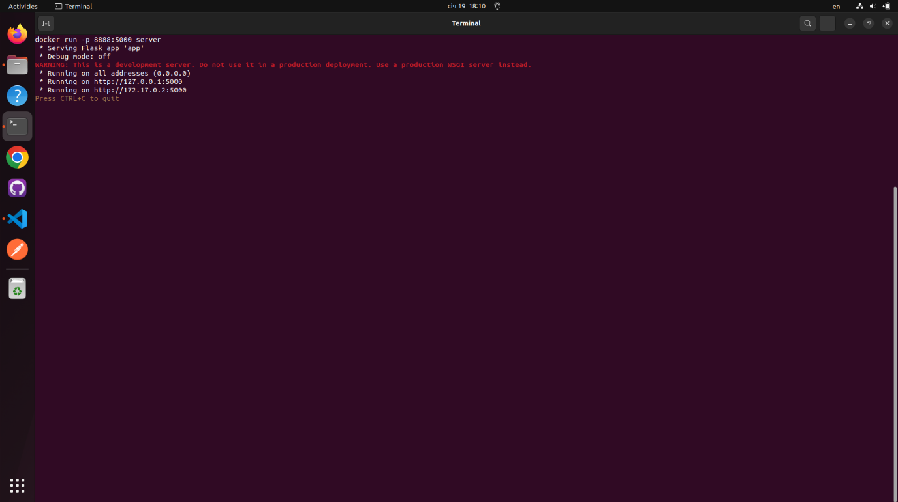

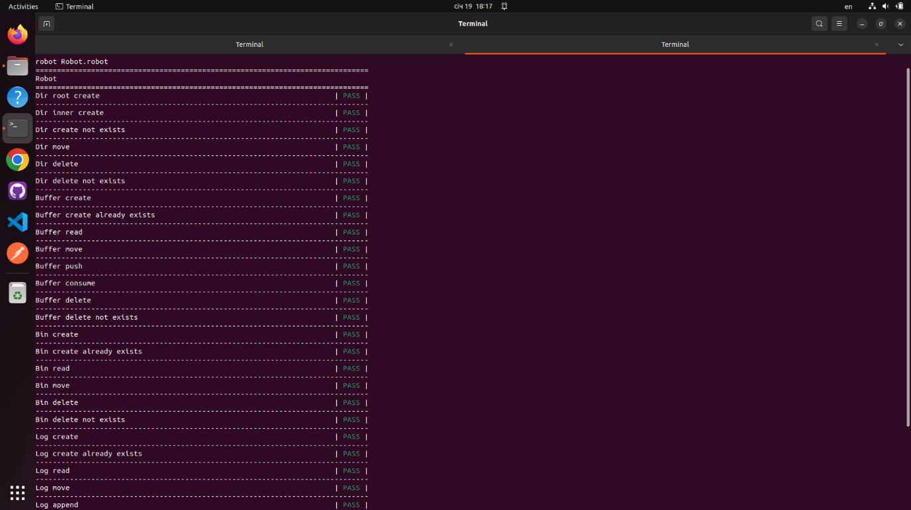

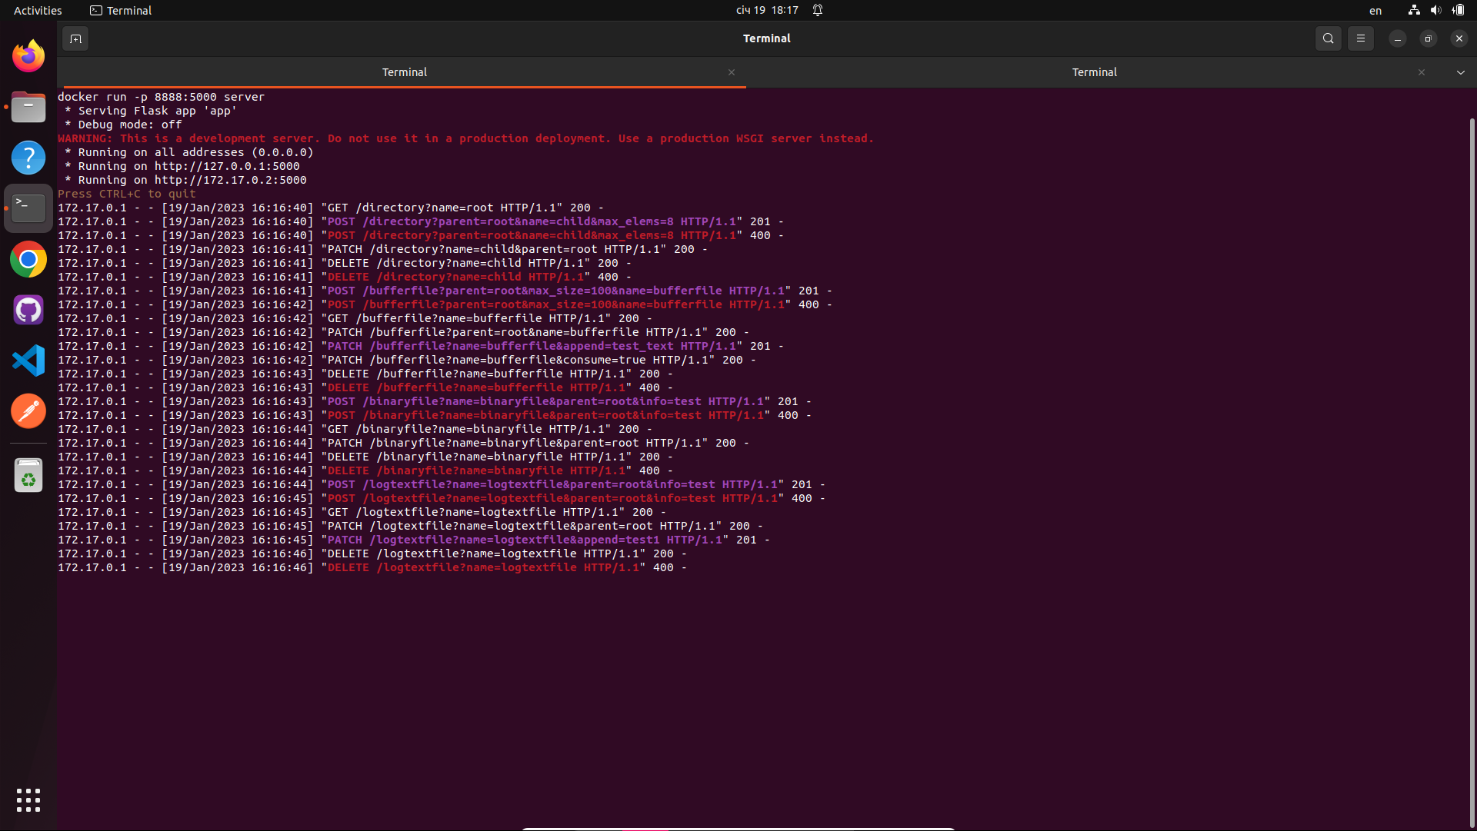

# Висновки

Метою даного курсового проекту було розроблення серверу на мові pyhton, розташування його у Docker контейнері, розроблення інтерфейсу командного рядка для створення запитів до серверу та тестування цього інтерфейсу за допомогою Robot framework.