NIIT

**Smart Grocery App**

**By**

**Ali Jacinta Fatima**

Developing Touch & Mobile Device

## TABLE OF CONTENTS

1. Project Overview

* Project Topic
* Project Analysis

1. Project Breakdown

* Project overview
* Core features
* Tools & technologies

1. System Analysis

* User flow/Journey
* Sitemap/navigation flow
* Project development rundown

1. Errors and Problems
2. Conclusion

**Project Overview**

### PROJECT TOPIC

Create a mobile smart grocery app that suggests recipes based on available ingredients.

### PROJECT ANALYSIS

*What is a Smart Grocery App?*

A **smart grocery app** is a mobile application that uses intelligent features like ingredient tracking, recipe suggestions, personalized recommendations, and real-time inventory management to help users cook with ease. Unlike traditional grocery apps, smart versions integrate tools like pantry monitoring, and AI-driven suggestions to reduce food waste and streamline the meal planning process.

These apps go beyond to learn from user behavior, suggest meals based on what’s already in your kitchen and even generate dynamic recipes based on your selected recipes or dietary goals.

**Project BREAKDOWN**

### PROJECT OVERVIEW

**Meal-It** is a smart mobile application designed to simplify grocery shopping and meal planning by helping users make the most of the ingredients they already have. The app uses a pantry-based system to track available items you already have, suggest personalized recipes, and generate automated recipes, making meal prep easier, faster, and more sustainable.

Meal-It’s goal is to reduce food waste, save time, and support healthier eating habits by providing meal suggestions tailored to the user’s pantry inventory and preferences. With features like ingredient selection, smart recipe filters, and a built-in meal planner, Meal-It creates a seamless and intelligent cooking experience for everyday users — from busy professionals to home cooks and students.

### CORE FEATURES

* Pantry Tracking
* Recipe Suggestions Based on Available Ingredients
* Categorized Recipe Browsing
* Sign Up and Sign In
* Notifications & Alerts (suggestions)
* Settings

### TOOLS & TECHNOLOGIES

In this project I incorporated a few tools and technologies such as;

1. Figma: this was used for the entire designing process; this is where the app was designed. An iPhone 13/14 frame was used.
2. ChatGPT & Wikipedia: this was used for researching purposes. I researched different recipes, meal categories etc. I conducted researches about what is a smart grocery app, what it consists of and different types.
3. FreePik, Pixels and Pinterest: these websites were used for generating all the pictures used in the creation of this project.
4. Iconify: this was used to get all the icons used in this project
5. W3Schools: this was used to generate the color codes and combinations in the designing process.

**SYSTEM ANALYSIS**

### USERFLOW/JOURNEY

Listed is a step-by-step outline of a user’s journey from opening the app;

1. Landing Page: This page is what the user sees when the app opens, it’s a slideshow of what Meal-it consists of. It has the ‘get started’ button that leads to the main app.
2. Sign Up: this page allows new users to input their details to create an account with Meal-It. If the user already has an existing account, there’s a button to navigate the user to the login page.
3. Sign In: this allows the user to input their details and login to their Meal-It account.
4. Pantry/Homepage: This is the page that appears once the user logs in. it shows you all the ingredients you can select if you have them. It displays according to meal categories, and all your already available ingredients are selected.
5. My pantry: this page shows the users every ingredient they have in an ordered manner, once you select a particular ingredient, it suggests different recipes based on only that selected ingredient. The user can add the recipe to ‘Favorites’ if not ready to be used.
6. Menu: This page shows the user different recipes based on different categories and meal plan.
7. Favorites: this page shows the user all their added recipes.
8. Settings: this shows all Meal-it settings a user can change.
9. Profile: This page allows the user to see their profile, change username and password, sign out or even delete account. Once the user signs out, it loops right to the beginning.

### SITEMAP/ NAVIGATION FLOW

Below is a visual or list-based map of the app’s structure and navigation.

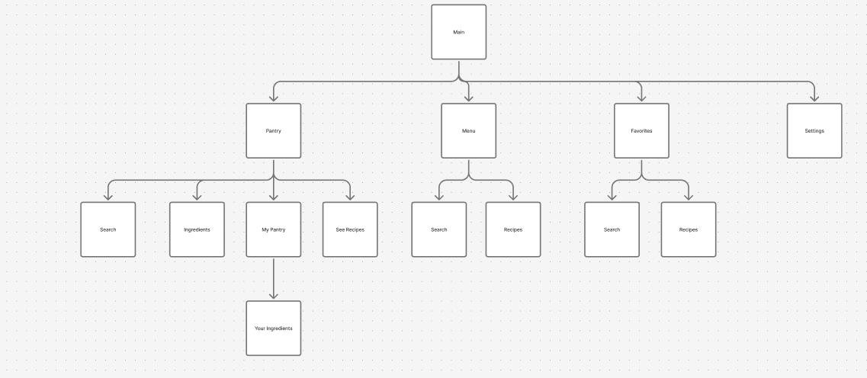

### PROJECT DEVELOPMENT RUNDOWN

In the creation of this app, I went through different processes such as;

1. Research: I conducted a bunch of research to understand what the topic given was about and to know exactly what features to incorporate. Created a feature list and grouped it into logical modules for smooth navigation.
2. Wireframing & UI design: A wireframe is a simple visual layout that outlines the structure and basic elements of a screen or page, without detailed design or color. It helps plan the app’s layout and functionality before styling.

I sketched out low-fidelity wireframes to block out each screen layout. The I transitioned to **Figma** to build digital wireframes and apply consistent spacing, typography, and layout rules.

Then I designed high-fidelity UI with:

* Soft colors
* Rounded corners
* Easy-to-read fonts (similar to iOS San Francisco)
* Mobile-friendly font sizes and tap areas

1. Branding & Logo Creation: I brainstormed logo concepts around “food, smart suggestions, and minimalism.” then generated and selected a clean, modern **MEAL-IT** logo in all caps, incorporating a pink and green color palette.
2. Prototype & Interactions: A prototype is an interactive version of the app that simulates user experience and flow. It allows users to click through screens and test how features work before development.

I added interactive components in Figma for user testing:

* Scrollable pages
* Hover effects
* Pop up notification
* Slide-in transitions

Then tested sticky frames, popups, and screen transitions in prototype mode.

1. Testing & Iteration: I reviewed user interactions and identified UX issues (e.g., scroll problems, hidden layers, font inconsistency). Also fixed UI bugs and refined animations. Then adjusted layout for clarity and readability on mobile screens.
2. Site Map & User Flow Creation: A sitemap is a visual or listed map that shows the structure of the app or website. It outlines how screens or pages are connected, helping define navigation and organization.

I developed a complete **site map** to visualize the app’s structure.

1. Documentation: Compiled all assets, wireframes, process notes, and final screens into documentation.

**ERRORS AND PROBLEMS**

During the course of designing and planning the Meal-It app, the following challenges and issues were encountered:

1. Navigation Conflicts

* Issue: Some interactive components (e.g., “slide-in” interactions or overlays) did not behave as expected during Figma prototype previews.
* Cause: Improper placement of animation triggers or incorrect frame constraints.
* Solution: Reviewed all interaction settings and applied proper “Smart Animate” settings; ensured frames were correctly nested.

2. Sticky Frame Not Working

* Issue: Sticky headers (like the bottom navigation bar or top search bar) were not staying fixed during scrolling.
* Cause: The frame was not set as “Fixed Position When Scrolling” or not nested inside the correct scrollable parent.
* Solution: Ensured the main frame had vertical scrolling enabled and applied the fixed position setting on desired layers.

3. Text Visibility in Preview

* Issue: Some texts or components did not appear during prototype preview.
* Cause: Either hidden under other layers, outside the visible frame area, or not part of the prototype flow.
* Solution: Checked layer order, adjusted frames, and used the "Focus on selection" and "Show prototype starting point" options.

4. Dropdown/Interactive Components

* Issue: Difficulty creating dropdown buttons or multi-option menus.
* Cause: Overlooked Figma’s use of components and interactive variants.
* Solution: Used variants and set up “On Click → Open Overlay” interactions with "Close when clicking outside" enabled.

5. Font & Readability Issues

* Issue: Inconsistent font sizes across the app affected readability.
* Solution: Set standard font sizes:
  + Body text: 14–16pt
  + Bottom Nav Text: 10–12pt
  + Headings: 18–24pt  
    Adopted a consistent text style system across components.

6. Scroll Area Misalignment

* Issue: Frames did not scroll even when content overflowed.
* Cause: The parent frame wasn’t set to "Vertical Scrolling" or child frames extended outside bounds.
* Solution: Enabled scrolling in the frame properties and adjusted content within boundaries.

**Conclusion**

The **Meal-It** app was designed to address real-life challenges around meal planning. By leveraging smart features like pantry tracking, personalized recipe suggestions, the app offers a user-friendly solution that simplifies daily cooking and supports healthier, more sustainable habits.

Throughout the project, I explored the full product design process — from research and ideation to wireframing, prototyping, and user experience design. This journey not only strengthened my skills in UI/UX design and problem-solving but also highlighted the importance of creating practical, user-centered solutions that make everyday life easier.

Meal-It is more than just a recipe app — it’s a smart kitchen companion that turns ingredients into meals with intention and simplicity.