DATABASE

MOVIE CLASS WORK (SAGES: BLESSING ASUELIMEN)

• Write a query in SQL to find the name and year of the movies.

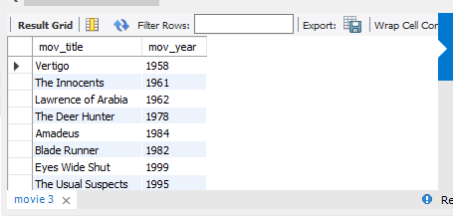

• Write a query in SQL to find the year when the movie American Beauty released.

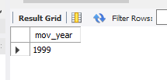

• Write a query in SQL to find the movie which was released in the year 1999



• Write a query in SQL to find the movies which was released before 1998

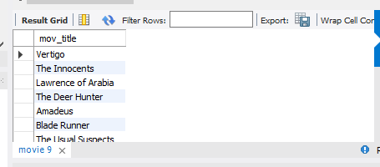

• Write a query in SQL to find the movie which was released in the year 1999

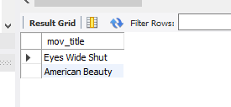

• Write a query in SQL to return the name of all reviewers and name of movies

together in a single list

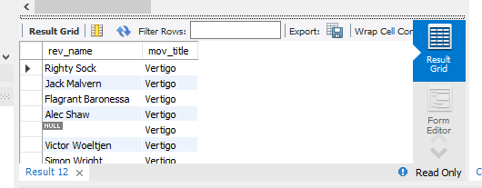

• Write a query in SQL to find the name of all reviewers who have rated 7 or more stars to their rating •

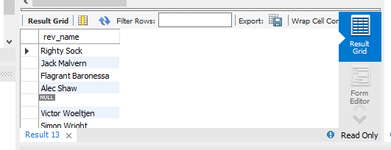

Write a query in SQL to find the titles of all movies that have no ratings.

• Write a query in SQL to find the name of all reviewers who have rated their ratings with a NULL value

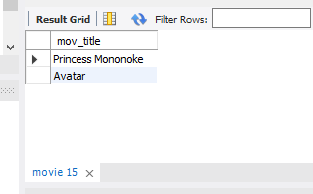

• Write a query in SQL to find the name of movie and director (first and last names) who directed a movie that casted a role for 'Eyes Wide Shut'.

