Project Overview: ZimStartUp
Introduction:
ZimStartUp is a platform that showcases mainly startups, SMEs’, youth ideas and connects them with various people in different communities., allows you to register and list your entity on the website. It enables companies to list their stock exchange capital and attract investors, lenders, customers, and partners from various communities. It also allows communities to access information, documents, and ratings of the companies and participate in their growth and success. It’s an easy-to-use platform that can be used by users with minimum computer skills. Its free and can be accessed with/ without the internet.
Its easy, efficient for the communities and businesses searching for other investment opportunities. Our main target are the youth who want to grow their startups by providing also another platform for the other youth to invest and become part of the growing community. This also then becomes a hub of all startups, one place to get all company information easily. Before you invest or think of investing, researching, ZimStartUp gives you the platform to get each info you want about a company without wasting resources or using too much data. All information in one place. It is a user-friendly platform that requires minimal computer skills and can be used online or offline. It is also a free platform that does not charge any fees for its services.
This document will provide step by step UI development process. Below is a summary of activities that will be involved.

Goals:
The main goals of ZimStartUp are:
- To provide a low-cost to free platform that facilitates the exchange of capital, loans, feedback, and partnerships between companies and communities in the stock market.
- To provide a one-stop place where users can find all the relevant documents and details of Startups, such as company documents, company board and directors, etc.
- To provide a transparent and objective scoring and rating system that evaluates the companies based on various criteria, such as financial performance, social impact, customer satisfaction, etc.
- Serve as a credit scoring board for individuals.
- To offer a platform for all startups or people with ideas to showcase their potential and attract opportunities.
- To facilitate the research and investment process for youth who want to learn more about the companies and support them.

Features:
The main features of ZimStartUp are:
- Listing: Startups, SMes’ can list their companies and specify the amount, price, and terms of their offering. They can also provide a brief description of their business, vision, and goals.
- Investing: Communities can browse the listings and choose to buy shares of the companies that interest them. They can also view the company's score and rating, as well as the feedback from other users.
- Lending: Communities can also choose to lend money to the companies that need funding. They can set the interest rate, duration, and repayment terms of their loans. They can also view the company's score and rating, as well as the feedback from other users.
- Feedback: Communities can also provide feedback to the companies about their products, services, or performance. They can rate and review the companies, as well as suggest improvements or ideas.
- Partnership: Communities can also look for partnership opportunities with the companies that match their interests, skills, or values. They can propose collaborations, projects, or deals to the companies and negotiate the terms and benefits.
- Information: Users can access all the documents and details of the companies in one place, such as company documents, company board and directors, etc. They can also filter, sort, and search the companies by various criteria, such as sector, location, score, rating, etc.
- Rating: Users can view the score and rating of the companies, which are based on various criteria, such as financial performance, social impact, customer satisfaction, etc.

Examples of Similar sites:
https://africanfinancials.com/company/zw-eco/
https://app.seedlegals.com/en/account

Phases:
How it works:
- Users register their idea, startup.
- User funds account.
- Company vetting and scoring (Not part of this scope)
- Company listed on the platform.
- Bidding process starts.
- Invested Funds management system tracker.

Flow Chart Diagram:
Customer Side:
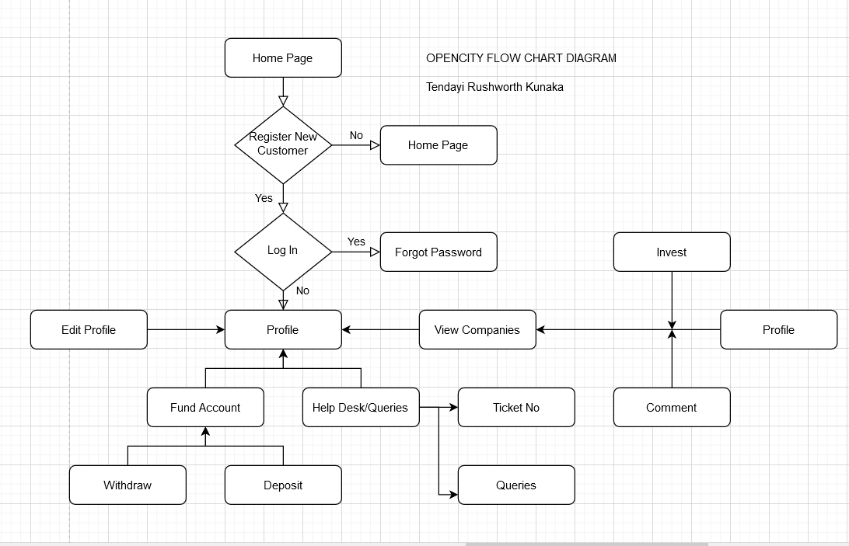

Home Page:
- Simple & easy to navigate.
- Option to search a company.
- Option to login using social media credentials.
- Rotating sponsor logos.
- Copyright
- User has to login to view company data for now.
- Unregistered User can search a company but cannot view any information except that it exists.

LogIn & Register Pages:
- No designs.
- Social media logins options
- SMS Notification login authorization to verify phone number.
- User has option to set up 2-way authentication profile.

Registration Pages:
- Allow user to select multiple options, (Ignore the Add Company Button)
- User is redirected to the below page when user clicks Register New User Button
- Carrying the below information to the next page, will only be submitted once.
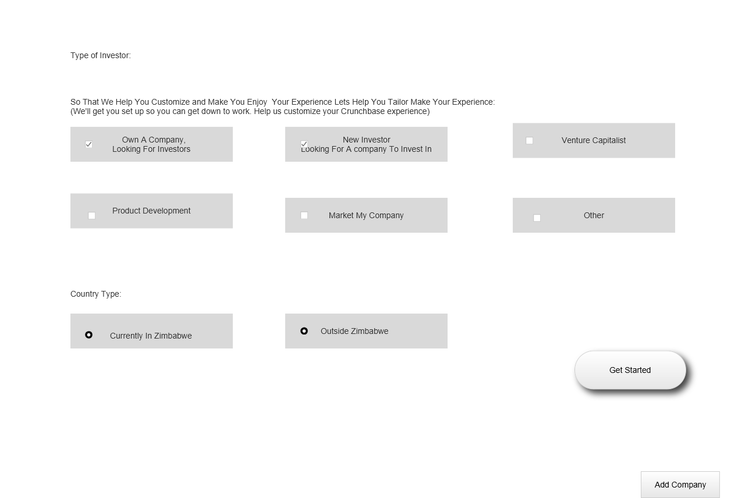

- Terms & Condition Page – Any works
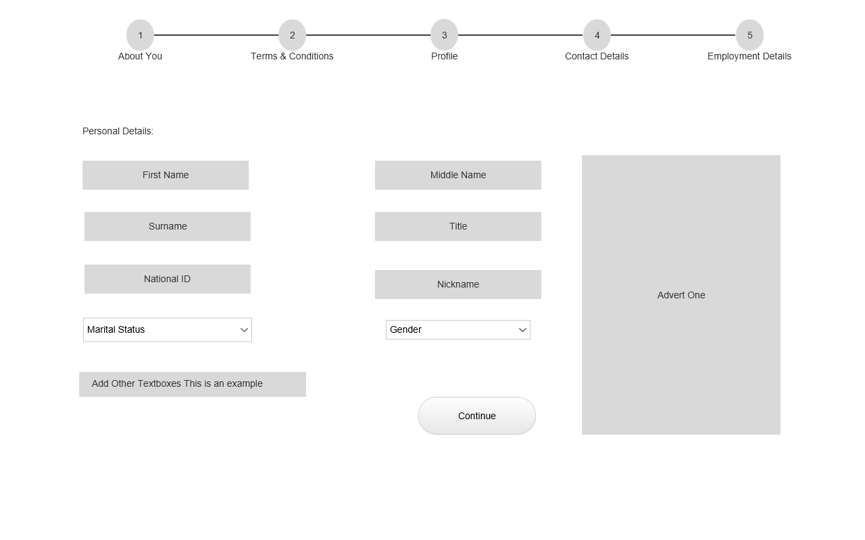
- Customer registration page
- Endpoints exposed.

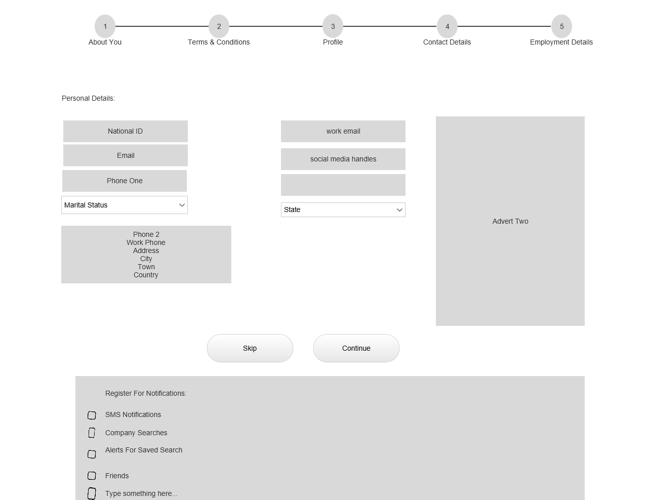

- Customer contact page
- Allow user to select multiple items on the bottom page for notifications.

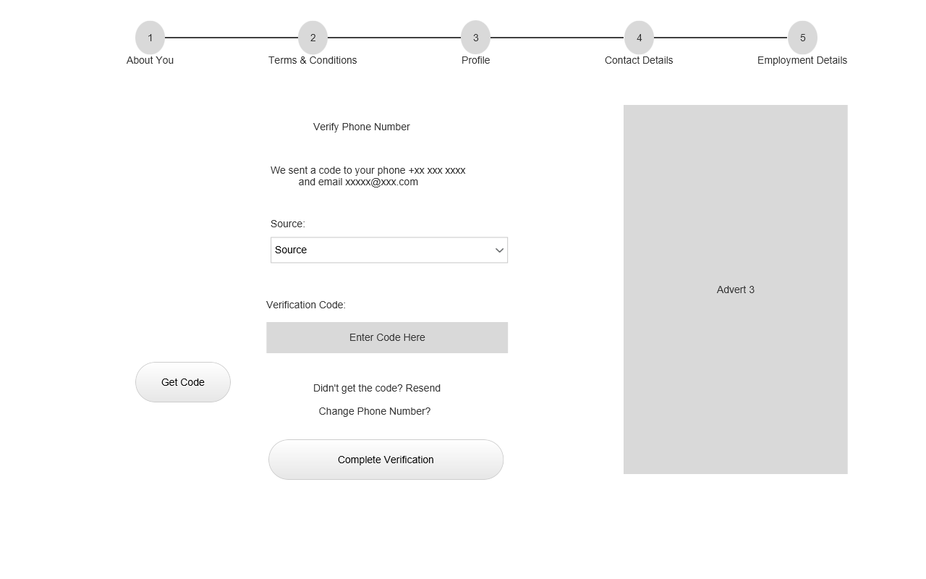
- User chooses Source – either Phone/ email
- User will get a code, that he enters above.
- Once verified, user is redirected to the set password page.
- User can use phone number/ email address to login.

Landing Page:
- Informative page, page educates a customer on how to buy or create a company
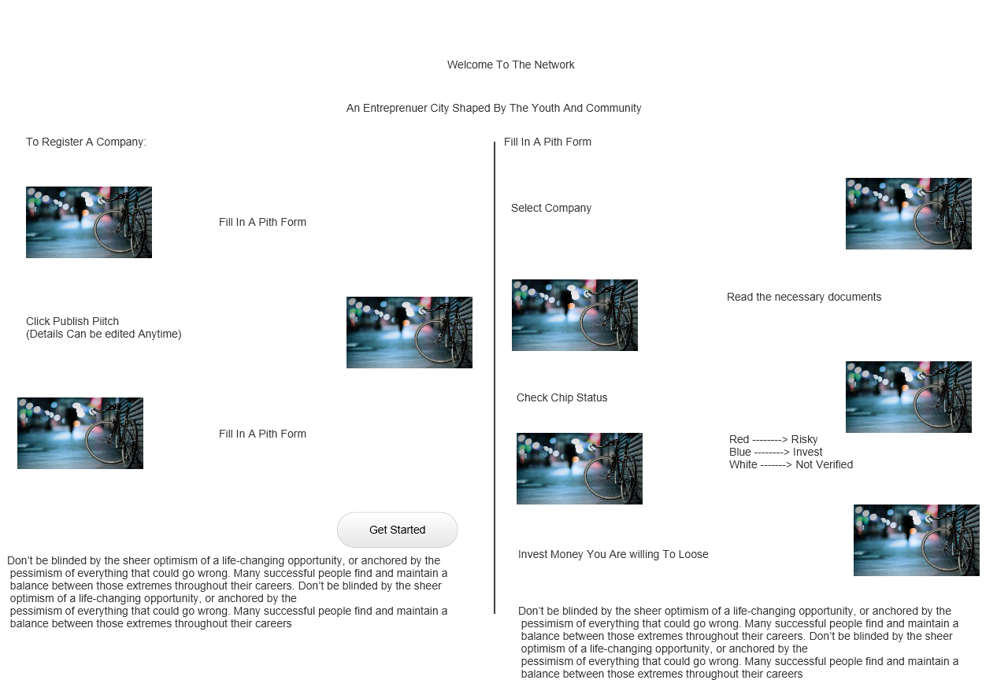
- U can change designs for this

Welcome Form:
- This form should always be accessible on the user’ profile.
- New users will be redirected to this page after registration process.
- The document shows the processes/ steps that a user should take to complete the process or invest in the system with minimum effort.

Profile:
- Once user is logged in, they are redirected to the profile page. Profile page shows the user overview summary for the banking, details & companies owned.
- Side bar will have options to manoeuvre between pages accessible to user.
- On registration user will be pending verification until national ID is verified.
- There should be a score below the user image, score is calculated at the back based on user profile.

Wallet:
- Second phase: Only show the wallet section on customer profile page.
- Access to wallet will be on the profile page only.
- Balance will be shown and link to access wallet shown.
- Wallet will list all the transactions done by user.
- To perform a transaction on the app or website, user can select type of transaction & amount or select a third-party option to do the transaction with.
- Transactions will be updated on intervals: 30 minutes/ 1-hr/ 2-hr basis.
- Anything outside that interval block is an issue.

Help Desk:
- This link will be accessible on all pages, easy access.
- Records the page user is at and any error on that web page/ app.
- Easy form to fill.
- Issues attended at intervals.

User Credit Vetting:
- User has access to request a Credit Vetting profile from RBZ.
- User will have an option to download and get ranked against other users in the market.
- User worthiness helps in acquiring of shares, will always get first preference.

User Documents:
- Saved as links.
- Saved for a certain period.
- Only the national ID will be mandatory.

Search Company:
- Multiple search option available on the company search page.
- Endpoint provided, search options available there.

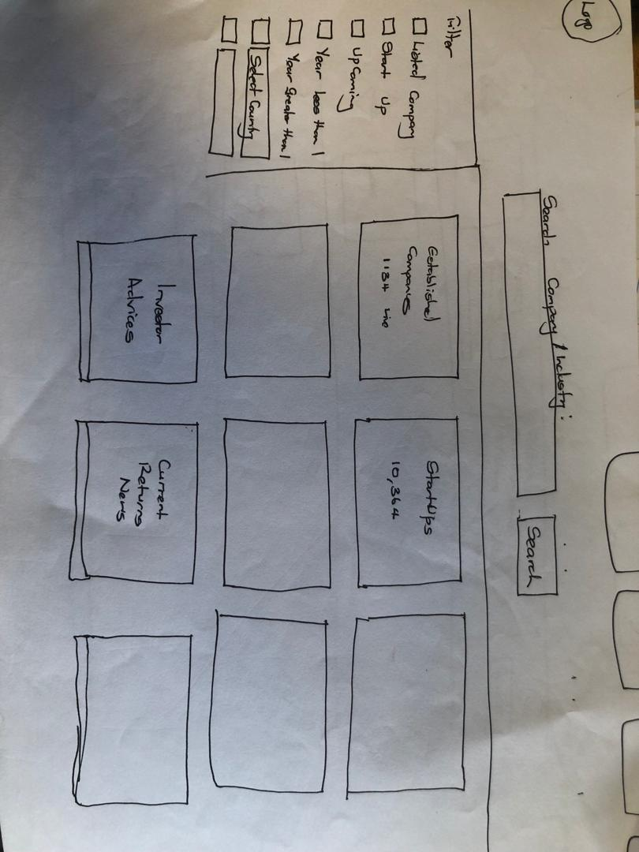

Company Listing:
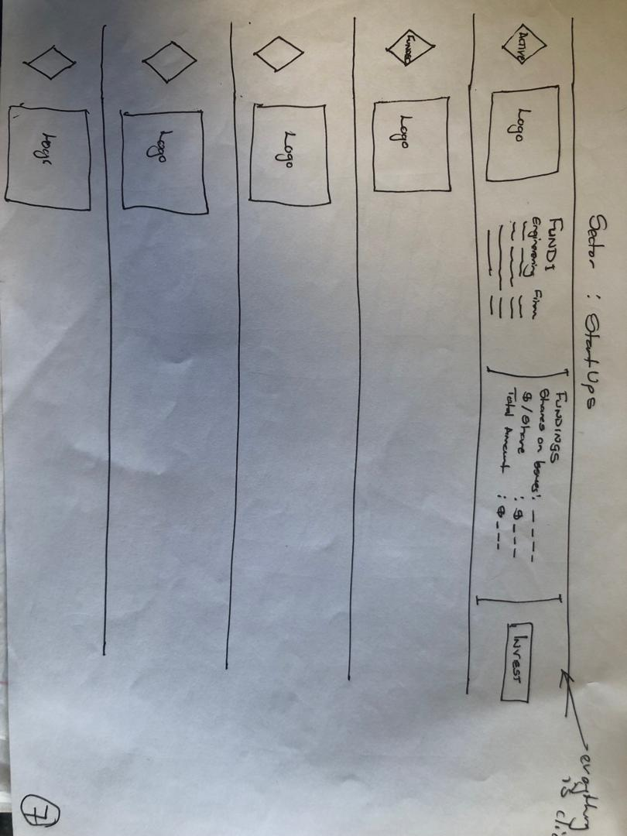
- User can click any item and be redirected to the company profile page.
- Minimum info shown.

Company Profile View:
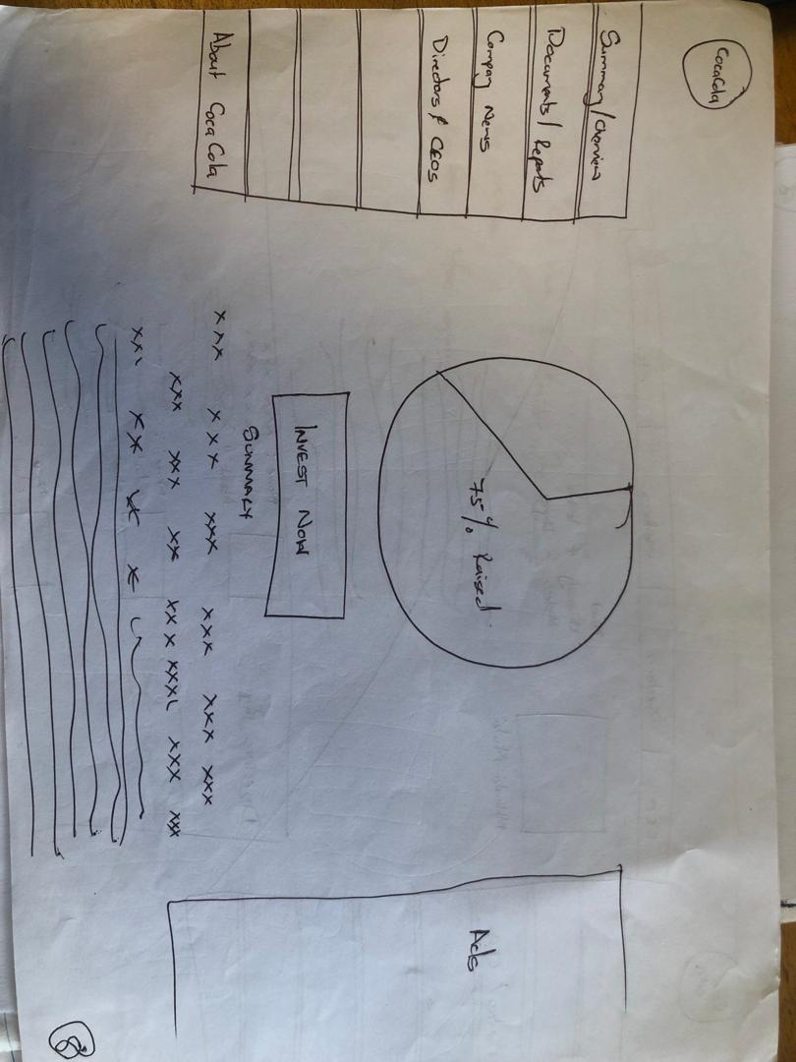

- Sample page of how it should look like
- Left side menu bar – will show all the selectable menu bars.
- Pie chart will show percentage of cash raised; you can use green.
- When cash is invested, use colour green.
- On the right side, minimum company information
- Invest button, once clicked shows a pop up where user can put amount they want.
- The system works out the qualification terms.
- Once user input an amount, system triggers the calculations.
- There should be 2 buttons, close & proceed.
- Summary page, shows the company description, provided.

END OF CUSTOMER JOURNEY: Phase 2 Begins

Company:
- Use
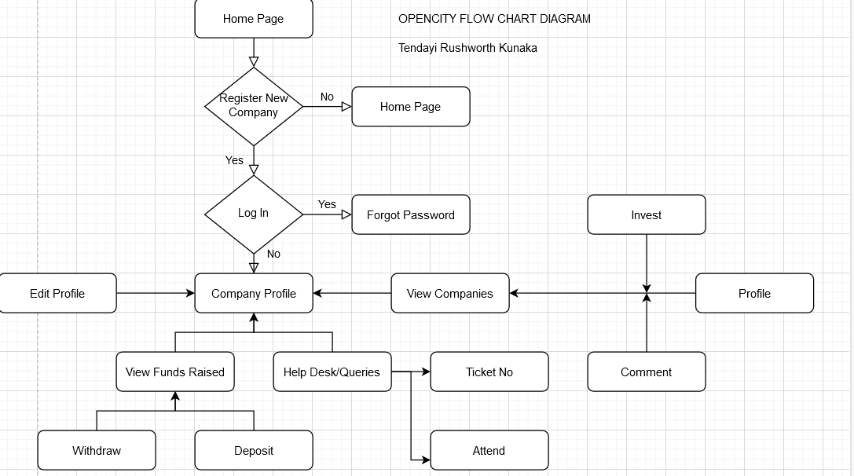
- Company Search:
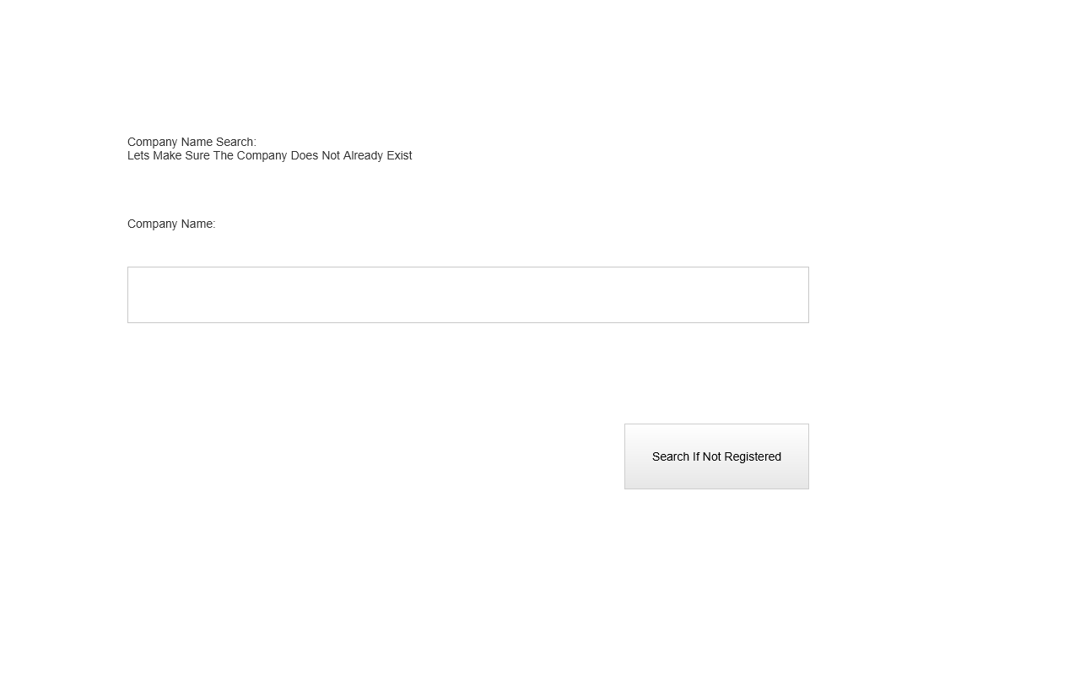
- Once user selects company registration, user will be redirected to the above page. Endpoint provided, user must search if company is available, if available reject & stay on the same page. If not available, option to go to the next page available

- Terms & Conditions:
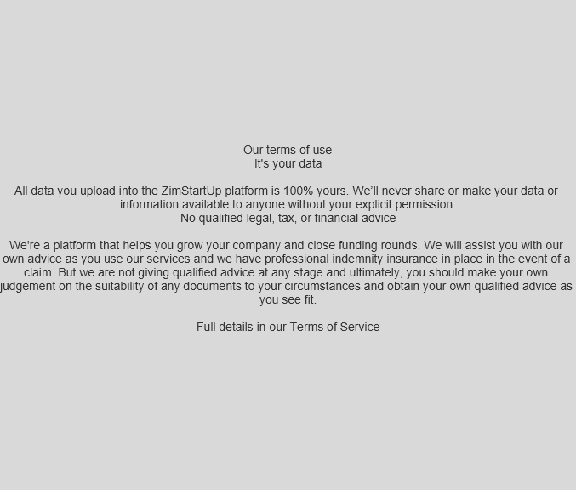
- Sample page & condition page, develop to your test. Checkbox/ radio button to accept.

- Industry Selection Page:
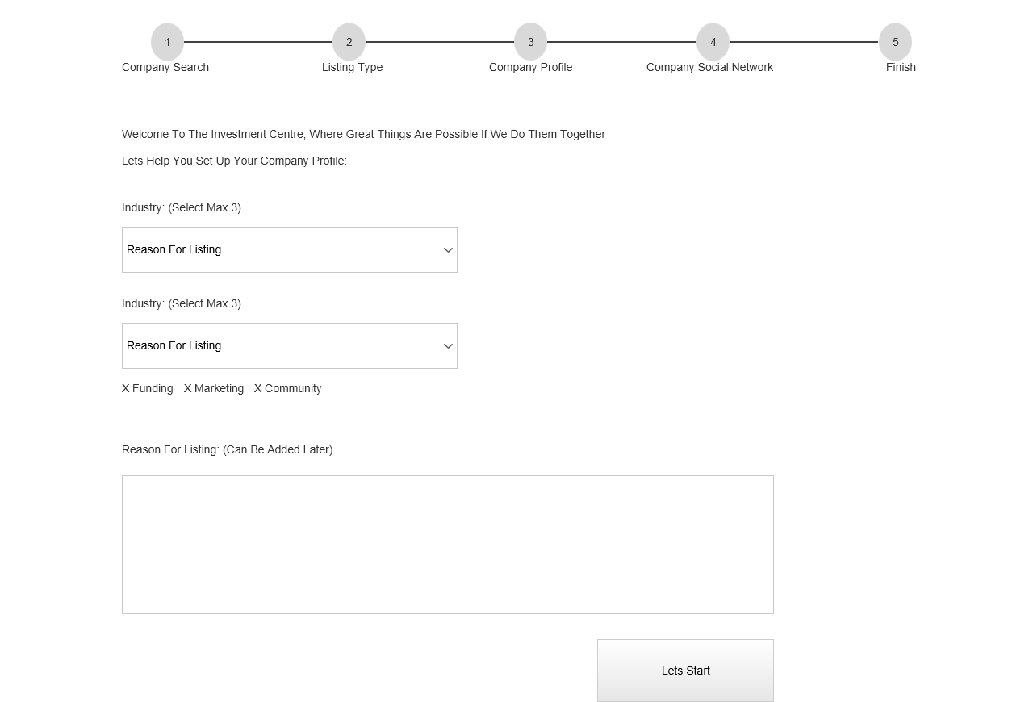
- Keep the top part in your designs. This then shows customer what point they are on their registrations.
- You can add a different colour once user has passed a certain stage, or tick in the circle.
- End points will be provided.
- Industry >>> [Established Business, New Business Idea, StartUp Phase, Community, Partnership, Franchise]
- Reason For Listing >>> Allow users to select maximum of 3 items >>> [Funding, Marketing, Loans, Research, Reviews]
- This part can be left blank.

- Company Data:
- Design to your own test
- Endpoints provided.
- Add company information.

- Previous funds
Design to your own test
Endpoints provided.

- Company Dashboard:
- Image below:
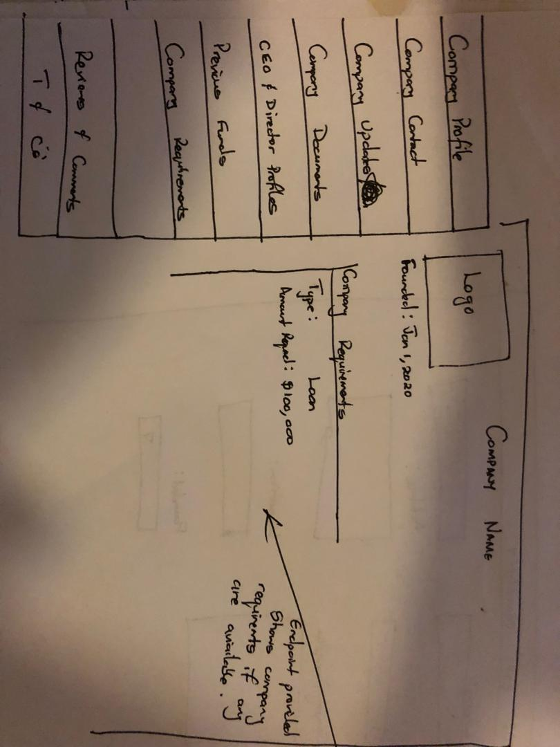
- Page contains company logo and company name.
- Then shows company requirements, (what the company is looking for, it can be either a loan, funding, research etc)

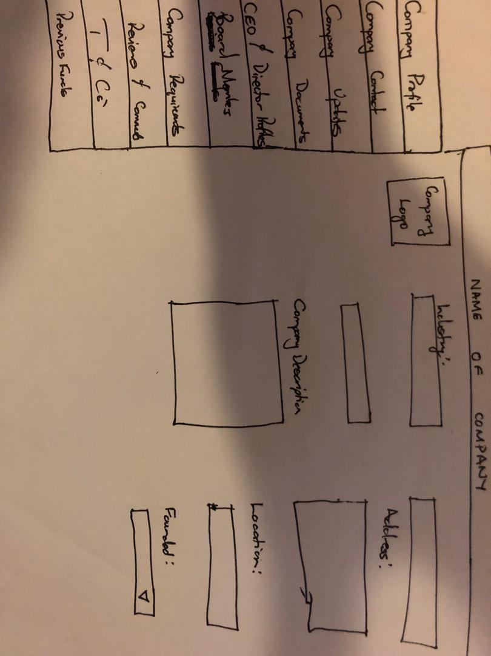

Company profile:
- Allows user to fill in the company profile details.

Company Contact Details:
- Company contacts details and social media links.

Company Updates:
- Contains a list of updates and an option to add a new update.

Company Documents:
- Option to upload a new document.
- User can only select type of document to upload from the list.
- Once document name is selected, user can then select document & upload.
- User can delete documents from the list.

CEO & Directors Profiles:
- 2 sections on this module
- First part is uploading company shareholders. Endpoints provided.
- Shareholders do not have any qualifications attached to them.
- Second part is uploading company board members and their qualifications.
- Board members will be linked to their qualifications and experience profiles.

Previous Funds & Stock Market:
- Company can list if they are attached to any stock market, first section.
- Second section: Previous funds listing, these are funds outsourced from other facilities or individuals.

Company Requirements:
- Section looks at what the company is looking for.
- Reason why they listed.

Reviews & Comments:
- Company can view comments left by customers.
- Company can respond on the comments left by customers.
T & Cs’: - Normal page

- View Company Schedule:
- User clicks Invest button, user can input amount then a schedule is shown.
- User then clicks invest & then shares are bought.

Company Dashboard Admin Panel:
Features That Should Be Included:
- Add Sector/ Industry Page:
- Adding of sector, has 2 columns.
- User should be able to update any sector with the following statuses only: ('ACTIVE', 'SUSPENDED', 'REJECTED')
- Add Stock Markets
- Page to add stock market entities in the country/ world.
- This is to be used during company registration if company is listed on a stock market.
- Endpoint provided.
- View of all companies listed on the site.
- Option to edit the companies.
- Option to search for a customer.
- Option to edit customer data.

