INDIAN AGRICULTURAL CROP PRODUCTION ANALYSIS
WEEK 3 REPORT
Performing Descriptive Analytics and Data Trend Analysis
Submitted By:
Blessings Soly Benny
Course: B.Sc. Data Science
Week: Week 3 — Agribusiness Data Analysis
Tools: Python | Pandas | Matplotlib | Jupyter Notebook | VS Code | Microsoft Word
Dataset: crop_production_cleaned.csv
Academic Year: 2026

Table of Contents
Table of Contents 1
3. Introduction 1
4. Objectives 1
5. Dataset Description and Data Source 1
6. Methodology 1
6.1 Data Preparation 1
6.2 Descriptive Statistics 1
6.3 Mean 1
6.4 Median 1
6.5 Variance 1
6.6 Standard Deviation 1
6.7 Minimum and Maximum 1
6.8 Grouped Analysis 1
6.9 Trend Analysis 1
6.10 Distribution Analysis 1
6.11 Relationship Analysis 1
6.12 Anomaly/Extreme Observation Analysis 1
7. Descriptive Statistical Analysis 1
7.1 Overall Dataset Statistics 1
7.2 Area Statistics 1
7.3 Production Statistics 1
7.4 Interpretation of Mean and Median 1
7.5 Interpretation of Variance and Standard Deviation 1
7.6 Range and Extreme Values 1
8. Trend and Pattern Analysis 1
8.1 Production by Year 1
8.2 Top Crops by Total Production 1
8.3 Top States by Total Production 1
8.4 Production by Season 1
8.5 Area vs Production 1
8.6 Production Distribution 1
8.7 Significant Patterns 1
8.8 Extreme/Unusual Observations 1
9. Visual Representations 1
10. Agribusiness Insights 1
11. Discussion 1
12. Limitations 1
13. Conclusion 1
14. References 1
15. Appendix 1

3. Introduction
Agriculture continues to be one of the most important sectors of the Indian economy, and reliable production data plays a central role in supporting planning, storage, transportation and market decisions in agribusiness. Week 1 of this project introduced the Indian Agricultural Crop Production dataset and its overall structure, while Week 2 focused on identifying and correcting data quality issues, including missing Production values, inconsistent text formatting and unusual observations.
This report presents Week 3 of the project, which applies descriptive analytics and trend analysis to the cleaned dataset produced in Week 2. Descriptive analytics is the branch of data analysis concerned with summarising and describing the main features of a dataset, using measures such as the mean, median, variance and standard deviation, together with grouped comparisons and visualisations. Unlike predictive or prescriptive analytics, descriptive analytics does not forecast future outcomes or recommend specific actions; instead, it answers the question "what does the data show?", which is the necessary first step before any deeper analysis can be attempted.
The Week 2 evaluator feedback noted that the previous report was well structured but needed more detailed explanations and dataset-specific examples, along with more careful proofreading and consistent formatting. This report directly responds to that feedback: every statistic reported below is calculated from the actual cleaned dataset, every important number is explained in plain language with reference to what it means for agribusiness, and headings, figure numbers and table numbers follow one consistent style throughout the document.

4. Objectives
- To apply descriptive statistical techniques to the cleaned Indian agricultural crop production dataset.
- To calculate and interpret the mean, median, variance, standard deviation, minimum, maximum and quartiles of Area and Production.
- To analyse how total agricultural production has changed across the years covered by the dataset (1997–2015).
- To compare production across crops, states and seasons, and to identify which categories contribute most to total production.
- To examine the relationship between cultivated Area and Production.
- To identify unusually large observations in the dataset and to distinguish genuine extreme values from possible data-quality issues.
- To present findings using clearly labelled tables and charts.
- To connect the statistical findings to practical agribusiness applications such as storage, transportation, supply planning and regional resource allocation.
- To directly address the Week 2 evaluator feedback by providing deeper, dataset-specific explanations and by maintaining consistent grammar and formatting throughout the report.

5. Dataset Description and Data Source
This report uses crop_production_cleaned.csv, which is the cleaned version of the Indian Agricultural Crop Production dataset produced during Week 2. The original raw file, crop_production.csv, contained 246,091 records across 7 columns. During Week 2 cleaning, 3,730 records with missing Production values were removed, leaving a cleaned dataset of 242,361 records. This cleaned file is used for all calculations in this report; the raw dataset and the cleaned dataset were not modified while preparing Week 3, and both files remain available for reference.
The seven columns in the dataset are described below.
Column | Description
State_Name | Name of the Indian state or union territory where the record was collected.
District_Name | Name of the district within the state.
Crop_Year | Agricultural year in which the crop was recorded.
Season | Agricultural season (e.g., Kharif, Rabi, Whole Year).
Crop | Name of the crop.
Area | Cultivated area associated with the record.
Production | Recorded production associated with the crop, area, year and season.

The dataset covers crop years from 1997 to 2015 and includes 33 states/union territories, 646 districts, 124 distinct crops, and 6 season categories (Autumn, Kharif, Rabi, Summer, Whole Year, Winter). After Week 2 cleaning, the dataset contains no missing values in any column, which was confirmed again at the start of this analysis.
This is a historical, secondary (government/open-data type) dataset. As noted in the Week 2 report, this type of source offers wide coverage across states and years at low cost, but the dataset documentation available for this project does not specify the exact unit of measurement used for Area and Production for every crop, nor does it explain why some years have far fewer records than others. Section 12 (Limitations) discusses how this affects the interpretation of the results.

6. Methodology

6.1 Data Preparation
The cleaned dataset from Week 2 was loaded directly using pandas (pd.read_csv). Before any statistics were calculated, the dataset was re-checked for missing values, and the row count, column count, data types and year range were re-confirmed to match the Week 2 output. No records were added, removed or modified during this step; Week 3 works only on top of the already-cleaned dataset, so the descriptive statistics in this report are calculated from a more reliable and complete base than would have been possible using the raw file.

6.2 Descriptive Statistics
Descriptive statistics summarise a dataset using a small number of representative values rather than requiring every individual record to be inspected. For this report, descriptive statistics were calculated separately for the Area and Production columns, because these are the two numeric variables in the dataset and they behave differently: Area represents land under cultivation, while Production represents the resulting output, which can vary because of the crop type, yield, season and other agronomic factors.

6.3 Mean
The mean (arithmetic average) is calculated by summing all values in a column and dividing by the number of records. The mean is useful because it summarises the "typical" value of a variable using every observation, but it is sensitive to very large or very small values. In a dataset such as this one, where a small number of crops (particularly Coconut) are recorded with very large production figures, the mean can be pulled well above the value that most individual records actually show.

6.4 Median
The median is the middle value of a column when all values are sorted in order. Unlike the mean, the median is not affected by extremely large or small values, because it depends only on the position of the middle observation, not its size. Comparing the mean and median is therefore a simple and effective way to check whether a variable is affected by extreme values, which is one of the central techniques used in Section 7 of this report.

6.5 Variance
Variance measures how spread out the values in a column are around the mean. It is calculated as the average of the squared differences between each value and the mean. Because the differences are squared, variance is always a positive number, and it is expressed in squared units (for example, tonnes-squared for Production), which makes it harder to interpret directly. Variance is still useful because it is the basis for the standard deviation, and because a very large variance is itself a signal that a variable contains a wide range of values, some of which may be far from the average.

6.6 Standard Deviation
The standard deviation is the square root of the variance, and it is expressed in the same unit as the original variable (for example, tonnes for Production), which makes it easier to interpret than variance. A large standard deviation relative to the mean indicates that the values in a column are widely spread out, while a small standard deviation indicates that most values are close to the mean. As shown in Section 7, both Area and Production in this dataset have standard deviations that are far larger than their means, which is an early indication of a highly uneven, right-skewed distribution.

6.7 Minimum and Maximum
The minimum and maximum values show the smallest and largest recorded values in a column. These are useful for a quick sanity check of the data (for example, confirming that there are no negative Area or Production values remaining after cleaning) and for identifying the scale of the most extreme observations, which is examined in more detail in Section 8.8.

6.8 Grouped Analysis
Grouped analysis uses the pandas groupby() function to calculate totals or averages for specific categories, such as Crop_Year, Crop, State_Name and Season. This makes it possible to move beyond a single overall summary of the dataset and instead compare how production differs between years, crops, states and seasons, which directly supports the trend and pattern analysis in Section 8.

6.9 Trend Analysis
Trend analysis in this report examines how total production changes from year to year across the 1997–2015 period covered by the dataset. Year-over-year percentage change was calculated using pandas' pct_change() function, which expresses the change between one year and the next as a percentage of the earlier year's value. This makes it possible to describe not just whether production went up or down, but by how much, in a way that is comparable across different points in the timeline.

6.10 Distribution Analysis
Distribution analysis looks at how values are spread across the full range of a variable, rather than only at the average. This report uses a histogram of Production (on a logarithmic scale, because of the very wide range of values) and quartile-based measures such as the interquartile range (IQR) to describe the shape of the Production distribution, including its skewness.

6.11 Relationship Analysis
Relationship analysis examines whether two numeric variables move together. This report calculates the Pearson correlation coefficient between Area and Production, which measures the strength and direction of a linear relationship on a scale from -1 to +1, and it visualises the relationship using a scatter plot. A correlation close to 0 does not necessarily mean there is no relationship at all; it can also mean that the relationship is not linear, or that it is obscured by very large values from a small number of records, both of which are discussed in Section 8.5.

6.12 Anomaly/Extreme Observation Analysis
Extreme observations were identified using the same Interquartile Range (IQR) method applied in Week 2: values above Q3 + 1.5 × IQR are flagged as statistical outliers. Following the Detect → Inspect → Validate → Interpret approach recommended in Week 2, every flagged record was not automatically treated as an error. Instead, the crop, state, district, year, area and production of the largest records were inspected individually, so that a genuine (if unusually large) observation could be distinguished from a possible data-entry problem. This process and its results are discussed in Section 8.8.

7. Descriptive Statistical Analysis

7.1 Overall Dataset Statistics
The cleaned dataset contains 242,361 records with no missing values in any of the seven columns. The total cultivated area recorded across all observations is 2,948,906,741 units, and the total recorded production across all observations is 141,176,116,767 units. These totals form the basis for the percentage-share calculations used later in this report (for example, what share of total production comes from the top crops or states).

7.2 Area Statistics
Statistic | Value
Count | 242,361
Mean | 12,167.41
Median | 603.00
Variance | 2,586,479,205.81
Standard Deviation | 50,857.44
Minimum | 0.10
Maximum | 8,580,100
1st Quartile (Q1) | 87.00
3rd Quartile (Q3) | 4,545.00
Interquartile Range (IQR) | 4,458.00
Range | 8,580,100

Table 1: Descriptive statistics for the Area column.

7.3 Production Statistics
Statistic | Value
Count | 242,361
Mean | 582,503.44
Median | 729.00
Variance | 291,241,979,235,613.40
Standard Deviation | 17,065,813.17
Minimum | 0.00
Maximum | 1,250,800,000
1st Quartile (Q1) | 88.00
3rd Quartile (Q3) | 7,023.00
Interquartile Range (IQR) | 6,935.00
Range | 1,250,800,000

Table 2: Descriptive statistics for the Production column.

7.4 Interpretation of Mean and Median
For Area, the mean (12,167.41) is more than 20 times larger than the median (603.00). For Production, the difference is even more extreme: the mean (582,503.44) is roughly 799 times larger than the median (729.00). In both cases the mean is much higher than the median, which is a classic sign of a right-skewed distribution — a distribution in which most records have relatively small values, while a smaller number of records have very large values that pull the average upward.
This pattern makes sense for an agricultural dataset that records many different crops together in the same Area and Production columns. A small plot of a district-level vegetable crop and a large state-level total for a plantation crop are stored in the same columns, even though their natural scale is completely different. Because of this, the median is a more representative measure of a "typical" record in this dataset, while the mean is more useful for describing overall national totals. Section 8.7 discusses the crop that is mainly responsible for this skew.

7.5 Interpretation of Variance and Standard Deviation
The standard deviation of Production (17,065,813.17) is far larger than its own mean (582,503.44), and the variance (291,241,979,235,613.40) is an extremely large number because it is expressed in squared units. A standard deviation that is many times larger than the mean confirms what the mean-versus-median comparison already suggested: Production is not evenly spread around its average value. Instead, most records are clustered at relatively low values (the median of 729.00 gives a better sense of this), while a small number of very large records increase the spread dramatically. The same pattern, though less extreme, is visible for Area, where the standard deviation (50,857.44) is also much larger than the mean (12,167.41).

7.6 Range and Extreme Values
The Production column ranges from a minimum of 0.00 to a maximum of 1,250,800,000, giving a range of 1,250,800,000. The Area column ranges from 0.10 to 8,580,100, a range of 8,580,100. Such a wide range is expected in a dataset that mixes small district-level records with large aggregated ones, but it also means that a single very large record can have a disproportionate effect on any statistic that is not resistant to outliers, such as the mean, variance, or a simple sum. The interquartile range (IQR) — 6,935.00 for Production and 4,458.00 for Area — is a more robust measure of typical spread, because it is based on the middle 50% of the data and is not affected by the most extreme values. The IQR is used again in Section 8.8 to formally identify extreme observations.

8. Trend and Pattern Analysis

8.1 Production by Year
Total production was calculated for each Crop_Year from 1997 to 2015 using a groupby-sum operation. The results are shown in Table 3 and Figure 1.
Year | Total Production | Change vs. Previous Year
1997 | 851,232,906 | —
1998 | 5,825,320,640 | +584.34%
1999 | 6,434,665,985 | +10.46%
2000 | 7,449,709,127 | +15.77%
2001 | 7,465,540,840 | +0.21%
2002 | 7,696,955,163 | +3.10%
2003 | 7,917,973,505 | +2.87%
2004 | 8,189,461,695 | +3.43%
2005 | 8,043,757,330 | -1.78%
2006 | 8,681,913,124 | +7.93%
2007 | 6,879,442,339 | -20.76%
2008 | 7,717,018,402 | +12.18%
2009 | 7,660,494,025 | -0.73%
2010 | 6,307,608,525 | -17.66%
2011 | 14,308,904,087 | +126.85%
2012 | 8,171,054,746 | -42.90%
2013 | 12,903,588,633 | +57.92%
2014 | 8,664,540,631 | -32.85%
2015 | 6,935,065 | -99.92%

Table 3: Total agricultural production by year, with year-over-year percentage change.
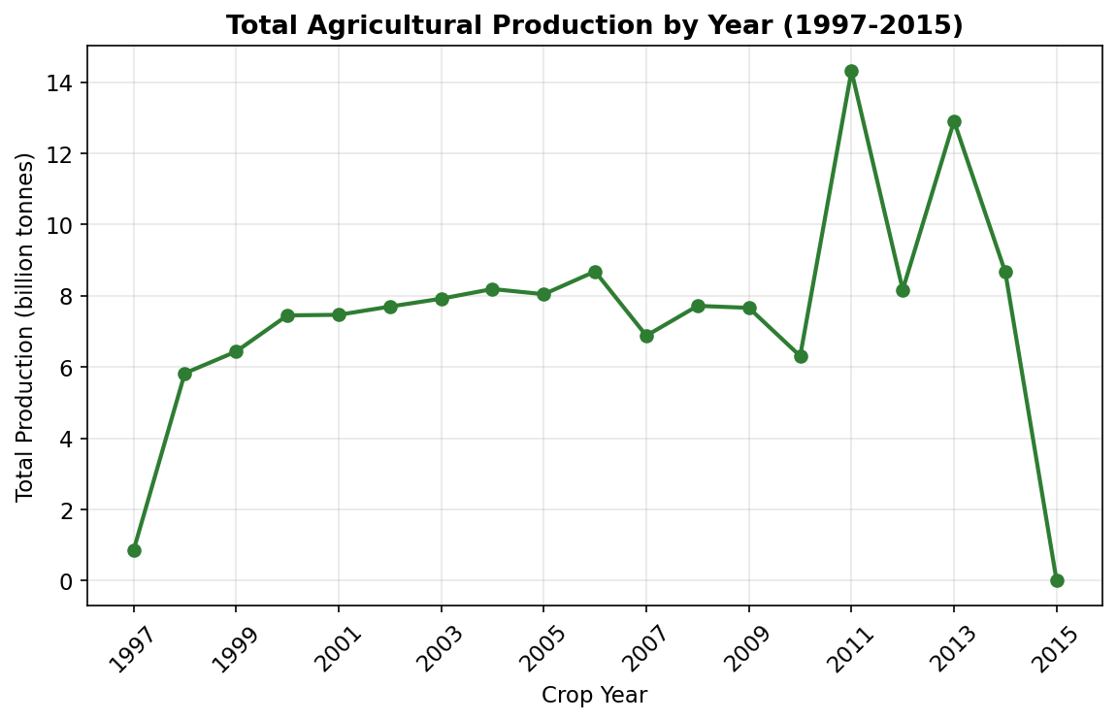
Figure 1: Total agricultural production by year (1997–2015).
Figure 1 shows that recorded total production rises sharply between 1997 and 1998 (a year-over-year increase of 584.34%), stays broadly in the range of 6–9 billion units for most years from 1999 to 2010, and then shows two very large spikes in 2011 (14,308,904,087) and 2013, before dropping sharply in 2015. This is the single most important pattern in the yearly trend, and it needs careful interpretation rather than a simple "production rose then fell" reading.
The 1997 and 2015 figures are almost certainly affected by incomplete data coverage rather than a genuine change in national agricultural output. The dataset contains records from only 23 of the 33 states in 1997, and from only 2 states (Odisha and Sikkim, 561 records in total) in 2015, compared with a typical 13,000–17,000 records covering most states in the other years. A year with far fewer participating states will naturally show far lower total production, regardless of how agriculture actually performed that year. For this reason, the overall change of -99.19% between 1997 and 2015 should not be read as "India's agricultural production fell by 99% over the study period" — it mainly reflects a difference in how many states were recorded in the first and last years of the dataset.
The 2011 and 2013 spikes have a different explanation, examined further in Sections 8.7 and 8.8: both years contain some of the very largest individual Coconut production records in the dataset (from Coimbatore in Tamil Nadu and from districts in Kerala). Because Coconut production values are recorded on a much larger numerical scale than most other crops, a handful of very large Coconut records in a given year can noticeably raise that year's national total, even without a broad-based change across all crops and states. This is an observed pattern; the underlying cause (for example, whether it reflects a genuine bumper coconut harvest, a change in the number of coconut-producing districts reported that year, or a difference in the unit used to record coconut output) cannot be confirmed from this dataset alone.

8.2 Top Crops by Total Production
The ten crops with the highest total recorded production are shown in Table 4 and Figure 2.
Crop | Total Production | % of Total Production
Coconut | 129,981,629,216 | 92.07%
Sugarcane | 5,535,681,526 | 3.92%
Rice | 1,605,470,383 | 1.14%
Wheat | 1,332,825,657 | 0.94%
Potato | 424,826,344 | 0.30%
Cotton(lint) | 297,000,016 | 0.21%
Maize | 273,341,804 | 0.19%
Jute | 181,558,178 | 0.13%
Banana | 146,132,680 | 0.10%
Soyabean | 141,837,219 | 0.10%

Table 4: Top 10 crops by total production.
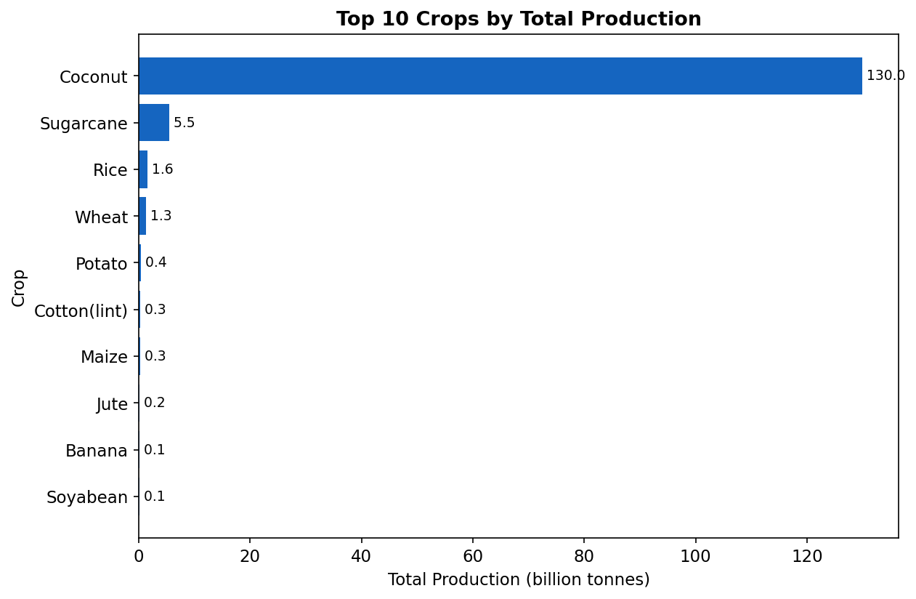
Figure 2: Top 10 crops by total production.
Coconut alone accounts for 92.07% of total recorded production, and the top 10 crops together account for 99.11% of the dataset's total production, out of 124 distinct crops. This is a very high level of concentration: a single crop contributes more than nine times as much as the second-largest crop (Sugarcane, 3.92%).
This pattern matters for agribusiness in two ways. First, it shows that any national-level summary of "total agricultural production" in this dataset is overwhelmingly driven by Coconut, so such totals should not be used to represent staple food crops such as Rice or Wheat, which appear much further down the list despite their importance to food security. Second, it raises a measurement question rather than only an agricultural one: Coconut is conventionally counted in "number of nuts" in Indian agricultural statistics, while crops such as Rice, Wheat and Sugarcane are typically measured in tonnes. If that convention applies to this dataset as well, then Coconut's huge numerical share partly reflects a difference in counting unit rather than a difference in agricultural weight or value, and the two should not be directly compared without adjustment. The dataset itself does not confirm which unit was used for each crop, so this remains a plausible explanation rather than a confirmed fact; it is discussed further in Section 8.7 and in the Limitations section.

8.3 Top States by Total Production
The ten states with the highest total recorded production are shown in Table 5 and Figure 3.
State | Total Production | % of Total Production
Kerala | 97,880,045,376 | 69.33%
Andhra Pradesh | 17,324,590,296 | 12.27%
Tamil Nadu | 12,076,443,049 | 8.55%
Uttar Pradesh | 3,234,492,663 | 2.29%
Assam | 2,111,751,759 | 1.50%
West Bengal | 1,397,904,390 | 0.99%
Maharashtra | 1,263,640,606 | 0.90%
Karnataka | 863,429,812 | 0.61%
Andaman and Nicobar Islands | 718,223,240 | 0.51%
Punjab | 586,385,001 | 0.42%

Table 5: Top 10 states by total production.
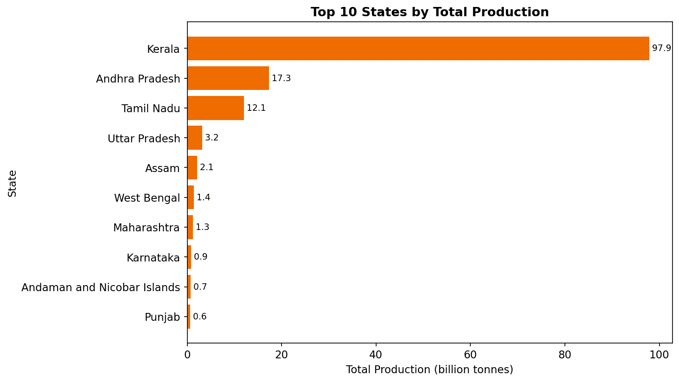
Figure 3: Top 10 states by total production.
Kerala alone contributes 69.33% of total recorded production, followed by Andhra Pradesh (12.27%) and Tamil Nadu (8.55%). This state ranking closely mirrors the crop ranking in Section 8.2: Kerala, Andhra Pradesh and Tamil Nadu are all well known as major coconut-growing states, which is consistent with Coconut being the dominant crop in the dataset's production totals. This cross-check between two independent groupings (by crop and by state) makes the earlier observation about Coconut's influence more convincing, because the same underlying pattern shows up from two different angles.

8.4 Production by Season
Total production was also grouped by Season, as shown in Table 6 and Figure 4.
Season | Total Production | % of Total Production
Whole Year | 134,424,837,450 | 95.22%
Kharif | 4,029,970,243 | 2.85%
Rabi | 2,051,687,553 | 1.45%
Winter | 434,549,828 | 0.31%
Summer | 170,657,925 | 0.12%
Autumn | 64,413,768 | 0.05%

Table 6: Total production by season.
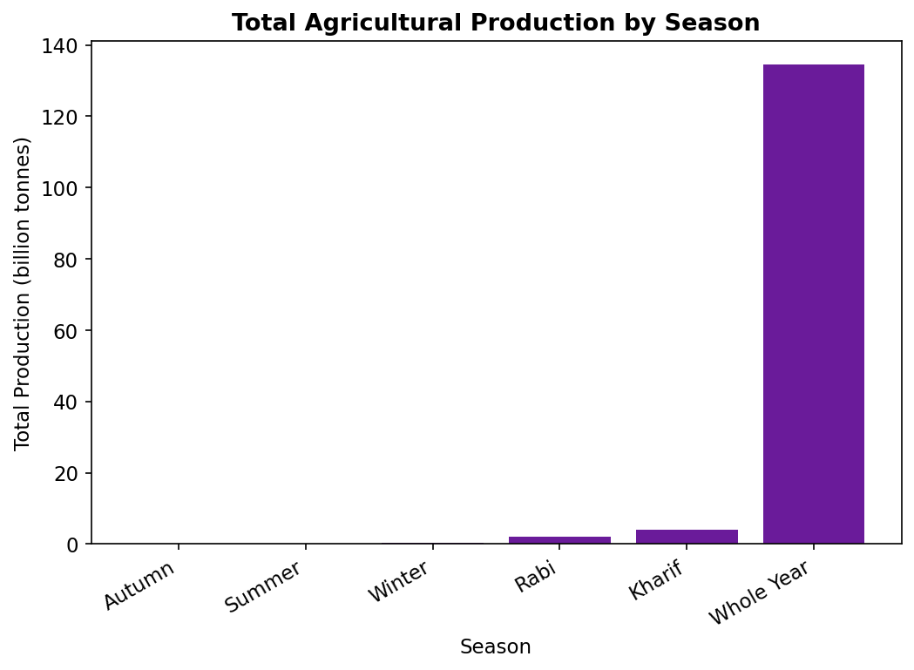
Figure 4: Total agricultural production by season.
"Whole Year" accounts for 95.22% of total production, far more than the seasonal categories such as Kharif (2.85%) and Rabi (1.45%), which are more commonly associated with staple crops such as Rice and Wheat. This is consistent with Coconut being recorded under the "Whole Year" season, since coconut palms are harvested continuously rather than in a single Kharif or Rabi cropping season. This finding again links back to the crop-level concentration identified in Section 8.2, and it means that seasonal totals in this dataset mainly describe when Coconut is harvested, rather than describing the overall seasonal rhythm of Indian agriculture as a whole.

8.5 Area vs Production
The Pearson correlation coefficient between Area and Production across all 242,361 records is 0.0406, which is very close to zero and indicates almost no linear relationship between the two variables when all crops are considered together. At first this may seem surprising, since it is reasonable to expect that a larger cultivated area would generally produce more output.
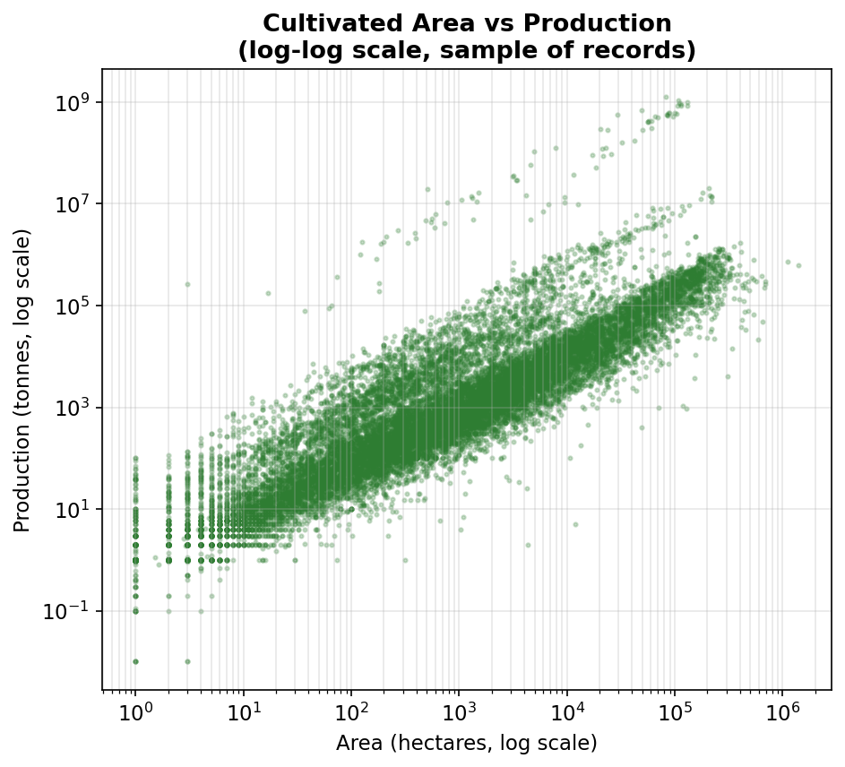
Figure 5: Cultivated Area vs Production (log-log scale, sample of records).
Figure 5 helps to explain this apparent contradiction. On a logarithmic scale, most points do follow a broadly upward-sloping pattern, showing that within a similar order of magnitude, more Area is generally associated with more Production. However, the Pearson correlation coefficient measures a straight-line (linear) relationship on the original scale, and it is heavily influenced by the small number of extremely large Production values described in Section 8.2. Because these extreme Coconut records combine a comparatively moderate Area with an extremely large Production value (discussed further in Section 8.8), they pull the overall correlation away from what a "typical" crop record shows. The average Production-to-Area ratio across all valid records is 41.65, but the median ratio is only 1.00, which is a further sign that a small number of records with unusually high output-per-unit-area are inflating the average relationship.

8.6 Production Distribution
Because Production ranges from 0.00 to 1,250,800,000, a standard histogram on the original scale would show almost all records crushed into a single bar near zero, with the few extreme values invisible. Figure 6 therefore shows the distribution of Production on a log10 scale, which makes it possible to see the overall shape of the distribution.
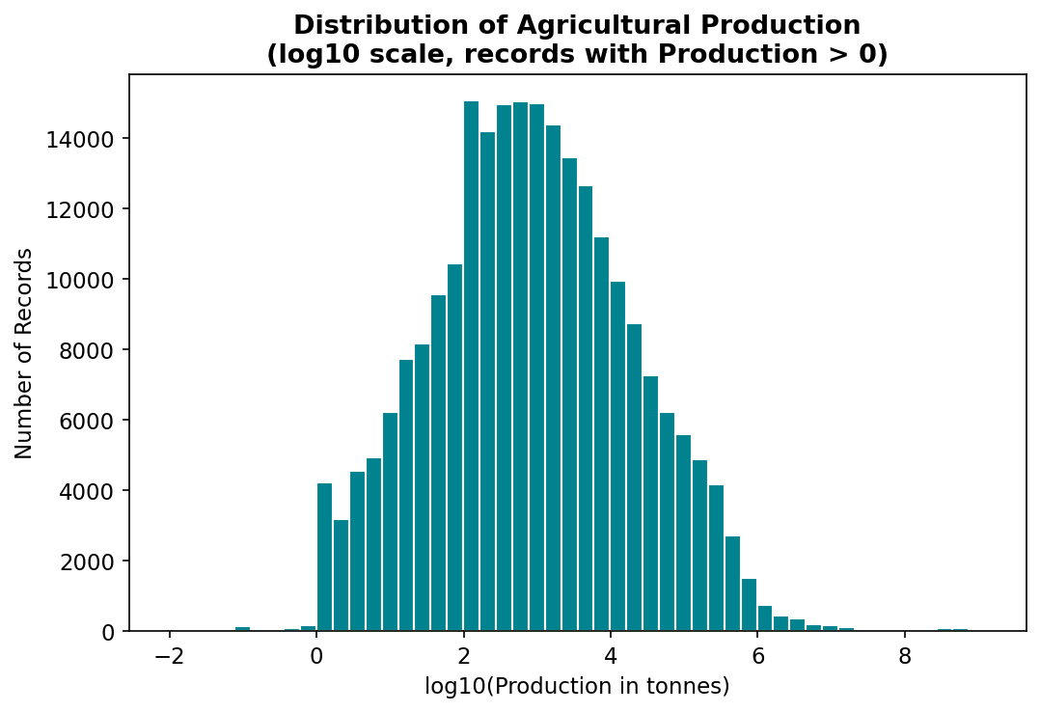
Figure 6: Distribution of agricultural production (log10 scale).
The distribution is unimodal (it has one main peak) and roughly bell-shaped on the log scale, which is typical for variables that span several orders of magnitude, such as agricultural production figures that mix small district records with large state-level totals. Exactly 50% of records have a Production value at or below the median of 729.00, by definition, while the top 2,423 records (the top 1% of the dataset by Production) account for 95.74% of total recorded production. This last figure is a striking illustration of concentration: a very small fraction of records is responsible for almost all of the production total, which is consistent with the right-skewed pattern already identified through the mean-median comparison in Section 7.4.

8.7 Significant Patterns
Bringing together the findings from Sections 8.1 to 8.6, three significant and mutually reinforcing patterns emerge from this dataset:
- Crop concentration: Coconut contributes 92.07% of total recorded production, far more than any other crop, and this single crop drives most of the patterns seen at the state, season and year level.
- Geographic concentration: the states most associated with Coconut cultivation — Kerala, Tamil Nadu and Andhra Pradesh — are also the states with the highest total recorded production, together contributing more than 90% of the national total.
- Statistical skew: both Area and Production are strongly right-skewed, with means far above their medians, wide standard deviations relative to the mean, and a small number of records responsible for a disproportionate share of total production.
A plausible (though unconfirmed) explanation links all three patterns together: if Coconut is recorded using a different counting unit (such as number of nuts) than most other crops (typically tonnes), then Coconut's numerical values would naturally be far larger than other crops even for a agronomically comparable harvest, which would explain why it dominates crop, state and season totals, and why it is responsible for most of the extreme, high-leverage records that create the observed statistical skew. This is presented here as a possible explanation, not a proven cause, because the dataset does not include a units column or documentation confirming this.

8.8 Extreme/Unusual Observations
Using the IQR method described in Section 6.12 (values above Q3 + 1.5 × IQR = 17,425.50 for Production), 42,390 records (17.49% of the dataset) are flagged as statistical outliers. This is a fairly high proportion, which itself reflects the fact that the dataset combines many different crops with very different natural scales of production, rather than indicating that 17% of the dataset consists of data-entry errors.
Table 7 lists the ten individual records with the highest Production values in the entire dataset.
State | District | Year | Season | Crop | Area | Production
Tamil Nadu | COIMBATORE | 2011 | Whole Year | Coconut | 82,704 | 1,250,800,000
Tamil Nadu | COIMBATORE | 2013 | Whole Year | Coconut | 84,531 | 1,212,000,000
Kerala | MALAPPURAM | 2012 | Whole Year | Coconut | 102,417 | 1,125,000,000
Kerala | MALAPPURAM | 2009 | Whole Year | Coconut | 108,380 | 1,063,000,000
Kerala | KOZHIKODE | 1999 | Whole Year | Coconut | 131,061 | 1,059,000,000
Kerala | KOZHIKODE | 2014 | Whole Year | Coconut | 123,066 | 1,001,000,000
Kerala | KOZHIKODE | 1998 | Whole Year | Coconut | 129,506 | 999,000,000
Kerala | MALAPPURAM | 2008 | Whole Year | Coconut | 105,789 | 952,000,000
Kerala | KOZHIKODE | 2013 | Whole Year | Coconut | 123,115 | 948,000,000
Kerala | MALAPPURAM | 2011 | Whole Year | Coconut | 109,229 | 946,781,000

Table 7: Top 10 highest individual production records in the cleaned dataset.
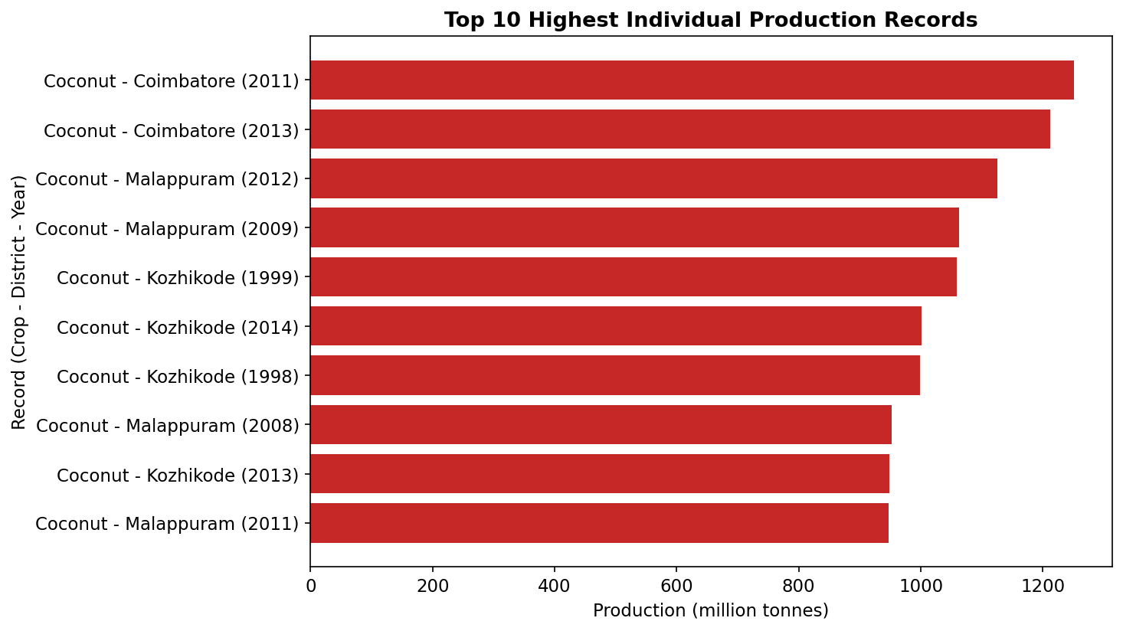
Figure 7: Top 10 highest individual production records.
Every one of the top 10 records is a Coconut record from either Tamil Nadu or Kerala, which is a clear and consistent pattern rather than a coincidence. The single largest record in the dataset — Coimbatore district, Tamil Nadu, 2011, Whole Year season, Coconut, with an Area of 82,704 and Production of 1,250,800,000 — was specifically identified for closer inspection, following the same record flagged during Week 2 cleaning.
Applying the Detect → Inspect → Validate → Interpret approach: this record was Detected by the IQR rule (it is far above the upper bound of 17,425.50). On Inspection, its Production-per-unit-Area ratio is 15,123.82, compared with an average ratio of 4,040.40 across all other Coconut records with a valid Area — around 3.7 times higher than the typical Coconut record, but still of the same general order of magnitude as other large Coconut records in Coimbatore and Kerala district data (Table 7), rather than being wildly inconsistent with them. For Validation, the record was checked against the rest of the dataset: Coimbatore is a well-documented coconut-growing district, the Area value (82,704) is plausible for a district-level total, the year and season fields are valid, and there are several other Coconut records of a broadly similar magnitude from the same district and neighbouring Kerala districts. For Interpretation: this record is best classified as a genuine extreme observation rather than a confirmed data-entry error, because it is consistent with other high-value records for the same crop and region, even though its exact value cannot be independently verified from this dataset alone.
This distinction matters in practice. An outlier is simply a value that is statistically far from the rest of the data; an extreme observation is a real, unusually large value that has been checked and found to be plausible; and a data-entry error is a value that inspection shows to be inconsistent with everything else known about the record (for example, an area or production value that is negative, that does not match the district's typical scale, or that duplicates another record incorrectly). Applying this distinction, none of the ten records in Table 7 were removed from the analysis, because inspection did not reveal a specific reason to treat them as errors, which is consistent with the approach recommended in the Week 2 report.

9. Visual Representations
Seven charts were created using Python and Matplotlib to support this report: a line chart of yearly production trend (Figure 1), horizontal bar charts of the top 10 crops and top 10 states by production (Figures 2 and 3), a bar chart of production by season (Figure 4), a log-log scatter plot of Area versus Production (Figure 5), a log-scale histogram of the Production distribution (Figure 6), and a horizontal bar chart of the ten highest individual production records (Figure 7). Each chart was introduced and interpreted alongside the relevant statistics in Section 8, rather than being repeated here, so that the numerical finding and its visual representation are read together.
Chart types were chosen to match the nature of each variable: a line chart for the year-based trend (because year is an ordered sequence), horizontal bar charts for ranked categorical comparisons (crops, states and top records, because category names are easier to read along the vertical axis), a bar chart for the six season categories, a scatter plot for the relationship between two continuous variables, and a histogram for the overall shape of a single continuous variable's distribution. All charts include a descriptive title and clearly labelled axes, and logarithmic scales were used specifically where the underlying data spans several orders of magnitude (Figures 5 and 6), so that the pattern in the bulk of the data remains visible rather than being compressed by a small number of extreme values.

10. Agribusiness Insights
The descriptive analysis in this report supports several practical observations for agribusiness, expressed cautiously because the dataset is historical (1997–2015) and does not include factors such as weather, market prices or policy changes.
- Storage and transportation planning: because Coconut, Sugarcane and Rice together account for a large share of recorded production and are concentrated in a small number of states (particularly Kerala, Tamil Nadu, Andhra Pradesh and Uttar Pradesh), storage and transport infrastructure investment may be most useful when prioritised in these regions, where the volumes to be handled are largest.
- Processing capacity: Coconut's dominance in the dataset, together with its "Whole Year" harvesting pattern, indicates that processing capacity for coconut-based products may need to be planned for continuous, year-round throughput rather than for a single seasonal harvest peak, unlike Kharif or Rabi staple crops.
- Crop prioritisation for food security versus commercial value: total-production rankings in this dataset are dominated by Coconut, but staple food crops such as Rice and Wheat remain critically important for food security even though their share of the numerical production total is comparatively small. Agribusiness planning that relies on "total production" rankings from a mixed-unit dataset such as this one should be cross-checked against crop-specific, unit-consistent sources before being used for food-security decisions.
- Regional agricultural planning: the concentration of high-value records in a few districts (particularly Coimbatore in Tamil Nadu, and Malappuram and Kozhikode in Kerala) suggests that district-level, rather than only state-level, analysis can help identify where agribusiness activity is most concentrated.
- Seasonal resource allocation: the very small share of production associated with Autumn and Summer seasons (together under 0.2% of the total) may indicate limited data coverage for these seasons in some states, rather than necessarily reflecting a true lack of agricultural activity in those periods; this would need to be checked against seasonal cropping calendars before being used for planning.
These insights are described using cautious language ("may support", "could be useful for", "indicates") because descriptive analytics on its own identifies patterns; it does not establish why those patterns exist or what would happen if a particular agribusiness decision were made.

11. Discussion
The central theme running through this Week 3 analysis is that a small number of records — nearly all associated with Coconut in Kerala and Tamil Nadu — have an outsized influence on almost every summary statistic and grouped total calculated from this dataset. This was first visible in the comparison between the mean and median (Section 7.4), was confirmed by the crop, state and season breakdowns (Sections 8.2–8.4), and was traced back to specific individual records in the extreme-observation analysis (Section 8.8).
This matters methodologically as well as substantively. When a dataset is this heavily skewed, any single overall figure — such as "average production per record" or "total production in year X" — can be misleading if it is reported without also mentioning the median, the degree of concentration, and which categories are driving the total. This report has tried to consistently pair every headline statistic with the median or percentage-share figures needed to interpret it correctly, which is a direct response to the Week 2 evaluator's request for more depth rather than short, generic statements.
At the same time, the analysis has been careful not to overstate what can be concluded. The weak linear correlation between Area and Production (Section 8.5) does not mean that cultivated area is unrelated to output — the log-scale scatter plot shows a clear positive association for the bulk of the data — but it does mean that a single correlation coefficient, calculated across crops with very different natural scales, is not a reliable summary of that relationship on its own. Similarly, the apparent "production collapse" in 2015 (Section 8.1) is very unlikely to reflect an actual collapse in Indian agriculture, and is far better explained by incomplete state coverage in that year of the dataset.

12. Limitations
- Historical period: the dataset covers crop years 1997–2015 only, and cannot be used to describe current agricultural conditions.
- Incomplete year coverage: 1997 includes only 23 of 33 states, and 2015 includes only 2 states (561 records in total), so year-over-year comparisons involving these two years should be treated with particular caution.
- Missing external factors: the dataset does not include rainfall, irrigation, fertiliser use, market prices or government policy variables, so it is not possible to explain why production changed in a given year or region using this dataset alone.
- Unclear or inconsistent units: the dataset documentation available for this project does not confirm whether Production is recorded in the same unit (such as tonnes) for every crop. The unusually high Production-to-Area ratio observed for Coconut relative to other crops (Section 8.7) is consistent with a different counting convention (such as number of nuts) for that crop, but this could not be confirmed from the dataset itself.
- Descriptive, not causal, analysis: this report identifies patterns and associations; it does not test or establish cause-and-effect relationships, and none of the findings above should be read as claiming that one factor caused another.
- Sensitivity to extreme values: because Area and Production are both strongly right-skewed, sum- and mean-based statistics (including total production by year, crop, state and season) are heavily influenced by a small number of very large records, as discussed throughout Section 8.
- Data already cleaned in Week 2: this report relies on the accuracy of the Week 2 cleaning process (removal of records with missing Production values); any residual data-quality issues not identified in Week 2 would also affect the results presented here.

13. Conclusion
This report applied descriptive analytics and trend analysis to the cleaned Indian Agricultural Crop Production dataset. Overall dataset statistics, grouped comparisons by year, crop, state and season, a relationship analysis between Area and Production, and an extreme-observation analysis were all calculated directly from the 242,361 cleaned records, and each result was interpreted in terms of what it means for agribusiness rather than being presented as a number on its own.
The most important finding is that this dataset's production totals are heavily concentrated in a single crop (Coconut, 92.07% of total production) and a small group of states (Kerala, Tamil Nadu and Andhra Pradesh), which in turn explains the strong right-skew observed in the overall descriptive statistics and the apparent spikes in the yearly production trend. A secondary but equally important finding is that year-to-year comparisons at the extremes of the dataset's time range (1997 and 2015) are affected by incomplete state coverage rather than genuine changes in agricultural output.
Building directly on Week 2, which established a reliable, cleaned dataset, this Week 3 analysis shows how descriptive statistics, grouped analysis and visualisation can be combined to move from a clean dataset to a set of well-supported, cautiously worded insights, while being explicit about what the data can and cannot show. This foundation of statistical description is intended to support any further analysis — for example, more advanced modelling or forecasting — that may be carried out in later stages of this project.

14. References
- Indian Agricultural Crop Production dataset (government/open-data source used for crop_production.csv and crop_production_cleaned.csv).
- pandas development team. pandas documentation. https://pandas.pydata.org/docs/
- The Matplotlib development team. Matplotlib documentation. https://matplotlib.org/stable/
- Python Software Foundation. Python documentation. https://docs.python.org/3/
- Week 2 Report: "Indian Agricultural Crop Production Analysis — Data Collection Methods and Data Cleaning Strategies" (this project, Week 2).

15. Appendix
This appendix summarises the Python workflow used to produce the results in this report. The complete, commented script (week3_analysis.py) is provided alongside this report.

