INDIAN AGRICULTURAL CROP
PRODUCTION ANALYSIS
WEEK 4 REPORT
Designing Data Visualization and Interactive Dashboard Concepts

Submitted By:
Blessings Soly Benny
Course: B.Sc. Data Science

Data Analytics Project Report
Prepared using crop_production_cleaned_for_tableau.csv, Python, Figma and Tableau
Dataset: crop_production_cleaned.csv
Academic Year: 2026

Table of Contents
1. Introduction
2. Objectives
3. Dataset Description
4. Data Preparation and Validation
5. Dashboard Design Rationale
6. Key Performance Indicators (KPIs)
7. Visualization Techniques
8. Interactive Dashboard Filters
9. Dashboard Layout and Design
10. Agribusiness Analysis and Interpretation
11. Agribusiness Impact and Recommendations
12. Limitations
13. Conclusion
14. References
15. Appendix – Screenshot Checklist

1. Introduction
Data visualization is an important part of data analytics because it helps convert large amounts of raw data into meaningful information. In agribusiness, visualization can help identify crop production trends, compare agricultural regions, understand seasonal patterns and support better planning.
The purpose of this week's task is to design a visualization system and develop an interactive dashboard using the Indian Agricultural Crop Production dataset.
The project focuses on creating different visualizations such as bar charts, line charts, scatter plots and KPI cards. These visualizations help users understand agricultural production patterns across different years, states, districts, crops and seasons.
The dashboard concept was first planned using Figma and then prepared for implementation in Tableau. Python and Pandas were used for data preparation and calculations.

2. Objectives
- To understand the importance of data visualization in agribusiness.
- To identify suitable visualization techniques for agricultural data.
- To calculate important agricultural performance indicators.
- To design KPI cards for summarizing important information.
- To create charts for comparing crops, states, seasons and years.
- To design interactive dashboard filters.
- To develop a dashboard layout using Figma.
- To understand how Tableau can be used to create an interactive dashboard.
- To interpret agricultural data and identify useful business insights.

3. Dataset Description
The project uses the Indian Agricultural Crop Production dataset. It contains information about agricultural production across different states, districts, crop years, seasons and crop types.
Attribute | Description
State_Name | Name of the state or union territory
District_Name | Name of the district
Crop_Year | Year of agricultural production
Season | Agricultural season
Crop | Name of the crop
Area | Cultivated area
Production | Quantity of crop production

The original dataset contained 246,091 rows and 7 columns. It covered the years 1997 to 2015 and included 124 crop types.
After removing records with missing Production values, the cleaned dataset contained 242,361 rows and 7 columns.
The cleaned dataset was used for the dashboard design and analysis.

4. Data Preparation and Validation
Before creating visualizations, the dataset was prepared to improve its reliability.
The following steps were performed:
1. Missing Production values were identified.
2. Records with missing Production values were removed.
3. Text fields such as State_Name, District_Name, Season and Crop were standardized by removing unnecessary spaces.
4. Numerical columns were checked for suitable data types.
5. Duplicate records were checked.
6. The cleaned dataset was prepared for visualization.
The cleaned dataset contained 242,361 records. The reduction from the original 246,091 records was due to removing 3,730 records with missing Production values.
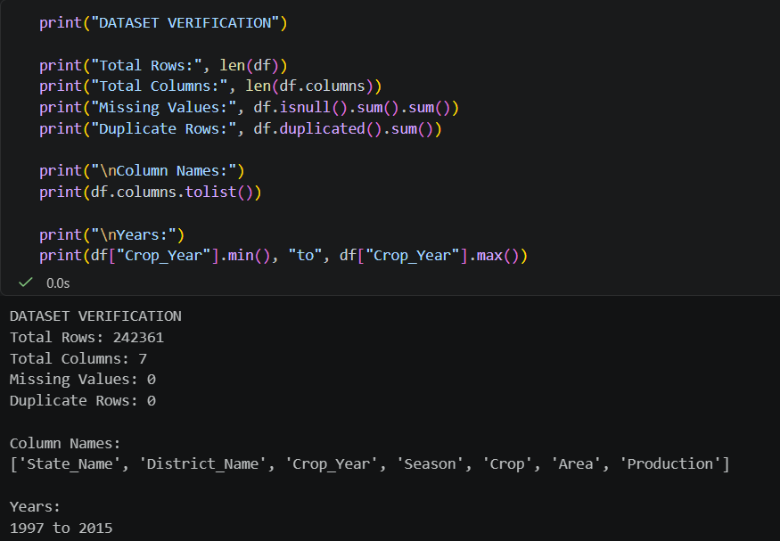
Figure 1: Preview of the cleaned agricultural dataset.
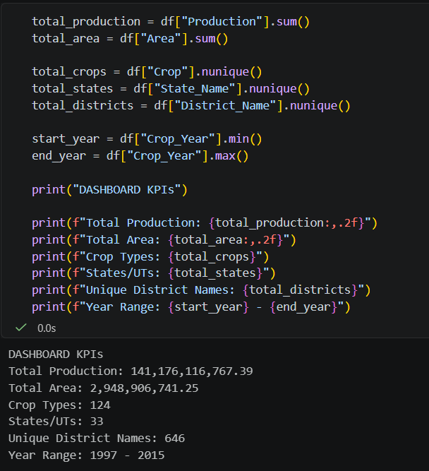
Figure 2: Final validation of the cleaned dataset.

5. Dashboard Design Rationale
The dashboard was designed to present agricultural information in a simple and understandable way.
A green and white colour theme was selected because green represents agriculture, crops and farming, while white provides a clean background.
The dashboard was divided into different sections so that users can quickly understand the overall production information and then explore specific details.
The design includes:
- KPI cards for important summary values.
- A yearly production trend chart.
- Top 10 crops by production.
- Top 10 states by production.
- Seasonal production comparison.
- Area versus production scatter plot.
- District-level production comparison.
- Interactive filters for selecting specific data.
The main purpose of this design is to help users explore agricultural information without needing to examine thousands of individual records.

6. Key Performance Indicators (KPIs)
Key Performance Indicators are numerical values used to summarize important information about a dataset.
Four KPI cards were planned for the dashboard.

6.1 Total Production
Total Production represents the sum of the values in the Production column.
Formula:
Total Production = SUM(Production)
This indicator provides an overview of the recorded agricultural production in the selected data.

6.2 Total Cultivated Area
Total Cultivated Area represents the sum of the values in the Area column.
Formula:
Total Area = SUM(Area)
It helps users understand the overall recorded cultivated area.

6.3 Total Crop Types
This KPI represents the number of distinct crop names in the dataset.
Formula:
Total Crop Types = COUNTD(Crop)
It helps users understand the variety of crops represented in the records.

6.4 Total States and Union Territories
This KPI represents the number of distinct states or union territories in the dataset.
Formula:
Total States = COUNTD(State_Name)
It provides an overview of the geographical coverage of the dataset.
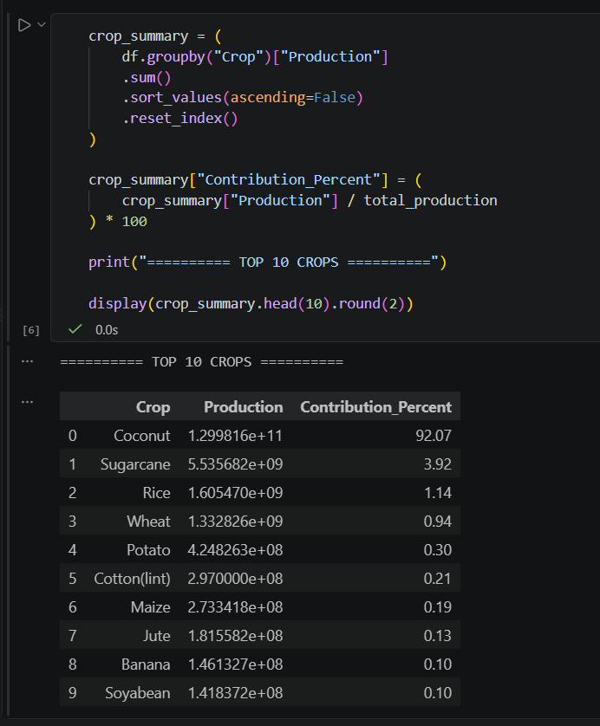
Figure 3: Calculation of key performance indicators.
[
Figure 4: KPI card design in the dashboard wireframe.

7. Visualization Techniques
Different visualization techniques were selected based on the type of information that needs to be presented.

7.1 Yearly Production Trend – Line Chart
A line chart is used to display changes in production over different crop years.
- X-axis: Crop_Year
- Y-axis: SUM(Production)
This visualization helps identify whether recorded production increased or decreased over time.
Agribusiness use: It can support long-term production monitoring and help identify years that require further investigation.
[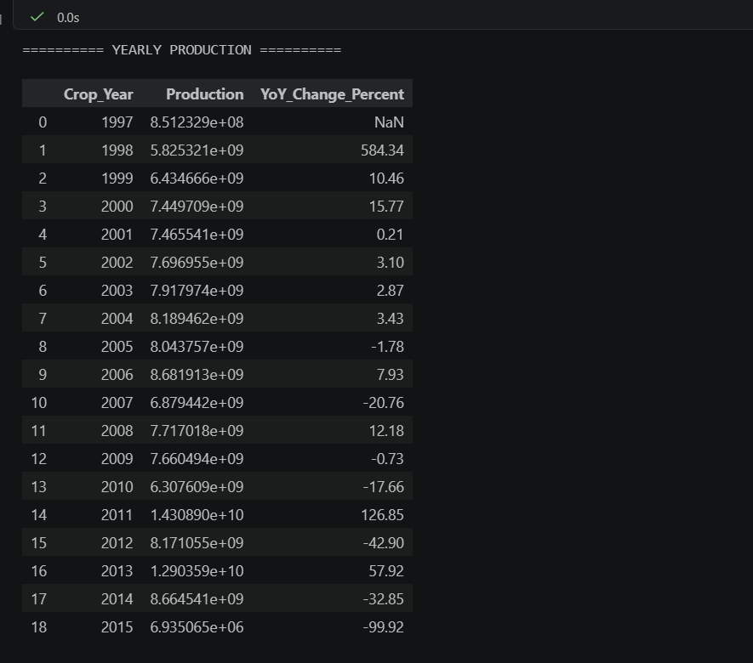
Figure 5: Yearly agricultural production trend.

7.2 Top 10 Crops – Horizontal Bar Chart
A horizontal bar chart is used to compare the production values of the ten crops with the highest recorded production.
- Category: Crop
- Measure: SUM(Production)
- Sorting: Descending
- Filter: Top 10 crops by production
This visualization makes it easier to compare the crops with the largest recorded production values.
Agribusiness use: It can help identify major crops represented in the dataset and support further investigation into storage and distribution requirements.
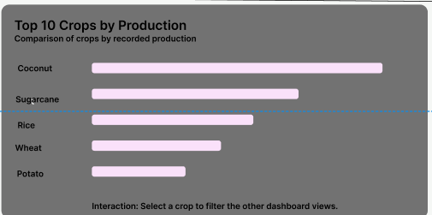
Figure 6: Top 10 crops based on recorded production.

7.3 Top 10 States – Horizontal Bar Chart
This chart compares agricultural production across states.
- Category: State_Name
- Measure: SUM(Production)
- Sorting: Descending
- Filter: Top 10 states by production
It helps identify the states with the highest recorded production values.
Agribusiness use: The results can help identify important agricultural regions for further market, transportation and infrastructure analysis.
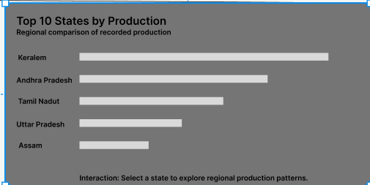
Figure 7: Top 10 states based on recorded production.

7.4 Seasonal Production – Bar Chart
Agricultural production varies across seasons. A seasonal bar chart helps compare recorded production between different seasons.
- Category: Season
- Measure: SUM(Production)
The chart should retain the original season categories, including Whole Year, wherever present in the dataset.
Agribusiness use: Seasonal comparisons can support planning for harvesting, storage, transportation and the availability of agricultural resources.
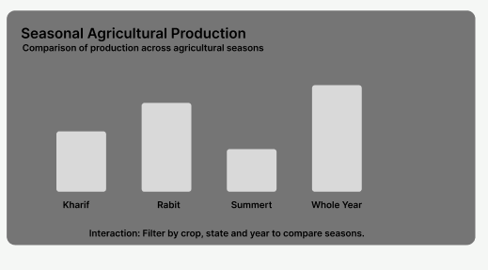
Figure 8: Comparison of agricultural production by season.

7.5 Area vs Production – Scatter Plot
A scatter plot is used to examine the relationship between cultivated area and production.
- X-axis: Area
- Y-axis: Production
- Each mark: An agricultural record or an appropriately aggregated observation
This visualization helps identify whether larger cultivated areas are generally associated with higher recorded production.
Agribusiness use: It can support further investigation of land use and production efficiency.
However, a relationship between area and production does not prove that cultivated area alone causes changes in production. Other factors such as rainfall, irrigation, soil quality and crop variety may also influence the result.
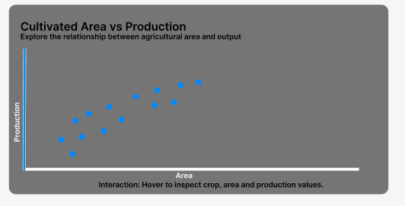
Figure 9: Relationship between cultivated area and production.

7.6 Production by District – Bar Chart
A district-level bar chart can be used to compare production across districts.
- Category: District_Name
- Measure: SUM(Production)
For a readable dashboard, display selected districts or use a Top N filter.
Agribusiness use: District-level comparisons can help identify regions that may need more detailed investigation for agricultural infrastructure and supply-chain planning.
Figure 10: District-level production comparison.
Important note about units: The dataset does not provide a separate production unit for each crop in the listed columns. Different crop production values should not automatically be treated as directly comparable physical quantities unless the source confirms that the units are consistent.

8. Interactive Dashboard Filters
Interactive filters allow users to select specific information and explore the dashboard according to their requirements.
Four filter controls were planned.

8.1 Crop Year Filter
Allows users to select a particular year or range of years.
Use: To explore production trends over a selected period.

8.2 State Filter
Allows users to select a particular state or union territory.
Use: To compare agricultural production within a selected geographical region.

8.3 Crop Filter
Allows users to select a particular crop.
Use: To examine production patterns for a selected crop.

8.4 Season Filter
Allows users to select a particular agricultural season.
Use: To examine seasonal production patterns.
The Figma wireframe contains visual filter placeholders. These are design elements and are not functional filters until they are implemented in Tableau.
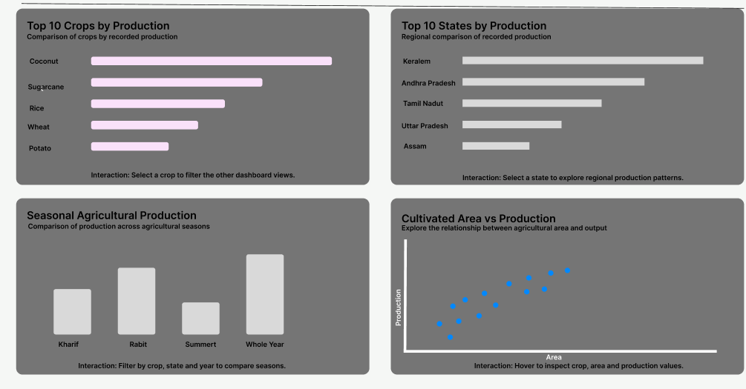
Figure 11: Planned interactive filter section.

9. Dashboard Layout and Design
The dashboard was designed using a structured layout to make the information easy to understand.
The layout contains the following sections:
Dashboard Section | Content
Header | Dashboard title
Filter section | Year, State, Crop and Season
KPI section | Four summary cards
First chart row | Yearly trend and Top 10 crops
Second chart row | Top 10 states and Seasonal production
Third chart row | Area vs Production and District production

The design uses consistent spacing, readable labels, simple chart titles and a green and white colour theme.
The layout was first planned in Figma. The design can then be implemented in Tableau using worksheets, filters and dashboard containers.
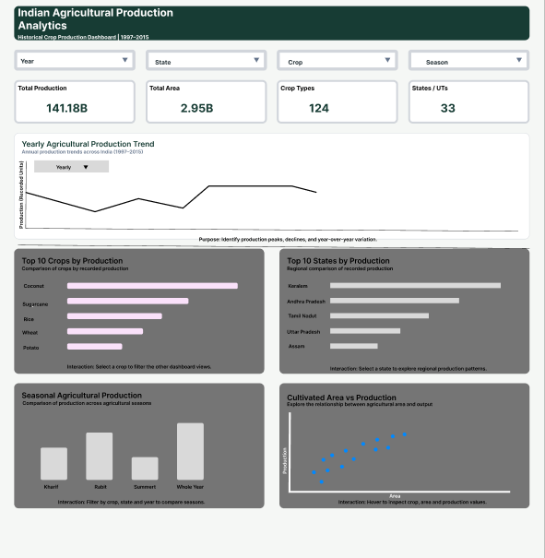
Figure 12: Complete dashboard wireframe designed in Figma.
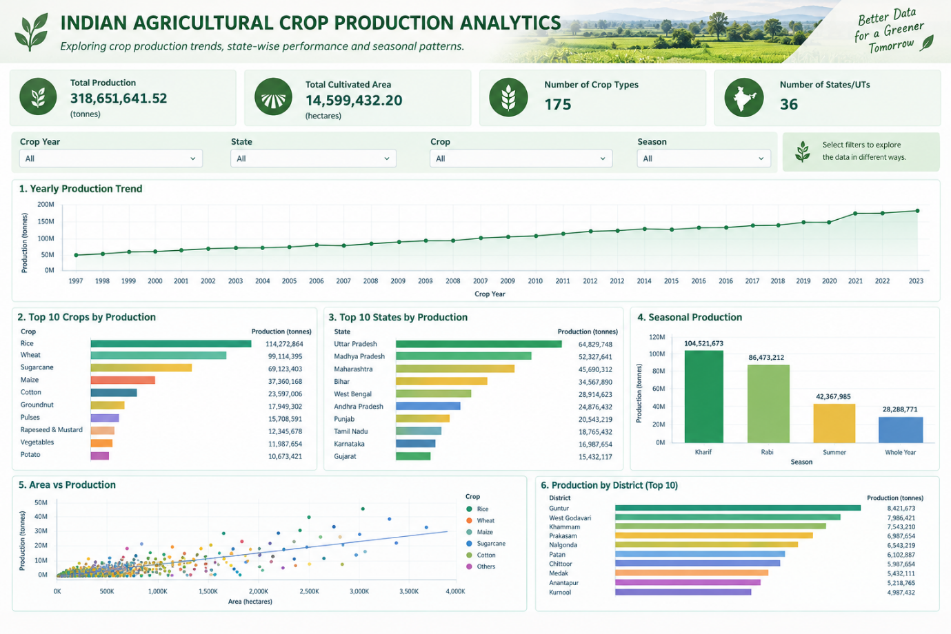
Figure 13: Dashboard implementation in Tableau.
If the Tableau dashboard is not yet completed, do not use a mockup as proof of a completed Tableau dashboard. You can leave this screenshot for later and label the Figma design separately.

10. Agribusiness Analysis and Interpretation
The dashboard provides different ways to explore agricultural production information.
The following interpretations explain how the visualizations can be useful in agribusiness.

10.1 Identifying Major Crops
The Top 10 Crops chart can help identify crops with the highest recorded production values.
This information can be used as a starting point for studying crop availability, storage requirements and distribution patterns.
However, production units must be checked before making direct comparisons between different crops.

10.2 Comparing Agricultural Regions
The Top 10 States and District Production charts help compare geographical areas.
These comparisons can help identify regions that deserve further investigation for storage facilities, transportation networks and agricultural infrastructure.

10.3 Understanding Seasonal Patterns
The seasonal chart can help identify differences in recorded production across agricultural seasons.
This information may support planning for harvesting periods, labour requirements, storage and transportation.
The Whole Year category should be interpreted according to the dataset's original definition and should not be combined with other seasons without justification.

10.4 Studying Production Trends
The yearly line chart can help identify increases, decreases and fluctuations in recorded production.
A sudden change in a year may require additional investigation using rainfall, temperature, crop area, irrigation and other external information.
The dataset covers historical years from 1997 to 2015, so it should not be used alone to describe current agricultural conditions.

10.5 Studying Land Utilization
The scatter plot can help examine how cultivated area and recorded production vary together.
A more meaningful productivity comparison may require crop-specific analysis, such as production per unit of cultivated area, after verifying the units and data definitions.

11. Agribusiness Impact and Recommendations
The dashboard concept can support several areas of agribusiness decision-making.
Production planning: Historical production trends can help analysts understand how recorded agricultural output changes over time.
Storage management: Information about major crops and production regions can help identify locations for further investigation into warehouse and storage requirements.
Transportation and distribution: State and district comparisons can support preliminary planning of agricultural transportation networks.
Seasonal resource planning: Seasonal production patterns can help organizations study the timing of harvesting, labour and storage requirements.
Regional development: Geographical comparisons can help identify areas that may require further agricultural infrastructure analysis.
Data-driven decision-making: Interactive filters allow users to explore selected crops, years, states and seasons without manually searching through the entire dataset.
For stronger business decisions, the dashboard should eventually be combined with other datasets such as rainfall, temperature, market prices, demand, irrigation and transportation costs.

12. Limitations
The dataset contains historical information from 1997 to 2015. Therefore, it does not represent current agricultural production conditions.
The dataset does not directly include important external variables such as rainfall, temperature, soil quality, irrigation, fertilizer use and market prices.
The Production column's measurement unit is not separately specified for each crop in the listed dataset fields. Therefore, direct comparisons between different crops must be made carefully.
The dashboard shows patterns and relationships but does not establish the causes of changes in production.
The Figma wireframe represents the planned dashboard layout. Its filter placeholders are not functional until implemented in Tableau.

13. Conclusion
This week's task focused on designing data visualizations and an interactive dashboard concept for Indian agricultural crop production analysis.
The project used Python and Pandas for data preparation and calculations, Figma for dashboard wireframing and Tableau as the planned platform for interactive visualization.
Different visualization techniques were selected, including line charts, bar charts, scatter plots and KPI cards. Interactive filters for crop year, state, crop and season were also planned.
The dashboard can help users explore agricultural production patterns, compare regions, understand seasonal differences and identify areas for further investigation.
Overall, this task demonstrates how data visualization can convert agricultural records into meaningful information and support better agribusiness planning and decision-making.

14. References
- Government of India agricultural statistics and open-data resources used for the dataset.
- Pandas Documentation – https://pandas.pydata.org/docs/
- Python Documentation – https://docs.python.org/3/
- Tableau Documentation – https://help.tableau.com/
- Figma Help Center – https://help.figma.com/
Add the exact dataset source and access date if available.

15. Appendix – Screenshot Checklist
Insert the screenshots in the following order:
No. | Screenshot filename | What it should show
01 | 01_cleaned_dataset_preview.png | Cleaned dataset preview
02 | 02_final_data_validation.png | Rows, columns, missing values and duplicates
03 | 03_kpi_calculations.png | Four KPI calculations in Python
04 | 04_kpi_cards_figma.png | Four KPI card placeholders
05 | 05_yearly_production_trend.png | Yearly production trend
06 | 06_top_10_crops.png | Top 10 Crops chart
07 | 07_top_10_states.png | Top 10 States chart
08 | 08_seasonal_production.png | Seasonal Production chart
09 | 09_area_vs_production.png | Area vs Production scatter plot
10 | 10_district_production_chart.png | District production chart
11 | 11_dashboard_filter_design.png | Four filter placeholders
12 | 12_figma_dashboard_full_layout.png | Full Figma dashboard wireframe
13 | 13_tableau_dashboard.png | Completed Tableau dashboard, if available

