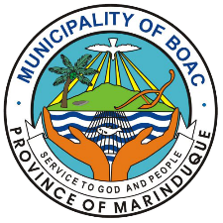

Republic of the Philippines
Province of Marinduque
Municipality of Boac
Office of the Mayor
Accomplishment Report
As of February 1 - 15, 2026

Date | Descriptions
February 1, 2026 | - SUNDAY
February 2, 2026 | - <accomplishment sample 1>  - <accomplishment sample 2>  - <accomplishment sample 3>  - <accomplishment sample 4>
February 3, 2026 | - <accomplishment sample 1>  - <accomplishment sample 2>
February 4, 2026
February 5, 2026
February 6, 2026
February 7, 2026 | - SATURDAY
February 8, 2026 | - SUNDAY
February 9, 2026
February 10, 2026
February 11, 2026
February 12, 2026
February 13, 2026
February 14, 2026 | - SATURDAY
February 15, 2026 | - SUNDAY

