DBMS Assignment
ER Diagram & Relational Schema Design
Application: Rapido — Bike & Cab Booking System
Prepared by: Tamajong Bless Ntumnyoh

1. Entities and Attributes
Six entities were identified for the Rapido bike & cab booking system. Each entity's primary key (PK) is marked in bold, and foreign keys (FK) are noted where applicable.

USER
Attribute | Description
user_id | PK — unique identifier for each rider
name | Full name of the user
phone_number | Contact number, used for login/OTP
email | User's email address
created_at | Account creation timestamp

CAPTAIN
Attribute | Description
captain_id | PK — unique identifier for each captain
name | Full name of the captain
phone_number | Contact number
vehicle_id | FK → VEHICLE — vehicle currently assigned to this captain
rating | Average rider rating for the captain

VEHICLE
Attribute | Description
vehicle_id | PK — unique identifier for each vehicle
vehicle_type | e.g. Bike, Auto, Cab
registration_number | Vehicle's license plate number
model | Vehicle make/model
capacity | Maximum number of riders the vehicle can carry

RIDE
Attribute | Description
ride_id | PK — unique identifier for each ride
user_id | FK → USER — rider who booked the ride
captain_id | FK → CAPTAIN — captain assigned to the ride
pickup_location | Ride start point
drop_location | Ride end point
fare | Fare charged for the ride
status | e.g. Requested, Ongoing, Completed, Cancelled

PAYMENT
Attribute | Description
payment_id | PK — unique identifier for each payment
ride_id | FK → RIDE — ride this payment is for
amount | Amount paid
payment_method | e.g. UPI, Card, Cash
payment_status | e.g. Success, Failed, Refunded
payment_time | Date and time of payment

ZONE
Attribute | Description
zone_id | PK — unique identifier for each service zone
zone_name | Name of the zone/locality (e.g. Koramangala)
city | City the zone belongs to

2. Relationships and Cardinality
Relationship | Entities | Cardinality
REQUESTS | User → Ride | 1 : M
DRIVES | Captain → Ride | 1 : M
GENERATES | Ride → Payment | 1 : 1
ASSIGNED TO | Vehicle → Captain | 1 : M
OPERATES IN | Captain ↔ Zone | M : N

3. ER Diagram
The complete ER diagram below shows all six entities, their key attributes, primary keys (underlined), foreign keys, relationships, and cardinalities using Chen notation (rectangle = entity, ellipse = attribute, diamond = relationship).
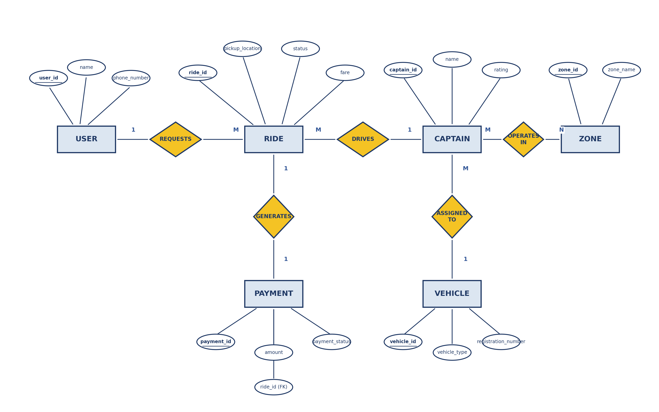
Fig. 3.1 — ER Diagram for the Rapido Bike & Cab Booking System

4. Relational Schema
Each strong entity maps to its own table. The USER–RIDE and CAPTAIN–RIDE (1:M) relationships are implemented by placing the foreign key on RIDE (the 'many' side). The VEHICLE–CAPTAIN (1:M) relationship places the foreign key on CAPTAIN. The RIDE–PAYMENT (1:1) relationship places the foreign key on PAYMENT. The CAPTAIN–ZONE (M:N) relationship requires a separate associative/junction table, CAPTAIN_ZONE, holding both primary keys as foreign keys.

Tables
USER (user_id PK, name, phone_number, email, created_at)
VEHICLE (vehicle_id PK, vehicle_type, registration_number, model, capacity)
CAPTAIN (captain_id PK, name, phone_number, vehicle_id FK → VEHICLE(vehicle_id), rating)
RIDE (ride_id PK, user_id FK → USER(user_id), captain_id FK → CAPTAIN(captain_id),
pickup_location, drop_location, fare, status)
PAYMENT (payment_id PK, ride_id FK → RIDE(ride_id), amount, payment_method,
payment_status, payment_time)
ZONE (zone_id PK, zone_name, city)
CAPTAIN_ZONE (captain_id FK → CAPTAIN(captain_id), zone_id FK → ZONE(zone_id))
— composite PK: (captain_id, zone_id) ← associative table for the M:N relationship

5. Primary Key and Foreign Key Identification
Table | Primary Key (PK) | Foreign Key(s) (FK)
USER | user_id | —
VEHICLE | vehicle_id | —
CAPTAIN | captain_id | vehicle_id → VEHICLE(vehicle_id)
RIDE | ride_id | user_id → USER(user_id); captain_id → CAPTAIN(captain_id)
PAYMENT | payment_id | ride_id → RIDE(ride_id)
ZONE | zone_id | —
CAPTAIN_ZONE | (captain_id, zone_id) — composite | captain_id → CAPTAIN(captain_id); zone_id → ZONE(zone_id)

6. Relationship Explanation

USER — REQUESTS — RIDE (1:M)
One user can request/book many rides over time, but each individual ride is requested by exactly one user. The foreign key user_id is stored on RIDE.

CAPTAIN — DRIVES — RIDE (1:M)
One captain can drive many rides over time, but each ride is driven by exactly one captain. The foreign key captain_id is stored on RIDE.

VEHICLE — ASSIGNED TO — CAPTAIN (1:M)
One vehicle can be linked to a captain's record; over time, a vehicle may be assigned to different captains (e.g. across shifts), while at any point a captain references exactly one vehicle. The foreign key vehicle_id is stored on CAPTAIN.

RIDE — GENERATES — PAYMENT (1:1)
Each completed ride generates exactly one payment record, and each payment corresponds to exactly one ride. The foreign key ride_id is stored on PAYMENT.

CAPTAIN — OPERATES IN — ZONE (M:N)
A captain can operate in multiple service zones (e.g. covering more than one locality), and a single zone can have many captains operating within it. Since this is a many-to-many relationship, it cannot be represented with a simple foreign key — it requires the associative table CAPTAIN_ZONE, whose composite primary key (captain_id, zone_id) records exactly which captains serve which zones.

