
MDI 3003 – Advanced Predictive Analysis

Sarah Blessy N
23MID 0296

LAB Assessment 7

Constructing a Recommendation System from Customer Transaction Data using Random Forest
From transaction history to candidate generation, purchase-propensity scoring, Top-K ranking, and responsible recommendation

List Of Contents

S.No | Topics | Page Num
1 | Executive Summary | 2
2 | Business Problem | 3
3 | Dataset Description | 4
4 | Methodology | 6
5 | EDA and Feature Engineering | 9
6 | Model Development | 11
7 | Evaluation Results | 13
8 | Interpretation | 17
9 | Limitations and Risks | 17
10 | Conclusion | 17

GitHub Repo https://github.com/blessy228/Course---Predictive-Analysis
1. Executive Summary
This project develops a customer-item recommendation system using transaction data from the UCI Online Retail dataset. The main goal is to recommend products that a customer is likely to purchase in the future, helping a business improve product recommendations and customer engagement.

The dataset contains online retail transactions recorded from December 2010 to December 2011. The data was cleaned by removing transactions with missing customer IDs, cancelled orders, and invalid quantities or prices. Customer, item, and customer-item purchase features were then created from historical transactions.

A Random Forest classifier was selected to predict the likelihood that a customer would purchase a particular item. The model was compared with a simple Popularity baseline, which recommends the most frequently purchased items. Recommendations were evaluated using Precision@K, Recall@K, and Hit Rate@K, with K values of 5, 10, and 20.
The main results are reported at K=10, where the Random Forest model is compared directly with the Popularity baseline. The model's overall ranking performance is measured using ROC-AUC and PR-AUC, while the recommendation results are measured using the Top-K metrics.

Major limitation: The recommendation system depends on previous customer purchase history. Customers with little or no purchase history may receive less useful recommendations. The candidate-item filtering and negative sampling process also limits the range of items considered by the model.

Overall, the project provides a practical recommendation approach that combines customer behaviour, item popularity, and customer-item purchase history to produce personalised Top-K product recommendations.

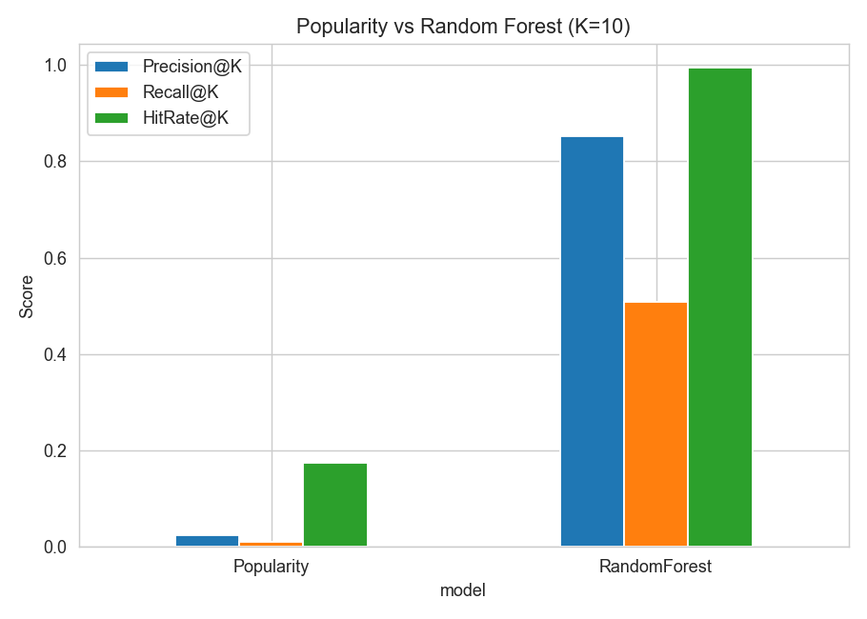
2. Business Problem
2.1 Stakeholder
The main stakeholders are online retail businesses, e-commerce managers, and marketing teams. They need to understand customer buying behaviour and provide relevant product recommendations

2.2 Business Decision
The system supports the decision of which products should be recommended to a customer based on their previous purchase behaviour and product information.
The recommendation system produces a ranked list of products for each customer. The business can use this list to support personalised product recommendations on an online retail platform

2.3 Prediction Target
The target is whether a customer is likely to purchase a particular item in the future.
The Random Forest model gives each customer-item pair a purchase probability. Items with higher scores are ranked higher and included in the customer's Top-K recommendations.

2.4 Error Costs
Two main types of errors are possible:
- False positive: Recommending an item that the customer does not purchase. This can reduce recommendation quality and may waste promotional space.
- False negative: Not recommending an item that the customer would have purchased. This can result in a missed sales opportunity.
For this application, both errors matter because the system needs to provide useful recommendations while avoiding irrelevant products.

2.5 Intended Uses
The system is intended to:
- Generate personalised Top-K product recommendations.
- Support product recommendation decisions for online retail.
- Compare personalised recommendations with a simple popularity-based approach.
- Identify customer and item behaviour that contributes to recommendation results

2.6 Prohibited Uses
The system should not be used as the only basis for:
- Making decisions about customers unrelated to product recommendations.
- Determining a customer's creditworthiness or financial risk.
- Making decisions about employment, insurance, or other high-impact services.
- Treating recommendations as guaranteed predictions of future purchases.

The model should be used as a decision-support tool, with business rules and human judgement applied where necessary.
3. Dataset Description
3.1 Data Source and Coverage
The project uses the UCI Online Retail dataset, which contains transaction records from an online retail business. The dataset covers transactions from 1 December 2010 to 9 December 2011 and contains 541,909 records in the original dataset.

The data contains customer purchases, product details, transaction dates, quantities, prices, and country information. The model uses historical transactions to learn customer and product behaviour and predict future purchases.
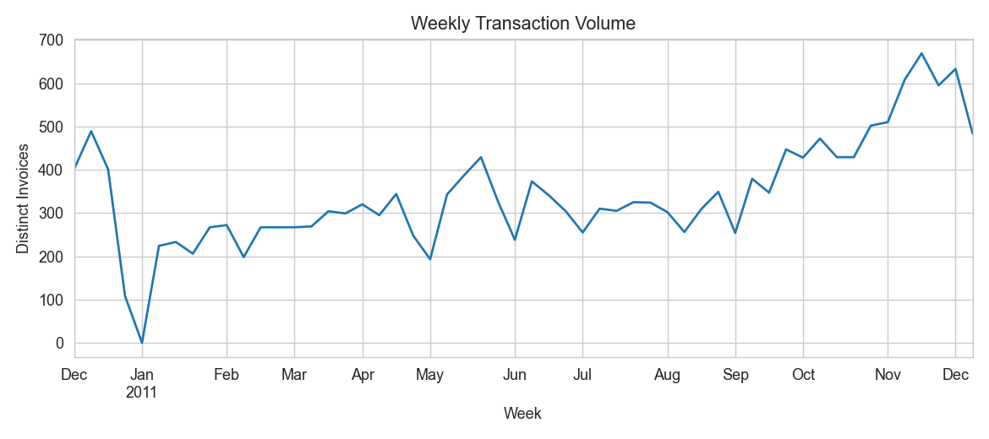
3.2 Dataset Schema
Field | Description | Use in Project
InvoiceNo | Transaction or invoice number | Identifies transactions and cancellations
StockCode | Product code | Identifies the product
Description | Product description | Product information
Quantity | Number of items purchased | Customer and item behaviour
InvoiceDate | Date and time of transaction | Time-based split and behaviour
UnitPrice | Price of one item | Product and customer features
CustomerID | Customer identifier | Identifies customers
Country | Customer's country | Dataset information; not directly used as a model feature
Amount | Quantity × UnitPrice | Customer spending feature
The Amount field is created during data preparation and is used to calculate customer spending

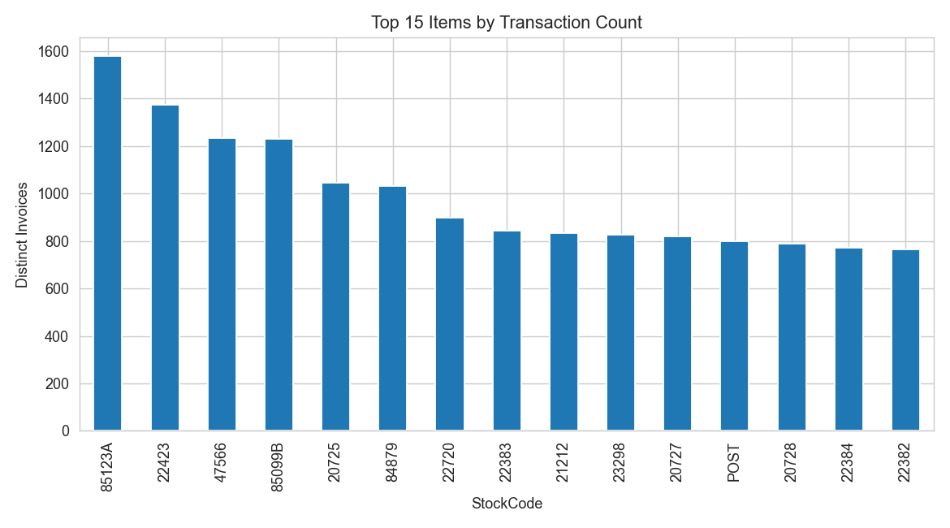
3.3 Target
The target represents whether a customer-item pair results in a future purchase.
- 1 Positive: The customer purchases the item in the future.
- 0 Negative: The customer does not purchase the item in the future.

The target is created using future transactions, while the model features are created only from transactions before the prediction point. This prevents future information from being used to predict the past.

3.4 Data Quality
The data is cleaned before model development. The following records are removed:
- Transactions with missing CustomerID.
- Cancelled transactions.
- Transactions with zero or negative quantity.
- Transactions with negative unit prices.
After cleaning, the project records the remaining number of rows, customers, products, and date range as part of the dataset summary
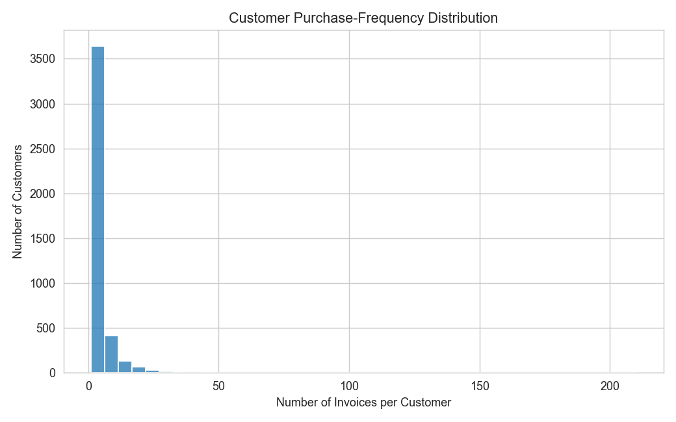

3.5 Dataset Limitations
The dataset has several limitations:
- It represents transactions from a limited time period.
- Customer information is mainly based on purchase history.
- Customers with little or no previous purchase history have limited information for recommendations.
- Cancelled and return transactions are removed, so they are not represented in the final modelling data.
- The recommendation model considers only products that meet the candidate-selection rules.
- The dataset does not provide information about customer preferences outside their recorded purchases

3.6 Dataset Summary
Dataset aspect | Summary
Source | UCI Online Retail
Original records | 541,909
Coverage | 1 Dec 2010 – 9 Dec 2011
Main entities | Customers, products, transactions
Prediction unit | Customer–item pair
Target | Future purchase: 0 or 1
Main model features | Customer, item, and customer-item purchase history
Data cleaning | Missing IDs, cancellations, invalid quantities/prices removed
Data split | Chronological train, validation, and test periods
Main limitation | Limited historical information for new or low-activity customers

4. Methodology
4.1 Data Split
The data is divided based on transaction time rather than randomly. This matches the real business situation where past purchases are used to predict future purchases.
- Training period: First 70% of the timeline.
- Validation period: Next 15%.
- Test period: Final 15%.
The model learns from past transactions and is tested on later transactions.

4.2 Preprocessing
The following preprocessing steps are applied:
- Remove records with missing CustomerID.
- Remove cancelled transactions.
- Remove transactions with zero or negative quantity.
- Remove records with negative unit prices.
- Calculate Amount as Quantity × UnitPrice.
- Convert customer IDs and transaction dates into the required format.
These steps ensure that invalid transactions do not affect model training.

4.3 Candidate Generation
- The model does not score every possible product. Products purchased by at least 5 different customers in the training data are considered eligible candidates, with a maximum of 2,000 products.
- This reduces the number of products that the model needs to evaluate and makes recommendation generation more practical.
- Candidate recall is also checked on the validation period to determine how much of the future purchase activity is covered by the candidate set.

4.4 Feature Engineering
Customer features
- Number of transactions
- Number of different products purchased
- Total quantity purchased
- Total spending
- Days since the last purchase
- Average basket quantity
Item features
- Number of transactions
- Number of customers
- Total quantity sold
- Average price
- Days since the last purchase
Customer-item features
- Previous purchases of the item
- Previous quantity purchased
- Previous spending on the item
These features represent customer behaviour, product popularity, and the customer's previous relationship with a product.
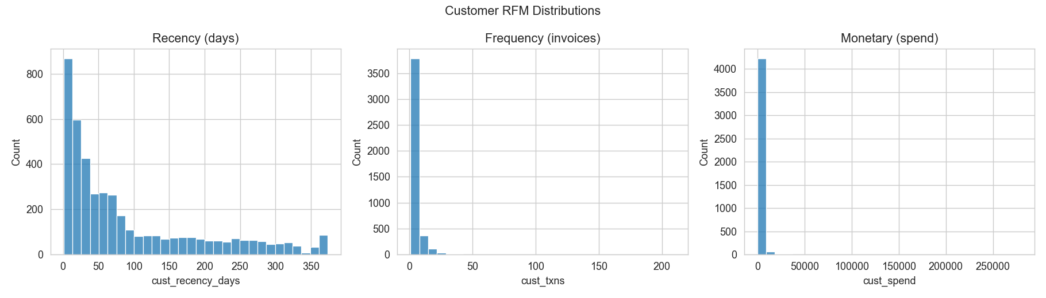

4.5 Negative Sampling
- For each customer, products that were not purchased in the future are sampled as negative examples. Up to 50 negative items per customer are selected.
- This creates both positive and negative examples for the classification model without generating every possible customer-product combination.
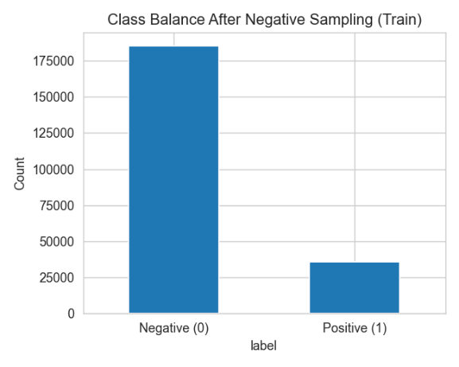
4.6 Model
A Random Forest classifier is used as the main recommendation model.
The model contains 300 decision trees and uses balanced class weights to handle the difference between positive and negative examples. The model produces a purchase probability for each customer-item pair. Items are then ranked according to this score to create the final Top-K recommendations.

4.7 Baseline Model
- A simple Popularity baseline is used for comparison.
- It recommends the most frequently purchased products that the customer has not already purchased. This provides a basic benchmark to determine whether the Random Forest model provides better recommendations than a popularity-only approach

4.8 Validation and Evaluation
The model is evaluated using two levels of metrics.
Classification metrics
- ROC-AUC
- PR-AUC
Recommendation metrics
- Precision@5, @10, @20
- Recall@5, @10, @20
- Hit Rate@5, @10, @20
The main business comparison is made at K=10, where the Random Forest recommendations are compared with the Popularity baseline.

4.9 Tuning
The supplied implementation uses a fixed Random Forest configuration rather than performing a separate hyperparameter search. The main settings include:
- 300 trees
- Minimum 2 samples per leaf
- Square-root feature selection
- Balanced class weighting
- Fixed random seed
Therefore, this project should be described as using a defined model configuration, not as performing extensive hyperparameter tuning

4.10 Leakage Controls
Data leakage is controlled through the following design:
- The data is split chronologically, so future transactions are not used to predict earlier transactions.
- Customer and item features are calculated from transactions available before the prediction cutoff.
- Future transactions are used only to create the target labels.
- Negative samples are selected without using future purchase information as model features.
- The test set is created using a history that includes the training and validation periods, while the actual test transactions are kept for future labels.
- A fixed random seed is used so that the sampling and model results can be reproduced.
These controls ensure that the model is evaluated using information that would realistically have been available when making recommendations

4.11 Reproducibility
- The project uses a fixed seed of 42. The trained Random Forest model, feature schema, data split information, candidate-selection policy, dataset card, evaluation results, and generated figures are saved as project outputs.
- A model reload check is also performed to confirm that the saved model produces the same predictions after being loaded again.

5. EDA and Feature Engineering
5.1 Customer Purchase Behaviour
The transaction data shows that customers have different levels of purchase activity. Some customers make many purchases, while others make only a small number of purchases.
This finding supports the use of customer-level features such as transaction count, number of different items purchased, total quantity, total spending, recency, and average basket size. These features help the model distinguish between different customer behaviours.


5.2 Customer Recency, Frequency and Spending
Customer behaviour is represented using three main measures:
- Recency: How many days since the customer's last purchase.
- Frequency: Number of transactions made by the customer.
- Monetary: Total amount spent by the customer.
These measures provide useful information about how active and valuable a customer has been in the available transaction history. Therefore, they are included as customer features for the recommendation model.


5.3 Product Popularity
The transaction data shows that some products are purchased much more frequently than others. This indicates that product popularity is an important part of customer purchasing behaviour.

This finding supports the use of item-level features, including transaction count, number of buyers, total quantity sold, average price, and item recency.

Product popularity is also used to create the Popularity baseline, which provides a simple method for comparison with the Random Forest model.


5.4 Customer-Item Behaviour
Previous interactions between a customer and a product are also used as features. The model considers the customer's previous number of purchases, quantity purchased, and spending for a particular item.
These features are important because a customer's previous interaction with an item can provide useful information about whether the customer may purchase that item again.

5.5 Feature Selection for the Model
Based on the EDA and the recommendation objective, the final features are grouped into:
Feature group | Examples | Reason for use
Customer | Transactions, spending, recency | Captures customer behaviour
Item | Transactions, buyers, quantity, price | Captures product behaviour
Customer-item | Previous purchases, quantity, spending | Captures previous customer-product relationship

The final feature set contains 14 features across these three groups. The EDA therefore directly influenced the feature engineering process: customer behaviour, product behaviour, and previous customer-item interactions were converted into numerical features for the Random Forest model.

6. Model Development
6.1 Model Selection
A Random Forest classifier was developed to predict whether a customer is likely to purchase a particular product. Random Forest was selected because it can handle multiple customer, product, and customer-product features and can capture non-linear relationships between them. The model was trained using the engineered features from the training data. The final model uses 300 decision trees, with sqrt feature selection and balanced class weights. A fixed random seed of 42 was used to make the results reproducible

6.2 Input Features
The model uses 14 features from three groups:
Feature group | Examples
Customer features | Number of transactions, number of items, quantity, spending, recency, average basket size
Product features | Transactions, number of buyers, quantity, average price, recency
Customer-product features | Previous purchases, quantity purchased, previous spending
These features provide information about customer activity, product popularity, and previous interaction between a customer and a product.

6.3 Candidate Generation
The model does not consider every product in the dataset. A candidate product must have been purchased by at least 5 different customers. The candidate list is also limited to a maximum of 2,000 products.
This reduces the number of customer-product combinations that the model needs to evaluate and makes the recommendation process more practical

6.4 Negative Sampling
The training data contains both:
- Positive examples: products that the customer purchased in the future.
- Negative examples: candidate products that the customer did not purchase.
Up to 50 negative products per customer were sampled. This creates a manageable training dataset while keeping examples of products that were not purchased.
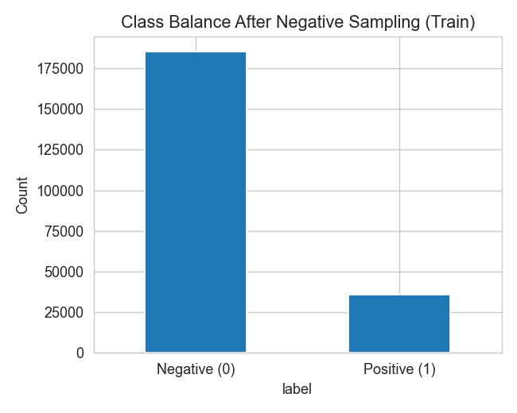
6.5 Model Training
The Random Forest was trained on the customer-product examples created from the training period. The model produces a purchase probability for each customer-product pair.
These probabilities are then used to rank candidate products. Products with higher predicted probability are placed higher in the recommendation list.

6.6 Baseline Model
A Popularity-based recommendation model was used as the baseline. It ranks products according to the number of distinct invoices containing each product in the training data.
The Random Forest recommendations are compared with this baseline to determine whether the machine-learning model provides better personalised recommendations than simply recommending popular products.

6.7 Model Explainability
Random Forest feature importance was used to understand which features contributed most to the model's predictions.
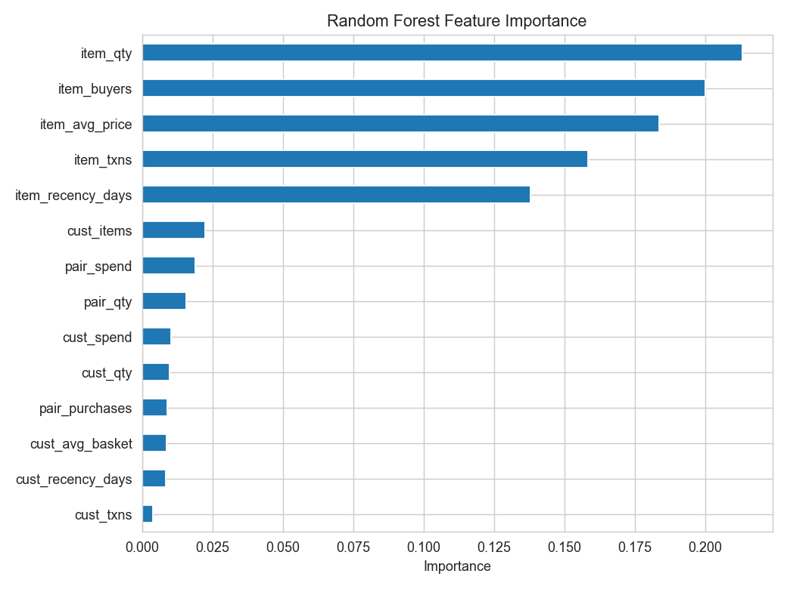

Key Model Development Summary
Component | Approach
Model | Random Forest
Trees | 300
Features | 14
Candidate products | Minimum 5 buyers, maximum 2,000
Negative samples | Up to 50 per customer
Baseline | Popularity
Output | Purchase probability
Ranking | Top-K products
Random seed | 42

7. Evaluation Results
The model was evaluated using both classification metrics and Top-K recommendation metrics. The Random Forest was compared with the Popularity baseline at K = 5, 10, and 20. An additional error analysis was performed for 200 test customers.

7.1 Recommendation Performance
The main business metrics are Precision@K, Recall@K, and Hit Rate@K. These measure how useful the recommended products are for future customer purchases.
Model | K | Precision@K | Recall@K | Hit Rate@K
Popularity | 5 | 0.0241 | 0.0055 | 0.1024
Random Forest | 5 | 0.9275 | 0.3297 | 0.9939
Popularity | 10 | 0.0231 | 0.0097 | 0.1737
Random Forest | 10 | 0.8508 | 0.5077 | 0.9939
Popularity | 20 | 0.0222 | 0.0165 | 0.2693
Random Forest | 20 | 0.7105 | 0.6904 | 0.9939
Table 7.1. Top-K recommendation performance

The Random Forest performs much better than the Popularity baseline at all three K values. At K = 10, the model achieves a Precision@10 of 0.8508, Recall@10 of 0.5077, and Hit Rate@10 of 0.9939.. For the business use case, K = 10 is the main operating point, as defined in the project. It provides a good balance between recommendation accuracy and the number of products shown to a customer.

7.2 Precision and Recall by K
The figure compares the Random Forest and Popularity models as the recommendation list increases from 5 to 20 products.

The Random Forest maintains much higher precision and recall than the Popularity baseline. Precision decreases as K increases, while Recall increases. This is expected because showing more products gives the model more opportunities to include products that the customer later purchases.

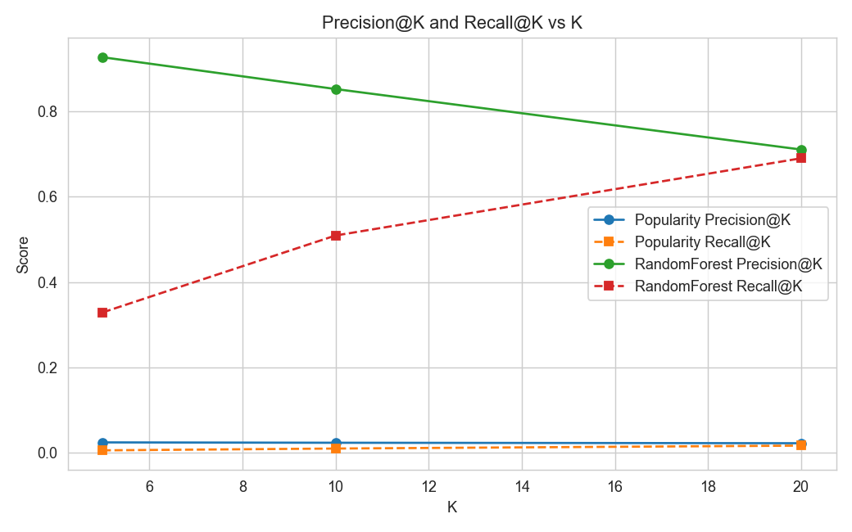

7.3 Model vs Baseline at K = 10
At K = 10, the Random Forest clearly outperforms the Popularity baseline on all three recommendation metrics:
- Precision@10: 0.8508 vs 0.0231
- Recall@10: 0.5077 vs 0.0097
- Hit Rate@10: 0.9939 vs 0.1737
This shows that using customer, product, and customer-product information provides a much stronger recommendation signal than recommending products based only on overall popularity.

7.4 Score Diagnostics
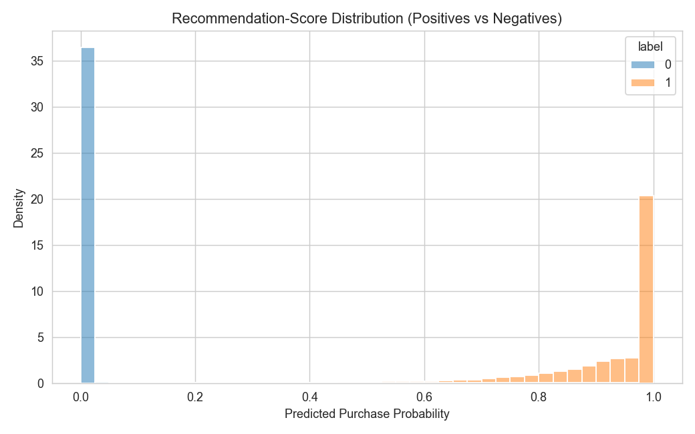
This figure shows the distribution of Random Forest prediction scores for positive and negative customer-product examples. It provides a diagnostic view of whether the model gives higher scores to products that are more likely to be purchased.
This is useful because ranking quality depends on the model assigning higher scores to relevant products.

7.5 Segment and Error Analysis
The error analysis examined 200 test customers and recorded their history size, future purchases, recommendations, and number of hits.
Customer history | Customers | Average hits in Top-10 | Average Hit Rate
1–5 purchases | 6 | 2.17 | 21.7%
6–20 | 20 | 6.25 | 62.5%
21–50 | 65 | 8.49 | 84.9%
51–100 | 52 | 8.92 | 89.2%
101–1000 | 56 | 9.71 | 97.1%
Table 7.2. Recommendation performance by customer history size

The main error pattern is clear: customers with very little purchase history are harder to recommend for. Customers with only 1–5 previous purchases had an average Top-10 hit rate of 21.7%, while customers with more than 100 purchases had an average hit rate of 97.1%.
This indicates a cold-start/low-history problem. The model has less information about a new or infrequent customer, so personalised recommendations are less reliable.

7.6 Evaluation Summary
Overall, the Random Forest provides a strong improvement over the Popularity baseline. The model performs particularly well for customers with sufficient purchase history. However, performance is weaker for customers with very limited history.
The results therefore support using the Random Forest as the main recommendation model, while keeping a popularity-based strategy as a fallback for customers with little or no purchase history.

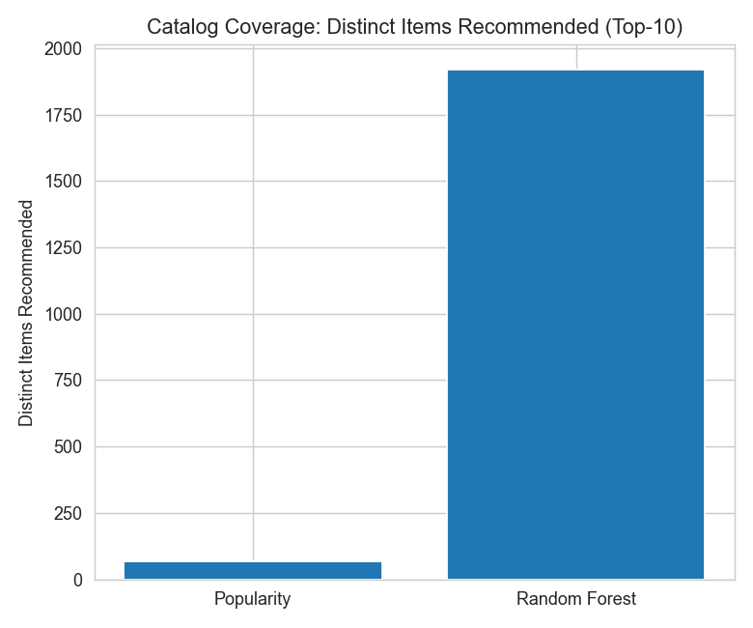
8. Interpretation
- Random Forest performed much better than the Popularity baseline, showing that customer and product behaviour provides useful information for personalised recommendations.
- K = 10 is a suitable recommendation size because it provides a good balance between precision and recall while keeping the recommendation list manageable.
- Customer purchase history strongly affects performance. Customers with more previous purchases receive more accurate recommendations.
- Cold-start customers are a major challenge. Customers with very little or no purchase history have limited information available for personalised recommendations.
- The model is more useful than popularity alone, but the Popularity method can still be used as a fallback for new or low-history customers.
- Feature importance helps explain the model, showing which customer, product, and customer-product signals contribute most to recommendation decisions.
- Business interpretation: the system can support personalised product recommendations, but recommendations should be treated as decision support rather than guaranteed predictions of future purchases.

9. Limitations and Risk
- Coverage: The model only considers products bought by at least 5 customers and limits the candidate list to 2,000 products. Some products may therefore never be recommended.
- Cold-start bias: Customers with very little purchase history receive weaker recommendations because the model has limited information about their preferences.
- Data bias: The model learns only from past transaction behaviour. Products that were already popular or frequently purchased may receive more attention than less frequently purchased products.
- Drift: Customer preferences and product popularity can change over time. The model was trained on historical data from 2010–2011, so performance may decrease if current customer behaviour is different.
- Invalid uses: The model should only be used for product recommendation and decision support. It should not be used for credit, employment, insurance, or other high-impact decisions.

10. Conclusion
The Random Forest recommendation model meets the stated success criteria for personalised product recommendation. It clearly outperforms the Popularity baseline across Precision@K, Recall@K, and Hit Rate@K. At K=10, it achieves strong recommendation performance, with a Precision@10 of 0.8508, Recall@10 of 0.5077, and Hit Rate@10 of 0.9939. The results show that customer, product, and customer-product features provide useful signals for predicting future purchases. However, performance is lower for customers with limited purchase history. Therefore, the model is suitable for recommendation support, with a popularity-based fallback recommended for cold-start customers.

