**Assignment – 1**

**• Install Power BI Desktop and share the final screenshot of the report view page which appears when power desktop starts.**

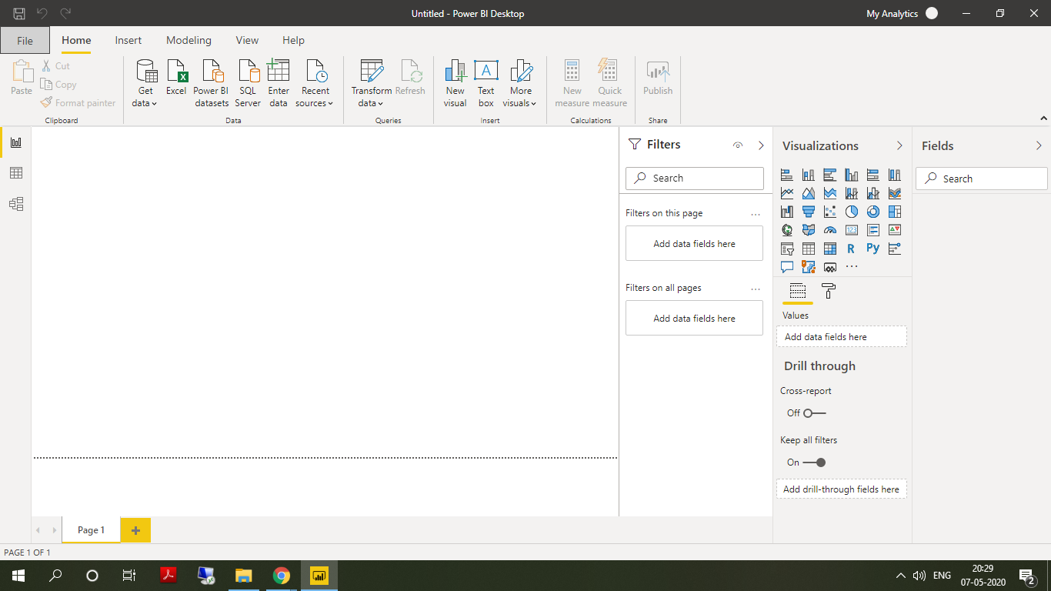

• Prepare a document and with the following screenshot

− Report View

− Data View

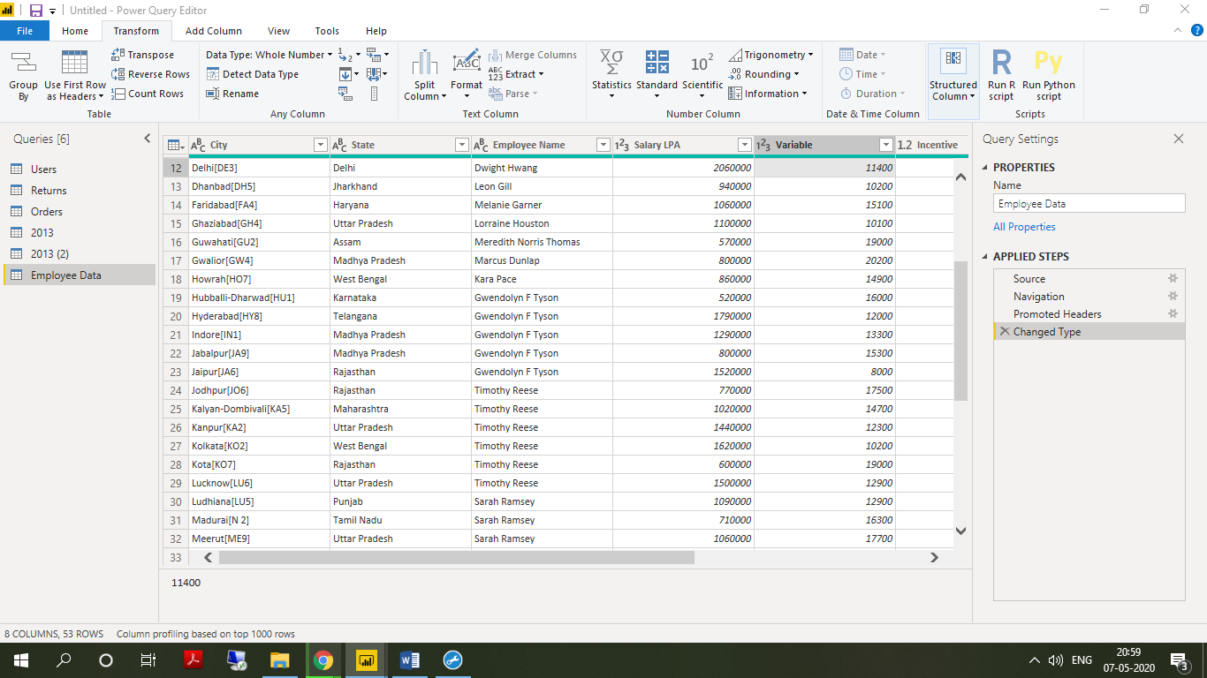

− Model View

− Power Query Editor

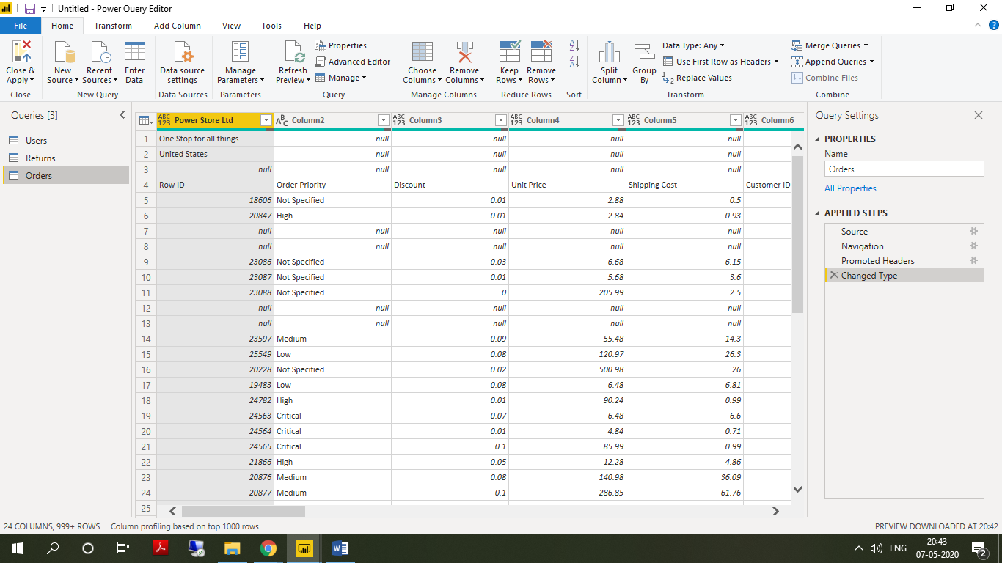

− Advance Editor

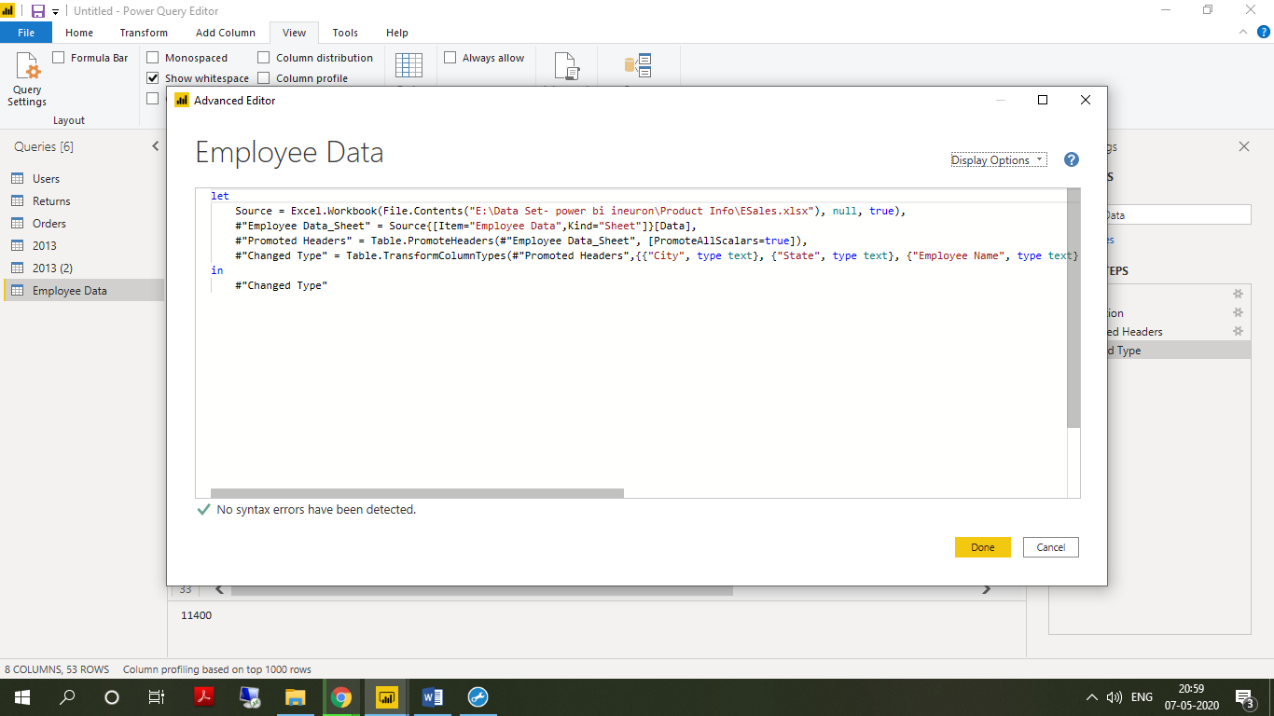

**Power BI Desktop**

Power BI Desktop is a free application we can install them on our local computer that let’s us connect to, transform, and visualize our data.

With Power BI Desktop, we connect to multiple different sources of data, and combine them into a data model. This data model lets us build visuals, and collections of visuals we can share reports, with other people inside your organization.

Most users who work on business intelligence projects use Power BI Desktop to create reports, and then use the Power BI service to share their reports with others.

− **Power BI Pro**

* Power BI Pro is an individual user license that lets users read and interact with reports and dashboards that others have published to the Power BI service.
* Users with this license type can share content and collaborate with other Power BI Pro users.
* Only Power BI Pro users can publish or share content with other users or consume content that's created by others, unless a Power BI Premium capacity hosts that content

**− Power BI Premium**

* Power BI Premium is a capacity based offering
* Greater scale and performance.
* Analyse data in Excel or Power BI Desktop
* Share with Excel Web App support
* Share dashboards and collaborate with Office 365 Groups
* Integrate content with Microsoft Team.
* Power BI Premium is billed monthly with an annual commitment