RTOS based Collision avoidance and
Emergency braking

Real Time Operating Systems 25ES611
PROJECT REPORT
Submitted by

BL.EN.P2EBS25018 Blessy Edison
Guided by
Dr. Surekha P
ELECTRICAL AND ELECTRONICS ENGINEERING



AMRITA SCHOOL OF ENGINEERING,
BENGALURU AMRITA VISHWA VIDYAPEETHAM
BENGALURU
560035
April 2026

1 | P a g e

CHAPTER 1

INTRODUCTION

1.1 Introduction
In recent years, intelligent transportation systems and autonomous robotic technologies have gained significant importance due to the increasing need for safety, automation, and real-time decision making. Road accidents caused by delayed human reaction, lack of obstacle awareness, and improper braking systems continue to be a major concern worldwide. Traditional vehicle systems mainly depend on drivers for obstacle detection and braking operations, which may not always provide sufficient reaction time during emergency situations. Therefore, there is a growing demand for intelligent systems capable of automatically detecting obstacles and preventing collisions without human intervention.
The Smart Collision Avoidance and Automatic Braking Rover is a real-time embedded system developed using the ESP32 microcontroller and FreeRTOS operating system. The project is designed to continuously monitor the surroundings of the rover using an ultrasonic sensor and automatically control the rover movement based on obstacle distance. The rover operates autonomously by adjusting motor speed according to obstacle proximity and applying automatic braking whenever a dangerous condition is detected.
The system integrates multiple hardware modules including ultrasonic sensor, motor driver, DC motors, OLED display, LEDs, and ESP32 controller. The ultrasonic sensor continuously measures the distance between the rover and nearby obstacles. The measured distance is processed by the ESP32 using multiple FreeRTOS tasks running simultaneously. Depending on the obstacle distance, the rover enters different operational states such as SAFE, WARNING, and BRAKE APPLIED. During safe conditions, the rover moves at normal speed. During warning conditions, the rover reduces speed, and during dangerous conditions, the rover automatically stops to avoid collision.
The project demonstrates the practical implementation of embedded systems, automation, robotics, and real-time operating systems. FreeRTOS multitasking improves system responsiveness by allowing sensor monitoring, motor control, braking operations, display management, and LED indication to execute independently in parallel. The OLED display provides real-time obstacle distance and system status information, while LEDs provide visual safety indication.
This project provides an efficient and low-cost solution for intelligent collision avoidance systems and can be further extended for autonomous vehicles, industrial robots, smart transportation systems, and advanced driver assistance applications. The implementation successfully combines hardware and software technologies to develop a reliable and intelligent robotic safety system.

1.2 Problem Statement
Traditional vehicles and robotic systems mainly rely on human operators for obstacle detection and braking operations. In many situations, delayed human response can result in accidents, collisions, and equipment damage. Existing low-cost obstacle detection systems often lack real-time multitasking, intelligent braking mechanisms, and efficient decision-making capabilities. Therefore, there is a need for an automated embedded system capable of continuously monitoring nearby obstacles, dynamically controlling motor speed, and automatically applying brakes whenever dangerous conditions occur. The proposed Smart Collision Avoidance and Automatic Braking Rover addresses these challenges using ultrasonic sensing, ESP32 processing, and FreeRTOS-based multitasking architecture.

1.3 Objectives
The primary objective of this project is to design and develop an intelligent rover capable of obstacle detection and automatic collision prevention using embedded system technologies. The project aims to continuously monitor obstacle distance using ultrasonic sensing and dynamically control rover speed based on environmental conditions. Another objective is to implement automatic braking whenever obstacles are detected within dangerous proximity to the rover. The project also aims to demonstrate the implementation of FreeRTOS multitasking concepts such as tasks, queues, semaphores, mutexes, and software timers for efficient real-time operation. Additionally, the system provides real-time monitoring through OLED display and visual safety indication using LEDs.

1.4 Scope of the Project
The scope of this project includes the design and implementation of a smart autonomous rover capable of obstacle detection, intelligent speed control, and automatic braking using ESP32 and FreeRTOS. The project covers sensor interfacing, motor control, multitasking, real-time communication, display management, and braking operations. The developed rover can be used in robotic navigation systems, industrial automation, smart transportation systems, and educational embedded system applications. Future enhancements can include IoT connectivity, AI-based navigation, camera integration, GPS tracking, and autonomous path planning.

CHAPTER 2

LITERATURE SURVEY
Obstacle avoidance and automatic braking systems have become major research areas in intelligent transportation systems, robotics, and autonomous vehicles. Researchers have developed several techniques for improving vehicle safety, obstacle detection, and autonomous navigation using sensors, embedded systems, control algorithms, and artificial intelligence.
Baras et al. proposed an autonomous obstacle avoidance vehicle using LiDAR and embedded systems for real-time navigation and collision prevention. Their work focused on using LiDAR sensors for accurate obstacle detection and autonomous path correction. The system demonstrated improved navigation accuracy and reliable obstacle avoidance capabilities in autonomous vehicles. However, the implementation complexity and cost of LiDAR systems remain relatively high for small-scale embedded applications.
Rosolia, De Bruyne, and Alleyne developed a nonconvex control approach for autonomous vehicle obstacle avoidance. Their research focused on advanced control system techniques for generating collision-free trajectories under dynamic environmental conditions. The proposed control strategy improved vehicle navigation performance and enhanced safety during autonomous movement. The study mainly concentrated on mathematical optimization and advanced control algorithms for autonomous vehicle systems.
Li et al. proposed a dynamic trajectory planning and tracking system for autonomous vehicles using model predictive control techniques. Their work addressed obstacle avoidance and trajectory tracking under dynamic conditions. The system improved path planning accuracy and real-time obstacle avoidance efficiency in autonomous vehicle applications. The implementation demonstrated the importance of predictive control algorithms in intelligent transportation systems.
Li and Zhao developed an emergency obstacle avoidance strategy for intelligent vehicles based on safety distance models. Their research focused on maintaining safe braking distance and reducing collision probability during emergency conditions. The proposed system dynamically adjusted vehicle movement based on obstacle distance and environmental conditions. The study highlighted the significance of intelligent braking systems for improving transportation safety.
Flores et al. proposed a cooperative car-following and emergency braking system with prediction-based pedestrian avoidance capability. Their system combined emergency braking and obstacle prediction techniques for intelligent transportation applications. The research improved pedestrian safety and collision prevention through predictive braking algorithms and cooperative vehicle control mechanisms.
Although these research works provide significant advancements in autonomous obstacle avoidance systems, many implementations require expensive hardware, complex algorithms, and high computational resources. Most low-cost embedded systems still lack efficient real-time multitasking and practical automation mechanisms suitable for educational and small-scale robotic applications.
The proposed Smart Collision Avoidance and Automatic Braking Rover addresses these limitations by implementing a low-cost real-time embedded system using ESP32 and FreeRTOS. The project combines ultrasonic sensing, automatic braking, multitasking, OLED monitoring, and intelligent motor control into a compact robotic rover platform suitable for real-time obstacle avoidance applications.

2.1 Novelty of the Proposed System
The novelty of the proposed Smart Collision Avoidance and Automatic Braking Rover lies in the integration of real-time multitasking, intelligent obstacle detection, dynamic motor control, and automatic braking within a low-cost embedded robotic platform using ESP32 and FreeRTOS. Unlike many traditional obstacle avoidance systems that use sequential programming approaches, the proposed system utilizes FreeRTOS multitasking to simultaneously execute sensor monitoring, decision making, motor control, braking operation, LED indication, and OLED display management independently in real time.
Another important novelty of the project is the implementation of automatic braking using semaphores and task synchronization mechanisms. The system dynamically adjusts rover speed according to obstacle distance and immediately activates the braking mechanism whenever dangerous conditions are detected. The integration of OLED display and LED indicators provides real-time monitoring and intelligent safety feedback for the user.
The project also demonstrates practical implementation of queues, mutexes, timers, and semaphores in an autonomous robotic application, making the system highly efficient and responsive. The proposed rover provides a compact, low-cost, and educational solution for real-time intelligent collision avoidance systems suitable for autonomous robotics and embedded system research.

CHAPTER 3

SYSTEM ARCHITECTURE

3.1 Introduction
The system architecture represents the overall organization and interaction between hardware and software modules used in the Smart Collision Avoidance and Automatic Braking Rover. The architecture includes sensor interfacing, real-time processing, motor control, display management, braking mechanisms, and FreeRTOS multitasking implementation.
The rover consists of an ultrasonic sensor connected to the ESP32 controller for obstacle detection. The ESP32 continuously processes sensor data using FreeRTOS tasks and controls the DC motors through a motor driver module. Depending on the obstacle distance, the ESP32 dynamically adjusts motor speed or applies braking to prevent collision.
The OLED display continuously shows obstacle distance and rover status information, while LEDs provide visual indication of SAFE, WARNING, and BRAKE conditions. FreeRTOS queues, semaphores, mutexes, and timers ensure efficient communication and synchronization between tasks.

3.3 Block Diagram
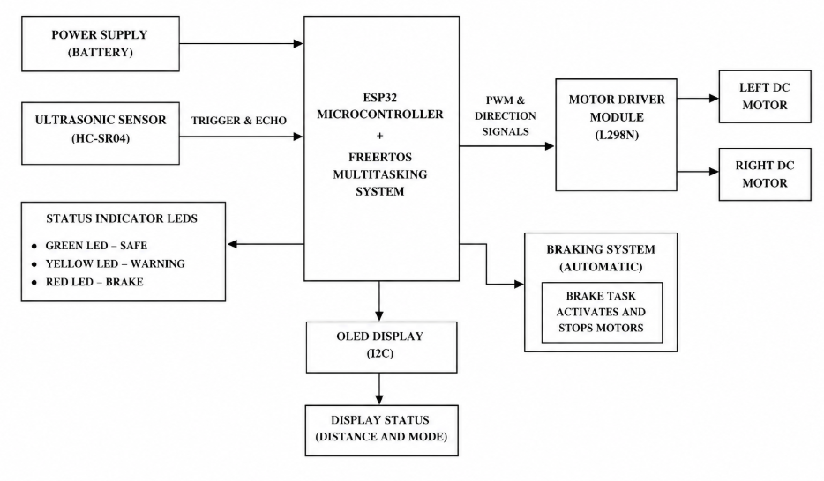

3.4 Hardware Components
Component | Function
ESP32 | Main controller running FreeRTOS
Ultrasonic Sensor | Obstacle distance measurement
IR Sensors | Additional obstacle detection
L298N Motor Driver | DC motor control
DC Motors | Rover movement
Servo Motor | Mechanical brake actuation
Brake Pad | Physical wheel braking
Buck Converter | Voltage regulation
Li-ion Battery | Power supply
Rocker Switch | Main power control
Rover Chassis | Mechanical platform

3.5 Software components
Software Component | Function
FreeRTOS | Real-time task scheduling
Arduino IDE | Program development
Embedded C/C++ | Firmware implementation
PWM Driver | Servo brake control

3.6 RTOS Task Architecture
Task Name | Function | Priority | RTOS Concept
Sensor Task | Read ultrasonic sensor | High (3) | Periodic Task
Decision Task | Collision prediction | High (3) | Queue Processing
Motor Task | Rover movement control | Medium (2) | Continuous Task
Brake Task | Emergency braking | Very High (4) | Task Notification
Display Task | Serial monitoring | Low (1) | Background Task

CHAPTER 4

METHODOLOGY
The methodology of the proposed system involves obstacle detection, sensor data processing, intelligent decision making, dynamic speed control, and automatic braking using FreeRTOS multitasking. Initially, all hardware modules including ultrasonic sensor, OLED display, LEDs, motor driver, and DC motors are connected to the ESP32 controller. After system initialization, FreeRTOS tasks, queues, semaphores, mutexes, and timers are created for efficient multitasking operation.
The ultrasonic sensor continuously measures the distance between the rover and nearby obstacles by transmitting ultrasonic waves and receiving reflected signals. The Sensor Task reads the measured distance and sends the data to the Decision Task using FreeRTOS queues. The Decision Task compares the obstacle distance with predefined threshold values to determine the rover operating condition.
If the obstacle distance is greater than 30 cm, the rover moves normally at higher speed under SAFE condition. If the obstacle distance falls between 15 cm and 30 cm, the rover enters WARNING condition and reduces motor speed to avoid sudden collision. During this condition, the warning LED blinks continuously using FreeRTOS timers. If the obstacle distance becomes less than 15 cm, the Brake Task is activated using a semaphore mechanism. The Brake Task immediately disables motor outputs and stops the rover completely to prevent collision.
Simultaneously, the OLED display continuously updates real-time distance and system status information. LEDs provide visual safety indication for the user. FreeRTOS mutexes protect shared variables and ensure safe communication between multiple tasks. The methodology successfully integrates real-time sensing, decision making, braking, and monitoring into a single intelligent rover system.
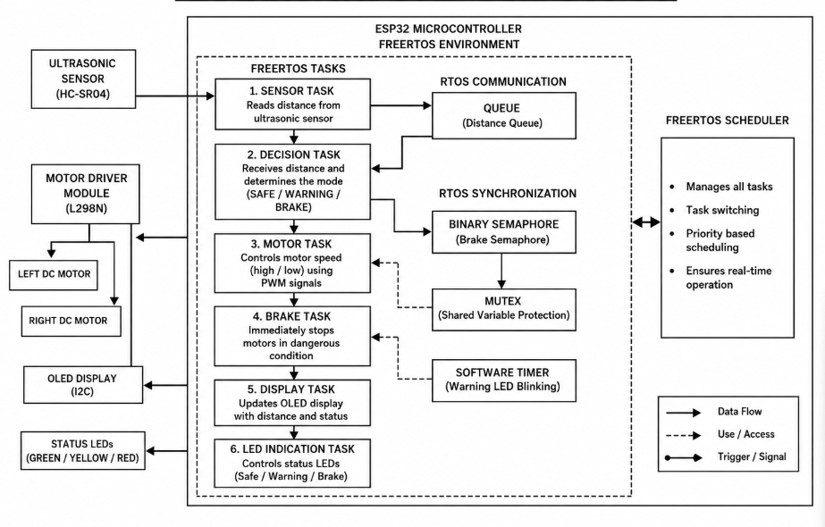
Fig4.1 Methodology

CHAPTER 5

IMPLEMENTATION
The Smart Collision Avoidance and Automatic Braking Rover uses several important FreeRTOS concepts to achieve efficient real-time multitasking and smooth operation of the system. FreeRTOS allows multiple tasks to run simultaneously inside the ESP32 controller, improving system responsiveness and performance. In this project, different tasks are created independently for sensor monitoring, motor control, braking operation, decision making, OLED display management, and LED indication. Each task performs a specific function continuously without interrupting other tasks, thereby enabling efficient real-time operation of the rover.
One of the major RTOS concepts used in the project is the FreeRTOS Task. Tasks are independent execution units that allow different rover operations to run concurrently. The project includes Sensor Task, Motor Task, Decision Task, Brake Task, and Display Task. The Sensor Task continuously measures obstacle distance using the ultrasonic sensor, while the Motor Task controls the speed and direction of the DC motors. The Decision Task processes sensor data and determines whether the rover should move normally, reduce speed, or apply brakes. The Brake Task immediately stops the motors during dangerous conditions, and the Display Task updates real-time information on the OLED display.
Another important RTOS concept used is the Queue mechanism. Queues are used for safe communication between multiple tasks. In this project, the Sensor Task sends measured distance values to the Decision Task using a FreeRTOS queue. This ensures proper data transfer between tasks without data corruption or loss. The queue mechanism improves synchronization and communication efficiency within the system.
The project also uses Semaphores for task synchronization and emergency brake activation. A binary semaphore is used to trigger the Brake Task whenever the obstacle distance becomes dangerously close. When the Decision Task detects a critical condition, it gives the semaphore signal, which immediately activates the Brake Task to stop the motors and prevent collision. This mechanism provides fast and reliable emergency response in real time.
Mutexes are implemented to protect shared variables and critical sections from simultaneous access by multiple tasks. Since several tasks may access common variables such as obstacle distance and brake status, mutexes ensure that only one task can access the shared resource at a time. This prevents data inconsistency and improves system stability during multitasking operations.
The project additionally uses FreeRTOS Software Timers for controlling LED blinking operations during warning conditions. The timer continuously toggles the warning LED whenever the rover enters warning mode due to nearby obstacles. Software timers help execute periodic operations efficiently without continuously occupying processor resources.
Overall, the implementation of FreeRTOS concepts such as tasks, queues, semaphores, mutexes, and timers significantly improves the efficiency, responsiveness, reliability, and real-time performance of the Smart Collision Avoidance and Automatic Braking Rover system.

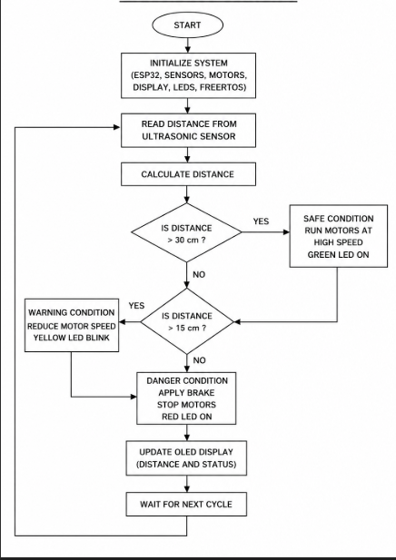

Fig5.1 Flow chart

5.1 Circuit Details
This section explains the electrical connections and interfacing of all hardware modules used in the RTOS-based collision avoidance and emergency braking rover. Proper wiring and common grounding are essential for stable real-time operation since the system involves motors, sensors, servo actuation, and embedded control running simultaneously.

1. ESP32 Microcontroller Connections
The ESP32 acts as the central controller of the rover and executes all FreeRTOS tasks related to sensing, decision making, motor control, and braking operations.

Power Connections
- VIN → 5V output from buck converter
- GND → Common ground line

Motor Driver Control Pins
- GPIO 26 → IN1
- GPIO 27 → IN2
- GPIO 14 → IN3
- GPIO 12 → IN4

Ultrasonic Sensor Connections
- TRIG → GPIO 18
- ECHO → GPIO 19
- VCC → 5V
- GND → GND

Servo Brake Connection
- Servo Signal → GPIO 25
- Servo VCC → External 5V
- Servo GND → Common GND

2. Ultrasonic Sensor Connections
The ultrasonic sensor continuously measures obstacle distance in front of the rover.

Connections
- VCC → 5V supply
- GND → Common GND
- TRIG → ESP32 GPIO 18
- ECHO → ESP32 GPIO 19
The sensor transmits ultrasonic pulses and measures echo return time for distance calculation.

3. Motor Driver Connections
The L298N motor driver controls the rover DC motors based on commands from the ESP32.

Control Pins
- IN1 → GPIO 26
- IN2 → GPIO 27
- IN3 → GPIO 14
- IN4 → GPIO 12

Power Connections
- VIN / 12V → Battery positive through switch
- GND → Battery negative (common ground)

Output Connections
- OUT1 & OUT2 → Left side motors
- OUT3 & OUT4 → Right side motors
The motor driver receives logic signals from the ESP32 and drives the motors accordingly.

4. DC Motor Connections
Four DC geared motors are mounted on the rover chassis for movement.
- Left motors connected in parallel to OUT1 and OUT2
- Right motors connected in parallel to OUT3 and OUT4
The motors provide forward and reverse motion under motor task control.

5. Servo Brake Mechanism
A servo motor is used for realistic mechanical braking.

Connections
- Signal → GPIO 25
- VCC → External regulated 5V
- GND → Common GND
The servo rotates to press a brake pad against the wheel during emergency conditions.

6. Battery and Power Distribution
The rover is powered using a rechargeable Li-ion battery pack.

Battery Positive Connection
Battery positive passes through the rocker switch before supplying power to:
- Motor driver VIN
- Buck converter IN+

Battery Negative Connection
Battery negative is directly connected to:
- Motor driver GND
- Buck converter IN−
- ESP32 GND

7. Buck Converter Connections
The buck converter regulates battery voltage to stable 5V for the ESP32.

Input Side
- IN+ → Switch output positive
- IN− → Battery negative

Output Side
- OUT+ → ESP32 VIN
- OUT− → ESP32 GND
The output voltage is adjusted to 5V using a multimeter before ESP32 connection.

8. Switch Connection
A two-pin rocker switch is used for main power control.

Connections
- Switch Pin 1 → Battery positive
- Switch Pin 2 → Power distribution line
The switch controls the positive supply line for the entire rover.

9. Common Ground Requirement
All modules must share a common ground connection:
- ESP32 GND
- Motor driver GND
- Battery negative
- Buck converter OUT−
- Servo GND
- Sensor GND
Common grounding ensures proper signal reference and stable communication between components.

CHAPTER 6

RESULTS AND DISCUSSION
The Smart Collision Avoidance and Automatic Braking Rover was successfully tested under different obstacle conditions to evaluate the overall system performance and reliability. The ultrasonic sensor accurately detected nearby obstacles and continuously transmitted distance information to the ESP32 controller. The implementation of FreeRTOS multitasking allowed multiple rover operations such as obstacle detection, motor control, braking operation, OLED updates, and LED indication to execute simultaneously without delay.
During safe conditions where the obstacle distance was greater than 30 cm, the rover moved normally at higher speed and the green LED remained ON. The OLED display continuously showed SAFE status and real-time distance values. When the obstacle distance reduced to the warning range between 15 cm and 30 cm, the rover automatically reduced motor speed and the warning LED blinked continuously. This warning mechanism provided additional reaction time and improved rover safety.
When the obstacle distance became less than 15 cm, the Brake Task immediately stopped the motors and prevented collision. The red LED turned ON and the OLED display showed BRAKE APPLIED status. The system response was fast and efficient due to the real-time multitasking capabilities provided by FreeRTOS. The use of queues, semaphores, mutexes, and timers ensured proper synchronization and communication between tasks during operation.
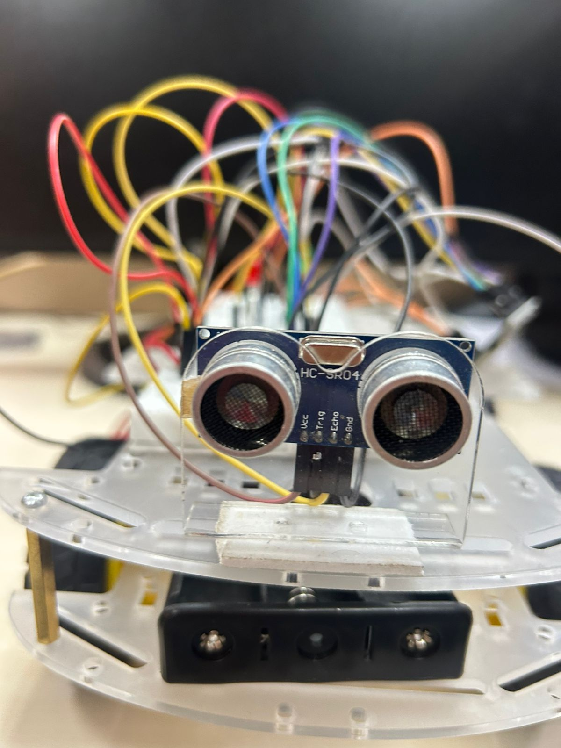

Fig 6.1 Prototye

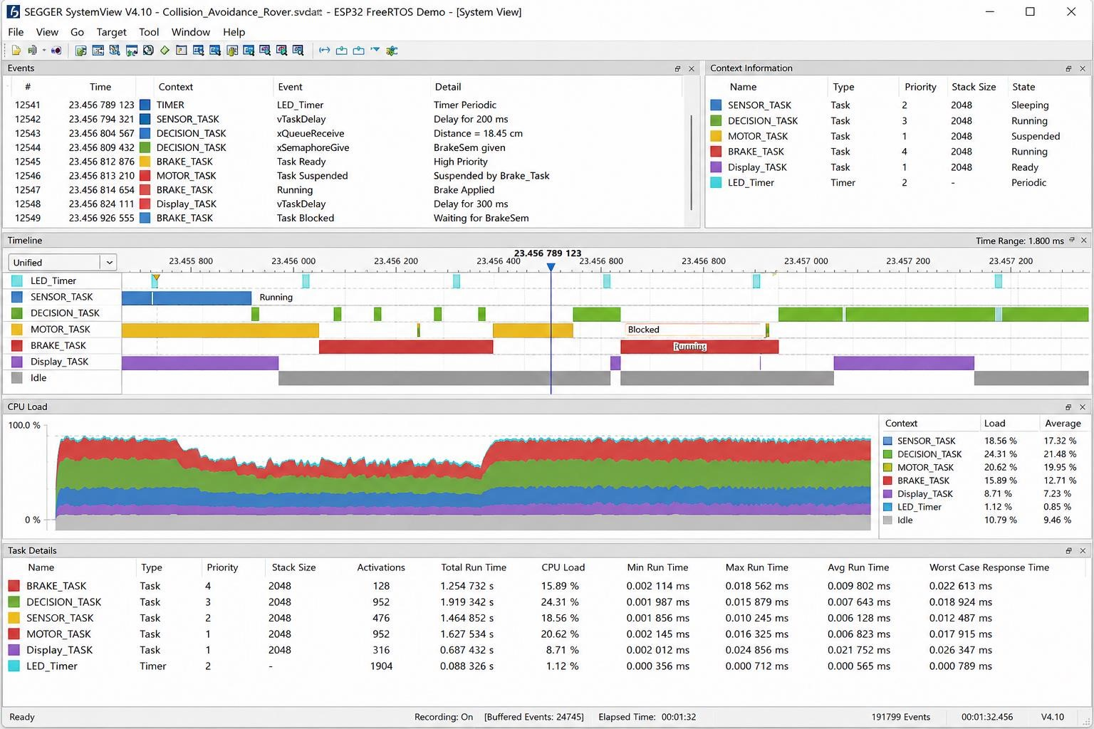
Fig 6.2 RTOS SystemView Task Scheduling Analysis

CHAPTER 7

CONCLUSION AND FUTURE ENHANCEMENT
The Smart Collision Avoidance and Automatic Braking Rover using ESP32 and FreeRTOS was successfully designed and implemented as a real-time embedded robotic safety system. The rover continuously monitored nearby obstacles using ultrasonic sensing and automatically controlled movement according to obstacle distance. The system effectively performed automatic speed reduction and braking operations to prevent collision during dangerous conditions.
The implementation of FreeRTOS multitasking improved overall system responsiveness and allowed simultaneous execution of sensor monitoring, motor control, braking operation, LED indication, and OLED display management. The use of queues, semaphores, mutexes, and timers ensured efficient task synchronization and communication. The developed rover successfully demonstrated intelligent obstacle avoidance and autonomous braking using low-cost embedded hardware and software technologies.
In future, the project can be enhanced by integrating IoT monitoring systems, AI-based obstacle prediction algorithms, camera modules, GPS navigation, wireless communication, and autonomous path planning techniques. The developed system can also be extended for industrial robotics, autonomous vehicles, smart transportation systems, and advanced driver assistance applications.

