Midterm Project

Digital Signal Processing

Edward Djan Niccolo V. Almaden   
College of Engineering  
*Adamson University*  
*Manila, Philippines*   
*edward.djan.niccolo.almaden@adamson.edu.ph*

Art Daryl D. Buenaventura  
College of Engineering  
*Adamson University*  
*Manila, Philippines*  
art.daryl.buenaventura@adamson.edu.ph

Paulo Valentin M. Gatchalian  
College of Engineering  
*Adamson University*  
Manila, Philippines  
paulo.valentin.gatchalian@ada

Panelo, Bryan V.  
*College of Engineering*  
*Adamson University  
Manila, Philippines  
bryan.panelo@adamson.edu.ph*

*Abstract*— The data gathered presents an overview of a study focusing on the impact of future climate change on precipitation patterns and associated data collection and analysis. The introduction underscores the significance of climate change and its effects on precipitation, while also highlighting the importance of environmental risk data and the fascination people have with weather. It addresses the vulnerability of New York State to climate change and emphasizes the need for more accurate and extensive hydrometeorological data, especially with the advancements in information technology. It also provides details about the specific climate data used, including wind, temperature, pressure, humidity, and precipitation data, covering the period from 01/01/2015 to 05/31/2022. The data is divided into daily, hourly, and monthly time stamps, obtained from datasets collected through Kaggle. The study employs time-series analysis as a statistical approach to analyze the data. It mentions the traditional methods of measuring precipitation using gauges, weather radar systems, and satellites, as well as the exploration of wireless communication networks as a potential new approach. The abstract sets the stage for a comprehensive study on the relationship between climate change and precipitation patterns, outlining the data and methods used in the research.

# Introduction

Future climate change is expected to result in changes to precipitation's frequency, duration, and intensity throughout the year.[1]. Environmental risk data can also provide information on a location's topography and how vulnerable it is to environmental hazards [2]. People are fascinated by the weather, and we regularly discuss it. It's amazing to see how frequently we lament the weather—too hot, too cold, or too rainy. For some reason, we ignore the weather when it's a sunny, pleasant day for outside activities. Precipitation varies in volume, intensity, frequency, and type from year to year and throughout decades. Changes in these elements (such as the amount of snow vs rain) influence the environment and civilization [3]. Even though the physically diversified region of New York State (NYS) is susceptible to climate change and in climate severity indicators haven't gotten much attention [4]. Since the Earth's precipitation patterns are changing, it is expected that regional precipitation in New York State will keep rising [5]. It is a crucial climatic parameter that has been applied to research the trend and variation of hydro-meteorological events [6]. Greater municipal management is required to solve these challenges since a significant rainstorm might affect the lives of thousands of people [7]. The requirement for exact information about the geographical and temporal fluctuations in precipitation at the Earth's surface has increased due to worries about human climate change.[8]. With the development of information technology, particularly information collecting and storage technology, the amount of hydrometeorological data information has increased tremendously [9].

# Theory discussion

The climate data covers the specific period of 01/01/2015 to 05/31/2022. The data are composed of wind, temperature, pressure, humidity and precipitation data. The sampled data is separated into three-time stamps, daily, hourly, monthly. This can be determined through the data sets that have been collected through Kaggle. The dataset used time series analysis in collecting the data, is a statistical approach for analyzing data from repeated measurements made over an extensive number of observations on one event or subject at periodic times. Time-series analysis is also the ideal illustration of a much longer observation [11]. Measurements of precipitation have traditionally been made using gauges, weather radar systems, and satellites. Wireless communications networks which do not need deployment procedures or fees and are currently widely used across nations, are just now being investigated as a potential new tactic [12]. Another way of calculating precipitation is through arithmetic mean, this method calculates the precipitation of all points of areal measurements considered in the analysis.

1. Application of DSP in Weather Data

Radar's ability to deliver real-time data at radar stations and scan large portions of the atmosphere at high resolution is beneficial for research that is related to meteorology. An X-ray image is comparable to the data obtained when a radar beam enters clouds and observes the precipitation that reveals the interior architecture of the clouds. Additionally, radar is crucial to the rainfall stimulation research conducted by the National Precipitation Research Program (NPRP), which is supported by the SAWB and the Water Research Commission (WRC)[13].

1. Application of Arithmetic Mean

Arithmetic means can be applied in meteorological research, particularly when utilizing radar data for precipitation analysis. Radar stations provide real-time data and high-resolution scans of the atmosphere, enabling researchers to gain valuable insights into meteorological phenomena. When radar beams penetrate clouds and capture precipitation data, arithmetic means can be employed to calculate the average precipitation levels within a specific area or timeframe. The arithmetic mean can help determine the average precipitation intensity or distribution within those cloud structures. This information is crucial for understanding the behavior of clouds and their potential impact on weather patterns.

1. Time Series Analysis

Data on precipitation can be examined over time to spot anomalies, trends, and patterns. Time series analysis and forecasting can be performed on precipitation data using the Autoregressive Integrated Moving Average (ARIMA) model. Precipitation patterns can be understood and predicted with the use of ARIMA, a statistical technique that is frequently used to describe and predict time-dependent data. It is crucial to determine whether the precipitation time series is stationary before using ARIMA. When a time series is said to be stationar, it indicates that its statistical characteristics, including its variance and mean, do not alter with time. Differentiating (integrating) the data may be required if it is non-stationary in order to make it stationary. [15]

1. Supervised Learning

Supervised learning is an artificial intelligence (AI) technique in which the computer is given labeled input data and expected output outcomes. When given previously unknown data, the AI system is taught until it understands the underlying patterns and correlations, because it is clearly instructed what to look for. As a result, the model outperforms. Regression and classification problems are the two forms of supervised learning tasks. One example is estimating the sales volume at a specific future date, as is selecting which category a news item belongs to.[16]

# Methodology

The methods used are Clustering and Data Interpolation and Resampling to obtain hourly, weekly, and overall precipitations that can help reduce the data size and based on precipitation patterns to identify distinct weather regimes or seasons. We created time series plots to help in understanding and presenting the data effectively. In this research, data collection and preprocessing involve gathering meteorological data from various sources, encompassing climate change information, precipitation patterns, and environmental risk data, including radar observations. Subsequently, the collected data undergoes a series of preprocessing steps. These steps encompass data integration, data cleaning to address issues like missing values and outliers, data formatting to create a structured dataset, and data transformation to ensure consistency. The overarching aim is to prepare diverse meteorological data for comprehensive analysis. This processed data serves as the foundation for various analyses, including the application of statistical and data clustering methods, enabling insights into climate change, precipitation behavior, and their potential implications on weather and the environment.

In meteorology and environmental research, digital signal processing (DSP) is widely used for a variety of purposes. These include the analysis of weather data, time series data, and the creation of supervised learning models for precipitation forecasting. To extract relevant features and improve data quality, signal processing techniques are crucial for filtering and cleaning noisy meteorological data. Signal processing helps reveal hidden trends and patterns in time series data that could otherwise go undetected.

Additionally, signal processing is essential for feature extraction and data pretreatment in the context of supervised learning for precipitation prediction, setting up the input data for machine learning models. Meteorologists can improve the accuracy and dependability of precipitation forecasts by utilizing signal processing in these applications. This can lead to a better understanding of meteorological phenomena, more precise weather forecasts, and preparedness for natural events.

# Results and Discussion

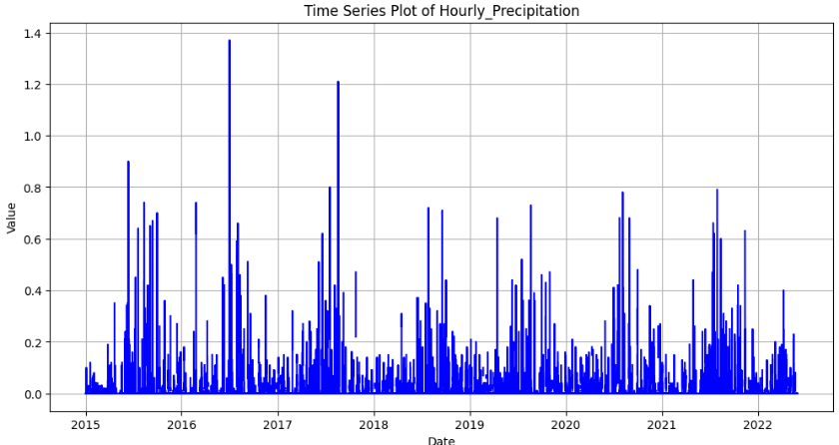

Fig 1. Hourly Precipitation

The data illustrating the hourly precipitation in Albany, New York from 2015 to 2022 is graphically displayed, although it doesn't indicate much of a difference. The overall pattern shows a discernible and steady increase in precipitation which is especially noticeable in the vicinity of 2021, the year with the largest amounts of precipitation recorded in the city over the course of the eight-year period. This observation of little hourly variation implies that a steady long-term trend, rather than sharp, short-term oscillations, is responsible for the increase in precipitation. This extended analysis places a lot of emphasis on the concentration of the highest precipitation levels around 2021, providing insightful information on how the city's weather patterns are changing.

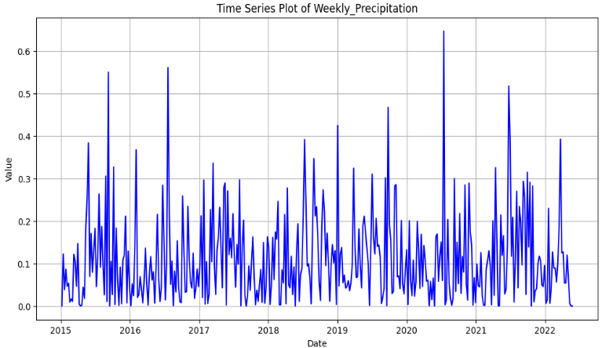

Fig 2. Weekly Precipitation

The dataset that depicts the weekly precipitation in Albany, New York from 2015 to 2022 shows a more pronounced pattern of variance than the more detailed hourly data. This increased level of specificity in the weekly dataset provides a clearer picture of changes in precipitation trends over time. The general trend, which shows a slow increase in rainfall, is unaffected by this enhanced granularity. The most noticeable of these changes is the closeness to the year 2021, which represents the time when the city saw the highest precipitation totals during this eight-year study. We can have a thorough grasp of the seasonal and annual variations in Albany's weather patterns by visualizing the weekly precipitation data. Our capacity to pinpoint the major causes of the city's changing precipitation patterns is improved by this enlarged perspective, which offers insightful information about the local climate.

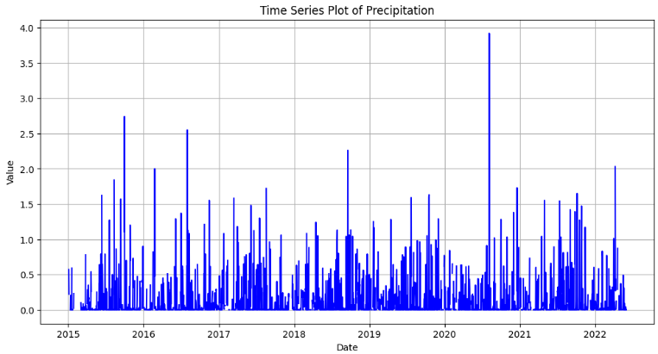

Fig 3. Overall Precipitation

An extensive analysis of the cumulative precipitation data for Albany, New York from 2015 to 2022 offers a broad overview of the city's long-term meteorological trends. This comprehensive data set captures all precipitation events over the course of the eight-year period, reflecting the dynamic interactions between meteorological systems, seasonal variations, and environmental factors. We can identify broad trends and variations in Albany's climate thanks to this long observation period, which provides a comprehensive picture of how precipitation has changed over time. We can learn a great deal about the nuances of Albany's climate by examining the cumulative precipitation data from 2015 to 2022. This helps us make informed decisions and take preventative action that takes into consideration the city's long-term trends and fluctuations in precipitation patterns.

# Conclusion

A thorough understanding of Albany and New York's climate over a long period of time can be obtained by examining the precipitation statistics overall for the years 2015 to 2022. With its vast dataset that highlights the trends and variations that have happened over the course of these eight years, it offers important insights on the rainfall patterns of the region. It is clear from examining the cumulative precipitation statistics that Albany saw a variety of weather patterns during this time. A better grasp of the city's climate dynamics can be attained by scholars and meteorologists by looking at the annual precipitation totals, seasonal variations, and any noteworthy departures from historical norms.

In addition to being a useful tool for meteorological study, the analysis of this multi-year precipitation dataset has applications across a range of industries. Decision-makers in the fields of urban planning, agriculture, water resource management, and disaster preparedness can make sense of this data. Furthermore, to evaluate the effects of climate variations on regional ecosystems and communities, climate scientists researching more extensive environmental changes need to have a thorough understanding of long-term precipitation trends. Monitoring the total precipitation data from 2015 to 2022 gives researchers and decision-makers crucial information for planning, resource management, and environmental analysis in addition to offering a window into Albany's weather patterns.

# References

1. J. M. Craine, “The importance of precipitation timing for grassland productivity - plant ecology,” SpringerLink, https://link.springer.com/article/10.1007/s11258-013-0236-4 (accessed Nov. 3, 2023).
2. “What is climate change?,” NASA, https://climate.nasa.gov/what-is-climate-change/ (accessed Nov. 3, 2023).
3. K. E. Trenberth, “Changes in precipitation with climate change - int-res.com,” Changes in precipitation with climate change, https://www.int-res.com/articles/cr_oa/c047p123.pdf (accessed Nov. 3, 2023).
4. T. Z. Insaf, S. Lin, and S. C. Sheridan, “Climate trends in indices for temperature and precipitation across New York State, 1948–2008 - air quality, Atmosphere & Health,” SpringerLink, https://link.springer.com/article/10.1007/s11869-011-0168-x (accessed Nov. 3, 2023).
5. A. Rai, T. Adeyeye, T. Insaf, and N. Muscatiello, “Assessing the effect of precipitation on asthma emergency department visits in New York State from 2005 to 2014: A case-crossover study,” GeoHealth, https://www.ncbi.nlm.nih.gov/pmc/articles/PMC10499370/ (accessed Nov. 3, 2023).
6. A. De Jesús, J. A. Breña-Naranjo, A. Pedrozo-Acuña, and V. H. Alcocer Yamanaka, “The use of TRMM 3B42 product for drought monitoring in Mexico,” MDPI, https://www.mdpi.com/2073-4441/8/8/325 (accessed Nov. 3, 2023).
7. J. Kang, H. Wang, F. Yuan, Z. Wang, J. Huang, and T. Qiu, “Prediction of Precipitation Based on Recurrent Neural Networks in Jingdezhen, Jiangxi Province, China,” *Atmosphere*, vol. 11, no. 3, p. 246, Feb. 2020, doi: 10.3390/atmos11030246. [Online]. Available: http://dx.doi.org/10.3390/atmos11030246.
8. M. New, M. Todd, M. Hulme, and P. Jones, Precipitation measurements and trends in the twentieth century, https://rmets.onlinelibrary.wiley.com/doi/abs/10.1002/joc.680 (accessed Nov. 3, 2023).
9. M. Kaur and S. K. Sood, “Hydro-meteorological hazards and role of ICT during 2010-2019: A ...,” Hydro-meteorological hazards and role of ICT during 2010-2019: A scientometric analysis, https://www.researchgate.net/publication/343677311_Hydro-meteorological_hazards_and_role_of_ICT_during_2010-2019_A_scientometric_analysis (accessed Nov. 3, 2023).
10. Iron486, “Climate Data - New York State,” Kaggle, https://www.kaggle.com/datasets/die9origephit/temperature-data-albany-new-york/?fbclid=IwAR17ZzpTXcfTV8RXNDG2X_OOen6n7mG3SCiI-gUHkmm92rnvcICZIBWBbdU (accessed Nov. 3, 2023).
11. [1] W. F. Velicer, “(PDF) time series analysis - researchgate,” Time Series Analysis, https://www.researchgate.net/publication/229633091_Time_Series_Analysis (accessed Nov. 3, 2023).
12. H. Messer and O. Sendik, "A New Approach to Precipitation Monitoring: A critical survey of existing technologies and challenges," in IEEE Signal Processing Magazine, vol. 32, no. 3, pp. 110-122, May 2015, doi: 10.1109/MSP.2014.2309705.
13. D. E. Terblanche, “Digital signal processing of data from conventional weather radar : The displace method,” UPSpace Home, https://repository.up.ac.za/handle/2263/83177?fbclid=IwAR38lIVEWVF76Uzlan9BtxVCBoNKyBWj-44nv0xLBNwrK82qWqZJqJsFBEY (accessed Nov. 3, 2023).
14. S. Michaelides, V. Levizzani, and E. N. Anagnostou, “Precipitation: Measurement, Remote Sensing, climatology and modeling ...,” Precipitation: Measurement, remote sensing, climatology and modeling, https://www.researchgate.net/publication/41460434_Precipitation_Measurement_remote_sensing_climatology_and_modeling (accessed Nov. 3, 2023).
15. Hayes, A. Autoregressive Integrated Moving Average (ARIMA) Prediction Model. Investopedia. https://www.investopedia.com/terms/a/autoregressive-integrated-moving-average-arima.asp (accessed: Nov.6,2023)\
16. Machine Learning: Theory of learning models and practice in python. Exploratio Journal. <https://exploratiojournal.com/machine-learning-theory-of-learning-models-and-practice-in-python/?fbclid=IwAR30U4qbMugCGtrR0wmZ9ufi8kkVVeSd1JIk081MXkIarfAE_0PVng1yUK4> (accessed Nov. 6,2023)