

SI430: Lab 03 --- PCAP Analysis

Names: Ian Coffey, Brendan Lewis
Alphas: m261194, m263708
External source(s)
Honor
We wrote the code on our own except the help from the external source(s) listed above. Moreover, we didn’t copy any part of the code from other midshipmen.
Initials: IKC and BAL
Challenges
Since we already know the breakdown of Ethernet frames, the main challenge was in formatting output and reading in the PCAP files with python.
What we learned and what was interesting to us
Despite PCAP files being filled with nothing but hexadecimal bytes, it was interesting to see how much information can be stored in that amount of data, and how easy it was to extract meaning from the data with just a few lines of python code.

Part 1
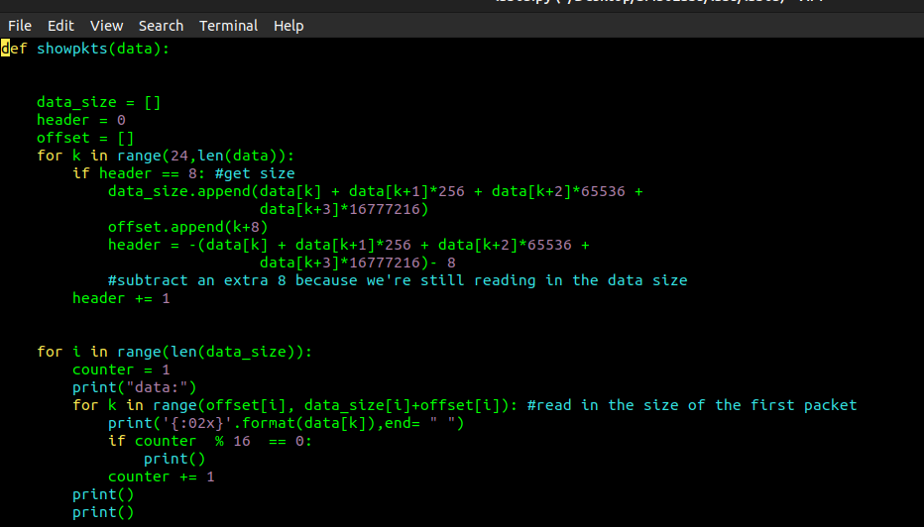
Part one works by using two for loops to traverse the length of the packet to read the byte information in the appropriate order. The first for loop starts at twenty four, because that ensures that we omit the global header, which is twenty four bytes long. From here, we get the size at the eight iteration of the loop with “header == 8”. Our second for loop is where we print out the data to the screen, whereas the first loop read and interpreted data.

Part 2
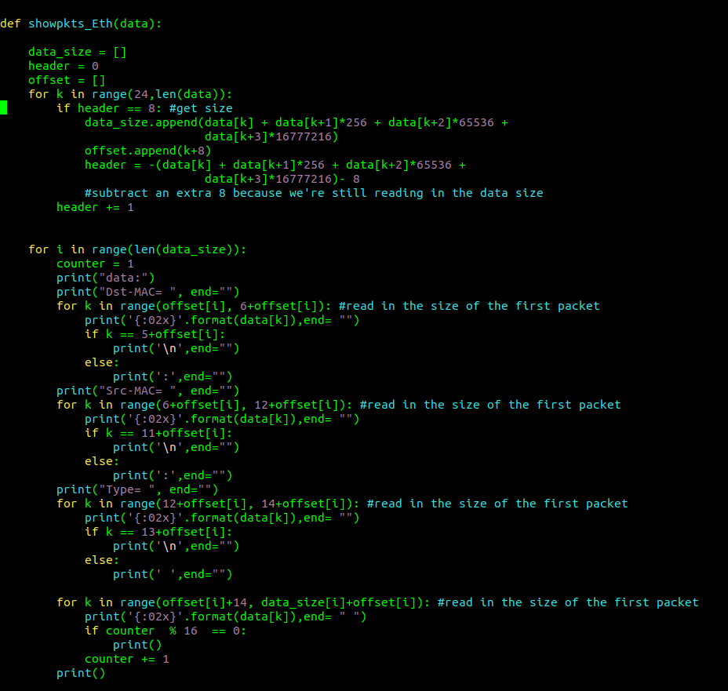

Part two works in a similar manner with one added feature of displaying the source and destination MAC address in the Ethernet frame. Since the program was largely the same, the only tweaks that were needed was in the interpretation of the data being read in the second for loop of the program, where we need to print out more information than part 1.

