

SI430: Lab xx --- Lab Title

Names: Brendan Lewis, Ian Coffey
Alphas: 263708, 261194
External source(s)
Class website to understand how to use bit ands and bit ors.
https://www.geeksforgeeks.org/python-int-function/
Honor
We wrote the code on my own except the help from the external source(s) listed above. Moreover, we didn’t copy any part of the code from other midshipmen.
Initials: BAL and IKC
Challenges
(e.g., it was difficult to figure out how to x)
It was tough trying to figure out formatting for both strings and ints in python.
What we learned and what was interesting to us
(Specify what you learned and what was interesting to you)
Python has a bevy of interesting and unique ways to modify data that I wasn't aware of before. I did not know that you could format strings in python to have a number be printed out in hex without having to convert the number outside of the print statement. Furthermore, we learned that literally everything is a library in python.

Part 1
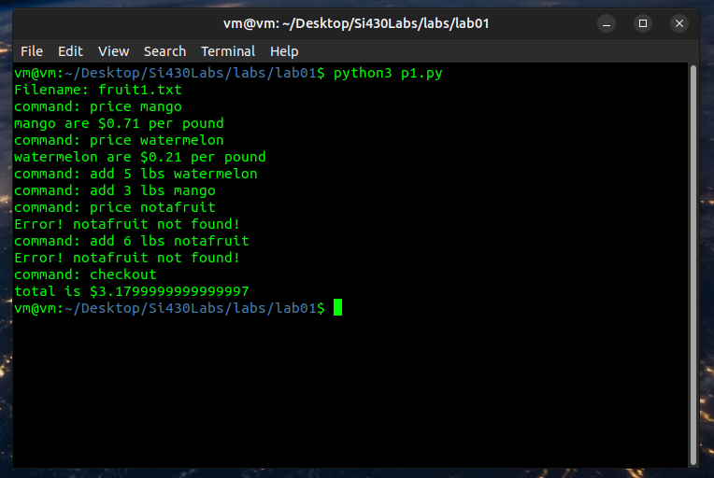
# Read & Open File
fName = str(input("Filename: "))
try:
file = open(fName, "r")
except OSError as e:
print("File not found!")
exit(1)
# Save Fruit Prices in Dict
fruitDict = {}
with open(fName, "r") as f:
for line in f:
parse = line.split()
fruitDict[parse[0]] = parse[1]
# Variable Declarations
total = 0.0
Here we use a simple while loop to keep the user entering commands until checkout. Using an inputed file, we read all of the file into a dictionary for easy lookup. From here it is trivial to do the math required to find out the cost of something, and to find the total for the user. The only thing that was difficult was the formatting of some strings and the syntax with regards to dictionaries
cmd = ""
# While Loop to Read Commands
while (cmd != "checkout"):
cmd = str(input("command: "))
parse = cmd.split()
# If User is adding an item
if (parse[0] == "add"):
numItem = float(parse[1])
item = parse[3]
# Check if item exists in Dict
if item in fruitDict.keys():
# Update Total
total = total + (numItem * float(fruitDict.get(item)))
else:
print("Error! " + item + " not found!")
# If User wants to check the price of an item
elif (parse[0] == "price"):
# Grab item from Dict
item = parse[1]
if item in fruitDict.keys():
print(item + " are $" + fruitDict.get(item) + " per pound")
else:
print("Error! " + item + " not found!")
# Calculate Total
print("total is $" + str(total))
exit(0)

Part 2
import sys
file = sys.argv[1]
with open(file, 'rb') as f:
data = f.read()
lower_val = 0
num_iters = len(data) #variable that figures out how far past data lenght the program needs to run so that it
#prints the correct number of double spaces to print the last text line (|****|)
while(num_iters % 16 == 0):
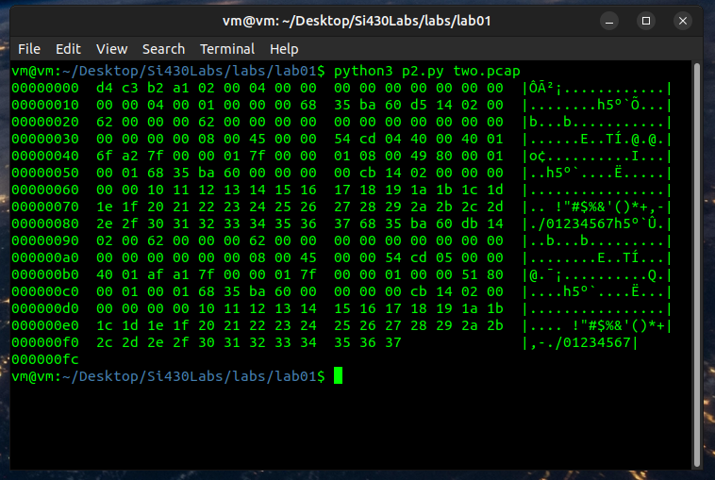
num_iters += 1
num_iters = int(num_iters/16)
counter = 0
for k in range(num_iters+1):
to_print = ""
bytes = data[k*16:(k+1)*16]
print('{:08x}'.format(k*16), end=' ') #print bytes read sofar
#print(k, " ", num_iters)
for i in range(0 + (k*16),16 + (k*16)):
if counter < len(data):
to_print += chr(data[counter])
counter += 1
#print(" | ")
if i >= len(data):
print(' ', end = ' ')
if i % 8 == 0 and (i % 16 == 8) or (i % 16 == 15):
print("", end=' ')
elif i % 8 == 0 and (i % 16 == 8) or (i % 16 == 15):
print('{:02x}'.format(data[i]), end=' ') #special print to print double
#space for formatting between
#bytes 8 and 9 of each 16 byte
#row
else:
print('{:02x}'.format(data[i]), end=' ')
print('|',end="")
for byte in to_print:
if(byte.isprintable()):
if byte == '\n': #check to see if the byte is = \n, this means
#that it read in a period as a newline,
#so change that \n into a . for printing
print('.',end="")
else:
print(byte, end="")
else:
print('.',end="")
print('|')

Part 3
def pr(a):
print(f"dec: {a:d}\nhex: 0x{a:02x}\nbin: {a:08b}")
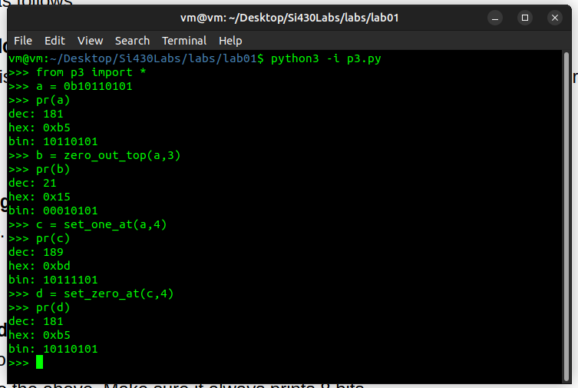
def zero_out_top(a,n):
d = int(n*'0' + (8-n)*'1',2)
a = a & d
return a
def set_zero_at(a,n):
de = int(n*'1'+ '0' + (8-n-1)*'1',2)
a = a & de
return a;
def set_one_at(a,n):
de = int(n*'0'+ '1' + (8-n-1)*'0',2)
a = a | de
return a;

Even though the prompt of part 3 can seem quite daunting, the reality is anything but. Simply using formatted strings to output hex and using basic bit operations, the desired outcome of each function can be achieved. For instance, pr is simply a formatted string to print out the different numeral representations of a given number. The second function creates a binary number where the index to change 0 at is a 1 and everything else is zero. So when an & operator is performed, only the specified index is changed. The same logic is applied but flip the ones and zeros for each other function. It is surprisingly simple.

