

SI430: Lab 02 --- Sockets

Names: Ian Coffey, Brendan Lewis
Alphas: 261194 263708

External source(s)
(“I referred to this site for x,” etc.)

Honor
We wrote the code on my own except the help from the external source(s) listed above. Moreover, we didn’t copy any part of the code from other midshipmen.
Initials: IKC and BAL
Challenges
It was difficult to learn the technical differences when implementing the python server between UDP and TCP
What we learned and what was interesting to us
Neither of us knew that you could run a website though python

Part 1
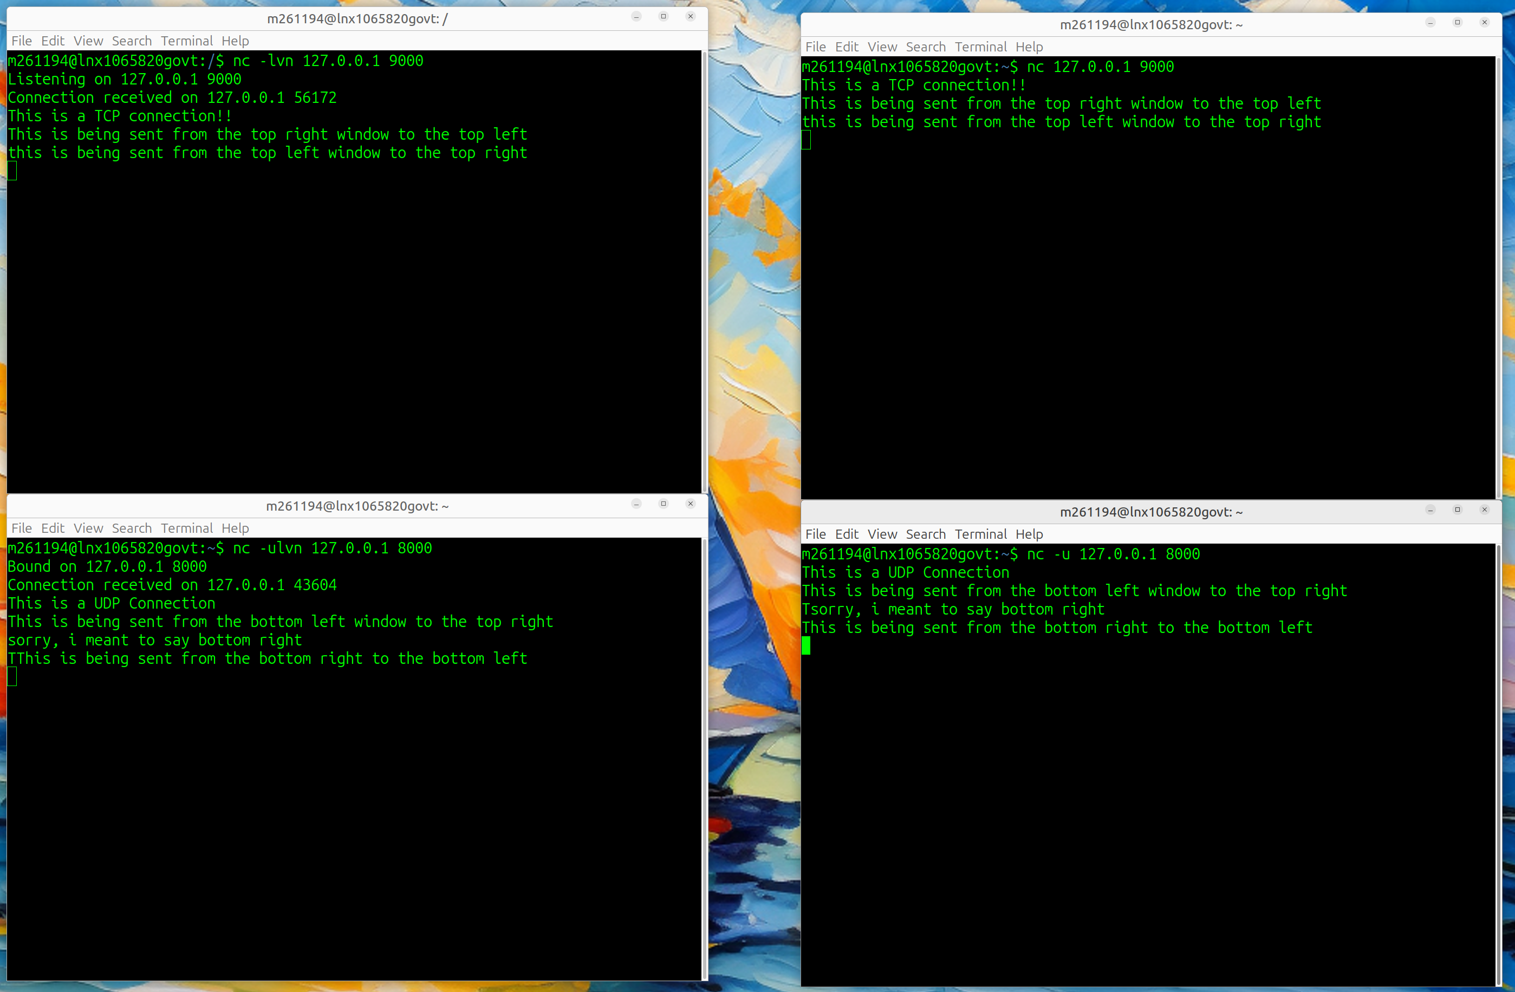
As we can see through the screenshots, the top two terminals demonstrate a TCP connection while the bottom two demonstrate a UDP connection. The commands needed to create this environment are virtually identical with only a ‘-u’ option being added for UDP to work correctly.

Part 2
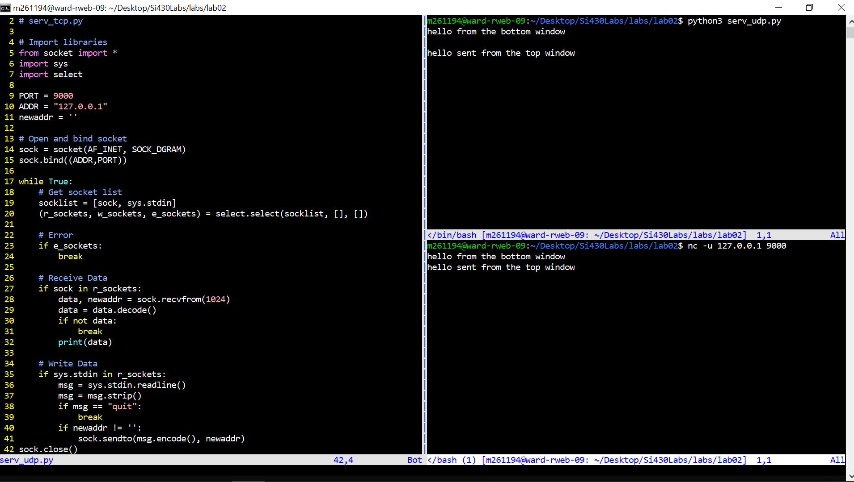
In this part, we had to re write a little bit of the given tcp_serv.py example. Given that we are now using UDP, we do not need a listen() or accept() within the code. However, we do still need to bind the socket with a given ip address and port number. Once this is done, we can then listen on the sockets for any input and output. Once input is detected, it will use stdin to read in the data and send it to the client. Any incoming data is alos read in through the r_sockets and are printed to the screen. A demonstration is shown on the right of the code, where there are two terminals communicating. The top terminal is running the python program while the bottom program is simply using netcat from communications over udp.

Part 3
Part 3 turned out to be far more simple than what we thought. It took less than 30 lines of code to make this work. Since we are given the address of the host we want to resolve in the args, we can use the gethostbyname() function to bind to a socket, and then once that is complete, we send a simple get request to the address and recv(4096) the incoming data to print out to the screen. While it is simple, it works just as needed.
