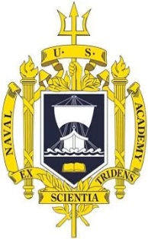

**SI430: Lab 02 --- Sockets**

Names: Ian Coffey, Brendan Lewis

Alphas: 261194 263708

External source(s)   
(“I referred to this site for x,” etc.)

Honor

We wrote the code on my own except the help from the external source(s) listed above. Moreover, we didn’t copy any part of the code from other midshipmen.

Initials: IKC and BAL

Challenges

(e.g., it was difficult to figure out how to x)

What we learned and what was interesting to us

(Specify what you learned and what was interesting to you)

# **Part 1**

(For each part of the lab, give your work -- attach code, screen captures, explanations and answers as necessary)