Bilgin AKSOY

2252286

Assignment-3

Image Processing Algorithms

Answer-1-b: Our filter computes the correlation between input and template images. Filter response shows the peaks which are most correlated to the template image.

Answer-2-b: The peaks and minimals show the intensity changes. Natural images has strong correlations so intensity changes shows the edges.

Answer-2-c: The second filter’s weight are different, using 8 neighborhood and cause ticker edges than the first one.

Answer-2-d: The first filter computes the derivates thorough X-axis. However, the second filter computes the derivative thorough Y-axis. For better result I combined two filtered images into another to be able to see two axis edges.

Answer-2-e: Yes, The laplacian filter computes a second order derivative of the input image.

Answer-3-d:

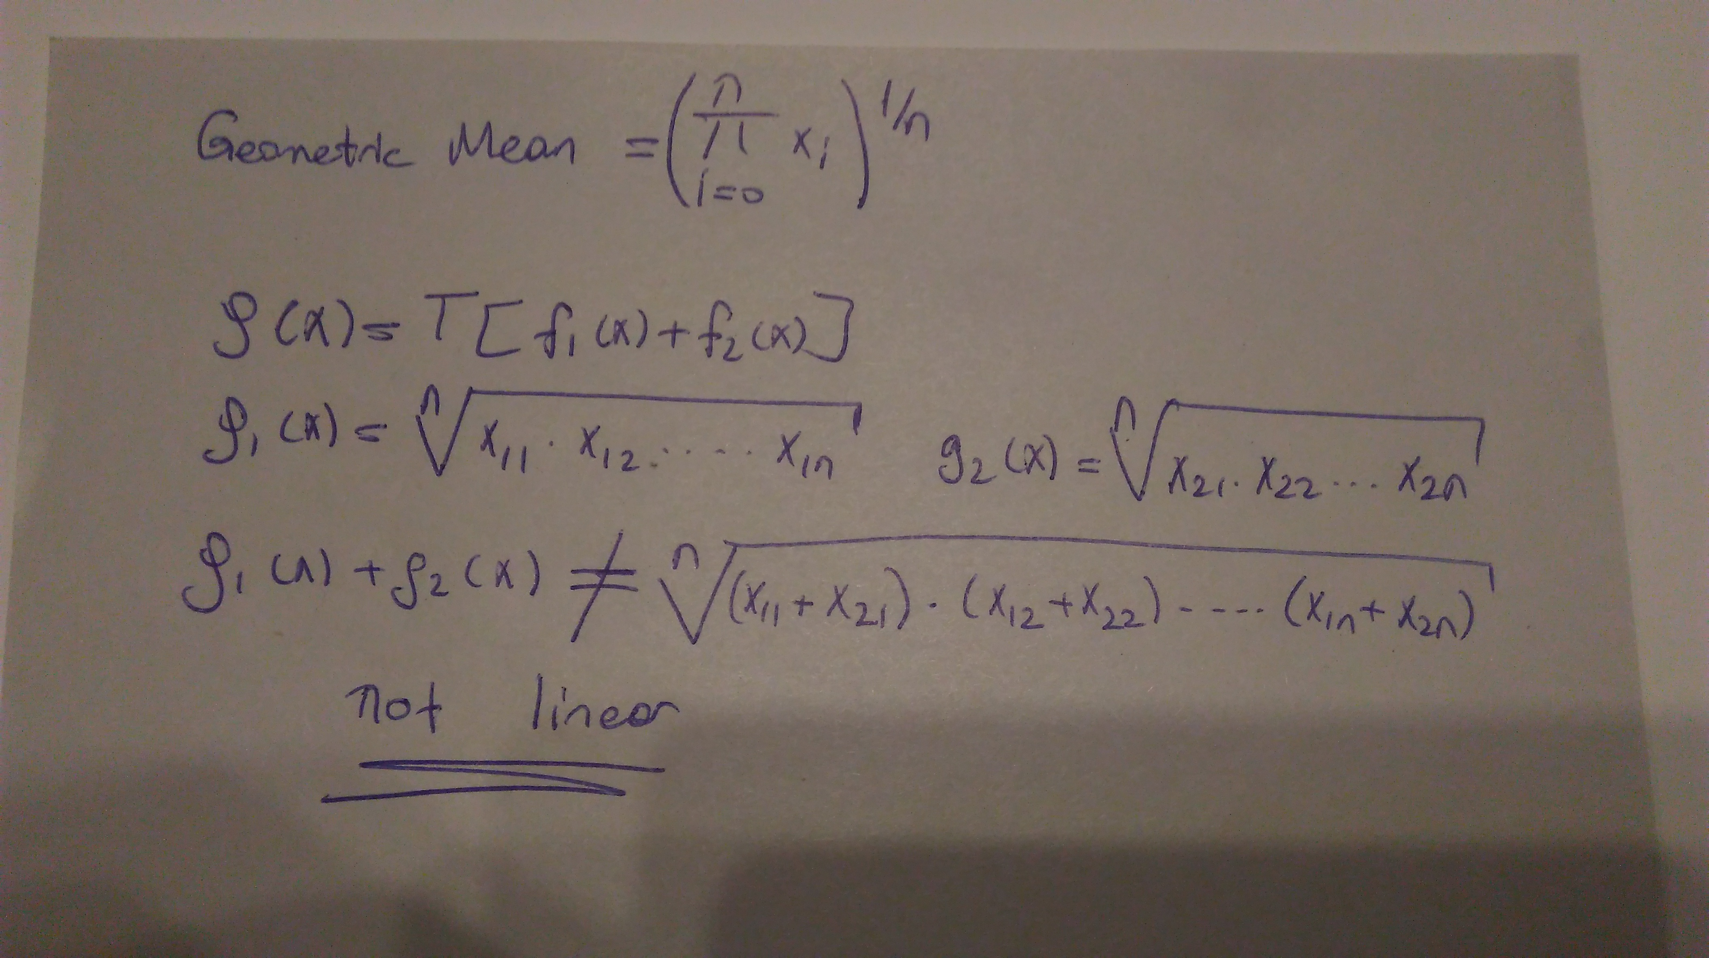

Answer-4-a:

**Cosine Filter**  f(x)=Cos()

W > changes the width of one cycle

f> changes frequency

**Disk Filter** f(x,y)=x2+y2, Where x2+y2<=W2

W> changes the diameter

**Ideal Filter**  f(x)=1

**Tangent Filter** f(x)=Tan()

W > changes the width of one cycle

f> changes frequency

**Gaussian Filter** f(x)=

σ > changes the width

µ > raises the initial point

Answer-4-b: My filter can only detect roads along Y-axis. It suffered from the noise.