Following the initial descriptive analysis, this study further refines its empirical strategy by conducting a series of regression analyses. The analysis proceeds in four stages:

(1) an overall regression using the full sample,
(2) regressions stratified by legal age of marriage,
(3) regressions incorporating Comprehensive Sexuality Education (CSE) as a control variable, and
(4) region-specific regressions focusing on Africa and Asia.

- 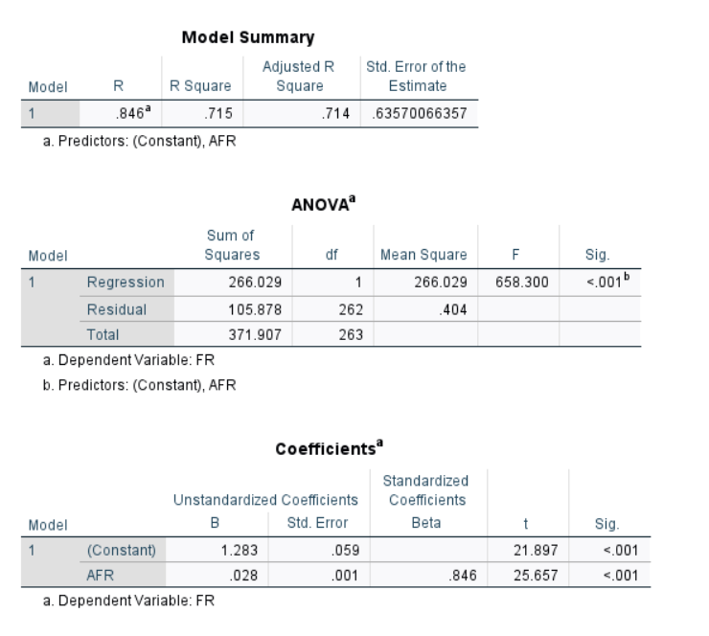
The overall regression analysis reveals a strong positive correlation between the adolescent fertility rate (AFR) and the total fertility rate (FR). The Pearson correlation coefficient (R) is 0.846, indicating a strong linear relationship between the two variables. The coefficient of determination (R²) is 0.715 (adjusted R² = 0.714), suggesting that approximately 71.5% of the variation in total fertility rates across countries can be explained by differences in adolescent fertility rates, with the model showing good explanatory power even after adjustment for the number of predictors.
The regression model is highly statistically significant overall, as indicated by the ANOVA results (F(1, 262) = 658.300, p < 0.001), confirming that the relationship is highly unlikely to be due to random chance and providing robust support for the study’s primary hypothesis.
Examination of the unstandardized and standardized coefficients shows that adolescent fertility rate is a significant positive predictor of total fertility rate. The unstandardized coefficient (B) for AFR is 0.028 (SE = 0.001), meaning that for each additional birth per 1,000 women aged 15–19, the total fertility rate increases by approximately 0.028 children per woman, holding other factors constant. The standardized coefficient (Beta) of 0.846 reflects the strong relative importance of AFR in explaining variation in FR. Both the constant term (B = 1.283, SE = 0.059, t = 21.897, p < 0.001) and the AFR predictor (t = 25.657, p < 0.001) are statistically significant at the 0.001 level, further confirming the reliability and strength of the observed association.

- hIGH
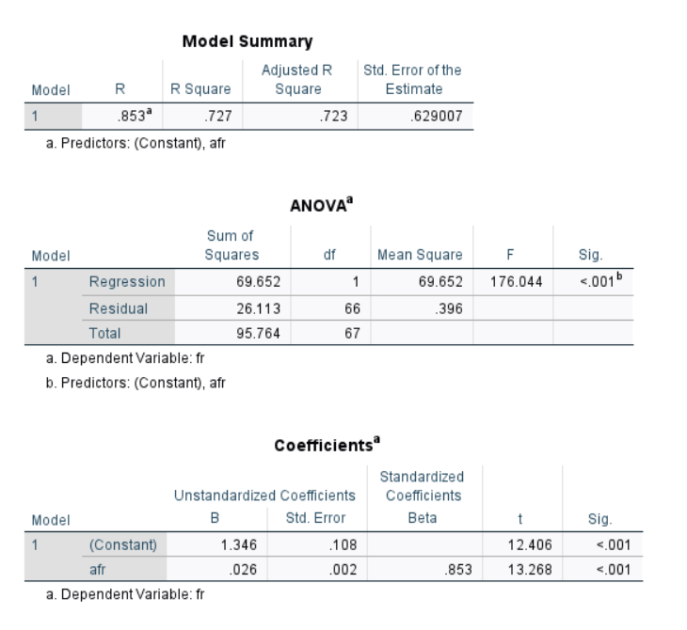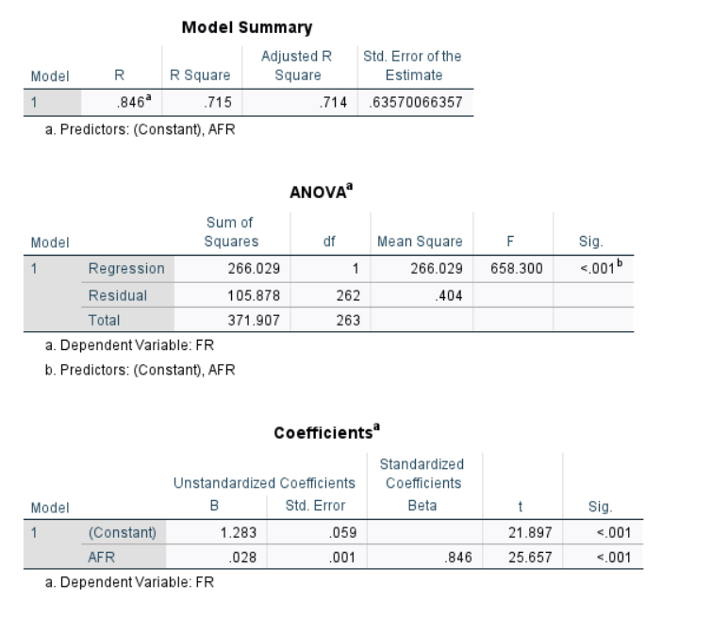
lOWER
To further examine the role of institutional factors, the sample was divided into two groups based on the minimum legal age of marriage for females without parental consent. Countries with a legal marriage age of 17 years or above were classified as the “higher-age group,” while those with a legal age below 17 were classified as the “lower-age group.” This stratification allows assessment of whether the strength of the association between adolescent fertility rate (AFR) and total fertility rate (FR) varies systematically with institutional permissiveness toward early marriage.
Separate simple linear regression models were estimated for each subgroup. In the higher-age group, a strong positive correlation persists, with R = 0.825, indicating a robust linear relationship between AFR and FR. The coefficient of determination (R²) implies that approximately 68.1% of the variation in total fertility rates within this group is explained by adolescent fertility rates (adjusted R² ≈ 0.679, depending on exact sample size). The relationship remains highly statistically significant (p < 0.001 overall).
In the lower-age group, the association is even stronger, with R = 0.853 and R² = 0.727 (adjusted R² = 0.723). This suggests that roughly 72.7% of the variation in total fertility rates among countries permitting earlier marriage without parental consent can be accounted for by differences in adolescent fertility rates. The unstandardized coefficient (B) for AFR in this subgroup is 0.026 (SE = 0.002), indicating that each additional birth per 1,000 women aged 15–19 is associated with an increase of approximately 0.026 children in the total fertility rate. The standardized coefficient (Beta) of 0.853 underscores the dominant role of AFR in this context. The predictor is highly significant (t = 13.268, p < 0.001), as is the overall model (F(1, 66) = 176.044, p < 0.001).
These subgroup findings suggest that in institutional environments where early marriage is legally facilitated (lower-age group), adolescent childbearing contributes more substantially to overall fertility outcomes compared to settings with higher legal marriage thresholds. The stronger correlation and higher explained variance in the lower-age group align with the theoretical expectation that legitimized early union increases the likelihood that adolescent pregnancies translate into completed fertility. This pattern provides preliminary evidence that legal marriage age may moderate the relationship between adolescent and total fertility, warranting inclusion of this variable (and potentially interaction terms) in subsequent multivariate models.
- 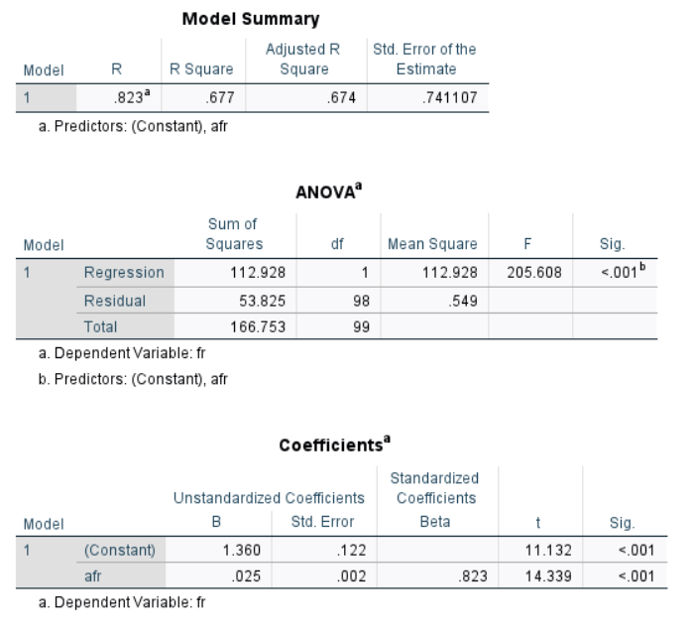
When Comprehensive Sexuality Education (CSE) participation is introduced as a control variable in a multiple regression model, the overall explanatory power of adolescent fertility rate (AFR) in predicting total fertility rate (FR) decreases modestly compared to the bivariate and stratified models. The multiple correlation coefficient (R) is 0.823, with a coefficient of determination (R²) of 0.677 (adjusted R² = 0.674). This indicates that approximately 67.7% of the variation in total fertility rates across countries is explained by the model including AFR and CSE, after adjustment for the number of predictors. The standard error of the estimate is 0.741, reflecting reasonable predictive precision.
The overall model remains highly statistically significant (F(1, 98) = 205.608, p < 0.001), confirming the robustness of the association. Examination of the coefficients shows that AFR continues to be a strong and significant positive predictor, with an unstandardized coefficient (B) of 0.025 (SE = 0.002), meaning that each additional birth per 1,000 women aged 15–19 is associated with an increase of approximately 0.025 children in the total fertility rate, holding CSE participation constant. The standardized coefficient (Beta) of 0.823 highlights the dominant contribution of AFR relative to the control variable. The AFR predictor is highly significant (t = 14.339, p < 0.001).
Notably, the R² value of 0.677 in this controlled model is lower than the explanatory power observed in the regressions stratified by legal marriage age—particularly the lower-age group (R² = 0.727) and even slightly below the higher-age group (R² ≈ 0.681, derived from R = 0.825). This reduction suggests that, within the scope of this cross-sectional analysis, the presence or absence of WHO-promoted Comprehensive Sexuality Education exerts a relatively limited confounding or moderating influence on the core relationship between adolescent and total fertility compared to institutional factors such as the legal age of marriage. While CSE initiatives are designed to enhance sexual health knowledge, reduce risky behaviors, and mitigate non-consensual pregnancies, the findings imply that such educational interventions may have less pronounced effects on aggregate national fertility patterns than structural-legal frameworks that shape the social legitimacy and timing of reproduction.
These results reinforce the importance of prioritizing institutional controls (e.g., legal marriage age) in demographic fertility models and support the study’s rationale for focusing on variables more directly tied to reproductive intent and societal norms. Future analyses could explore interaction effects between CSE and AFR or incorporate additional socioeconomic controls to further disentangle these dynamics.
- 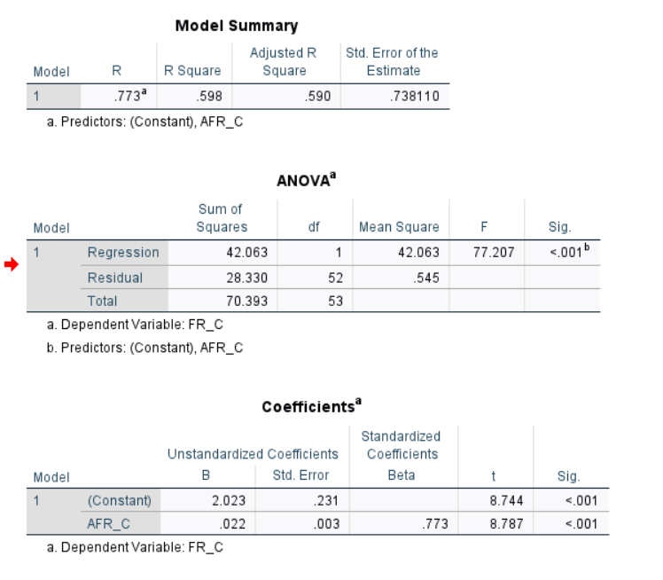
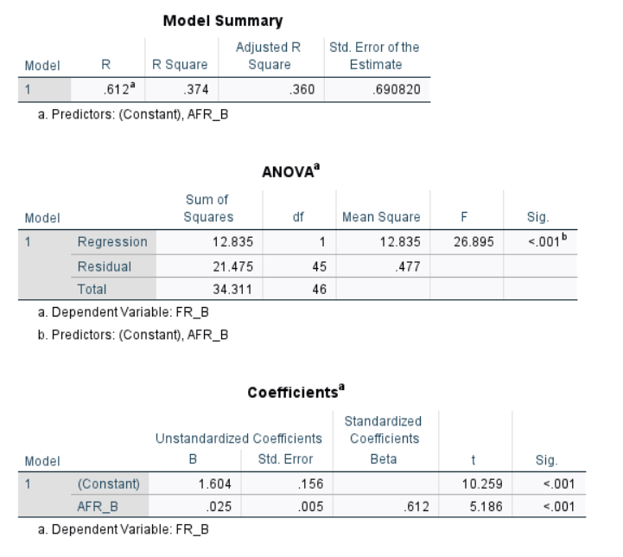
Finally, to explore potential regional heterogeneity, separate simple linear regression models were estimated for African and Asian countries, allowing examination of whether the relationship between adolescent fertility rate (AFR) and total fertility rate (FR) varies systematically across these continents.
In Asia, the association is relatively moderate, with a Pearson correlation coefficient (R) of 0.612 and a coefficient of determination (R²) of 0.374 (adjusted R² = 0.360). This indicates that approximately 37.4% of the variation in total fertility rates among Asian countries is explained by differences in adolescent fertility rates. The unstandardized coefficient (B) for AFR is 0.025 (SE = 0.005), suggesting that each additional birth per 1,000 women aged 15–19 is associated with an increase of about 0.025 children in the total fertility rate. The standardized coefficient (Beta) of 0.612 reflects a moderate but significant effect. The overall model is statistically significant (F(1, 45) = 26.895, p < 0.001), as is the AFR predictor (t = 5.186, p < 0.001).
In contrast, African countries exhibit a substantially stronger relationship, with R = 0.773 and R² = 0.598 (adjusted R² = 0.590). Here, roughly 59.8% of the variation in total fertility rates is accounted for by adolescent fertility rates—considerably higher explanatory power than in Asia. The unstandardized coefficient (B) is 0.022 (SE = 0.003), indicating a similar per-unit effect size to Asia but within a context of much stronger overall association. The standardized coefficient (Beta) of 0.773 underscores the dominant role of AFR in this region. The model is highly significant (F(1, 52) = 77.207, p < 0.001), with the AFR predictor also highly significant (t = 8.787, p < 0.001).
These regional differences highlight meaningful heterogeneity in the demographic role of adolescent fertility. In Asia, the weaker correlation and lower explained variance likely stem from greater diversity in cultural norms, policy environments (including strict historical family planning measures in some countries), socioeconomic development trajectories, and institutional frameworks surrounding marriage and reproduction. This variability introduces substantial noise into the bivariate relationship, reducing the linear predictive power of AFR alone. In Africa, where high adolescent fertility often occurs within contexts of earlier marriage, limited access to contraception, and cultural norms that more consistently link early reproduction to completed family size, the relationship appears more direct and robust.
Overall, these findings suggest that regional patterns in the correlation between adolescent and total fertility are driven less by geography per se and more by the underlying degree of cultural, institutional, and normative homogeneity (or divergence) within each continent. The stronger association in Africa aligns with the observation that adolescent childbearing contributes more substantially to overall fertility in high-fertility settings, whereas Asia's greater institutional and behavioral diversity dilutes this link. These results reinforce the importance of context-specific factors in demographic modeling and support the inclusion of regional dummies or interaction terms in future multivariable analyses to better capture such heterogeneity.

