Brian Huynh, Jessie Wilson

BME 515

04 DEC 2014

**Final Report**

***Introduction***

This investigation will answer the following question: is it possible for the parameters for transcutaneous trigeminal nerve stimulation as used by NeuroSigma to elicit an action potential in the infraorbital branch of the trigeminal nerve? Eliciting an action potential in the trigeminal nerve will serve as a proxy for locus coeruleus stimulation, which has an antikindling effect on epileptic seizures.[1]

***Background***

The Monarch external Trigeminal Nerve Stimulation (eTNS) device claims to provide an effective and safe alternative to pharmaceutical treatments for epilepsy. Vagal nerve stimulation (VNS) is one approach that has been a successful alternative to anti-epileptic drugs (AEDs); it involves stimulation of both the locus coeruleus (LC) and the solitary nucleus (NTS), which both have projections to the trigeminal nucleus, and stimulation of these regions has antikindling effects.[2] [3] Similarly, the Monarch eTNS device stimulates the LC and NTS by stimulating the infraorbital branch of the trigeminal nerve (location shown in Figure A of the Appendix). The device can be applied unilaterally or bilaterally to either the infraorbital or supraorbital tracts of the trigeminal nerve, allowing for customized and more effective stimulation.[4] [5] The antiepileptic effects of either mode of trigeminal nerve stimulation (TNS) have been demonstrated in a rodent model and in preliminary clinical trials.[6] Therefore, transcutaneous stimulation of the trigeminal nerve could provide a non-invasive and reversible method for electrical stimulation for drug-resistant epilepsy.

In clinical and feasibility trials, transcutaneous TNS was powered by a battery-powered neurostimulator at 120 Hz for 20-30 seconds on and 20-30 seconds off. An asymmetrical biphasic square wave pulse between 0 to 100 mAs was delivered across 1.25-inch disposable adhesive electrodes.[7] The positive electrode was positioned above the infraorbital foramen and the negative electrode ½ to 1 inch posteriorly, above the nasal-labial fold.[8] TNS in the rat model has indicated that seizure reduction is associated with increasing current levels likely due to increased fiber activation in the infraorbital branch of the trigeminal nerve.[9] Clinical stimulation of < 8 mA (device settings of 0 or 1) has reported no sensation while stimulation at 8-25 mA (device settings of 2 to 4) has been reported as comfortable, with no induced muscle contractions. Higher current stimulation amplitudes resulted in facial twitching and mild sensations in the mouth or teeth. The pilot study reported a reduction in seizures at six months in two patients of 39% and 76%, respectively,[10] and the an average reduction of 43.7% in seizure frequency at last treatment visit (at either 3 or 6 months) across seven patients.[11] While this was an “open-label study” in the authors’ own words, and therefore susceptible to placebo effects, this proof of concept trial nonetheless indicates that there is some merit to further investigation of TNS for epilepsy.[12]

***Methods***

A computational model was designed to model the function of this device and judge its efficacy. The model is visualized in the block diagram shown in Figure 1.

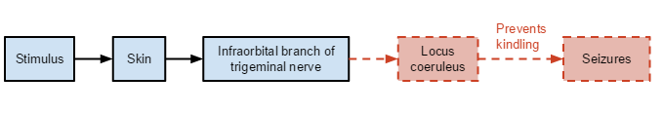

**Figure 1.** Red figures indicate important assumptions and proxies in the model. Blue figures indicate actual modeled components. Arrows denote the flow of stimulation.

The model concerns the transmission of the stimulus through the skin to the trigeminal nerve. The distinguishing feature of this device is its transcutaneous method of stimulation, as opposed to direct stimulation of nerves as in an implant, and so transcutaneous conduction constitutes a major focus of quantitative evaluation in this model. It is assumed that an action potential, once induced in the infraorbital branch of the trigeminal nerve, will be conducted to the terminus of the trigeminal nerve in the brain stem, stimulating the locus coeruleus to produce an antikindling effect on epileptic seizures.[13] In essence, if stimulation of the locus coeruleus is possible by means of the trigeminal nerve, then it will be assumed that epileptic activity will be inhibited.[14] The physical properties and geometry of the trigeminal nerve and the locus ceruleus are incredibly complex, and so such simplifying assumptions must be made.

The model makes several structural assumptions. First, the electrode is modeled as a circular disk 1.25 inches in diameter, in accordance with the dimensions given in the clinical feasibility trial by DeGeorgio.[15] Additionally, it is assumed that tissues are layered as shown in Figure 2, with the skin and fat having a single lumped conductivity, σ.

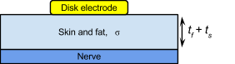

**Figure 2.** Configuration of tissue layers and electrode in model.

This σ is calculated as the weighted average of the resistivity of the skin and fat, weighted according to their thicknesses: $σ=\frac{1}{ρ_{lumped}}$ where $ρ_{lumped}=\frac{t_{f}}{t_{f}+t_{s}}ρ_{f}+\frac{t_{s}}{t_{f}+t_{s}}ρ_{s}$. Values for these parameters are summarized in Table I below.

**Table I.** Summary of parameter values used in model, with sources.

|  |  |  |
| --- | --- | --- |
| **Parameter** | **Variable** | **Value** |
| Skin thickness | ts | 2.25 mm [16] |
| Fat thickness | tf | 18 mm [17] |
| Skin resistivity | ρs | Standard value of 1000 Ω*m [18] |
| Fat resistivity | ρf | 27.33 Ω*m [19] |
| Lumped resistivity (calculated) | ρlumped | 135.404 Ω*m |
| Lumped conductivity (calculated) | σ | 0.007385 S/m |

This calculation takes into account both tissue types in a manner proportional to their thickness, and models a voltage divider; effectively, the two tissues are treated as two successive resistors. The electrode-skin interface and bulk tissue capacitances were ignored due to minor effects on activation,[20] and both tissues are assumed to be homogeneous and isotropic. This is a reasonable assumption to make because skin and fat have no structures that would cause anisotropy, unlike in muscle tissue where the fibrous structure causes faster propagation in one direction relative to another. Similar assumptions are also found in several existing models.[21]

Conduction of the stimulus through the layers as depicted in Figure 2 will be accomplished by calculating the potential at a point within a semi-infinite homogeneous medium of conductivity σ according to a method outlined in a study by Wiley and Webster.[22] For known current values from the device (ranging 0 - 25 mA, where the latter is the threshold of painful stimulation)[23], the following are calculated:

Current density as a function of current applied by electrode: $J_{0}=\frac{I_{0}}{πa^{2}}$

Voltage at electrode as a function of radius along electrode: $V_{0}\left(r\right)=\frac{π*J_{0}*\sqrt{a^{2}-r^{2}}}{2σ}$

Voltage at a point within the medium: $V\left(r,z\right)=\frac{2*V_{0}}{π}*\sin^{-1}\left(\frac{2a}{\sqrt{{\left(r-a\right)}^{2}+z^{2}}+\sqrt{{\left(r+a\right)}^{2}+z^{2}}}\right)$

Variable *a* represents the radius of the electrode (here, a constant 0.625 inches, or 1.5875 cm), *z* represents depth in the medium (essentially a y-coordinate), and *r* represents the coordinate along the dimension parallel to the electrode (essentially an x-coordinate). Figure 3 below (from the original paper by Wiley and Webster) visualizes these variables used above.

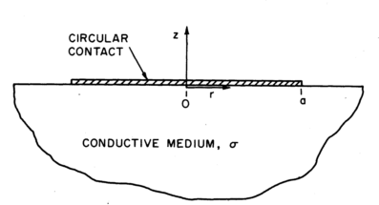

**Figure 3.** Wiley and Webster variable assignment for calculating the potential at a point within a semi-infinite homogeneous medium.

This model allows calculation of voltage as a function of depth in the tissue across the skin and fat layers as the stimulus is conducted to the nerve. In executing this model, however, it can be assumed that z is a constant value equal to the combined thickness of the skin and fat (*ts+tf*) as this is the assumed location of the nerve.

The maximum strength of the stimulation current applied by the device is limited by the patient’s pain tolerance. As mentioned earlier, stimulation above 25 mA was perceived as uncomfortable, so that will remain an upper limit for stimulation in this model.[24] The efficacy of the device can be refuted if no action potential can be generated at this stimulus intensity: stimulation above this threshold will be uncomfortable for the patient, and it is unlikely that a patient would continue use of the device if it is exceedingly uncomfortable to use.

The final part of the model includes application of the conducted stimulus to a simulated nerve bundle. The extracellular potentials along a single axon in a conducting, homogeneous, isotropic, semi-infinite volume were generated in MATLAB (version R2014a) using equations listed above. [25] A multi-compartment double cable model of a mammalian axon (the MRG model) was modeled in NEURON (version 7.1) to represent a C-fiber in the infraorbital branch of the trigeminal nerve.[26] A current-regulated charge-balanced rectangular asymmetrical waveform at 120 Hz and 200 μs was delivered above the central node of Ranvier. A recording electrode was placed at the effective end nodes (second to last nodes since the last nodes were set as passive) and checked for a propagating action potential. A 1 μm fiber with interpolated segment lengths was implemented and solved using Euler integration with a time step of 0.05 ms for 50 ms. Based on published values of C-fiber diameters, the model will determine if the stimulus produces an action potential: if it does, then it is assumed that the device is feasible.[27] C-fibers are chosen to model the infraorbital branch of the trigeminal nerve because these are both types of sensory fibers in the somatosensory system with similar properties and small diameters.[28]

In summary, the quantitative model of this device tests whether the device settings cited by NeuroSigma are below the pain threshold of 25 mA and can elicit action potentials in the trigeminal nerve from stimulation of the infraorbital branch of the trigeminal nerve. Elicited action potentials will be a proxy for locus coeruleus stimulation, which has been found to have an antikindling effect on epileptic seizures.[29]

***Results***

The plot of potentials in the skin-fat medium based on the Wiley and Webster formulas is shown in Figure 4.

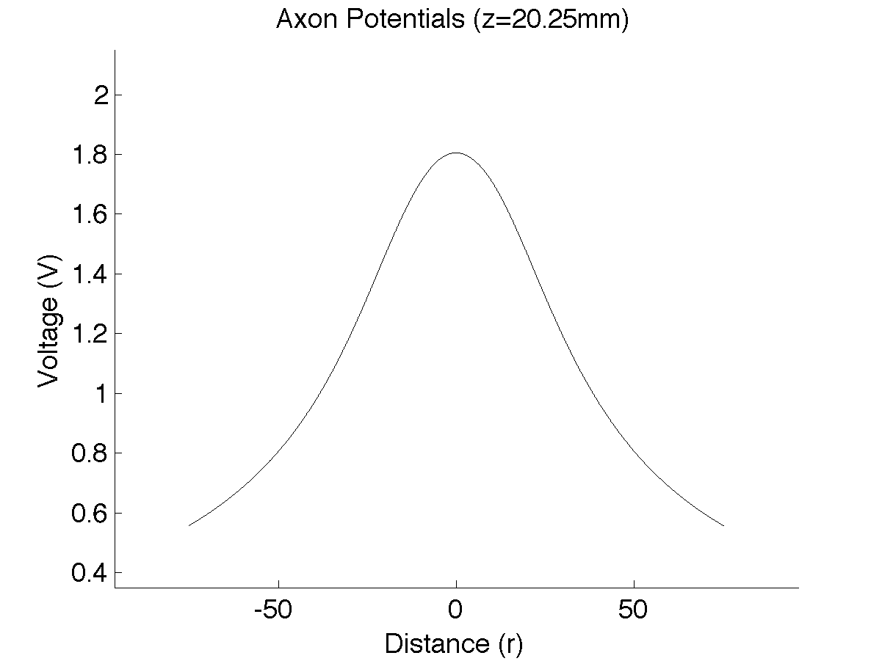

**Figure 4.** Potentials on electrode surface and at a depth of 20.25 cm in the skin-fat tissue.

This indicates that the region of highest potential lies directly below the center of the disk electrode, which makes sense intuitively. From these potentials at z = 20.25 cm (the depth at which the nerve is located in the tissue), the activating function of the neuron was calculated with the formula $f\left(x\right)=\frac{δ^{2}}{δx}V_{e}(x)$ to yield the plot shown in Figure 5.

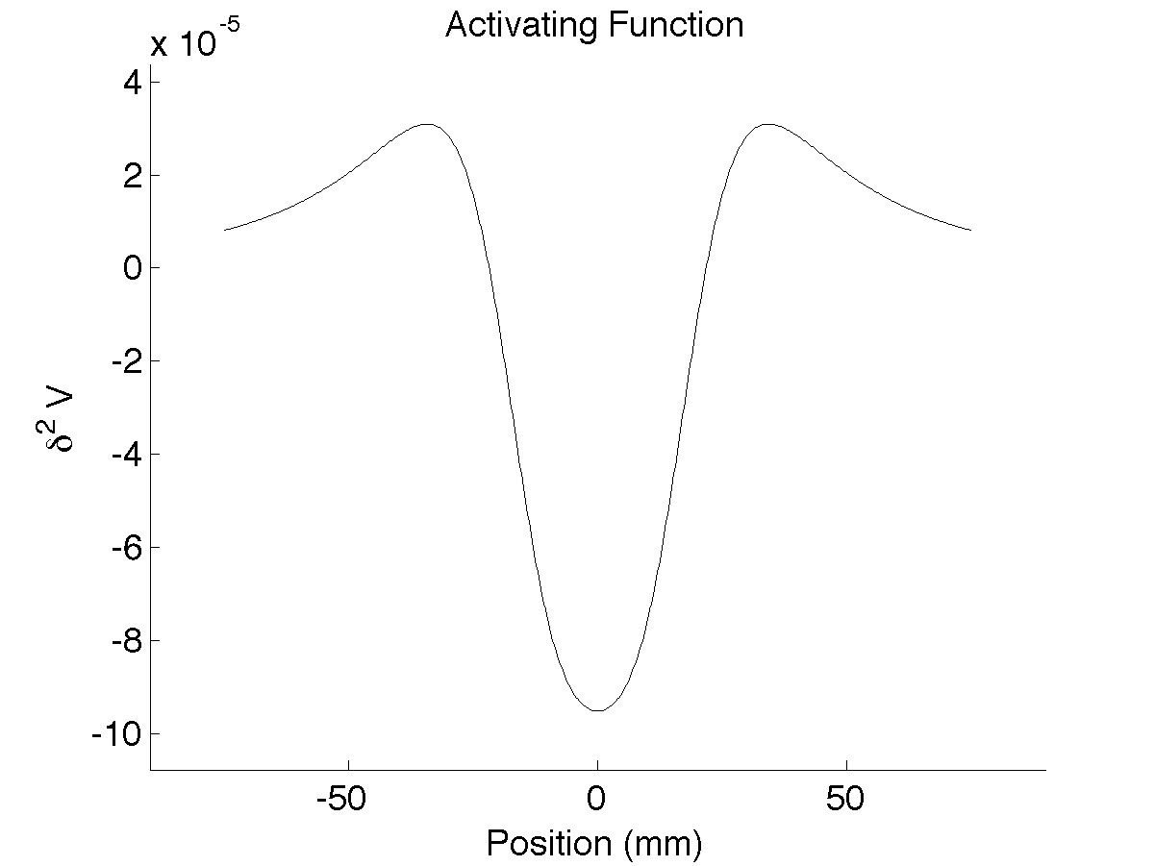

**Figure 5.** Activating function (anodic stimulation).

The activating function was used to verify that cathodic stimulation would yield a lower activation threshold than anodic stimulation. The depolarizing main lobe in cathodic stimulation is approximately three times larger than the depolarizing side lobes in anodic stimulation.

Using the potentials plotted in Figure 4, the response shown in Figure 6 was achieved for a stimulation current of 15 mA, a value 60% of the pain threshold of 25 mA.

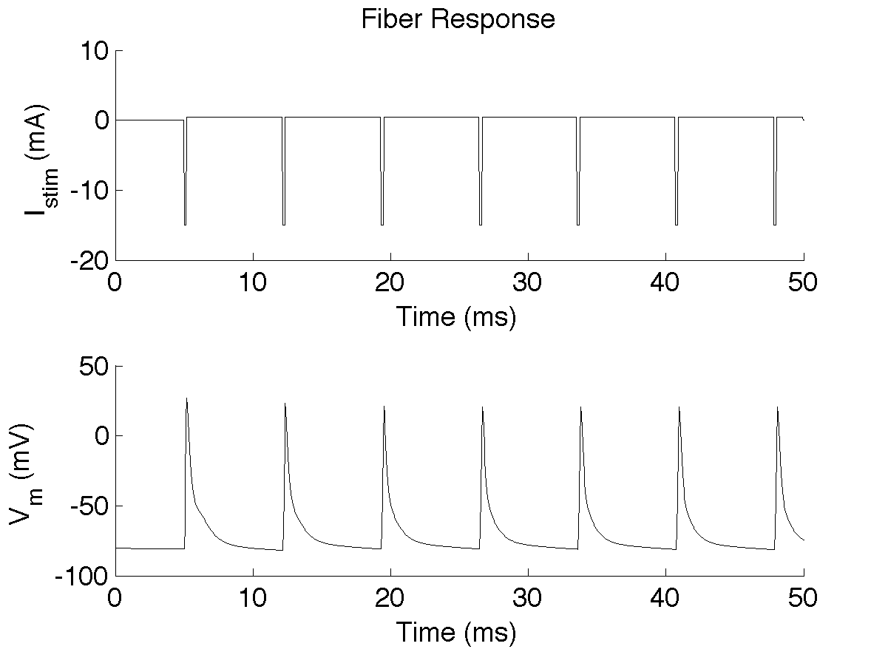

**Figure 6.** Stimulation current train and neuron response for cathodic stimulation at 15mA.

Some lower values of stimulation also generated a response in the neuron: using 1.83mA cathodic stimulation generates a single action potential, but no response was elicited for stimulation below that threshold. Similarly, stimulation of 2.15 mA generates two action potentials, and 2.24 mA generates three action potentials, and more action potentials are generated as stimulation increases. This phenomenon is shown in Figure 7.

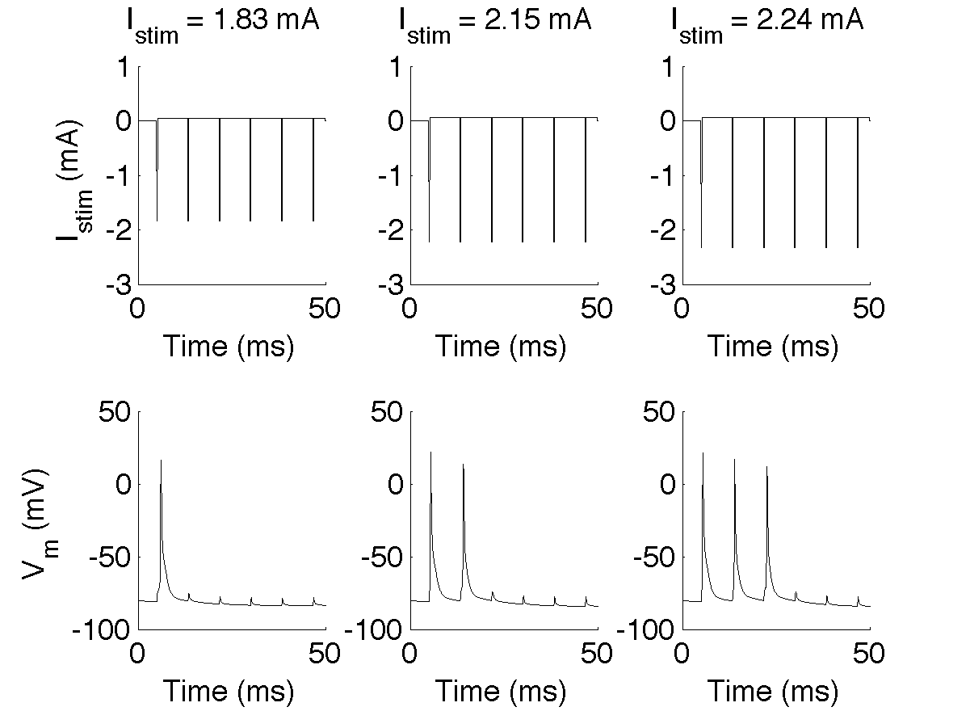

**Figure 7.** Increasing numbers of action potentials with increasing stimulation.

***Discussion***

Based on the response shown in Figure 6, the device appears to satisfy the conditions established for efficacy in this model. The stimulus is conducted through the skin and elicits an action potential in the modeled at values below the pain threshold. An action potential in the modeled nerve represents an action potential in the trigeminal nerve, which will be conducted to the locus coeruleus. As discussed previously, stimulation of this structure has an antikindling effect on seizures.[30] From this, it can be said that this device is capable of contributing to some reduction in seizures. However, the model is limited in quantitatively determining the effects of such results.

A monopolar disc was used as a simplifying model of the bipolar stimulation setup used by DeGiorgio and colleagues. However, although both electrode setups would have generated similar activation thresholds, bipolar setups generally have higher sensory and pain thresholds that would allow for higher stimulation amplitude ranges and hopefully a higher percentage of infraorbital nerve activation across populations. [31]

The stimulation waveform used in this model was a shortened version of that used by DeGiorgio and colleagues: their investigation used a 120 Hz, < 250 μs asymmetric biphasic wave applied for ≤ 30s and off for 30s. Comparatively, a 120 Hz, 200 μs asymmetric biphasic rectangular wave was used in this model to simulate stimulation for 50 ms was implemented for simplification and decreased computational time.

An approximation of the lumped conductivity was used in order to account for both the geometric and electrical properties of the skin and fat. However, a multi-layer finite element method volume conductor model would likely provide a more accurate solution of the extracellular potentials across a single fiber from a circular transcutaneous electrode. Furthermore, a FEM model would also allow for ease of computation in characterizing the response of the trigeminal nerve as a whole, represented as several bundles of fascicles with statistically distributed populations of axon diameters and nonlinear geometries instead of approximated as a single, straight axon with a fixed diameter.

Unfortunately, few patients have participated in the clinical studies for infraorbital nerve stimulation for epilepsy. More recent clinical studies have focused on stimulation of the supraorbital nerve due to the awkward and prominent positioning of the electrodes on the face while supraorbital stimulation of the ophthalmic nerve (across the forehead) can be much more easily concealed in daily activities.

***Conclusions***

According to the model established in this investigation, the device is effective and supported by a biophysical model.However, it is recommended that Johnson & Johnson should *not* invest in this company. Despite the niche market, lack of significant competitors, and significant cost and barriers to entry, there is little potential for return on investment due to lack of consumer appeal to this product. The prominence of infraorbital electrodes on the face “proved awkward” for patients in clinical trials, and many prefered the easy-to-conceal supraorbital electrodes.[32] Therefore, while the device may work, not enough people will want to buy it for this to be anything but a liability for NeuroSigma.

Most recently, as of October 21, 2014, NeuroSigma has been issued a Notice of Allowance for a U.S. Patent Application for commercialization of the non-invasive Monarch eTNS system. NeuroSigma has an exclusive license with UCLA and the Regents of the University of California for this patent application.[33] NeuroSigma had planned to schedule a $50MM IPO on the NASDAQ under the symbol NSIG on October 9, 2014, but was postponed, citing poor market conditions.[34] NeuroSigma is currently seeking FDA approval for the Monarch eTNS, which is currently limited to investigational use, and faces competition from Cyberonics (FDA approved VNS therapy for epilepsy) and NeuroPace (closed-loop Responsive Neurostimulation System).[35] [36] NeuroSigma is in a good position for growth, but this device is not its ideal catalyst.

***Appendix***

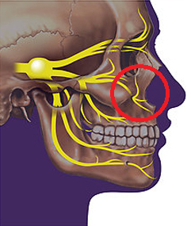

**Figure A.** Location of infraorbital branch of trigeminal nerve (circled in red), the target of the device’s stimulation. From “Trigeminal Neuralgia,” Bethesda TMJ.[37]

**References**

Baruchin, Aliyah. "Implantable Devices Could Detect and Halt Epileptic Seizures." Scientific American Global RSS, 3 July 2012. Web. 06 Nov. 2014. <http://www.scientificamerican.com/article/implant-epilepsy-seizure/>.

Bugge H, Negaard A, Skeie L, Bergersen B. Hyaluronic acid treatment of facial fat atrophy in HIV-positive patients. HIV Med. 2007;8(8):475-82.

Collins, WF, FE Nulsen, and CT Randt. 1960. “Relation of Peripheral Nerve Fiber Size and Sensation in Man.” Archives of Neurology 3 (4): 381–85. http://archneur.ama-assn.org/cgi/content/summary/3/4/381.

DeGiorgio, C. M., Shewmon, D. A., & Whitehurst, T. (2003). Trigeminal nerve stimulation for epilepsy. *Neurology*, *61*(3), 421–422. doi:10.1212/01.WNL.0000073982.42650.57

DeGiorgio, C. M., Shewmon, A., Murray, D., & Whitehurst, T. (2006). Pilot Study of Trigeminal Nerve Stimulation (TNS) for Epilepsy: A Proof-of-Concept Trial. *Epilepsia*, *47*(7), 1213–1215.

DeGiorgio, C. M., Murray, D., Markovic, D., & Whitehurst, T. (2009). “Trigeminal nerve stimulation for epilepsy: long-term feasibility and efficacy.” *Neurology*, *72*(10), 936–938.

DeGiorgio, C. M., Fanselow, E. E., Schrader, L. M., & Cook, I. A. (2011). Trigeminal nerve stimulation: seminal animal and human studies for epilepsy and depression. *Neurosurgery clinics of North America*, *22*(4), 449–456.

Fanselow, E. E., Reid, A. P., & Nicolelis, M. A. (2000). “Reduction of pentylenetetrazole-induced seizure activity in awake rats by seizure-triggered trigeminal nerve stimulation.” *The Journal of Neuroscience*, *20*(21), 8160–8168.

Geddes LA, Baker LE. The specific resistance of biological material--a compendium of data for the biomedical engineer and physiologist. Med Biol Eng. 1967;5(3):271-93.

Grill, W.M. 1999. “Modeling the Effects of Electric Fields on Nerve Fibers: Influence of Tissue Electrical Properties.” IEEE Transactions on Biomedical Engineering 46 (8): 918–28.

Handforth A, DeGiorgio CM, Schachter SC, et al. “Vagus nerve stimulation therapy for partial onset seizures. A randomized active-control study.” *Neurology* 1998;51:48–55.

IPO Desktop. "IPO Preview: NeuroSigma." Seeking Alpha, 8 Oct. 2014. Web. 6 Nov. 2014. <http://seekingalpha.com/article/2549555-ipo-preview-neurosigma>.

Keller, Thierry, and Andreas Kuhn. 2008. “Electrodes for Transcutaneous (surface) Electrical Stimulation.” Journal of Automatic Control 18 (2): 35–45.

McIntyre, C. C., Richardson, A. G., & Grill, W. M. (2002). Modeling the excitability of mammalian nerve fibers: influence of afterpotentials on the recovery cycle. Journal of Neurophysiology, 87(2), 995–1006.

"NeuroSigma Receives Notice of Allowance of U.S. Patent Application." *Subcutaneous Trigeminal Nerve Stimulation (sTNS) for the Treatment of Neuropsychiatric Disorders*. PR Newswire, 21 Oct. 2014. Web. 06 Nov. 2014. <http://www.prnewswire.com/news-releases/neurosigma-receives-notice-of-allowance-of-us-patent-application-530573626.html>.

Pellacani G, Seidenari S. Variations in facial skin thickness and echogenicity with site and age. Acta Derm Venereol. 1999;79(5):366-9.

Renaissance Capital. "NeuroSigma Postpones $50 Million IPO." NASDAQ, 9 Oct. 2014. Web. 06 Nov. 2014. <http://www.nasdaq.com/article/neurosigma-postpones-50-million-ipo-cm400043>.

"Trigeminal Neuralgia." Bethesda TMJ: Comprehensive Facial Pain and Dental Treatment Center. January 1, 2013. Accessed December 3, 2014. http://www.bethesdatmj.com/trigeminal-neuralgia.php.

Virtanen AS. Electrical stimulation of pulp nerves--comparison of monopolar and bipolar electrode coupling. Pain. 1985;23(3):279-88.

Weiss, Gerald K., Johnnye Lewis, Carlos Jimenez-Rivera, Anthony Vigil, and Michael E. Corcoran. 1990. “Antikindling Effects of Locus Coeruleus Stimulation: Mediation by Ascending Noradrenergic Projections.” *Experimental Neurology* 108 (2): 136–40.

Wiley, J. D., and J. G. Webster. 1982. “Analysis and Control of the Current Distribution.” *IEEE Transactions on Biomedical Engineering*. BME-29 (5): 381–85.

**Acknowledgements**

**Warren Grill**

For continually challenging, inspiring, and mentoring us and many other students of bioelectricity.

**Nikki Pelot**

For her patience and excellent direction in planning and constructing this model.

**Leonel Medina**

For his guidance on multilayer volume conductor models.

**Bryan Howell**

For his support with NEURON models and code.

1. Weiss, Gerald K. 1990. “Antikindling Effects of Locus Coeruleus Stimulation: Mediation by Ascending Noradrenergic Projections.” *Experimental Neurology* 108 (2): 136–40.
2. Handforth A, et al. Vagus nerve stimulation therapy for partial onset seizures. A randomized active-control study. *Neurology* 1998;51:48–55.
3. Weiss (1990).
4. DeGiorgio, C. M., Murray, D., Markovic, D., & Whitehurst, T. (2009). Trigeminal nerve stimulation for epilepsy: long-term feasibility and efficacy. *Neurology*, *72*(10), 936–938.
5. DeGiorgio, C. M., et al. (2006). Pilot Study of Trigeminal Nerve Stimulation (TNS) for Epilepsy: A Proof-of-Concept Trial. *Epilepsia*, *47*(7), 1213–1215.
6. Fanselow, E. E., Reid, A. P., & Nicolelis, M. A. (2000). Reduction of pentylenetetrazole-induced seizure activity in awake rats by seizure-triggered trigeminal nerve stimulation. *The Journal of Neuroscience*, *20*(21), 8160–8168.
7. DeGiorgio (2006).
8. DeGiorgio (2006).
9. DeGiorgio, C. M., Fanselow, E. E., Schrader, L. M., & Cook, I. A. (2011). Trigeminal nerve stimulation: seminal animal and human studies for epilepsy and depression. *Neurosurgery clinics of North America*, *22*(4), 449–456.
10. DeGiorgio, C. M., Shewmon, D. A., & Whitehurst, T. (2003). Trigeminal nerve stimulation for epilepsy. *Neurology*, *61*(3), 421–422.
11. DeGiorgio (2006).
12. DeGiorgio (2006).
13. Weiss (1990).
14. Weiss (1990).
15. DeGiorgio (2006).
16. Pellacani G, Seidenari S. Variations in facial skin thickness and echogenicity with site and age. Acta Derm Venereol. 1999;79(5):366-9.
17. Bugge H, Negaard A, Skeie L, Bergersen B. Hyaluronic acid treatment of facial fat atrophy in HIV-positive patients. HIV Med. 2007;8(8):475-82.
18. Keller, Thierry, and Andreas Kuhn. 2008. “Electrodes for Transcutaneous (surface) Electrical Stimulation.” Journal of Automatic Control 18 (2): 35–45.
19. Geddes LA, Baker LE. The specific resistance of biological material--a compendium of data for the biomedical engineer and physiologist. Med Biol Eng. 1967;5(3):271-93.
20. Keller, Thierry, and Andreas Kuhn. 2008. “Electrodes for Transcutaneous (surface) Electrical Stimulation.” Journal of Automatic Control 18 (2): 35–45.
21. Grill (1999).
22. Wiley, J. D., and J. G. Webster. 1982. “Analysis and Control of the Current Distribution.” *IEEE Transactions on Biomedical Engineering.* BME-29 (5): 381–85.
23. DeGiorgio, C. M., Shewmon, D. A., & Whitehurst, T. (2003). Trigeminal nerve stimulation for epilepsy. *Neurology*, *61*(3), 421–422.
24. DeGiorgio (2003).
25. Wiley (1982).
26. McIntyre, C. C., Richardson, A. G., & Grill, W. M. (2002). Modeling the excitability of mammalian nerve fibers: influence of afterpotentials on the recovery cycle. Journal of Neurophysiology, 87(2), 995–1006.
27. Collins, WF, FE Nulsen, and CT Randt. 1960. “Relation of Peripheral Nerve Fiber Size and Sensation in Man.” *Archives of Neurology.* 3 (4): 381–85.
28. Ibid.
29. Weiss (1990).
30. Weiss (1990).
31. Virtanen, A. S. Electrical stimulation of pulp nerves--comparison of monopolar and bipolar electrode coupling. Pain. 1985;23(3):279-88.
32. DeGeorgio (2009).
33. "NeuroSigma Receives Notice of Allowance of U.S. Patent Application." *Subcutaneous Trigeminal Nerve Stimulation (sTNS) for the Treatment of Neuropsychiatric Disorders*. PR Newswire, 21 Oct. 2014. Web. 06 Nov. 2014.
34. Renaissance Capital. "NeuroSigma Postpones $50 Million IPO." NASDAQ, 9 Oct. 2014. Web. 06 Nov. 2014.
35. IPO Desktop. "IPO Preview: NeuroSigma." *Seeking Alpha*, 8 Oct. 2014. Web. 6 Nov. 2014.
36. Baruchin, Aliyah. "Implantable Devices Could Detect and Halt Epileptic Seizures." Scientific American Global RSS, 3 July 2012. Web. 06 Nov. 2014.
37. "Trigeminal Neuralgia." Bethesda TMJ: Comprehensive Facial Pain and Dental Treatment Center. January 1, 2013. Accessed December 3, 2014. http://www.bethesdatmj.com/trigeminal-neuralgia.php.