I have adhered to the Duke Community Standard in completing this assignment.

**Part 1 – Why Model Epilepsy?**

Epilepsy has been classified as a seizure disorder. Seizures have been characterized by “abnormal excessive or synchronous neuronal activity in the brain” (Fisher) but are caused by a complicated web of interacting effects. The multitude and complexity of varying factors from each individual case of epilepsy to the next appeals to the ability of computational modeling to simplify and tease apart the overlapping causes that initiate seizures in epileptic patients. Computational models can be built as static, using pre-defined or existing data to identify patterns and trends in connectivity and influence, or as dynamic, generating data based on governing equations and sifting through that data to then determine quantified relationships. Dynamic models also include stochastic models such as Poisson, Monte Carlo, and Markov models.

Published in 2007, Wong et al. demonstrated the applications of modeling to epilepsy by incorporating a hidden Markov model, both a dynamic and stochastic model, to the underlying three states to be predicted by a seizure-prediction algorithm. The Markov model transitioned between the interictal, preictal, and seizure states as part of the predictive algorithm. The ability to model epileptic seizures would potentially allow for researchers to better tune implanted medical devices to ascertain whether a seizure was about to happen and potentially attempt to pre-emptively abort it. In this paper, Wong derives equations for predicting the onset of a seizure using a detection algorithm. However, he asserts that this model comes with caveats; for example, it only uses the minimum number of epileptic states and may not completely pass validation.

In 2002, Wendling et al at INSERM created a model of EEG activity that incorporated an inhibitory feedback loop to replicate realistic activity recorded by intracerebral electrodes to explain the transition from interictal to fast ictal activity due to the impairment of dendritic inhibition. Since low-voltage discharges are often observed at seizure onset, the region that they originate from, the epileptogenic zone, has been probed for a deeper understanding of a mechanism of action. This computational model parameterized dendritic excitation, dendritic inhibition, and somatic inhibition provided by interneurons to pyramidal cells. However, it was noticed that transitions between periods of epileptic activity were more abrupt than observed signals. Nevertheless, this model allowed for insight into neurophysiological mechanisms of epileptogenesis.

Traub et al at SUNY Brooklyn and UPenn build a neuronal network to conceptualize the population connections in TC networks. Multiple types of neurons, including RS, FRB, FS, LTS, and TCR neuron types were included. By replicating experimentally observed biological patterns such as persistent gamma oscillations, thalamocortical sleep spindles, series of synchronized population bursts, isolated double population bursts and spike-wave fast runs, the synaptic relationships between axons were defined under varying conditions. However, due to the realistic emphasis of this model, as the number of cell types grows, the number of cellular interactions grows as the square as the number of cell types. Thus, the sheer amount of code and time required to compute measures significantly diminishes the ability to widely use this code.

**References**

Fisher, R. S. et al. Epileptic seizures and epilepsy: definitions proposed by the international league against epilepsy (ILAE) and the international bureau for epilepsy (IBE). Epilepsia **46**, 470–472 (2005).

Lytton, W. W. (2008). Computer modelling of epilepsy. *Nature Reviews Neuroscience*, *9*(8), 626–637. doi:10.1038/nrn2416

Traub, Roger D., et al. (2005). Single-Column Thalamocortical Network Model Exhibiting Gamma Oscillations, Sleep Spindles, and Epileptogenic Bursts. *J Neurophysiol* 93:2194-2232. Doi:10.1152/jn.00983.2004

Wendling F., et al. (2002). Epileptic fast activity can be explained by a model of impaired GABAergic dendritic activity. *European Journal of Neuroscience*, 15, 1499-1508.

**Part 2 – Intrinsically bursting Izhikevich neuron**

An intrinsically bursting Izhikevich neuron was implemented based on the two-dimensional ordinary differential equations

$$v^{'}=0.04v^{2}+5v+140-u+I$$

$$u^{'}=a(bv-u)$$

where $a=0.02$, $b=0.2$, $c=-55$, $d=4$, and $V_{initial}=-70 mV$. Furthermore, the auxiliary after-spike resetting was implemented where

if $v≥30$ mv, then $\left\{\begin{aligned}v←c \\ u←u+d\end{aligned}\right.$

for dimensionless variables $v$ and $u$, dimensionless parameters $a,b,c,$ and $d$, $'=d/dt$, and $t$ time. Variables $v$ and $u$ represent the membrane potential of the neuron and the membrane recovery variable, respectively. Variable $u$ also inhibits $v$ via negative feedback by activating K+ and inactivating Na+ ionic currents. Parameters $a$ and $b$ represent the time scale and sensitivity of $u$ while parameters $c$ and $d$ represent the after-spike reset value of $v$ based on fast high-threshold K+ conductances and slow high-threshold Na+ and K+ conductances. See Figure 1 for an implementation of the intrinsically bursting Izhikevich neuron at $I_{stim}=8$ mA.

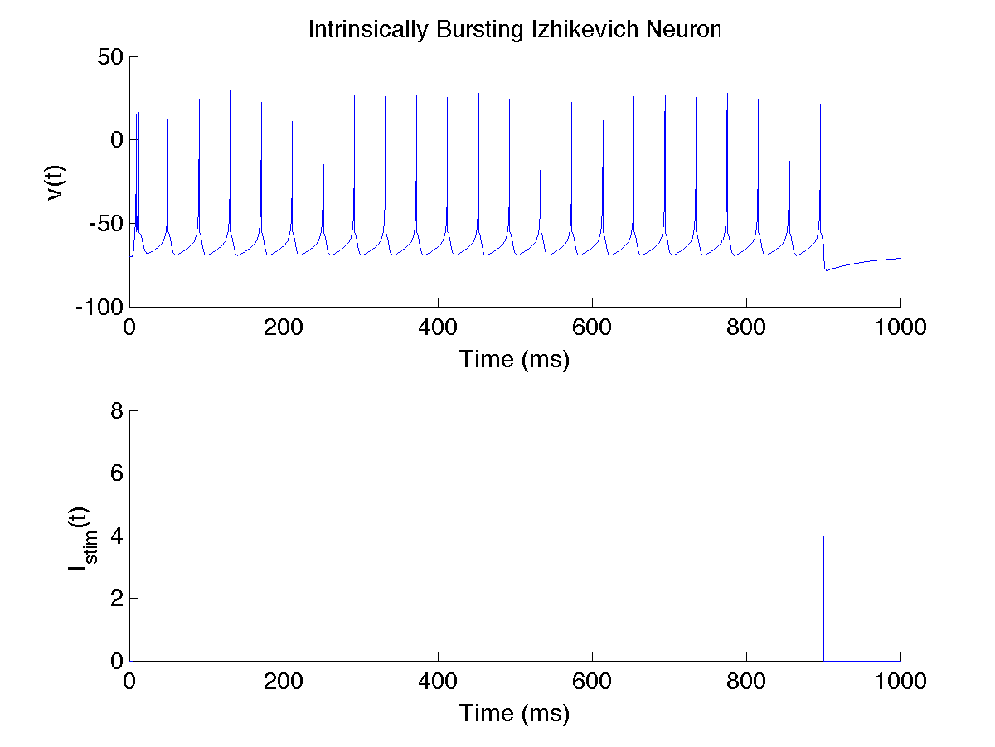

Figure : Intrinsically Bursting Izhikevich Neuron

**Part 3 – Synapse**

The alphas synapse function $P_{s}\left(t\right)= P_{max}t*\frac{\exp\left(1-\frac{t}{τ_{s}}\right)}{τ_{s}}$ where $P_{max}$ and $τ_{s}$ are the peak value and decay time constant is shown in Figure 2 for $P_{max}=1$ and $τ_{s}=5$ ms.

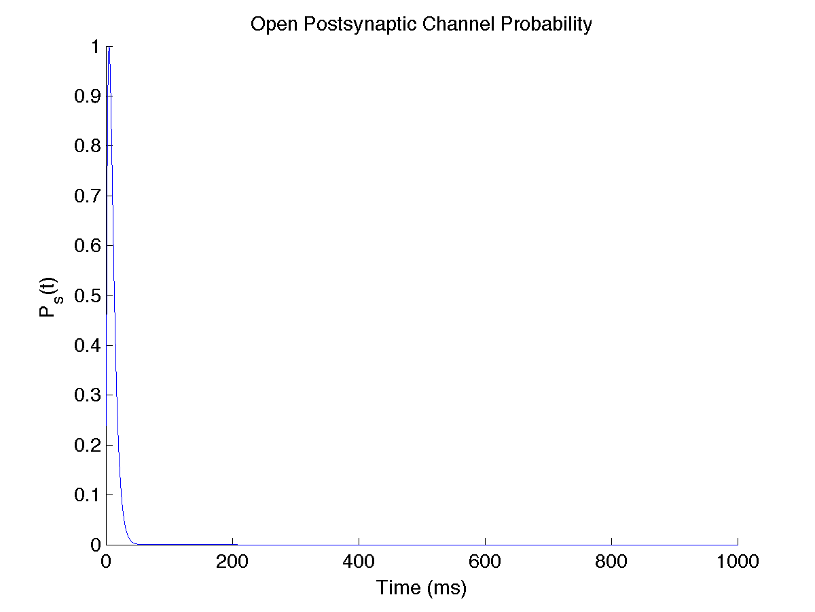

Figure : Single Spike Synaptic Terminal

The $P_{s}(t)$ for a series of spikes arriving at the terminal at $t=\{1,5,9,15\}$ ms is shown in Figure 3.

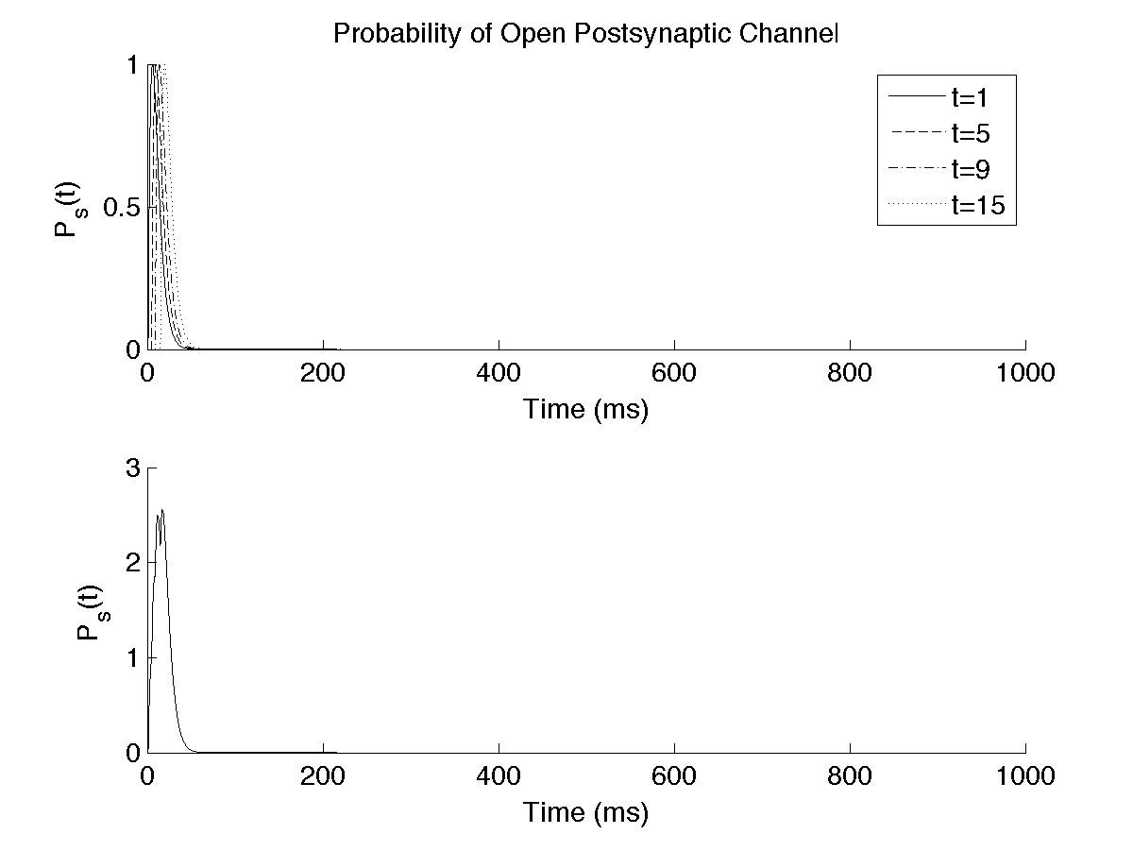

Figure : Multiple Spiking Synaptic Terminal

**Part 4 – Two-neuron oscillating network**

A mutual inhibitory network of two oscillating neurons is shown in Figure 4 at $P_{max}=4$ and $τ_{s}=3$ ms with $I_{stim}$ delayed by 19 ms.

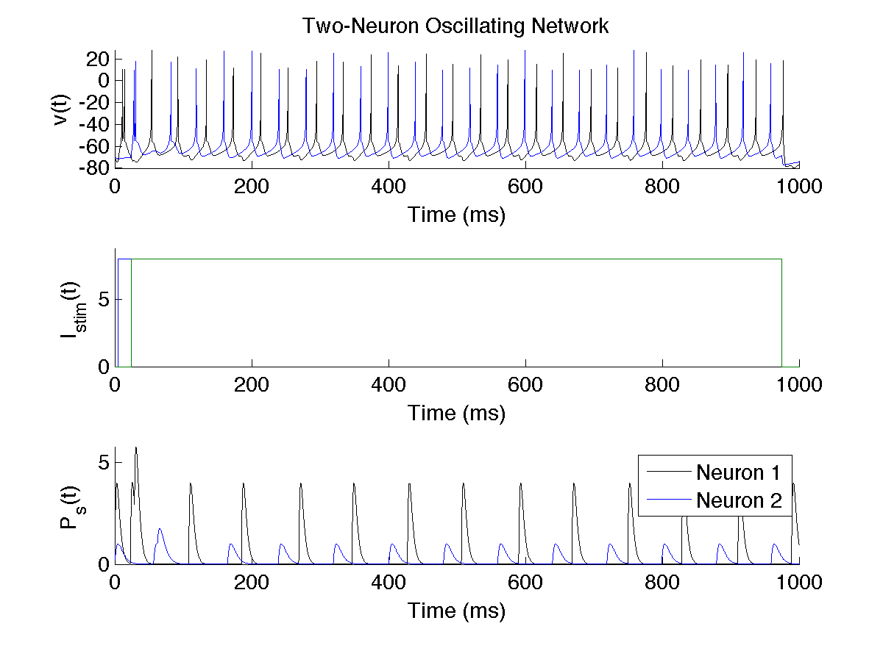

Figure : Mutually Inhibitory Two-Neuron Oscillating Network

**Part 5 – Quantification of the oscillation**

There were repeated sets of single bursts (one spike per neuron per period) that appeared between the two oscillating neurons. Between those sets, the time between each successive set of neurons was calculated to determine the period of that set of oscillations and shown in Table 1. The average period for neuron 1 and 2 were calculated to be 80.3 and 79.6 ms, respectively. The phase offsets ($φ°$) between the four sets of oscillations were calculated using the equation

$$φ°=360°*f*Δt$$

where *f* was the frequency in Hz and $Δt$ was the time difference between the first peaks of a burst between the two neurons. The frequency $f$ was calculated by averaging the inverse time delay between all sets of successive bursts for a single neuron. The phase offsets are shown in Table 2 and were calculated to have an average offset of 248.45.

Table : Period of Oscillation

|  |  |  |  |  |  |  |  |  |  |  |  |
| --- | --- | --- | --- | --- | --- | --- | --- | --- | --- | --- | --- |
| **Neuron** | **Period of Oscillation (ms)** | | | | | | | | | | **Average** |
| 1 | 80.4 | 79.4 | 81.3 | 79.7 | 80.4 | 79.8 | 81.4 | 79.7 | 80.6 | 79.8 | 80.3 |
| 2 | 77.2 | 80.5 | 79.6 | 79.8 | 80.0 | 79.8 | 79.9 | 79.7 | 79.9 | 79.7 | 79.6 |

Table : Phase Offsets of Neuron 1 with regard to Neuron 2

|  |  |  |  |  |  |  |  |  |  |  |
| --- | --- | --- | --- | --- | --- | --- | --- | --- | --- | --- |
| **Phase Offset (°)** | | | | | | | | | | **Average (°)** |
| 286.32 | 232.55 | 243.77 | 244.51 | 238.05 | 248.12 | 244.66 | 248.88 | 246.01 | 251.59 | 248.45 |

**Part 6 – Perturbation of the system**

The system was perturbed by adding additional stimulus current, as shown in Figure 5, and removing stimulus current (or adding negative stimulus current), as shown in Figure 6. As expected, a higher $I_{stim}=15$ mA resulted in more spikes while a reduced $I_{stim}=2$ mA failed to activate the neuron.

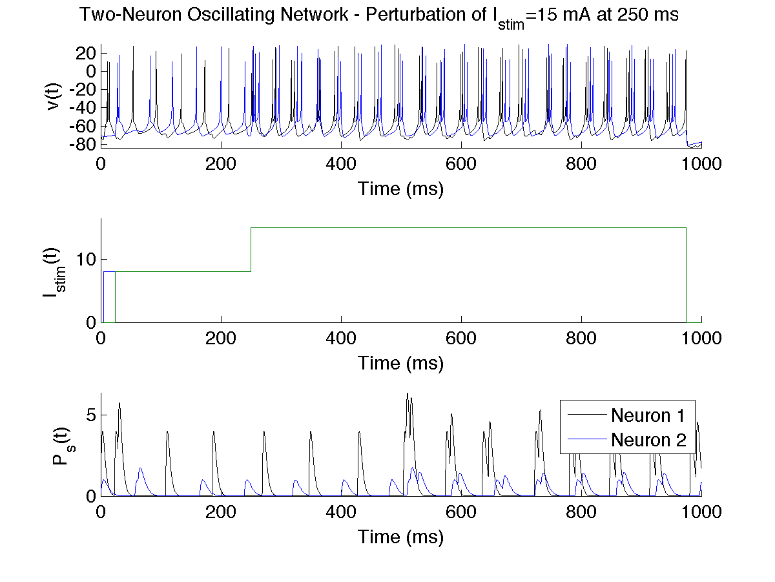

Figure : Perturbation of the system with additional positive stimulus current

The perturbation of the two neurons resulted in a 23 and 24 spikes over the 1-second period at a period of 38.657 and 38.508 ms for neuron 1 and 2, respectively. The phase offset was calculated to be approximately 329.26 degrees when averaged across all spikes.

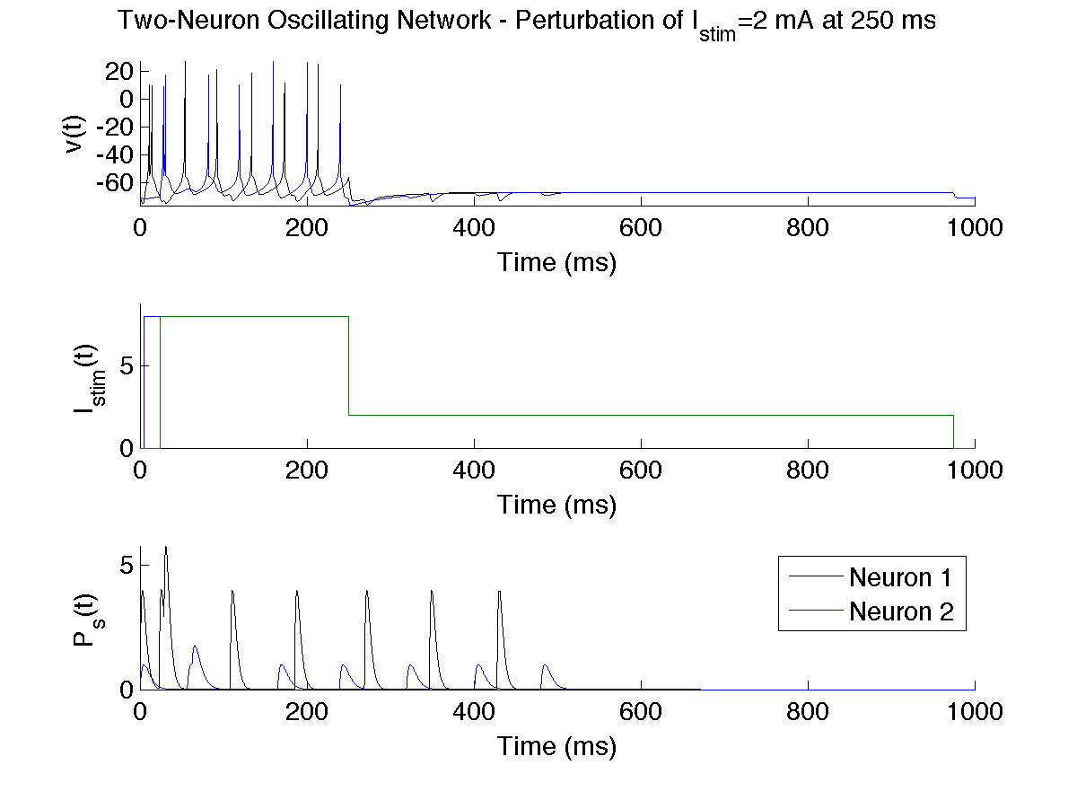

Figure : Perturbation of the system with additional negative stimulus current

The perturbation of the two neurons resulted in a 8 and 8 spikes over the 1-second period at a period of 80.4 and 65.65 ms for neuron 1 and 2, respectively. The phase offset was calculated to be approximately 171.02 degrees when averaged across all spikes.