Homework Assignment 2

**Part 1 – Binary search algorithm in Neuron**

A binary search algorithm starts at the middle element of an ordered array and checks whether the middle element is greater or less than the search element. If the elements match, usually the index or position is returned. Otherwise, this process is repeated on the upper or lower half of the ordered array based on whether or not the array is ordered in ascending or descending value.

For pseudo code of a binary search algorithm for an ascending array (i.e. array=[1 2 3]), the following recursive method can be used to identify the index of the search value given that the search value exists within the array.

binarySearch(array, value)

define midpoint

if midpoint==value

return index of midpoint

if midpoint > value

return binarySearch(array[0:midpoint],value)

if midpoint < value

return binarySearch(array[midpoint:end],value)

Unfortunately, it was difficult to implement a function in hoc that allowed for an array as an input so the following iterative method was used to determine the index of a value in an array.

**Part 2 – Model axon in NEURON**

Given – Fiber diameter

Diameter of node:

Length of myelin:

The internodal or axoplasmic resistance, , is calculated using the equation

where is the axoplasmic resistivity, is the internodal length, is the node diameter, and is the myelin diameter. Since consecutive nodes of Ranvier are separated by internodal spaces, the internodal resistance, , can represent these spaces if the myelin is assumed to be a perfect insulator and the internode is modeled as a tube of axoplasm. Therefore, the product of the axoplasmic resistivity and internodal length can be divided by the cross-sectional area of the nerve fiber to calculate the internodal resistance.

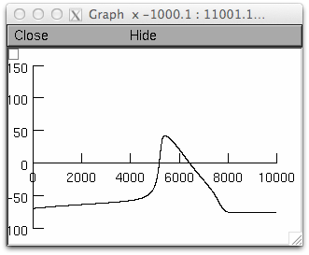

Figure 1: Vm(t) at 45th node

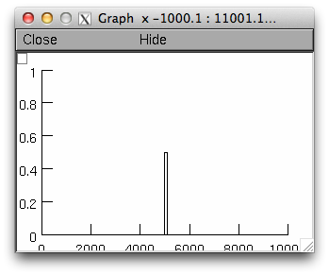

Figure 2: Istim(t)