Brian Huynh

Dr. Grill

BME 515 – Neural Prosthetic Systems

30 October 2014

Homework Assignment 3

I have adhered to the Duke Community Standard in completing this assignment.

1. The Source: Transmembrane Current during an Action Potential
   1. By recording at a node far away from the point source, the stimulus artifact will likely have decayed due to the distance. 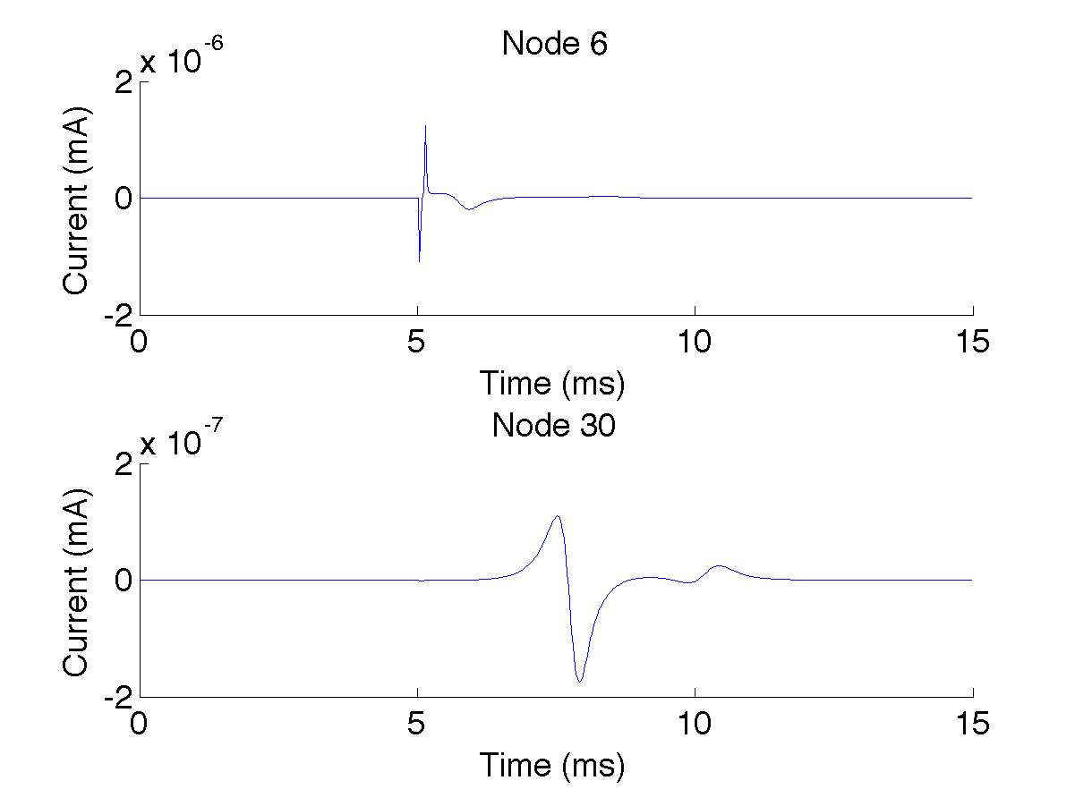
   2. The total membrane current can be calculated as and was recorded in NEURON using i_membrane.
   3. 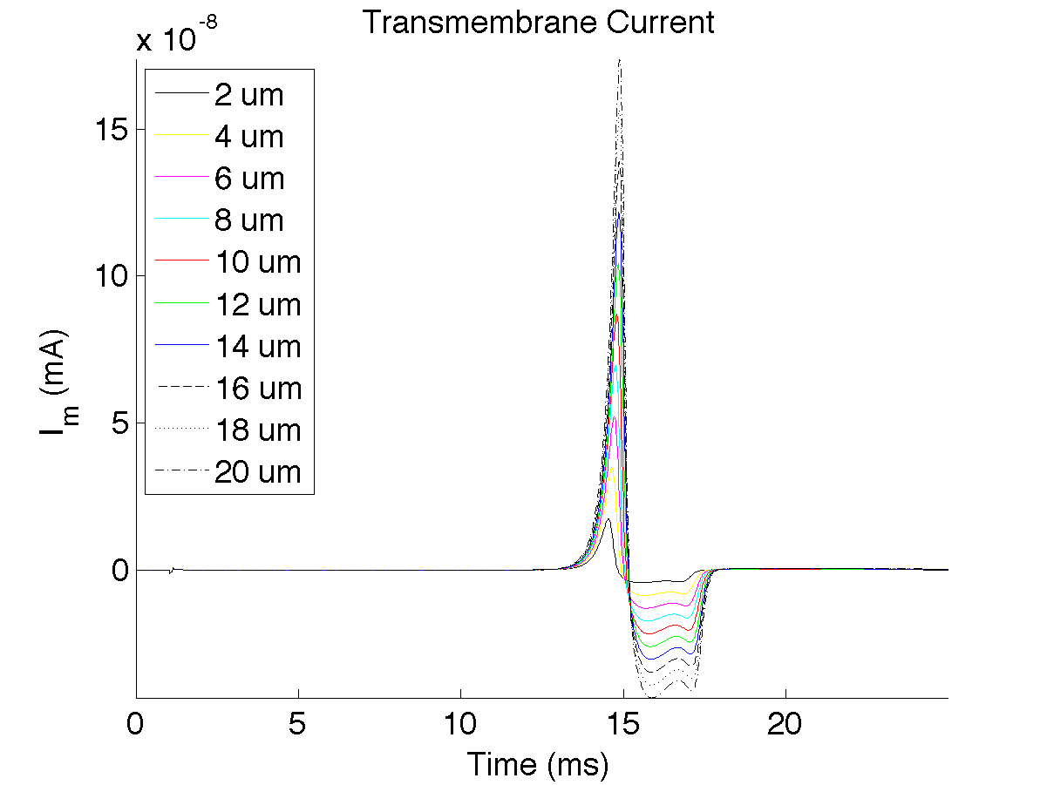

Figure : Transmembrane Current at Node 150 of 151

* 1. 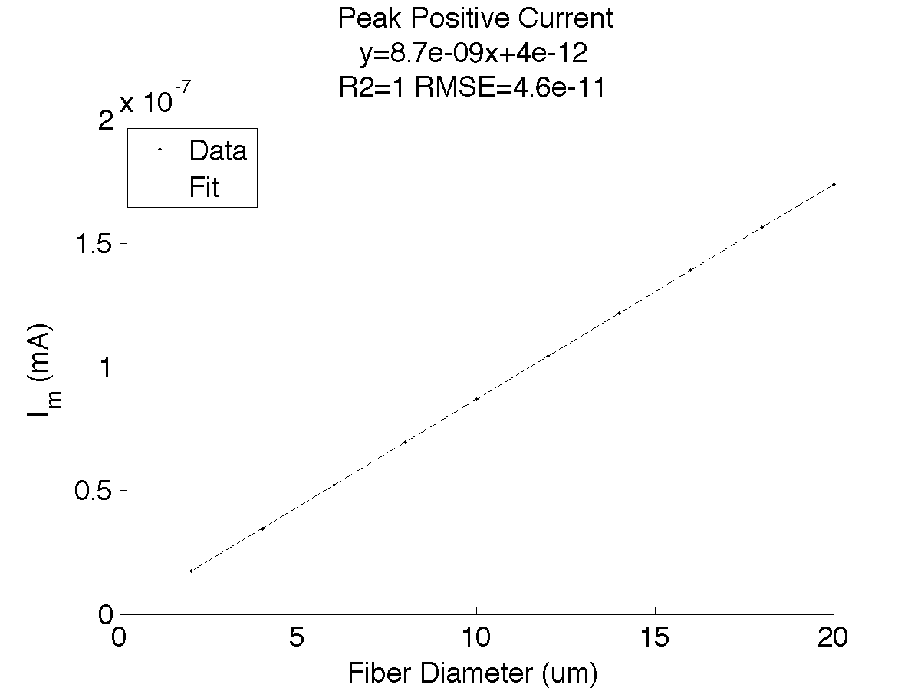

Figure : Peak Positive Current as a function of Fiber Diameter

1. Conduction Speed
   1. Using the network connection object in NEURON, the target is set to nil or a NULLObject that inactivates the NetCon object. However, this is useful for recording the spike train from an output cell. The conduction speed can be calculated by dividing the difference in spike times at two different nodes by the distance between the two nodes.

|  |  |
| --- | --- |
| **Fiber Diameter (um)** | **Conduction Velocity (m/s)** |
| 20 | 23.3650 |
| 18 | 21.1563 |
| 16 | 18.8069 |
| 14 | 16.4575 |
| 12 | 14.1081 |
| 10 | 11.7587 |
| 8 | 9.3530 |
| 6 | 7.0599 |
| 4 | 4.6823 |
| 2 | 2.3330 |

* 1. 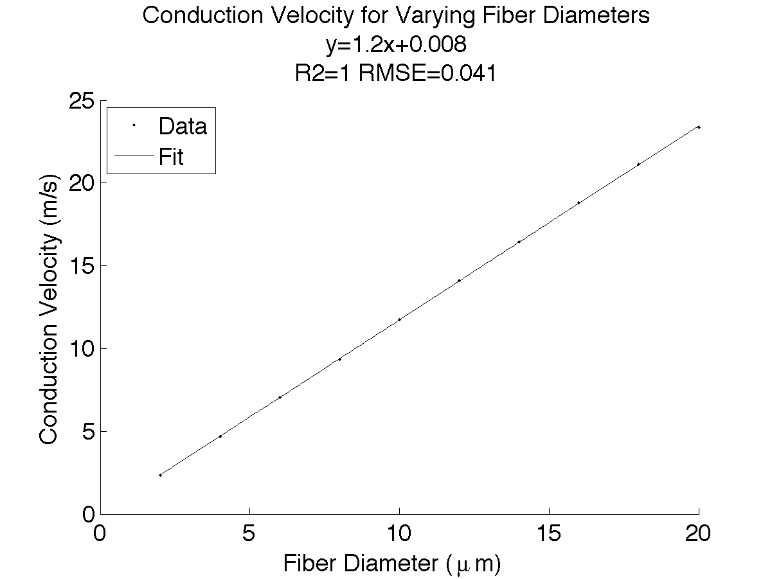

Figure : Conduction Velocity as a function of Fiber Diameter

* 1. A trend line of was fit to the conduction velocity data.

1. Compound Nerve Action Potential (CNAP)
   1. 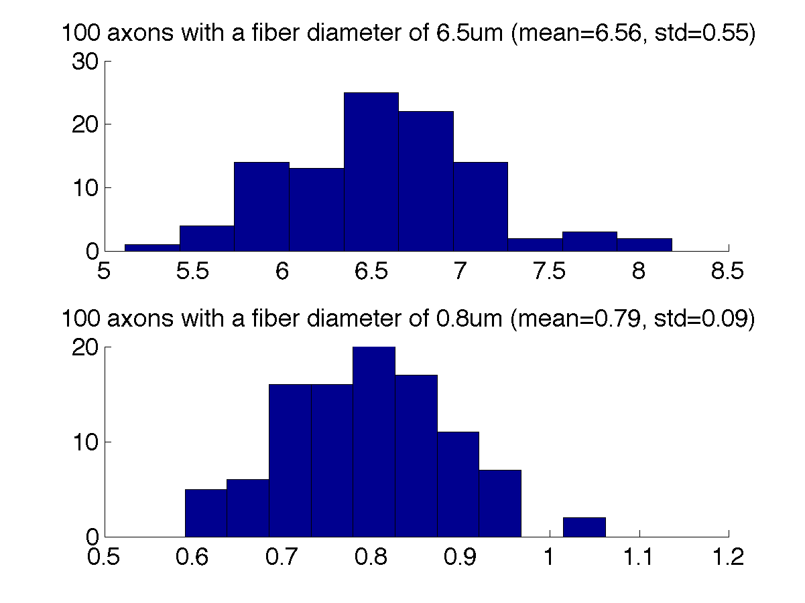

Figure : Histogram of Axon Diameters

Population 1 was generated at and . Population 2 was generated at and .

* 1. 1. A larger diameter fiber has a greater peak positive current and a faster conduction velocity.
     2. The potential at a recording electrode can be calculated as for potential , membrane current , extracellular resistivity , and distance from recording electrode to node N.
     3. The net recorded voltage in response to from a given node N and potentials V1, V2, and V3 is .
     4. Placing the recording electrode very close to the axons’ proximal end results in a more prominent net recorded voltage in response to since there will be larger differences between the recorded voltages at the three electrode contacts. Placing the recording electrode further away to the axons’ proximal end results in a smaller net recorded voltage profile since the differences in distance between the electrode contacts is more negligible compared to the average distance from the electrode contacts to all the nodes.

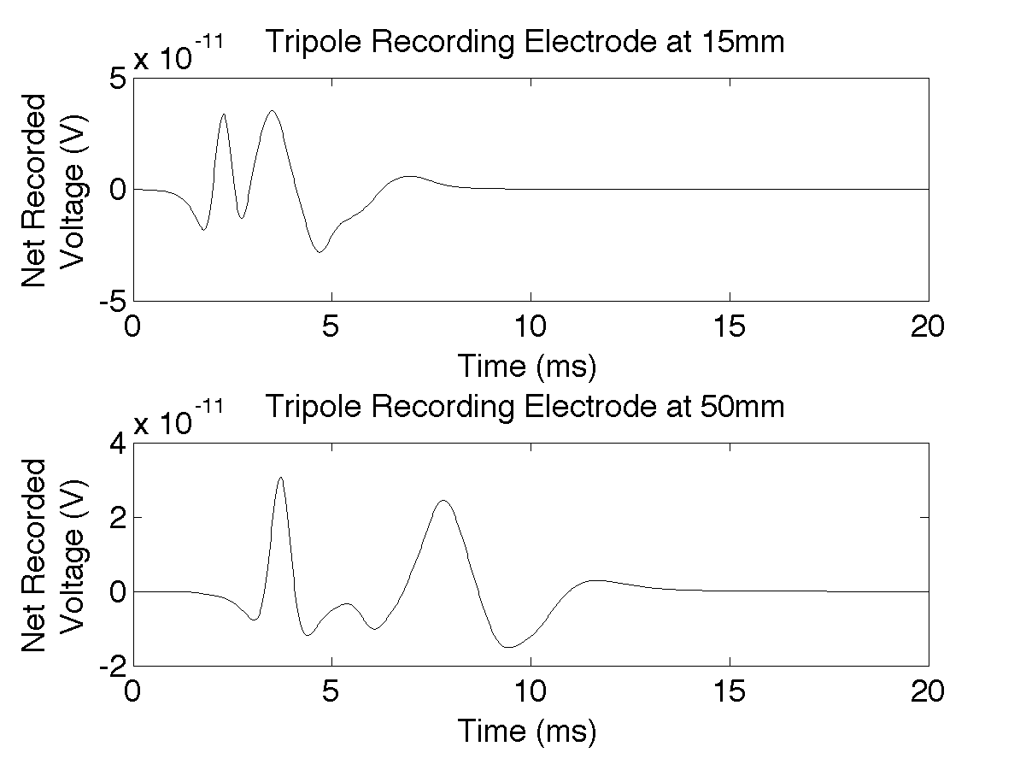

* + 1. The conduction velocities of the ECAPs were measured by calculating the time delay between the peak voltages of the ECAP at the two different recording electrode locations. The conduction velocity of the ECAP of fiber population 1 with and was measured to be 8.06 m/s. The conduction velocity of the ECAP of fiber population 2 with and was measured to be 24.3 m/s. Comparatively, using the fitted trend line from part 2C, the expected conduction velocity of the two fiber populations were calculated to be 7.6 m/s and 23.2 m/s, respectively. It is likely that the differences in the expected compared to the calculated conduction velocities is due to the distribution of axon diameters which may have skewed the overall ECAP conduction velocity.
    2. ECAPs were recorded for three different interelectrode spacings mm. The net recorded voltages increase for larger interelectrode spacings since the distances between contacts increases thus creating a larger difference of potentials at the electrode contacts.

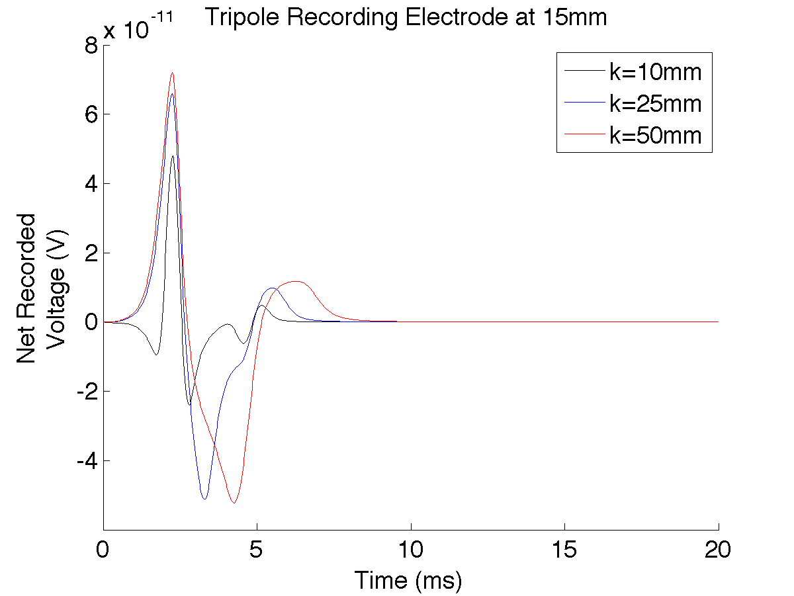

* 1. Stypulkowski, van den Honert and colleagues at Biosciences Research Laboratory used compound action potentials of the auditory nerve to characterize refractory behavior in the auditory brainstem. Cochlear stimulation is dependent on good nerve survival and the wide variation in nerve survival patterns in implant candidates stresses the need for additional information for implant candidates. The differentiation of this information could potentially allow for future assessment of dendritic degeneration in cochlear implant candidates and users. [1]

1. Electroneurogram (ENG)
   1. 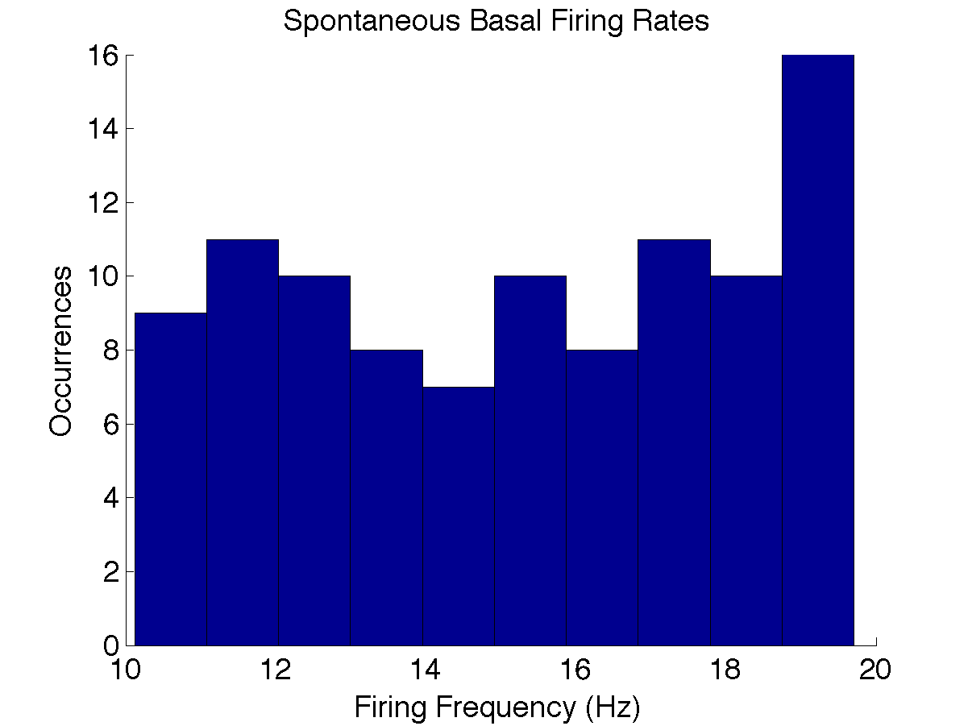

Figure : Histogram of Firing Frequencies

1. Stypulkowski, P., & Van den Honert, C. (1984). Physiological properties of the electrically stimulated auditory nerve. I. Compound action potential recordings. *Hearing Research,* *14*, 205-223.