EE512 – Applied Biomedical Signal Processing
Practical session – SVD
Instructions
- Please submit your report as a single PDF file.
- We recommend working in groups of 3 students; the last group can be a group of 2 or 4. You can prepare one single report for the group (name1_name2_name3_lab_SVD.pdf), but every member needs to upload the same file individually.
- There are 3 experiments in this practical session. The python scripts for each experiment are already coded and will only require minimal inputs from you. A major part of this practical session is therefore focused on questions testing your understanding and correct interpretation of the signals and the analysis results that you see.

Useful commands: Type help function_name for more information on inputs and outputs, and doc function_name for a more detailed description of the function.
numpy.linalg.svd singular value decomposition.
Scipy.stats.zscore center data to have mean 0 and scaled to have standard deviation 1.
numpy.cumsum returns the cumulative sum of a vector A.

Additional command:
SSA_decomposition singular spectrum analysis decomposition.

Experiment 1: 12-leads ECG

File ECG.csv contains 500 samples from the 12-leads ECG (sampling frequency 50 Hz) during an episode of atrial fibrillation, after ventricular activity cancellation.
A 12-leads ECG contains 12 signals computed from 10 electrodes (Figure 1) :
- 6 precordial leads (V1-V6)
- 3 limb leads (I, II, III)
- 3 augmented limb leads (VR, VL, VF)
The 3 augmented limb leads are a combination of the limb leads, which are themselves dependent with respect to the potential reference.
Extract the singular values on the first six columns only (leads I, II, III, VR, VL, VF), and the last six columns (leads V1 – V6).

QUESTION #1.1: Limb leads and augmented limb leads
- Explain the difference between singular values of the six first columns, and of the last 6 columns.
- Computate of the effective rank with a threshold of 0.98.

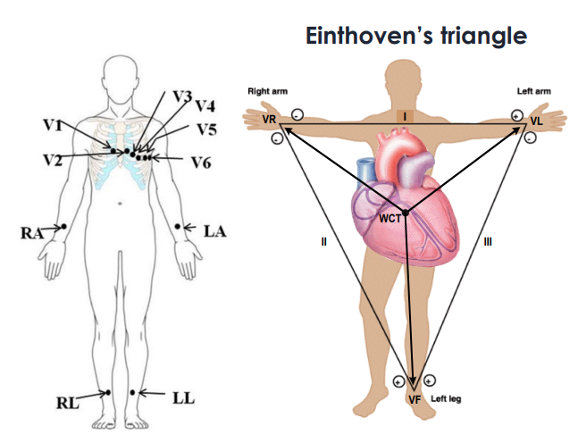
Figure 1. Placement of the 10 electrodes from which 12-leads ECG signals are computed.

Experiment 2: Singular values and process complexity
In this experiment we analyze EEG signals from a patient with Parkinson’s disease implanted with an electrical stimulation device (sampling frequency 512 Hz). EEG signals were recorded before, during and afer brain stimulation.
Files EEG_av.dat, EEG_pe.dat, and EEG_ap.dat contain each four EEG signals (4 leads) respectively recorded prior to stimulation, during stimulation and after stimulation. We compute in all three situations the singular value decomposition of the data matrix, and divide the singular values by the largest one.
The goal of this experiment is to understand the relationship between the EEG leads in each case (before, during and after stimulation) through their singular values.

QUESTION #2.1: Data pre-processing
- Explain from the singular values of the SVD of the raw EEG signal, the relationship between EEG leads before stimulation.
- Implement pre-processing of the EEG signals before stimulation to normalize the data. Then re-compute the singular value decomposition of the pre-processed signals.
- Explain the relationship between EEG leads based on these new singular values, and the difference observed with the ones computed in a).
Figure 2. 4 leads ECG signals before stimulation
QUESTION #2.2: Correlation interpretation
Apply the same pre-processing to the EEG during and after the stimulation, compute their singular values and normalize them by the largest one.
- Based on the resulting singular values are the signals more correlated before, during or after stimulation.
- Explain in terms of correlation the difference between each case ( ‘before’, ‘during’, ‘after’).

Experiment 3: Drift cancellation and frequency component extraction
In this experiment we analyze the ppg and accelerometer signal from wrist device on a subject during a running session.
The goal in this experiment is to separate the respiration signal from the heart rate and running cadence, using SSA.
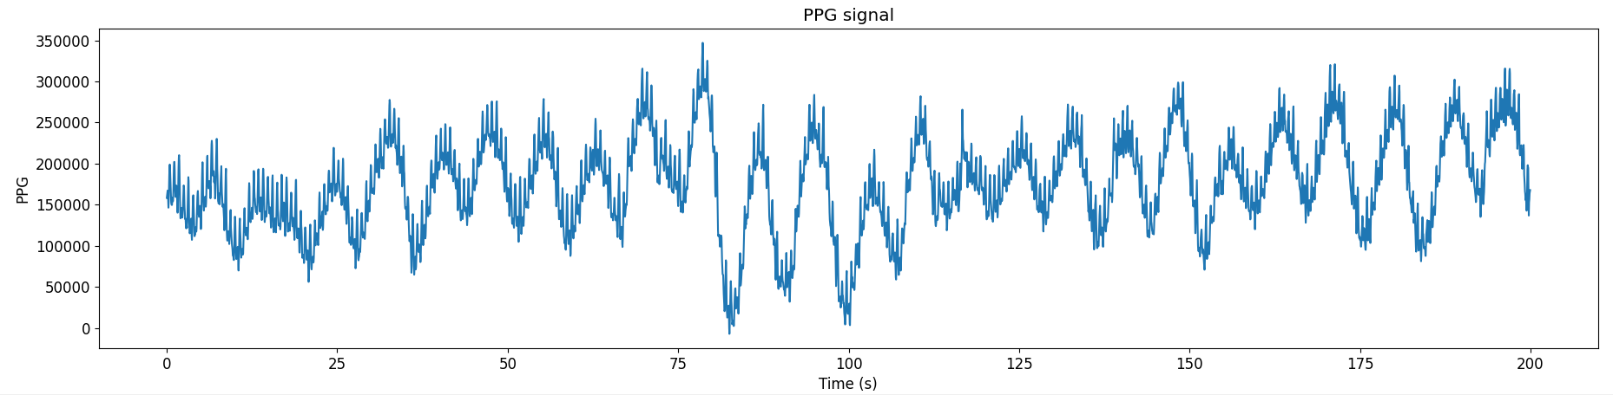

QUESTION #3.1: Drift cancellation
Find a window length L, so that the first component obtained using the function SSA_decomposition corresponds to the long-term drift (baseline) on both ppg and accelerometer signals.

QUESTION #3.2: Respiration and cadence components extraction
The baseline is subtracted from the signals and decomposed using SSA_decomposition.
- Find the component(s) related to the respiration in the PPG signal. Plot their sums.
- Find the component(s) related to the cadence in the accelerometer signal and give the corresponding frequency in steps per minute (Hint: in general cadence is about 180 steps per minute).
- Explain where the components of the SSA deocomposition of the accelerometer signal at 1.5Hz and 6Hz come from. (Hint: c.f. Module 04 Time-Frequency Lab)

QUESTION #3.3: Heart rate estimation
The respiration components are subtracted from the PPG signal without baseline and decomposed using SSA_decomposition. The resulting signal is now mainly driven by the running cadence and the heart rate.
- Based on the components observed from the accelerometer signal analysis, find the component related to the heart rate in the ppg signal, and give the corresponding heart rate in bpm (beats per minute)?
Have a good session, and don’t hesitate to ask questions!

