|  |
| --- |
| haribo inc |
| Test |
| Suggestion de commande avec Ctrl+space |
|  |
| **Nicolas BERNARD** |
| **27/02/2014** |

|  |
| --- |
|  |

# TEST:

Au moment:

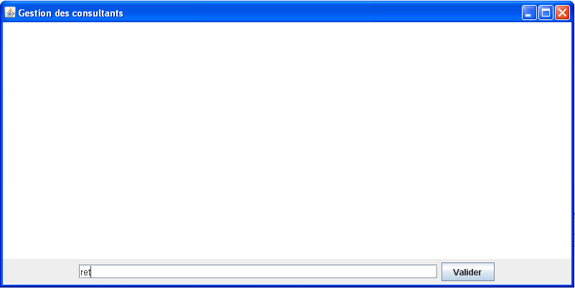

Et ‘Ctrl+space’:

