广州大学学生实验报告

开课实验室：计算机科学与工程实验（电子楼416A）
学院 | 计算机科学与教育软件学院 |  | 年级、专业、班 | 计科173 | 姓名 | 谢绍波 | 学号 | 1706100109
实验课程名称 |  | Java语言实验 |  |  |  |  | 成绩
实验项目名称 |  | 实验四 综合应用实验 |  |  |  |  | 指导老师 | 周娜琴
- 实验目的
（1）掌握网络编程的基本概念。
（2）掌握java.net包中常用网络编程工具类的功能和使用。
（3）掌握Socket编程的基本方法和步骤。

二、实验任务
1.使用JAVA编程实现多人聊天室（需要用到多线程）。
三、实验过程原始数据记录（程序运行结果截图）
1．
（1）程序代码
//ChatSocket.java
package com.dmtech.net.simplechat.server;

import java.io.DataInputStream;
import java.io.DataOutputStream;
import java.io.IOException;
import java.net.Socket;

public class ChatSocket{
public interface Callback {
void onReadSocket(ChatSocket chatSocket, String msg);
void onError(ChatSocket chatSocket, String error);
}

private DataInputStream inputStream = null;
private DataOutputStream outputStream = null;
private Callback callback = null;

public DataInputStream getInputStream() {
return inputStream;
}

public DataOutputStream getOutputStream() {
return outputStream;
}

public ChatSocket(Socket socket, Callback callback) {
try {
inputStream = new DataInputStream(socket.getInputStream());
outputStream = new DataOutputStream(socket.getOutputStream());
} catch (IOException e) {
e.printStackTrace();
}

this.callback = callback;
}

public void send(String send) { // 向客户端发送数据
try {
outputStream.writeUTF(send);
outputStream.flush();
} catch (IOException e) {
e.printStackTrace();
}
}

public void start() {
Thread thread = new Thread(new Runnable() {
@Override
public void run() {
String accept = null;
while (true) {
try {
accept = inputStream.readUTF();
if (callback != null) {
callback.onReadSocket(ChatSocket.this, accept);
}
} catch (IOException e) {
if (callback != null) {
callback.onError(ChatSocket.this, e.getMessage());
}
}
}
}
});
thread.start();
}

public void close() throws IOException {
if (inputStream != null) {
inputStream.close();
}
if (outputStream != null) {
outputStream.close();
}
}

}

//ClientManager.java
package com.dmtech.net.simplechat.server;

import java.io.IOException;
import java.net.Socket;
import java.util.ArrayList;

public class ClientManager {

public ArrayList<ChatSocket> chatSockets = new ArrayList<>();

public void addClientSocket(Socket socket) {
final ChatSocket chatSocket = new ChatSocket(socket, new ChatSocket.Callback() {

@Override
public void onReadSocket(ChatSocket cs, String msg) {
// TODO Auto-generated method stub
sendAll(cs, msg);
}

@Override
public void onError(ChatSocket cs, String error) {
synchronized (chatSockets) {
chatSockets.remove(cs);
}
}
}); //新客户端连接

synchronized (chatSockets) {
chatSockets.add(chatSocket); //往客户端管理器里添加客户
}

chatSocket.start();
}

//向其他客户端发送数据
public void sendAll(ChatSocket chatSocket, String msg) {
synchronized (chatSockets) {
for (ChatSocket cs : chatSockets) {
if (!cs.equals(chatSocket)) {
cs.send(msg);
}
}
}
}

public void close() throws IOException {
synchronized (chatSockets) { //关闭各个连接
for (ChatSocket socket : chatSockets) {
socket.close();
}
chatSockets.clear();
}
}
}

//SimpleChatServerApp.java
package com.dmtech.net.simplechat.server;

public class SimpleChatServerApp {

public static void main(String[] args) {
ClientManager clientManager = new ClientManager();
SimpleChatService service = new SimpleChatService(clientManager);
SimpleChatServerView view = new SimpleChatServerView(service);
}
}

//SimpleChatServerView.java
package com.dmtech.net.simplechat.server;

import java.awt.BorderLayout;
import java.awt.FlowLayout;
import java.awt.GridLayout;
import java.awt.TextArea;
import java.awt.event.ActionEvent;
import java.awt.event.ActionListener;
import java.net.Socket;

import javax.swing.JButton;
import javax.swing.JFrame;
import javax.swing.JLabel;
import javax.swing.JOptionPane;
import javax.swing.JPanel;
import javax.swing.JScrollPane;
import javax.swing.JTextArea;
import javax.swing.JTextField;

import com.dmtech.net.simplechat.server.SimpleChatService.OnSocketAcceptListener;

//import com.dmtech.net.simplechat.client.ClientView;

public class SimpleChatServerView extends JFrame implements ActionListener, OnSocketAcceptListener {
private JButton btnOpen;
private JButton btnStop;
private JTextArea tfLogInfo;
private JScrollPane scrollPane;

JPanel jp1;

private JLabel label;
private SimpleChatService service = null;

public SimpleChatServerView(SimpleChatService service) {
this.service = service;
this.service.setOnAcceptListener(this);
initView();
}

private void initView() {
jp1 = new JPanel();
btnOpen = new JButton("打开服务器");
btnStop = new JButton("关闭服务器");
btnStop.setEnabled(false);
btnOpen.addActionListener(this);
btnStop.addActionListener(this);
jp1.add(btnOpen);
jp1.add(btnStop);
jp1.setLayout(new FlowLayout(FlowLayout.CENTER));

tfLogInfo = new JTextArea(20, 20);
tfLogInfo.setEditable(false);
scrollPane = new JScrollPane(tfLogInfo);

label = new JLabel("服务器停止工作");

add(jp1, BorderLayout.NORTH);
add(scrollPane, BorderLayout.CENTER);
add(label, BorderLayout.SOUTH);
// add(btnOpen);
// add(btnStop);
setTitle("服务器");
// setLayout(new GridLayout(3, 1, 0, 10));

setSize(300, 300);
setLocation(450, 150);
setVisible(true);
setDefaultCloseOperation(EXIT_ON_CLOSE);
}

@Override
public void actionPerformed(ActionEvent e) {
if (e.getSource() == btnOpen) {
open();
} else {
stop();
}
}

private void open() {
// service = new SimpleChatService();
service.startup();
label.setText("服务器正在运行");
btnOpen.setEnabled(false);
btnStop.setEnabled(true);
}

private void stop() {
label.setText("服务器已关闭");
btnOpen.setEnabled(true);
btnStop.setEnabled(false);
service.shutdown();
}

@Override
public void onSocketAccept(Socket socket) {
tfLogInfo.append("客户端" + socket.getInetAddress() + "已连接");
tfLogInfo.append("\r\n");
}
}

//SimpleChatService.java
package com.dmtech.net.simplechat.server;

import java.io.IOException;
import java.net.ServerSocket;
import java.net.Socket;

public class SimpleChatService {

public interface OnSocketAcceptListener {
void onSocketAccept(Socket socket);
}

private ClientManager clientManager = null;
private OnSocketAcceptListener onAcceptListener = null;
private ServerSocket serverSocket = null;

public SimpleChatService(ClientManager clientManager) {
this.clientManager = clientManager;
}

public void setOnAcceptListener(OnSocketAcceptListener listener) {
onAcceptListener = listener;
}

public void startup() {
// TODO Auto-generated method stub
Thread thread = new Thread(new Runnable() {
@Override
public void run() {
runStartup();
}

});
thread.start();
}

public void shutdown() {
try {
clientManager.close();
serverSocket.close();
} catch (IOException e) {
e.printStackTrace();
}
}

private void runStartup() {
try {
serverSocket = new ServerSocket(8765);
while (true) {
Socket socket = serverSocket.accept();
if (onAcceptListener != null) {
onAcceptListener.onSocketAccept(socket);
}

clientManager.addClientSocket(socket);
}
} catch (IOException e) {
e.printStackTrace();
}

}
}

//ClientView.java
package com.simplechat;

import javax.swing.*;
import java.awt.*;
import java.awt.event.*;

public class ClientView extends JFrame implements
ActionListener, KeyListener {
@Override
public void actionPerformed(ActionEvent actionEvent) {
if(actionEvent.getSource()==btnSend){
sendMessage();
}else if(actionEvent.getSource()==btnConnect){
// 响应连接/断开按钮
if (!networkService.isConnected()) {
// 未连接状态下，执行连接服务器操作
String host = tfHost.getText();
int port = Integer.valueOf(tfPort.getText());
networkService.connect(host, port);
} else {
// 已连接状态下，执行断开连接操作
networkService.disconnect();
}
}
}
private void sendMessage() {
// 响应发送按钮
String name = tfName.getText();
String msg = tfMessage.getText();
// 检查参数合法性
if (name == null || msg == null || "".equals(name) || "".equals(msg)) {
return;
}
// 发送消息
networkService.sendMessage(name, msg);
}
@Override
public void keyTyped(KeyEvent keyEvent) {
}

@Override
public void keyPressed(KeyEvent keyEvent) {
if(keyEvent.getKeyCode()==keyEvent.VK_ENTER){
sendMessage();
}
}

@Override
public void keyReleased(KeyEvent keyEvent) {
}
private JTextArea taChatList; // 聊天内容区
private JTextField tfMessage; // 聊天输入框
private JTextField tfName; // 用户名输入框
private JButton btnSend; // 发送按钮
private JLabel labelNick;
private JPanel jp1, jp2;

private JScrollPane scrollPane;
private JLabel labelHost;
private JLabel labelPort;
private JTextField tfHost; // 服务器地址输入框
private JTextField tfPort; // 服务器端口输入框
private JButton btnConnect; // 连接/断开服务器按钮

private void initView() {
taChatList = new JTextArea(20, 20);
taChatList.setEditable(false);

scrollPane = new JScrollPane(taChatList);
tfMessage = new JTextField(15);
btnSend = new JButton("发送");

jp1 = new JPanel();
labelHost = new JLabel("主机地址");
tfHost = new JTextField(15);
tfHost.setText("localhost");
labelPort = new JLabel("端口号");
tfPort = new JTextField(4);
tfPort.setText("8765");
btnConnect = new JButton("连接");

jp1.add(labelHost);
jp1.add(tfHost);
jp1.add(labelPort);
jp1.add(tfPort);
jp1.add(btnConnect);

labelNick = new JLabel("昵称：");
tfName = new JTextField(8);
jp2 = new JPanel();
jp2.add(labelNick);
jp2.add(tfName);
tfName.setText("用户0");
jp1.setLayout(new FlowLayout(FlowLayout.CENTER));
jp2.add(tfMessage);
jp2.add(btnSend);
jp2.setLayout(new FlowLayout(FlowLayout.CENTER));

add(jp1, BorderLayout.NORTH);
add(scrollPane, BorderLayout.CENTER);
add(jp2, BorderLayout.SOUTH);
setTitle("聊天室");
setSize(500, 500);
setLocation(450, 150);
setVisible(true);
setDefaultCloseOperation(EXIT_ON_CLOSE);

// 当光标定位在聊天输入框时监听回车键按下事件
tfMessage.addKeyListener(this);
// 为发送按钮增加鼠标点击事件监听
btnSend.addActionListener(this);
// 为连接按钮增加鼠标点击事件监听
btnConnect.addActionListener(this);
// 当窗口关闭时触发
addWindowListener(new WindowAdapter() { // 窗口关闭后断开连接
@Override
public void windowClosing(WindowEvent e) {
networkService.disconnect();
}
});
}
public ClientView(){
initView();
initNetworkService();
}
private NetworkService networkService;
// 显示标题为title，内容为message的对话框
private void alert(String title, String message) {
JOptionPane.showMessageDialog(this, message, title, JOptionPane.INFORMATION_MESSAGE);
}
private void initNetworkService() {
networkService = new NetworkService();
networkService.setCallback(new NetworkService.Callback() {
@Override
public void onConnected(String host, int port) {
// 连接成功时，弹对话框提示，并将按钮文字改为“断开”
alert("连接", "成功连接到[" + host + ":" + port + "]");
btnConnect.setText("断开");
}

@Override
public void onConnectFailed(String host, int port) {
// 连接失败时，弹对话框提示，并将按钮文字设为“连接”
alert("连接", "无法连接到[" + host + ":" + port + "]");
btnConnect.setText("连接");
}

@Override
public void onDisconnected() {
// 断开连接时，弹对话框提示，并将按钮文字设为“连接”
alert("连接", "连接已断开");
btnConnect.setText("连接");
}

@Override
public void onMessageSent(String name, String msg) {
// 发出消息时，清空消息输入框，并将消息显示在消息区
tfMessage.setText("");
taChatList.append("我(" + name + "):\r\n" + msg + "\r\n");
}

@Override
public void onMessageReceived(String name, String msg) {
// 收到消息时，将消息显示在消息区
taChatList.append(name + ":\r\n" + msg + "\r\n");
}
});
}

public static void main(String[] args){
ClientView view = new ClientView();
}
}

//NetworkService.java
package com.simplechat;

import java.io.DataInputStream;
import java.io.DataOutputStream;
import java.io.IOException;
import java.net.Socket;

public class NetworkService {
public void connect(String host,int port){
try {
// 创建套接字对象，与服务器建立连接
socket = new Socket(host, port);
isConnected = true;
// 通知外界已连接
if (callback != null) {
callback.onConnected(host, port);
}
// 开始侦听是否有聊天消息到来
beginListening();
} catch (IOException e) {
// 连接服务器失败
isConnected = false;
// 通知外界连接失败
if (callback != null) {
callback.onConnectFailed(host, port);
}
e.printStackTrace();
}
}

private void beginListening() {
Runnable listening = new Runnable() {
@Override
public void run() {
try {
inputStream = new DataInputStream(socket.getInputStream());

while (true) {
String[] s = inputStream.readUTF().split("#");
if (callback != null) {
callback.onMessageReceived(s[0], s[1]);
}
}
} catch (IOException e) {
e.printStackTrace();
}
}
};
(new Thread(listening)).start();
}

public void disconnect(){
try {
if (socket != null) {
socket.close();
}
if (inputStream!= null) {
inputStream.close();
}
if (outputStream != null) {
outputStream.close();
}
isConnected = false;
// 通知外界连接断开
if (callback != null) {
callback.onDisconnected();
}
} catch (IOException e) {
e.printStackTrace();
}
}
public boolean isConnected(){
return isConnected;
}
public void sendMessage(String name,String msg){
if (name == null || "".equals(name) || msg == null || "".equals(msg)) {
return;
}
if (socket == null) { //套接字对象必须已创建
return;
}

try {
// 将消息写入套接字的输出流
outputStream = new DataOutputStream(socket.getOutputStream());
outputStream.writeUTF(name + "#" + msg);
outputStream.flush();
// 通知外界消息已发送
if (callback != null) {
callback.onMessageSent(name, msg);
}
} catch (IOException e) {
e.printStackTrace();
}
}
// 套接字对象
private Socket socket = null;
// 套接字输入流对象，从这里读取收到的消息
private DataInputStream inputStream = null;
// 套接字输出流对象，从这里发送聊天消息
private DataOutputStream outputStream = null;
// 当前连接状态的标记变量
private boolean isConnected = false;

public interface Callback {
void onConnected(String host, int port); //连接成功
void onConnectFailed(String host, int port); //连接失败
void onDisconnected(); //已经断开连接
void onMessageSent(String name, String msg); //消息已经发出
void onMessageReceived(String name, String msg);//收到消息
}

private Callback callback;
public void setCallback(Callback callback) {
this.callback = callback;
}
}

（2）运行结果
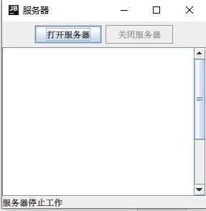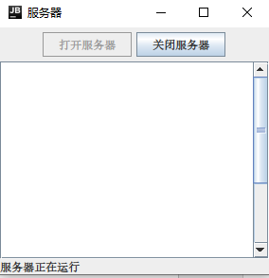
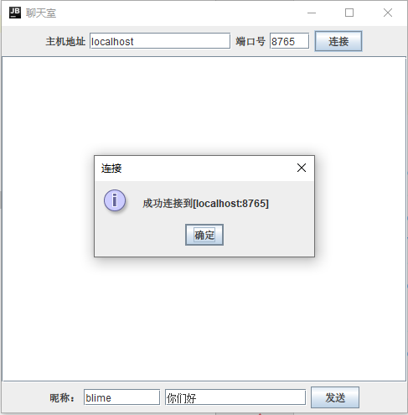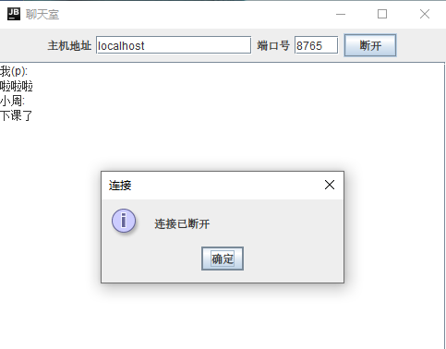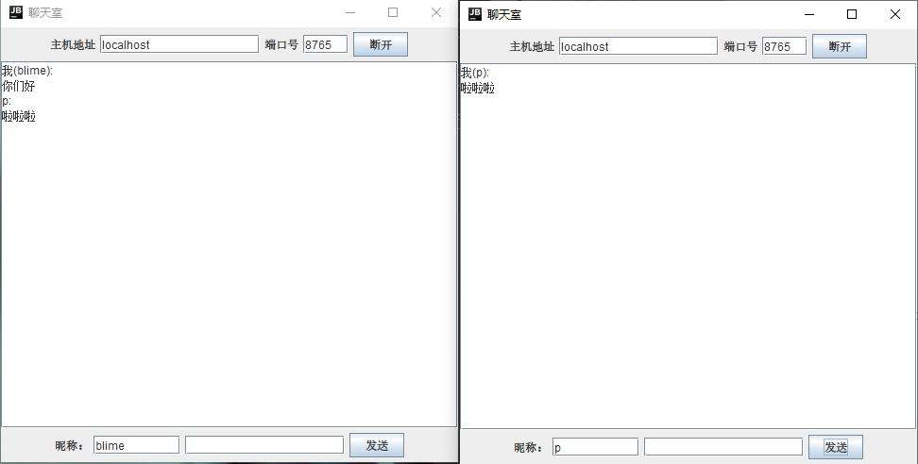
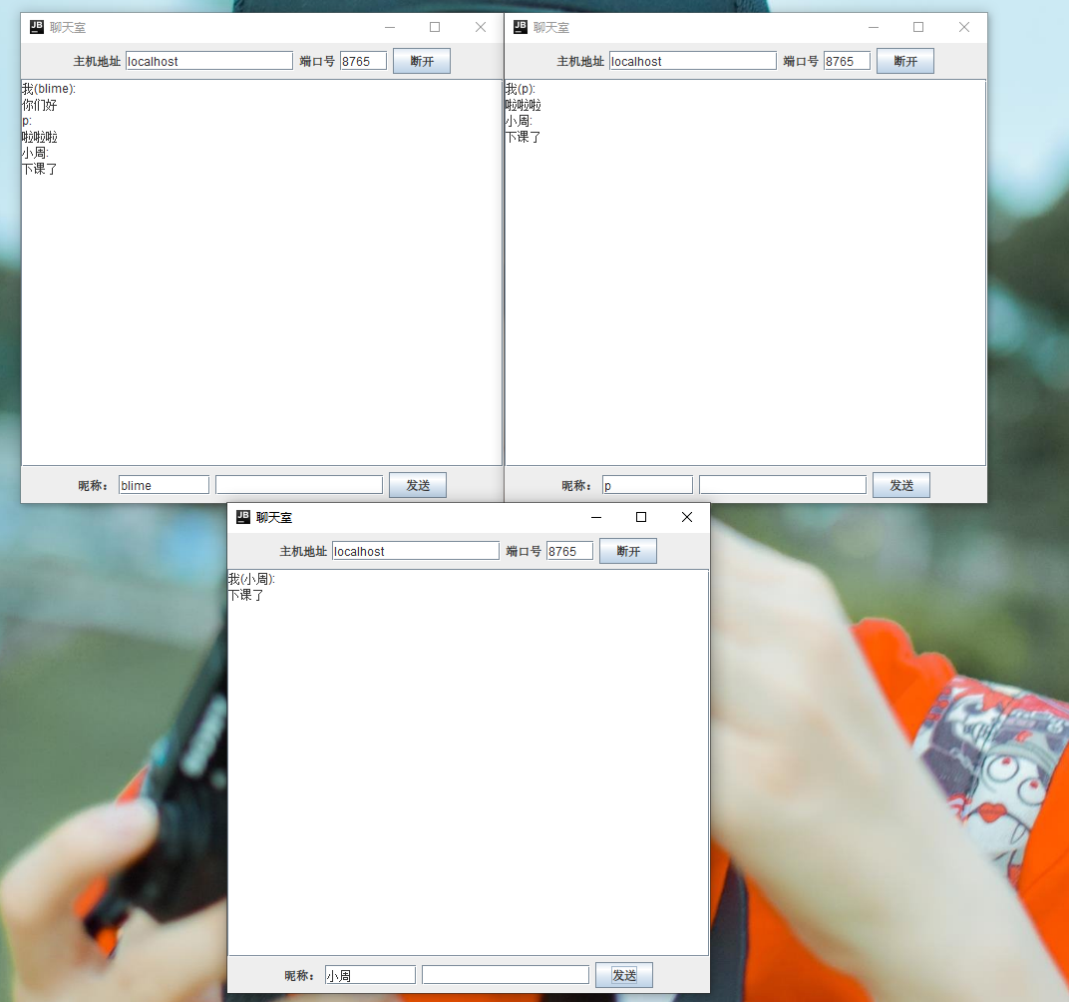
四、实验结果及分析
1. 通过本次实验，学会了坚持。找bug的时候，学会了坚强。
2. 本实验基于TCP协议，以Socket为端点，端到端的通信技术，实现了多用户群聊的动能，并使用了swing做GUI界面。
3. 聊天室分为两个部分，一个是客户端，一个是服务端，先运行SimpleChatServerApp.java，再运行ClientView.java，在terminal打开多个客户端
4． 学习了处理事件交互接口的使用，例如ClientView中的ActionListener，KeyListener。来处理鼠标点击事件和键盘事件。
5. 通过网络服务NetworkService，实现服务器的连接，断开，判断，与发送信息。
6. 服务器端，包括用户管理clientManager，聊天服务SimpleChatService，和聊天服务窗体SimpleChatServerView三大部分。
7. 用户管理clientManager通过Socket实现了新用户的连接，以及向其他用户发送Socket数据包的功能，并使用了多线程添加用户和发送数据包。
8. 聊天服务SimpleChatService实现了多线程的调度，控制着用户的连接服务和关闭服务。和socket数据包传输服务。
9. 聊天服务窗体SimpleChatServerView通过swing，创建了服务端的可视化界面。
10. 受益良多，收获满满，谢谢老师。

