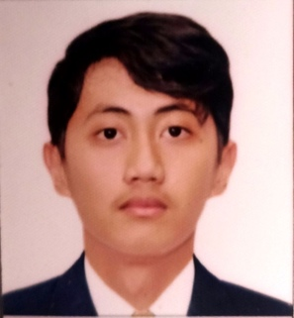
DRICIAN FRANCIS D. CORDON
Blk 11 Lot 62 SM Square Exec. Homes Ugong Valenzuela City
December 27, 2004
09813938660
dricianfranciscordon@gmail.com

OBJECTIVE:
To gain experience while learning and to showcase my skills while contributing on development of an organization and to be able to fully use and utilize my skills to the company that will benefit from it.

WORK EXPERIENCE:
GreenLight Power Inc - Encoder February 2026 – Present
accurately input, update, and organize information into a company’s digital database or system. responsible for reviewing source documents, checking for errors, and ensuring that all records are perfectly maintained and easy to retrieve
- Encoded and processed corporate information into the digital database with a high degree of speed and accuracy.
- Reconciled conflicting system data against physical reference files to identify missing or mismatched information.
- Investigated data anomalies and resolved unmatched records to maintain total database accuracy and integrity.
- Categorized and organized high volumes of physical paperwork to streamline the data entry pipeline.
- Verified raw source documents against database entries to eliminate formatting errors before final submission.

EDUCATIONAL BACKGROUND: Year Graduated
Tertiary Level: BSIT in Pamantasan ng Lungsod 2023- Present
Ng Valenzuela
Secondary Level: Sitero Francisco Memorial Natl. HS 2018 - 2022
Dagupan City National High School 2017 - 2018
Primary Level: Silvestre Lazaro Elem. School 2011 - 2017

AFFILIATIONS: N/A
SKILLS: Can do basic computer skills
Can use Microsoft Office Softwares (Word, Powerpoint, Excel)
Can do Basic Canva Visual Presentations

SEMINARS ATTENDED:
Workshop For Work Immersion Students (March 20, 2022)

REFERENCES:
Name: Roselle G. Hutamariz
Position: Teacher III Contact Number: 09476158065
Name: Louise Jonalyn L. Atienza
Position: Teacher I Contact Number: 09953261970
Name: Ruby Alcala-Partible
Position: Teacher III Contact Number: 09233211171

