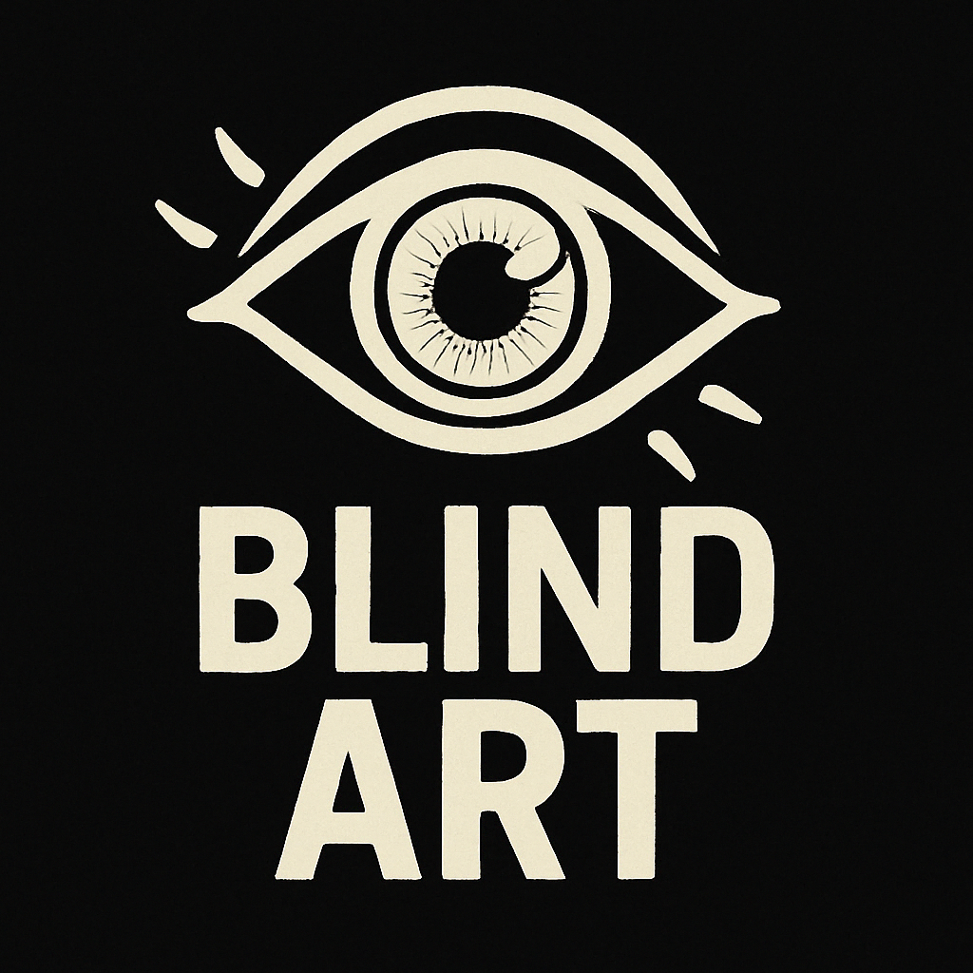

Blind Art was formed in 2020 as “therapy”. We started by drawing and painting improving our skills. The desire to create and leave behind something beautiful has grown immensely since then.

Today we have expanded into other forms of Art and Design including what page design and app creation. We presently have many exciting endeavors in progress ranging from nft design and production to application developments.

You can help support our projects by donating and purchasing NFTs. We appreciate your patronage and welcome any input or suggestions for new projects.

Thank you and have a beautiful day!

click here to contact us

