CAMPUS INFORMATION KIOSK WITH 3D WAYFINDING AND REAL-TIME ANNOUNCEMENT SYSTEM

MARY GRACE MANATA ENRIQUEZ

A THESIS SUBMITTED
IN PARTIAL FULFILLMENT OF THE REQUIREMENTS
FOR THE DEGREE OF MASTER IN INFORMATION TECHNOLOGY
AEMILIANUM COLLEGE INC.
SORSOGON CITY

2026
RECOMMENDATION FOR APPROVAL

The thesis attached hereto, titled “Campus Information Kiosk with 3D Wayfinding and Real-Time Announcement System”, prepared and submitted by Mary Grace Manata Enriquez, in partial fulfillment of the requirements for the degree, Master in Information Technology, is hereby recommended.

JOSEFINA R. SARMIENTO, MIT, PhD
Adviser

REV. FR. CHARLES G. BANIEL, CRS
Chairperson

MILAN E. BAUSA, MIT
Member

MARILYN D. BERDIN, MPA
Member

GASPAR D. ESCOTE, LPT, PhD
Member

Recommended for approval in partial fulfillment of the requirements for the degree, Master in Information Technology.

FIRST NAME MIDDLE INITIAL FAMILY NAME, Degree Earned
Dean, CECTLA

APPROVAL SHEET

By virtue of the recommendation of the thesis committee, this thesis titled “Campus Information Kiosk with 3D Wayfinding and Real-Time Announcement System”, prepared and submitted by Mary Grace Manata Enriquez, is hereby approved in partial fulfillment of the requirements for the degree, Master in Information Technology.

FIRST NAME MIDDLE INITIAL FAMILY NAME, Degree Earned
School Director

ACKNOWLEDGMENT

This section reflects the student’s gratitude and should convey sincerity and individuality in recognizing the contributions and support of individuals or institutions on the completion of their thesis.
Write the ACKNOWLEDGMENT section as follows:
- Present the text in paragraph form.
- Use a regular font style (non-bold, non-italic) with font size 12
- Write in double-spacing
- Use third-person nouns and pronouns to express gratitude.
- Indicate the student’s name initials, flush right, two spaces after the last line of the acknowledgment, as shown below:
A.B.C.
(Student’s name initials written in bold
uppercase letters, with a period in each
initial, and no spaces in between.)

ABSTRACT

TABLE OF CONTENTS
 |  |  | Page
TITLE PAGE…………………………………….………………….…………. |  |  | i
RECOMMENDATION FOR APPROVAL………………………………….. |  |  | ii
APPROVAL SHEET………………….………………….……………………. |  |  | iii
ACKNOWLEDGMENT………………….………………….………………. |  |  | iv
ABSTRACT………………….………………….………………….…………... |  |  | vii
LIST OF TABLES………………….………………….………………………. |  |  | viii
LIST OF FIGURES………………….………………….……………………... |  |  | ix
INTRODUCTION
 | Subtopic 1………………….………………….………………….…………... |  | 1
 | Subtopic 2………………….………………….………………….…………... |  | 4
 | Subtopic 3………………….………………….……………………………… |  | 6
 | Subtopic 4………………….………………….……………………………… |  | 7
 | Subtopic 5………………….………………….……………………………… |  | 8
 | Subtopic 6………………….………………….……………………………… |  | 10
 | The Frameworks of the Study………………….………………….…………. |  | 12
 | The Present Study………………….………………….……………………… |  | 17
 | Definition of Key Terms………………….………………….………………. |  | 22
METHODOLOGY
 | Resources ………………….………………….………………………..…… |  | 26
 | Stakeholders ………………….………………….………………………… |  | 30
 | Constraints … ………………….………………….………………………… |  | 32
 | Project Development Methodology ………………….………………….…… |  | 36
RESULTS |  |  | n
 | Result 1………………….………………….………………….……………... |  | n
 | Result 2………………….………………….………………….……………... |  | n
 | Result 3………………….………………….………………………………… |  | n
 | Result 4………………….………………….………………….……………... |  | n
DISCUSSION (the number of subtopics here must be the same as those in the Results)
 | Discussion 1………………….………………….……………………………. |  | n
 | Discussion 2………………….………………….……………………………. |  | n
 | Discussion 3………………….………………….……………………………. |  | n
 | Discussion 4………………….………………….………………….………… |  | n
CONCLUSION AND RECOMMENDATION………………………………. |  |  | n
REFERENCES………………….………………….………………………….. |  |  | n
APPENDICES………………….………………….………………….………... |  |  | n
BIONOTE………………….………………….………………….…………….. |  |  | n
LIST OF TABLES

No. |  |  |  |  |  |  |  |  |  | Page
1 |  | Software Requirements . . . . .. . . . . . . . . . . . . . . . . . . . . . . . . . . . |  |  |  |  |  |  |  | 26
2 |  | Hardware Requirements . . . . .. . . . . . . . . . . . . . . . . . . . . . . . . . . . |  |  |  |  |  |  |  | 28
3 |  | Gantt Chart of the Development Time Frame of the Proposed System |  |  |  |  |  |  |  | 34

LIST OF FIGURES

No. |  |  |  |  |  |  |  |  |  | Page
1 |  | Conceptual Paradigm . . . . . . . . . . . . . . . . . . . . . . . . . . . . . . . . . . . . . . . |  |  |  |  |  |  |  | 16
3 |  | Agile Development Methodology . . . . . . . . . . . . . . . . . . . . . . . . . . . . |  |  |  |  |  |  |  | 38
4 |  | Figure 4 Title or Description . . . . . . . . . . . . . . . . . . . . . . . . . . . . . . . . . |  |  |  |  |  |  |  | n
5 |  | Figure 5 Title or Description . . . . . . . . . . . . . . . . . . . . . . . . . . . . . . . . . |  |  |  |  |  |  |  | n

INTRODUCTION
This section discusses the Background of the Study, Related Literature, Legal Foundations, Philosophical Perspectives, Rationale, SDG Relevance, and other related sources. These provide the basis and support for developing a Campus Information Kiosk with 3D Wayfinding and Real-Time Announcement System.

Digital Campus Information
The continuous development of digital technology has created opportunities for educational institutions to improve the way information is organized, managed, and accessed by students, teachers, parents, visitors, and other stakeholders. Schools commonly share information about their offices, facilities, programs, schedules, activities, services, and other institutional matters. Yet, if the information is spread out via separate channels such as bulletin boards, printed notices, signs, and by means of personal inquiries, users might find it difficult to find accurate and up-to-date information. A central digital information system can address this problem by making relevant school information available through an accessible, interactive platform. Developing accessible digital information services aligns with Republic Act No. 10533, or the Enhanced Basic Education Act of 2013, which supports quality basic education through resources and approaches responsive to learners' needs.
A Campus Information Kiosk can serve as a central information hub within the school, allowing users to access what they need on their own. The system can divide information into categories, including school offices, facilities, services, schedules, activities, and other pertinent campus information. Authorized administrators can manage and update the content displayed on the kiosk, making it easier to keep the information up to date. By adopting this method, the system can reduce reliance on printed materials and repeated inquiries while offering users a convenient way to access school information.
Recent studies indicate that interactive digital systems can be used to provide information about the campus. Oyeman et al. (2024) created a Campus Interactive Information Kiosk with 3D Mapping that not only provided campus information and detailed instructions but also used a 3D map to help users navigate. Their study shows the potential of integrating information services with navigation in an interactive kiosk. Similarly, Garcia et al. (2023) developed a playable 3D virtual tour which enabled users to explore the school's facilities interactively, illustrating how digital technologies can enhance access to information on educational environments.
The proposed system extends these concepts by providing a central platform for campus information, along with several other functions relevant to the school community. In addition to general campus information, it will allow authorized students to view their academic grades. Integrating these information services supports Sustainable Development Goal 4 (SDG 4): Quality Education, specifically by promoting inclusive and supportive educational environments. By improving access to relevant school information, the proposed system can help create a more organized, accessible, and technology-supported school environment.

3D Campus Wayfinding
Campus navigation can be challenging for students, parents, visitors, and other individuals who are unfamiliar with the physical arrangement of a school. Since classrooms, offices, laboratories, activity areas, and other buildings are situated in various parts of the campus, those who are using it for the first time find it hard to know where their destination is. Although standard signs and printed maps give some guidance, they do not properly show the real appearance and surroundings of the different campus locations. As a result, people often have to ask members of the school or someone else for help in order to find a particular facility.
The application of 360-degree imagery and interactive three-dimensional environments offers an alternative method of navigating a campus. With a 360-degree view, users are able to see the surrounding area from various angles, and interactive elements allow them to digitally explore different parts of the campus. Anshary et al. (2023) created a 360-degree panoramic virtual tour by using point-tracking technology in order to introduce the Siliwangi University campus, showing how panoramic imagery can be employed to present campus environments in an interactive way. Similarly, Garcia et al. (2023) developed a playable 3D virtual tour of the campus which enabled users to explore the school's facilities via an interactive environment.
The fact that an interactive campus wayfinding system is needed is also supported by Apu, Koo, and Amir Sharji (2025), who looked into the requirement for a 3D interactive university campus aimed at wayfinding. The study was concerned with helping students, faculty members, and visitors to explore the campus areas and showed that interactive digital campus environments are relevant for navigation. The studies thus form a basis for introducing visual and interactive technologies into campus wayfinding and prove that digital representations can complement traditional maps and physical signs by giving users a clearer understanding of the campus spaces.
The proposed system will use 360-degree camera images to show the real campus locations and to support the 3D wayfinding feature. Rather than mainly depend on AutoCAD-based representations, the actual 360-degree images will help users to identify buildings, pathways, classrooms, offices, laboratories, and other facilities on the school premises. This element corresponds with Sustainable Development Goal 9 (SDG 9): Industry, Innovation and Infrastructure, especially in relation to technological innovation and the enhancement of infrastructure via digital solutions. By incorporating 360-degree images of the campus into an information kiosk, the proposed system puts digital innovation into practice in order to improve navigation around the campus and the accessibility of the school's existing facilities.

Real-Time School Announcements
It is important for an educational institution to communicate effectively since students, teachers, parents, visitors, and all other stakeholders need timely and accurate access to information about the school. The school usually sends out notices concerning its programs, activities, meetings, schedules, reminders, any changes in its operations, and other official business. Yet, if the notices are sent through several channels, the information may become hard to keep track of or might not get to all the people it should reach. Moreover, printed notices can become outdated when there are changes to the schedule or activities, which means that there is a need for a more flexible and easily updatable way of distributing information.
A Real-Time Announcement System offers a central platform on which authorized members of the school staff are able to create, update, manage, and display official announcements and events. Instead of having to repeatedly print and replace physical notices, digital announcements can be altered whenever changes take place. The system is also capable of arranging the announcements in a clear and accessible manner so that users can see up-to-date school information on the campus kiosk. It thus enhances the efficiency and consistency of communication within the institution and decreases the need for relying on traditional methods of announcement. Where announcements or other displayed information involve personal data, the system must also observe the principles of Republic Act No. 10173 or the Data Privacy Act of 2012, particularly regarding the proper collection, processing, storage, and disclosure of personal information.
Recent research has shown that centralized digital announcement systems can be developed. Zabidin, Rubbini, and Ali Yusny (2025) created a web-based announcement system for Universiti Utara Malaysia in order to deal with the problems of decentralized communication, information overload, redundancy, and uneven distribution of messages. Their study shows the advantages of using a centralized platform for the management and distribution of educational and institutional announcements. The proposed system adopts a similar approach but combines the announcements with campus information and 3D wayfinding in a physical campus kiosk.
The real-time announcement feature corresponds to Sustainable Development Goal 16 (SDG 16): Peace, Justice and Strong Institutions, specifically by promoting effective, accountable and inclusive institutions as well as access to information. In a school setting, offering up-to-date and well-organized official announcements can help to improve transparency and enhance communication between the institution and its various stakeholders. The proposed system will therefore integrate real-time announcements with campus information, 3D wayfinding, and authorized access to student grades on a single platform. By incorporating these different functions, the Campus Information Kiosk with 3D Wayfinding and Real-Time Announcement System seeks to deliver an accessible, innovative and responsive digital information service to the school community.
The Frameworks of the Study
This section presents the conceptual framework that organizes the major components, processes, and expected output of the study. It explains how the technological resources and system requirements are transformed through an Agile development process into an AI-powered and centralized information management system.
Conceptual Framework. The conceptual framework of the study presents the main ideas involved in developing the Campus Information Kiosk with 3D Wayfinding and Real-Time Announcement System. It shows the connection between the inputs, development process, and expected outputs of the study. It also provides a guide on how the proposed system addresses the need for accessible campus information, interactive navigation, and timely school announcements.
The conceptual paradigm, shown in Figure 1, presents the framework of the study. It shows how campus information, 360-degree camera images, announcements, events, and student information and grades serve as inputs to the system development process. The process includes system design, database development, 3D wayfinding integration, announcement management, SMS and email notification, and student grade-viewing integration, which lead to the development of the proposed system.
The framework also shows how the system's features work together to improve access to campus information. Campus information provides users with relevant school details, while 3D wayfinding helps users locate facilities, and the announcement system delivers real-time school announcements and events through the kiosk, SMS, and email. Notifications may also include links that direct users to the venue location through the wayfinding feature.
The framework will guide the researchers in developing and evaluating the proposed system. It will also help determine whether the system meets the identified needs for accessible campus information, effective wayfinding, timely announcements, and authorized student grade viewing.

Figure 1
Conceptual Paradigm
Input Process Output
Campus Information Kiosk with 3D Wayfinding and Real-Time Announcement System
Agile Development Methodology

Plan
Design
Develop
Test
Deploy
Review
Launch

Develop a campus information kiosk that provides centralized and accessible information about the school, offices, facilities, services, and other relevant campus information;

Develop a 3D wayfinding feature using 360-degree camera imagery to provide interactive and realistic visualization of campus locations and assist users in locating buildings, offices, classrooms, laboratories, and other facilities;

Develop a real-time announcement system that enables authorized administrators to create, update, manage, and display official school announcements and events through the kiosk;

Integrate an authorized student information and grade-viewing feature that allows students to securely access and view their academic grades through the system; and

Evaluate the system's software quality using the ISO/IEC 25010 Software Quality Model in terms of functional suitability, performance efficiency, compatibility, usability, reliability, security, maintainability, and portability.

Feedback

The findings of this study may benefit Aemilianum College Inc. by providing a centralized Campus Information Kiosk with 3D Wayfinding and Real-Time Announcement System that improves access to and management of campus information. Students will be able to obtain information about the school, announcements, events, and their authorized academic grades via the kiosk, while the 3D wayfinding feature will help them find classrooms, offices, laboratories, and other buildings. Faculty members and administrative staff will find it easier to manage and distribute official announcements and information through the system, including by means of SMS and email notifications. Parents and visitors too can access the relevant campus information and make use of the wayfinding feature to locate the school's facilities. Finally, the school administrators and management will be able to enhance institutional communication, information management, and its digital services.

The Present Study

The related studies focus on developing a campus interactive information kiosk that provides information and detailed instructions to campus visitors and clients. It features an interactive interface that enables users to find campus information on their own and includes a 3D map module to help them navigate the school's facilities. Similar to the present study, it aims to provide a centralized and self-service platform so that students, visitors, and other members of the campus community can easily access school information and find facilities. Both systems acknowledge the value of an interactive kiosk in reducing the need for staff to provide basic information and directions. Nevertheless, the present study differs in that it uses 360-degree camera images for its 3D wayfinding feature and also incorporates extra functions such as real-time announcements and event notifications, SMS and email alerts, and authorized access to student grades. Therefore, while the related system is mainly focused on campus information and 3D mapping, the present study offers a wider range of information, navigation, communication, and student information services.
The other system is a Student Information System intended to manage and provide access to academic information about students. It includes features like keeping student records, handling class details, and giving access to academic performance, such as marks and grades. The purpose of the system is to increase the accessibility of student information and to cut down the amount of time that teachers and other members of the school have to spend retrieving and managing the records. Similar to the present study, it offers centralized access to student information and grades and helps to improve information management in an educational institution. Both systems place an emphasis on accessibility and on ensuring that information is available to authorized users in a timely manner. The related system, however, is mainly concerned with student records and academic information, whereas the present study incorporates the ability to view student grades as part of a wider campus information kiosk.
Another related system, IntelliSchool, is a web-based Student Information System designed to improve academic data management and facilitate communication between the school and its various stakeholders. It offers features such as web-based class record management, student information management, academic form production, grade viewing, and communication via messaging and SMS. Students and parents can view grades through their accounts, and advisers can send SMS messages and tailored communications to students and parents about important school matters. The present study has a similar feature; this system combines grade viewing with communication and notification functions. Like the present study, both systems grant authorized access to academic information and acknowledge the value of timely communication through electronic means. However, the present study differs in that its main platform is a campus information kiosk rather than a dedicated student information system. The proposed system integrates grade viewing with campus information, 360-degree wayfinding, real-time announcements and events, and SMS and email notifications.
A similar system uses a web-based academic information system and an SMS gateway to manage students' academic records and send parents school-related information. It was designed to improve how student data is processed and to support the delivery of important academic information via SMS. Similar to the present study, it shows that electronic notification systems are useful for the timely distribution of school-related information. Both systems use centralized information and electronic communication to reduce delays normally found in information dissemination. Nevertheless, the related system mainly focuses on academic information and SMS-based communication, whereas the present study combines real-time announcements and events with campus information, 3D wayfinding, email and SMS notifications, and authorized grade viewing. In this study, notifications also include location links in announcement messages to help users find an event venue if needed.
The related system, Virtual Campus Walkthrough App for Aemilianum College Inc., explores the development of a virtual campus tour using 3D modeling, 360-degree panoramic images, interactive maps, guided tours, and information hotspots. This application enables prospective students, current students, members of the faculty, and visitors to navigate the various pathways, hallways, staircases, and certain facilities via an interactive web-based walkthrough. In order to take the panoramic images, the researchers employed an Insta360 ONE X2 camera and used 3Sixty Web Tour Maker to link the images and thus produce an immersive experience of exploring the campus. The related study is related to the present study because both of them make use of 360-degree panoramic imagery and interactive campus visualization to help users get acquainted with the school facilities and to navigate around the campus. The study is particularly relevant because it focuses on Aemilianum College Inc., the same institution covered by the present study. The difference lies in the fact that the related system mainly concentrates on virtual campus exploration, while the present study develops a functional Campus Information Kiosk together with 3D Wayfinding and a Real-Time Announcement System. Furthermore, the present study includes a real-time interactive map which enables users to navigate the campus, follow directions, and identify the correct routes to their destinations. It also combines centralized campus information, real-time announcements and events, SMS and email notifications, links to venues and locations, and authorized access to student grades into a single platform.
The gap analysis shows that existing studies generally address campus information kiosks, 360-degree virtual tours, campus wayfinding, announcement management, or student information systems as separate functions, with limited integration of these features into one platform. The present study is unique because it combines in a single system centralized campus information, a real-time interactive map that can be used to navigate around the campus and find the correct directions, real-time announcements and events, SMS and email notifications, and authorized access to student grades. The notifications can also include links that take users to the relevant event venues via the wayfinding feature. This integrated method meets the need for a more accessible, well-organized, and user-friendly campus information service for students, staff, faculty members, and visitors.
The study focuses on the development of a Campus Information Kiosk with 3D Wayfinding and Real-Time Announcement System for Aemilianum College Inc. The system encompasses campus information management, wayfinding based on 360-degree camera images together with an interactive map, real-time announcements and event management, the sending of SMS and email notifications including links to the venue and location, and access by authorized students to their personal information and grades. It does not include AI-powered chatbot services, online payment processing, enrollment processing, accounting, payroll, library management, tuition fee collection, and the development of a native mobile application. Furthermore, the study is constrained by the accuracy and completeness of the campus information and student records supplied, by the availability of internet connectivity and notification services, by the quality of the 360-degree camera imagery, and by the capabilities of the technologies employed in the development of the system.
The general objective of this study is to develop a Campus Information Kiosk with 3D Wayfinding and Real-Time Announcement System for Aemilianum College Inc., that provides a centralized, accessible, and user-friendly platform for campus information, interactive navigation, real-time announcements, and authorized student grade viewing. Specifically, it aims to: 1) develop a campus information kiosk that provides centralized and accessible information about the school, offices, facilities, services, and other relevant campus information; 2) develop a 3D wayfinding feature using 360-degree camera imagery to provide interactive and realistic visualization of campus locations and assist users in locating buildings, offices, classrooms, laboratories, and other facilities; 3) develop a real-time announcement system that enables authorized administrators to create, update, manage, and display official school announcements and events through the kiosk; 4) integrate an authorized student information and grade-viewing feature that allows students to securely access and view their academic grades through the system; and 5) evaluate the system's software quality using the ISO/IEC 25010 Software Quality Model in terms of functional suitability, performance efficiency, compatibility, usability, reliability, security, maintainability, and portability.

Project Dictionary
The following key terms are conceptually and operationally defined to provide clarity and consistency in understanding the major concepts, technologies, system components, and evaluation criteria used in the study.
Campus Information Kiosk. This refers to an interactive self-service system that enables users to access institutional information and selected services through a digital interface (Bitner, Ostrom, & Meuter, 2002). In this study, it serves as the primary platform for students, faculty members, staff, and visitors to access campus information, announcements, events, interactive wayfinding, and authorized student grade-viewing services.
Campus Information. This refers to information about an educational institution, including its offices, facilities, services, schedules, and other relevant details. In this study, it covers the school-related information organized and presented through the proposed campus information kiosk.
3D Wayfinding. This refers to the use of three-dimensional visual representations and navigation aids to help users identify locations and determine directions within an environment (Apu, Koo, & Amir Sharji, 2025). In this study, users can navigate campus locations through 360-degree camera imagery and an interactive map to identify the correct routes to buildings, offices, classrooms, laboratories, and other facilities.
360-Degree Camera Imagery. This refers to panoramic images that capture the surrounding environment in all directions. In this study, it provides realistic visual representations of campus locations and supports the interactive wayfinding feature of the proposed system.
Real-Time Announcement System. This refers to a digital platform that enables authorized personnel to create, update, manage, and disseminate announcements and event information. In this study, it allows authorized administrators to publish official school announcements and events through the campus information kiosk.
SMS Notification. This refers to delivering information through the Short Message Service, which enables messages to be sent to mobile phones. In this study, it allows users to receive school announcements and event notifications via text messages, which may include links to the corresponding venue or campus location.
Email Notification. This refers to the electronic delivery of messages and information to designated recipients through email services. In this study, it enables users to receive school announcements and event notifications through email, including venue-location links when applicable.
Venue-Location Link. This refers to a clickable link that directs users to information about a specific event venue or campus location. In this study, it may be included in SMS and email notifications to help users locate the appropriate destination through the system's wayfinding feature.
Student Information. This refers to information associated with students and their academic records maintained by an educational institution. In this study, it covers the student information needed to support the proposed system's authorized grade-viewing feature.
Student Grade Viewing. This refers to the electronic access and display of students' academic grades through a digital platform. In this study, it allows authorized students to securely view their academic grades through the proposed system without covering the institution's complete student information management functions.
User Authentication. This refers to the process of verifying a user's identity before granting access to a system or its restricted features (National Institute of Standards and Technology [NIST], 2017). In this study, it helps protect restricted system features and student academic information from unauthorized access.
METHODOLOGY
This section presents the resources, stakeholders, constraints, and development methodology employed in designing, developing, testing, and implementing the Campus Information Kiosk with 3D Wayfinding and Real-Time Announcement System.

Resources
The development of the Campus Information Kiosk with 3D Wayfinding and Real-Time Announcement System. requires reliable software, hardware, and development tools to ensure the system's functionality, efficiency, security, and scalability. These resources include programming languages, frameworks, database management systems, software applications, hosting services, and hardware components that support the design, development, implementation, testing, and deployment of the proposed system. They form the technological basis upon which the integration of central campus information, 360-degree camera-based 3D wayfinding, interactive campus navigation, real-time announcements, SMS and email notifications, and access by authorized students to their grades can be achieved on a single platform. As a result, these resources contribute to the system's accessibility, usability, and its ability to effectively provide campus information and services to the intended users.
Table 1
Software Requirements
Software | Specifications
Operating System | Windows 10/11 (64-bit) or later
Web Server | Laravel Herd / Apache / Nginx
Database Management System | MySQL 8.0 or MariaDB
Database Administration Tool | phpMyAdmin
Programming Languages | PHP 8.3, JavaScript, HTML5, Tailwind CSS
Front-end Framework | React.js with Inertia.js
Back-end Framework | Laravel 12/13
SMS Gateway | PinasSMS API
Development Environment | Visual Studio Code
Version Control | Git and GitHub
Package Manager | Composer and Node.js (NPM)
Web Browser | Google Chrome, Microsoft Edge, Mozilla Firefox
Email Notification Service | SMTP / compatible email service

Table 1 presents the software requirements necessary for the development, deployment, and operation of the proposed Campus Information Kiosk with 3D Wayfinding and Real-Time Announcement System.. React.js and Inertia.js support the responsive user interface, while Laravel provides the back-end application logic and API services. MySQL serves as the centralized database for institutional information. Development tools such as Visual Studio Code, Composer, Node.js, Git, and GitHub facilitate coding, package management, and version control. These technologies also support the digital school manual, announcements and events, multimedia content, selected online payment functions, and the interactive 3D school map and campus navigation features.

Table 2
Hardware Requirements
Hardware | Specifications
Processor | Intel Core i5 (10th Generation) or AMD Ryzen 5 or higher
Memory (ram) | 16 GB or higher
Storage | 240 GB SSD or higher
Graphics | Integrated Graphics or Dedicated GPU
Display | 21.5-inch Full HD Monitor
Internet connection | Fiber Internet (50 Mbps or higher)
Touchscreen kiosk | 24-inches Touchscreen Display
Printer | Inkjet or Laser Printer (Optional)
Backup storage | External Hard Drive or Cloud Storage

Table 2 presents the recommended hardware requirements necessary for the development, testing, deployment, and operation of the Campus Information Kiosk with 3D Wayfinding and Real-Time Announcement System. The recommended processor specification is at least an Intel® Core™ i5 (10th Generation or higher) or an AMD Ryzen™ 5 processor, providing sufficient computing power to support software development, database processing. A 240 GB Solid-State Drive (SSD) or higher is recommended to provide faster data access, reduced application loading time, and adequate storage for the system source code, multimedia files, database backups, documentation, and other project-related resources essential for system development and maintenance.
The system also requires at least 16 GB of Random Access Memory (RAM) to support efficient multitasking, allowing the integrated development environment, web server, database management system, AI services, and web browsers to operate simultaneously without performance degradation. A 21.5-inch Full HD monitor or larger is recommended to provide developers and administrators with a clear and comfortable workspace when designing user interfaces, monitoring dashboards, and managing institutional information. Since the proposed system incorporates an interactive Campus Information Kiosk, a 24-inch touchscreen display is also required to enable students, faculty members, visitors, and other stakeholders to conveniently interact with the system and access institutional information through an intuitive touch-based interface.
Furthermore, a fiber internet connection with a minimum bandwidth of 50 Mbps is recommended to ensure stable communication with cloud-based services, particularly the PinasSMS Gateway for automated SMS notifications. Reliable internet connectivity also supports software updates, cloud synchronization, online testing, and remote access to the system when necessary. In addition, external storage devices or cloud backup solutions are recommended to provide secure data backup and disaster recovery, while an optional inkjet or laser printer may be utilized for printing reports, system documentation, and administrative records. Collectively, these hardware specifications provide a stable, secure, and efficient computing environment that supports the successful implementation, continuous operation, and long-term maintenance of the proposed Campus Information Kiosk with 3D Wayfinding and Real-Time Announcement System.
Stakeholders
The proposed Campus Information Kiosk with 3D Wayfinding and Real-Time Announcement System is designed to serve various stakeholders of Aemilianum College Inc. by providing a centralized platform for accessing, managing, and disseminating institutional information. Each stakeholder is assigned specific roles and responsibilities according to their functions within the institution. Through role-based access control, the system ensures appropriate information management and restricts access to administrative functions and student records to authorized users.
The School President, serving as the Super Administrator, holds the highest level of administrative authority in the system. This role includes managing user accounts, assigning access permissions, overseeing system operations, and ensuring compliance with institutional policies. The System Administrator manages the platform's day-to-day operations, including keeping campus information up to date, handling announcements and events, updating office directories, and monitoring system performance. These administrative positions help secure the system and ensure its reliability and continuous operation.
The Dean oversees departmental information and academic policies and ensures that relevant academic information is properly disseminated. Faculty Members provide academic announcements, instructional updates, and other relevant information for students and the campus community. The Registrar manages authorized student information and academic grade records, ensuring that these records are accurate and updated. The Accounting Office may publish approved financial announcements and schedules for information purposes. Each office is responsible for maintaining information relevant to its designated functions, subject to the access permissions assigned within the system.
The Students are provided with a dedicated feature that allows them to securely view their own academic grades through the system. Access to grade information is restricted to authenticated students, ensuring that each student can view only their authorized academic records. This feature is intended solely for grade viewing and does not include enrollment processing or the full management of student information records.
The Campus Visitors and Other General Users, including faculty members and staff when accessing public information, can use the kiosk and web-based platform to view school information, office directories, announcements, upcoming events, and other publicly accessible institutional content. They can also use the 3D wayfinding features and interactive campus map to locate offices, classrooms, laboratories, and other facilities. SMS and email notifications may provide updates about important announcements and events, including links that direct users to the corresponding venues through the wayfinding feature. These functions aim to improve campus navigation, enhance information accessibility, and promote efficient communication within the institution.
Constraints
The proposed Campus Information Kiosk with 3D Wayfinding and Real-Time Announcement System aims to improve institutional information dissemination through centralized digital management of the school manual and an interactive touchscreen kiosk. However, despite its capabilities, the system faces several operational and technical constraints that may affect its performance, functionality, and overall implementation. These constraints set the system's boundaries and define the conditions under which it is expected to operate effectively.
One of the primary constraints of the proposed system is its dependence on a stable internet connection for accessing web-based services, updating campus information, displaying announcements, and delivering SMS and email notifications. The availability of notification services also depends on the reliability of the selected SMS gateway, email service, and network connection. Any interruption in connectivity or service availability may delay the delivery of notifications and temporarily limit access to certain system features.
Another constraint involves the accuracy and completeness of the institutional information stored within the system. The reliability of the campus directories, school information, announcements, events, and academic records depends on timely, accurate updates from authorized personnel. If the information is out of date or incomplete, users will see incorrect details. Similarly, the 3D wayfinding feature is effective only if the 360-degree camera imagery is high quality and fully covers the area, the mapped positions of places on campus are accurate, and up-to-date directions are available. Therefore, regular maintenance and content updates are necessary to ensure the system information remains reliable and relevant.
The proposed system is also limited to the operational requirements and organizational structure of Aemilianum College Inc. It includes centralized campus information, 360-degree camera-based 3D wayfinding, an interactive campus map, real-time announcements and event management, SMS and email notifications with venue-location links, and authorized student grade viewing. However, it is not intended to function as a comprehensive Student Information System (SIS), Learning Management System (LMS), or Enterprise Resource Planning (ERP) solution. It does not include AI-powered chatbot services, online payment processing, enrollment processing, accounting, payroll, library management, or tuition fee collection. Access to student grades is restricted to authenticated students who are authorized to view their own academic records, while administrative functions are limited according to assigned user roles and permissions.
Table 4
Gantt Chart of the Development Time Frame of the Proposed System
Activities | MONTHS
Activities | 1 | 2 | 3 | 4 | 5 | 6
Plan
Design
Develop
Test
Deploy
Review
Launch

Table 4 presents the System Development Time Frame (Gantt Chart) of the proposed Campus Information Kiosk with 3D Wayfinding and Real-Time Announcement System. The development of the project was done in six (6) months using Agile Software Development Methodology. The system development time frame shows some important activities like Planning, Design, Development, Testing, Deployment, Review, and Launch. Although each activity is allocated an appropriate time frame within the Gantt Chart, the Agile method made it possible for the researchers to develop the system iteratively through testing and validation of the process.
In the first month of the project, the activities of Planning and Design were done by the researchers. In the Planning process, the functional and non-functional requirements of Aemilianum College Inc. were gathered and analyzed through consultation with stakeholders, interview, document analysis, and review of the current information dissemination process of the college. The data gathered was the foundation in establishing the system scope, user roles, needed system modules, and system requirements. Simultaneously, the Design process entailed the construction of system architecture, database design, user interface mock-ups, UML diagrams, and other technical specifications to serve as guide in the succeeding development process.
From the second to the fourth month, the researchers focused on the Development of the proposed system. The development activities were performed incrementally such that the researchers had the ability to implement and improve the system components based on their priorities. The major modules developed included the Campus Information Management Module, 360-Degree Camera-Based 3D Wayfinding, Interactive Campus Map, Real-Time Announcements and Events Management, User Management, SMS and Email Notification Services, Student Grade-Viewing Module, and Database Management. Through the Agile approach, each module was developed and refined continuously to ensure that its features aligned with the system's objectives and requirements.
The fifth month was primarily allocated to Testing and Debugging. At this stage, the researchers undertook functional and integration testing while also carrying out debugging of the system to address any software problems that existed. Testing was also done to ensure that the integration of the system modules was correct, as well as ensuring that the functionalities developed met the required requirements.
In the sixth month, the system progressed through Deployment, Review, and Launch activities. Deployment involved preparing and implementing the system in the operating environment for which it was designed. The Review activity entailed reviewing the system after it was deployed, making observations, and noting feedback from chosen stakeholders and users and finding out where problems could be addressed. The Launch activity was the official launching of the system for its intended purpose. In keeping with the principles of the Agile approach, the feedback from the review was used to improve the system and suggest improvements.

Project Development Methodology
The present study will employ the Agile Development Methodology in developing the Campus Information Kiosk with 3D Wayfinding and Real-Time Announcement System. Agile is appropriate for the study because it provides an iterative and flexible approach in which the system can be developed, tested, evaluated, and improved continuously based on identified requirements and stakeholder feedback. The development process will follow seven activities: Plan, Design, Develop, Test, Deploy, Review, and Launch, as presented in the project development time frame. In the Plan phase, the foundation of the project will be created by defining system objectives, scope, requirements, users, resources, and activities. In the Design phase, will focus on translating the identified requirements into the system's structure, including its architecture, database, user interfaces, navigation flow, interactive campus map, and 360-degree camera-based wayfinding design. In the Develop phase, the researchers will implement the system using the selected programming languages, frameworks, and database technologies. The development will include the Campus Information Management Module, 3D Wayfinding and Interactive Campus Map, Real-Time Announcements and Events Management, SMS and Email Notification Services, User Management, Student Grade-Viewing Module, and an administrative dashboard with role-based access control. These modules will be integrated to provide centralized campus information, interactive navigation, timely announcements, and secure access to authorized student grades. In the Test phase, the developed system will be tested to find out if its features work efficiently and effectively in accordance with the set standards of functionality, usability, compatibility, reliability, security, and performance, and deficiencies and errors will be corrected. In the Deploy phase, the developed system will be placed in the desired operating environment. The Review phase will examine the results of testing and gather feedback from identified stakeholders, which will help the researchers to determine which features require modification, enhancement, or further refinement. Lastly, the Launch stage will see the final implementation of the developed and analyzed system for the target users at Aemilianum College Inc. Through these phases, Agile allows the researchers to progressively develop and refine the system while ensuring that its features remain aligned with the needs and requirements of the institution.
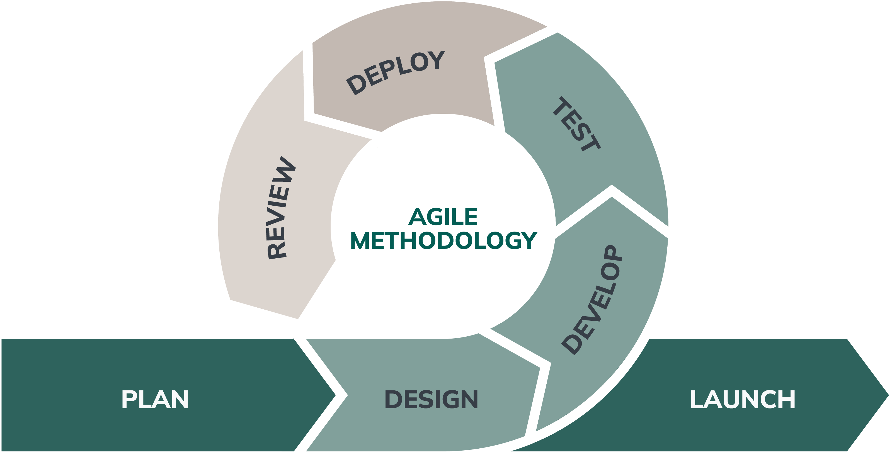

Image: Pierre-Jean Lajoie Michaud
Figure 2
Agile Development Methodology

RESULT
This section presents the outputs of the development of the Campus Information Kiosk with 3D Wayfinding and Real-Time Announcement System for Aemilianum College Inc. The results are organized according to the seven activities of the Agile Development Methodology identified in the Methodology section: Plan, Design, Develop, Test, Deploy, Review, and Launch.
Plan
The Plan activity served as the foundation for the development of the Campus Information Kiosk with 3D Wayfinding and Real-Time Announcement System for Aemilianum College Inc. During this activity, the researcher collected and analyzed the information required to determine the functional and non-functional requirements of the system. This was done through consultations, document review, and direct observation of the current information handling and campus navigation processes at ACI. The result was an understanding of the institution's information needs and the functions the proposed system would need to provide.
The researcher conducted interviews and consultations with relevant stakeholders to understand their information needs, concerns, and expectations regarding the system. The discussion focused on access to school information, locating offices and facilities, receiving news and updates on events, and giving students access to their own grades via the system. The existing institutional information and the way information is currently shared around the campus were also reviewed. All this information was used in the definition of the system requirements and in the structuring of the functions to meet the needs of the kiosk users, students, staff, registrars, and admin.
Based on the information gathered, the researcher identified the principal functions required for the system, including centralized campus information, 360-degree wayfinding, announcement and event management, notification services, student information and grade viewing, and administrative controls. There was a clear requirement to have access controls in place, with access to protected functions being restricted. The public user would be able to access general campus information; student grades would only be available to the student via a login; and admin and academic functions would be restricted according to the user's role.
The researcher also considered the technical and operational constraints that could affect the system. The accuracy of the campus information, announcements, events, and student records would be contingent upon the completeness and timeliness of the data provided by the appropriate staff. The usefulness of the 3D wayfinding would depend on the extent and quality of the 360-degree imagery, the accuracy of the campus location data, and the calibration of the map reference points. The SMS and email notification services would, in turn, depend on internet connectivity and the availability of external services. These constraints and requirements would inform the system design and testing.

Design
The Design activity translated the requirements identified during the Plan activity into the structure of the system. The researcher prepared the system architecture, the flow of data between the system and its users, the database design, and the layout of the user interfaces. These designs served as the guide for the Develop activity and made sure that every function identified in the Plan activity had a place in the system.
The system was designed as a web-based application with four layers, as shown in Figure 3. The client layer consists of the touchscreen kiosk used by campus visitors, mobile phones that open the campus map as an installable web application, the student portal, and the administration panel used by administrators, registrars, and teachers. All of these connect to the system through a web browser over a secure connection, so no separate application has to be installed. The presentation layer was built with React and Inertia.js for the pages, Three.js for the 3D campus map and the 360-degree photo viewer, and Tailwind CSS for the interface and kiosk colors. The application layer runs on the Laravel framework and contains the routes, the security checks, the controllers for the kiosk, student portal, and administration panel, and a queue worker that sends SMS and email notifications in the background. The data layer consists of the MySQL database and the file storage for photos, videos, and 360-degree images. The system connects to two outside services: the PinasSMS gateway for text messages and a mail server for email.
Figure 3
System Architecture of the Developed System
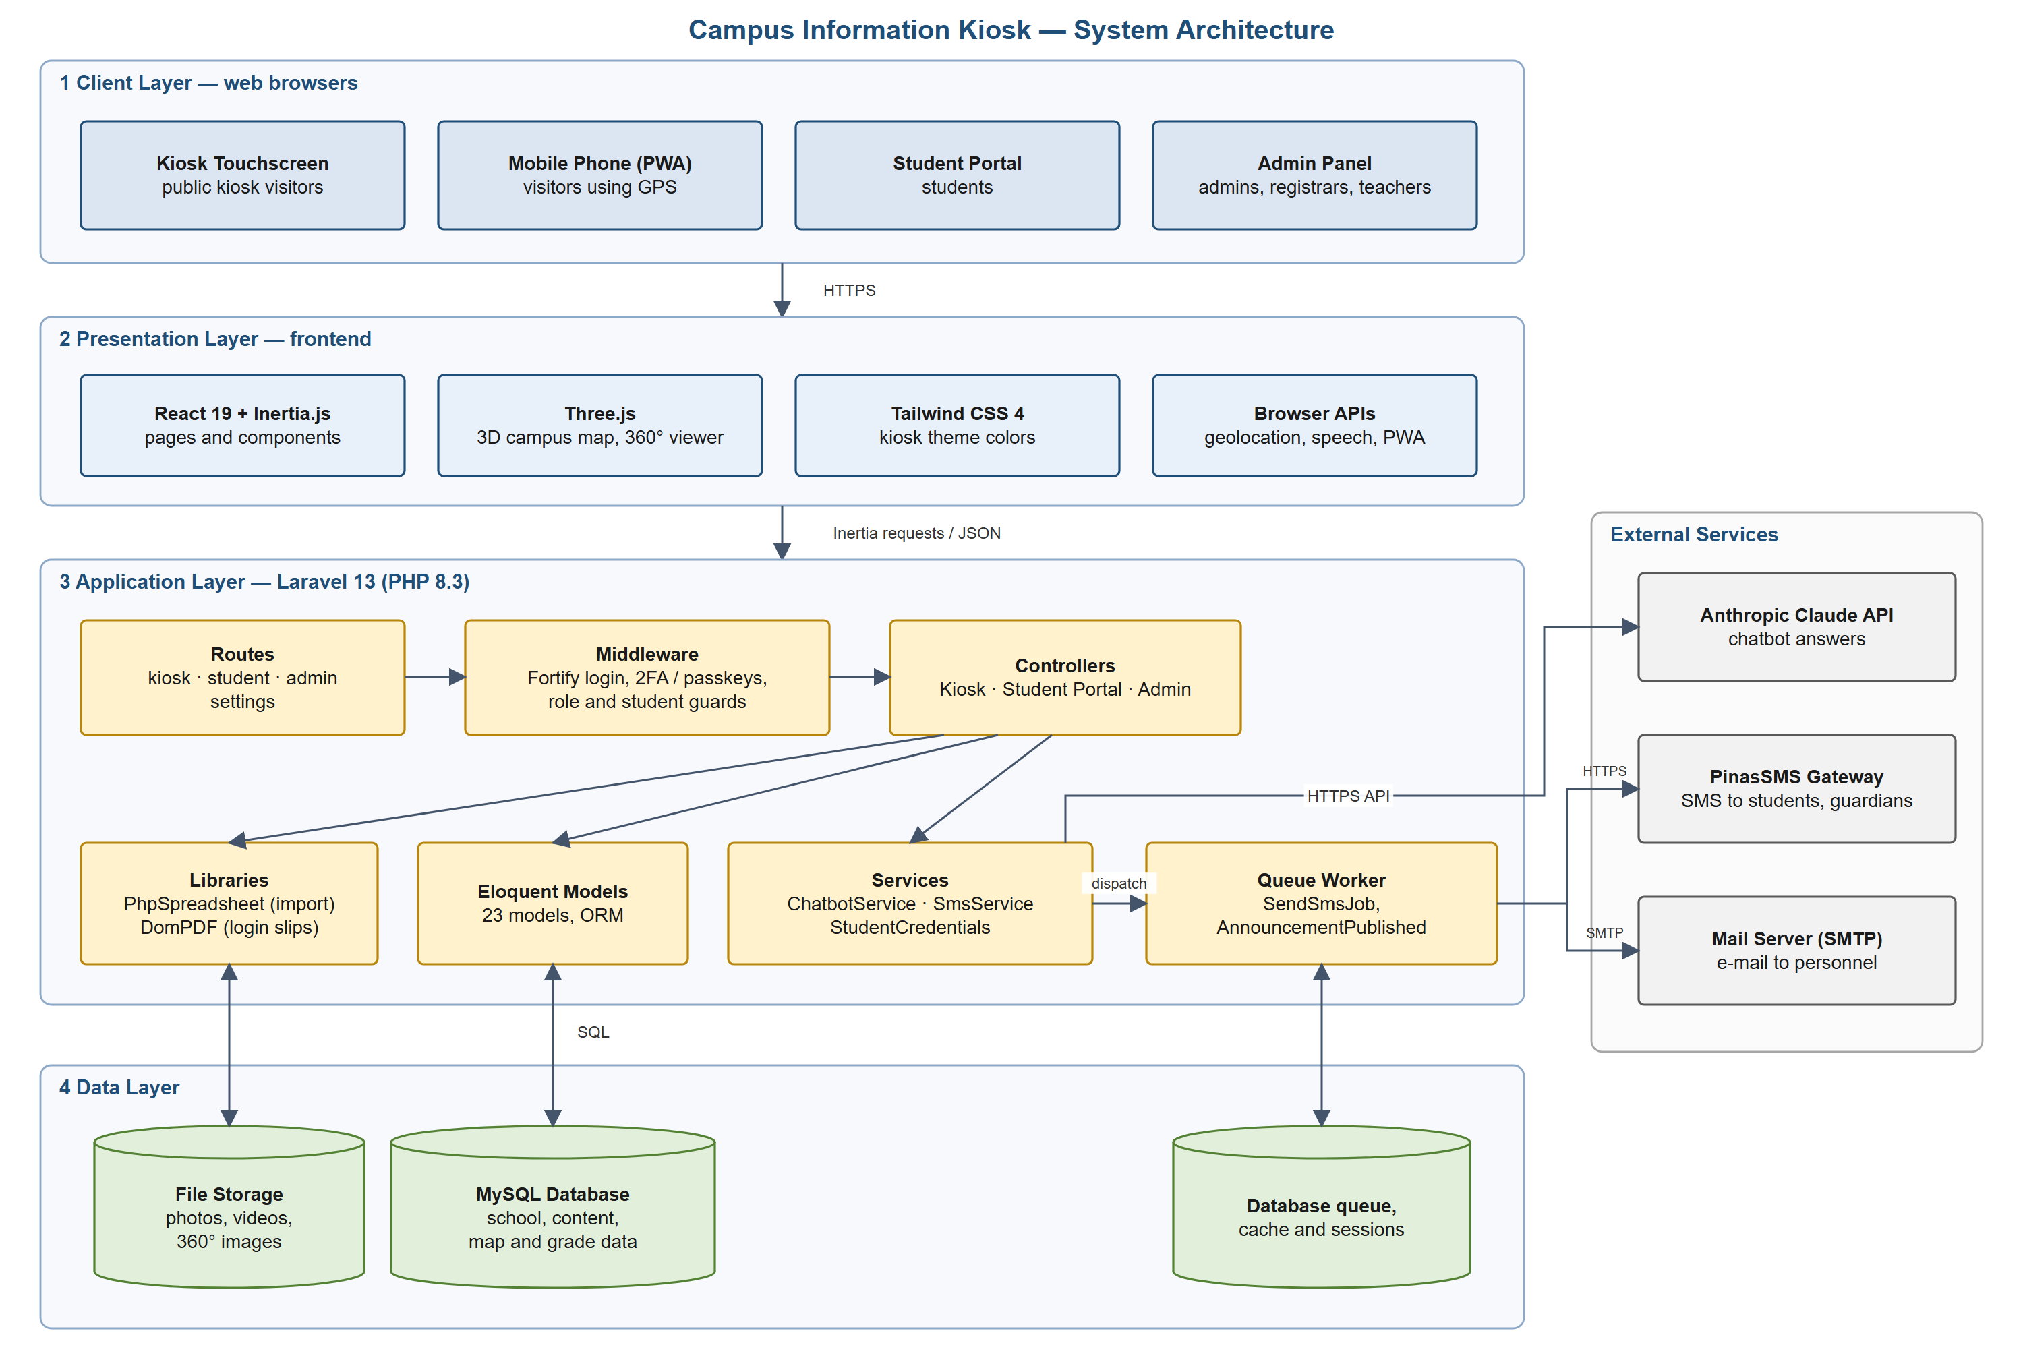
Figure 4 presents the Level 1 Data Flow Diagram of the developed system. It shows how data moves between the users, the main processes, and the data stores. Staff members log in and verify their identity, manage the school manual, create announcements and events, manage the academic setup and student records, encode and release grades, and set up the campus map. Kiosk visitors receive the published articles, announcements, and events, and send their position and chosen destination to the campus map, which returns a walking route, directions, and the matching 360-degree photo. When an announcement is published, the notification process takes the phone numbers of the students and their guardians and sends the message through the SMS gateway and the mail server. Students log in with their student number and password and receive only their own grade report.
Figure 4
Data Flow Diagram (Level 1) of the Developed System
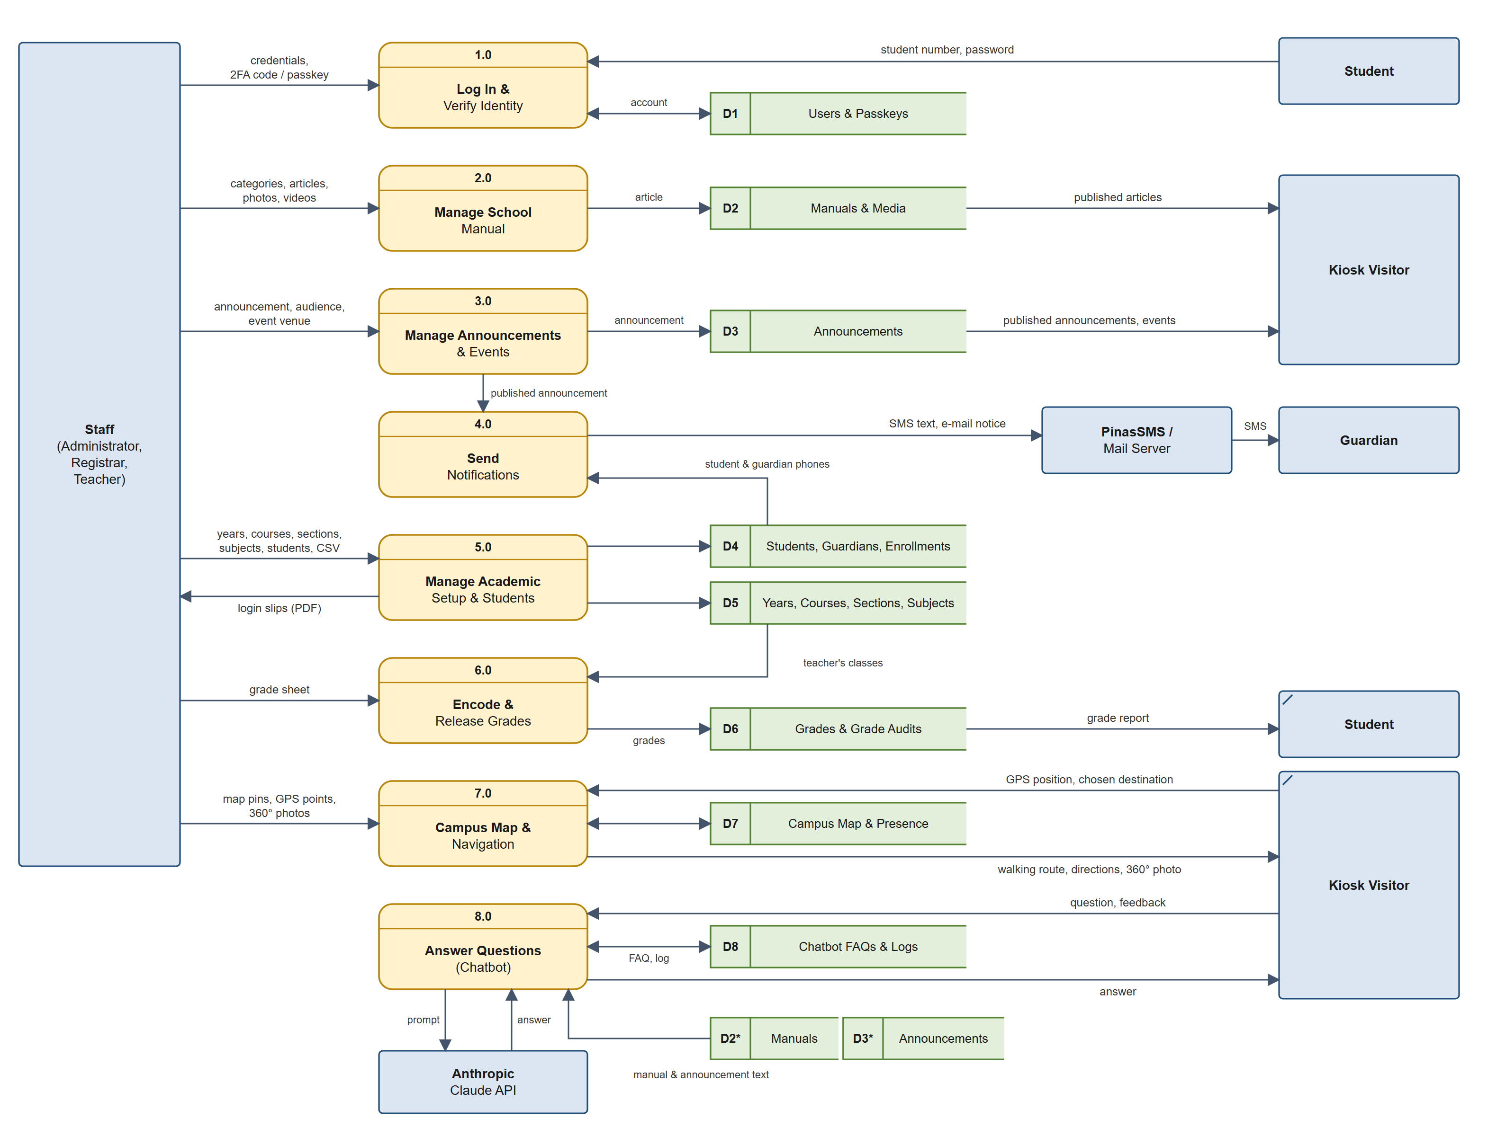
The database was designed around the main records that the school handles, as shown in the Entity-Relationship Diagram in Figure 5. Users, who are the school personnel, write manual articles and post announcements. Announcements may have photos and videos, may be held at a campus location, and may be addressed to selected students. Students belong to courses, have guardians, and are enrolled in sections for each school year, which keeps a history of their enrollment. Teachers are assigned to subjects and sections through teaching assignments, and the grades they encode are linked to the student, the subject, and the school year. Every change to a grade is recorded in a grade audit so that the registrar can trace who changed a grade and when. The campus map is supported by the campus locations, the GPS reference points used to line the map up with real positions, and the 360-degree photos of the campus.
Figure 5
Entity-Relationship Diagram of the Developed System
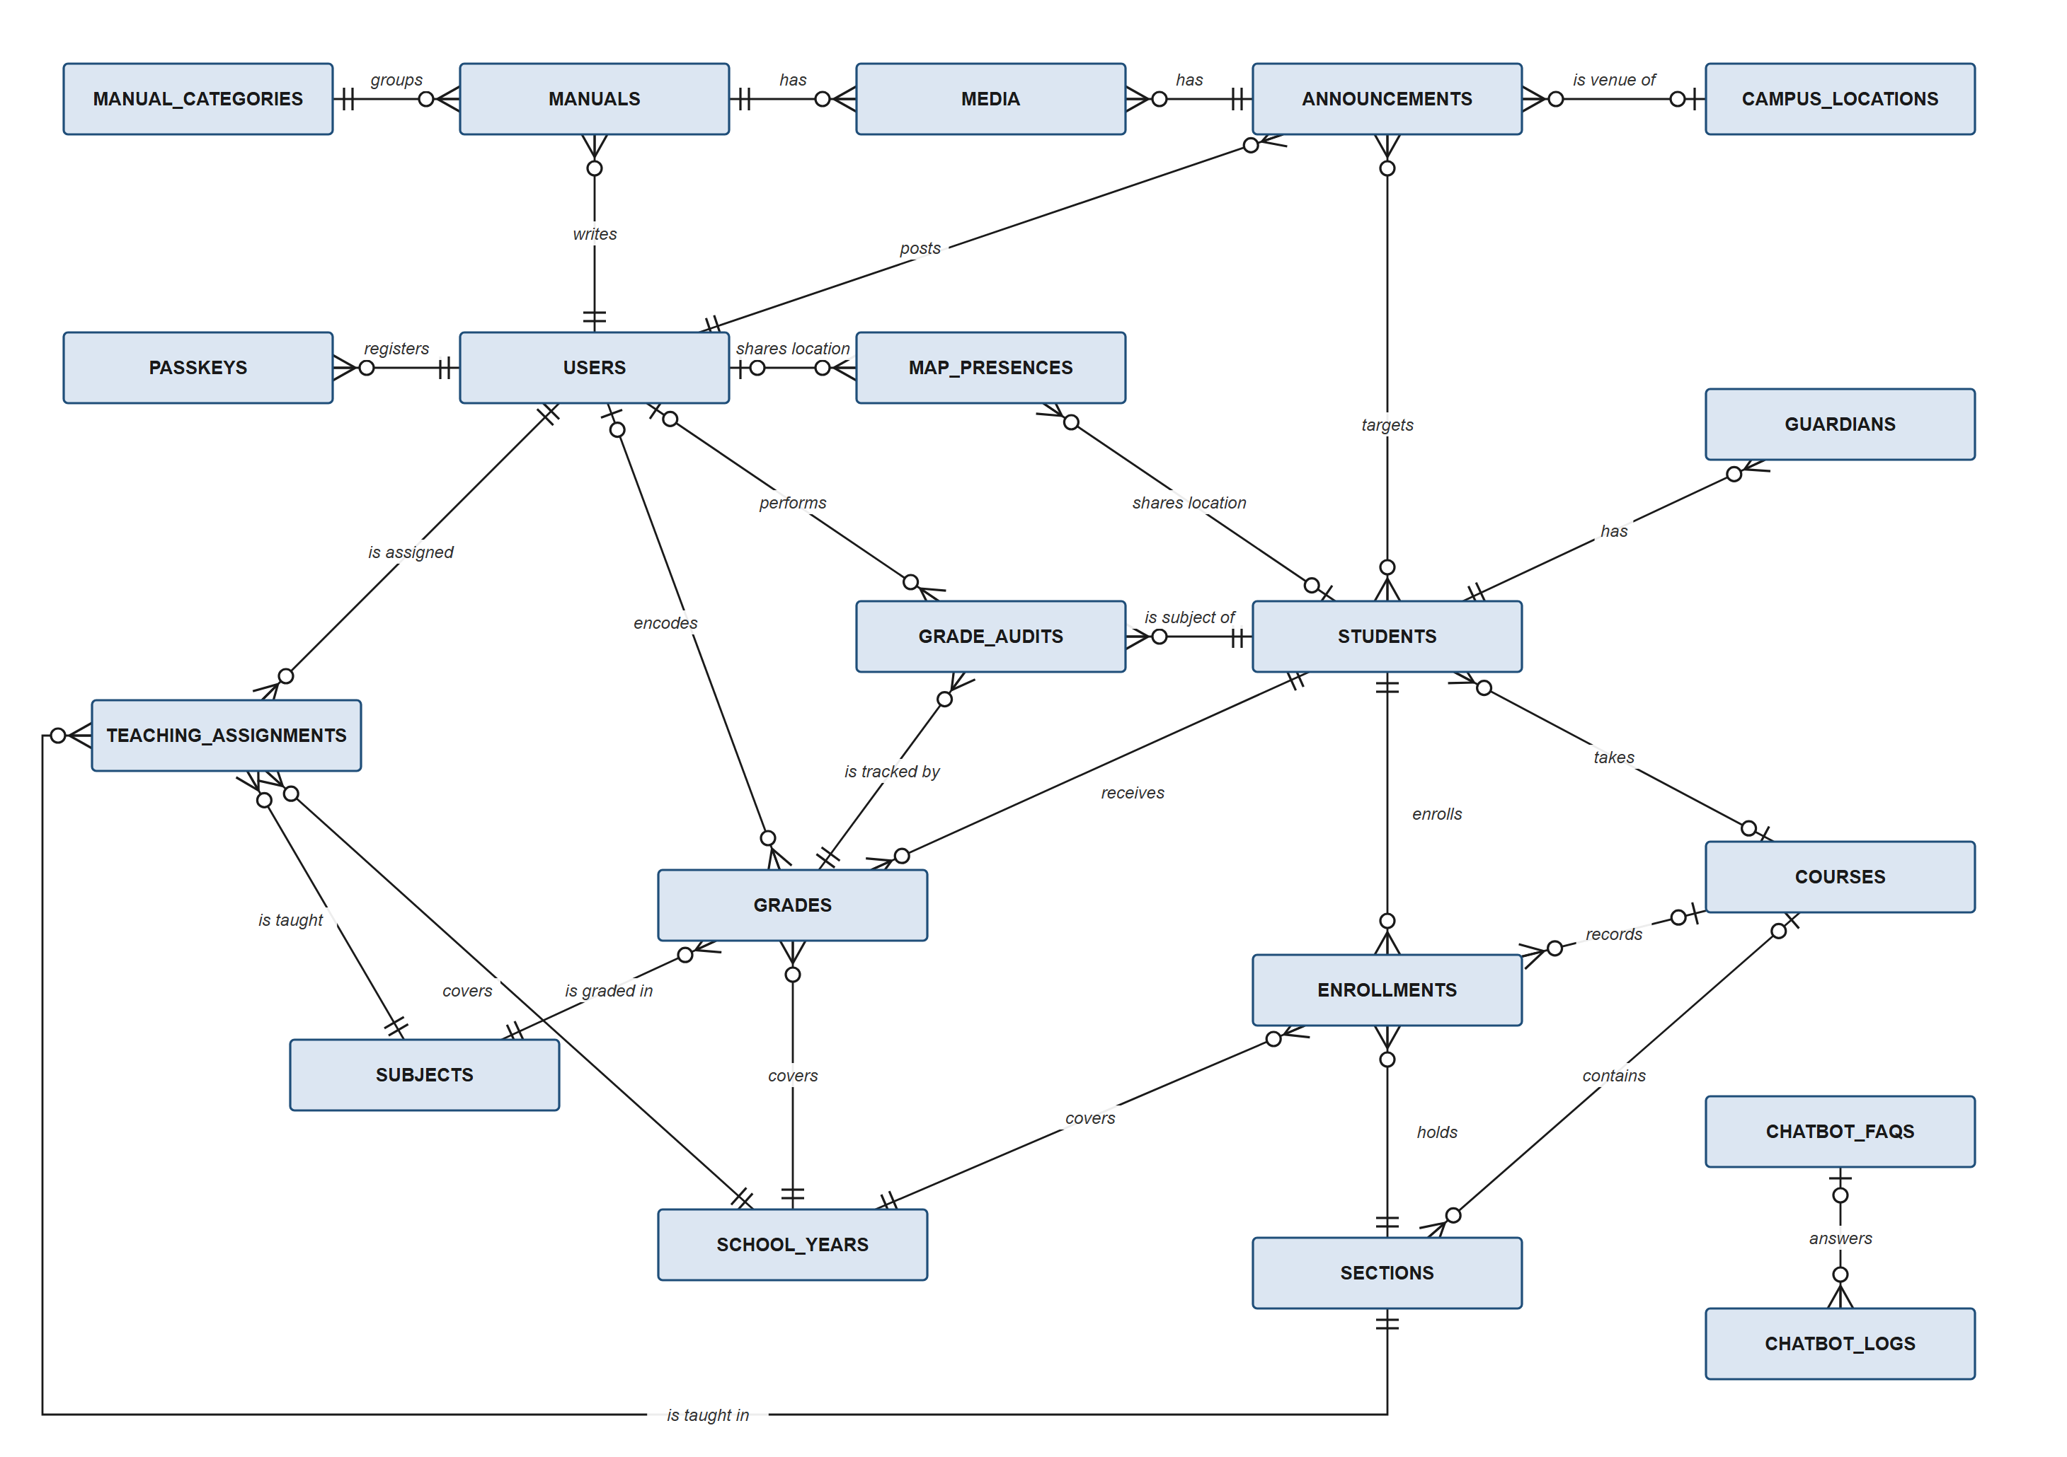
The user interface was designed for two kinds of use. The kiosk screens were designed for a 24-inch touchscreen, with large buttons and short paths to each function, so that a visitor could reach the school manual, the announcements, the campus map, or the student grades from the home screen in a single touch. The same pages were also arranged for the smaller screens of mobile phones, so that a visitor could carry the campus map while walking. The 3D campus model was drawn from the printed site plan of Aemilianum College Inc., with north at the top, so that the buildings, pathways, and covered walks appear in their actual positions.
Access to the system was designed around user roles. The Super Administrator manages the staff accounts. The Administrator manages the school manual, announcements, campus map, and kiosk settings. The Registrar manages the academic setup, student records, and grades, while Teachers encode the grades of their own classes. Because registrars and teachers handle grades, the design requires them to protect their accounts with two-factor authentication. Students sign in through a separate student portal and can see only their own grades, while kiosk visitors use the public functions without signing in.
Develop
During the Develop activity, the researcher built the system module by module, following the designs prepared in the Design activity. The system was developed using Laravel with PHP 8.3 for the back end, React with Inertia.js for the user interface, Three.js for the 3D campus map, and MySQL for the database. Each module was completed, tested, and refined before the next one was added, in line with the Agile approach. The modules and their screens are presented below.
Kiosk Home Screen. The home screen, shown in Figure 6, is the first screen that users see on the kiosk. It gives direct access to the school manual, announcements and events, the campus map, and the student grade portal. The latest announcements and upcoming events are shown on the home screen so that users see current school information without having to search for it.
Figure 6
Kiosk Home Screen
[Insert screenshot: kiosk home screen]
School Manual and Campus Information. The school manual module, shown in Figure 7, presents information about the school, its offices, facilities, services, and policies. The information is organized into categories and articles, and each article may include photos and videos. Administrators add, edit, reorder, and remove articles through the administration panel, so that the information on the kiosk can be kept up to date without printing new materials.
Figure 7
School Manual Page
[Insert screenshot: school manual / campus information page]
3D Campus Map and Wayfinding. The campus map, shown in Figure 8, presents a 3D model of the campus in which users can select a building, office, or facility to see where it is located. On a mobile phone, the system reads the phone's GPS position, shows the user's location on the map, draws the walking route from the user's position to the chosen destination, and gives spoken directions along the way, while the camera follows behind and above the user, similar to common navigation applications. To place the GPS position correctly on the map, administrators record reference points that pair a real position, either read from a phone standing at the spot or copied from Google Maps, with the same spot on the map. The system fits the map through every reference point, steadies the position shown on the screen, and points out reference points that appear to be misplaced.
Figure 8
3D Campus Map with Walking Route
[Insert screenshot: 3D campus map showing a walking route]
360-Degree Photo View. The 360-degree photo view, shown in Figure 9, displays actual photos of the campus taken with a 360-degree camera. Each photo is tied to its GPS position, and as the user walks along the route, the system shows the photo nearest to the user's position, so the user can compare the photo with their actual surroundings. On the kiosk, users choose the photo they want to view. The photo stays in place through brief losses of the GPS signal. Administrators can upload new photos, correct a photo's name and GPS position, and replace a photo with a newer one.
Figure 9
360-Degree Photo View
[Insert screenshot: 360-degree photo view on the campus map]
Announcements and Events. The announcements module, shown in Figure 10, displays the official announcements and events of the school on the kiosk. An event shows its date, time, and venue, and when the venue is a campus location, the user can open the campus map directly at that location. Administrators create announcements and events through the form shown in Figure 11, where they choose the audience of the message: all students, selected students, or no students, together with any school personnel who should be informed.
Figure 10
Announcements and Events Page
[Insert screenshot: kiosk announcements and events page]
Figure 11
Announcement Form in the Administration Panel
[Insert screenshot: admin announcement form with audience and venue]
SMS and Email Notifications. When an announcement is published, the system sends a text message through the PinasSMS gateway to the chosen students, their guardians, and the chosen school personnel, and sends an email to the personnel. Phone numbers are converted into a single format and duplicates are removed, so that no one receives the same message twice. The messages are sent in the background so that the administrator does not have to wait for them. For an event held at a campus location, the message includes a link that opens the campus map at the venue.
Student Grade Portal. The student grade portal, shown in Figure 12, allows students to sign in with their student number and a password, and to view their own grades. The registrar issues the login details and can print login slips for the students. A student must change the given password on the first sign-in before the grades are shown. The portal supports both the college grading system, which is recorded per semester, and the K-12 grading system for Junior and Senior High School, which is recorded per term, and it computes the final grade and remarks for each subject. Repeated failed sign-in attempts are limited to protect the student accounts.
Figure 12
Student Grade Portal
[Insert screenshot: student login and grade view]
Academic Records and Grade Encoding. The registrar sets up the school years, courses, sections, and subjects, adds students one by one or imports them from a spreadsheet, and assigns teachers to their subjects and sections. Teachers encode the grades of their classes by importing a filled-in Excel or CSV template, as shown in Figure 13. Every change to a grade is recorded in the grade history together with the name of the person who made it, so that the registrar can review all changes.
Figure 13
Grade Import in the Administration Panel
[Insert screenshot: grade import screen]
User Management and Security. The Super Administrator creates the staff accounts and assigns each one a role, as shown in Figure 14. Each role can open only the functions that belong to it. Registrars and teachers must set up two-factor authentication before they can use the system, and the Super Administrator can reset a staff member's two-factor authentication when needed.
Figure 14
User Management
[Insert screenshot: user management screen]
Kiosk Settings. Administrators can change the colors used on the kiosk to match the school's identity, as shown in Figure 15, and can return to the default colors at any time. The kiosk pages can also be installed on a mobile phone as a web application, so that visitors can open the campus map like an ordinary phone application.
Figure 15
Kiosk Color Settings
[Insert screenshot: kiosk color settings]
Test
The Test activity checked that each module worked correctly on its own and together with the other modules. Testing was done in three ways: automated tests, browser testing of the complete system, and field testing of the campus map on the actual campus. Errors found during testing were corrected, and the tests were run again to confirm that the corrections did not affect the other functions.
Automated feature and unit tests were written for the major functions of the system, including role-based access, announcement audiences and SMS sending, the student portal, student and grade import, the grade history, the GPS reference points, the 360-degree photos, and the two-factor authentication requirement. At the time of writing, the test suite contained 212 automated tests with 1,141 checks, of which 210 passed and 2 were skipped, with no failures.
The complete system was also tested in a web browser by going through every page as each type of user, from the kiosk and the student portal to each role in the administration panel. The errors found in this pass were corrected. The campus map was tested on mobile phones on the campus itself. These tests showed that the GPS position could move unsteadily and that some reference points had been placed in the wrong spot, which led to the improvements described in the Develop activity: steadying the position shown on the screen, fitting the map through every reference point, pointing out misplaced reference points, and keeping the 360-degree photo in place through brief losses of the GPS signal.
The software quality of the system was evaluated using the ISO/IEC 25010 Software Quality Model in terms of functional suitability, performance efficiency, compatibility, usability, reliability, security, maintainability, and portability. The evaluation was answered by [number] IT experts and [number] end users composed of [students, faculty members, staff, and visitors]. Each item was rated on a five-point scale, and the mean ratings were interpreted using the scale in Table 5.
Table 5
Interpretation Scale for the System Evaluation
Mean Range | Descriptive Rating | Interpretation
4.21 - 5.00 | Excellent | The system far exceeds the quality expected.
3.41 - 4.20 | Very Good | The system exceeds the quality expected.
2.61 - 3.40 | Good | The system meets the quality expected.
1.81 - 2.60 | Fair | The system partly meets the quality expected.
1.00 - 1.80 | Poor | The system does not meet the quality expected.

Table 6
Summary of the ISO/IEC 25010 Evaluation of the Developed System
Quality Characteristic | IT Experts | End Users | Mean | Descriptive Rating
Functional Suitability | [__] | [__] | [__] | [__]
Performance Efficiency | [__] | [__] | [__] | [__]
Compatibility | [__] | [__] | [__] | [__]
Usability | [__] | [__] | [__] | [__]
Reliability | [__] | [__] | [__] | [__]
Security | [__] | [__] | [__] | [__]
Maintainability | [__] | [__] | [__] | [__]
Portability | [__] | [__] | [__] | [__]
Overall Mean | [__] | [__] | [__] | [__]

Table 6 presents the results of the evaluation. The IT experts gave an overall mean of [__], while the end users gave an overall mean of [__], for a combined overall mean of [__], which is interpreted as [descriptive rating]. The highest rating was given to [characteristic] with a mean of [__], which shows that [explanation]. The lowest rating was given to [characteristic] with a mean of [__], which shows that [explanation].
Deploy
After testing, the system was deployed in its operating environment at Aemilianum College Inc. The application was installed on [server or hosting service], and the touchscreen kiosk was set up at [location of the kiosk on campus]. The database was prepared with the campus locations, the GPS reference points, the 360-degree photos, and the initial school manual and announcements. The background worker that sends the SMS and email notifications was set to run continuously, and the system was served over a secure connection, which mobile phones require before they share their GPS position with the campus map.
The staff accounts for the administrators, registrar, and teachers were created and assigned their roles, and the registrar and teachers set up their two-factor authentication. The student records were imported, and login slips were prepared for the students who would use the grade portal.
Review
During the Review activity, the deployed system was observed in use and feedback was gathered from [the stakeholders who reviewed the system]. The feedback was used to decide which features needed to be changed, improved, or added. In line with the Agile approach, the following refinements were made during this activity:
1. Two-factor authentication was required for teachers as well as registrars, because both roles can change grades.
2. The campus map was arranged for mobile phones and made installable as a web application, so that visitors could carry the map while walking.
3. The 360-degree photo view was added to the campus map, and administrators were allowed to correct the name and GPS position of each photo and to replace a photo with a newer one.
4. Administrators were allowed to add and edit GPS reference points, and the map was made to fit through every reference point to improve the accuracy of the position shown on the map.
5. Administrators were allowed to change every color used on the kiosk.
6. School years, courses, sections, and enrollment history were added so that student records and grades could be kept for each school year.
Launch
After the refinements from the Review activity, the system was officially launched for its intended users at Aemilianum College Inc. on [date of launch]. [Describe the launch, such as the orientation given to administrators, registrars, and teachers, and the announcement of the kiosk and the student grade portal to the students.] From this point, the system serves as the central source of campus information, campus navigation, school announcements, and student grades for the school community.

DISCUSSION

Findings
Building, testing, and evaluating the Campus Information Kiosk with 3D Wayfinding and Real-Time Announcement System produced the following findings, presented according to the specific objectives of the study:
1. A campus information kiosk was developed that gathers information about the school, its offices, facilities, services, and policies into a single school manual. The information is organized into categories and articles with photos and videos, and administrators can update it at any time through the administration panel.
2. A 3D wayfinding feature was developed using a 3D model of the campus drawn from the school's site plan and 360-degree photos of the actual campus. The feature shows the walking route to a chosen building, office, classroom, laboratory, or facility, follows the user's GPS position on mobile phones, and shows the 360-degree photo nearest to the user. GPS reference points line the map up with real positions, and field testing led to a steadier position on the map and to the detection of misplaced reference points.
3. A real-time announcement system was developed that allows administrators to create, update, and publish official announcements and events, choose the audience of each message, and link an event to its venue on the campus map. Published announcements appear on the kiosk at once and are sent by SMS to students and their guardians and by SMS and email to school personnel, with a link to the venue when there is one.
4. A student grade-viewing feature was integrated that allows students to sign in through a separate portal and view only their own grades under the college or K-12 grading system. Grades are encoded by teachers through spreadsheet templates, every change is recorded in the grade history, and the accounts of registrars and teachers are protected by two-factor authentication.
5. The system was evaluated using the ISO/IEC 25010 Software Quality Model and obtained an overall mean of [__], interpreted as [descriptive rating]. The IT experts gave an overall mean of [__] and the end users gave an overall mean of [__]. In addition, 210 of the 212 automated tests passed, with 2 skipped and none failing.
Conclusion
From these findings, the researcher arrived at the following conclusions:
1. The campus information kiosk provides a centralized and accessible source of school information that can be kept up to date without printed materials, reducing the need for students and visitors to ask staff for basic information.
2. The 3D wayfinding feature, which combines a 3D campus model, GPS positioning, and actual 360-degree photos, helps users who are new to the campus find buildings, offices, classrooms, laboratories, and other facilities, provided that the reference points and photos are kept accurate.
3. The real-time announcement system makes school communication faster and more consistent by publishing announcements on the kiosk and reaching students, guardians, and personnel by SMS and email at the same time, with links that lead them to the event venue.
4. The student grade-viewing feature gives students secure access to their own grades while protecting grade records through role-based access, two-factor authentication, and a complete history of grade changes.
5. The developed system [meets / exceeds] the quality expected under the ISO/IEC 25010 Software Quality Model, showing that it is suitable for use as the campus information, navigation, announcement, and grade-viewing platform of Aemilianum College Inc.
Recommendation
In light of the findings and conclusions, the researcher offers these recommendations:
1. The school may continue to use the system and assign each office the responsibility of keeping its own information, announcements, and events up to date.
2. The 360-degree photos may be extended to the inside of the buildings and to the upper floors, so that users can be guided to specific rooms and not only to the buildings.
3. The GPS reference points may be reviewed each semester and whenever buildings or pathways change, to keep the position shown on the map accurate.
4. The school may provide training and a short user guide for administrators, registrars, and teachers, and post simple instructions beside the kiosk for visitors.
5. The school may monitor the SMS credits and the delivery of SMS and email notifications, so that important announcements are not delayed.
6. The system's data may be backed up regularly, and its security may be reviewed periodically to protect student records and grades.
7. Future researchers may add features such as a Filipino language option, voice guidance, and other accessibility options for users with visual or physical difficulties.
8. Future researchers may connect the system with the school's enrollment or student information system, so that student records and grades do not need to be imported separately.
9. The system may be evaluated again with a larger number of respondents after a full school year of use to measure its long-term effect on campus communication and navigation.

CONCLUSIONS AND RECOMMENDATIONS
One paragraph for CONCLUSION…
One Paragraph for RECOMMENDATION…

BIBLIOGRAPHY

- Books

- Journals

- Internet Resources

APPENDICES

APPENDIX A
COMMUNICATION TOOLS

ANNEX B
EVALUATION TOOLS

ANNEX C
SOURCE CODE

ANNEX D
SYSTEM EVALUATION
One picture for IT Expert Evaluation and One for End User. One paragraph discussion for each picture. Details of every evaluation.

BIONOTE

REFERENCES
Anshary, M. A. K., Ramdani, C. M. S., Dewi, E. N. F., Rachman, A. N., & Syahriszani, R. (2023). Application of point tracking technology in 360 degree panorama virtual tour applications for introduction to Siliwangi University campus. CESS (Journal of Computer Engineering, System and Science), 8(1), 12–21. https://doi.org/10.24114/cess.v8i1.39363

Apu, M. W., Koo, A. C., & Amir Sharji, E. (2025). Need analysis of a 3D interactive university campus for wayfinding: A design and development research approach. ALAM CIPTA International Journal of Sustainable Tropical Design & Practice, 18(S1), 62–76. https://doi.org/10.47836/AC.18.S1.PAPER04 MMU Institutional Repository

Garcia, M. B., Mansul, D. M. C., Pempiña, E. B., Perez, M. R. L., & Adao, R. T. (2023). A playable 3D virtual tour for an interactive campus visit experience: Showcasing school facilities to attract potential enrollees. 2023 9th International Conference on Virtual Reality, 461–466. https://doi.org/10.1109/ICVR57957.2023.10169768 Paraverse

Oyeman, E. C., Bantiling, J. R. A., Lerio, M. L. P., & Soberano, K. T. (2024). Campus interactive information kiosk with 3D mapping. International Journal of Creative Research Thoughts, 12(6), g968–g978. https://ijcrt.org/viewpaperforall.php?paper=IJCRT2406786 IJCRT

Zabidin Husin, M., Rubbini Kumaran, R., & Ali Yusny Daud, A. Y. (2025). A web-based announcement system: A case study of Universiti Utara Malaysia. Journal of Digital System Development, 3(2), 142–156. https://doi.org/10.32890/jdsd2025.3.2.10

Anshary, M. A. K., Ramdani, C. M. S., Dewi, E. N. F., Rachman, A. N., & Syahriszani, R. (2023). Application of point tracking technology in 360 degree panorama virtual tour applications for introduction to Siliwangi University campus. CESS (Journal of Computer Engineering, System and Science), 8(1), 12–21. https://doi.org/10.24114/cess.v8i1.39363

Garcia, M. B., Mansul, D. M. C., Pempiña, E. B., Perez, M. R. L., & Adao, R. T. (2023). A playable 3D virtual tour for an interactive campus visit experience: Showcasing school facilities to attract potential enrollees. 2023 9th International Conference on Virtual Reality (ICVR), 461–466. https://doi.org/10.1109/ICVR57957.2023.10169768 Paraverse
Oyeman, E. C., Bantiling, J. R. A., Lerio, M. L. P., & Soberano, K. T. (2024). Campus interactive information kiosk with 3D mapping. International Journal of Creative Research Thoughts, 12(6), g968–g978. https://ijcrt.org/viewpaperforall.php?paper=IJCRT2406786 IJCRT

Zabidin Husin, M., Kumaran, R., & Ali Yusny Daud, A. Y. (2025). A web-based announcement system: A case study of Universiti Utara Malaysia. Journal of Digital System Development, 3(2), 142–156. https://doi.org/10.32890/jdsd2025.3.2.10 UUM e-journals System

Apu, M. W., Koo, A. C., & Amir Sharji, E. (2025). Need analysis of a 3D interactive university campus for wayfinding: A design and development research approach. ALAM CIPTA International Journal of Sustainable Tropical Design & Practice, 18(S1), 62–76. https://doi.org/10.47836/AC.18.S1.PAPER04

Argote, J. C., Argarin, R. C., & Sarmiento, J. R. (2024). Virtual campus walkthrough app for Aemilianum College Inc. Global Scientific Journal, 12(6).

