System Diagrams
Campus Information Kiosk with 3D Wayfinding and Real-Time Announcement System
Aemilianum College Inc. · Updated 24 October 2026
This document shows how the kiosk system is built, using four kinds of diagram: data flow diagrams, a system function diagram, UML use case diagrams, and an entity relationship diagram (ERD) of the database. Each one was redrawn from the current source code (the Laravel routes, controllers, models and database migrations), so it includes the features added since the July edition: student grades, the student portal, subjects and teaching assignments, the GPS campus map with turn-by-turn directions and 360° photos, and SMS and e-mail notices.

Figure | Diagram
Figure 1 | Context Diagram (Data Flow Diagram, Level 0)
Figure 2a, 2b | Data Flow Diagram, Level 1 (processes 1.0–4.0 and 5.0–8.0)
Figure 3 | System Function Diagram
Figure 4a | Use Case Diagram: Public Kiosk & Student Portal
Figure 4b | Use Case Diagram: Academic Records
Figure 4c | Use Case Diagram: Administration
Figure 5 | Entity Relationship Diagram (Database Diagram)

1. Data Flow Diagrams
The data flow diagrams use Gane & Sarson notation. A shaded rectangle is an external entity (a person or outside system), a rounded box is a process, an open-ended box is a data store, and each arrow is labelled with the data it carries.

1.1 Context Diagram (Level 0)
The context diagram shows the whole system as one process and every outside party it exchanges data with.
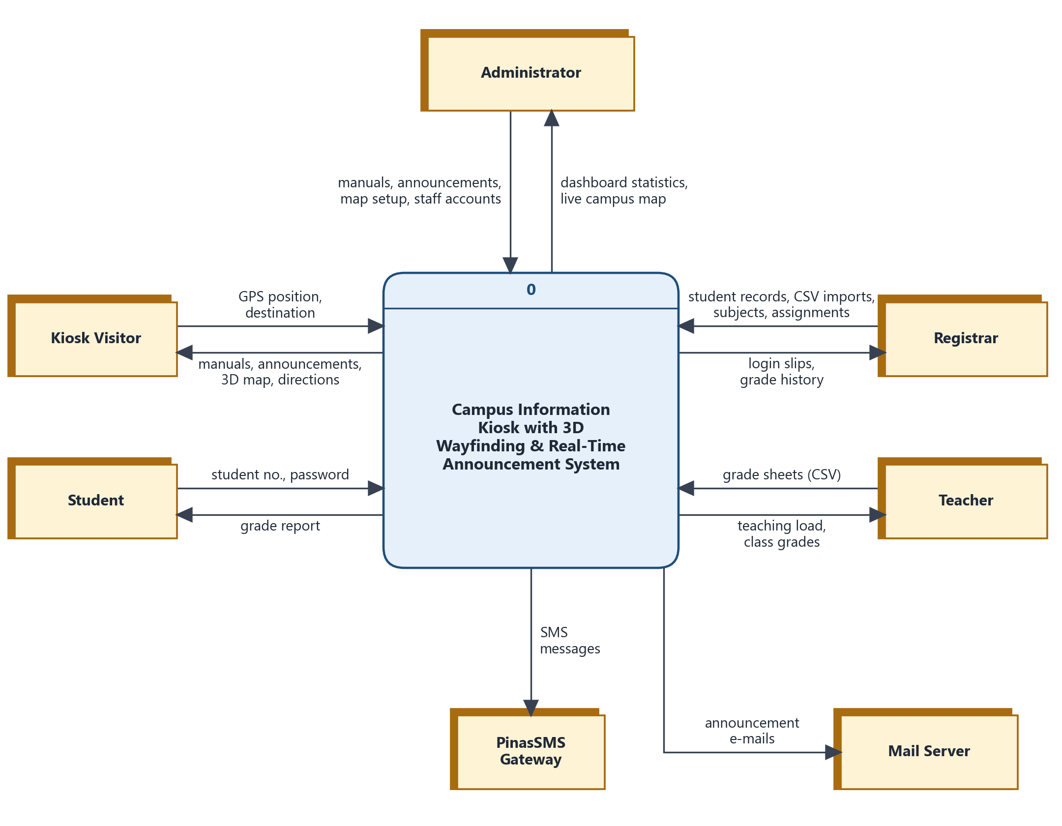
Figure 1. Context Diagram (Level 0)
External entity | Sends to the system | Receives from the system
Kiosk Visitor | GPS position and chosen destination on the campus map | School Manual pages, announcements and events, the 3D campus map, walking directions, 360° photos
Student | Student number and password | Their grade report
Registrar | Student and guardian records, CSV imports, subjects, teaching assignments | Printable student login slips, grade change history
Teacher | Grade sheets (CSV) | Their teaching load and class grades
Administrator | Manual articles, announcements, campus map setup (locations, GPS points, 360° photos), staff accounts | Dashboard statistics and the live campus map of who is on campus
PinasSMS Gateway | — | SMS messages to students and guardians when an announcement is published
Mail Server | — | Announcement e-mails to personnel

1.2 Level 1 Data Flow Diagram
Level 1 breaks the system into eight processes. To keep every arrow straight and readable, the diagram is drawn in two parts, with each process on its own row: entities on the left, the process in the middle, and its data stores on the right. When an entity or data store appears more than once, its repeats carry the Gane & Sarson duplicate mark: a diagonal line in the corner of an entity, or an extra vertical line on a data store.
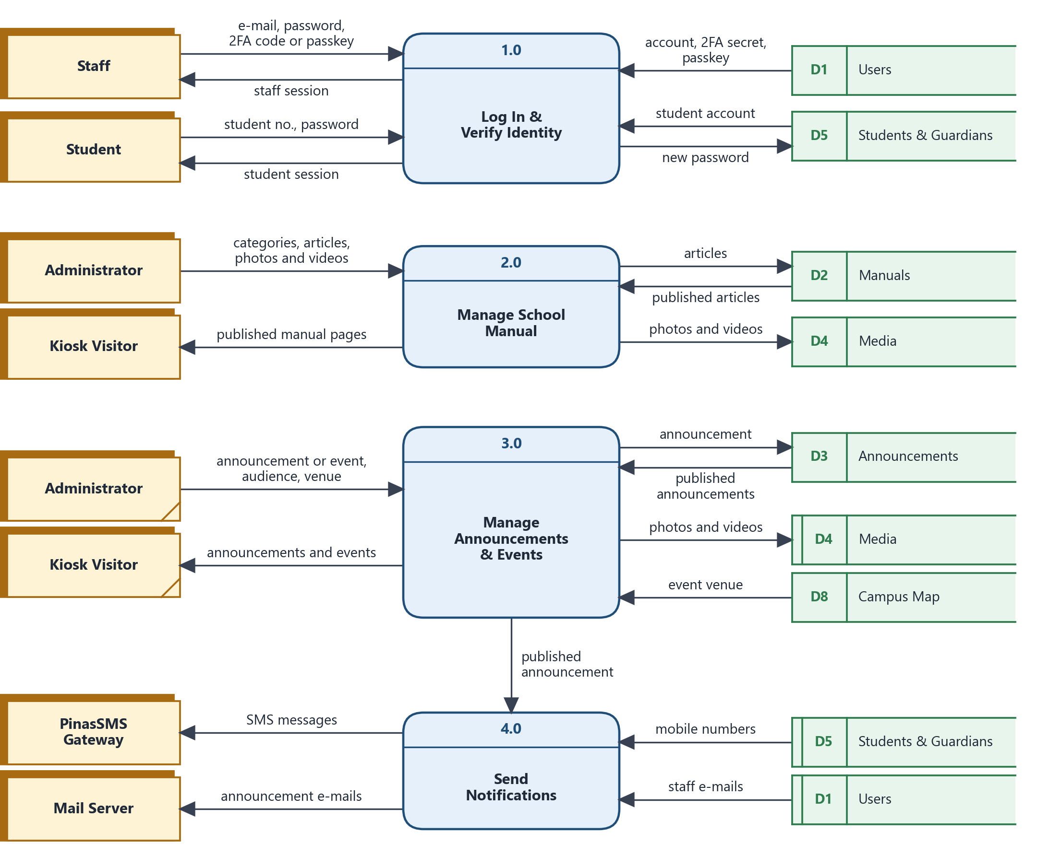
Figure 2a. Level 1 DFD, processes 1.0–4.0
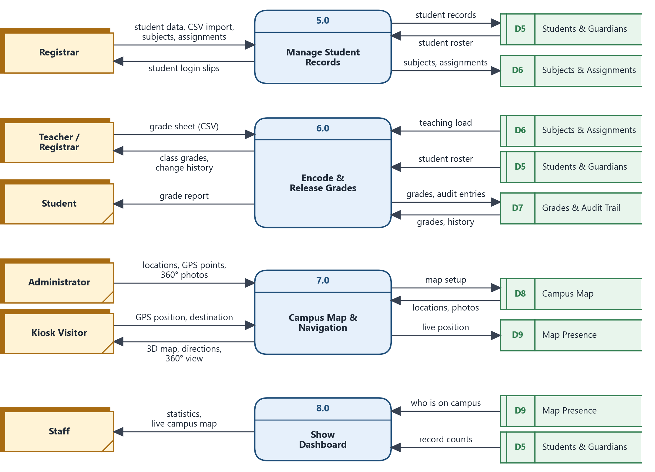
Figure 2b. Level 1 DFD, processes 5.0–8.0

Processes
No. | Process | What it does
1.0 | Log In & Verify Identity | Signs staff in with e-mail and password plus a two-factor code or passkey (required for registrars and teachers), and signs students in with their student number. Students must change their temporary password on first log in.
2.0 | Manage School Manual | Administrators write manual categories and articles with photos and videos; visitors read the published articles.
3.0 | Manage Announcements & Events | Administrators post announcements and events, choose who they are for (everyone, selected students, or personnel roles) and link an event to a campus location.
4.0 | Send Notifications | When an announcement is published, texts the targeted students and their guardians through PinasSMS and e-mails the chosen personnel. Sending runs in the background queue.
5.0 | Manage Student Records | Registrars keep student and guardian records (one at a time or by CSV import), subjects and teaching assignments, and print login slips with each student's temporary password.
6.0 | Encode & Release Grades | Teachers and registrars import grade sheets; a teacher can only import grades for their own classes. Every change is written to the audit trail, and students see their grades in the portal.
7.0 | Campus Map & Navigation | Turns the visitor's GPS position into a spot on the 3D map using the admin's reference points, gives turn-by-turn walking directions with voice, shows the nearest 360° photo, and reports each phone's position for the staff dashboard.
8.0 | Show Dashboard | Gives staff record counts and a live map of who is on campus.

Data stores
ID | Data store | Database tables
D1 | Users | users, passkeys
D2 | Manuals | manual_categories, manuals
D3 | Announcements | announcements, announcement_student
D4 | Media | media (photos and videos for manuals and announcements)
D5 | Students & Guardians | students, guardians
D6 | Subjects & Assignments | subjects, teaching_assignments
D7 | Grades & Audit Trail | grades, grade_audits
D8 | Campus Map | campus_locations, map_reference_points, campus_panoramas
D9 | Map Presence | map_presences

2. System Function Diagram
The system function diagram breaks the system into its seven main modules and lists what each one does. The numbers match the module and function references used in the rest of the documentation.
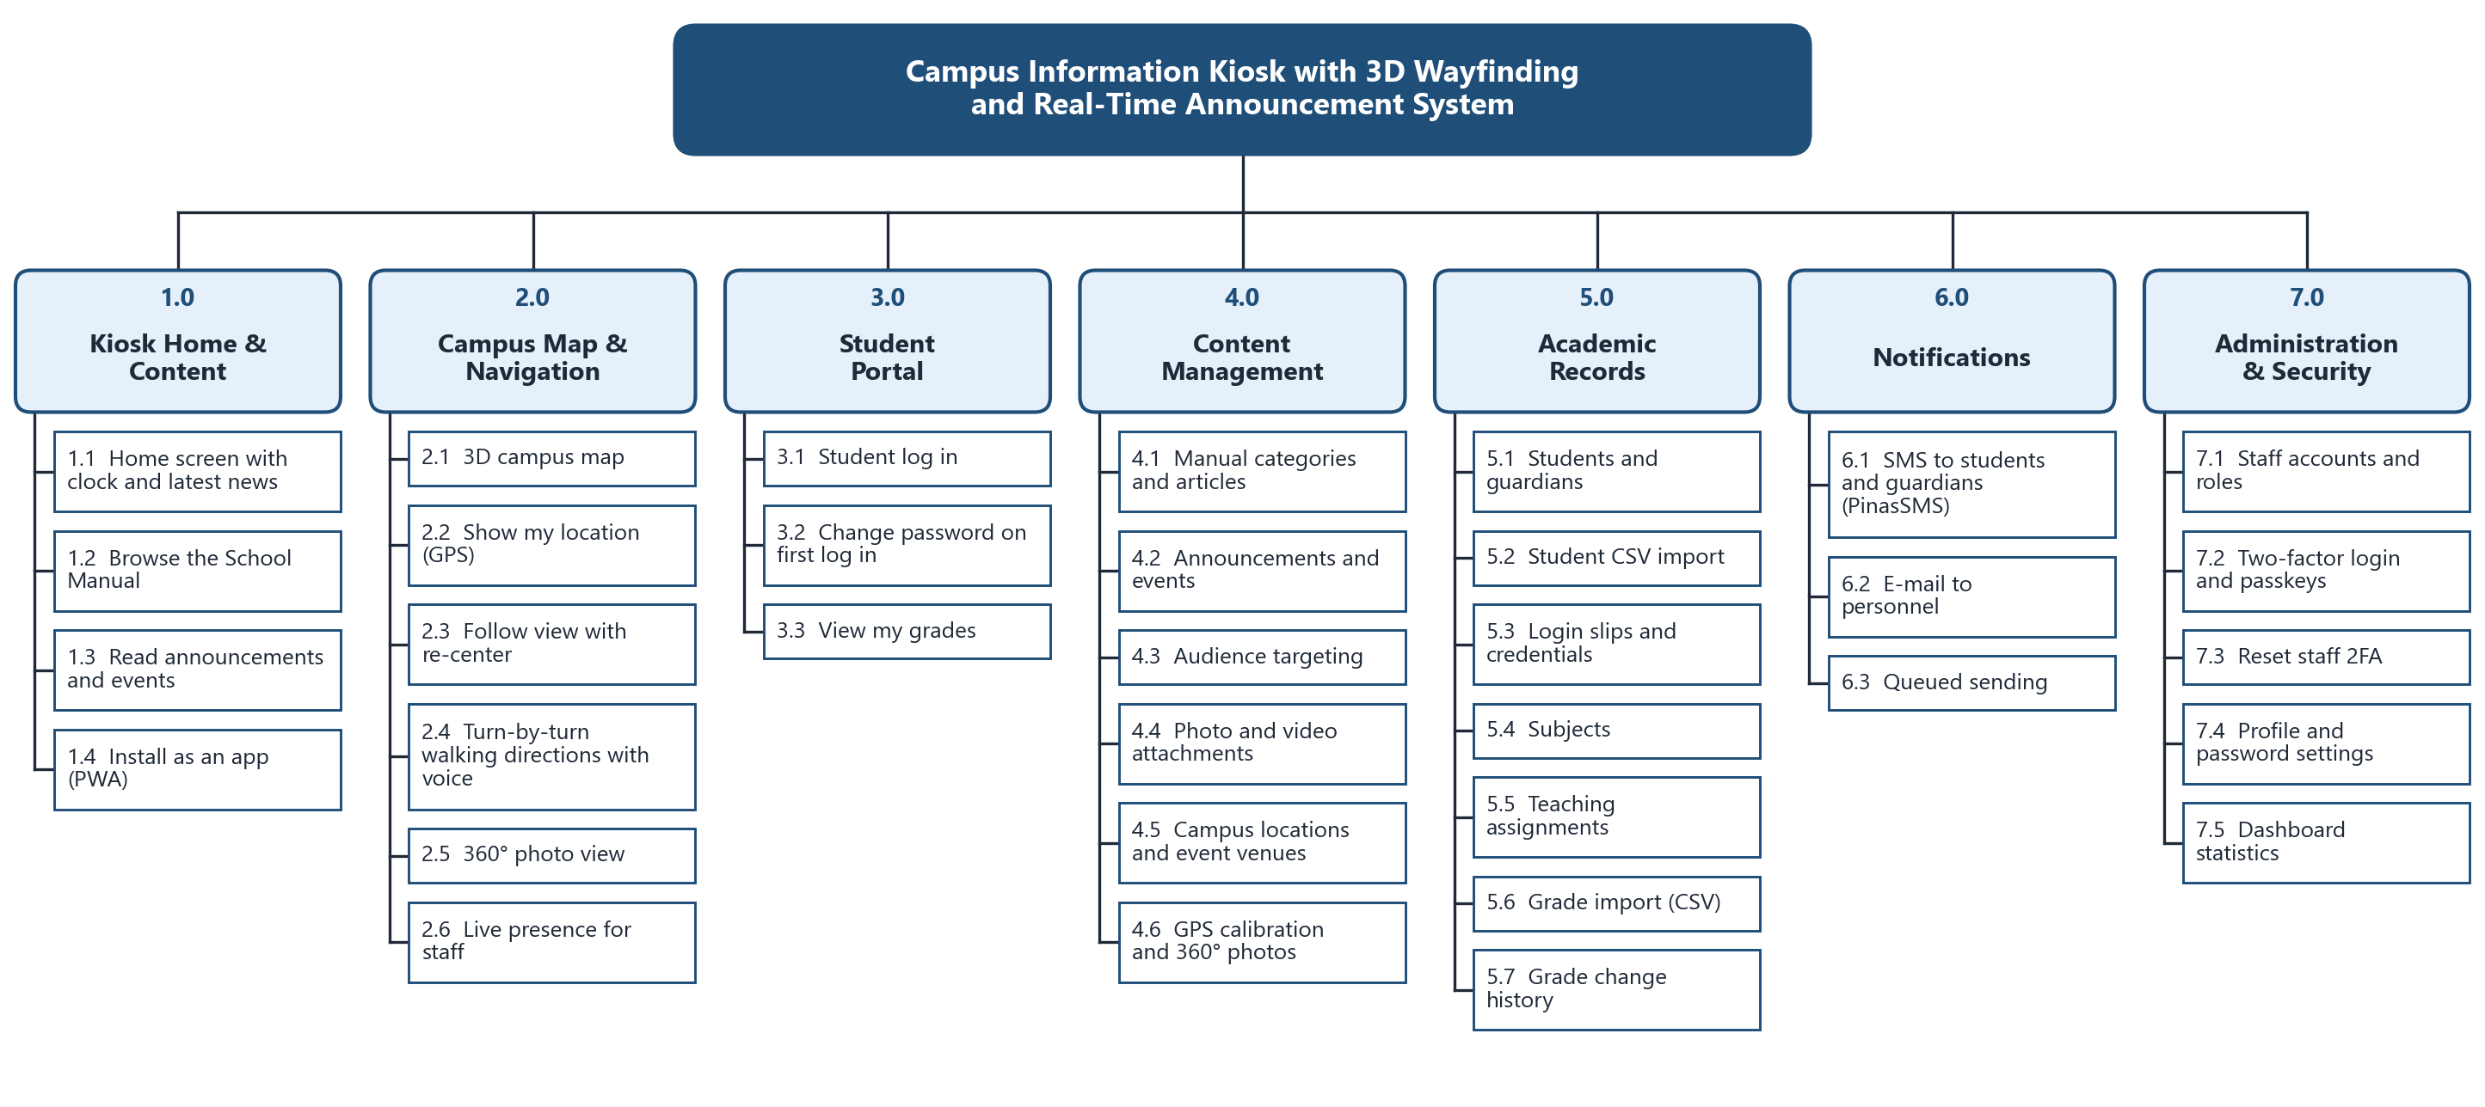
Figure 3. System Function Diagram
Module | Used by | Summary
1.0 Kiosk Home & Content | Kiosk visitors | The public touchscreen and website: home screen, School Manual, announcements and events. It can be installed on a phone as an app.
2.0 Campus Map & Navigation | Kiosk visitors, staff | A 3D campus map that follows the visitor by GPS, with walking directions, voice prompts, 360° photos, and live positions shown on the staff dashboard.
3.0 Student Portal | Students | Secure log in, a forced password change on first use, and the student's own grades.
4.0 Content Management | Administrators | Manuals, announcements, audience targeting, media, and the campus map setup.
5.0 Academic Records | Registrars, teachers | Students, guardians, subjects, teaching assignments, and grade import with a full change history.
6.0 Notifications | System | SMS and e-mail notices sent in the background when announcements are published.
7.0 Administration & Security | Super administrators, all staff | Staff accounts and roles, two-factor login and passkeys, profile settings and the dashboard.

3. Use Case Diagrams
The use case diagrams follow UML notation. Stick figures are actors; ovals are use cases inside the system boundary; a line links an actor to what it can do; a hollow-headed arrow means "is a kind of" (generalization); and dashed «include» and «extend» arrows link use cases that always or optionally run together. Outside systems are shown as boxes marked «external system». The use cases are split into three diagrams by who uses them.
Actor | Who it is
Kiosk Visitor | Anyone using the public kiosk or website. No log in needed.
Student | A student with a portal account. A student can also do everything a visitor can.
Staff | Any signed-in staff member (abstract). Teacher, Registrar and Administrator are kinds of Staff.
Teacher | Encodes grades for the classes in their teaching assignments.
Registrar | Keeps student, subject, assignment and grade records.
Administrator | Manages school content and the campus map. Can also do everything a Registrar can.
Super Administrator | Manages staff accounts and roles. Can do everything an Administrator can.
PinasSMS Gateway, Mail Server | Outside systems the kiosk uses to send SMS and e-mail.
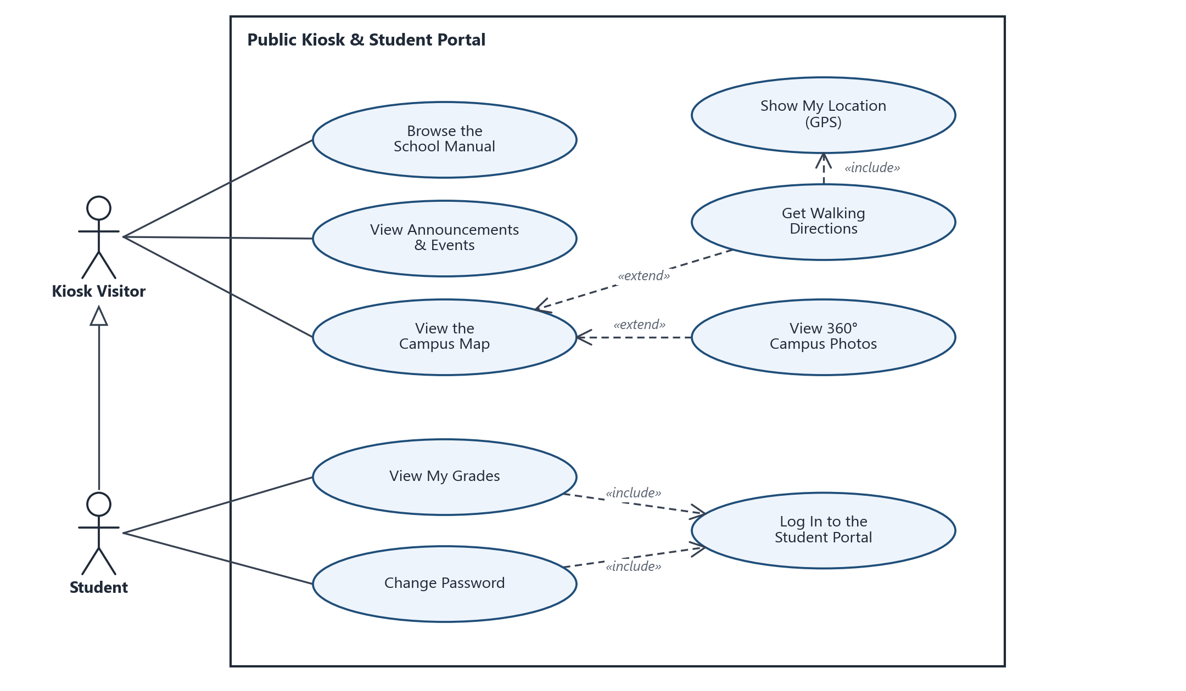
Figure 4a. Use Case Diagram: Public Kiosk & Student Portal
Notes. Getting walking directions and viewing 360° photos are optional extensions of viewing the campus map, and directions always include finding the visitor's GPS location. Viewing grades and changing a password both require logging in to the student portal.
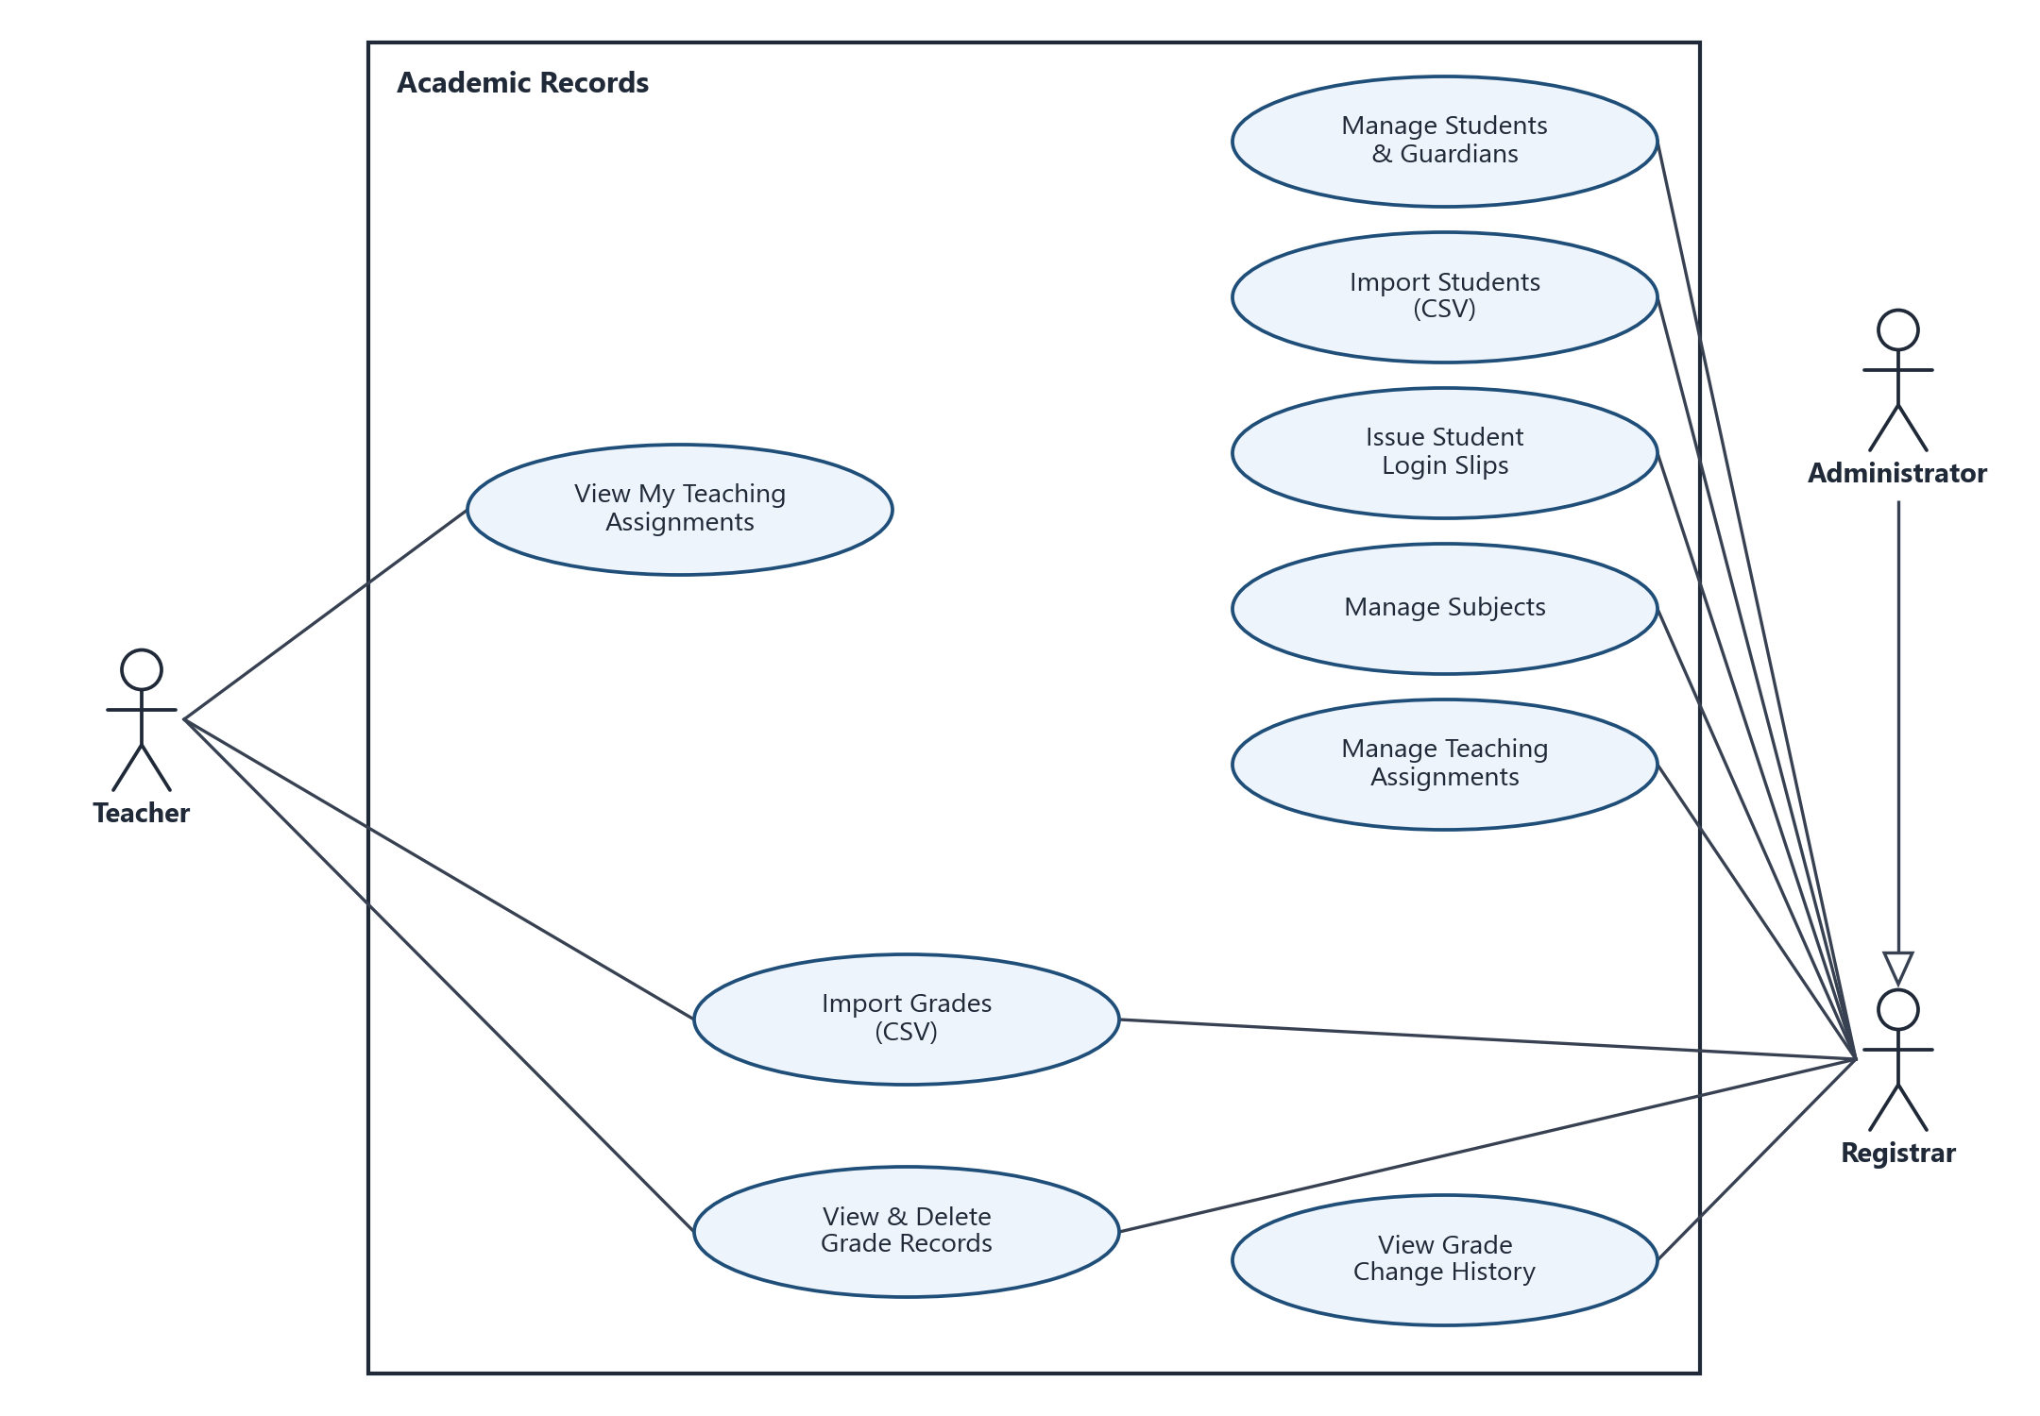
Figure 4b. Use Case Diagram: Academic Records
Notes. Teachers and registrars share grade import and grade records; a teacher can only import grades for subjects and sections in their own teaching assignments. Because an Administrator is a kind of Registrar, administrators can do every use case in this diagram except View My Teaching Assignments.
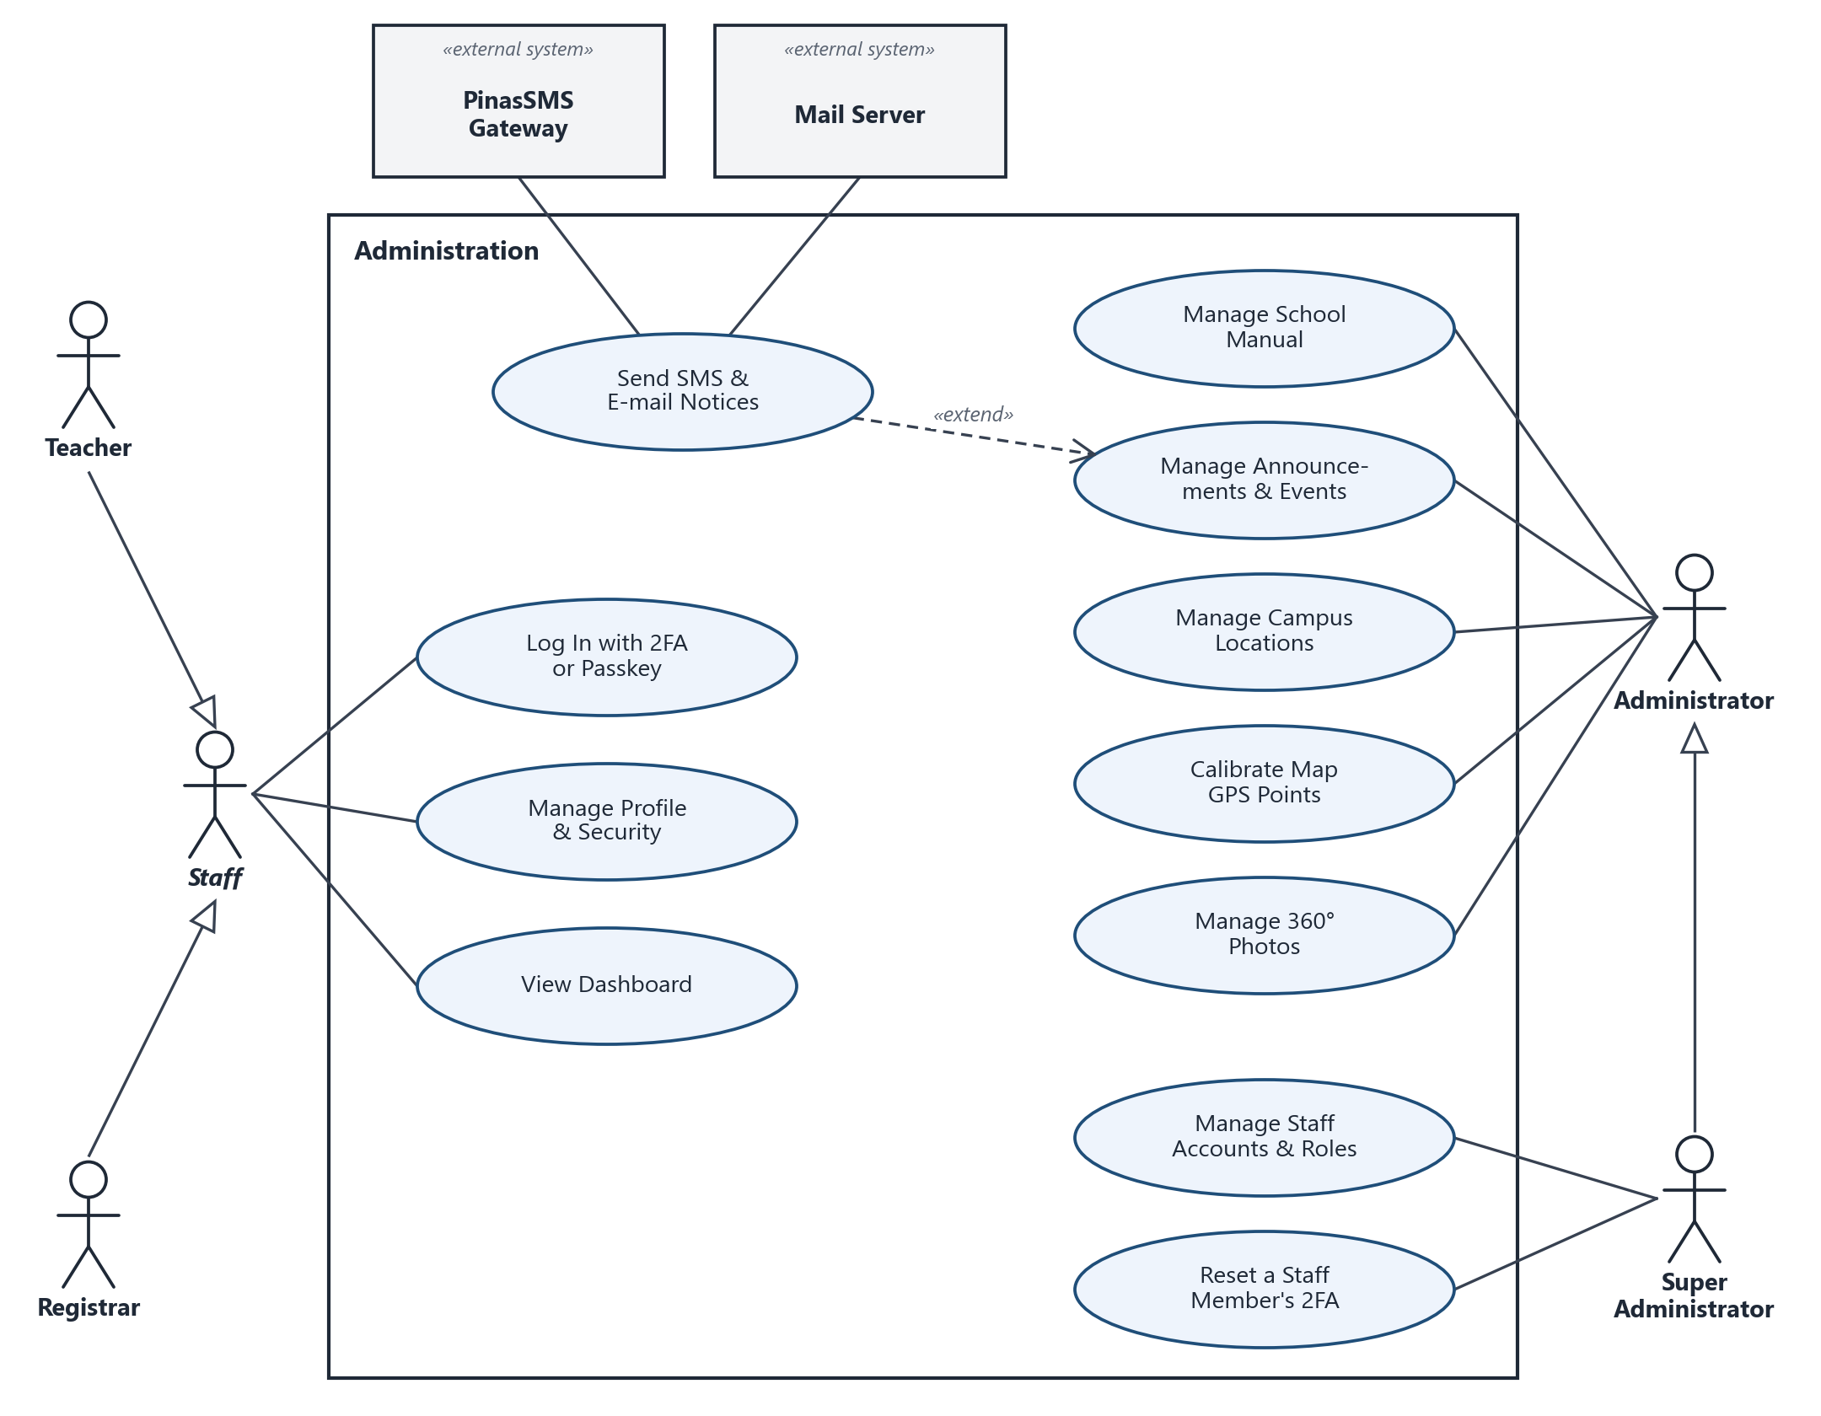
Figure 4c. Use Case Diagram: Administration
Notes. Every staff member logs in with two-factor authentication or a passkey (required for registrars and teachers), manages their own profile and sees the dashboard. Publishing an announcement can extend into sending SMS and e-mail notices, depending on its audience.

4. Entity Relationship Diagram (Database Diagram)
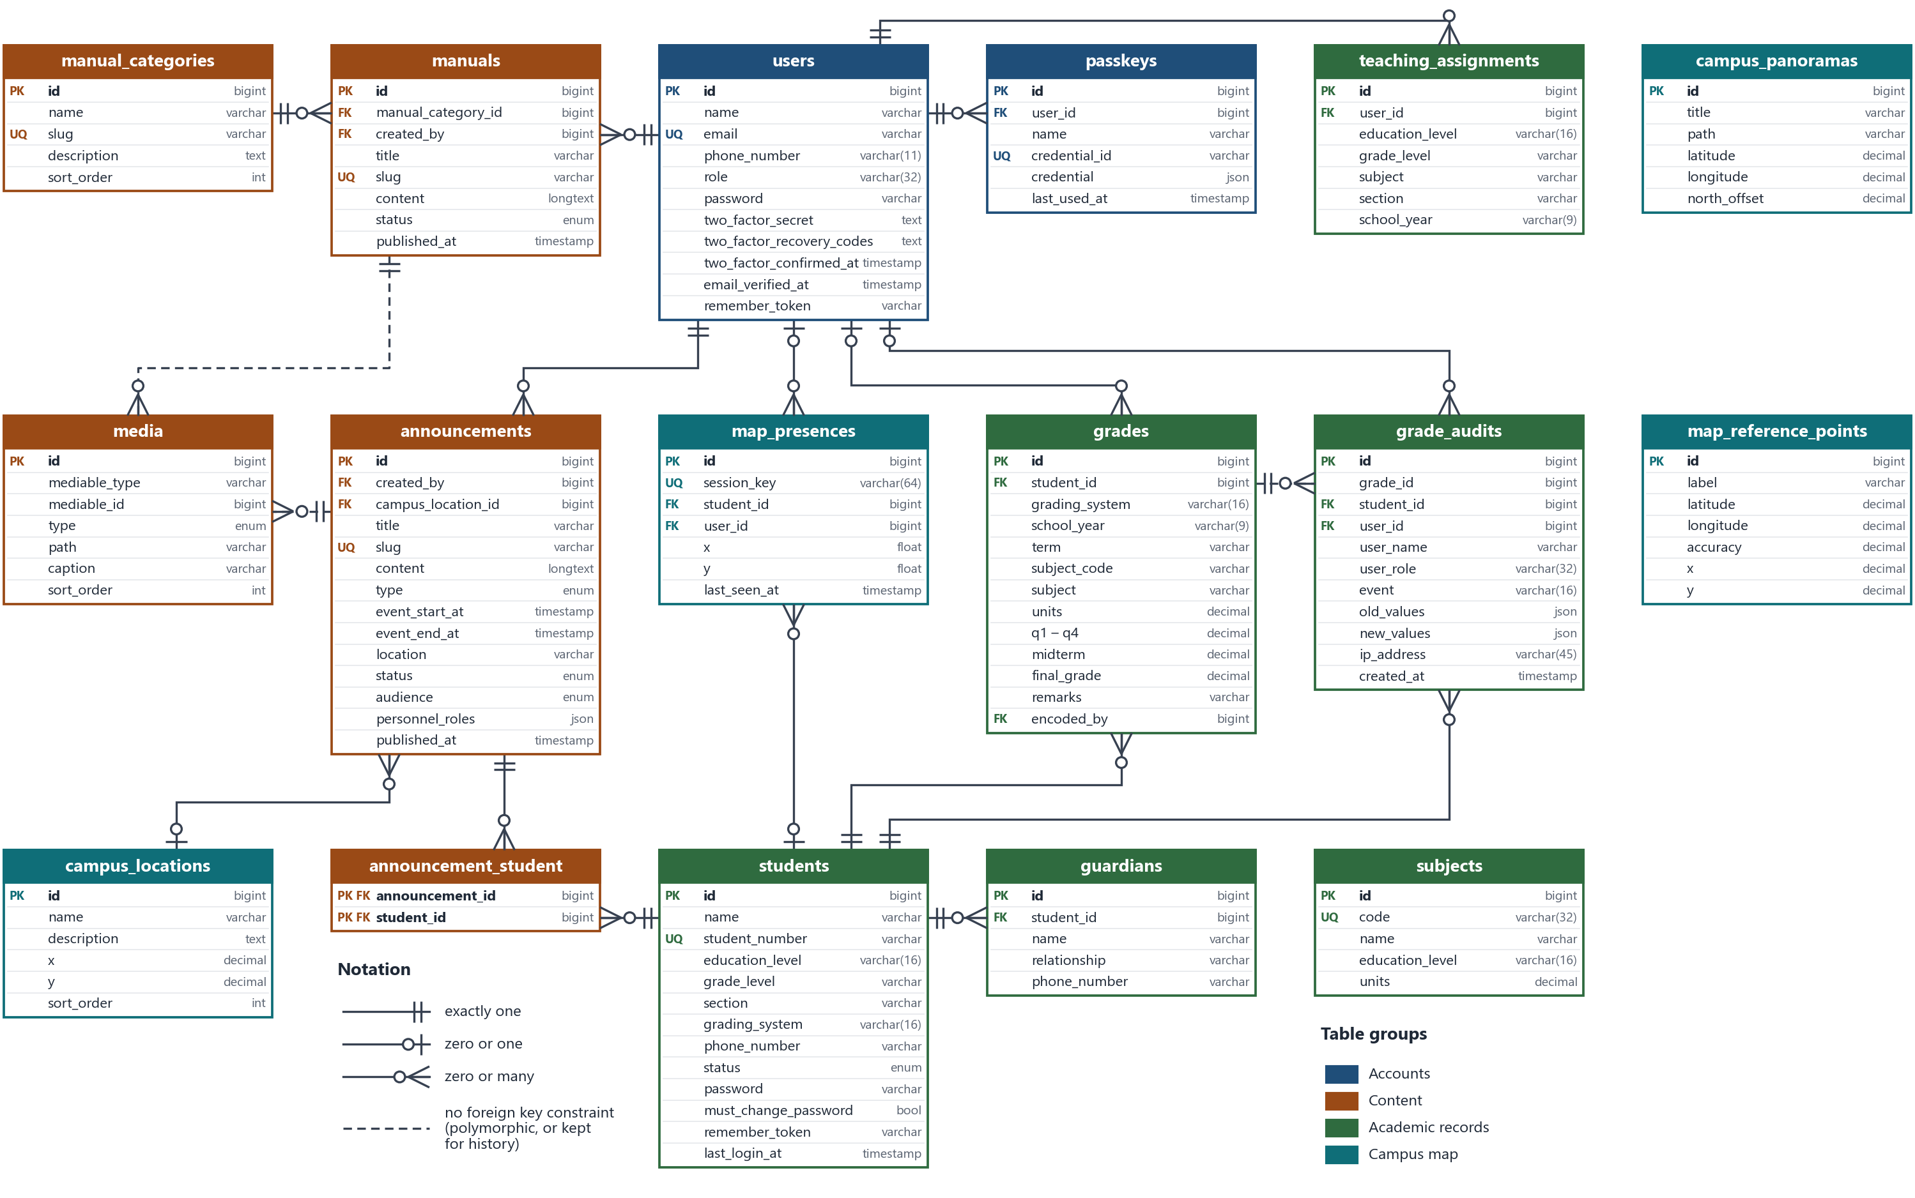
Figure 5. Entity Relationship Diagram
The ERD shows the system's tables with their columns and types, taken from the database migrations. Lines use crow's-foot notation. Laravel's built-in support tables (sessions, password_reset_tokens, cache, cache_locks, jobs, job_batches and failed_jobs) are left out because they hold no school data.

Relationships
Parent | Child | Cardinality | Through
manual_categories | manuals | one to zero or many | manuals.manual_category_id
users | manuals | one to zero or many | manuals.created_by
users | announcements | one to zero or many | announcements.created_by
users | passkeys | one to zero or many | passkeys.user_id
users | teaching_assignments | one to zero or many | teaching_assignments.user_id
users | grades | zero or one to zero or many | grades.encoded_by (kept empty if the user is deleted)
users | grade_audits | zero or one to zero or many | grade_audits.user_id, with a copy of the name and role
users | map_presences | zero or one to zero or many | map_presences.user_id
campus_locations | announcements | zero or one to zero or many | announcements.campus_location_id (event venue)
announcements | students | many to many | announcement_student (targeted announcements)
manuals, announcements | media | one to zero or many | media.mediable_type + mediable_id (polymorphic, no foreign key)
students | guardians | one to zero or many | guardians.student_id
students | grades | one to zero or many | grades.student_id
students | grade_audits | one to zero or many | grade_audits.student_id
students | map_presences | zero or one to zero or many | map_presences.student_id
grades | grade_audits | one to zero or many | grade_audits.grade_id (no foreign key, so history survives a deleted grade)

Tables
Table | Holds
users | Staff accounts: name, e-mail, phone, role (super_admin, admin, registrar or teacher), password and two-factor settings.
passkeys | Passkeys (WebAuthn credentials) that staff can use to log in.
manual_categories, manuals | The School Manual: categories and their articles, as draft or published.
announcements, announcement_student | Announcements and events, their audience (everyone, selected students or none), personnel roles to e-mail, and the targeted students.
media | Photos and videos attached to manuals or announcements.
students, guardians | The student roster with portal login details, and each student's guardians for SMS.
subjects | Subjects offered per education level. Grades and teaching assignments refer to subjects by name, not by a foreign key.
teaching_assignments | Which subject and section each teacher handles per school year.
grades, grade_audits | Student grades (quarterly or semestral) and the full history of every change.
campus_locations, map_reference_points, campus_panoramas | Map pins, GPS reference points used to fit the map to real GPS, and 360° photos with their GPS spot and north offset.
map_presences | Where each phone currently showing its location is on the map, for the staff dashboard.

