System Diagrams
Campus Information Kiosk with 3D Wayfinding and Real-Time Announcement System
Aemilianum College Inc.
28 October 2026

Contents
About This Document 2
1. System Architecture Diagram 3
Layers and components 4
2. Context Diagram 5
External entities 6
3. Data Flow Diagram (DFD) 7
Processes 8
Data stores 8
4. Use Case Diagram 9
Actors 11
5. Entity-Relationship Diagram (ERD) 12
Relationships 13
6. Database Schema Diagram 14
Tables 16

Right-click the table above and choose Update Field to refresh page numbers.

About This Document
This document presents six diagrams of the Campus Information Kiosk system. Each one was drawn from the current source code: the Laravel routes, controllers, services, models and database migrations. They include the newest features, such as school years, courses, sections and enrollment history, the AI chatbot, and the kiosk theme settings.
No. | Diagram | What it shows
1 | System Architecture Diagram | The layers of the system, the technology in each layer, and the outside services it uses.
2 | Context Diagram | The whole system as a single process and the data it exchanges with every outside party.
3 | Data Flow Diagram (DFD) | The eight main processes, the data stores, and how data moves between them (Level 1).
4 | Use Case Diagram | What each kind of user can do, split into three diagrams: public kiosk and student portal, academic records, and administration.
5 | Entity-Relationship Diagram (ERD) | The entities in the system and how they relate, in crow's foot notation.
6 | Database Schema Diagram | Every table with its columns, data types and keys, in three groups.

1. System Architecture Diagram
The system is a web application with four layers. Every user reaches it through a web browser, whether on the kiosk touchscreen, a phone, or a staff computer.
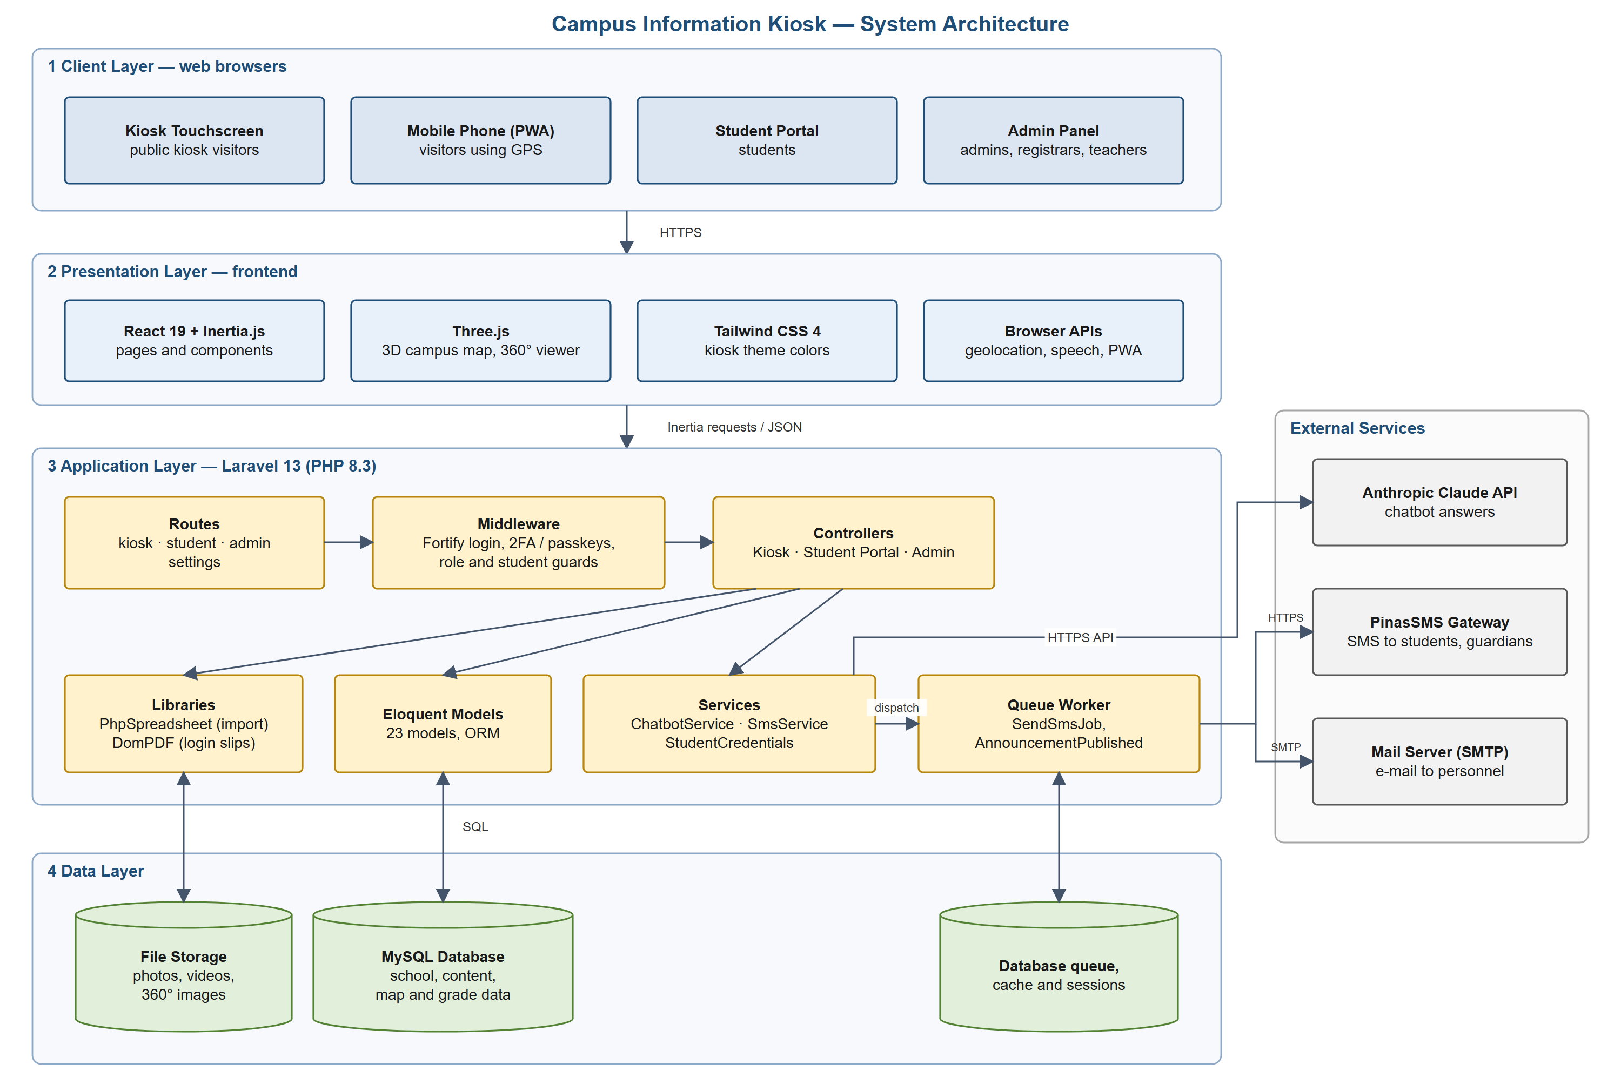
Figure 1. System Architecture Diagram

Layers and components
Layer | Components | Role
Client | Kiosk touchscreen, mobile phone (installable PWA), student portal, admin panel | All users connect through a web browser over HTTPS. No separate app is installed.
Presentation | React 19 with Inertia.js, Three.js, Tailwind CSS 4, browser APIs | Draws the pages, the 3D campus map and 360° photo viewer, applies the kiosk theme colors, and reads the phone's GPS position and speaks walking directions.
Application | Laravel 13 on PHP 8.3: routes, middleware, controllers, services, Eloquent models, queue worker | Handles every request. Fortify handles staff login with two-factor codes and passkeys; middleware checks each user's role. Services talk to outside systems, and the queue worker sends SMS and e-mail in the background.
Data | MySQL database, file storage | MySQL holds all records, plus the job queue, cache and sessions. Uploaded photos, videos and 360° images are kept in file storage.
External services | Anthropic Claude API, PinasSMS gateway, mail server | Claude writes chatbot answers from the school manual and announcements. PinasSMS sends text messages to students and guardians. The mail server sends e-mail notices to personnel.

2. Context Diagram
The context diagram (DFD Level 0) shows the whole system as one process, numbered 0, and every outside party that sends data to it or receives data from it.
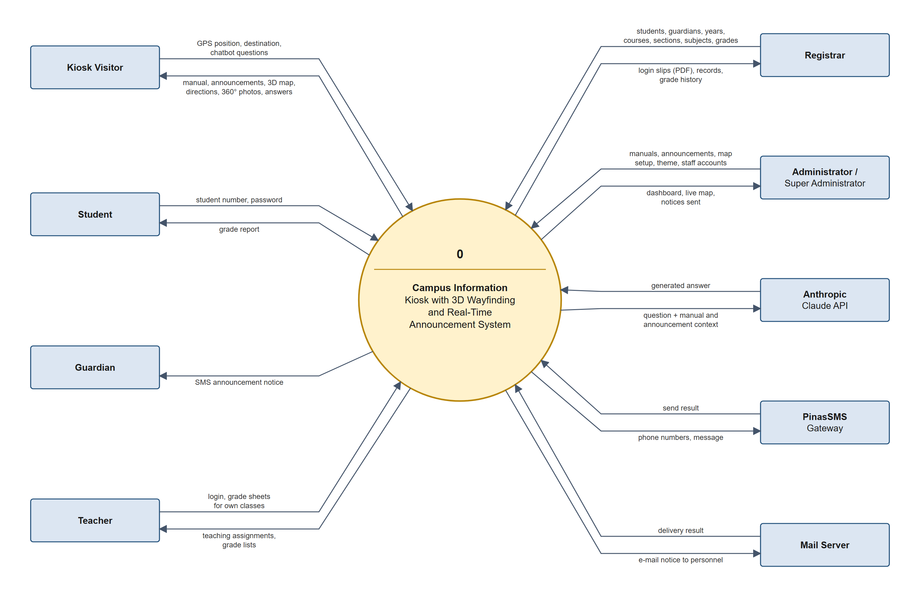
Figure 2. Context Diagram (Level 0)

External entities
External entity | Sends to the system | Receives from the system
Kiosk Visitor | GPS position, chosen destination, chatbot questions | School manual, announcements and events, 3D map, walking directions, 360° photos, chatbot answers
Student | Student number and password | Their grade report
Guardian | Nothing directly (the registrar enters guardian phone numbers) | SMS notices for announcements that target their student
Teacher | Login details, grade sheets for their own classes | Their teaching assignments and grade lists
Registrar | Students, guardians, school years, courses, sections, subjects, teaching assignments, grades | Printable login slips (PDF), records, grade change history
Administrator / Super Administrator | Manuals, announcements, campus map setup, kiosk theme, staff accounts | Dashboard, live campus map, confirmation of notices sent
Anthropic Claude API | Generated chatbot answer | The question plus matching manual and announcement text
PinasSMS Gateway | Send result | Phone numbers and message text
Mail Server | Delivery result | E-mail notices to personnel

3. Data Flow Diagram (DFD)
The Level 1 data flow diagram breaks process 0 into eight processes. It uses Gane & Sarson notation: rounded boxes are processes, open-ended boxes are data stores, and plain boxes are external entities. A store or entity marked with * or a corner slash is drawn a second time to avoid crossing lines.
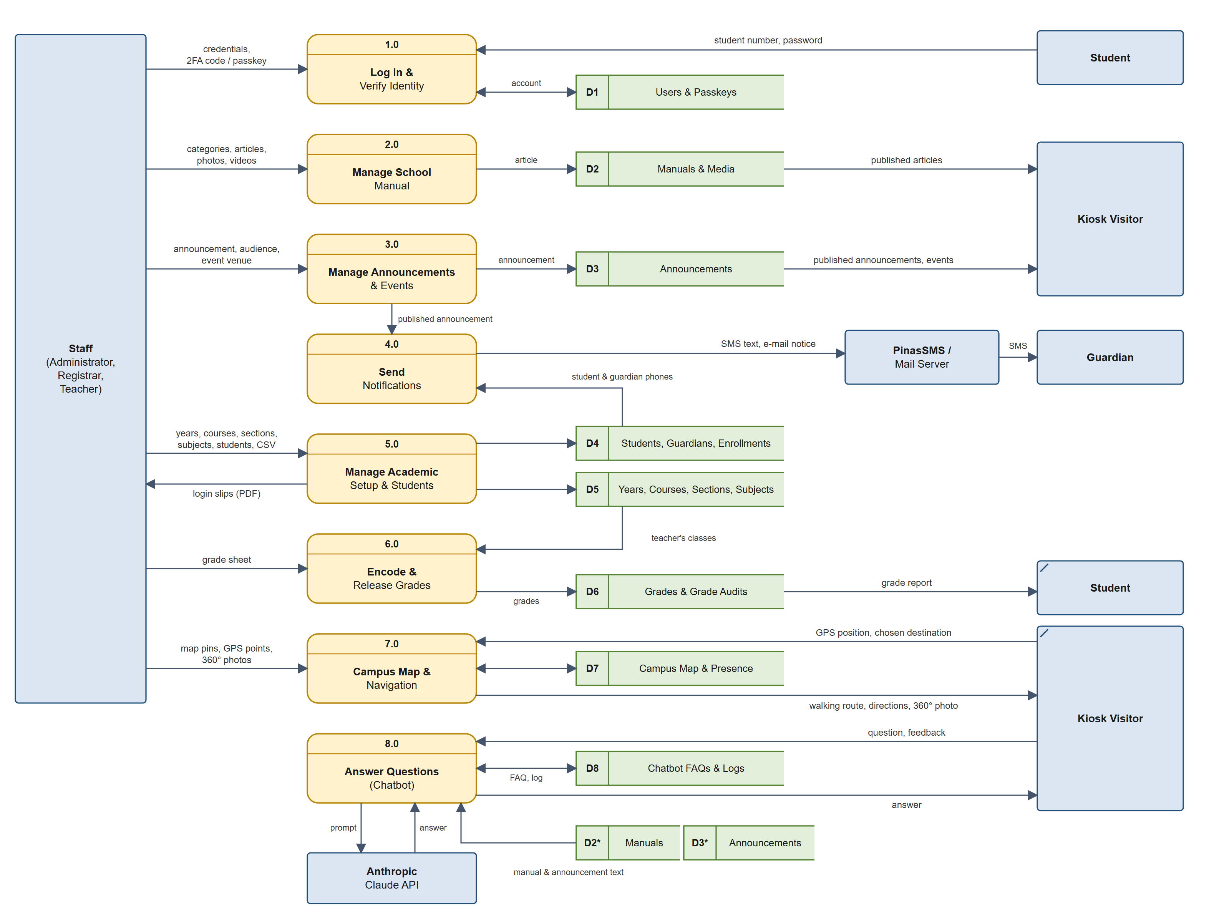
Figure 3. Data Flow Diagram, Level 1

Processes
No. | Process | What it does
1.0 | Log In & Verify Identity | Signs staff in with e-mail and password plus a two-factor code or passkey (required for registrars and teachers), and signs students in with their student number. Students must change their temporary password on first login. Reads D1 and D4.
2.0 | Manage School Manual | Administrators write and reorder manual categories and articles with photos and videos; visitors read the published articles.
3.0 | Manage Announcements & Events | Administrators post announcements and events, choose the audience (everyone, selected students, or none) and personnel roles to e-mail, and link an event to a campus location.
4.0 | Send Notifications | When an announcement is published, texts the targeted students and their guardians through PinasSMS and e-mails the chosen personnel. Runs in the background queue.
5.0 | Manage Academic Setup & Students | Registrars keep school years (and which one is current), courses, sections, subjects, teaching assignments, and student and guardian records, entered one at a time or by CSV import. Each student's level, course and section is saved per school year as an enrollment. Prints login slips with temporary passwords.
6.0 | Encode & Release Grades | Teachers and registrars import grade sheets. A teacher can only import grades for subjects and sections in their own teaching assignments. Every change is written to the audit trail, and students see their grades in the portal.
7.0 | Campus Map & Navigation | Turns the visitor's GPS position into a spot on the 3D map using the reference points, gives walking directions with voice, shows the nearest 360° photo, and records each phone's position for the staff live map.
8.0 | Answer Questions (Chatbot) | Matches the visitor's question to FAQs, manual articles and announcements, asks the Claude API to write the answer, logs the question and answer, and records the visitor's rating.

Data stores
ID | Data store | Database tables
D1 | Users & Passkeys | users, passkeys
D2 | Manuals & Media | manual_categories, manuals, media
D3 | Announcements | announcements, announcement_student, media
D4 | Students, Guardians, Enrollments | students, guardians, enrollments
D5 | Years, Courses, Sections, Subjects | school_years, courses, sections, subjects, teaching_assignments
D6 | Grades & Grade Audits | grades, grade_audits
D7 | Campus Map & Presence | campus_locations, map_reference_points, campus_panoramas, map_presences
D8 | Chatbot FAQs & Logs | chatbot_faqs, chatbot_logs

4. Use Case Diagram
The use case diagrams follow UML notation. Stick figures are actors and ovals are use cases inside the system boundary. A solid line links an actor to a use case it performs. A hollow-headed arrow means "is a kind of" (generalization): the actor at the tail can do everything the actor at the head can. Dashed «include» arrows point to a step that always runs; dashed «extend» arrows point from an optional step to the use case it extends.
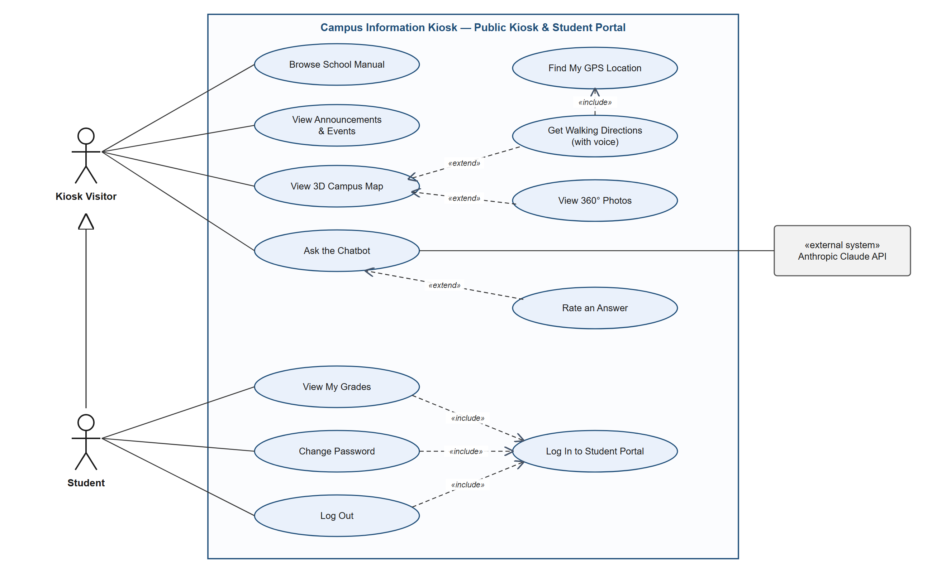
Figure 4a. Use Case Diagram: Public Kiosk & Student Portal
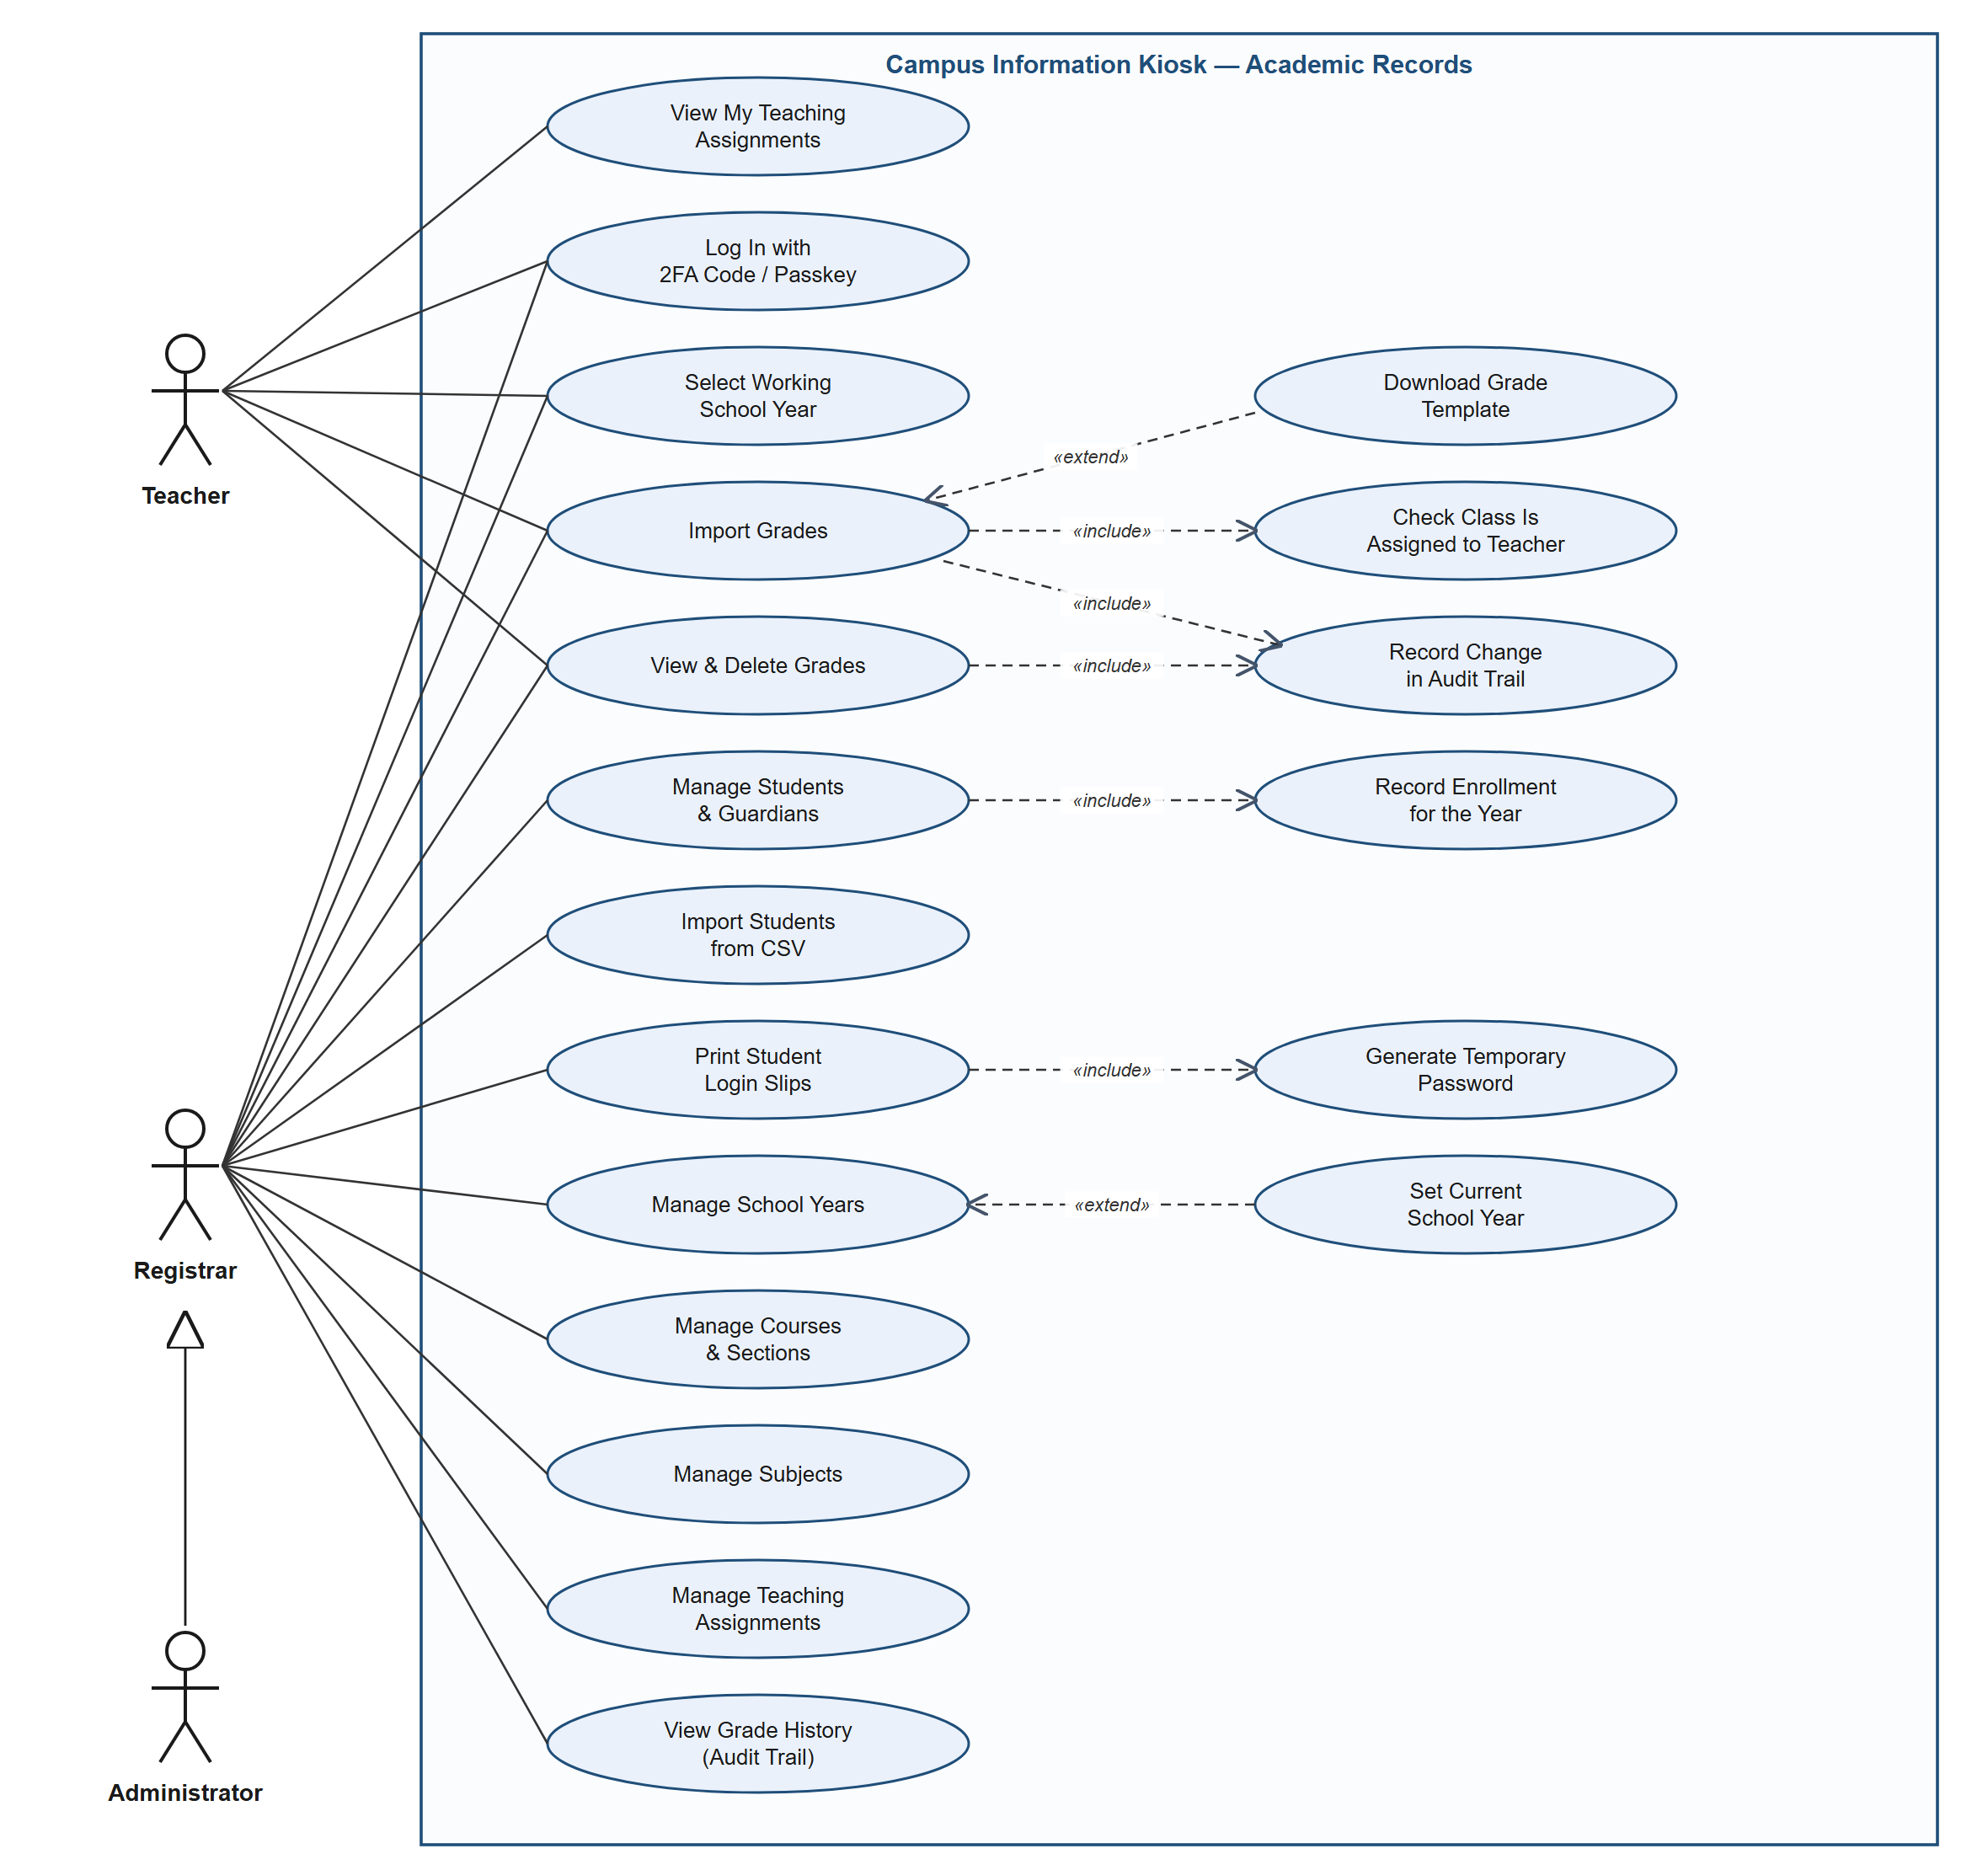
Figure 4b. Use Case Diagram: Academic Records
Teachers and registrars share login, school year selection, grade import and grade records. Because an Administrator is a kind of Registrar, administrators can also do every registrar use case here.
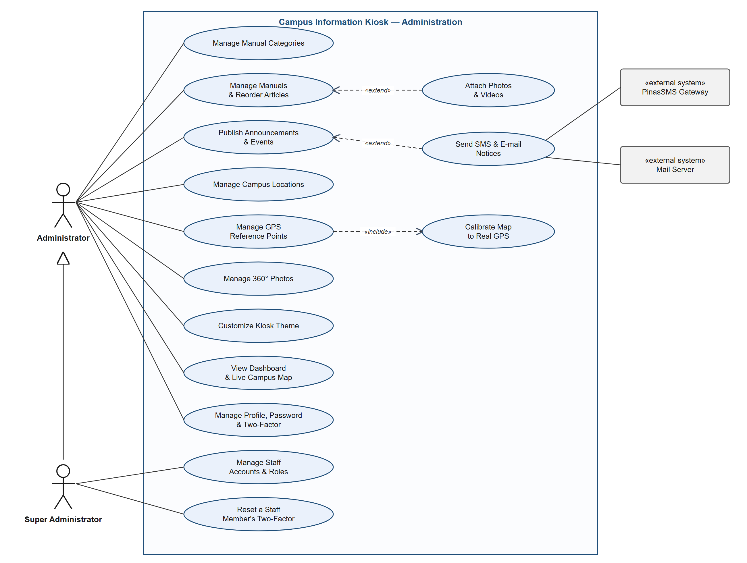
Figure 4c. Use Case Diagram: Administration
Publishing an announcement can extend into sending SMS and e-mail notices, depending on its audience. Managing one's own profile, password and two-factor settings is open to every staff role.

Actors
Actor | Who it is
Kiosk Visitor | Anyone using the public kiosk or the website. No login needed.
Student | A student with a portal account. A student can also do everything a visitor can.
Teacher | Encodes grades only for the classes in their own teaching assignments.
Registrar | Keeps student, guardian, enrollment, school year, course, section, subject, assignment and grade records.
Administrator | Manages school content, the campus map and the kiosk theme. Can also do everything a Registrar can.
Super Administrator | Manages staff accounts and roles. Can do everything an Administrator can.
Claude API, PinasSMS, Mail Server | Outside systems the kiosk uses for chatbot answers, SMS and e-mail.

5. Entity-Relationship Diagram (ERD)
The ERD shows the entities and how they relate, using crow's foot notation: two bars mean exactly one, a bar and a circle mean zero or one, and a crow's foot with a circle means zero or many. Column details are in the Database Schema Diagram in section 6.
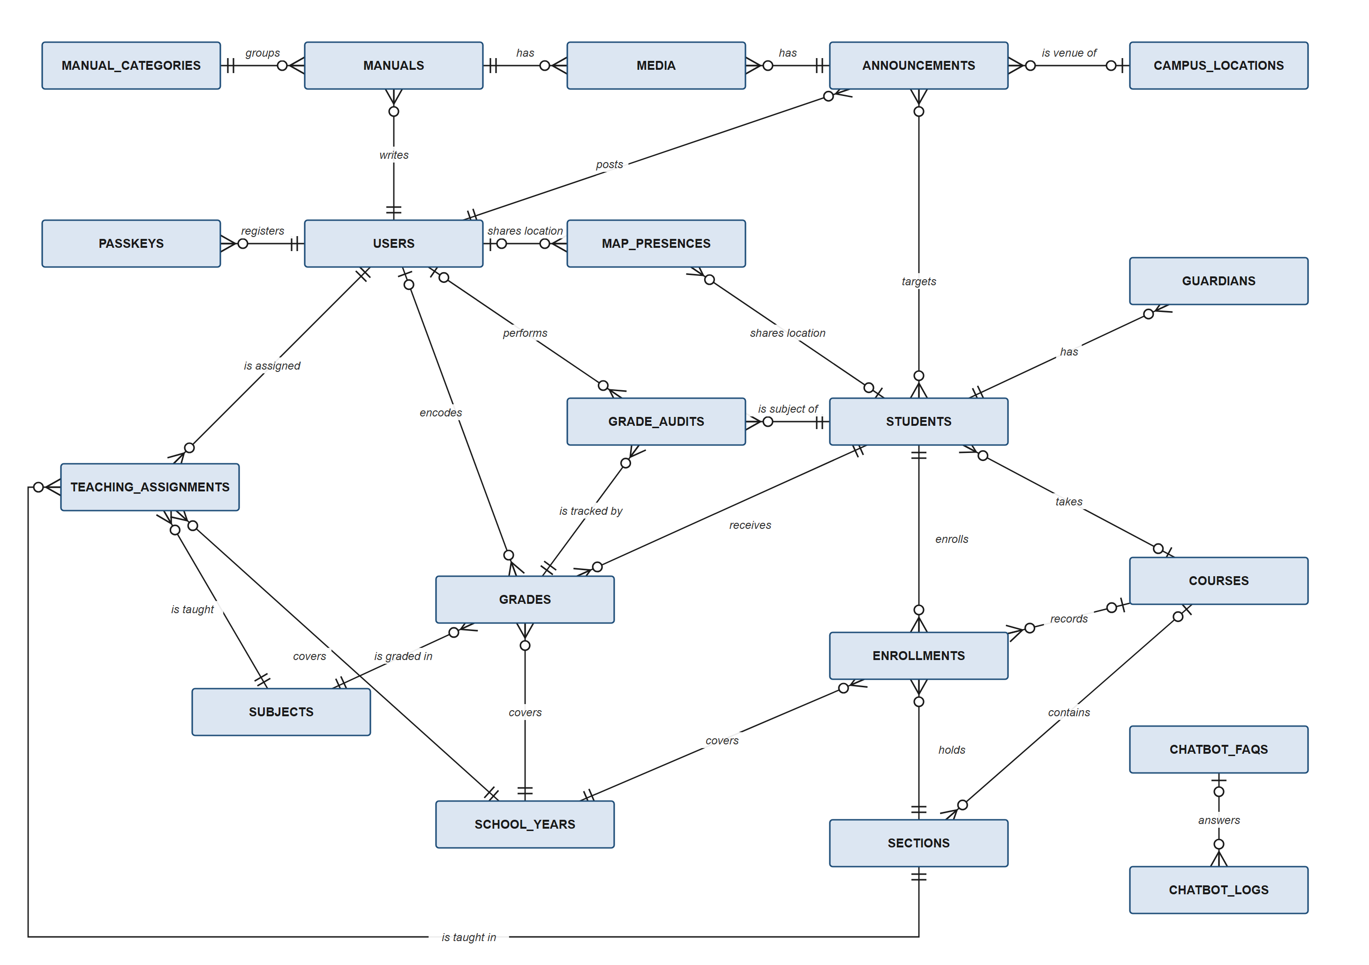
Figure 5. Entity-Relationship Diagram

Relationships
Parent | Child | Cardinality | Linked by
users | passkeys, manuals, announcements, teaching_assignments | one to zero or many | user_id / created_by
users | grades, grade_audits, map_presences | zero or one to zero or many | encoded_by / user_id (kept empty if the user is deleted)
manual_categories | manuals | one to zero or many | manuals.manual_category_id
manuals, announcements | media | one to zero or many | media.mediable_type + mediable_id (polymorphic)
campus_locations | announcements | zero or one to zero or many | announcements.campus_location_id (event venue)
announcements | students | many to many | announcement_student (targeted announcements)
students | guardians, enrollments, grades, grade_audits | one to zero or many | student_id
students | map_presences | zero or one to zero or many | map_presences.student_id
courses | students, sections, enrollments | zero or one to zero or many | course_id
school_years | enrollments, grades, teaching_assignments | one to zero or many | school_year column holds the year name (e.g. 2026-2027)
sections | enrollments, teaching_assignments | one to zero or many | section column holds the section name
subjects | teaching_assignments, grades | one to zero or many | subject column holds the subject name
grades | grade_audits | one to zero or many | grade_audits.grade_id (no foreign key, so history survives a deleted grade)
chatbot_faqs | chatbot_logs | zero or one to zero or many | chatbot_logs.matched_faq_id
Note. The school year, section and subject links are made by name, not by a database foreign key, so a record keeps its original value even if the source row is renamed or removed.

6. Database Schema Diagram
The schema diagrams list every table with its columns and data types, taken from the database migrations. PK is the primary key, FK a foreign key and UK a unique key. Tables are split into three groups; a table drawn with only its id and name belongs to another group and is shown to make the link clear. Every table also has created_at and updated_at timestamps unless noted. Laravel's built-in support tables (sessions, password_reset_tokens, cache, cache_locks, jobs, job_batches, failed_jobs) are left out.
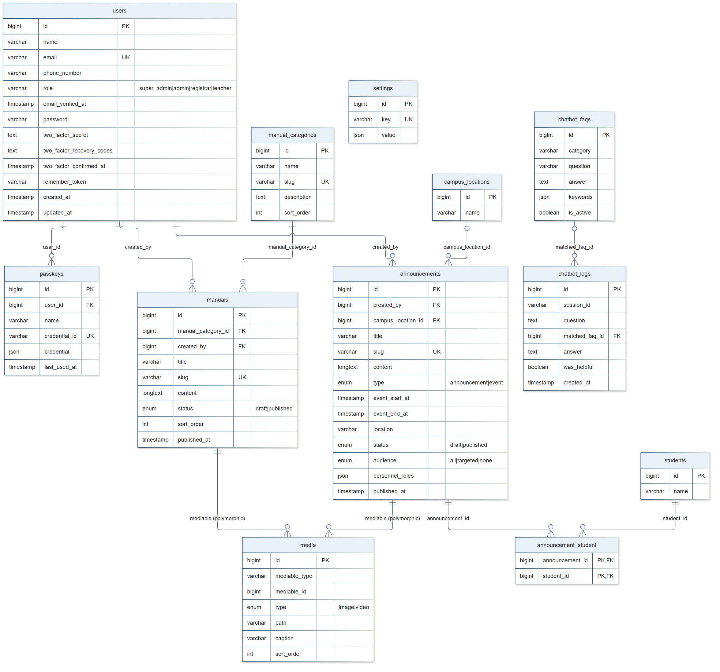
Figure 6a. Database Schema: Users, Content & Chatbot
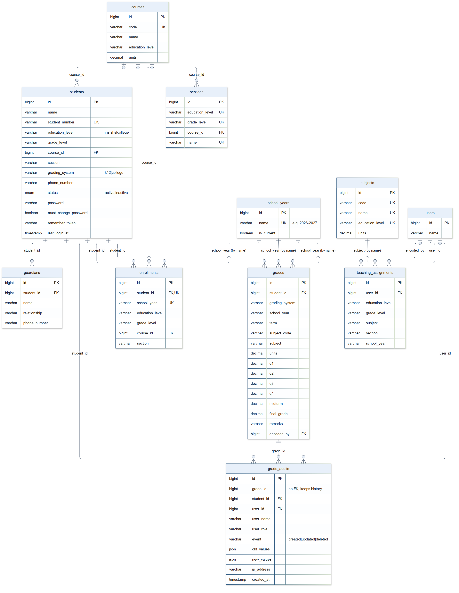
Figure 6b. Database Schema: Students & Academic Records
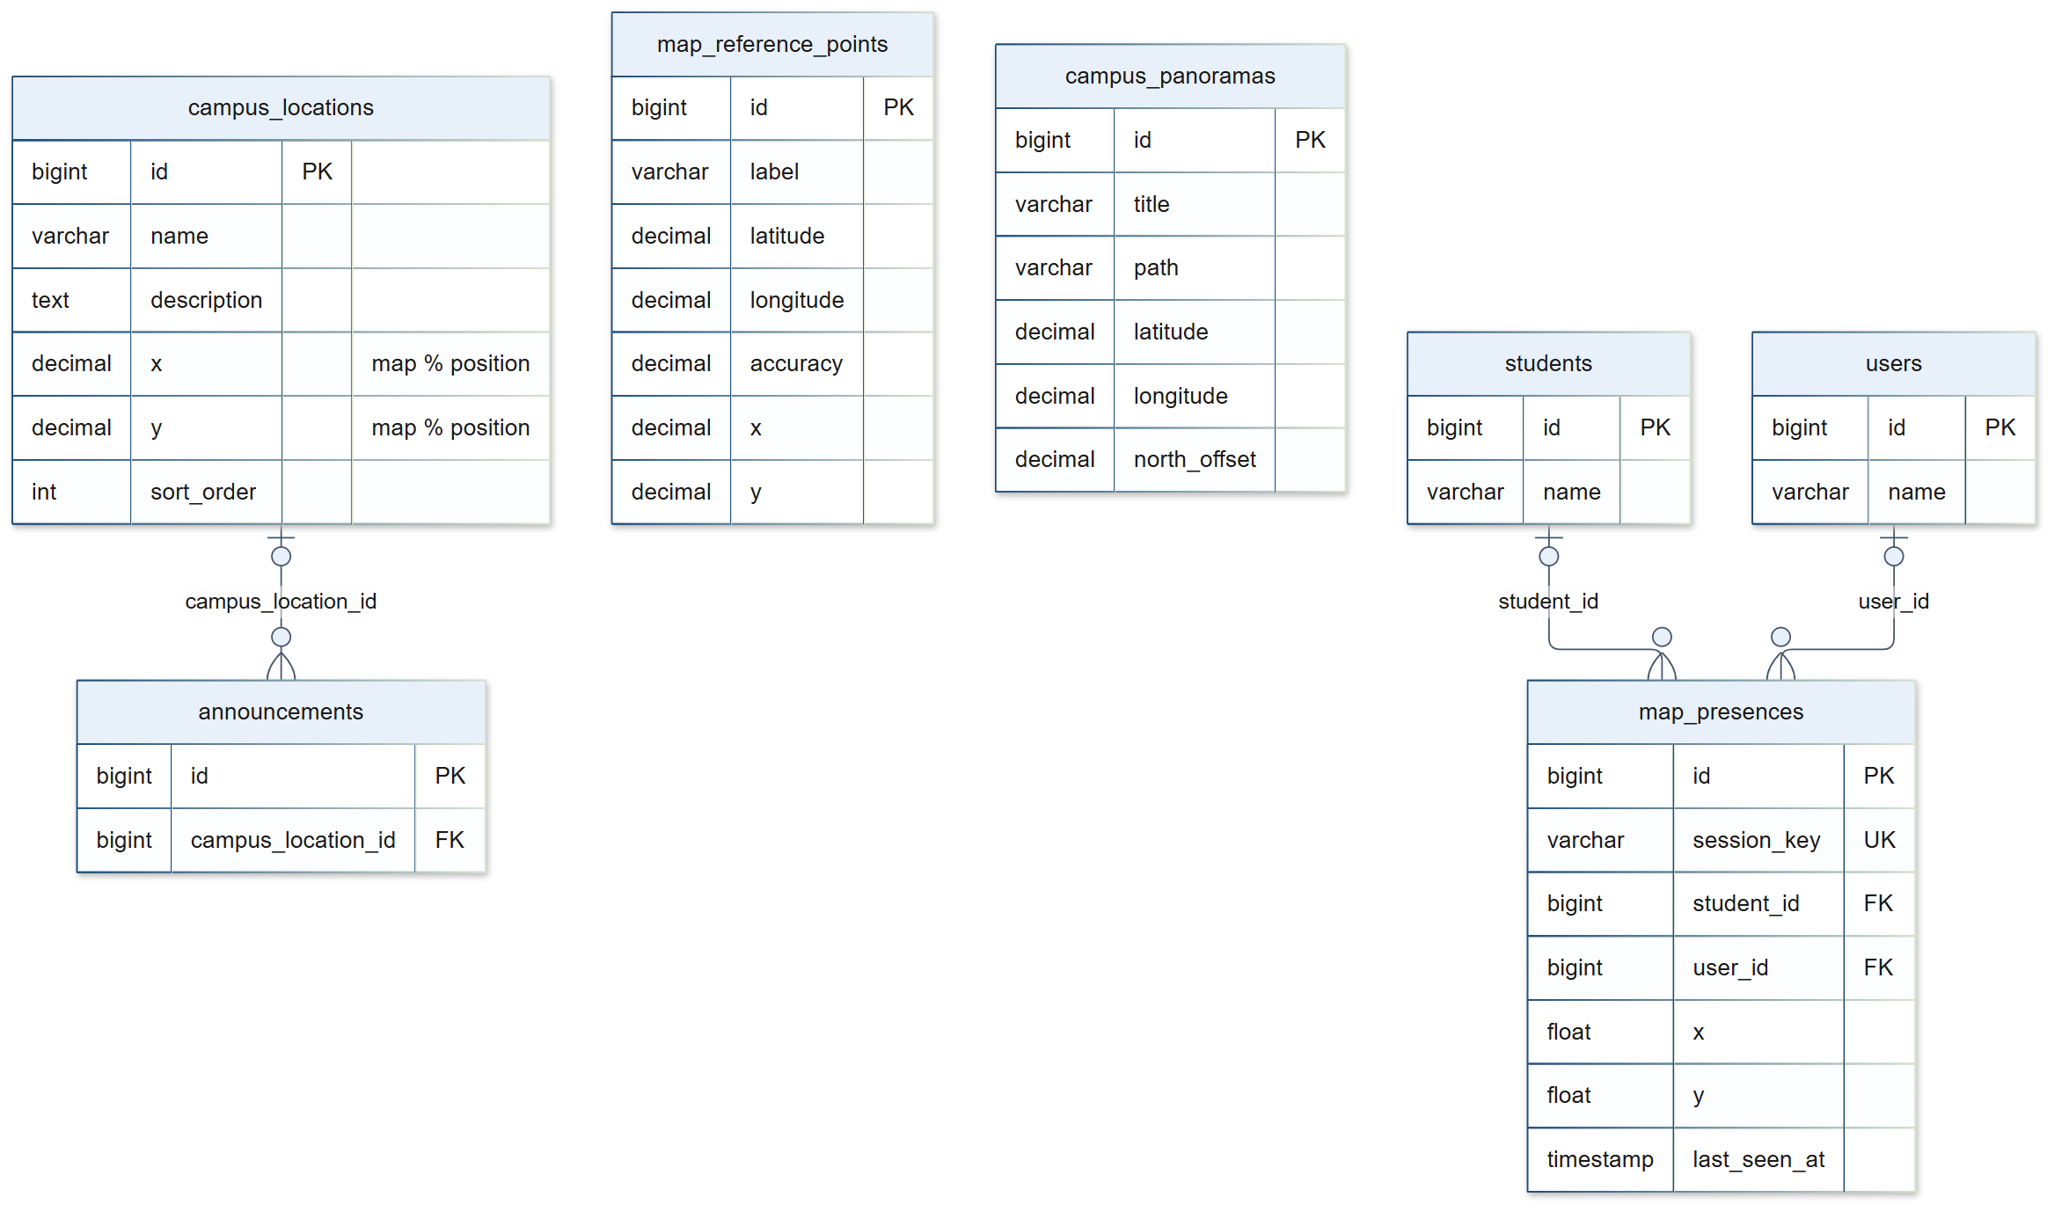
Figure 6c. Database Schema: Campus Map

Tables
Table | Holds
users | Staff accounts: name, e-mail, phone, role (super_admin, admin, registrar or teacher), password and two-factor settings.
passkeys | Passkeys (WebAuthn credentials) that staff can use to log in.
manual_categories, manuals | The School Manual: categories and their articles in display order, as draft or published.
announcements, announcement_student | Announcements and events, their audience, personnel roles to e-mail, event venue, and the targeted students.
media | Photos and videos attached to manuals or announcements.
settings | Key-value settings such as the kiosk theme colors.
chatbot_faqs, chatbot_logs | Prepared chatbot answers, and a log of every question asked with the answer given and the visitor's rating.
students, guardians | The student roster with portal login details, and each student's guardians for SMS.
school_years | The school years (e.g. 2026-2027), with one marked as current.
courses, sections | College and graduate courses (for example BSIT), and the sections offered per level and grade.
enrollments | Each student's level, grade, course and section for each school year, one row per student per year.
subjects | Subjects offered per education level, with code and units.
teaching_assignments | Which subject and section each teacher handles per school year.
grades, grade_audits | Student grades (quarterly or semestral) and the full history of every change, with who made it.
campus_locations, map_reference_points, campus_panoramas | Map pins, GPS reference points that fit the map to real GPS, and 360° photos with their GPS position and north offset.
map_presences | The current map position of each phone sharing its location, for the staff live map.

