System Diagrams
AI-Powered Smart Information Kiosk
Aemilianum College Inc. — Capstone Project Documentation
Context Diagram · Data Flow Diagram · Entity Relationship Diagram · Use Case Diagram
System Architecture Diagram · Sequence Diagrams · Class Diagram · Activity Diagram

List of Figures
- Figure 1. Context Diagram (Level 0 Data Flow Diagram)
- Figure 2. Data Flow Diagram — Level 1
- Figure 3. Entity Relationship Diagram (ERD)
- Figure 4. Use Case Diagram
- Figure 5. System Architecture Diagram
- Figure 6a. Sequence Diagram — Publish Announcement & SMS Notification
- Figure 6b. Sequence Diagram — AI Chatbot Ask
- Figure 6c. Sequence Diagram — Bulk Student Import (CSV)
- Figure 7. Class Diagram (Eloquent Models)
- Figure 8. Activity Diagram — Publish Announcement & Notify Workflow

1. Context Diagram (Level 0 DFD)
The context diagram is the highest-level view of the system: it shows the entire AI-Powered Smart Information Kiosk as a single process and identifies every external entity it exchanges data with, without exposing any internal processing detail.
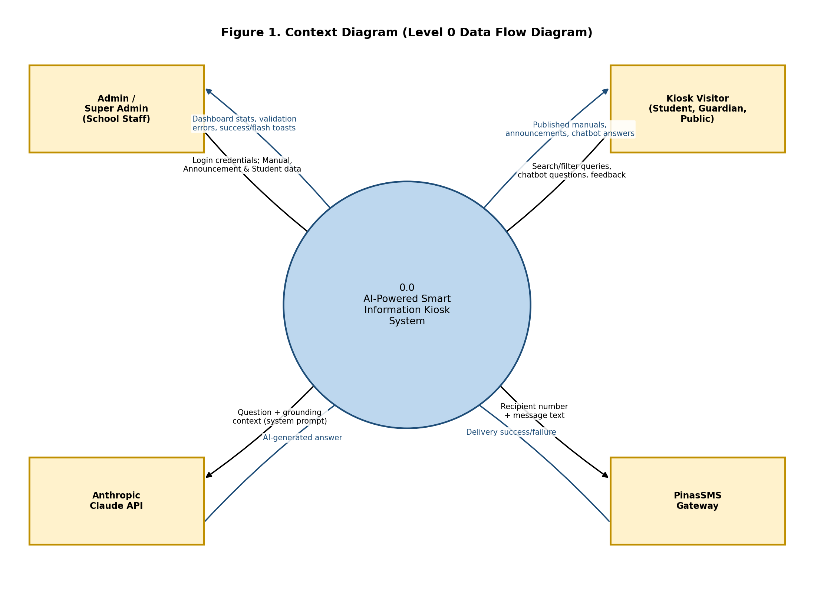

Description
- Admin / Super Admin — school staff who authenticate into the backoffice to manage manuals, announcements, students, and (for super admins) user accounts.
- Kiosk Visitor — students, guardians, or the general public using the public touchscreen/website: browsing content and chatting with the AI assistant, with no login required.
- Anthropic Claude API — the external large-language-model provider the chatbot calls for grounded, natural-language answers.
- PinasSMS Gateway — the external SMS provider used to text students/guardians when an announcement is published.
All data entering or leaving the system passes through exactly one of these four external entities, which is what makes this the correct system boundary for the diagram.

2. Data Flow Diagram — Level 1
The Level 1 DFD decomposes the single process from the context diagram into the system’s seven major functional processes, and introduces the data stores each one reads from or writes to.
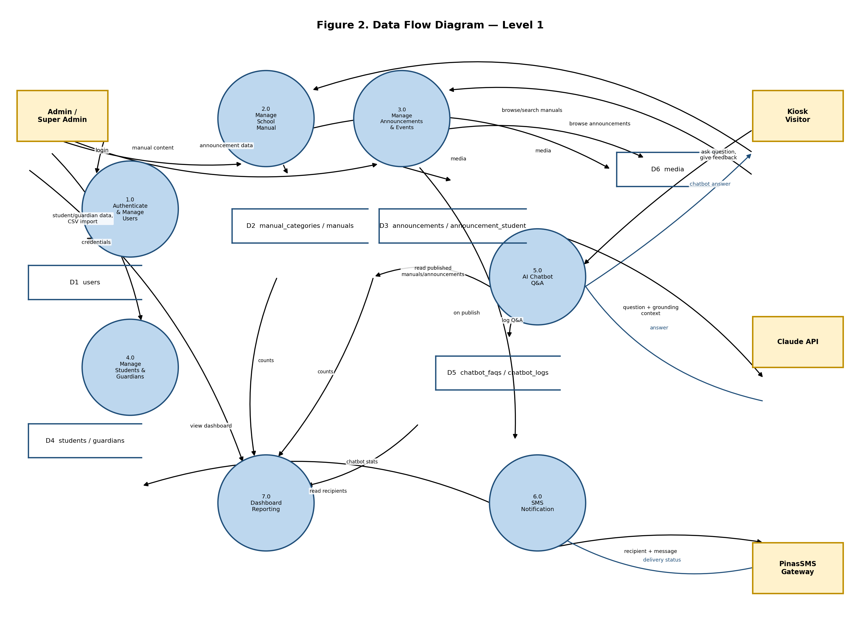

Processes
- 1.0 Authenticate & Manage Users — Fortify login/2FA/passkeys plus super-admin-only user CRUD.
- 2.0 Manage School Manual — categories and manual articles (draft/published workflow).
- 3.0 Manage Announcements & Events — announcements/events, audience targeting, and media.
- 4.0 Manage Students & Guardians — roster maintenance and CSV bulk import.
- 5.0 AI Chatbot Q&A — Claude-backed or local-fallback question answering, grounded in published content.
- 6.0 SMS Notification — resolves recipients and dispatches queued SMS on publish.
- 7.0 Dashboard Reporting — aggregates counts across all other processes for the admin dashboard.

Data Stores
- D1 users — accounts, roles, credentials, 2FA/passkey state.
- D2 manual_categories / manuals — the School Manual content.
- D3 announcements / announcement_student — announcements/events and their targeted-student pivot.
- D4 students / guardians — the student roster and contact records.
- D5 chatbot_faqs / chatbot_logs — chatbot question/answer history and feedback.
- D6 media — polymorphic image/video attachments shared by manuals and announcements.

3. Entity Relationship Diagram (ERD)
The ERD documents every table in the database (matching the Laravel migrations in database/migrations) and the relationships between them, as implemented by the Eloquent model relations in app/Models.
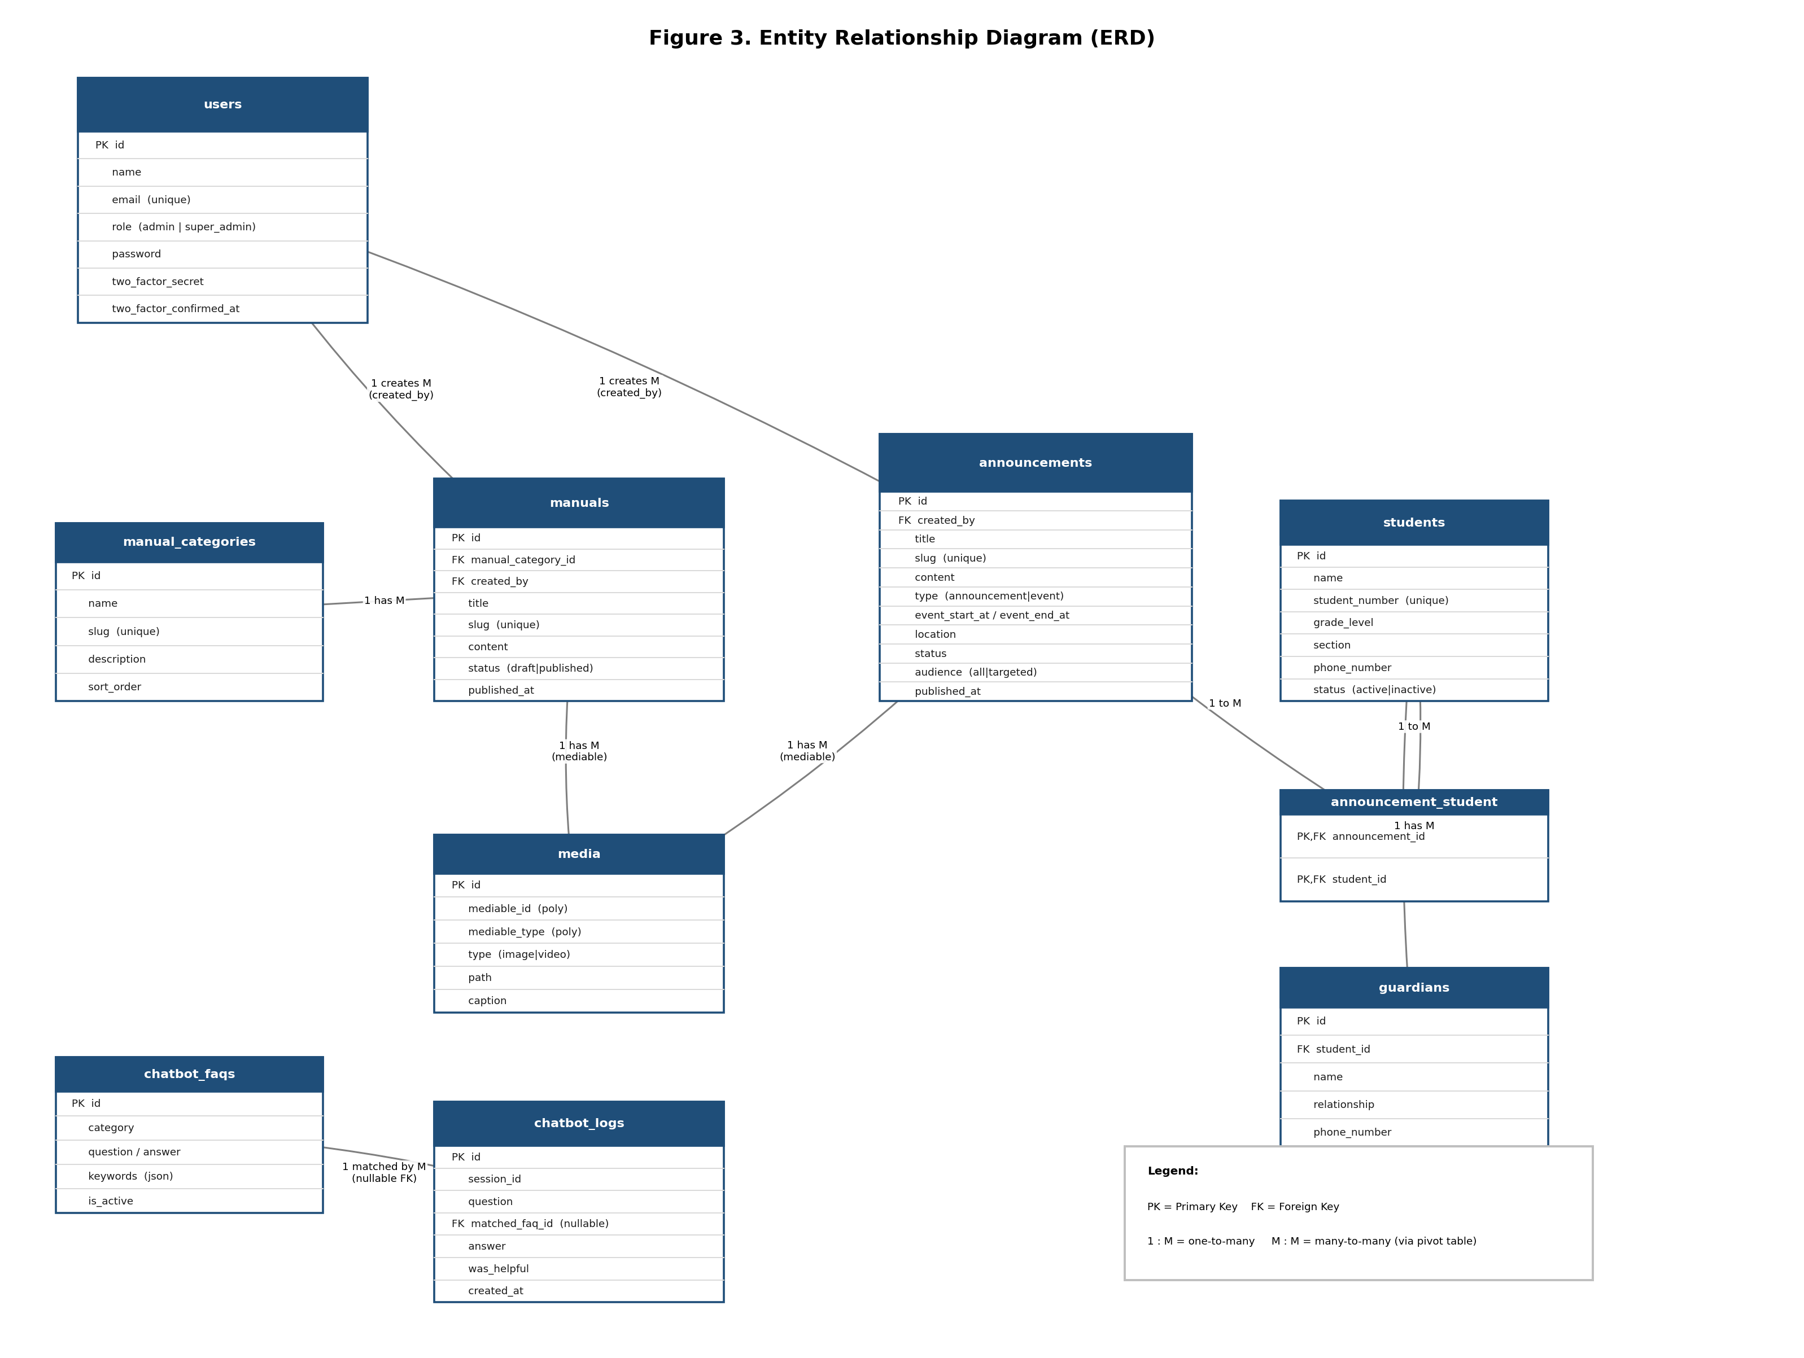

Key relationships
- users → manuals / announcements (1:M) — every manual and announcement records who created it via created_by.
- manual_categories → manuals (1:M) — a category groups many manual articles.
- manuals / announcements → media (1:M, polymorphic) — a single media table serves both parents via mediable_id + mediable_type.
- announcements ↔ students (M:M via announcement_student) — used only when an announcement's audience is ‘targeted’.
- students → guardians (1:M) — each student has one or more parent/guardian contacts, cascade-deleted with the student.
- chatbot_faqs → chatbot_logs (1:M, nullable FK) — a log entry may optionally reference a matched FAQ.

4. Use Case Diagram
The use case diagram identifies the system’s actors and the discrete goals each actor can accomplish, along with <<include>> relationships (a use case that always triggers a sub-use-case) and <<extend>> relationships (optional behavior that augments a base use case).
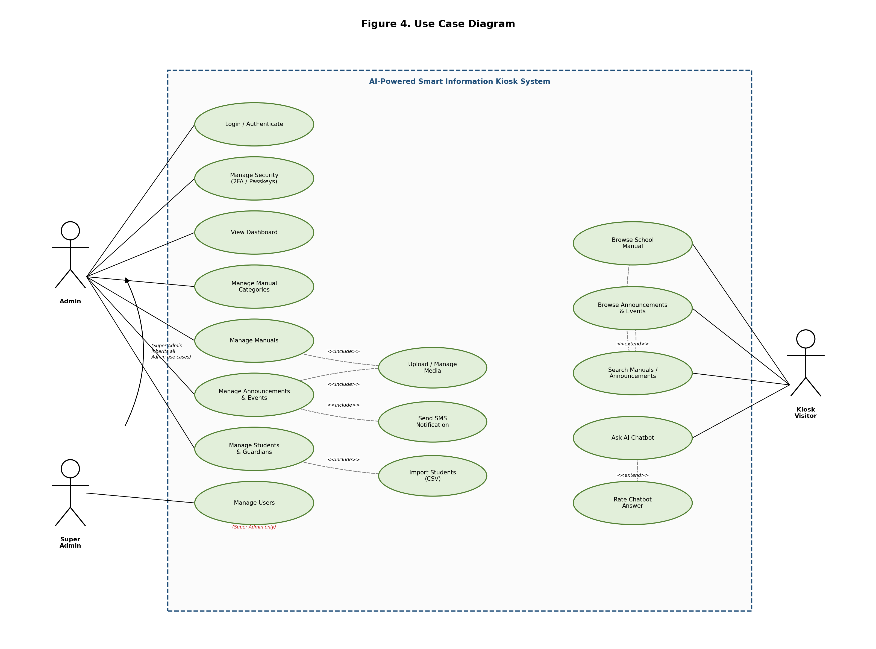

Actors
- Admin — school staff who manage content: manuals, categories, announcements, students, security settings.
- Super Admin — inherits every Admin use case and is additionally the only actor who can manage user accounts.
- Kiosk Visitor — the public/unauthenticated actor who browses content and uses the AI chatbot.

Notable include/extend relationships
- Manage Manuals / Manage Announcements <<include>> Upload / Manage Media.
- Manage Announcements <<include>> Send SMS Notification (fires automatically on publish).
- Manage Students & Guardians <<include>> Import Students (CSV).
- Ask AI Chatbot <<extend>> Rate Chatbot Answer (feedback is optional, after an answer is given).

5. System Architecture Diagram
This diagram shows the system’s five physical/logical layers and how a request or background job moves between them, from the browser down to the database and out to external APIs.
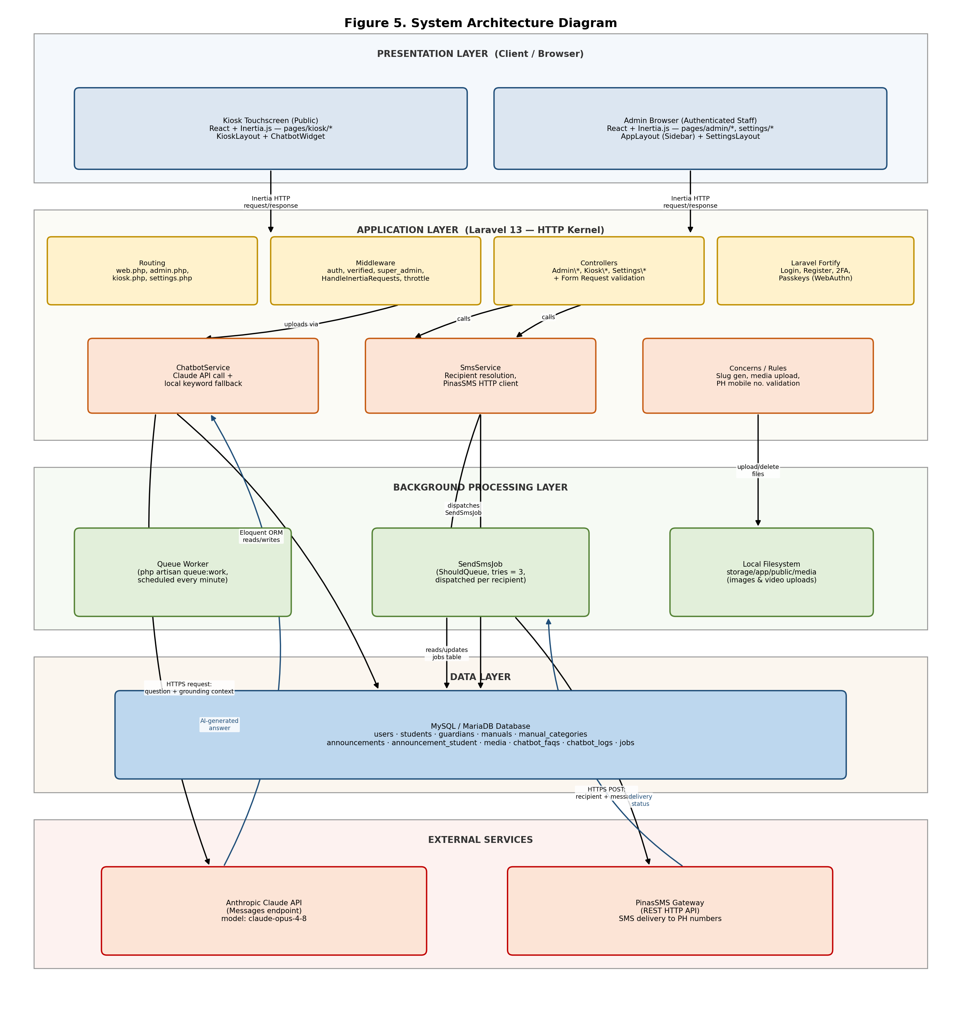

Layers
- Presentation Layer — the Kiosk (public) and Admin (authenticated) single-page experiences, both built with React + Inertia.js and served the same Laravel routes.
- Application Layer — Laravel 13’s routing, middleware, controllers, Form Request validation, and Fortify authentication, plus the two domain services (ChatbotService, SmsService).
- Background Processing Layer — the queue worker that processes SendSmsJob asynchronously, and the local filesystem disk that stores uploaded media.
- Data Layer — a single MySQL/MariaDB database holding all application tables plus Laravel’s jobs queue table.
- External Services — the Anthropic Claude API (chatbot answers) and the PinasSMS gateway (SMS delivery), both called over HTTPS.

6. Sequence Diagrams
The following three sequence diagrams trace the exact object/component interactions, in call order, for the system’s three most representative workflows.

6.1 Publish Announcement & SMS Notification
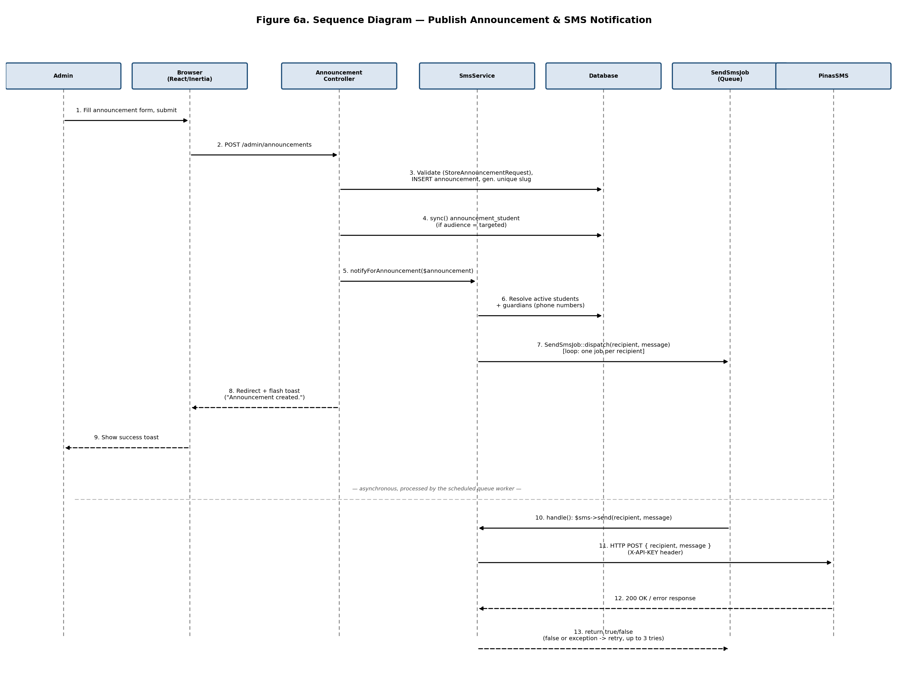
Steps 1–9 are synchronous (within the HTTP request/response cycle); the admin’s browser receives its redirect and success toast immediately after the announcement and its SMS jobs are queued. Steps 10–13 happen later, out-of-band, when the scheduled queue worker (routes/console.php) picks up each queued SendSmsJob and actually calls the PinasSMS gateway — this is why publishing an announcement to hundreds of recipients still feels instant to the admin.

6.2 AI Chatbot Ask
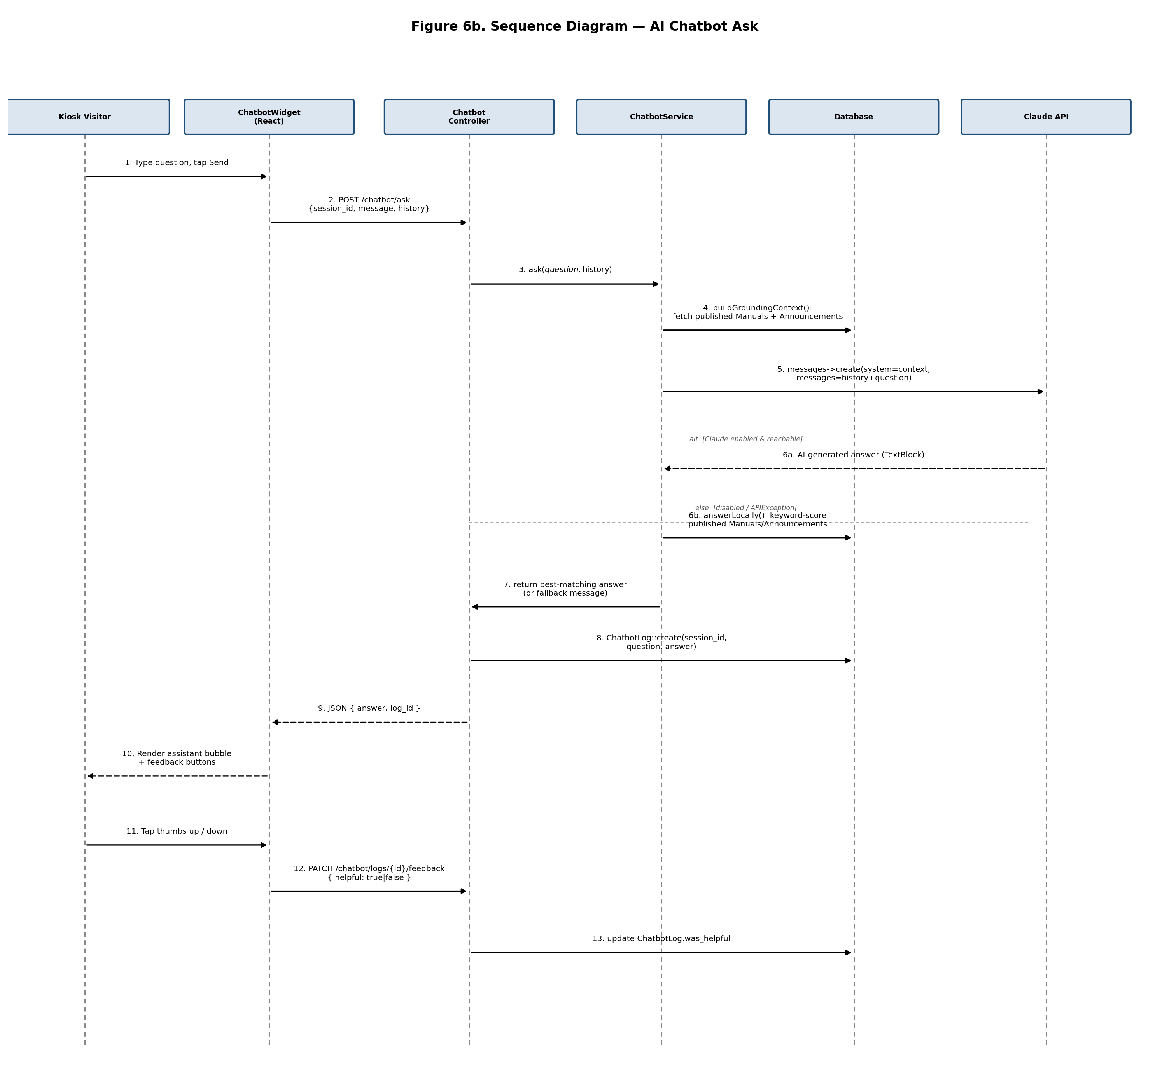
The alt/else block (steps 6a/6b) is the core design decision behind the chatbot: if Claude is enabled and reachable, ChatbotService returns its grounded answer; otherwise — or if the Claude call throws an APIException — it falls through to the free, offline keyword-scoring fallback against the same published Manuals/Announcements. Either path is logged identically (step 8), so the feedback loop (steps 11–13) works the same regardless of which path answered the question.

6.3 Bulk Student Import (CSV)
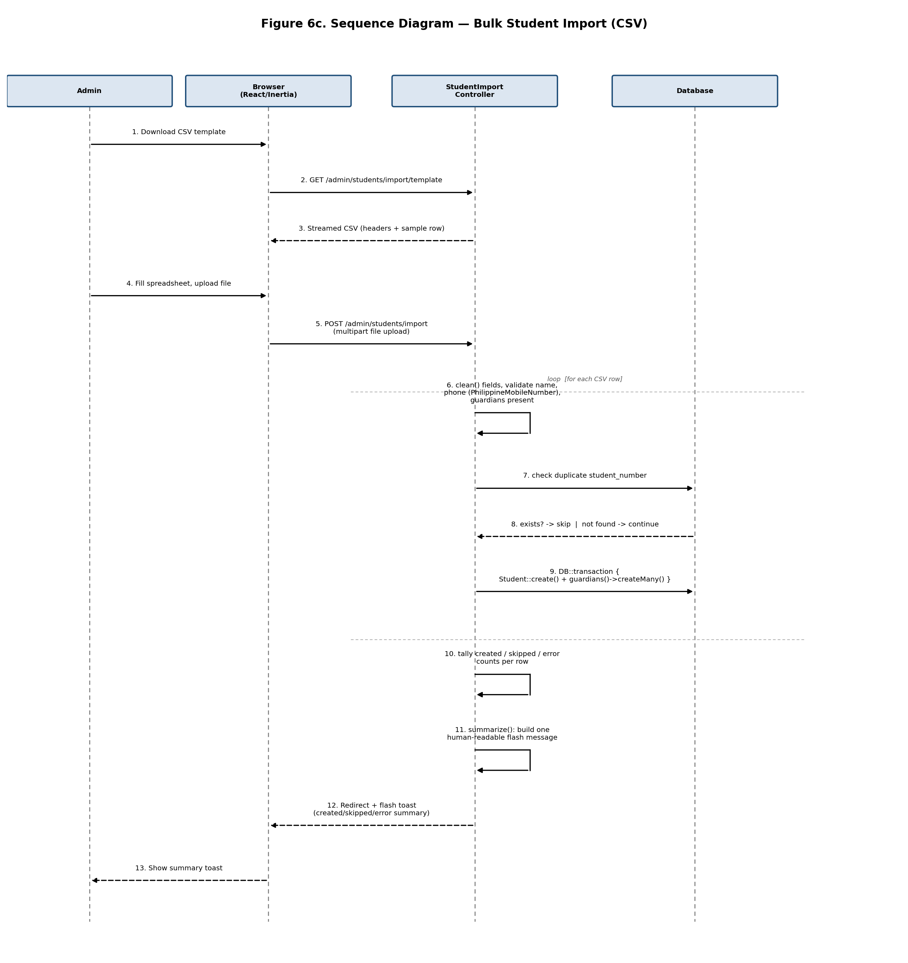
Each CSV row is validated and imported independently inside its own DB::transaction (step 9), so a single malformed row cannot leave a half-created student record, and duplicate student_number rows are silently skipped rather than treated as errors — making repeat uploads of the same master spreadsheet safe.

7. Class Diagram
The class diagram documents the system’s Eloquent models — their key attributes, key methods/relations — plus the two domain services (ChatbotService, SmsService) that operate on them. Solid lines are real Eloquent relationships (as defined by hasMany/belongsTo/morphMany/belongsToMany methods); dashed lines show a service reading from or being triggered by a model, which is a dependency rather than a stored relationship.
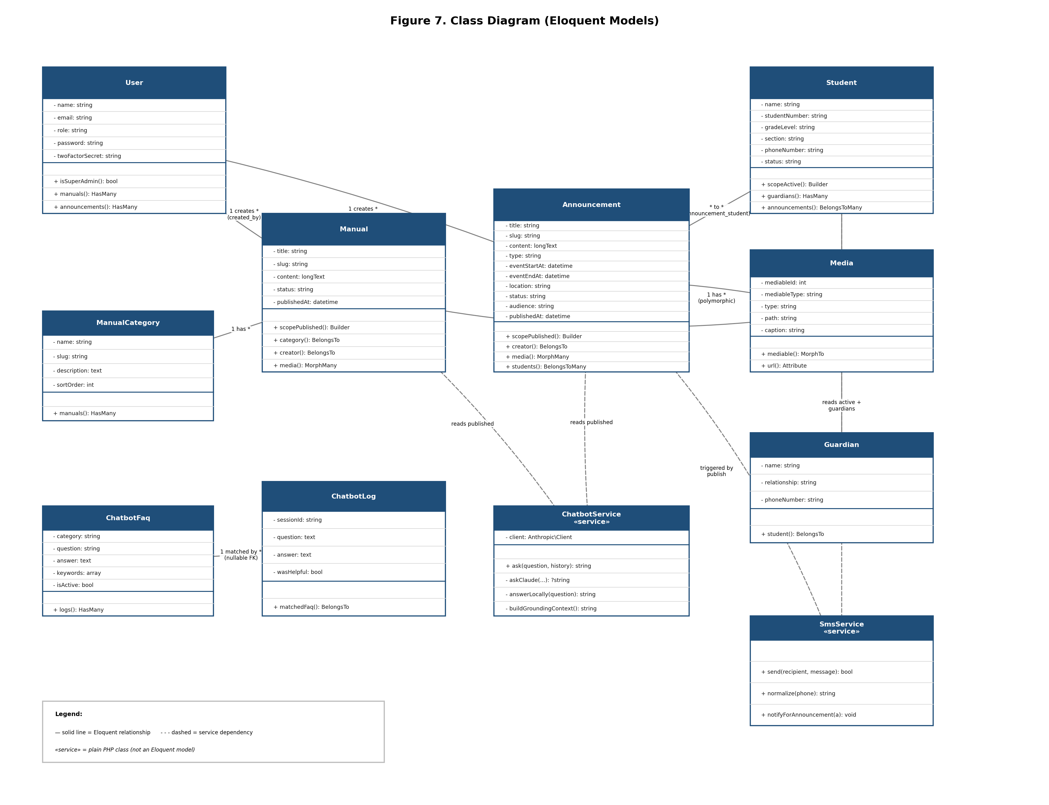

Design notes
- Media is polymorphic — one class serves both Manual and Announcement galleries via mediable(), instead of two near-identical media tables.
- ChatbotService and SmsService are plain PHP classes (marked «service»), not Eloquent models — they orchestrate business logic across models rather than representing a database table themselves.
- User carries the entire authorization model in a single role attribute plus an isSuperAdmin() helper, rather than a separate roles/permissions table — deliberately minimal for a two-tier (admin/super_admin) system.

8. Activity Diagram (Flowchart)
This flowchart traces the control flow of the system’s most business-critical operation — publishing an announcement — including every conditional branch implemented in AnnouncementController and StoreAnnouncementRequest.
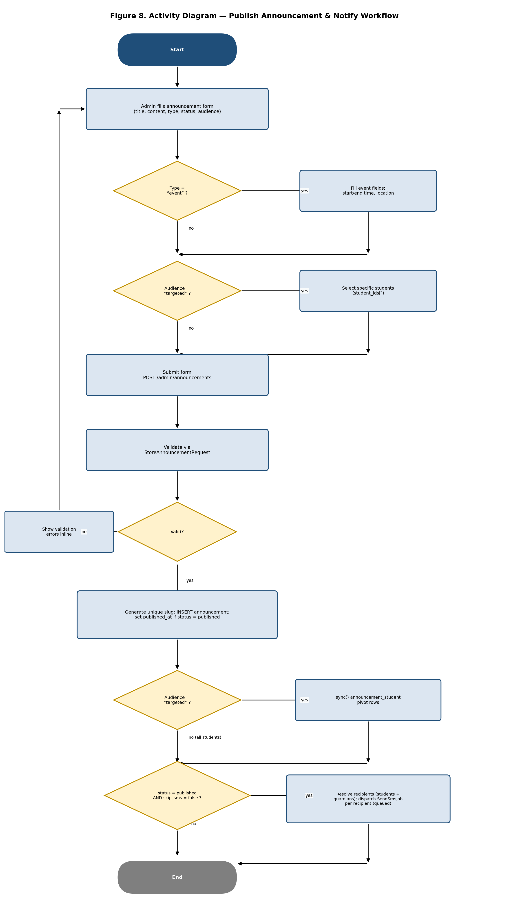

Key decision points
- Type = “event”? — determines whether the form collects event start/end time and location.
- Audience = “targeted”? (appears twice) — first to decide whether the admin picks specific students in the UI, and again server-side to decide whether the announcement_student pivot is synced.
- Valid? — failed validation returns the admin to the same form with inline errors, rather than losing their input.
- status = published AND skip_sms = false? — the single guard that decides whether SMS is dispatched at all, satisfied only on the initial publish (not on later edits) unless the admin explicitly opts back in.

