Featured Events
Admin guide for the Aemilianum College Inc. Smart Information Kiosk
November 4, 2026

What is new
The kiosk home page now has a Featured events section. It sits at the very top of the page, right under the welcome message, so it is the first thing students, parents and visitors see when they walk up to the kiosk.
You choose which events appear there from the admin panel. Tick one box when you create or edit an event, and it is showcased on the kiosk with its photo, date, place and a short description. When the event is over, it leaves the section by itself, so there is nothing to clean up afterwards.

How to feature an event
- Sign in to the admin panel and open Announcements from the left menu.
- Click New Announcement to create a new event, or click the pencil icon next to an existing event to edit it.
- Set Type to Event, then fill in the title, content and when the event starts (and ends, if you know).
- Tick Feature this event on the kiosk home page. This box only appears when the type is Event.
- Set Status to Published. Draft events are never shown on the kiosk.
- Optional but recommended: add a photo under Photos & videos. The first photo becomes the event's picture on the kiosk.
- Click Create Announcement (or Save Changes when editing).
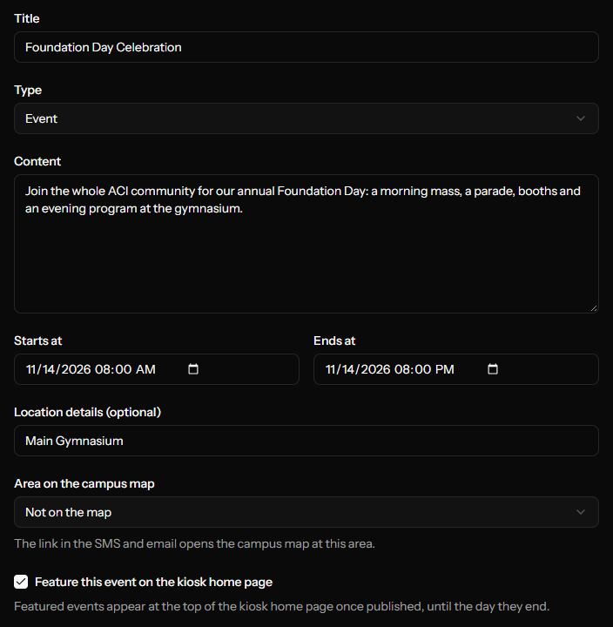
Figure 1. The event form with the new "Feature this event" option ticked.
Tip: If you only want to feature the event and not text anyone about it, also tick "Don't send SMS or email notifications" before saving.

Seeing which events are featured
In the Announcements list, featured events have a Featured badge with a star next to their title.
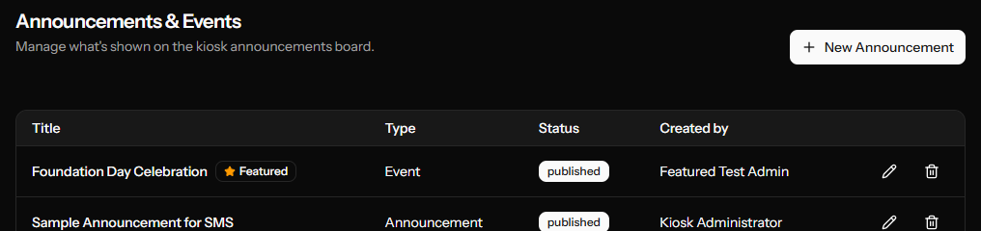
Figure 2. The Announcements list marks featured events with a star badge.

What visitors see on the kiosk
Each featured event appears as a card showing:
- Photo: the first photo attached to the event. If there is no photo, a calendar icon is shown instead.
- Date and time the event starts.
- Title and location (if one was entered).
- A short description: the first lines of the event's content.
Touching a card opens the full event page with all its details, photos and videos. The All events link beside the heading opens the full list of events.
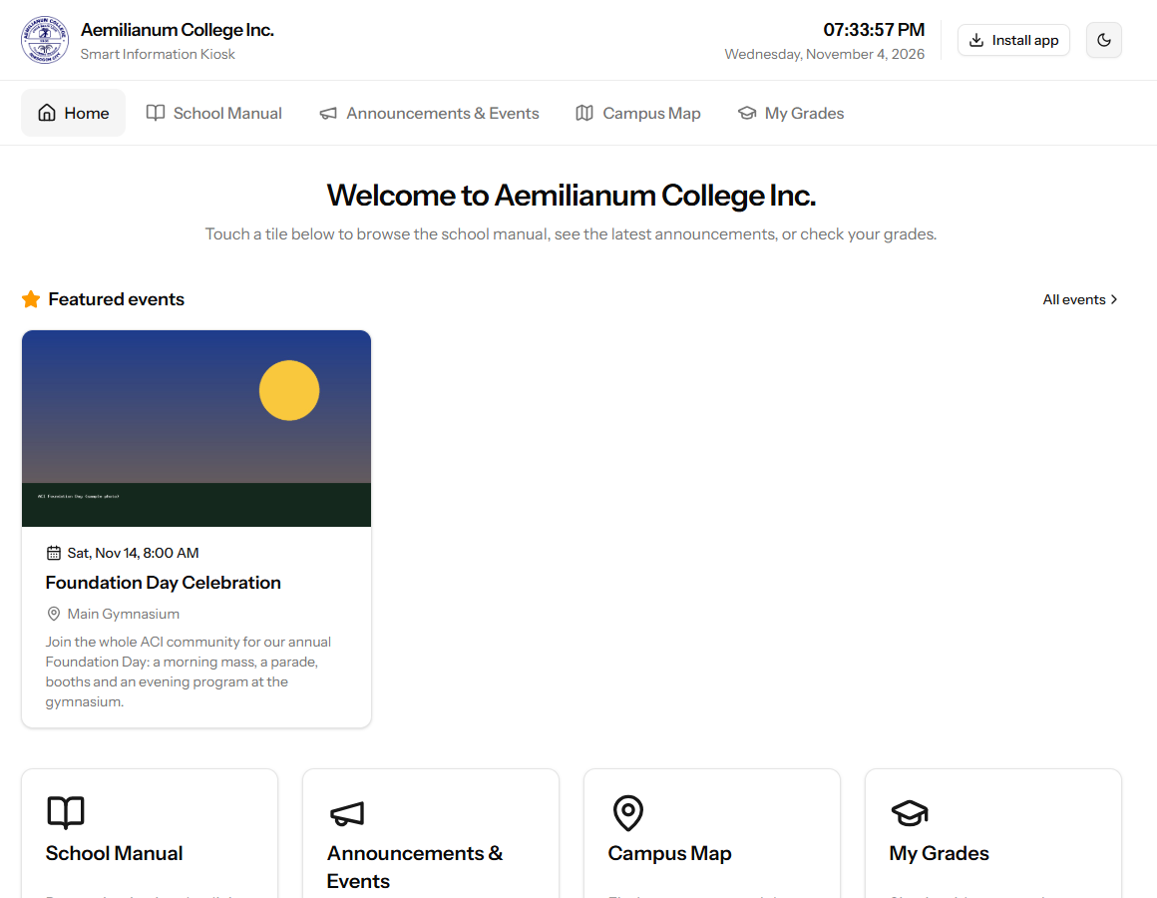
Figure 3. The kiosk home page with a featured event at the top.
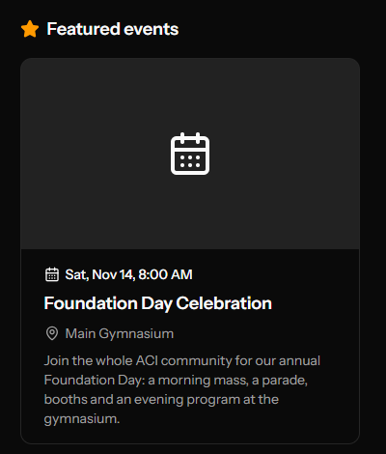
Figure 4. A featured event without a photo shows a calendar icon instead.
The section works in both the light and dark kiosk themes, and it is hidden completely when there are no featured events, so the home page never shows an empty box.

How the kiosk decides what to show
An event appears in Featured events only when all of these are true:
Rule | What it means
It is an Event | Regular announcements cannot be featured. If you change an event's type to Announcement, it is automatically un-featured.
It is Published | Drafts stay hidden until you publish them.
The box is ticked | "Feature this event on the kiosk home page" is checked.
It has not ended yet | The event stays on the home page until the end of the day it ends (or the day it starts, if no end time was entered). After that it disappears from Featured on its own. It is still listed under Announcements & Events.

When several events are featured, the kiosk shows the soonest one first, up to 6 events at a time. If more than six are featured, the later ones appear automatically as earlier events finish.

Removing an event from Featured
- Open Announcements and click the pencil icon next to the event.
- Untick Feature this event on the kiosk home page.
- Click Save Changes.
The event disappears from the kiosk home page right away but stays published under Announcements & Events. You do not need to do this for events that are already over, because they leave the section automatically.

Tips for good-looking featured events
- Use a landscape (wide) photo. The kiosk shows the picture in a wide 16:9 frame, so tall photos get trimmed at the top and bottom.
- Put the most important information in the first sentence of the content. Only the first lines (about 140 characters) are shown on the card.
- Fill in Location details so visitors know where to go at a glance.
- Feature only the events that matter most, such as Foundation Day, enrollment or graduation. A short list stands out more than a long one.

Questions and answers
I ticked the box but the event is not on the kiosk. Why?
Check that the event is Published (not Draft), that its Type is Event, and that its end date has not already passed. Also check whether six other events are already featured with earlier dates. If they are, yours will appear once those finish. Refresh the kiosk page after saving.
I don't see the "Feature this event" box.
The box only appears after you set Type to Event.
Can I choose which photo is shown?
The kiosk uses the first photo you uploaded to the event. Videos are skipped. To use a different picture, remove the current first photo in the event's Media section and upload the one you want.
Will featuring an event send SMS messages again?
No. Ticking or unticking Featured never sends messages. SMS and email go out only the first time an event is published, exactly as before, and not at all if "Don't send SMS or email notifications" is ticked.

Testing
The feature was checked in two ways before delivery:
- Automated tests: 11 new tests cover featuring and un-featuring events, drafts, past events, regular announcements, the 6-event limit, sort order and cover photos. The full test suite passes (214 passed, 2 skipped, 0 failed).
- Manual walkthrough: an event was created and featured from the admin panel, a photo was added, and the kiosk home page was checked in light and dark mode, including opening the event from its card. The screenshots in this guide come from that walkthrough.

Appendix: technical notes
For the person who maintains or deploys the system.
Item | Detail
Database | New migration adds an is_featured column (boolean, default false) to the announcements table. Run "php artisan migrate" when deploying.
Model | Announcement::featuredEvents() scope returns published, featured events that end today or later.
Admin | is_featured is validated as a boolean and forced off for non-event announcements.
Kiosk | Home page receives up to 6 featured events, soonest first, with a short summary and the first image as cover.
Front-end build | Run "npm run build" after pulling the change so the kiosk shows the new section.
Tests | tests/Feature/Admin/FeaturedEventTest.php

