Aemilianum College Inc.

Smart Information Kiosk: System Update Report
Dashboard, Announcements, Students and Subjects updates · October 5, 2026
This report lists the changes made to the kiosk system in response to the requested revisions. Each section explains what changed, how to use it, and shows a screenshot taken from the updated system. The names and records in the screenshots are sample data.
Summary of requested changes
Requested change | Where to find it | Status
View the map with the active users on the dashboard | Dashboard → Live Campus Map | Done
Send announcements and events to ACI personnel (e.g. faculty) by SMS | Announcements → New/Edit → "Also send to ACI personnel" | Done
Upload media (image or video) with an announcement | Announcements → New/Edit → "Photos & videos" | Done
Specific area of an event, opened on the map from the SMS/email link | Announcements → New/Edit → "Area on the campus map" | Done
Login slips as a printable PDF with the school header and footer; single slip as a ¼-page strip | Students → Login slips, or the key icon on a student | Done
Education level (JHS, SHS, College, Grad School) with a matching year-level drop-down; Excel import updated | Students → New/Edit, Students → Import | Done
Phone number must be exactly 11 digits | All phone fields | Done
All required student data must be filled out (optional data excluded) | Students → New/Edit, Import | Done
Registrar can add subjects | Subjects (new menu item) | Done

1. Dashboard: map of active users
What changed
- The dashboard now has a Live Campus Map card. It shows a dot for every phone currently using "Show my location" on the kiosk campus map.
- Dots are color-coded: green for students (shown by name when signed in to the student portal), purple for personnel, and orange for visitors.
- The list beside the map shows who is active and when they were last seen. The map refreshes on its own every 15 seconds.
- A person disappears from the map about 90 seconds after their phone stops sharing its location, or right away when they turn location off.
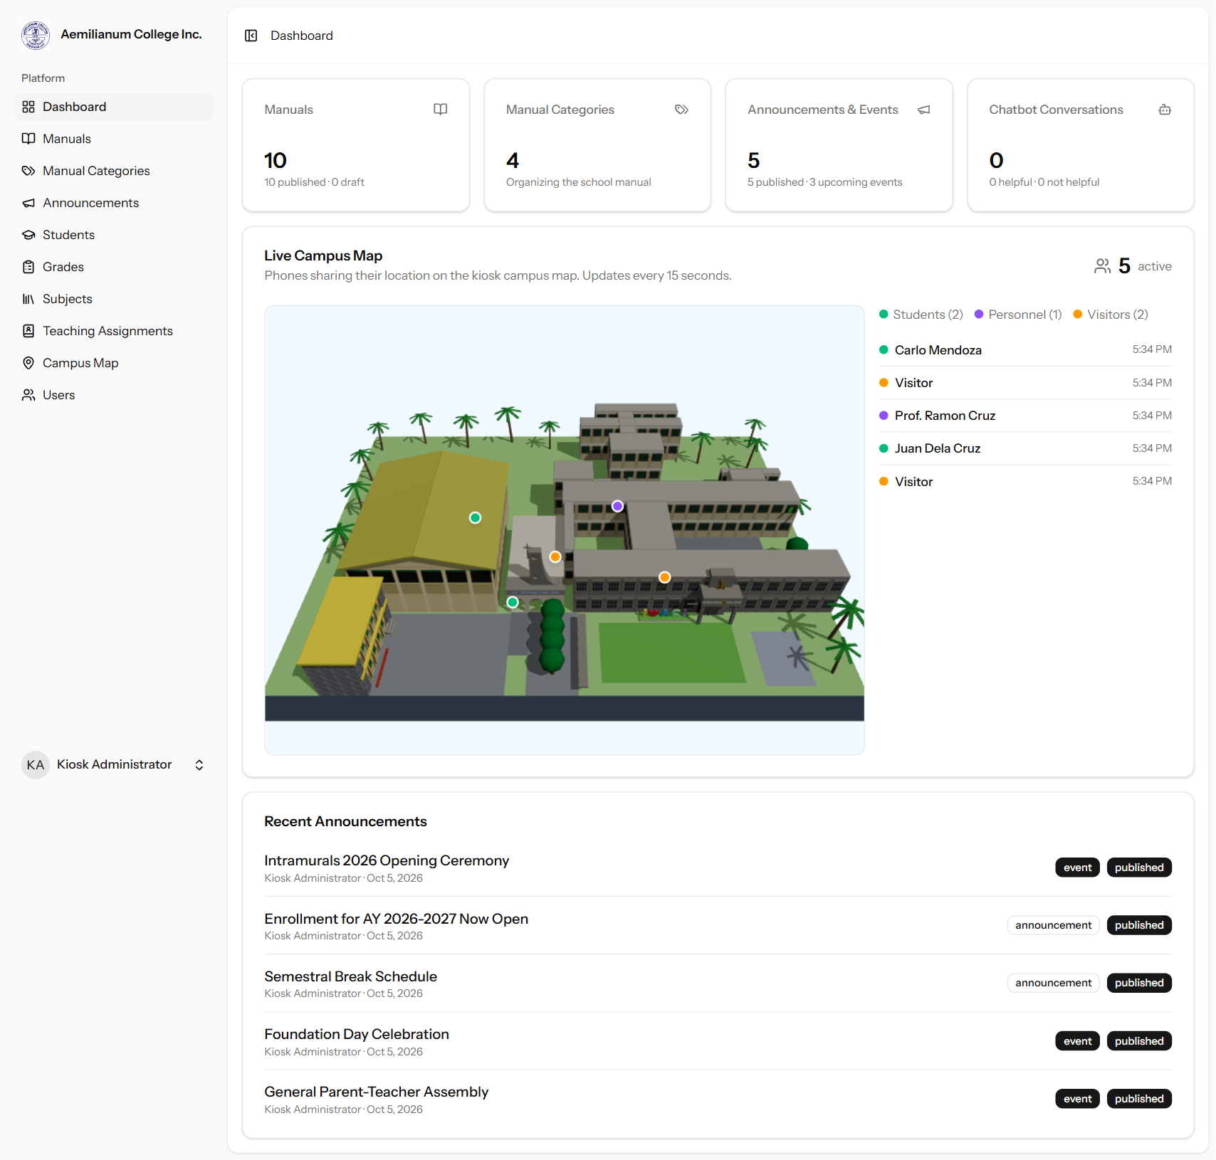
Figure 1. Dashboard with the Live Campus Map showing five active users.

2. Announcements and events

2.1 ACI personnel as an audience
- A new "Also send to ACI personnel" section lets you include Faculty, Registrar staff and/or Administrators.
- Personnel receive an SMS (when their account has a mobile number) and an email.
- A new audience option, "No students (personnel only)", is for events that involve personnel only.
- A mobile number field was added to user accounts (Users → Edit) so personnel can receive SMS.
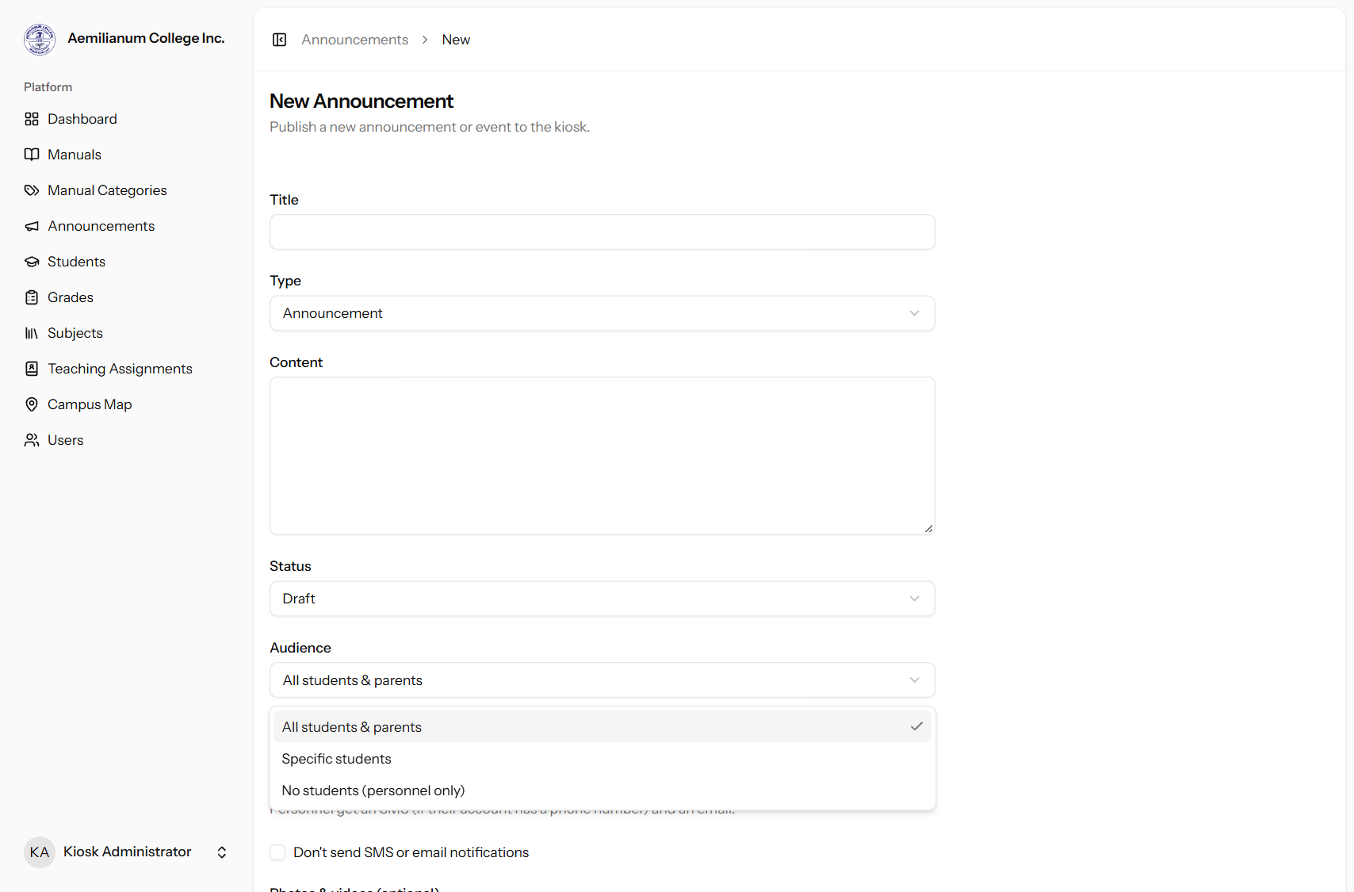
Figure 2. The Audience drop-down, including the new "No students (personnel only)" option.
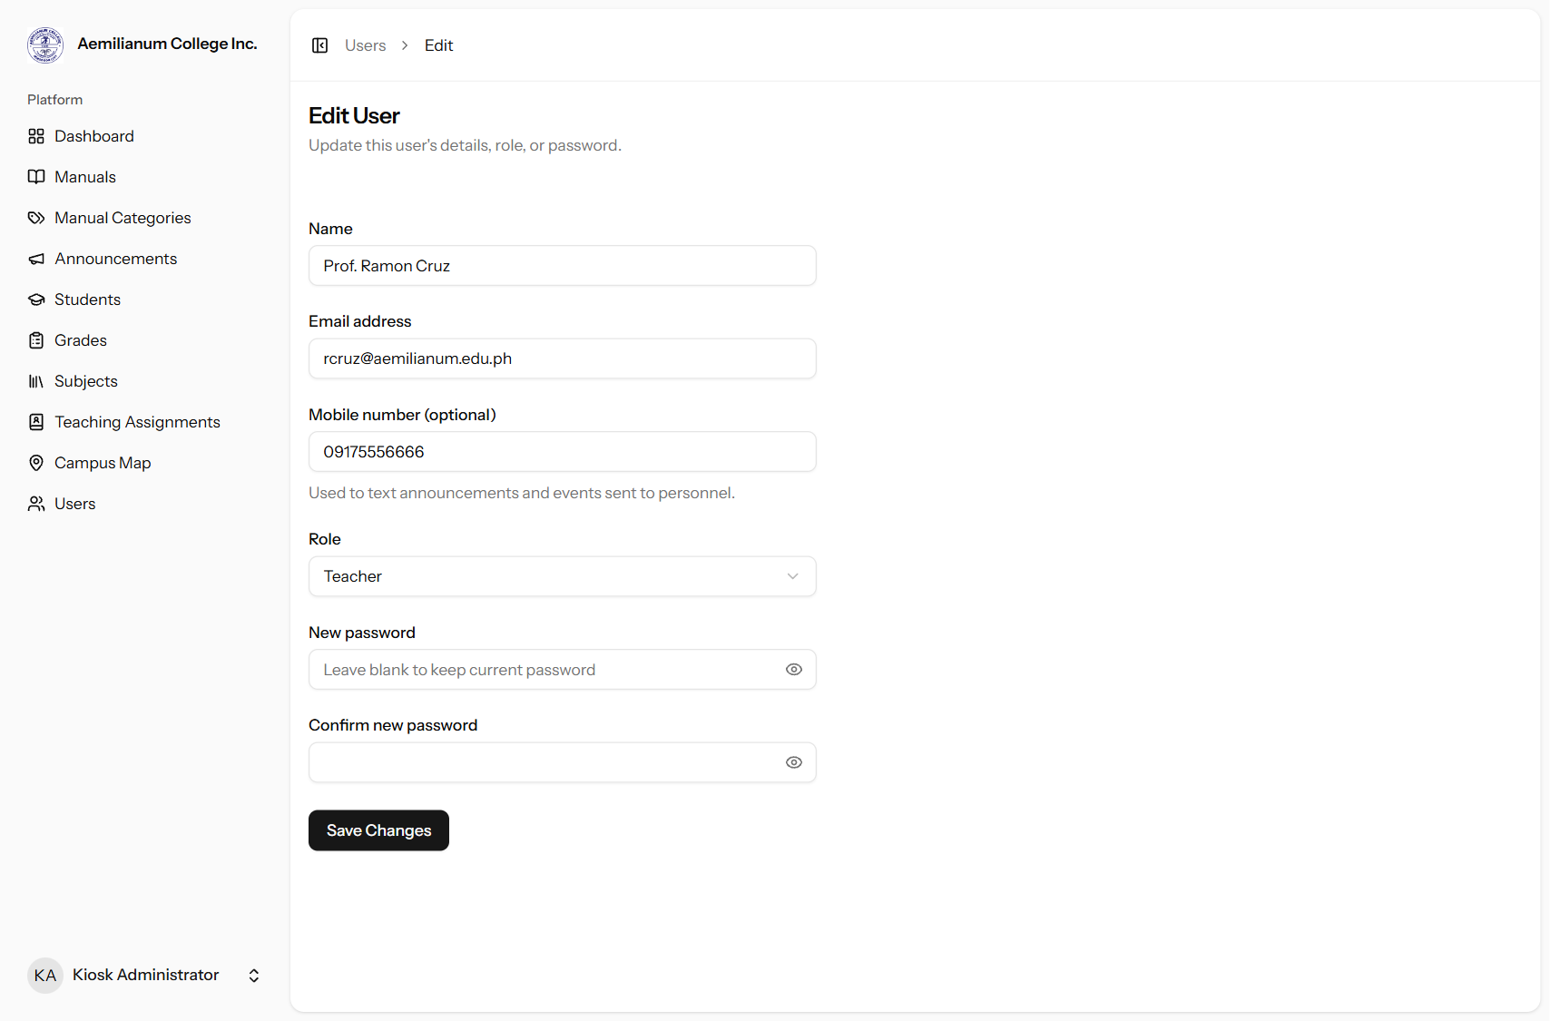
Figure 3. User account with the new optional mobile number used for personnel SMS.

2.2 Uploading media
- Photos and videos can now be attached while creating an announcement, not only when editing it afterwards.
- Up to 10 files per save, 20 MB each. Images: JPG, PNG, GIF, WebP. Videos: MP4, WebM, MOV.

2.3 Specific area of an event
- When the type is Event, an "Area on the campus map" drop-down appears. It lists the places pinned on the campus map.
- The link in the SMS and email opens the kiosk campus map with that area already selected, plus a banner showing the event name and time.
- The optional "Location details" field can add specifics such as "Main stage" or "2nd floor".
How to use
- Go to Announcements → New Announcement and set Type to Event.
- Pick the place under "Area on the campus map".
- Choose the audience and tick any personnel groups.
- Optionally attach photos or videos, set Status to Published, then click Create Announcement.
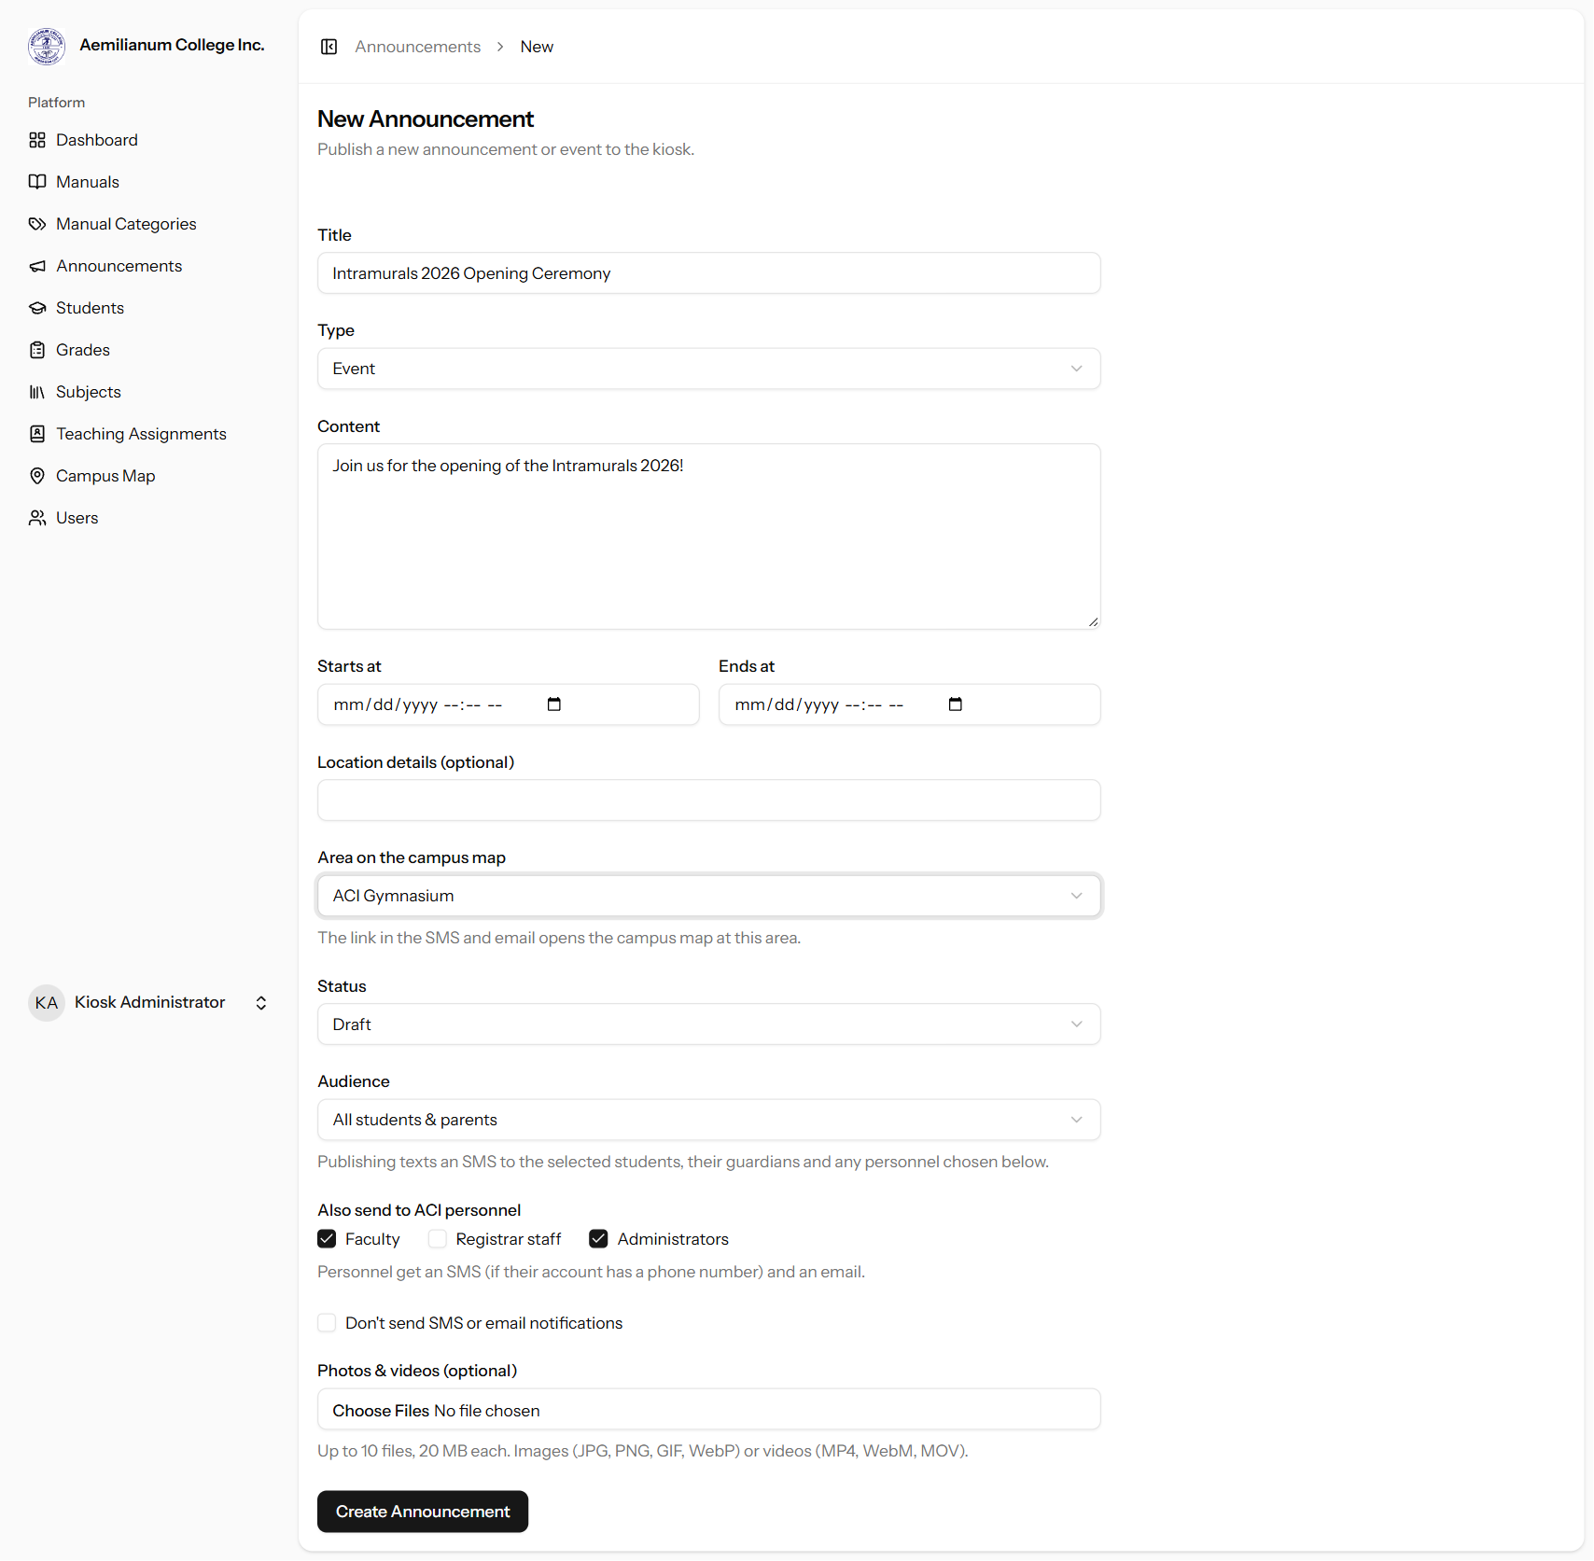
Figure 4. New event form with the campus map area, personnel audience and media upload fields.
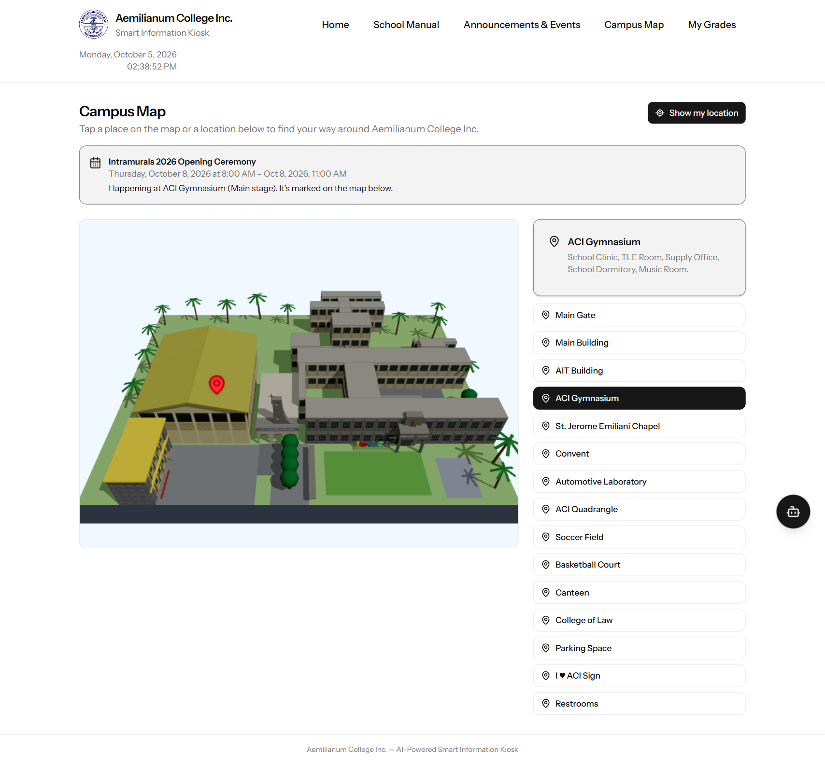
Figure 5. Opening the link from the SMS/email: the campus map highlights the event area (ACI Gymnasium).
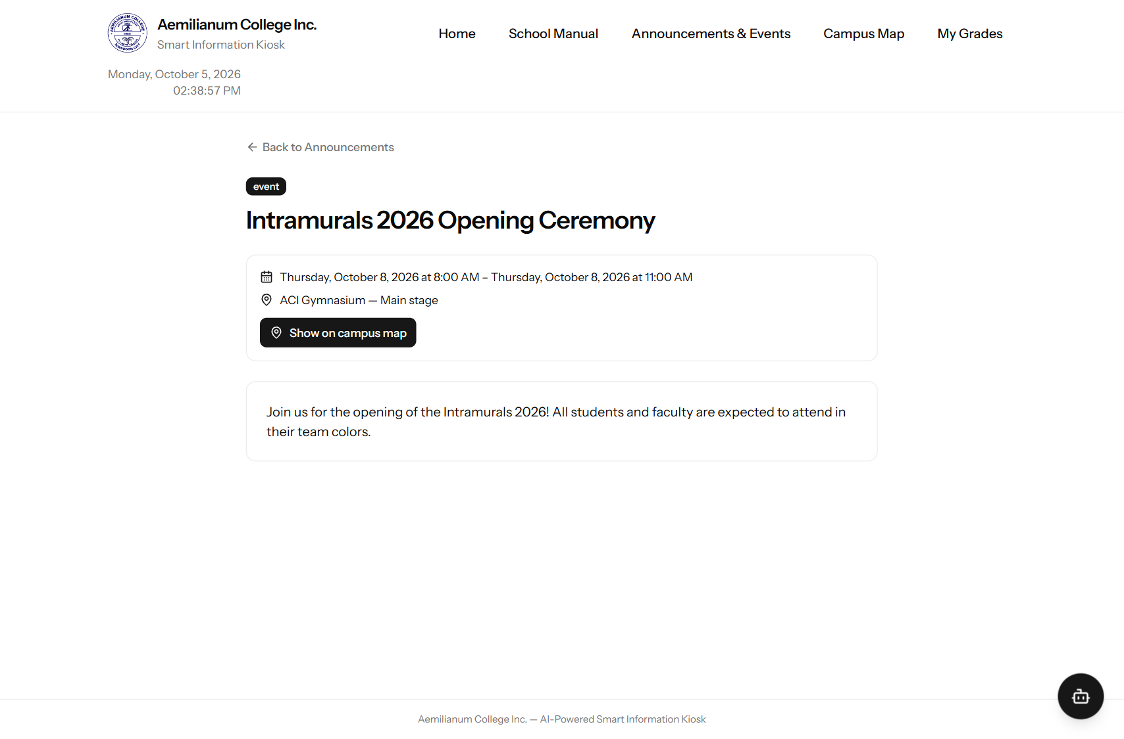
Figure 6. The event page on the kiosk now shows the area and a "Show on campus map" button.

3. Students

3.1 Login slips (PDF)
- Login slips are now PDF files, ready to print, with the school logo, name and address in the header and a privacy reminder plus issue date in the footer.
- Single student: after issuing a password (key icon on the student list), click "Print slip (PDF)". The slip is a strip ¼ of a short bond page (8.5 × 2.75 in).
- Whole section or school: Students → Login slips. The PDF has four slips per short bond page with dashed cut lines.
- Each slip shows the student's name, level, year and section, student number, temporary password, and sign-in steps.
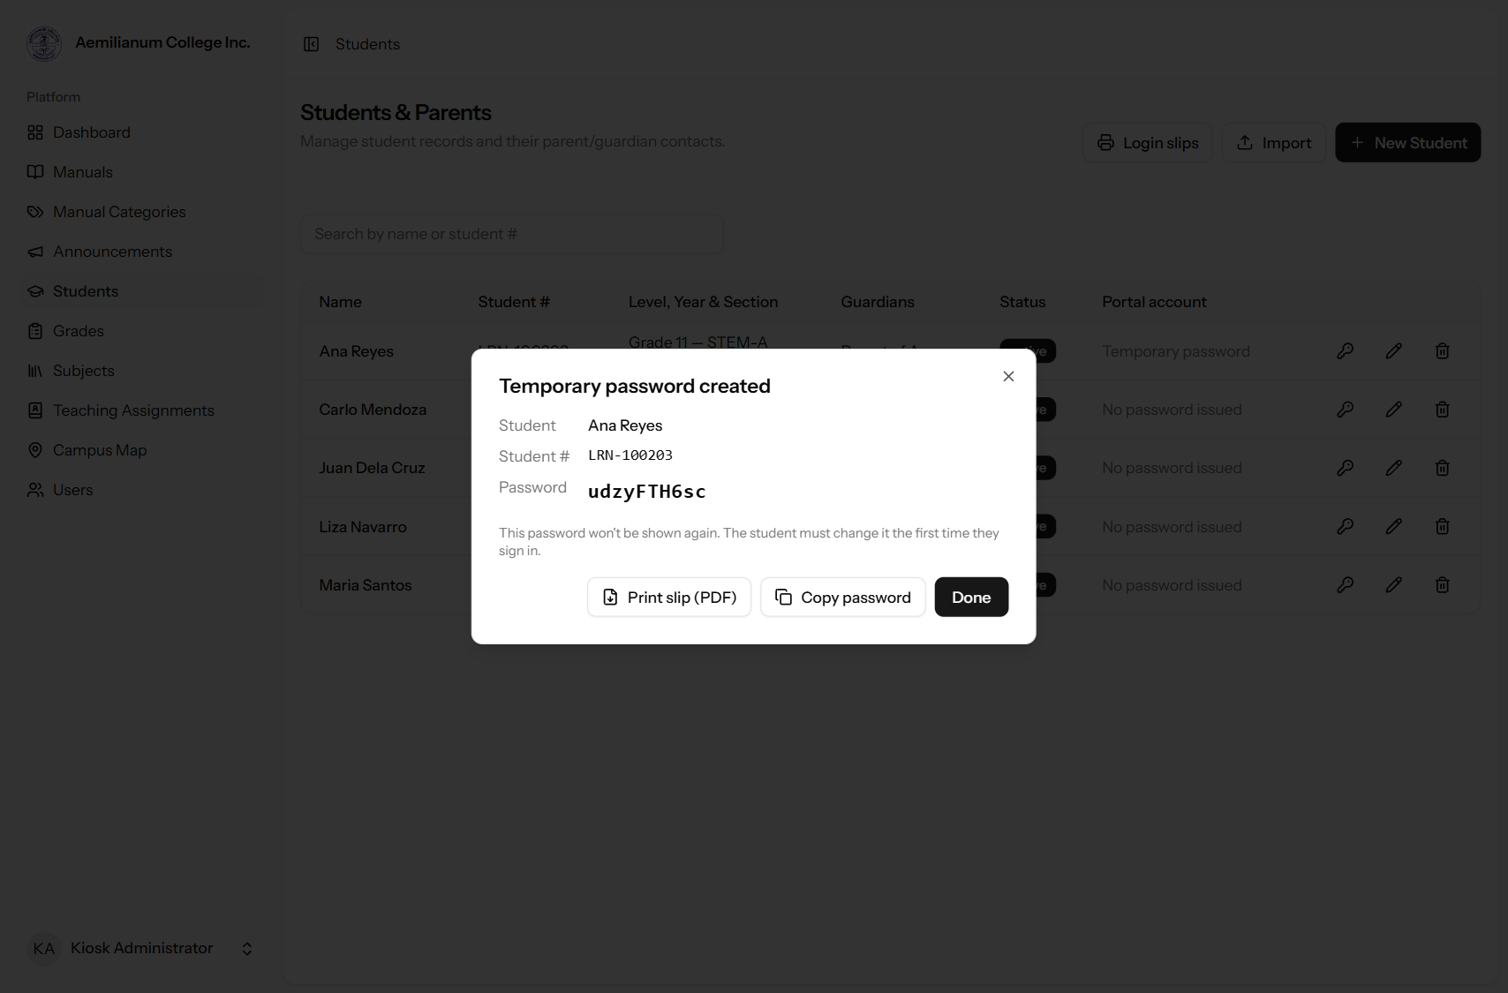
Figure 7. After issuing a password, the new "Print slip (PDF)" button downloads the single-student strip.
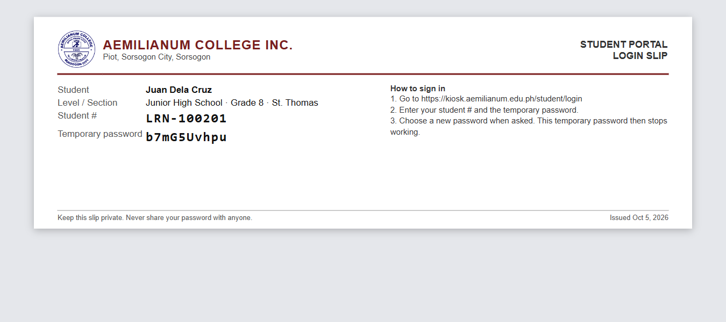
Figure 8. Single-student login slip: a ¼-page strip with the school header and footer.
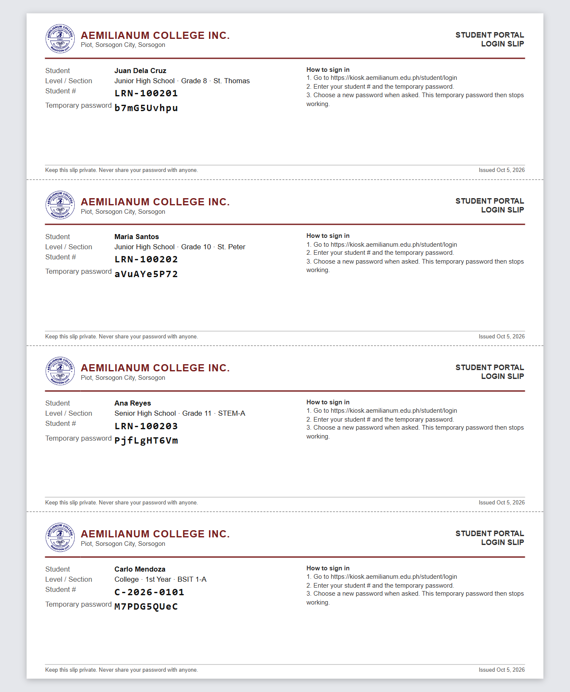
Figure 9. Batch login slips: four per short bond page, separated by dashed cut lines.

3.2 Education level and year level
- A new Education level field: Junior High School, Senior High School, College or Graduate School.
- The Year level drop-down only lists the years for the chosen level:
  - Junior High School: Grade 7 to Grade 10
  - Senior High School: Grade 11 and Grade 12
  - College: 1st Year to 5th Year
  - Graduate School: 1st Year to 3rd Year
- The grading system (K-12 quarterly or College semestral) is now set automatically from the education level.
- The student list shows the education level under each student's year and section.
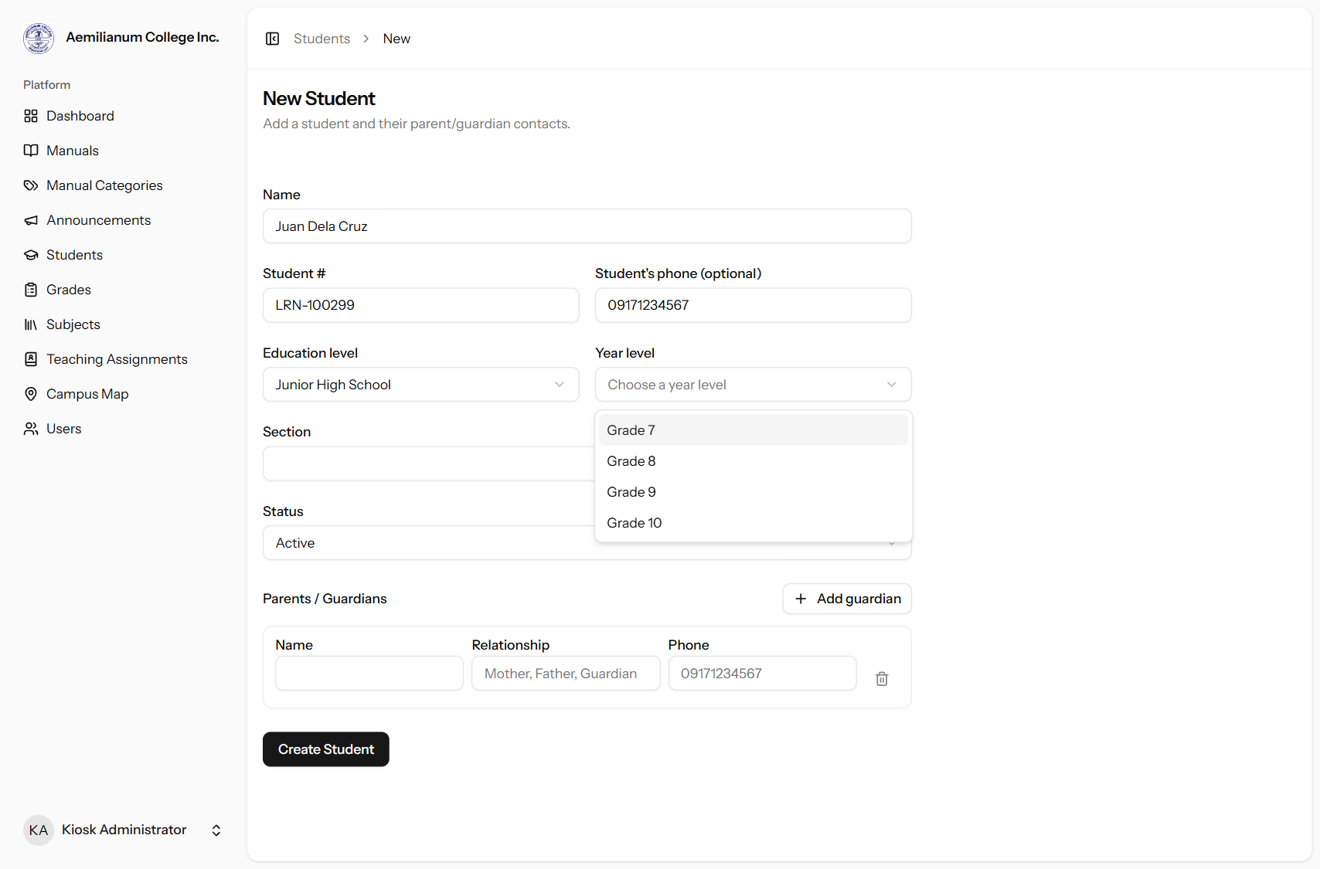
Figure 10. New Student form: choosing Junior High School limits the year level to Grades 7–10.
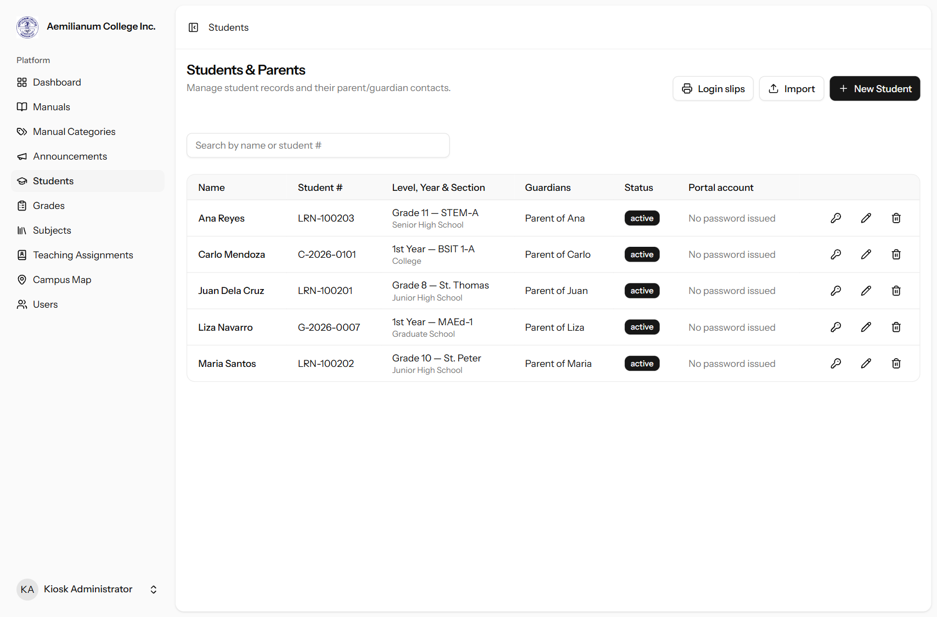
Figure 11. Student list showing level, year and section for each student.

3.3 Phone numbers: exactly 11 digits
- All phone fields (student, guardian and personnel) accept exactly 11 digits starting with 09, for example 09171234567.
- Letters and symbols are removed as you type, and the field stops at 11 digits. The system rejects anything else when saving.

3.4 Required information
The following must be filled out before a student can be saved: name, student number, education level, year level, section, status, and at least one parent/guardian (name, relationship and phone). The student's own phone number remains optional and is labeled as such.

3.5 Excel import template
- "Download Excel template" now gives a real Excel (.xlsx) file instead of a CSV.
- The education level and year level columns have drop-down lists; the year list follows the level chosen in the same row.
- Phone columns are formatted as text, so Excel keeps the leading 0. If a number still loses its 0, the import puts it back.
- Rows with missing required data, a year that doesn't match the level, or a phone number that isn't 11 digits are skipped and reported by row number.
Template columns
Column | Required? | Example
name | Yes | Juan Dela Cruz
student_number | Yes | LRN-00012345
education_level | Yes | Junior High School (drop-down)
grade_level | Yes | Grade 8 (drop-down)
section | Yes | St. Thomas
status | Yes | active (drop-down)
phone_number | Optional | 09171234567
guardian_1_name / _relationship / _phone | Yes | Maria Dela Cruz / Mother / 09171234567
guardian_2_name / _relationship / _phone | Optional | Jose Dela Cruz / Father / 09181234567
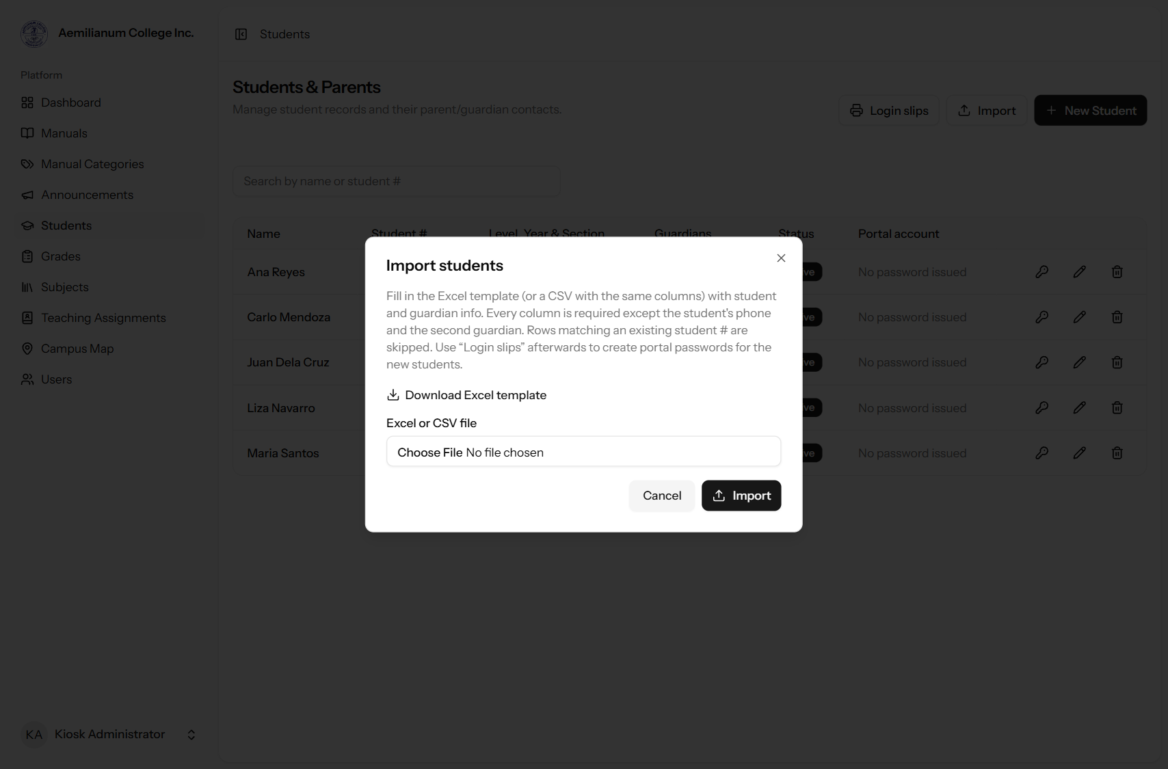
Figure 12. Import dialog with the new Excel template download.

4. Subjects (registrar)
- A new Subjects page in the menu, available to the registrar and administrators.
- Subjects are grouped by education level. Each has a name and an optional code and units (useful for college).
- The same subject name can't be added twice for the same level.
- When assigning a teacher under Teaching Assignments, the Subject field suggests subjects from this list.
How to use
- Open Subjects from the menu and click Add Subject.
- Enter the subject name, choose the education level, and optionally a code and units.
- Click Add. Use the pencil icon to edit or the trash icon to remove a subject.
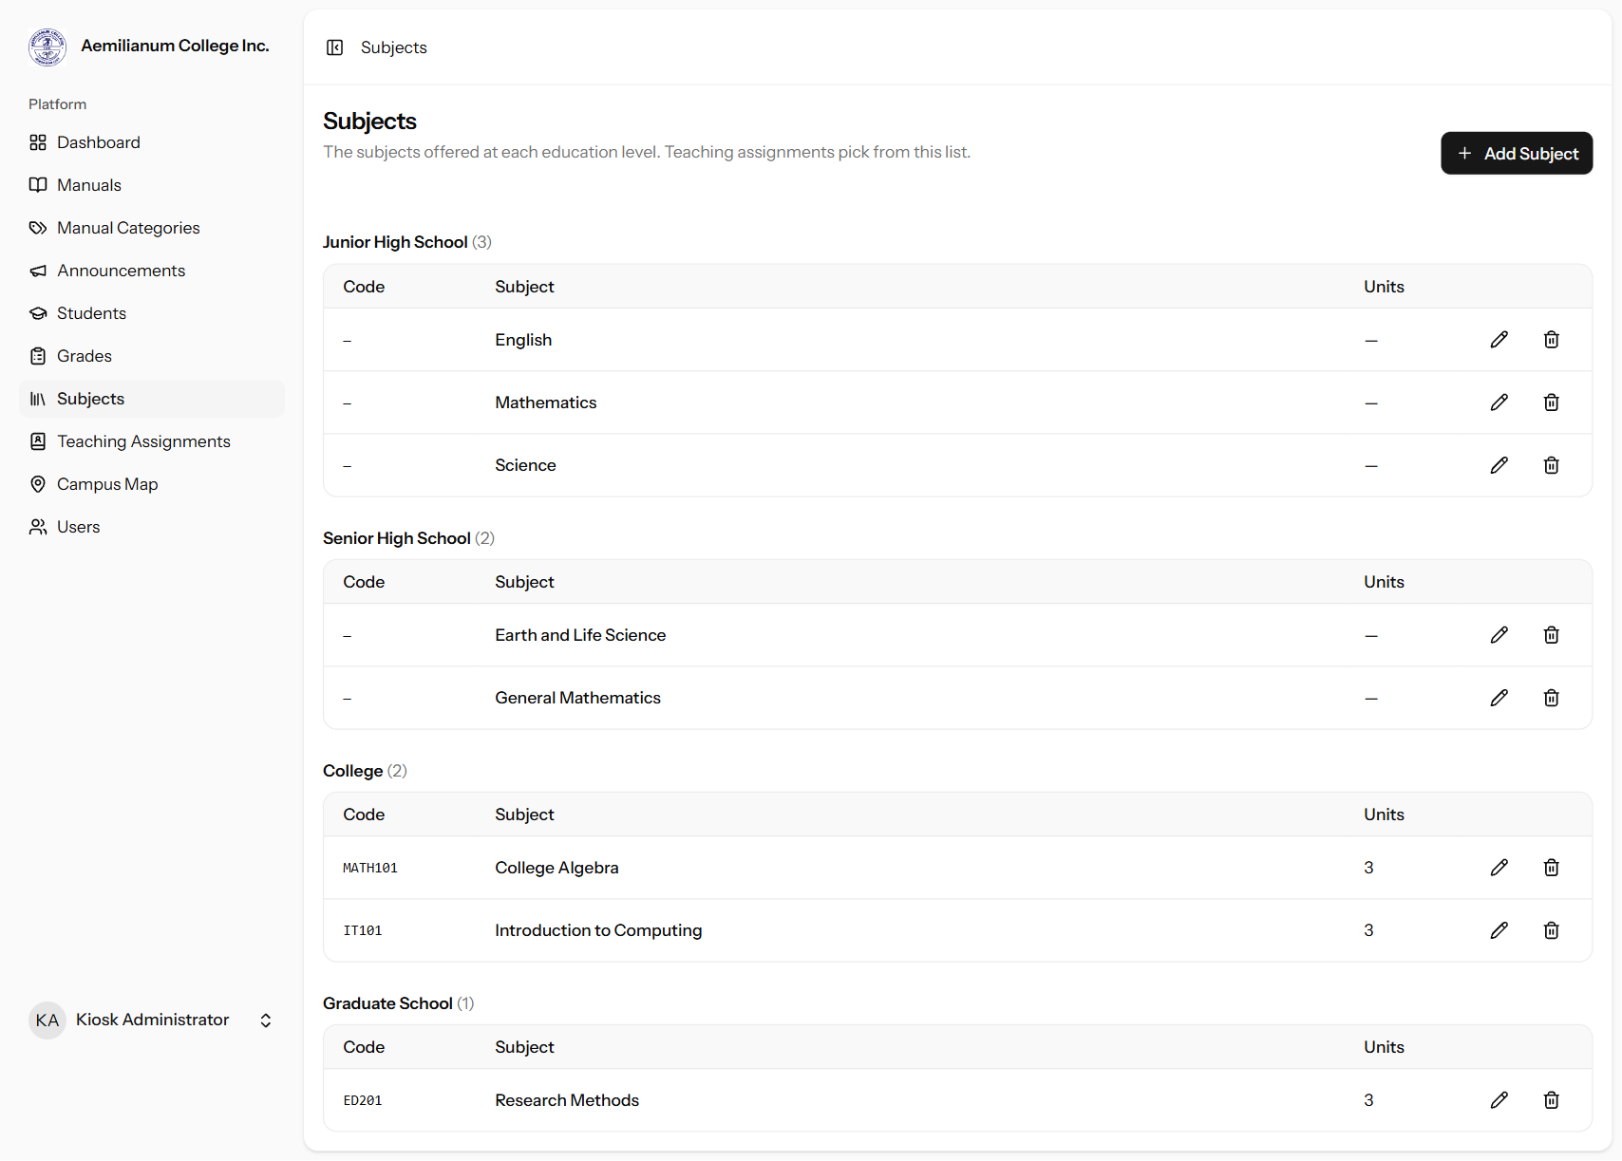
Figure 13. The Subjects page, grouped by education level.
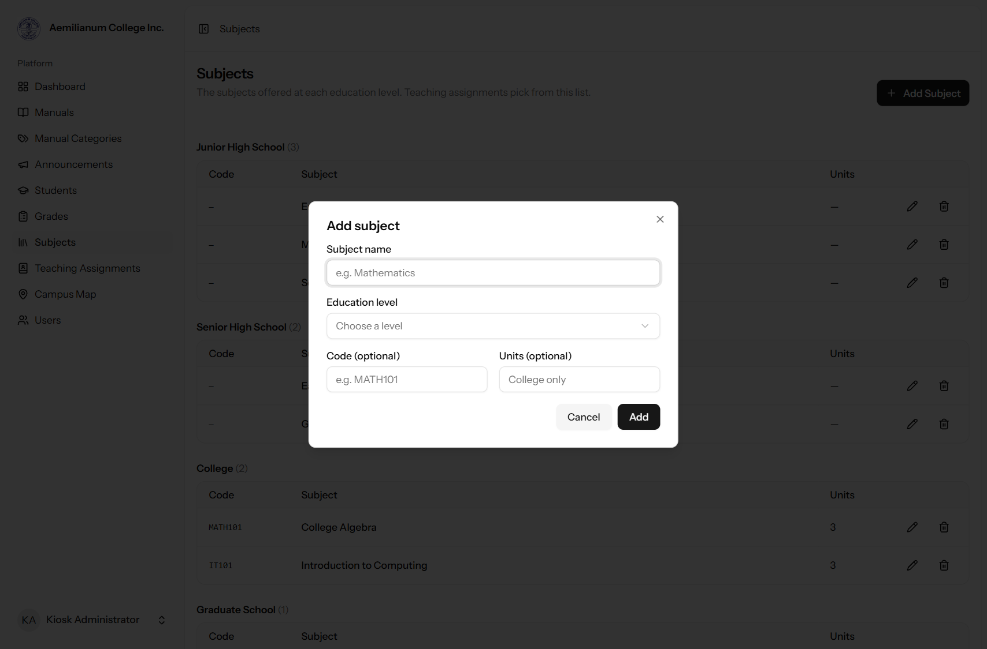
Figure 14. Adding a subject.

5. Notes before going live
- School address on slips: the slip header currently reads "Piot, Sorsogon City, Sorsogon". Please confirm it. It can be changed, along with a contact line and the footer text, in the system settings file (.env: SCHOOL_ADDRESS, SCHOOL_CONTACT, SCHOOL_FOOTER).
- Email delivery: personnel emails are written to the system log until a mail server is configured and the background queue worker is running.
- Location privacy: to show active users on the dashboard, the kiosk map now sends each phone's position on the campus map (not its exact GPS coordinates) to the server while "Show my location" is on. We recommend adding a short notice on the map page telling visitors this.
- Existing student records: students added before this update may not have an education level yet. They will be asked for one the next time their record is edited. Phone numbers saved earlier in the +63 format were not converted.
- Event times (known issue): the system clock is set to UTC, so event times can display 8 hours off on devices in the Philippines (an 8:00 AM event may show as 4:00 PM). This affects all event pages, not only the new features, and should be corrected by setting the system timezone to Asia/Manila.

